Untold Ticketing App

Student:Bar Luca-Narcis

**Group:30431/1**

Table of Contents

1. Requirements Analysis 3

1.1 Assignment Specification 3

1.2 Functional Requirements 3

1.3 Non-functional Requirements 3

2. Use-Case Model 3

3. System Architectural Design 3

4. UML Sequence Diagrams 3

5. Class Design 3

6. Data Model 3

7. System Testing 3

8. Bibliography 3

1. Requirements Analysis

# Assignment Specification

The application is a Java Desktop app designed for selling tickets to the Untold festival. It has 2 types of users(cashier and admin) who must provide their credentials when opening the app, before being able to use it. The data that they work with is stored in a relational database implemented using PostgreSQL. The tables are for artists, users, concerts, tickets and an intermediary table used to link multiple artists to a single concert.

# Functional Requirements

* The admin user can perform the following operations:
  + CRUD on cashiers’ information
  + CRUD on the concerts at Untold
  + Export all the tickets that were sold for a certain show
* The cashier user can perform the following operations:
  + Sell tickets to a concert
  + CRUD on tickets
* The system notifies the users when:
  + The number of tickets per concert was exceeded
* Data is stored in a relational database
* Layers architectural pattern is used to organize the application
* User interface

# Non-functional Requirements

*-Responsive GUI*

*-Fast access time*

*-Password encryption for extra security*

*-Portability(can be ran on any device)*

*-Scalable*

*-Local, for now.*

2. Use-Case Model

General Use-Cases for the actors of the application:

Use case: Creating a Ticket for a concert/show

Primary actor: Cashier(user)

Main success scenario:

User enters their credentials- > credentials are checked and if they are correct, the loginFrame will open un a CashierFrame since it will get its role from the UserBL method-> User (cashier) can select from the available operations, and in this case they will select the “Sell Ticket” option and will be prompted to insert the details for the ticket(s). If the operation is executed successfully(i.e. entered data is correct and there are enough tickets), the tickets will be created and added in the tickets table.

Extensions:

-should the user provide some incorrect credentials, they will receive an error

-should the user provide the incorrect name of the concert, they will receive an error

-should there be too few tickets for the operation, the user will again receive an error.

Screenshots for the successful case:

Login screen:

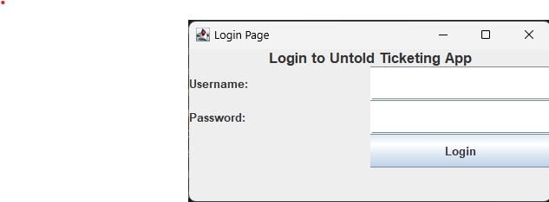

Interface for providing ticket details:

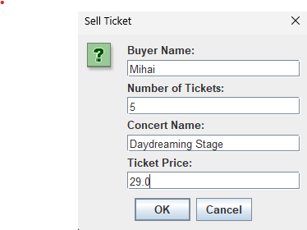

Before confirming ticket sale:



After confirming ticket sale(we see that the tickets for DayDreaming Stage have gone down):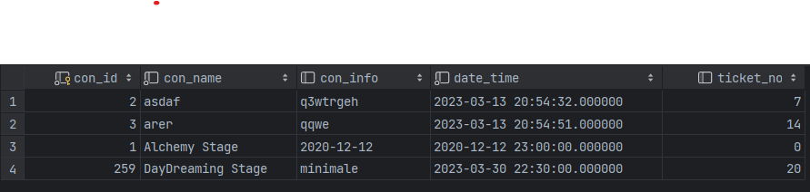

Example of error, if we try to sell too many tickets(currently pops up only in the terminal, and no tickets will be sold in this case):



3. System Architectural Design

For the project I’ve used the Layered architecture(i.e. Data layer, business layer and presentation layer).

**3.1 Architectural Pattern Description**

**The Layered architecture pattern is one of the most common patter in Java development and, in essence, it implies organizing the data into multiple horizontal layers, each performing a specific role within the application.**

**In my app, I’ve split the layers into 3(or 4 rather): The data package is used to create the model classes after the database tables, the persistence layer consists of an AbstractDAO class, which is extended by the DAO classes for each of the classes in the data package and are used to represent the way operations on the database(i.e. the CRUD operations) are performed. The business layer is used to build effective roles within the app, such as the administrator and the cashier BL classes, which are used to represent the available operations for each user type and also a UserBL class which is used for authentication and user type retrieval. And finally, the presentation class is the one responsible for the interface of the app and its functionality(i.e. the action listeners for the buttons).And the DBCon class is responsible with connecting to my PostgreSQL database, using the JDBC driver.(included in the app are the libraries needed for jdbc and for the openCSV library).**

**3.2 Diagrams**

The package modelling of the app:

4. UML Sequence Diagrams

Sequence Diagram for the “Create Ticket” operation which was also described in the Use-Case section:

5. Class Design

**5.1 Design Patterns Description**

As a design pattern, the one I’ve got to use was for the CSV exporting, and I’ve used the Factory design pattern, which implies that we create object without exposing the creation logic to the client and refer to newly created object using a common interface

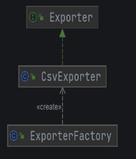

And I used it to create my CSV exporting methods which was then used in my AdminPanel class in order to export the list of tickets for a specific concert to a .csv format file.

**5.2 UML Class Diagram**

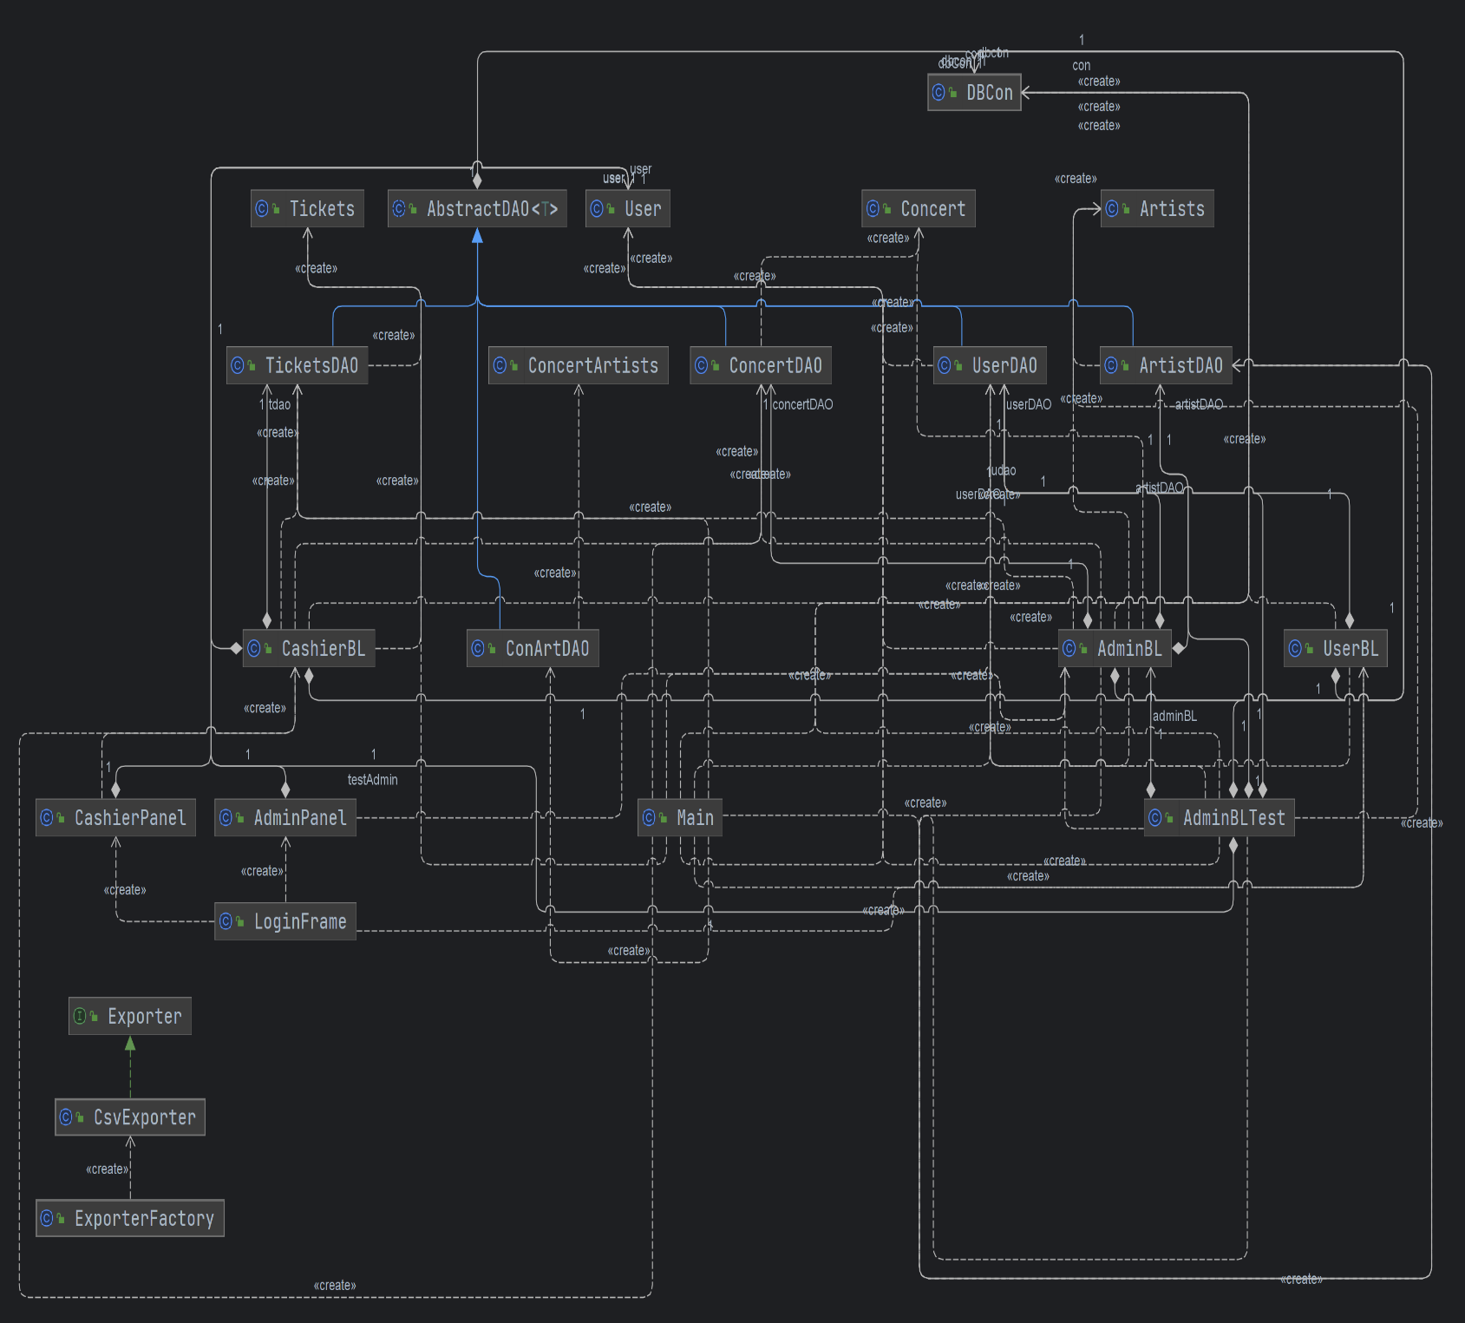

6. Data Model

For this project, I’ve structured my database using PostgreSQL, and separated my data into different tables. The users table contains the data for the admins and cashiers, concerts represent the performances with their dates and a short description, artists are the singers/bands performing, tickets are created by the cashiers for a specific concert and contain the id of the cashier that created them and the name of the buyer, and con_arts is used to represent a relation between concerts and artists, meaning that a single concert may have multiple artists performing at it.

7. System Testing

For testing, I’ve created a JUnitTest class which tests the method that updates a specific artist, which only an Admin can perform:

public void testUpdateArtist() throws SQLException {  
 // Insert a new artist into the database  
 Artists artist = new Artists(220, "Test Artist", "Test Genre");  
 artistDAO.insert(artist);  
  
  
 // Update the artist's name and genre  
 boolean result = adminBL.updateArtist(artist.getArtistId(), "New Artist Name", "New Artist Genre");  
  
 // Verify that the artist was updated successfully  
 *assertTrue*(result);  
  
 Artists updatedArtist = artistDAO.findbyId(artist.getArtistId());  
 *assertEquals*("New Artist Name", updatedArtist.getArtistName());  
 *assertEquals*("New Artist Genre", updatedArtist.getArtistGenre());  
  
 // Clean up test data  
 artistDAO.delete(artist);  
 userDAO.delete(testAdmin);  
}

here we create a new artist with some random values that are not present in the table already, then we use the updateArtist method in the adminBL class, and user assertTrue(result) to make sure that the update is performed successfully.

Then we retrieve the updated artist and user assertEquals in order to check if the modification was performed successfully. And finally we delete the created artist and admin for the test, in order to avoid unwanted errors in our app.

8. Bibliography

[1. Layered Architecture - Software Architecture Patterns [Book] (oreilly.com)](https://www.oreilly.com/library/view/software-architecture-patterns/9781491971437/ch01.html)

<https://docs.oracle.com/middleware/1212/jdev/OJDUG/java_swing.htm>

<https://www.tutorialspoint.com/design_pattern/factory_pattern.htm>

<https://www.geeksforgeeks.org/data-access-layer/>

https://www.postgresqltutorial.com/postgresql-jdbc/connecting-to-postgresql-database/