Video Games Shop

Use-Case Model

Version <1.0>

Revision History

|  |  |  |  |
| --- | --- | --- | --- |
| **Date** | **Version** | **Description** | **Author** |
| <20/03/23> | 1.0 | Sketching up the initial use-case model and identifying the details, i.e. actors, levels, etc. | Bar Luca-Narcis |
|  |  |  |  |
|  |  |  |  |
|  |  |  |  |

Table of Contents

1. Use-Cases Identification 4

2. UML Use-Case Diagrams 4

# Use-Cases Identification

Use case: Purchasing a Video Game

Level: user-goal

Primary actor: User

Main success scenario: User will be asked for credentials-> User enters credentials-> credentials are verified successfully and user is logged in->User searches for a game(could be by genre, name, publisher, price, etc.)-> User is given a list of games relevant to their search -> User selects the desired game and adds it to cart-> user selects payment option and enters payment details -> payment is confirmed and user receives the estimated delivery time and the receipt(and maybe add an option to receive the receipt via email as well).

Extensions:

- If user’s details are incorrect -> user receives an error and is asked to log in again

- The user may receive no results for their search if there are no games matching the specified criteria

- The user may enter incorrect payment details, case in which they’ll also receive an error.

Use case : authorizing a refund

Level : User-goal

Primary Actor: Site administrator

Main success scenario: Administrator logs in successfully-> Enters the refunds menu-> gets displayed all active refund requests -> can select to approve or deny any request(if denying, must enter a reason)-> request is approved/denied.

Extensions: Administrator may enter incorrect credentials(could lock out after 3 unsuccessful attempts, for security reasons)

There may be no refunds to authorize

The administrator might try to cancel a refund without giving a reason, case in which a warning will pop up.

# UML Use-Case Diagrams

Use-case diagram for the site user:

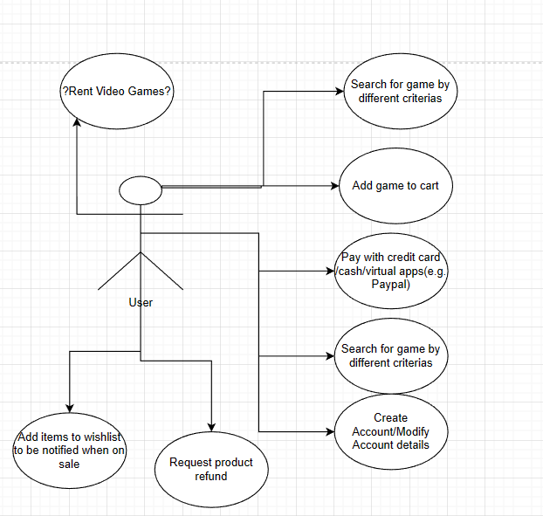

Use-case diagram for site administrator:

