Shaukat Khanum Memorial Cancer Hospital & Research Centre
Information Systems

Change Request
Automated Employee Probation Evaluation

Document ID | CR-2026-XXX-PEV
Version | 0.6
Status | DRAFT
Date | 2026-10-09
Prepared by | Claude (AI draft) for Business Analyst
Source documents | SRS v0.5; HRD schema

Version History
Version | Date | Author | Change summary
0.6 | 2026-10-09 | Claude (AI draft) for Business Analyst | Department probation hierarchy, else organizational leave hierarchy

Approvals
Role | Name | Decision | Signature | Date
Business Analyst (author)
Solution Architect
Business Owner / Department Head
Approval is recorded by the named person only. AI-drafted documents remain DRAFT until then.

Change Request: Automated Employee Probation Evaluation
Item | Value
CR No. | CR-2026-XXX-PEV (placeholder: real CR number to be assigned)
Module / Schema | HR (HRD), Oracle APEX
Requested by | HR Department
Prepared by | Claude (AI draft) for Business Analyst
Version / Status | 0.6 / DRAFT (approval routing: department probation hierarchy, else organizational leave hierarchy)
Date | 09-Oct-2026
Sources merged | CR-2026-XXX-PEV_CR_v0.1 (client template) + CR-2026-XXX-PEV_SRS_v0.3 (detailed requirements, impact analysis). SA review: CR-2026-XXX-PEV_SRS-Review_v2

Open-question (Q-NN) and assumption (A-NN) references point to the internal SRS (`CR-2026-XXX-PEV_SRS_v0.3`); they are not repeated in this CR. Table and column details: `CR-2026-XXX-PEV_Design_v0.2` (Design Document).

1. Client Needs / Expectations
HR wants the employee probation evaluation to run automatically, on time and with full visibility, without manual follow-up:
- Every employee on probation is evaluated by their respective supervisor before the probation end date. The system starts the evaluation automatically 15 days before the probation end date.
- The evaluator can work on the evaluation over more than one sitting (Save as Draft) and send it when ready (Submit for approval).
- Every submitted evaluation goes through the approval hierarchy set up for the department (for example HOD, then Director). If no hierarchy is set up for the department, it follows the organizational leave hierarchy already defined in the system.
- Once approved, the completed evaluation reaches the HR Department automatically.
- HR and supervisors can see the current status of every probation evaluation at any time. The status updates itself at each step.
- The evaluation form has four sections (replacing today's Excel form):
- Evaluation criteria (standard parameters such as job knowledge and quality of work), each rated 1 to 5;
- Assignments completed during the probationary period, each rated 1 to 5;
- Employee's assessed training needs;
- Specific reasons and observations, with evidence, when the employee is not recommended for confirmation.
Expected benefits: no missed or late evaluations, a consistent approval path, no manual chasing by HR, and an audit trail of who did what and when.
Today: a probation-ending alert is e-mailed 15 or 30 days before the probation end date with an Excel probation evaluation form attached. The concerned person fills in the Excel form and sends it back as feedback. In the HRD system, the alert is configured as alert 001 (HRD.ALERTS / HRD.HR_ALERT_QUEUE, visible to HR users only), and HR records the confirm/extend decision on form S07FRM00362. There is no online form, approval routing or status tracking.

1.1 Business requirements
ID | Business requirement | Source (M-NN) | Priority
BR-01 | Every employee on probation shall be evaluated by their supervisor before the probation end date, with the evaluation started automatically in good time. | M-01, M-02, M-03 | Must
BR-02 | Evaluators shall be able to work on an evaluation over more than one session before committing it. | M-04, M-05 | Must
BR-03 | Every submitted evaluation shall be reviewed through the organisation's configured approval hierarchy. | M-06 | Must
BR-04 | HR shall receive every completed evaluation without manual follow-up. | M-07 | Must
BR-05 | HR and supervisors shall always know the current stage of each probation evaluation. | M-08 | Must
BR-06 | Probation evaluations shall be captured online (standard criteria and assignments rated 1–5, assessed training needs, and evidence-based reasons when not recommended for confirmation), replacing the Excel form. | M-09, M-10, M-11, M-12, M-13 | Must

1.2 Background
Employees joining SKMCH serve a probation period. Before the probation end date, the employee's supervisor must evaluate the employee so that HR can decide on confirmation. Today this is done through an e-mailed alert with an Excel evaluation form (see 1.3). The requested change moves the evaluation online: the system starts it automatically, routes it through the approval hierarchy, delivers it to HR and keeps its status up to date (M-01 to M-13).

1.3 Current process (As-Is)
- Step 1: A probation-ending alert is e-mailed 15 or 30 days before the probation end date, with an Excel probation evaluation form attached (alert 001 in HRD.ALERTS; the queue in HRD.HR_ALERT_QUEUE is visible to HR users only).
- Step 2: The concerned person (supervisor) fills in the Excel form and sends it back by e-mail as feedback. The form's main sections are:
- Assignments completed during the probationary period, rated 1 to 5;
- Employee's assessed training needs;
- Specific reasons and observations, with evidence, if the employee is not recommended for confirmation.
- Step 3: HR follows up manually, then records the confirm/extend decision on form S07FRM00362 (PKG_S07FRM00362, HRD.EVALUATION_ALERT_QUEUE).
- Step 4: Approvals above the supervisor are obtained outside the system, and nobody can see where an evaluation stands.
Pain points: offline Excel forms, late or missing feedback, no approval routing, no evidence kept with the record, and no status tracking.

1.4 Scope

In scope
- Automatic generation of a probation evaluation queue item for the respective supervisor 15 days before the employee's probation end date (M-02, M-03).
- Evaluation entry by the evaluator with Save as Draft and Submit for approval (M-04, M-05).
- Online evaluation form replacing the Excel form: assignments with 1–5 ratings, assessed training needs, and reasons/observations with evidence when not recommended for confirmation (M-09 to M-12).
- Routing of a submitted evaluation through the configured approval hierarchy (M-06).
- Automatic routing of the completed evaluation to the HR Department (M-07).
- Automatic update of the probation request status throughout the workflow, with status history (M-08).

Out of scope
- HR's downstream action on the evaluation (confirmation letter, probation extension, termination, payroll/grade changes). Not discussed; HR's exact action on receipt is open (Q-06).
- Probation evaluation of employees whose probation is ended early (resignation, termination) — the queue is cancelled only (see FR-004); no separate process is specified.
- Self-evaluation by the employee. Not mentioned.
- Automatic confirmation, extension or termination of probation, including when an evaluation is overdue (changed in v0.2, RV-17).

1.5 Stakeholders
Name / Role | Department | Interest / responsibility | Attended meeting
HR Department representative(s) (names not stated, Q-13) | HR | Business owner; receives completed evaluations; owns probation policy | Not stated
Supervisors / evaluators | All departments | Complete probation evaluations on time | No
Approvers in the approval hierarchy (e.g. HOD) | All departments | Review and approve submitted evaluations | No
Employees on probation | All departments | Subject of the evaluation (no system action) | No
Business Analyst | IT / Development | Requirement owner for this SRS | Not stated
Solution Architect | IT | SRS review and approval (Gate 1) | Not stated
Development team / QA | IT | Build and test | Not stated

1.6 Definitions and abbreviations
Term | Meaning
Probation end date | The date on which the employee's probation period ends, as held in the employee's HR record
Probation request | The HR record that tracks an employee's probation period and its evaluation outcome (whether this already exists in HRD is to be confirmed, Q-03)
Probation request status | The HR-level status of the employee's probation period, updated automatically from the evaluation workflow (changed in v0.2, RV-04; mapping to be finalised with Q-03, Q-09)
Evaluation status | The workflow status of a probation evaluation, with the values and transitions in RULE-08 (added in v0.2, RV-04)
Probation evaluation | The assessment of an employee on probation, completed by the evaluator and approved through the hierarchy
Evaluator | The respective supervisor of the employee, who completes the evaluation
Respective supervisor | The employee's direct supervisor / reporting manager on record (source to be confirmed, Q-04)
Queue | A pending work item shown to a user on their queue / inbox screen
Approval hierarchy | The configured ordered list of approval levels a submitted evaluation passes through
Draft | A saved but not submitted evaluation, visible and editable only by the evaluator
HOD | Head of Department
APEX | Oracle Application Express, the platform for the HRD applications
MoM | Minutes of Meeting

1.7 References
- Request: "Automated Employee Probation Evaluation", proposed workflow points 1 to 5 (shared in chat, 2026-10-09). Meeting date and attendees not stated (Q-13).
- Earlier SRS versions: none.
- Related CRs: none known. CR number to be assigned (Q-14). Placeholder CR-2026-XXX-PEV used because CR-2026-XXX is already used by the Committee Workflow CR.
- HR probation policy / SOP: to be supplied by HR (Q-08).
- Current Excel probation evaluation form (attached to the probation-ending alert).

2. Workflow
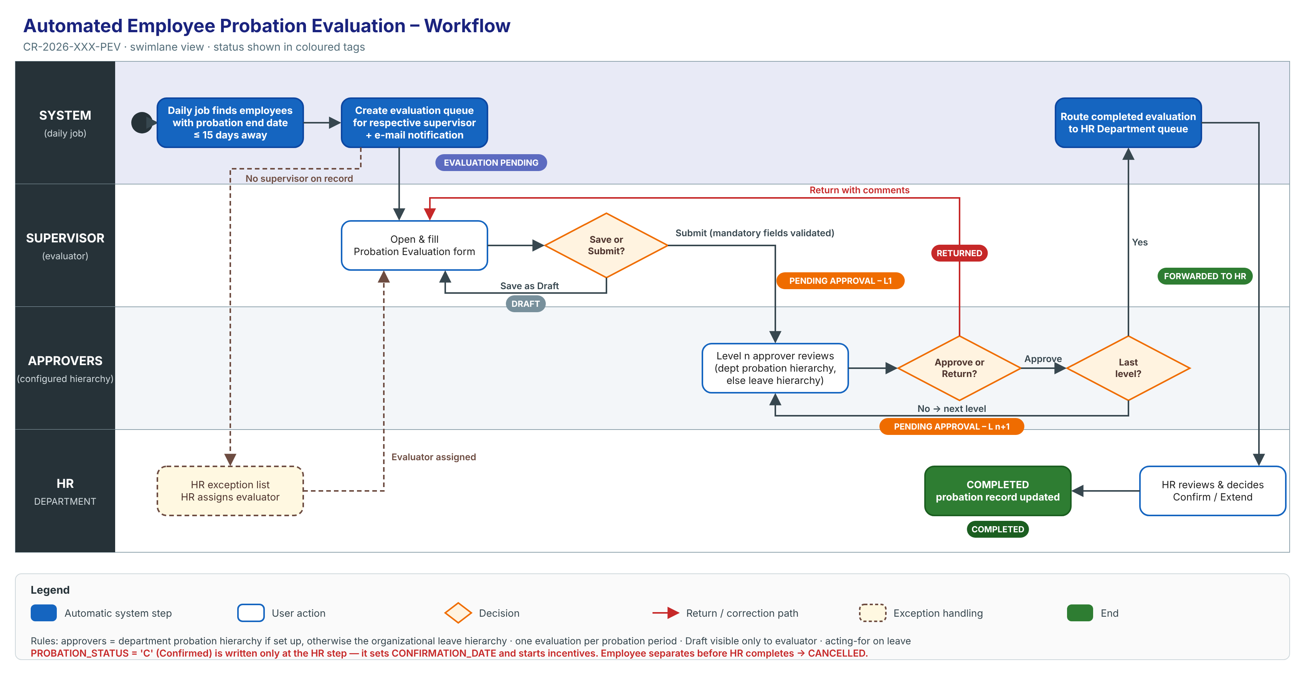
Editable source: `CR-2026-XXX-PEV_Workflow.svg`.
Step | Actor | Action | System result | Status after step
1 | System (daily job) | Finds employees whose probation end date is within 15 days and who have no evaluation yet | Creates an evaluation queue item for the respective supervisor and notifies them | Evaluation Pending
2a | Supervisor (evaluator) | Fills part of the form and clicks Save as Draft | Saves; the item stays in the supervisor's queue | Draft
2b | Supervisor | Completes the form and clicks Submit | Validates mandatory fields and routes to Level 1 | Pending Approval – Level 1
3a | Approver (Level n) | Approve | Moves to the next level | Pending Approval – Level n+1
3b | Approver | Return with comments | Back to the supervisor for correction | Returned
4 | System | Last level approves | Routes to the HR Department queue | Forwarded to HR
5 | HR | Processes the evaluation (confirm / extend, per HR policy) | Closes the evaluation and updates the probation record | Completed

Status names are proposed and need HR to confirm them.

2.1 Status model
Allowed statuses and transitions are defined in RULE-08 (section 4.1 below).

3. Functional Requirements
Each requirement below follows the client template: a summary, a GUI prototype (screen mock-up in the SKMCH APEX GUI template — title bar with page code, tabs, region headers, rating-scale panel, score bar, Preview/Save/Exit buttons; sample data is synthetic and form content is indicative until HR supplies the evaluation form) and the detailed functional requirements (FR-NNN) with acceptance criteria. Editable prototype sources: prototypes/src/.

3.1 Requirement 1: Automatic generation of the probation evaluation queue
Description: Every day, the system shall identify each employee on probation whose probation end date is within the next 15 days and who has no evaluation for the current probation period. For each one, it shall create a probation evaluation queue item assigned to the employee's respective supervisor.
- One evaluation only per employee per probation period. A re-run never creates a duplicate.
- If a day's run is missed, the next run picks up the employees that were missed.
- If the employee has no supervisor on record, the item goes to an HR exception list. HR can assign or reassign the evaluator.
- If the employee leaves (separation) before HR completes the evaluation, the evaluation is cancelled.
- The supervisor is notified by e-mail when an item is assigned.
- Probation end date: taken from the probation record (HRD.F_PROBATION_END_DATE). Respective supervisor: HRD.INFORMATION.MANAGER_MRNO (to be confirmed by HR).
Acceptance (summary):
- An employee whose probation ends on 25-Oct-2026 appears in their supervisor's queue on 10-Oct-2026.
- An employee whose probation ends on 26-Oct-2026 does not appear in the queue on 10-Oct-2026.
- An employee who has been confirmed or has left never appears in the queue.
Traceability: FR-001 – FR-006, RULE-01 – RULE-03.

3.1.1 Prototype (GUI): Supervisor pending tasks (queue)
Screen 1 – My Pending Tasks (supervisor)
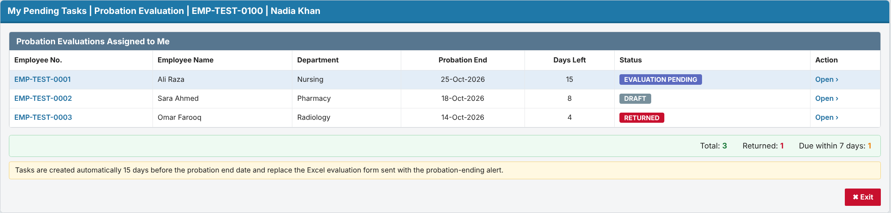

3.1.2 Detailed functional requirements

FR-001 Identify employees due for evaluation
Description: The system shall, once every day, identify each employee on probation whose probation end date is on or before 15 calendar days after the current date, is not earlier than the current date, and who has no evaluation for the current probation period (changed in v0.2, RV-05). Priority: Must Source: M-02 Business rules: RULE-01, RULE-03 Acceptance criteria:
- AC1: Given an employee on probation with a probation end date of 25-Oct-2026, when the daily process runs on 10-Oct-2026, then the employee is identified as due for evaluation.
- AC2 (negative): Given an employee on probation with a probation end date of 26-Oct-2026, when the daily process runs on 10-Oct-2026, then the employee is not identified.
- AC3 (negative): Given an employee who is not on probation (confirmed or separated), when the daily process runs, then the employee is not identified regardless of dates.
- AC4 (catch-up): Given the daily process did not run on 10-Oct-2026 and an employee's probation end date is 25-Oct-2026 with no evaluation, when the process runs on 12-Oct-2026, then the employee is identified.

FR-002 Generate evaluation queue item for respective supervisor
Description: The system shall create a probation evaluation queue item, assigned to the employee's respective supervisor, for each employee identified by FR-001. Priority: Must Source: M-02, M-03 Business rules: RULE-02, RULE-03 Acceptance criteria:
- AC1: Given employee EMP-TEST-0001 is identified and their supervisor on record is EMP-TEST-0100, when the daily process completes, then a probation evaluation queue item for EMP-TEST-0001 appears in EMP-TEST-0100's queue.
- AC2 (negative): Given employee EMP-TEST-0001 is identified, when the daily process completes, then no other user except the assigned supervisor (and HR monitoring, FR-017) sees the queue item.

FR-003 Prevent duplicate evaluation queue items
Description: The system shall create no more than one active probation evaluation for the same employee and probation period. Priority: Must Source: M-02 (Inferred) Business rules: RULE-03 Acceptance criteria:
- AC1: Given a queue item already exists for EMP-TEST-0001's current probation period, when the daily process runs again (e.g. re-run of the same day), then no second queue item is created.
- AC2: Given an employee's probation period is extended by HR with a new end date, when the new trigger date is reached, then a new evaluation is created for the new period (subject to Q-08).

FR-004 Cancel evaluation when probation ends early
Description: The system shall cancel an open probation evaluation and remove it from all queues when the employee is no longer on probation (separation or early confirmation) before the evaluation is completed. Priority: Should Source: M-08 (Inferred) Business rules: RULE-08 Acceptance criteria:
- AC1: Given an evaluation in Draft for EMP-TEST-0002, when HR records EMP-TEST-0002's separation, then the evaluation status becomes Cancelled and it disappears from the supervisor's queue.
- AC2 (negative): Given an evaluation already Forwarded to HR, when the employee separates, then the evaluation is not cancelled automatically and remains with HR.

FR-005 Handle missing supervisor
Description: The system shall, when an identified employee has no respective supervisor on record, create the evaluation unassigned and show it on an HR exception list instead of a supervisor queue. Priority: Must Source: M-03 (Inferred) Business rules: RULE-02 Acceptance criteria:
- AC1: Given an identified employee with no supervisor on record, when the daily process runs, then the evaluation appears on the HR exception list with the reason "Supervisor not defined".
- AC2: Given an evaluation on the HR exception list, when an HR Administrator assigns an evaluator using FR-006, then the queue item moves to that evaluator's queue.
- AC3 (negative): Given an identified employee with no supervisor, when the daily process runs, then the process does not fail and continues for the other employees.

FR-006 Reassign evaluator
Description: The system shall allow an HR Administrator to assign or reassign an evaluation that is unassigned or not yet submitted to a different evaluator (changed in v0.2, RV-15). Priority: Should Source: M-03 (Inferred) Business rules: RULE-02 Acceptance criteria:
- AC1: Given an evaluation in Evaluation Pending or Draft, when an HR Administrator reassigns it to EMP-TEST-0101, then it leaves the old supervisor's queue and appears in EMP-TEST-0101's queue with any draft content kept.
- AC2 (negative): Given an evaluation in Pending Approval, when an HR Administrator tries to reassign the evaluator, then the action is not available.

3.2 Requirement 2: Evaluation entry with Save as Draft / Submit
Description: The system shall let the assigned evaluator open the evaluation from the queue and fill in the evaluation form.
- The form shows the employee's details: employee no., name, department, designation, joining date, probation start and end dates.
- Save as Draft: saves without validation and without routing. Only the evaluator can see a Draft.
- Submit: checks that all mandatory fields are filled. If any are missing, it blocks submission and highlights them. Otherwise it routes the evaluation to approval (Requirement 3).
- After Submit the form is read-only for the evaluator, unless an approver returns it.
- The form has four tabs: Evaluation Criteria | Assignments | Training Needs | Recommendation.
- Evaluation Criteria: the standard parameters maintained by HR (e.g. Job Knowledge, Quality of Work, Punctuality & Attendance), each rated 1 to 5 with optional remarks, beside the Rating Scale panel and a score bar.
- Assignments: the evaluator lists the assignments completed during the probationary period and rates each one from 1 (Very Low) to 5 (Very High), with optional remarks. The system calculates the total, obtained score and performance %.
- Training Needs: the evaluator lists the employee's assessed training needs.
- Recommendation: Confirm, Extend Probation (with days) or Not to Confirm. When the employee is not recommended for confirmation (Extend or Not to Confirm), the evaluator must enter the specific reasons and observations and attach the evidence.
- A warning appears if the user leaves the page with unsaved changes. If another user changed the evaluation after it was opened, the save is rejected with "Changed by another user, reload".
Acceptance (summary):
- A Draft is saved and reopens with all values intact.
- Submit with a mandatory field empty is refused, and the status does not change.
- Submit with an unrated mandatory criterion, without any assignment, with an unrated assignment, or (when not recommending confirmation) without reasons and evidence is refused.
- A user who is not the evaluator cannot open the form.
Traceability: FR-007 – FR-010, FR-021 – FR-024, RULE-04, RULE-05, RULE-12, RULE-13.

3.2.1 Prototype (GUI): Probation Evaluation form (Evaluation Criteria, Assignments, Training Needs, Recommendation)
Screen 2 – Evaluation Criteria tab: standard parameters rated 1–5
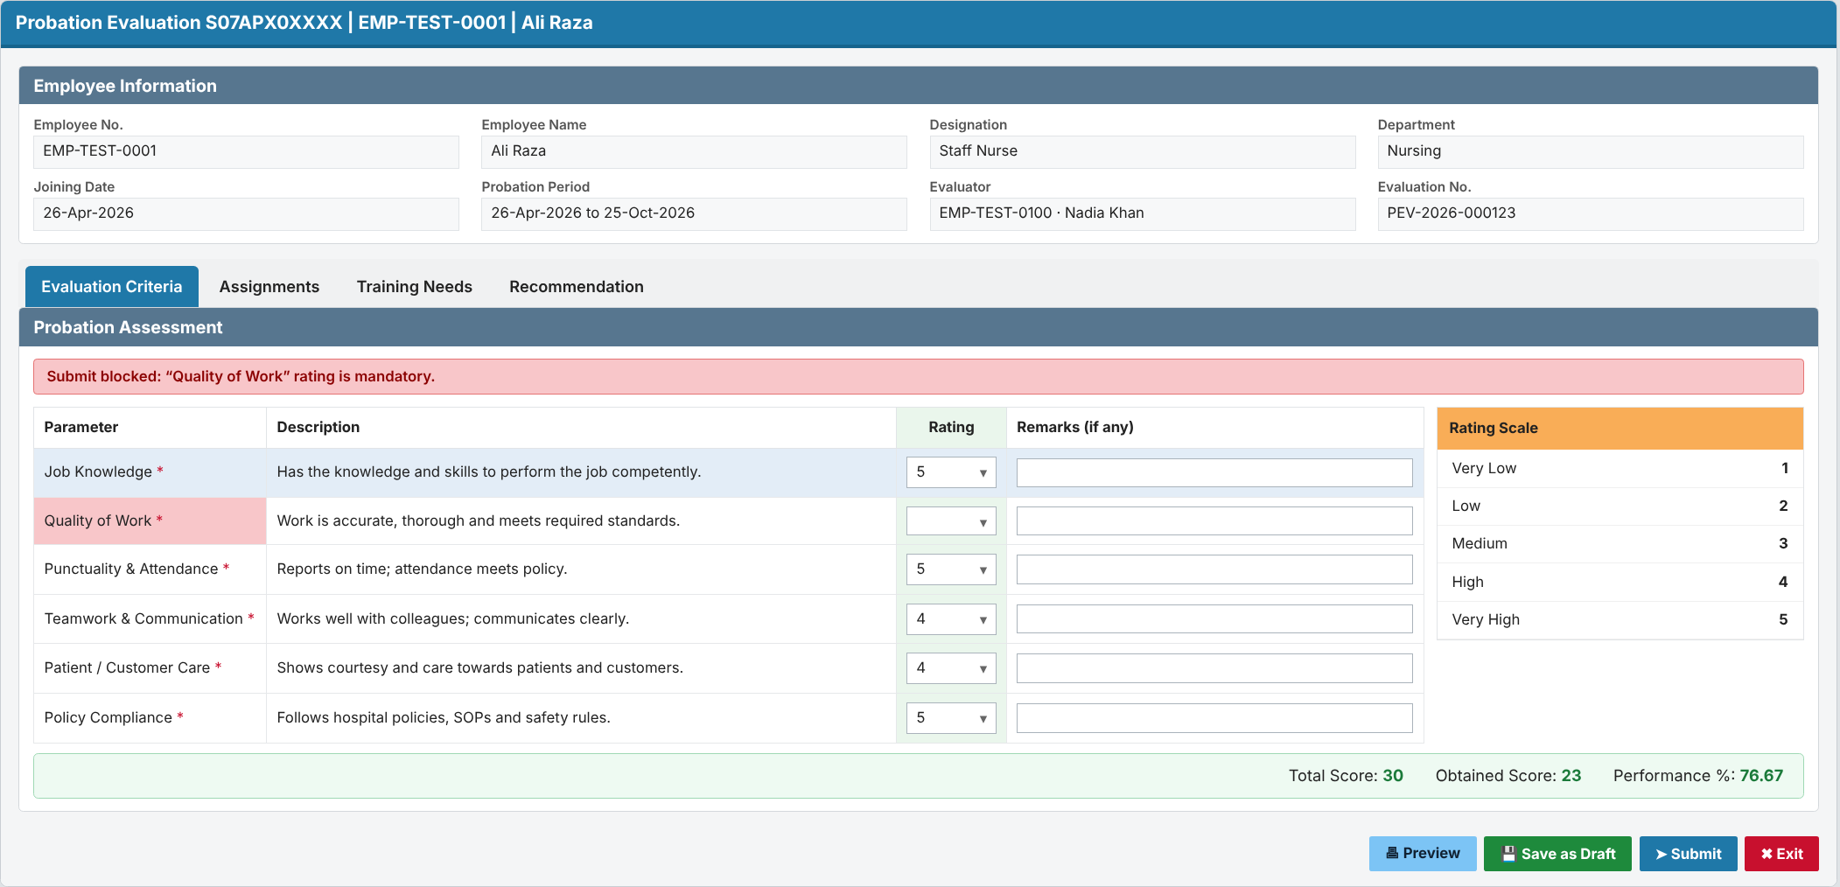
Screen 3 – Assignments tab: assignments completed during probation, rated 1–5
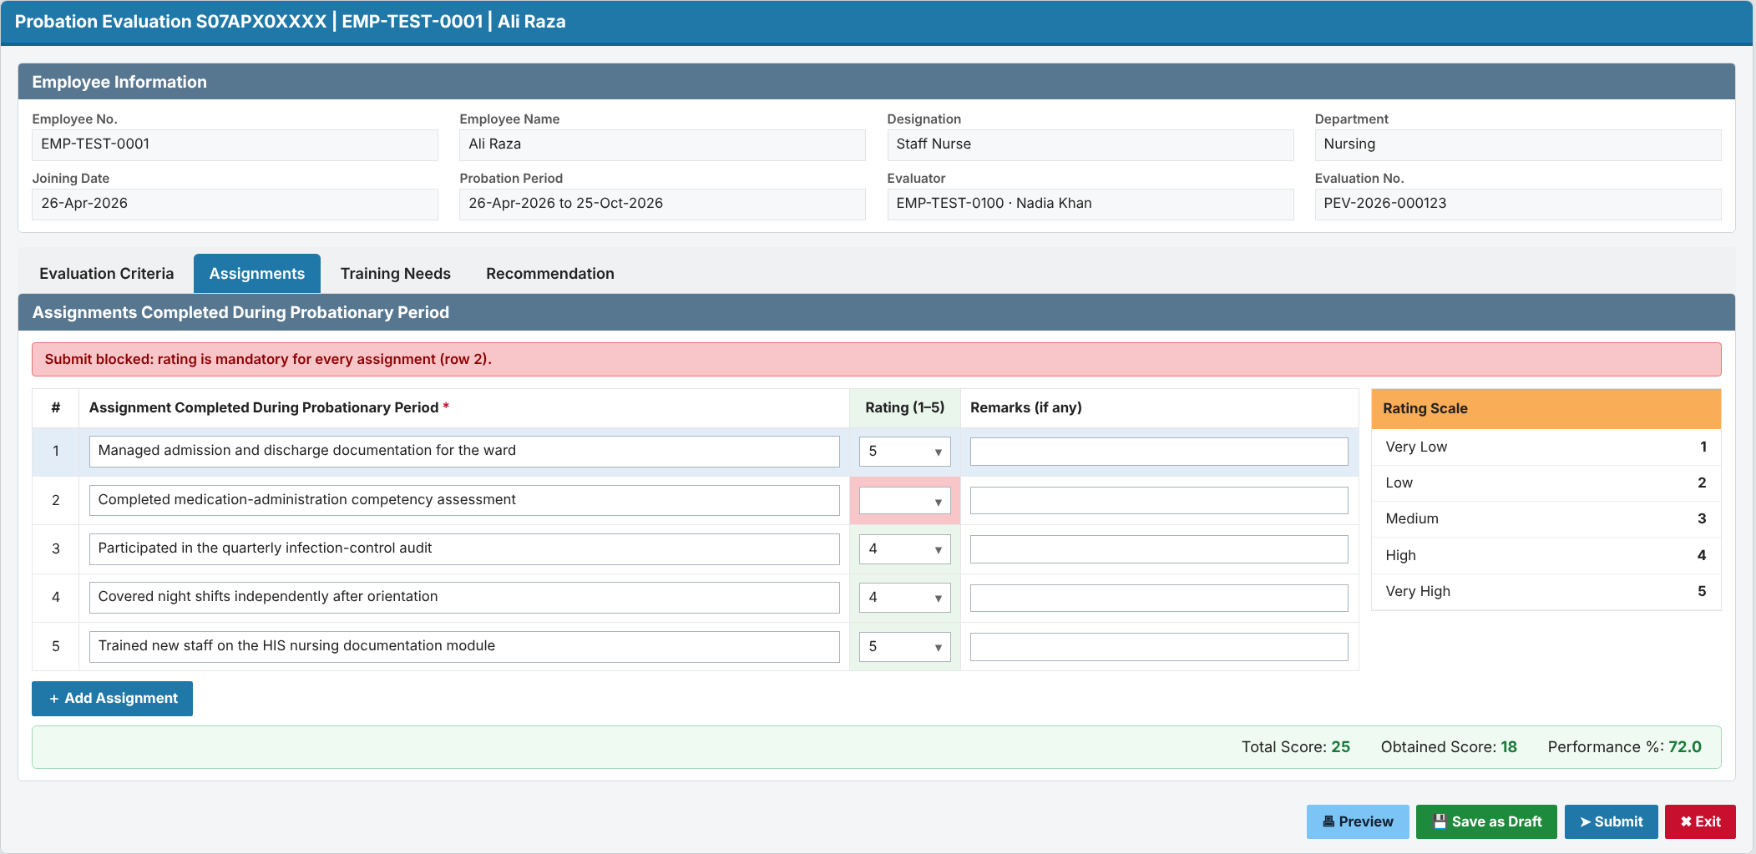
Screen 4 – Training Needs tab: employee's assessed training needs
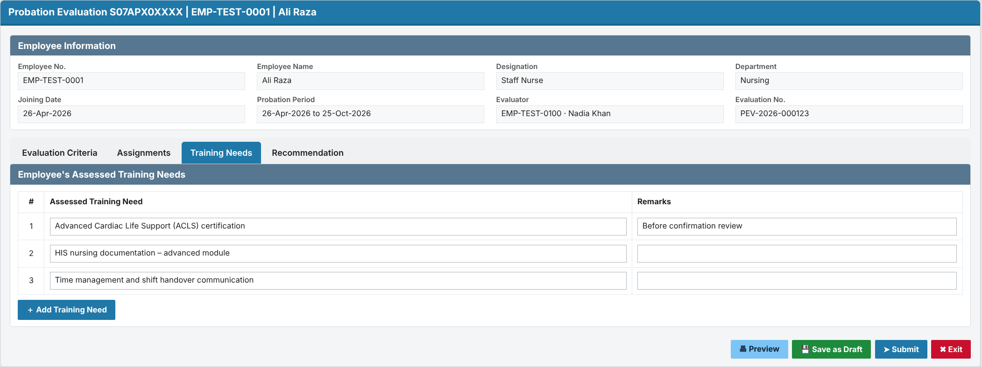
Screen 5 – Recommendation tab: reasons, observations and evidence when not recommended
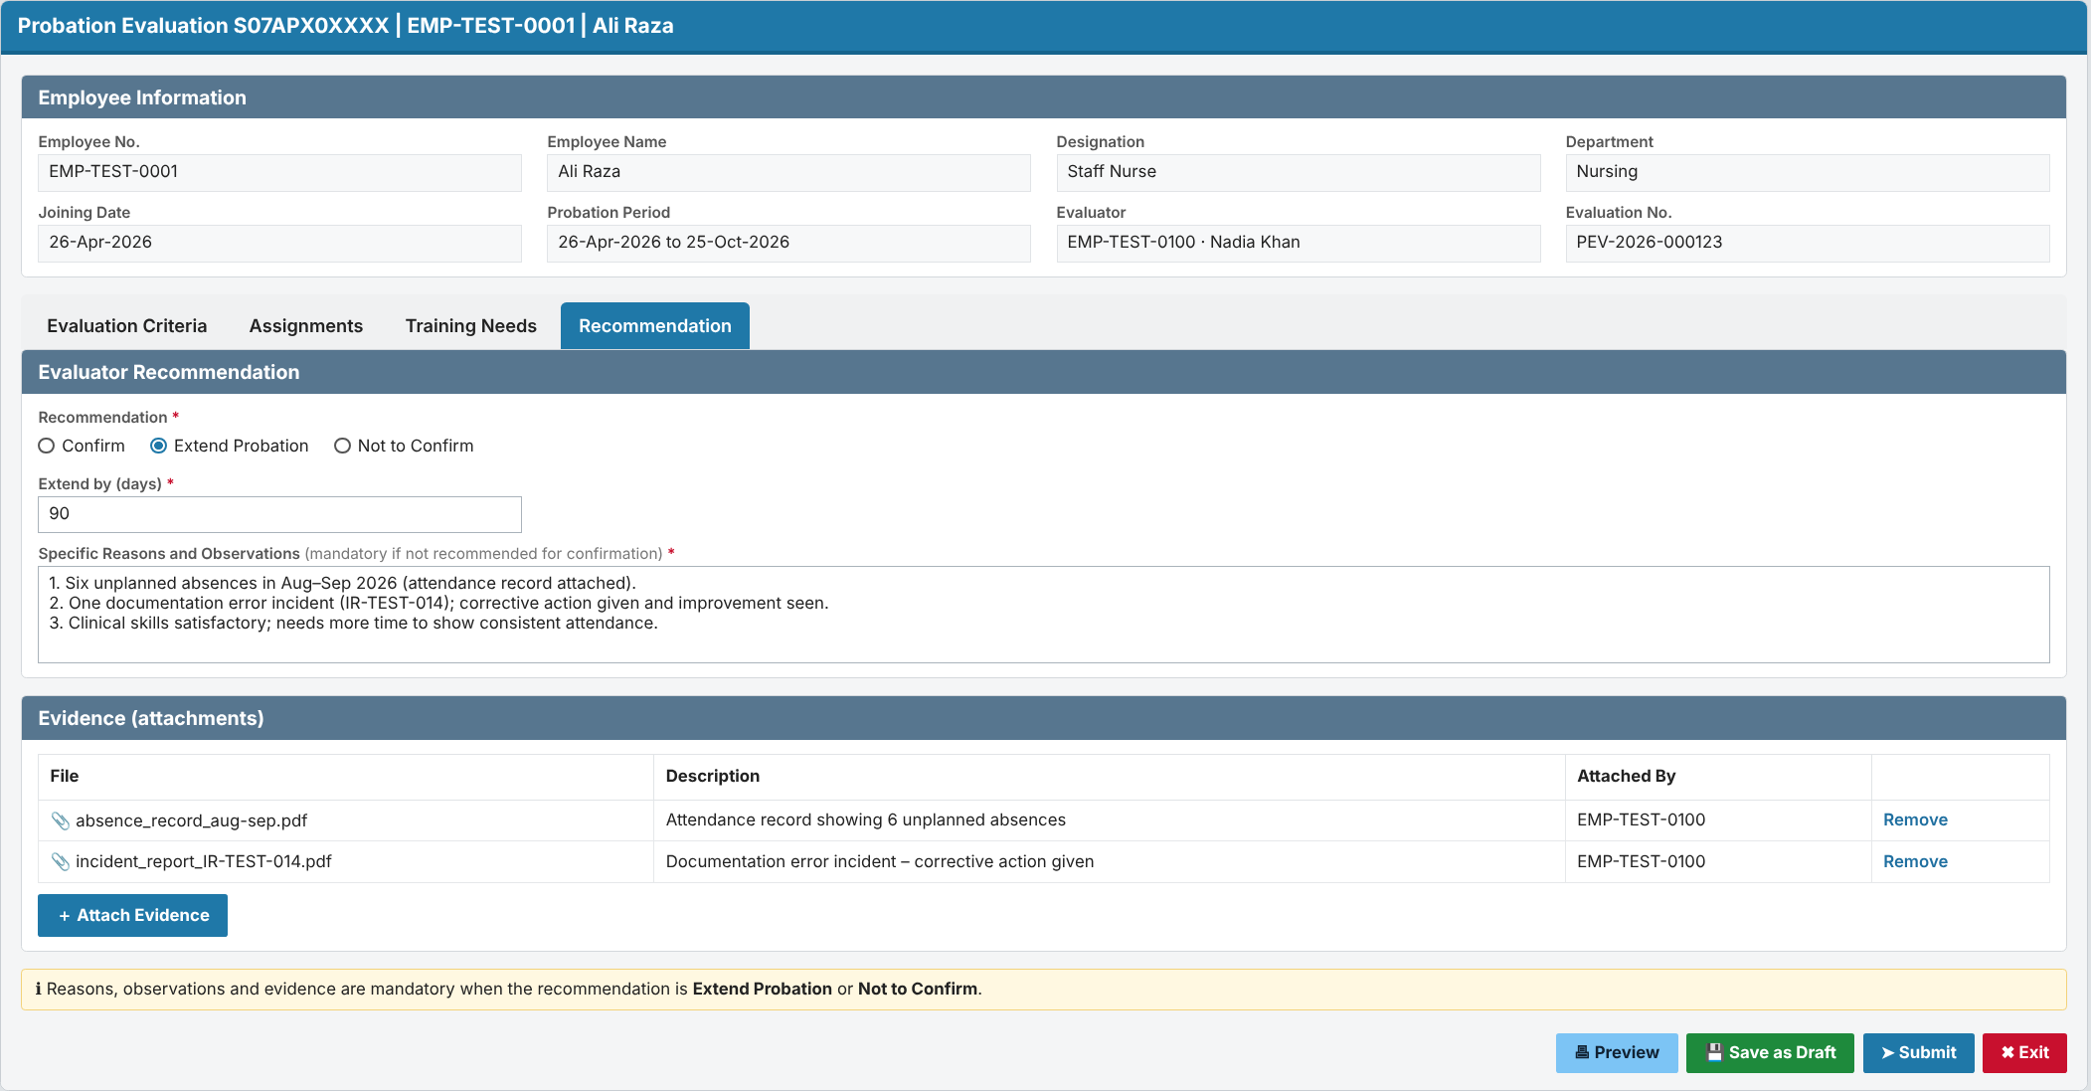

3.2.2 Detailed functional requirements

FR-007 Open evaluation from queue
Description: The system shall allow the assigned evaluator to open a probation evaluation from their queue showing the employee's basic details (employee number, name, department, designation, joining date, probation end date) and the evaluation form. Priority: Must Source: M-02, M-03 Business rules: - Acceptance criteria:
- AC1: Given a queue item assigned to the evaluator, when they open it, then the employee details and the evaluation form are shown.
- AC2 (negative): Given a user who is not the assigned evaluator, when they try to open the evaluation by URL, then access is denied.

FR-008 Save evaluation as Draft
Description: The system shall allow the evaluator to save a partially or fully completed evaluation as Draft without routing it, and to reopen and edit it later. Priority: Must Source: M-04 Business rules: RULE-04, RULE-05 Acceptance criteria:
- AC1: Given an evaluation with some fields filled, when the evaluator clicks Save as Draft, then the entries are saved, the status becomes Draft, and the item stays in the evaluator's queue.
- AC2: Given an evaluation in Draft, when the evaluator reopens it, then all previously saved values are shown and editable.
- AC3 (negative): Given an evaluation in Draft, when any approver or HR user looks at their queue, then the evaluation is not there.

FR-009 Submit evaluation for approval
Description: The system shall allow the evaluator to submit a completed evaluation for approval after validating that all mandatory fields are filled: every mandatory criterion rated, at least one assignment with a rating, a recommendation, and, when the employee is not recommended for confirmation, the reasons and observations with at least one evidence attachment. Priority: Must Source: M-05 Business rules: RULE-05 Acceptance criteria:
- AC1: Given an evaluation with all mandatory fields filled, when the evaluator clicks Submit and confirms, then the evaluation is submitted and FR-011 routing starts.
- AC2 (negative): Given an evaluation with a mandatory field empty, when the evaluator clicks Submit, then submission is refused, the missing fields are highlighted, and the status is unchanged.

FR-010 Lock submitted evaluation
Description: The system shall prevent the evaluator from changing a submitted evaluation unless it has been returned to them. Priority: Must Source: M-05 (Inferred) Business rules: RULE-08 Acceptance criteria:
- AC1: Given a submitted evaluation, when the evaluator opens it, then it is read-only.
- AC2: Given an evaluation returned by an approver, when the evaluator opens it, then it is editable again and can be re-submitted.

FR-024 Rate standard evaluation criteria
Description: The system shall show the active evaluation criteria (parameter and description, maintained by HR) on the Evaluation Criteria tab, require the evaluator to rate each mandatory criterion from 1 (Very Low) to 5 (Very High) with optional remarks, and include these ratings in the evaluation score. Priority: Must Source: M-13 Business rules: RULE-05, RULE-13 Acceptance criteria:
- AC1: Given six active criteria, when the evaluator rates them 5, 3, 5, 4, 4, 5, then the tab shows total score 30, obtained score 26 and performance 86.67 %.
- AC2 (negative): Given a mandatory criterion without a rating, when the evaluator clicks Submit, then submission is refused and the parameter is highlighted.
- AC3: Given HR deactivates a criterion, when a new evaluation is created, then that criterion is not shown; existing evaluations keep their ratings.

FR-021 Record assignments completed during probation
Description: The system shall allow the evaluator to add, edit and remove the assignments completed by the employee during the probationary period, rate each assignment from 1 (Very Low) to 5 (Very High) with optional remarks, and shall calculate the total score, obtained score and performance %. Priority: Must Source: M-10 Business rules: RULE-05 Acceptance criteria:
- AC1: Given an evaluation in Draft, when the evaluator adds three assignments rated 5, 4 and 3, then total score = 15, obtained score = 12 and performance % = 80.00.
- AC2 (negative): Given an assignment without a rating, when the evaluator clicks Submit, then submission is refused and the rating cell is highlighted.
- AC3 (negative): Given an evaluation with no assignments, when the evaluator clicks Submit, then submission is refused with "At least one assignment is required".

FR-022 Record assessed training needs
Description: The system shall allow the evaluator to record one or more assessed training needs of the employee, each with optional remarks, and shall show them to approvers and HR. Priority: Must Source: M-11 Business rules: - Acceptance criteria:
- AC1: Given an evaluation in Draft, when the evaluator adds two training needs and saves, then both are shown on the Training Needs tab to the evaluator, the approvers and HR.
- AC2 (negative): Given a submitted evaluation, when the evaluator tries to edit a training need, then the tab is read-only (unless the evaluation is returned).

FR-023 Reasons, observations and evidence when not recommended for confirmation
Description: The system shall require the evaluator to enter specific reasons and observations and to attach at least one evidence document when the recommendation is Extend Probation or Not to Confirm. Priority: Must Source: M-12 Business rules: RULE-12 Acceptance criteria:
- AC1: Given the recommendation is Extend Probation, when the evaluator enters reasons and attaches an attendance record, then Submit succeeds and approvers and HR can open the evidence.
- AC2 (negative): Given the recommendation is Not to Confirm and no evidence is attached, when the evaluator clicks Submit, then submission is refused with "Reasons, observations and evidence are required when the employee is not recommended for confirmation".
- AC3: Given the recommendation is Confirm, when the evaluator submits without reasons or evidence, then Submit succeeds.

3.3 Requirement 3: Routing through the configured approval hierarchy
Description: On Submit, the system shall route the evaluation one level at a time in order:
- If a probation approval hierarchy is set up for the employee's department, it follows that hierarchy.
- Otherwise it follows the organizational leave hierarchy already defined in HRD, the same approvers who approve the employee's leave: the department leave hierarchy if one is defined, else the supervisor chain upwards until the final leave approver.
- The screen shows which route source is used.
- Approve (optional comments): moves the evaluation to the next level.
- Return (comments mandatory): sends it back to the evaluator (status Returned). The evaluator corrects it and re-submits.
- No one approves their own case. If the evaluator is also the approver at a level, that level is skipped and the reason is logged. If there is no next level, the evaluation goes to the HR exception list.
- If an approver's level cannot be resolved, the evaluation goes to the HR exception list. It is never lost.
- Approver on leave: the evaluation goes to their acting-for person (HRD.ACTING_FOR), to be confirmed by HR.
- The hierarchy levels (for example L1 = HOD, L2 = Director, by department or grade) are maintained by the HR Administrator. The levels are pending from HR.
- Approach (decided): dedicated probation tables: hierarchy levels in HRD_PROBATION_HIERARCHY_MST, per-level actions in HRD_PROBATION_APPROVAL_TRN (see the Design Document). Approver on leave → acting-for person from HRD.ACTING_FOR.
Acceptance (summary):
- After Level 1 approves, the evaluation appears in the Level 2 queue and leaves the Level 1 queue.
- A Return without comments is refused.
- The evaluated employee never receives their own evaluation in their queue.
Traceability: FR-011 – FR-014, RULE-06, RULE-09.

3.3.1 Prototype (GUI): Approver screen and hierarchy setup
Screen 6 – Approval view (Approve / Return to Evaluator)
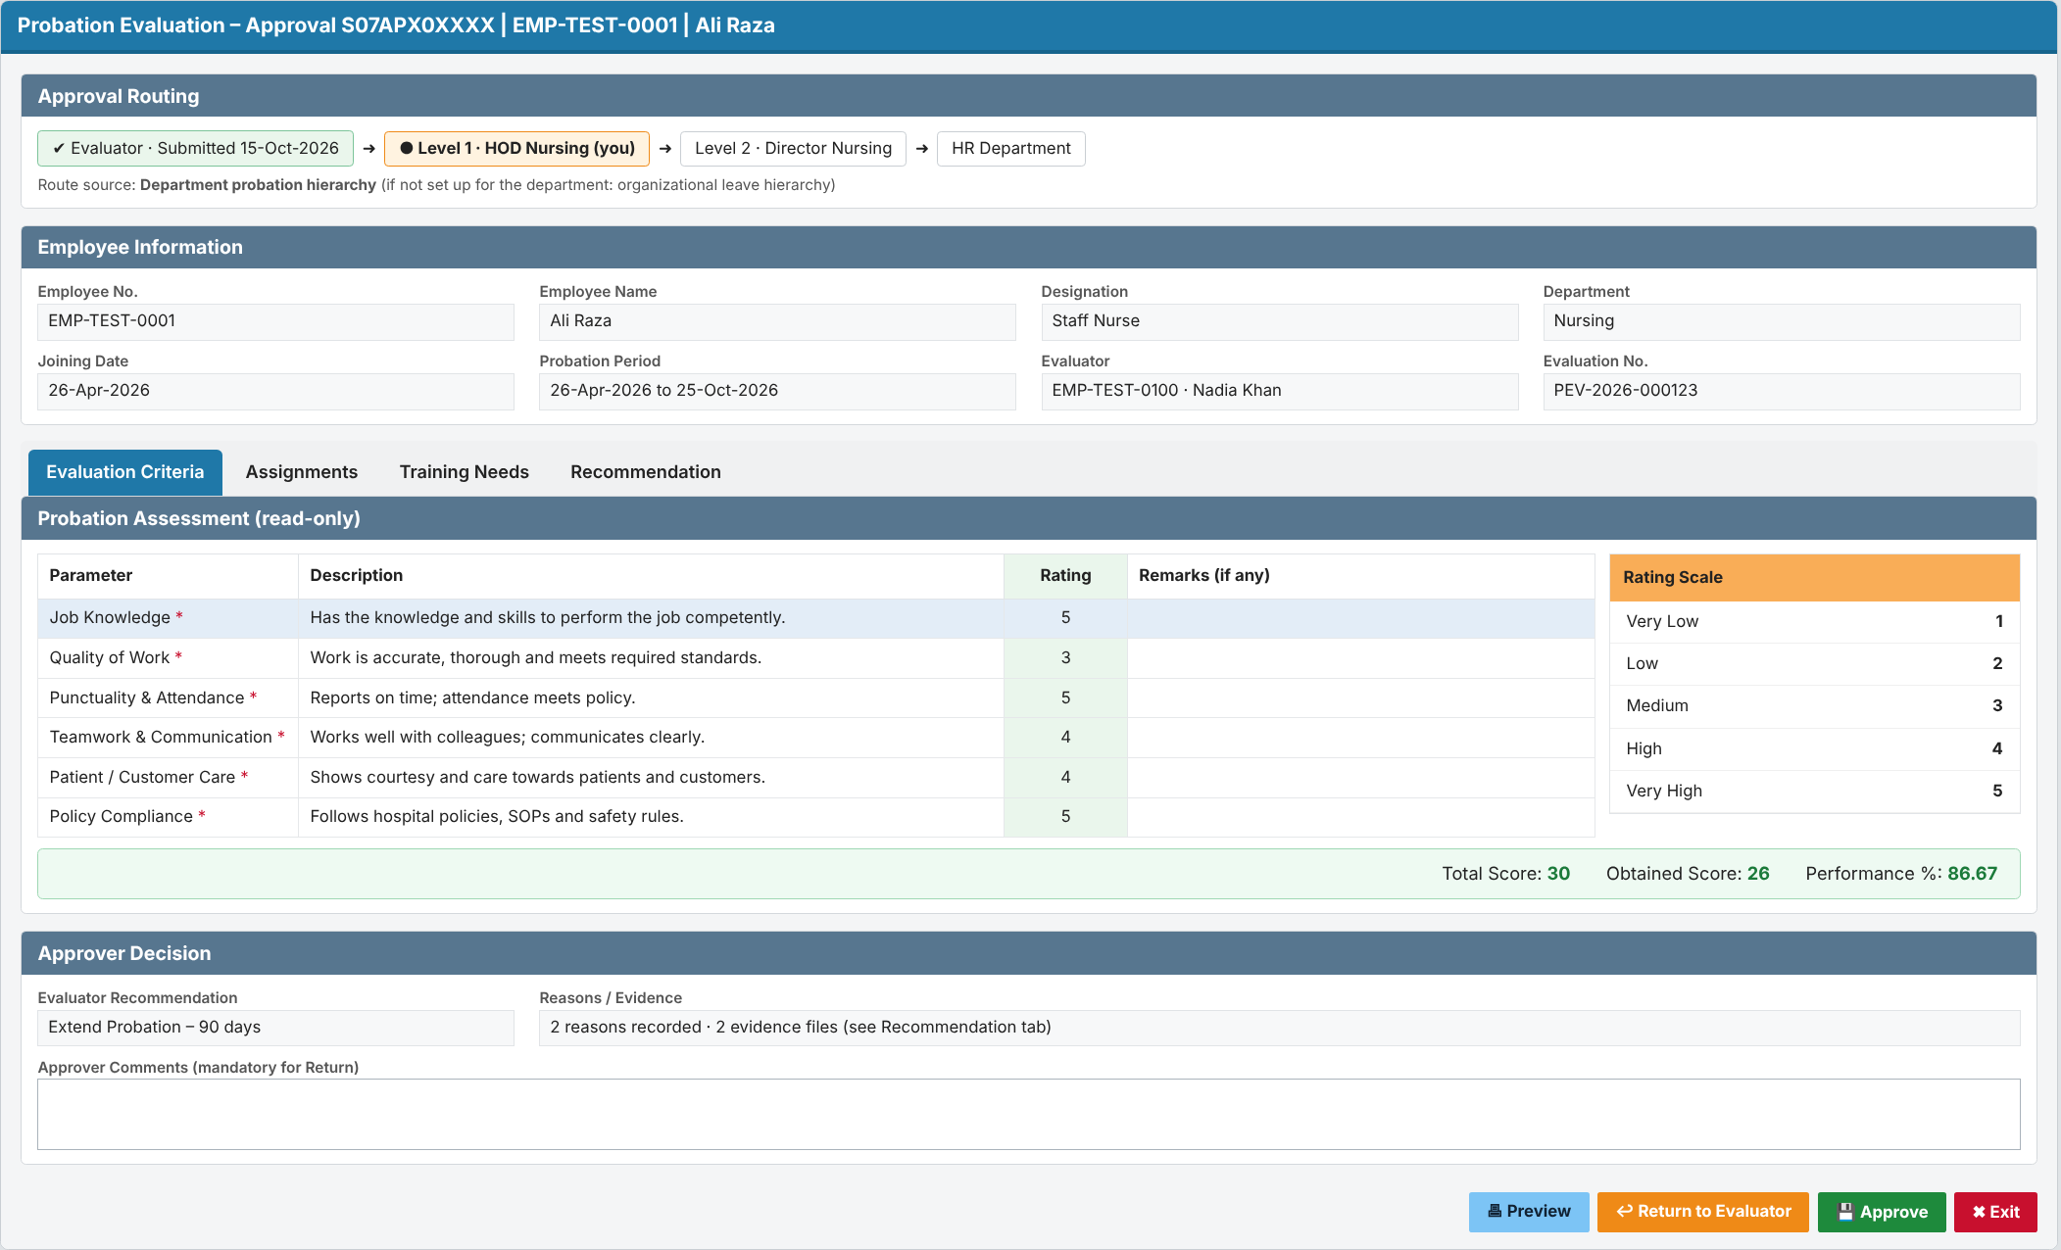
Screen 7 – Probation Approval Hierarchy Setup (HR Administrator)
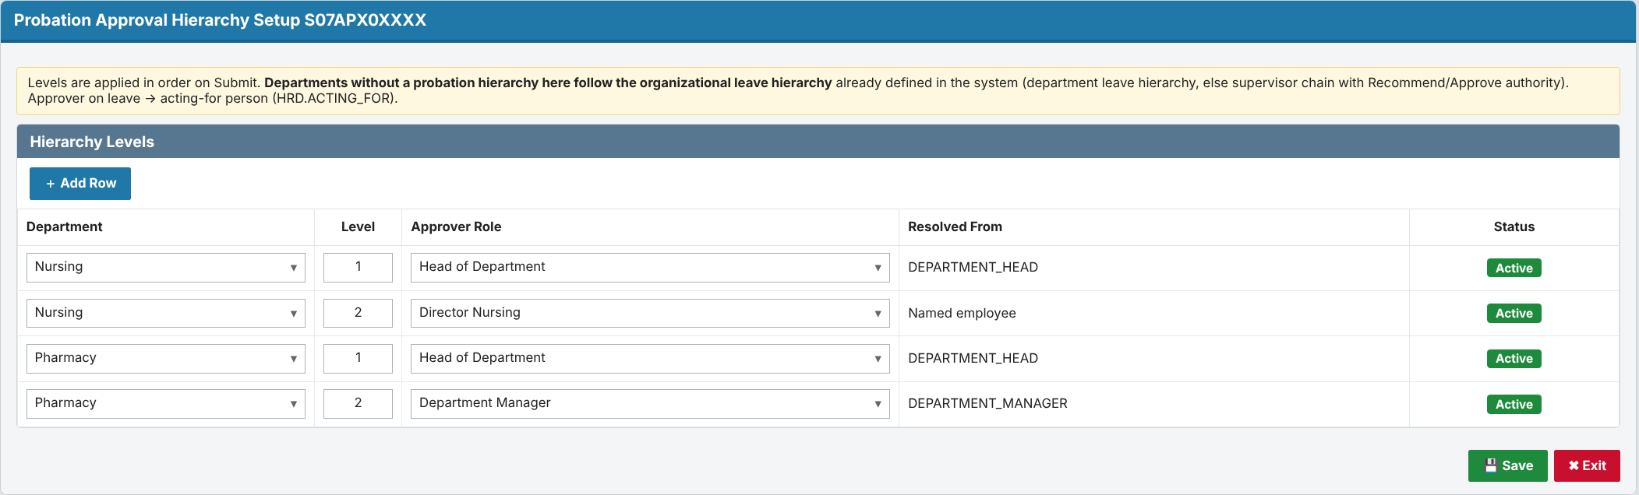

3.3.2 Detailed functional requirements

FR-011 Route to configured approval hierarchy
Description: The system shall route a submitted evaluation through the probation approval hierarchy set up for the evaluated employee's department; when no probation hierarchy is set up for that department, the system shall route it through the organizational leave hierarchy already defined in the system. Priority: Must Source: M-06 Business rules: RULE-06, RULE-09, RULE-14 Acceptance criteria:
- AC1: Given a configured hierarchy of Level 1 = HOD and Level 2 = Director, when an evaluation for an employee in Department D-TEST is submitted, then it appears in the D-TEST HOD's approval queue and the status shows Pending Approval – Level 1.
- AC2 (negative): Given a hierarchy level whose approver cannot be resolved, when the evaluation reaches that level, then it is placed on the HR exception list with the reason "Approver not defined for level n" and is not lost.
- AC3 (fallback): Given the employee's department (e.g. Radiology) has no probation hierarchy, when the evaluation is submitted, then it is routed through the organizational leave hierarchy (department leave hierarchy if defined, else the evaluator's manager and upwards until the final leave approver), and the route source is shown as "Leave hierarchy".

FR-012 Approve at a level
Description: The system shall allow the approver at the current level to approve the evaluation, with optional comments, and move it to the next configured level. Priority: Must Source: M-06 Business rules: RULE-06 Acceptance criteria:
- AC1: Given an evaluation at Level 1 of a 2-level hierarchy, when the Level 1 approver approves, then it moves to the Level 2 approver's queue and leaves the Level 1 queue.
- AC2 (negative): Given an evaluation at Level 2, when the Level 1 approver tries to approve it again, then the action is not available.

FR-013 Return evaluation to evaluator
Description: The system shall allow an approver to return an evaluation to the evaluator with mandatory comments. Priority: Should Source: M-06 (Inferred) Business rules: RULE-08 Acceptance criteria:
- AC1: Given an evaluation at any level, when the approver returns it with comments, then the status becomes Returned and it appears in the evaluator's queue with the comments shown.
- AC2 (negative): Given the approver leaves the comments empty, when they click Return, then the action is refused.

FR-014 Prevent self-approval
Description: The system shall prevent a user from approving an evaluation in which they are the evaluated employee or the evaluator. Priority: Must Source: M-06 (Inferred) Business rules: RULE-09 Acceptance criteria:
- AC1: Given the evaluator is also the resolved Level 1 approver, when the evaluation is submitted, then it moves to the next level and the history records "Skipped: approver is evaluator". If there is no next level, it is placed on the HR exception list (changed in v0.2, RV-06).
- AC2 (negative): Given the evaluated employee is a resolved approver, when routing runs, then the evaluation is never placed in that employee's queue.

3.4 Requirement 4: Automatic routing of the completed evaluation to HR
Description: When the last approval level approves, the system shall route the completed evaluation to the HR Department queue automatically. HR shall be able to process it and close it.
- HR sees the complete evaluation, the recommendation and the full approval trail.
- HR records the outcome (Confirm / Extend, per HR policy) and closes the evaluation (status Completed).
- Important (from the HRD code): the probation record (HRD.EMPLOYEE_PROBATION_HISTORY.PROBATION_STATUS) is set to Confirmed ('C') only at this HR step. Setting 'C' automatically:
- sets HRD.INFORMATION.CONFIRMATION_DATE;
- creates incentive/allowance queue entries;
- clears the HR probation alert.
- An extension updates the probation period instead (reason from HRD.PROBATION_REASONS).
- To be confirmed with HR:
- Does "after submission" mean after final approval (assumed here), or should HR see it as soon as the supervisor submits?
- Does this replace the current alert 001 / form S07FRM00362 process?
Acceptance (summary):
- After the last-level approval, the evaluation appears in the HR queue with status Forwarded to HR.
- HR cannot process an evaluation that is still pending approval.
- Confirmation date and incentives change only after HR confirms.
Traceability: FR-015, FR-016, RULE-07, IMP-15, IMP-34.

3.4.1 Prototype (GUI): HR queue and decision
Screen 8 – HR queue of completed evaluations
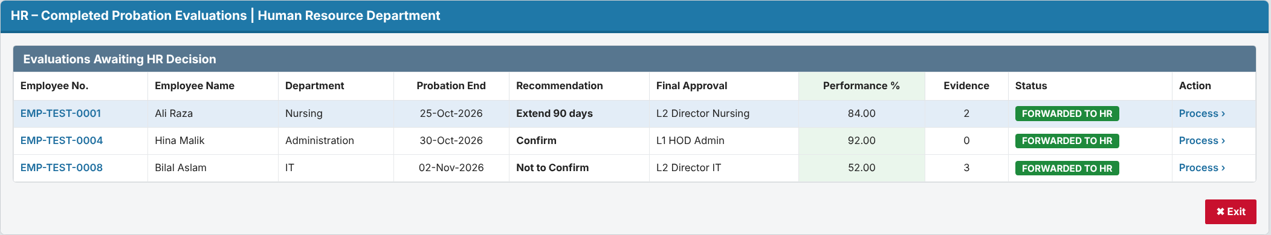
Screen 9 – HR Finalization (Confirm / Extend)
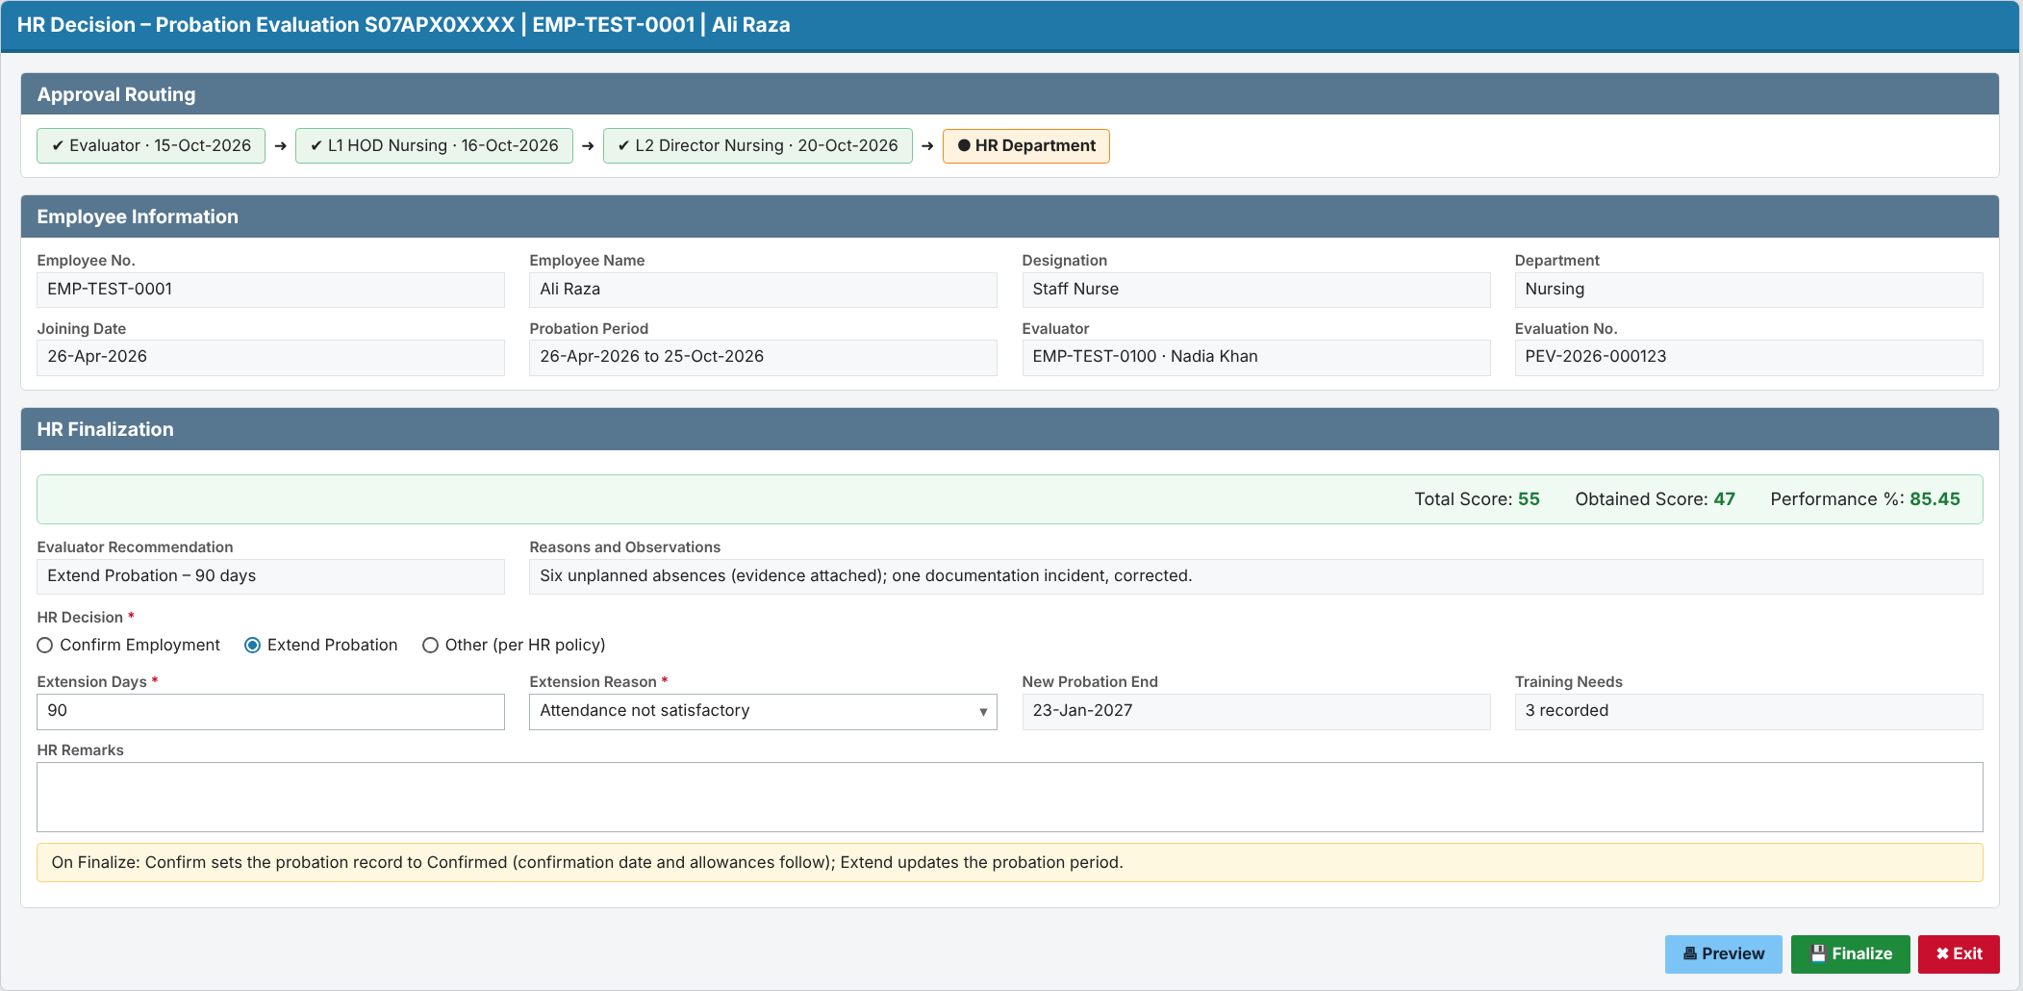

3.4.2 Detailed functional requirements

FR-015 Forward completed evaluation to HR
Description: The system shall automatically route the evaluation to the HR Department queue when the last level of the approval hierarchy approves it. Priority: Must Source: M-07 Business rules: RULE-07 Acceptance criteria:
- AC1: Given an evaluation at the last configured level, when that approver approves, then the evaluation appears in the HR Department queue and the status becomes Forwarded to HR.
- AC2 (negative): Given an evaluation still at an intermediate level, when HR views its queue, then the evaluation is not in HR's actionable queue (only on the monitoring view, FR-017).

FR-016 HR closes evaluation
Description: The system shall allow an HR user to mark a forwarded evaluation as processed, which completes the evaluation. Priority: Must Source: M-07, M-08 Business rules: RULE-08 Acceptance criteria:
- AC1: Given an evaluation Forwarded to HR, when an HR user marks it as processed, then the status becomes Completed and it leaves the HR queue.
- AC2 (negative): Given an evaluation in Pending Approval, when an HR user tries to mark it processed, then the action is not available.

3.5 Requirement 5: Automatic status update throughout the workflow
Description: The system shall update the evaluation / probation request status automatically at every workflow event. Users cannot edit the status by hand. Every change is kept in an insert-only history.
- Status values (proposed): Evaluation Pending → Draft → Pending Approval – Level n → Returned → Forwarded to HR → Completed, plus Cancelled.
- History records the old status, new status, action, comments, user and date-time.
- HR has a monitoring screen of all evaluations, with filters by status, department, evaluator and end date. It flags evaluations as overdue when they are not with HR by the probation end date.
- Supervisors and approvers see the status of their own items.
Acceptance (summary):
- Submitting a Draft changes the status to Pending Approval – Level 1 with no manual step.
- The history shows each step in time order.
- No user can edit or delete history.
Traceability: FR-017 – FR-020, RULE-08, RULE-10.

3.5.1 Prototype (GUI): Monitoring and status history
Screen 10 – Probation Evaluation Monitoring and status history (HR)
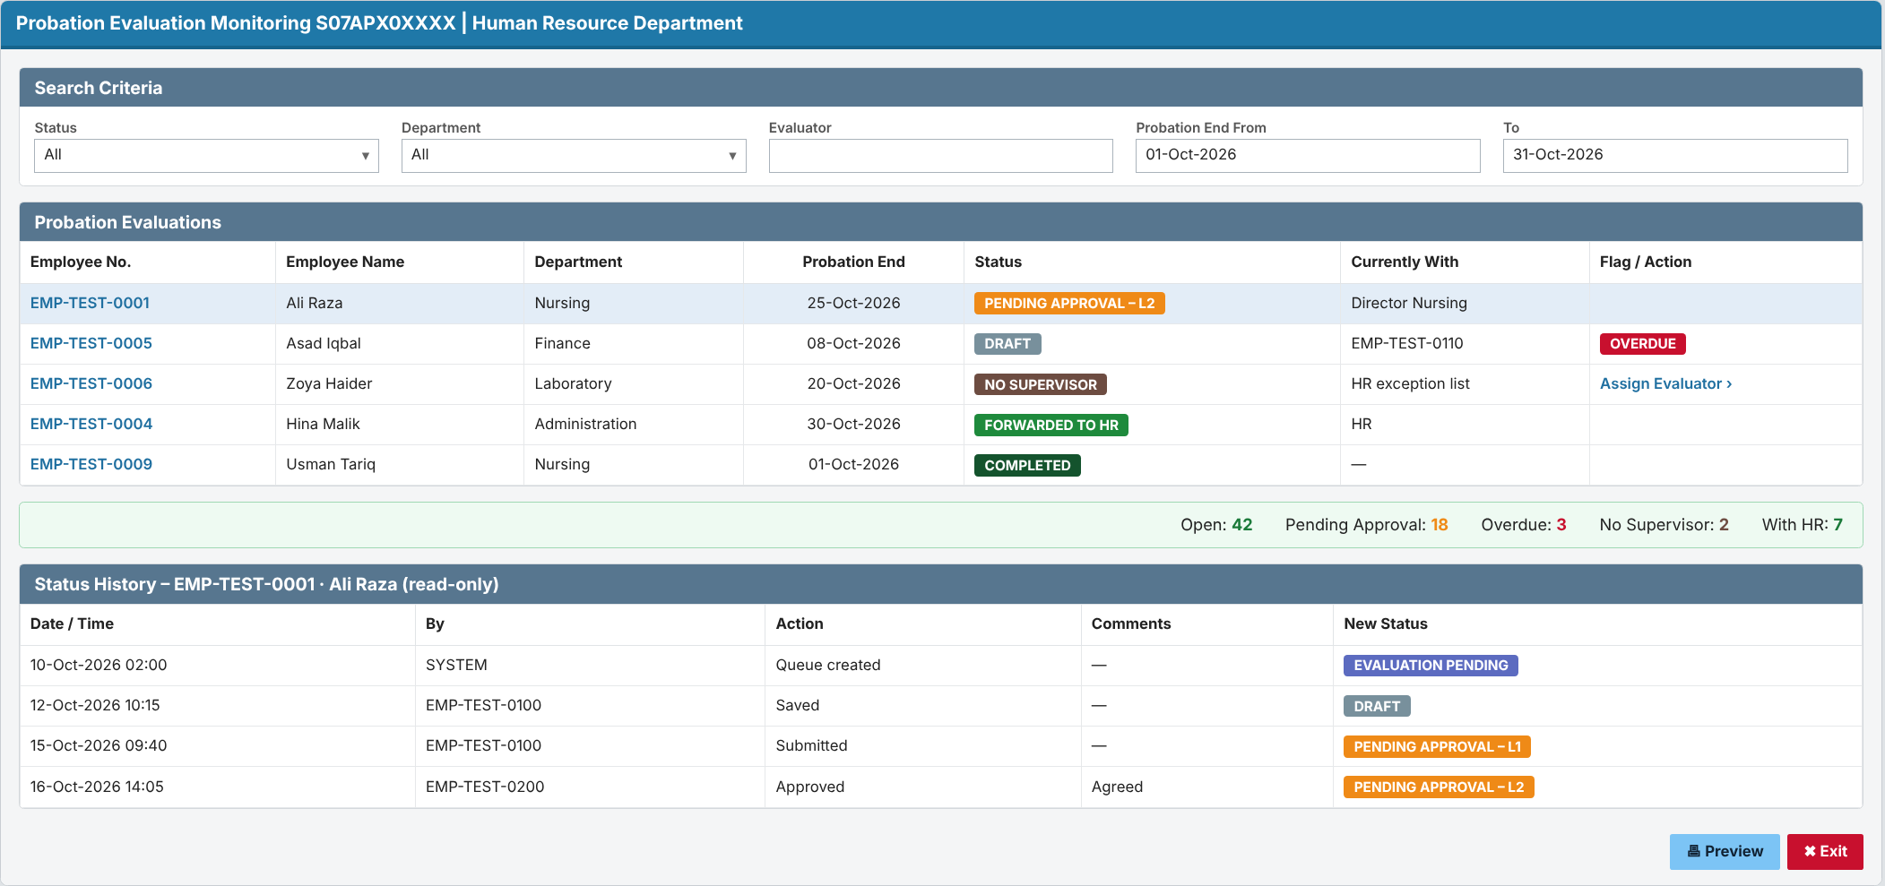

3.5.2 Detailed functional requirements

FR-017 Automatic probation request status update
Description: The system shall update the probation request status automatically at each workflow event: queue generated, saved as draft, submitted, approved at a level, returned, forwarded to HR, completed and cancelled. Priority: Must Source: M-08 Business rules: RULE-08 Acceptance criteria:
- AC1: Given an evaluation in Draft, when the evaluator submits it, then the probation request status changes to Pending Approval – Level 1 with no manual step.
- AC2: Given each event in the list, when it occurs, then the status changes to the value defined in RULE-08.
- AC3 (negative): Given a user tries to change the status directly (not through a workflow action), then the system does not allow it.

FR-018 Status history
Description: The system shall record every status change of a probation evaluation with old status, new status, action, comments, user and date-time. Priority: Must Source: M-08 Business rules: - Acceptance criteria:
- AC1: Given an evaluation that has gone through Draft, Submit and Level 1 approval, when an HR user views its history, then three entries are shown in time order with user and date-time.
- AC2 (negative): Given any user, when they try to edit or delete a history entry, then the action is not available.

FR-019 Probation evaluation monitoring view
Description: The system shall provide HR users with a list of all probation evaluations, filterable by status, department, evaluator and probation end date range. Priority: Should Source: M-08 (Inferred) Business rules: - Acceptance criteria:
- AC1: Given evaluations in several statuses, when an HR user filters by status "Pending Approval", then only those evaluations are listed with their current level and approver.
- AC2 (negative): Given a supervisor without the HR role, when they try to open the monitoring view, then access is denied.

FR-020 Overdue flag
Description: The system shall flag an evaluation as overdue when it is not Forwarded to HR or Completed by the probation end date. Priority: Should Source: M-02 (Inferred) Business rules: RULE-10 Acceptance criteria:
- AC1: Given an evaluation in Draft on the day after the probation end date, when HR opens the monitoring view, then the evaluation is shown as overdue.
- AC2 (negative): Given an evaluation Forwarded to HR before the probation end date, then it is never flagged overdue.

4. Business Rules, Data and Access

4.1 Business rules
- RULE-01: trigger date = probation end date − 15 calendar days (lead days held as a setting; today's alert uses 15 or 30). The employee is picked up on the first daily run on or after that date and before the end date.
- RULE-02: the evaluator is the employee's supervisor on the trigger date (HRD.INFORMATION.MANAGER_MRNO). If no supervisor is recorded, the evaluation goes to the HR exception list.
- RULE-03: there is one active evaluation per employee per probation period (MRNO + probation start date).
- RULE-04: a Draft is never routed; only the evaluator can see it.
- RULE-05: mandatory fields are checked on Submit only, not on Save as Draft.
- RULE-06: approval levels are applied in order, using the hierarchy that is in effect when the evaluation is submitted.
- RULE-07: the evaluation goes to HR after the last approval level.
- RULE-08: allowed status changes are:
- Evaluation Pending → Draft → Pending Approval (level n) → next level, Returned, or Forwarded to HR.
- Returned → Draft or Pending Approval (level 1).
- Forwarded to HR → Completed.
- Any status before Forwarded to HR → Cancelled.
- RULE-09: no one approves their own case. If the evaluator is also the approver, that level is skipped (and logged). If there is no next level, the evaluation goes to the HR exception list.
- RULE-10: an evaluation that is not with HR by the probation end date is flagged Overdue.
- RULE-11: EMPLOYEE_PROBATION_HISTORY.PROBATION_STATUS = 'C' is written only when HR finalizes a confirmation. It fires the incentive, confirmation-date and alert triggers. An extension updates the probation period instead.
- RULE-12: when the recommendation is Extend Probation or Not to Confirm, specific reasons and observations and at least one evidence attachment are mandatory on Submit.
- RULE-13: the overall score uses every rated item: total = (number of criteria + number of assignments) × 5, obtained = sum of all ratings, performance % = obtained ÷ total × 100. Each tab also shows its own section score.
- RULE-14: If a probation approval hierarchy is set up for the employee's department, the evaluation follows it. Otherwise it follows the organizational leave hierarchy already defined in HRD: the department leave hierarchy (HRD.LEAVE_QUEUE_HIERARCHY for the reference leave type and the Medical/Admin hierarchy type), else the supervisor chain (INFORMATION.MANAGER_MRNO upwards) until an approver whose leave authority (ROLE_AUTHORITY.LEAVE_AUTHORY_ID) is 002 = Approve.

4.2 Data requirements (for development)
Full table and column definitions are in the separate document CR-2026-XXX-PEV_Design_v0.2 (Design Document).
- Evaluation No.: VARCHAR2(20), system-generated as PEV-YYYY-NNNNNN, unique.
- Employee: MRNO VARCHAR2(14), mandatory, from HRD.INFORMATION. The employee must be active and on probation.
- Probation period: start date (FK with MRNO to HRD.EMPLOYEE_PROBATION_HISTORY) and end date (F_PROBATION_END_DATE). Both are mandatory.
- Evaluator: MRNO VARCHAR2(14), mandatory. Must be active and must not be the employee.
- Criterion rating: NUMBER(1), 1–5, mandatory on Submit for every mandatory active criterion; remarks VARCHAR2(1000), optional. Criteria (parameter, description, order, mandatory, active) are maintained by HR.
- Assignment completed: VARCHAR2(500), at least one row mandatory on Submit; rating NUMBER(1) 1–5 mandatory per row; remarks VARCHAR2(1000), optional.
- Assessed training need: VARCHAR2(500) per row, optional; remarks VARCHAR2(1000), optional.
- Reasons and observations: VARCHAR2(4000), mandatory when the recommendation is E or N (RULE-12).
- Evidence: one or more attachments (DOCUMENT_ID VARCHAR2(15) + description), stored in the existing HRD.EMPLOYEE_PROBATION_ATTACHMENT; at least one is mandatory when the recommendation is E or N.
- Recommendation: CHAR(1), C = Confirm, E = Extend, N = Not to confirm. Mandatory on Submit.
- Extend by (days): NUMBER(4), greater than 0. Mandatory only when the recommendation is Extend.
- Scores: calculated by the system per RULE-13 (criteria + assignments).
- Workflow status: VARCHAR2(2). Codes: EP, DR, PA, RT, FH, CM, CN (RULE-08).
- Current level and approver: set by the system when the evaluation is routed.
- Approver action: A = Approve, R = Return, S = Skipped. Comments are mandatory for Return.
- HR decision: CHAR(1), C = Confirm, E = Extend, O = Other. If Extend, the extension days and reason (HRD.PROBATION_REASONS) are mandatory.
- Hierarchy setup: department (mandatory), level number, and approver source (department head, department manager or a named employee). Departments with no rows use the organizational leave hierarchy (RULE-14).

4.3 User roles and access
- Evaluator (supervisor): creates, edits and submits their own evaluations, and views those evaluations and their history.
- Approver: views the evaluations routed to them, and approves or returns them.
- HR User: views all evaluations and the monitoring screen, and finalizes evaluations Forwarded to HR.
- HR Administrator: everything an HR User can do, plus assigning and reassigning evaluators (exception list) and maintaining the department probation hierarchy.
- Evaluated employee: no access in this CR.

4.4 Reports and notifications
- Evaluation assigned: e-mail to the evaluator when a queue item is created or reassigned.
- Pending approval: e-mail to the approver at each level.
- Evaluation returned: e-mail to the evaluator, with the approver's comments.
- Forwarded to HR: e-mail to HR after the last approval.
- Monitoring screen: all evaluations by status, with Overdue and No-supervisor flags and status history.
- Reminders and escalation before the end date: to be confirmed with HR.

5. Impact Analysis
The design uses new dedicated probation tables (decided 09-Oct-2026). All object names were checked against the HRD, DEFINITIONS and PAYROLL DDL exports.

5.1 Business impact
- HR: manual tracking of due evaluations is replaced by the automatic queue and monitoring screen, and the probation SOP needs updating.
- Supervisors (all departments): get a new task 15 days before each subordinate's probation end date. They need a short briefing.
- Approvers (HOD and above): get new approval items in their queue.
- Payroll and incentives: confirming an employee still starts allowances and sets the confirmation date, but now only at the HR finalize step.

5.2 System impact
- New package HRD.PKG_PROBATION_EVALUATION: queue generation, save, submit, routing, approve/return, HR finalize, status history.
- New daily job (DBMS_SCHEDULER): runs queue generation, with a run log.
- New APEX pages:
- Probation Evaluation (Evaluation Criteria / Assignments / Training Needs / Recommendation tabs), replacing the Excel form.
- Approval view.
- HR queue and Finalization.
- Monitoring.
- Approval Hierarchy Setup.
- `HRD.PKG_PENDING_TASKS`: add a probation-evaluation queue procedure that follows the existing pattern (P_USER_MRNO, P_ACTING_FOR, …), so items appear in the existing inbox.
- Notifications: configure rows in HRD.ALERTS and HRD.ALERT_RECIPIENTS (existing alert framework).
- Approval routing fallback: reuses the organizational leave hierarchy rules of HRD.LEAVE_AUTOMATION (read-only; no change to leave processing).
- Existing probation process: alert 001 (HR probation-expiry alert in HR_ALERT_QUEUE) and form S07FRM00362 (PKG_S07FRM00362, confirm/extend decision). HR must decide whether the new workflow replaces them or runs alongside.
- Regression testing: code that reads probation status. That is PKG_COMMON, PKG_EMPLOYEE_INFO, PKG_EMP_INCENTIVE, PKG_HR_ALERTS, PKG_HR_DOCUMENT_RECORD, PKG_HR_EMPLOYEE_RECORD, LEAVE_AUTOMATION, EMAILS and the view V_HR_EMP_DOCUMENTS.
- APEX authorization schemes: Evaluator, Approver, HR User, HR Administrator.

5.3 Database impact
- New tables (proposed): HRD_PROBATION_EVAL_MST, HRD_PROBATION_CRITERIA_MST, HRD_PROBATION_CRITERIA_DTL, HRD_PROBATION_ASSIGNMENT_DTL, HRD_PROBATION_TRAINING_DTL, HRD_PROBATION_HIERARCHY_MST, HRD_PROBATION_APPROVAL_TRN, HRD_PROBATION_EVAL_HIS, HRD_PROBATION_JOB_LOG, with sequences, indexes and audit triggers. Details are in the DD document.
- Read only:
- HRD.INFORMATION (employee, MANAGER_MRNO, department, ACTIVE).
- DEFINITIONS.DEPARTMENT (DEPARTMENT_HEAD, DEPARTMENT_MANAGER).
- HRD.ACTING_FOR (approver on leave).
- HRD.PROBATION_REASONS.
- Organizational leave hierarchy, for routing when a department has no probation hierarchy: HRD.LEAVE_QUEUE_HIERARCHY, HRD.ROLE_AUTHORITY, HRD.LEAVE_ROLE, HRD.INFORMATION.LEAVE_ROLE_ID / MANAGER_MRNO.
- Written at HR finalize only: HRD.EMPLOYEE_PROBATION_HISTORY, either PROBATION_STATUS = 'C' for a confirmation or the probation period for an extension. The existing triggers (EMP_INCENTIVE_QUEUE, EMP_PROBATION_HISTORY_INFO_UPD, TR_PROBATION_EXPIRE_QUEUE_DEL) then update HRD.INFORMATION.CONFIRMATION_DATE, the incentive queue and alert 001.
- Reused for evidence: HRD.EMPLOYEE_PROBATION_ATTACHMENT (keyed by MRNO + probation START_DATE; no existing code writes to it).
- Configuration data: evaluation criteria, hierarchy rows and alert rows (seed scripts).
- Data migration: none. An optional go-live backlog run can create evaluations for employees already within 15 days of their end date.
- Volume: low, about one evaluation per new hire or extension.
- Privacy: HRD.INFORMATION.MRNO is also the patient MR number (FK to REGISTRATION.PATIENT). Screens must not show or link to patient data.

