Shaukat Khanum Memorial Cancer Hospital & Research Centre
Information Systems

Technical Design Document (RFC)
Automated Employee Probation Evaluation

Document ID | CR-2026-XXX-PEV
Version | 0.3
Status | DRAFT
Date | 2026-10-09
Prepared by | Claude (AI draft) for Solution Architect
Source documents | CR v0.6 / SRS v0.5 (DRAFT)

Version History
Version | Date | Author | Change summary
0.3 | 2026-10-09 | Claude (AI draft) for Solution Architect | Routing fallback to leave hierarchy; ROUTE_SOURCE

Approvals
Role | Name | Decision | Signature | Date
Solution Architect (author)
Lead Architect
DBA
Development Lead
Approval is recorded by the named person only. AI-drafted documents remain DRAFT until then.

Design Document: Automated Employee Probation Evaluation
- CR: CR-2026-XXX-PEV · Version: 0.3 DRAFT (Solution Architect approval pending)
- Based on: CR v0.6 and SRS v0.5. Warning: the SRS is not yet approved, so this design may change.
- Schema checked against: HRD, DEFINITIONS, HIS and PAYROLL DDL exports, including package bodies. APEX applications were not in the export.
- Approach: dedicated probation tables plus one new package. Existing HRD objects are reused where they already fit.
- Changed in v0.3: approval routing uses the department's probation hierarchy if one is set up. Otherwise it uses the organizational leave hierarchy already in HRD, the same rules as HRD.LEAVE_AUTOMATION.GET_AUTHORITY (RULE-14).
- Changed in v0.2: the evaluation form has four tabs: Evaluation Criteria | Assignments | Training Needs | Recommendation.
- Standard criteria rated 1–5.
- Assignments completed during probation, each rated 1–5.
- The employee's assessed training needs.
- Specific reasons and observations, with evidence, when the employee is not recommended for confirmation.
The form has no Approval History or Finalization tabs: approval history is on the approval and monitoring pages, and HR finalization is its own page. Evidence is stored in the existing HRD.EMPLOYEE_PROBATION_ATTACHMENT.

1. Design Summary
- A daily job finds employees whose probation ends within 15 days (a setting, default 15) and creates an evaluation for each one's supervisor. This replaces the Excel form sent with the probation-ending alert.
- The supervisor fills in four tabs, then saves as Draft or submits:
- Evaluation Criteria: standard parameters, each rated 1–5;
- Assignments completed during probation, each rated 1–5;
- Training Needs;
- Recommendation. If the recommendation is Extend or Not to Confirm, the reasons, observations and evidence are mandatory.
- On Submit, the evaluation goes through the approval levels set up for the department. If none are set up, it goes through the organizational leave hierarchy. Each approver can approve it or return it.
- After the last approval it goes to HR, who finalize it as Confirm or Extend. Only at this step is the existing probation record updated.
- Every status change is logged. HR can see every evaluation on a monitoring screen.

2. Key Design Decisions
- DS-D1 Dedicated tables, not the PA appraisal engine. The VU_PA_* views and PKG_PERFORMANCE_APPRAISAL are not affected.
- DS-D2 Workflow status kept in the new table, not in `EMPLOYEE_PROBATION_HISTORY.PROBATION_STATUS`. Writing 'C' to that column fires three triggers:
- EMP_INCENTIVE_QUEUE, which creates incentive/allowance queue entries;
- EMP_PROBATION_HISTORY_INFO_UPD, which sets INFORMATION.CONFIRMATION_DATE;
- TR_PROBATION_EXPIRE_QUEUE_DEL, which clears alert 001.
So 'C' is written only at HR finalize.
- DS-D3 All logic lives in `HRD.PKG_PROBATION_EVALUATION`. APEX pages only call package procedures.
- DS-D4 Queues use the existing pending-task framework: a new procedure in HRD.PKG_PENDING_TASKS, registered in HIS.USER_ASSIGNMENT.
- DS-D5 Optimistic locking: a VERSION_NO column on the header (error -20802 on a mismatch).
- DS-D6 Approver on leave: the approval goes to the acting-for person from HRD.ACTING_FOR.
- DS-D10 Routing fallback to the leave hierarchy (RULE-14):
- The probation hierarchy applies when the department has active rows in HRD_PROBATION_HIERARCHY_MST.
- Otherwise the leave hierarchy applies. It is resolved read-only, the way HRD.LEAVE_AUTOMATION.GET_AUTHORITY does it:
- Department leave hierarchy: HRD.LEAVE_QUEUE_HIERARCHY for the department, the reference leave type (a setting, Q-29) and hierarchy type M (doctor, from HIS.PKG_DOCTOR.IS_DOCTOR) or A (admin). Active rows are taken in ORDER_BY order.
- Otherwise the supervisor chain: start at the evaluator's MANAGER_MRNO and move up. Each approver's INFORMATION.LEAVE_ROLE_ID is looked up in ROLE_AUTHORITY for the reference leave type: authority 001 (Recommend) continues to the next manager; 002 (Approve) is the last level. Safety limit: 6 levels.
- The route is resolved once at Submit and stored as APPROVAL_TRN rows, so later hierarchy changes don't move evaluations already in progress.
- The source is recorded in EVAL_MST.ROUTE_SOURCE: PH = probation hierarchy, LQH = department leave hierarchy, SUP = supervisor chain.
- Leave processing itself is not changed or called; only its setup tables are read.
- DS-D7 Evidence reuses the existing `HRD.EMPLOYEE_PROBATION_ATTACHMENT`. It is keyed by MRNO + probation START_DATE, and no existing package writes to it.
- DS-D8 Scores are calculated (RULE-13):
- total = (number of criteria + number of assignments) × 5;
- obtained = sum of all ratings;
- performance % = obtained ÷ total × 100.
Each tab also shows its own section score.
- DS-D9 Existing process (alert 001 with the Excel form, and form S07FRM00362): the e-mail no longer carries the Excel form. Whether the alert is retired or kept for HR monitoring is HR's decision (Q-24).

3. DB Structure
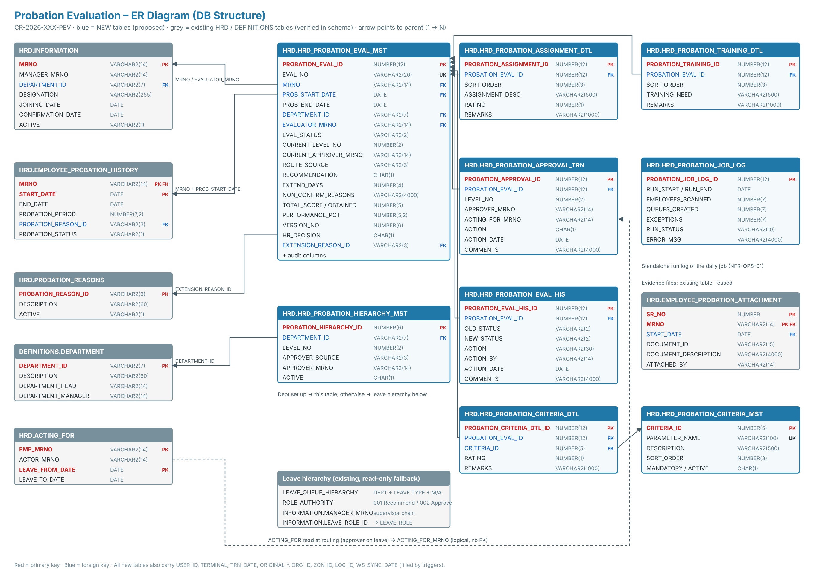
New tables. All follow the HRD audit-column pattern (USER_ID, TERMINAL, TRN_DATE, ORIGINAL_*, ORG_ID/ZON_ID/LOC_ID), filled by triggers.
- DS-01 `HRD.HRD_PROBATION_EVAL_MST`: evaluation header, one row per evaluation.
- Keys:
- PROBATION_EVAL_ID NUMBER(12) is the PK.
- EVAL_NO VARCHAR2(20) is unique, in the form PEV-YYYY-NNNNNN.
- MRNO VARCHAR2(14) + PROB_START_DATE is an FK to EMPLOYEE_PROBATION_HISTORY.
- Who and where: PROB_END_DATE, DEPARTMENT_ID VARCHAR2(7), EVALUATOR_MRNO (NULL = HR exception list).
- Workflow: EVAL_STATUS VARCHAR2(2) (EP / DR / PA / RT / FH / CM / CN), CURRENT_LEVEL_NO, CURRENT_APPROVER_MRNO, `ROUTE_SOURCE` VARCHAR2(3) (PH / LQH / SUP).
- Evaluation:
- RECOMMENDATION (C = Confirm / E = Extend / N = Not to confirm) and EXTEND_DAYS.
- `NON_CONFIRM_REASONS` VARCHAR2(4000), the specific reasons and observations. Required once submitted when the recommendation is E or N (check constraint CK_PROB_EVAL_REASONS).
- TOTAL_SCORE, OBTAINED_SCORE, PERFORMANCE_PCT, and SUBMITTED_DATE.
- HR decision: HR_DECISION (C / E / O), HR_EXTEND_DAYS, EXTENSION_REASON_ID (FK to PROBATION_REASONS), HR_DECISION_BY, HR_DECISION_DATE, HR_REMARKS.
- Control: EXCEPTION_REASON, and VERSION_NO for locking.
- One active evaluation per probation period is enforced by the unique index IDX_PROB_EVAL_ACTIVE_UK, which ignores cancelled rows.
- DS-02a `HRD.HRD_PROBATION_CRITERIA_MST`: standard evaluation criteria that HR maintains.
- Columns: CRITERIA_ID, PARAMETER_NAME VARCHAR2(100), DESCRIPTION VARCHAR2(500), SORT_ORDER, MANDATORY Y/N, ACTIVE Y/N.
- The existing EVALUATION_CRITERIA_MASTER is too limited to reuse: its description is only VARCHAR2(55).
- DS-02b `HRD.HRD_PROBATION_CRITERIA_DTL`: one rating per criterion per evaluation.
- Columns: PROBATION_EVAL_ID, CRITERIA_ID, RATING (1–5), REMARKS.
- Unique on (evaluation, criterion). One row per active criterion is created when the evaluation is created.
- DS-02 `HRD.HRD_PROBATION_ASSIGNMENT_DTL`: assignments completed during the probationary period.
- Columns: PROBATION_ASSIGNMENT_ID, PROBATION_EVAL_ID, SORT_ORDER, ASSIGNMENT_DESC VARCHAR2(500), RATING NUMBER(1) (1–5), REMARKS VARCHAR2(1000).
- DS-03 `HRD.HRD_PROBATION_TRAINING_DTL`: the employee's assessed training needs.
- Columns: PROBATION_TRAINING_ID, PROBATION_EVAL_ID, SORT_ORDER, TRAINING_NEED VARCHAR2(500), REMARKS VARCHAR2(1000).
- Free text: the training subject master is in the TRAINING schema, which is not in the export. Linking to it is a later option (Q-28).
- DS-04 `HRD.HRD_PROBATION_HIERARCHY_MST`: approval levels.
- Columns: DEPARTMENT_ID (mandatory; departments without rows use the leave hierarchy), LEVEL_NO, APPROVER_SOURCE, APPROVER_MRNO, ACTIVE. Unique on (department, level).
- APPROVER_SOURCE is DH (department head), DM (department manager) or EMP (named employee).
- DS-05 `HRD.HRD_PROBATION_APPROVAL_TRN`: one row per level per evaluation.
- Columns: LEVEL_NO, APPROVER_MRNO, ACTING_FOR_MRNO, ACTION, ACTION_DATE, COMMENTS.
- ACTION is P (pending), A (approved), R (returned) or S (skipped). Comments are mandatory on Return.
- DS-06 `HRD.HRD_PROBATION_EVAL_HIS`: status history.
- Columns: OLD_STATUS, NEW_STATUS, ACTION, ACTION_BY, ACTION_DATE, COMMENTS.
- Insert-only: trigger TRG_PROBATION_EVAL_HIS_BUD blocks updates and deletes.
- DS-07 `HRD.HRD_PROBATION_JOB_LOG`: daily job log.
- Columns: RUN_START, RUN_END, EMPLOYEES_SCANNED, QUEUES_CREATED, EXCEPTIONS, CANCELLED, RUN_STATUS, ERROR_MSG.
- DS-08 Supporting objects:
- 9 sequences (PROBATION_*_SEQ).
- Indexes on every FK and on the main searches: status, evaluator, approver, end date.
- Audit triggers TRG_<TABLE>_BI / _BU, following the existing EMPLOYEE_PROBATION_HISTORY_INS pattern.
Existing objects used.
- Read:
- HRD.INFORMATION: MRNO, MANAGER_MRNO (evaluator), DEPARTMENT_ID, ACTIVE H/Y/N.
- DEFINITIONS.DEPARTMENT: DEPARTMENT_HEAD, DEPARTMENT_MANAGER.
- HRD.ACTING_FOR.
- HRD.PROBATION_REASONS.
- HRD.F_PROBATION_END_DATE, which returns MAX(END_DATE).
- Leave hierarchy, for the fallback (RULE-14), code-verified in `LEAVE_AUTOMATION`:
- HRD.LEAVE_QUEUE_HIERARCHY (DEPARTMENT_ID, LEAVE_TYPE_ID, HIERARCHY_TYPE, ORDER_BY, MRNO, ACTIVE);
- HRD.ROLE_AUTHORITY (LEAVE_ROLE_ID, LEAVE_TYPE_ID, LEAVE_AUTHORY_ID);
- HRD.LEAVE_ROLE;
- HRD.INFORMATION.LEAVE_ROLE_ID / MANAGER_MRNO;
- HIS.PKG_DOCTOR.IS_DOCTOR and HRD.F_GET_DEPARTMENT_ID.
- Evidence written to `HRD.EMPLOYEE_PROBATION_ATTACHMENT`:
- Columns used: SR_NO, MRNO, START_DATE = PROB_START_DATE, DOCUMENT_ID VARCHAR2(15), DOCUMENT_DESCRIPTION, ATTACHED_BY, DOCUMENT_TYPE_ID.
- SR_NO = MAX + 1 per MRNO, under a row lock on the evaluation header.
- The file itself goes to the existing document store, which is referenced by DOCUMENT_ID (the same pattern as V_HR_EMP_DOCUMENTS).
- Written at HR finalize only: HRD.EMPLOYEE_PROBATION_HISTORY.
- Confirm sets PROBATION_STATUS = 'C'.
- Extend sets a new END_DATE and PROBATION_REASON_ID, with PROBATION_STATUS staying 'P'.
- Seed data: HIS.USER_ASSIGNMENT (pending-task registration), HRD.ALERTS / ALERT_RECIPIENTS (notification set-up).
Data migration: none. An optional backlog run at go-live creates evaluations for employees who are already within 15 days of their probation end date.

4. Technical Details: Package HRD.PKG_PROBATION_EVALUATION (NEW)
All procedures use %TYPE parameters. The caller commits (an APEX page process or the job).
- `P_GENERATE_EVAL_QUEUE(P_RUN_DATE IN DATE DEFAULT TRUNC(SYSDATE))`: the daily job. FR-001 to FR-005.
- Write a log row (RUNNING).
- Do a set-based insert into EVAL_MST for active employees on probation where:
- F_PROBATION_END_DATE(MRNO) is between P_RUN_DATE and P_RUN_DATE + lead days (default 15);
- and there is no non-cancelled evaluation for that MRNO and probation start date.
This also catches up on missed days.
- Set the evaluator from INFORMATION.MANAGER_MRNO. If it is NULL, set EXCEPTION_REASON = 'Supervisor not defined'.
- Insert one CRITERIA_DTL row per active criterion, and a history row (action CREATED).
- Cancel open evaluations (status EP/DR/PA/RT) for employees whose INFORMATION.ACTIVE <> 'Y'.
- Queue the notification e-mails, update the log to SUCCESS with counts, and commit. On error: roll back, log FAILED and re-raise.
- `P_SAVE_DRAFT(P_PROBATION_EVAL_ID, P_VERSION_NO, P_RECOMMENDATION, P_EXTEND_DAYS, P_NON_CONFIRM_REASONS)`. FR-008.
- The caller must be the evaluator, and the status must be EP, DR or RT.
- Sets status DR and writes history. Mandatory fields are not checked.
- `P_SAVE_CRITERIA_RATING(P_PROBATION_EVAL_ID, P_CRITERIA_ID, P_RATING, P_REMARKS)`. FR-024.
- Updates the rating and recalculates the scores (RULE-13).
- `P_SAVE_ASSIGNMENT(P_PROBATION_EVAL_ID, P_PROBATION_ASSIGNMENT_ID, P_ASSIGNMENT_DESC, P_RATING, P_REMARKS)` and `P_DELETE_ASSIGNMENT(P_PROBATION_ASSIGNMENT_ID)`. FR-021.
- Insert when the ID is NULL, otherwise update.
- Recalculates TOTAL_SCORE, OBTAINED_SCORE and PERFORMANCE_PCT (RULE-13).
- `P_SAVE_TRAINING_NEED(P_PROBATION_EVAL_ID, P_PROBATION_TRAINING_ID, P_TRAINING_NEED, P_REMARKS)` and `P_DELETE_TRAINING_NEED(P_PROBATION_TRAINING_ID)`. FR-022.
- `P_ADD_EVIDENCE(P_PROBATION_EVAL_ID, P_DOCUMENT_ID, P_DESCRIPTION)` and `P_REMOVE_EVIDENCE(P_PROBATION_EVAL_ID, P_SR_NO)`. FR-023.
- Insert or delete the row in HRD.EMPLOYEE_PROBATION_ATTACHMENT for the evaluation's MRNO + PROB_START_DATE, with ATTACHED_BY = the user.
- Allowed only while the evaluation is editable (EP, DR or RT).
- `P_SUBMIT(P_PROBATION_EVAL_ID, P_VERSION_NO)`. FR-009, FR-010, FR-011, FR-021, FR-023, FR-024, RULE-12.
- Check every mandatory criterion is rated, otherwise -20801. Check there is at least one assignment, otherwise -20807.
- Check every assignment is rated, otherwise -20801.
- Check a recommendation is set, and that Extend has its days, otherwise -20805.
- If the recommendation is E or N, check NON_CONFIRM_REASONS is filled and at least one evidence row exists, otherwise -20806.
- Set SUBMITTED_DATE, call P_BUILD_ROUTE, then call P_ROUTE(level 1).
- `P_BUILD_ROUTE(P_PROBATION_EVAL_ID)` (internal, called by P_SUBMIT). FR-011, RULE-14.
- Delete any pending (P) route rows left from an earlier submit.
- If the department has active HIERARCHY_MST rows, resolve each level from DH / DM / EMP and set ROUTE_SOURCE = 'PH'.
- Otherwise call F_GET_LEAVE_ROUTE and set the source to LQH or SUP.
- Insert one APPROVAL_TRN row per level with ACTION = 'P'.
- If no approver is found at all, place the evaluation on the HR exception list ("No approval hierarchy found").
- `F_GET_LEAVE_ROUTE(P_MRNO, P_EVALUATOR_MRNO, P_ROUTE_SOURCE OUT) RETURN T_APPROVER_LIST` (internal, read-only). RULE-14.
- Department leave hierarchy first (LEAVE_QUEUE_HIERARCHY by department, reference leave type and M/A type, ordered by ORDER_BY).
- Otherwise the supervisor chain from the evaluator's manager, up to the first approver with ROLE_AUTHORITY.LEAVE_AUTHORY_ID = '002'. Maximum 6 levels; cycles are detected.
- `P_ROUTE(P_PROBATION_EVAL_ID, P_LEVEL_NO)` (internal). FR-011, FR-014, RULE-09.
- Read the next pending APPROVAL_TRN row (built by P_BUILD_ROUTE).
- Use its approver.
- If that approver is on leave, use the HRD.ACTING_FOR actor.
- If the approver is the evaluator or the employee, insert an S (skipped) row and move to the next level.
- If the approver cannot be resolved, place the evaluation on the HR exception list.
- If there is no next level, set status FH (Forwarded to HR).
- Otherwise set status PA, CURRENT_LEVEL_NO and CURRENT_APPROVER_MRNO, and insert an APPROVAL_TRN row with action P.
- `P_APPROVE(P_PROBATION_EVAL_ID, P_VERSION_NO, P_COMMENTS)`. FR-012.
- The caller must be the current approver or the acting-for person.
- Marks the level A, then calls P_ROUTE(level + 1).
- `P_RETURN(P_PROBATION_EVAL_ID, P_VERSION_NO, P_COMMENTS)`. FR-013.
- Comments are mandatory (-20803).
- Marks the level R and sets status RT. On re-submit, approval restarts at level 1 (pending Q-07).
- `P_ASSIGN_EVALUATOR(P_PROBATION_EVAL_ID, P_EVALUATOR_MRNO)`: HR Administrator only. FR-005, FR-006.
- `P_HR_FINALIZE(P_PROBATION_EVAL_ID, P_VERSION_NO, P_HR_DECISION, P_HR_EXTEND_DAYS, P_EXTENSION_REASON_ID, P_HR_REMARKS)`: HR role only, and the status must be FH. FR-015, FR-016, RULE-11.
- C (Confirm): PROBATION_STATUS = 'C' on the probation record. The existing triggers then set the confirmation date, queue incentives and clear alert 001.
- E (Extend): END_DATE = END_DATE + days and PROBATION_REASON_ID (pending Q-08).
- O (Other): no change to the probation record.
- In all cases: set status CM and write history.
- `P_LOG_STATUS(...)` (internal): inserts the EVAL_HIS row on every status change.
- `F_IS_OVERDUE(P_PROBATION_EVAL_ID) RETURN CHAR`: FR-020.
- Error codes:
Code | Meaning
-20800 | Not authorised
-20801 | Unrated criterion or assignment, or mandatory field missing
-20802 | Record changed by another user, reload
-20803 | Comments required for Return
-20804 | Invalid status for this action
-20805 | Recommendation, or extension days/reason, missing
-20806 | Reasons, observations and evidence are required when not recommended for confirmation
-20807 | At least one assignment is required

Modified package `HRD.PKG_PENDING_TASKS`:
- Add P_PROBATION_EVAL_QUEUE, with the standard signature (P_USER_MRNO, P_ACTING_FOR, P_OBJECT_CODE, P_PROCESS_ID, P_TERMINAL, P_EVENT, P_ASSIGNMENT_ID).
- It inserts the user's item count into HIS.TMP_USER_ASSIGNMENT_VAL. The items counted are:
- as evaluator: status EP, DR or RT;
- as current approver: status PA;
- as HR: status FH.
- Register it with one row in HIS.USER_ASSIGNMENT.

5. GUI Pages (APEX, SKMCH GUI template)
The application ID and page numbers are to be confirmed. Page code S07APX0XXXX is a placeholder. Static IDs follow HRD standards (REG_, P<n>_, BTN_, DA_, LOV_).
- Page A: My Pending Tasks. This is the existing inbox, and it lists the new task type. A row click opens Page B.
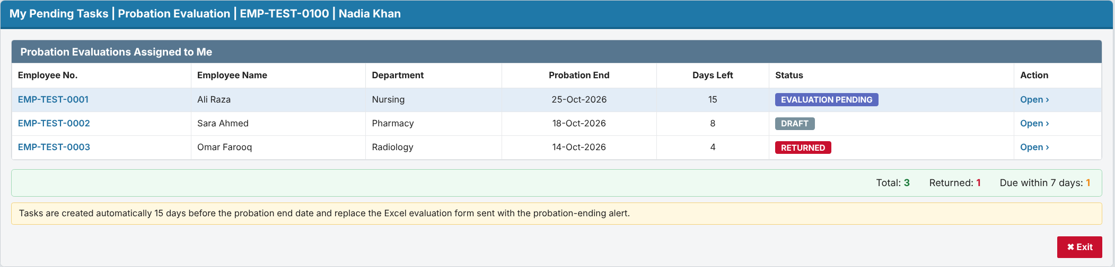
- Page B: Probation Evaluation (NEW), Evaluation Criteria tab (first tab).
- Header: region REG_EMPLOYEE_INFO (read-only).
- Tabs: Evaluation Criteria | Assignments | Training Needs | Recommendation.
- Criteria grid REG_CRITERIA:
- Interactive Grid on HRD_PROBATION_CRITERIA_DTL joined to CRITERIA_MST.
- Columns: Parameter, Description (read-only), Rating (LOV_RATING 1–5), Remarks. Saves call P_SAVE_CRITERIA_RATING.
- The Rating Scale panel and the score bar sit beside and below the grid.
- Buttons: BTN_PREVIEW, BTN_SAVE_DRAFT (calls P_SAVE_DRAFT), BTN_SUBMIT (calls P_SUBMIT), BTN_EXIT.
- Validation: an unrated mandatory parameter is highlighted pink.
- Hidden item: P<n>_VERSION_NO.
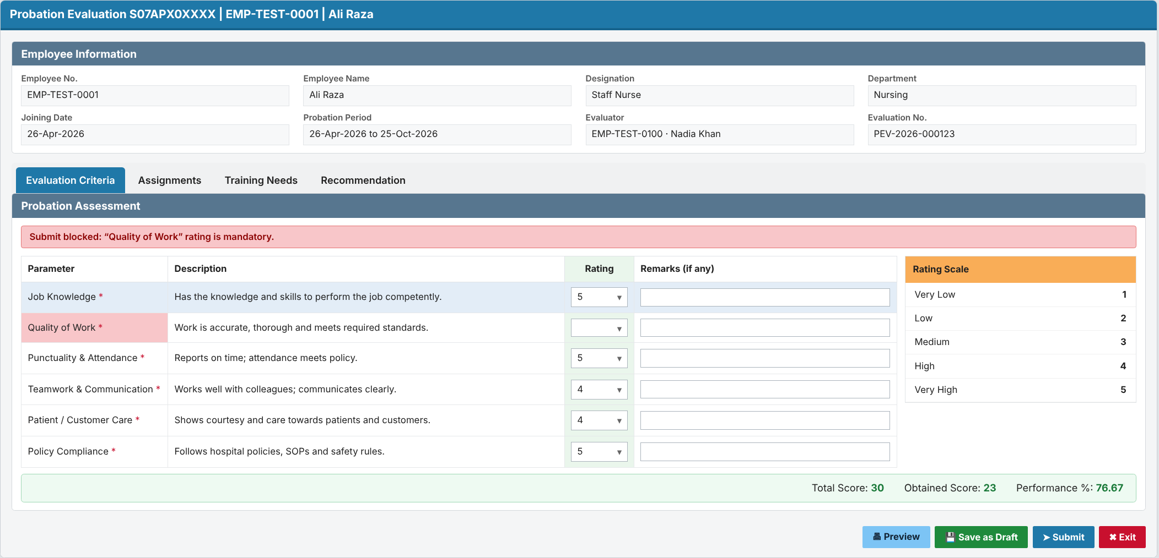
- Page B, Assignments tab.
- Assignments grid REG_ASSIGNMENTS:
- Interactive Grid on HRD_PROBATION_ASSIGNMENT_DTL, with columns Assignment, Rating (LOV_RATING 1–5) and Remarks.
- Row add and delete call P_SAVE_ASSIGNMENT / P_DELETE_ASSIGNMENT.
- The Rating Scale panel and the score bar sit beside and below the grid.
- Same buttons as the criteria tab.
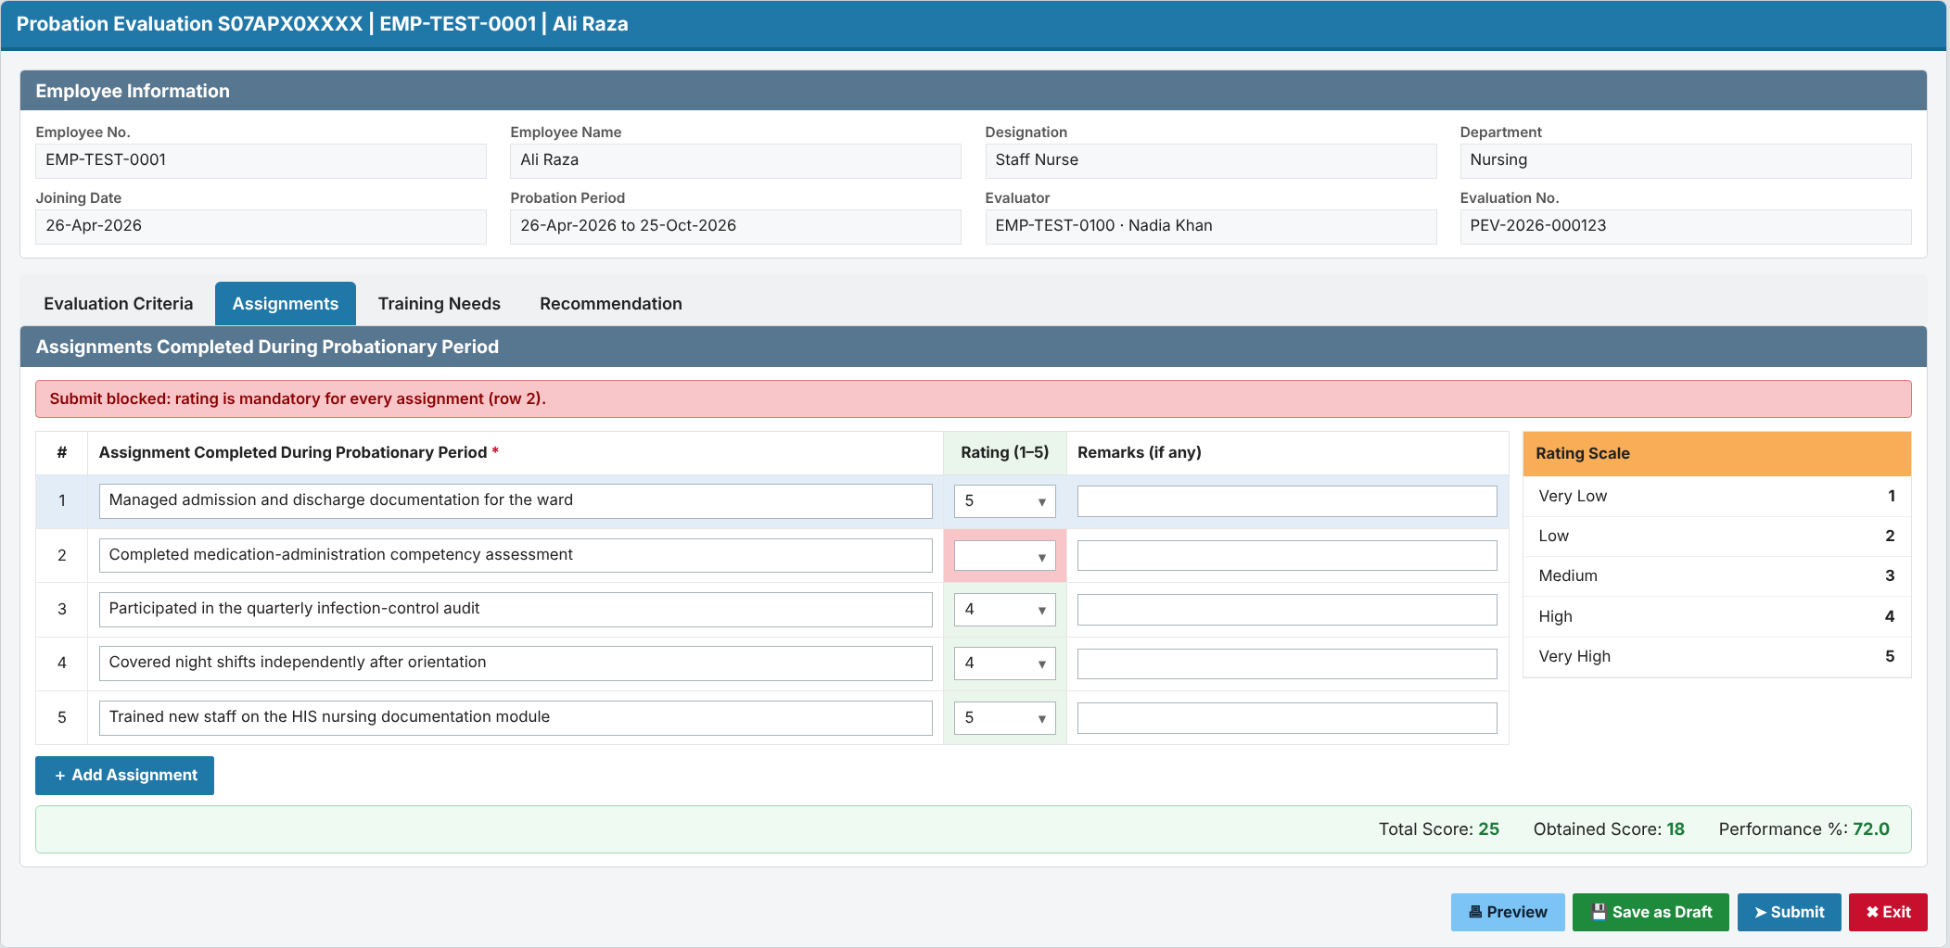
- Page B, Training Needs tab: Interactive Grid REG_TRAINING_NEEDS on HRD_PROBATION_TRAINING_DTL, with columns Training Need and Remarks. Calls P_SAVE_TRAINING_NEED / P_DELETE_TRAINING_NEED.
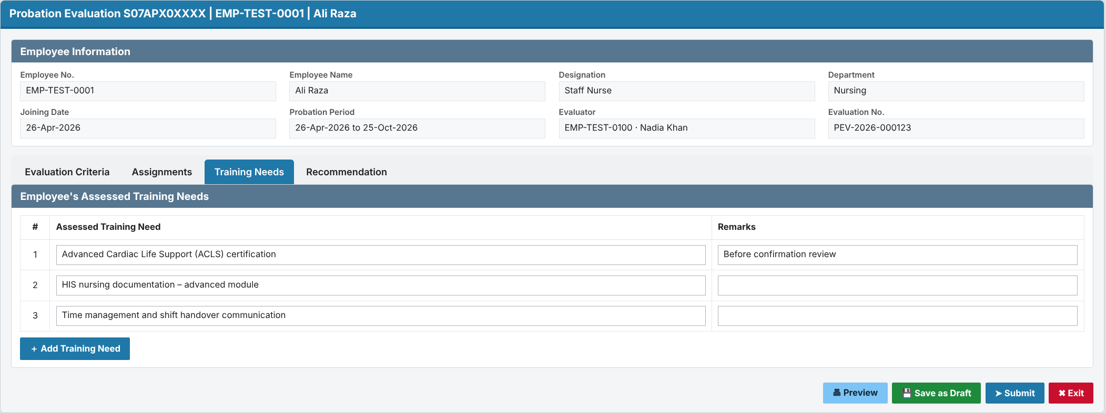
- Page B, Recommendation tab:
- Radio P<n>_RECOMMENDATION (C / E / N).
- P<n>_EXTEND_DAYS, shown only for Extend.
- `P<n>_NON_CONFIRM_REASONS` (textarea) and the Evidence region REG_EVIDENCE. The evidence report lists EMPLOYEE_PROBATION_ATTACHMENT rows; "Attach Evidence" calls P_ADD_EVIDENCE and "Remove" calls P_REMOVE_EVIDENCE.
- DA_TOGGLE_REASONS shows and marks the reasons and evidence as required when the recommendation is E or N.
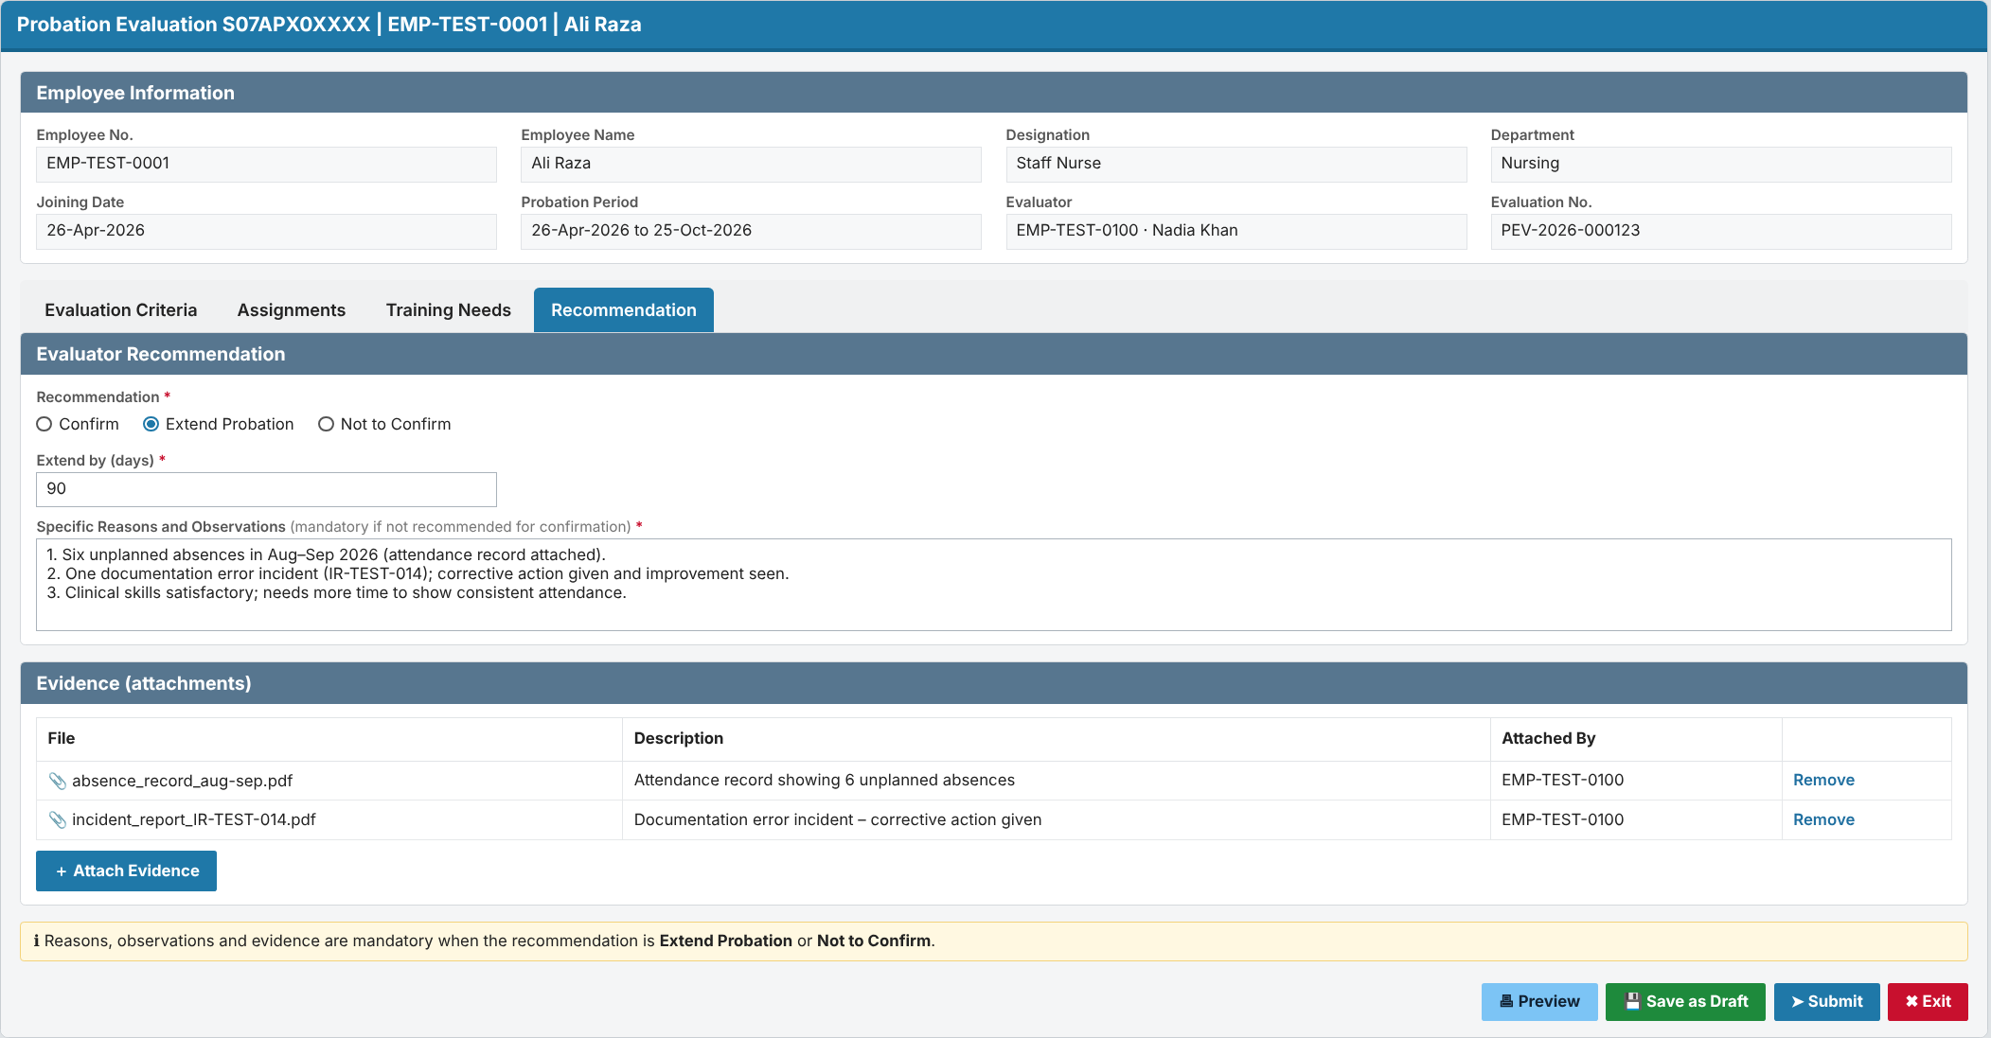
- Page C: Approval (NEW).
- Routing bar showing the evaluator and each level with its status, plus the route source (department probation hierarchy or leave hierarchy).
- The four form tabs shown read-only (criteria, assignments, training needs, reasons and evidence), plus the approver comments.
- BTN_APPROVE calls P_APPROVE; BTN_RETURN calls P_RETURN.
- Authorization: the current approver or acting-for person only.
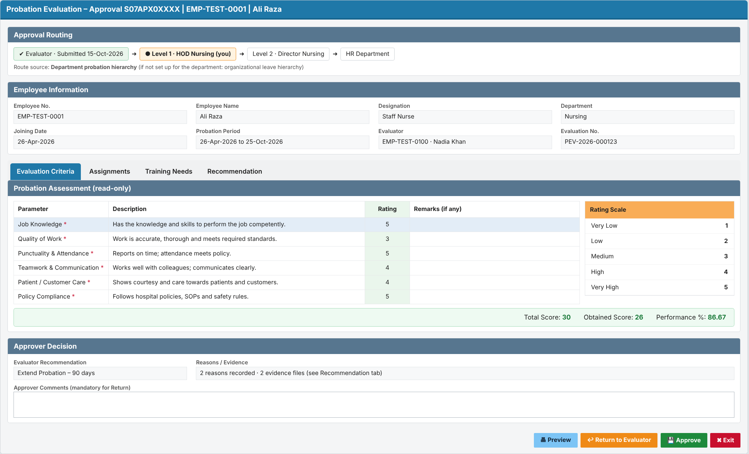
- Page D: Probation Approval Hierarchy Setup (NEW). Interactive Grid on HRD_PROBATION_HIERARCHY_MST; the department is mandatory. A note explains that departments without rows follow the organizational leave hierarchy. Authorization: HR Administrator.
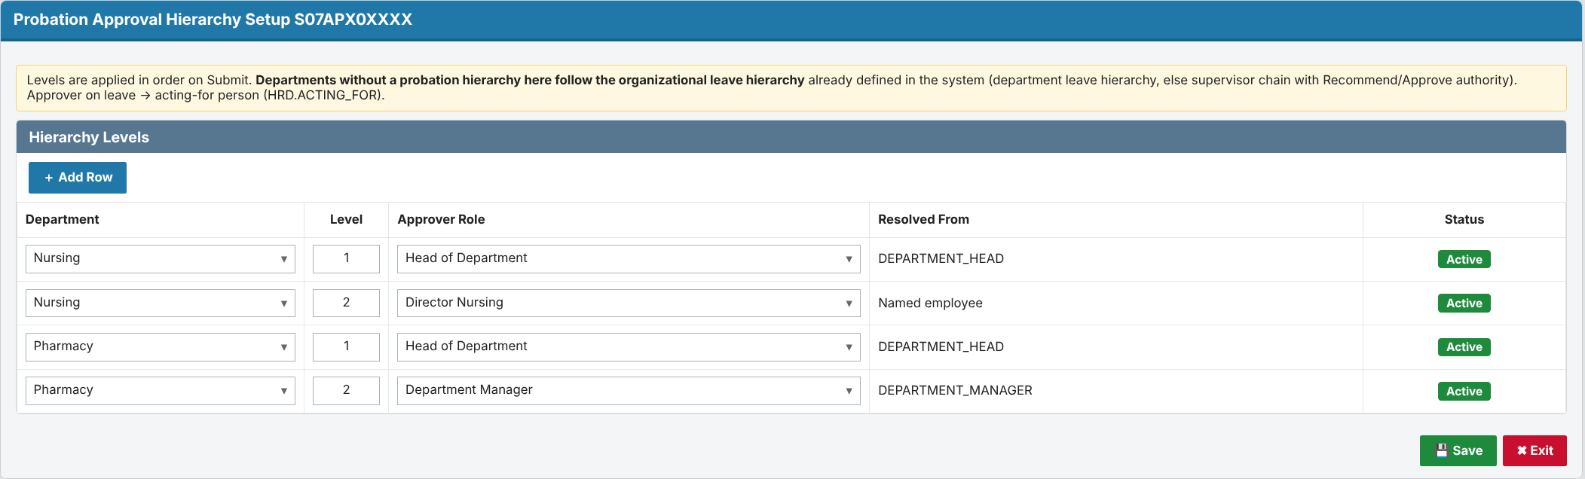
- Page E: HR queue (NEW). Report of evaluations with status FH, showing recommendation, final approver, performance % and evidence count. "Process" opens Page F.
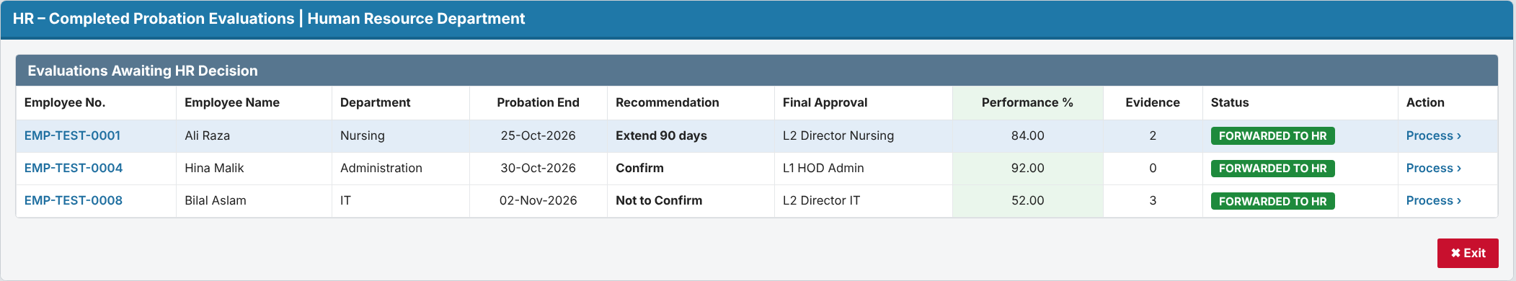
- Page F: HR Finalization (NEW, a separate page, not a tab).
- Shows the routing bar, the overall score, the recommendation, the reasons and the training needs.
- Decision radio, extension days and reason (LOV_PROBATION_REASONS), remarks.
- BTN_FINALIZE calls P_HR_FINALIZE.
- Authorization: HR User.
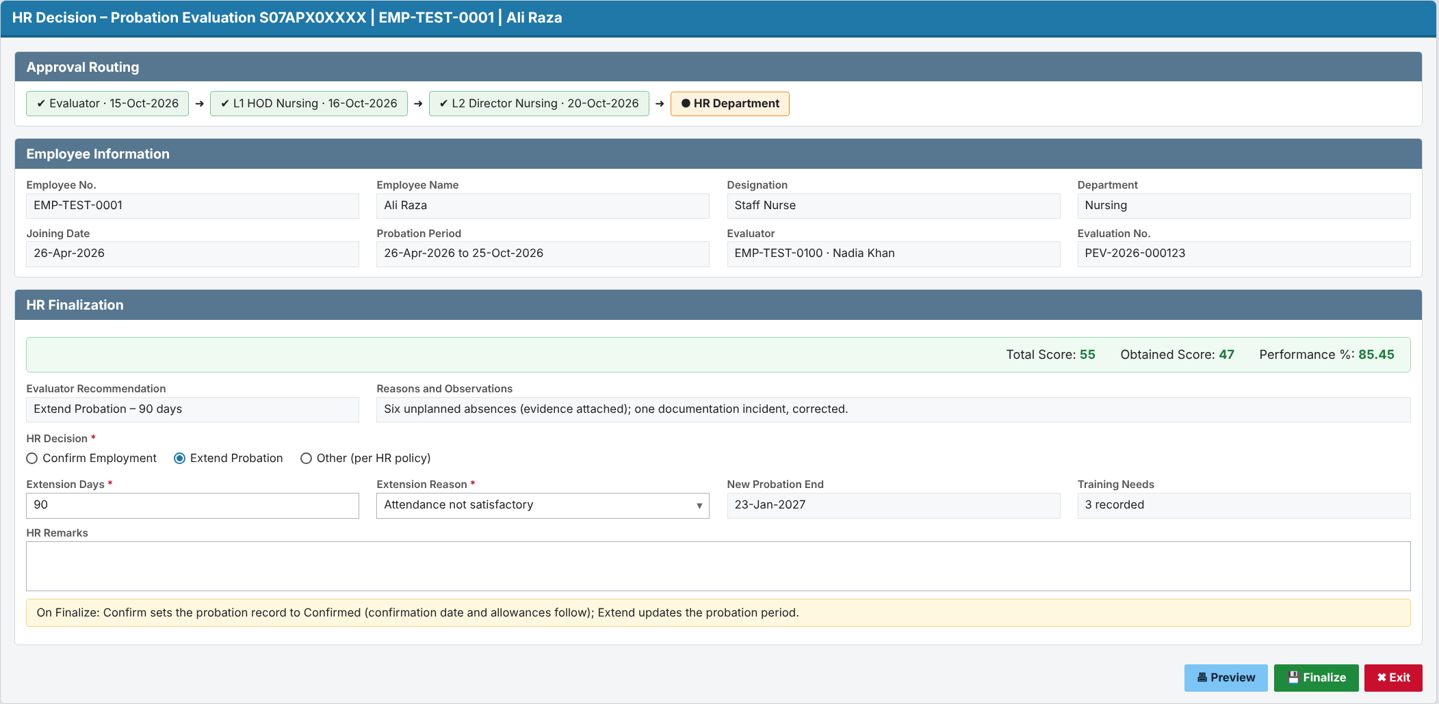
- Page G: Probation Monitoring (NEW).
- Filters, an evaluation grid with Overdue and No-supervisor flags, "Assign Evaluator", and the status-history report.
- Authorization: HR User; assigning needs HR Administrator.
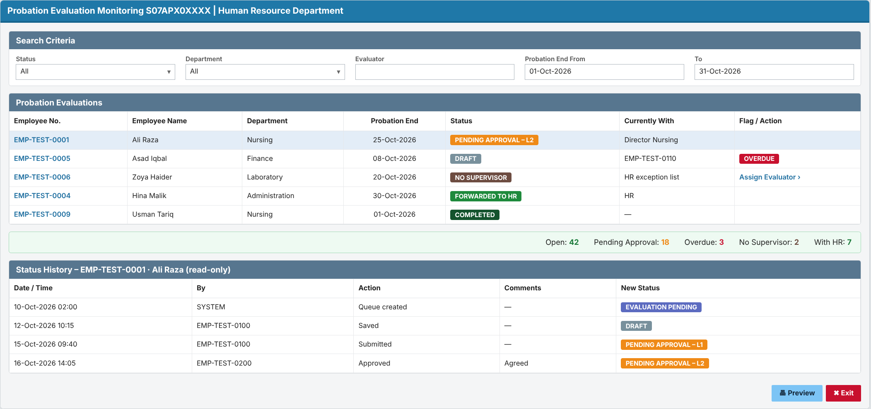

6. Jobs, Notifications and Security
- Job `HRD.JOB_PROBATION_EVAL_QUEUE` (DBMS_SCHEDULER):
- Runs daily at 02:00 and calls P_GENERATE_EVAL_QUEUE.
- A failed run is logged and IT support is alerted.
- Notification e-mails:
- Sent for: evaluation assigned, pending approval, returned, and forwarded to HR.
- They use APEX_MAIL, configured through HRD.ALERTS / ALERT_RECIPIENTS. No Excel attachment: the e-mail links to the online form (Q-27 asks IT for the mail API).
- Authorization schemes:
- AUTH_PROB_EVALUATOR;
- AUTH_PROB_APPROVER (the current approver or acting-for person);
- AUTH_PROB_HR_USER and AUTH_PROB_HR_ADMIN (security groups, to be confirmed by IT).
- Data access: all reads and writes go through the package's role checks. Evidence is visible only to the evaluator, the approvers in the routing path, and HR.
- Audit: audit columns on every table, the insert-only history, and no physical delete of evaluations (cancel sets status CN).
- Privacy: MRNO is also the patient MR number. The pages do not join or link to REGISTRATION data.

7. Requirement Coverage
- FR-001, FR-002, FR-003, FR-004, FR-005, FR-006 (queue generation, duplicates, cancel, exceptions, reassign): DS-01, DS-07, P_GENERATE_EVAL_QUEUE, P_ASSIGN_EVALUATOR, Page G.
- FR-007, FR-008, FR-009, FR-010 (form, Draft, Submit, lock): DS-01, P_SAVE_DRAFT, P_SUBMIT, Page B.
- FR-024 (standard criteria rated 1–5): DS-02a, DS-02b, P_SAVE_CRITERIA_RATING, Page B Evaluation Criteria tab.
- FR-021 (assignments rated 1–5): DS-02, P_SAVE_ASSIGNMENT, score calculation, Page B Assignments tab.
- FR-022 (assessed training needs): DS-03, P_SAVE_TRAINING_NEED, Page B Training Needs tab.
- FR-023 (reasons, observations and evidence when not recommended): NON_CONFIRM_REASONS, EMPLOYEE_PROBATION_ATTACHMENT, P_ADD_EVIDENCE, the P_SUBMIT check, Page B Recommendation tab.
- FR-011, FR-012, FR-013, FR-014 (routing with leave-hierarchy fallback, approve, return, no self-approval): DS-04, DS-05, DS-D10, P_BUILD_ROUTE, F_GET_LEAVE_ROUTE, P_ROUTE, P_APPROVE, P_RETURN, Pages C and D.
- FR-015, FR-016 (forward to HR, finalize): P_ROUTE (status FH), P_HR_FINALIZE, Pages E and F.
- FR-017, FR-018, FR-019, FR-020 (status, history, monitoring, overdue): DS-06, P_LOG_STATUS, F_IS_OVERDUE, Page G.
- NFR-SEC-01, NFR-SEC-02: authorization schemes, plus role checks inside the package.
- NFR-AUD-01, NFR-AUD-02: audit triggers, plus the insert-only history.
- NFR-PERF-01, NFR-PERF-02: set-based job SQL, plus indexes.
- NFR-AVL-01: the job's date window catches up on missed days. NFR-AVL-02: new objects only; no downtime.
- NFR-DAT-01: no physical delete. NFR-DAT-02: unique index. NFR-DAT-03: VERSION_NO with error -20802.
- NFR-USA-01, NFR-USA-02: APEX pages in the SKMCH GUI template, plus the "warn on unsaved changes" setting.
- NFR-CMP-01: status rules agreed with HR. NFR-INT-01: employee data read live from INFORMATION.
- NFR-OPS-01: job log and failure alert. NFR-OPS-02: non-blocking notification e-mails.

8. Change Inventory and Deployment
- Scripts, run in this order (no downtime):
Step | Script | What it does
0 | CR-2026-XXX-PEV_00_precheck.sql | Checks that no HRD_PROBATION_% objects exist, and backs up the PKG_PENDING_TASKS source
1 | CR-2026-XXX-PEV_01_ddl.sql | Sequences, 9 new tables, indexes, triggers (provided)
2 | CR-2026-XXX-PEV_02_pkg_probation_evaluation.pks / .pkb | New package
3 | CR-2026-XXX-PEV_03_pkg_pending_tasks.pkb | Adds P_PROBATION_EVAL_QUEUE
4 | CR-2026-XXX-PEV_04_seed.sql | Evaluation criteria from HR's form, department hierarchies (where HR wants them), the reference leave type setting, the HIS.USER_ASSIGNMENT row, alert rows, and the lead-days setting (default 15)
5 | CR-2026-XXX-PEV_05_job.sql | Creates the scheduler job
6 | APEX export | Pages B–G, authorization schemes, LOVs

- After deployment, verify: all objects are VALID; a manual run of the job creates evaluations and a SUCCESS log row; the inbox shows the task count; on a test record, a Submit with E and no evidence is refused (-20806).
- Rollback: CR-2026-XXX-PEV_99_rollback.sql (provided). It does not revert finalized probation records or the evidence rows stored in EMPLOYEE_PROBATION_ATTACHMENT; those are business records.
- Retest these dependents:
- readers of EMPLOYEE_PROBATION_HISTORY: PKG_COMMON, PKG_EMPLOYEE_INFO, PKG_EMP_INCENTIVE, PKG_HR_ALERTS, PKG_HR_DOCUMENT_RECORD, PKG_HR_EMPLOYEE_RECORD, LEAVE_AUTOMATION, EMAILS, V_HR_EMP_DOCUMENTS;
- any HR document screen that lists EMPLOYEE_PROBATION_ATTACHMENT;
- leave approval itself (regression only, to confirm it is unaffected, since LEAVE_QUEUE_HIERARCHY and ROLE_AUTHORITY are only read).

9. Risks and Open Questions
- Risk: probation status written too early. Mitigation: only P_HR_FINALIZE writes it.
- Risk: duplicate channels (Excel alert 001 and S07FRM00362). HR decides before go-live (Q-24).
- Risk: stale `MANAGER_MRNO`. Mitigation: HR exception list and a data-quality report.
- Open questions:
- Q-07 (HR): after a Return, does approval restart at level 1?
- Q-08 (HR): for an extension, extend the current probation period or add a new one?
- Q-16 (HR): which departments get their own probation hierarchy, and their levels. All other departments use the leave hierarchy.
- Q-29 (HR/IT): which leave type's hierarchy to use for the fallback (proposed: annual/earned leave).
- Q-30 (HR): in the supervisor-chain fallback, does level 1 start at the evaluator's manager, and does it stop at the first leave approver (authority 002)?
- Q-24 (HR): retire the Excel alert 001 and S07FRM00362, or keep them for HR monitoring? Should the lead time be 15 or 30 days?
- Q-27 (IT): mail API and sender; security groups for the HR roles; the DOCUMENT_TYPE_ID to use for evidence.
- Q-28 (HR): should training needs link to the training-subject master (TRAINING schema), or stay as free text?

