Shaukat Khanum Memorial Cancer Hospital & Research Centre
Information Systems

Software Requirements Specification
Automated Employee Probation Evaluation – Change Request

Document ID | CR-2026-XXX-PEV
Version | 0.2
Status | DRAFT
Date | 2026-10-09
Prepared by | Claude (AI draft) for Business Analyst
Source documents | CR v0.1 + SRS v0.3; HRD schema

Version History
Version | Date | Author | Change summary
0.2 | 2026-10-09 | Claude (AI draft) for Business Analyst | Merged CR and SRS; GUI prototypes in SKMCH GUI template

Approvals
Role | Name | Decision | Signature | Date
Business Analyst (author)
Solution Architect
Business Owner / Department Head
Approval is recorded by the named person only. AI-drafted documents remain DRAFT until then.

Change Request: Automated Employee Probation Evaluation
Item | Value
CR No. | CR-2026-XXX-PEV (placeholder: real CR number to be assigned)
Module / Schema | HR (HRD), Oracle APEX
Requested by | HR Department
Prepared by | Claude (AI draft) for Business Analyst
Version / Status | 0.2 / DRAFT (CR + SRS merged)
Date | 09-Oct-2026
Sources merged | CR-2026-XXX-PEV_CR_v0.1 (client template) + CR-2026-XXX-PEV_SRS_v0.3 (detailed requirements, impact analysis). SA review: CR-2026-XXX-PEV_SRS-Review_v2

1. Client Needs / Expectations
HR wants the employee probation evaluation to run automatically, on time and with full visibility, without manual follow-up:
- Every employee on probation is evaluated by their respective supervisor before the probation end date. The system starts the evaluation automatically 15 days before the probation end date.
- The evaluator can work on the evaluation over more than one sitting (Save as Draft) and send it when ready (Submit for approval).
- Every submitted evaluation goes through the configured approval hierarchy (for example HOD, then Director).
- Once approved, the completed evaluation reaches the HR Department automatically.
- HR and supervisors can see the current status of every probation evaluation at any time. The status updates itself at each step.
Expected benefits: no missed or late evaluations, a consistent approval path, no manual chasing by HR, and an audit trail of who did what and when.
Today (from the HRD system): probation-expiry alerts (alert 001, HRD.HR_ALERT_QUEUE) go to HR users only, and HR records the confirm/extend decision on form S07FRM00362. Supervisors have no system task, and the evaluation is not routed through approvals.

1.1 Business requirements
ID | Business requirement | Source (M-NN) | Priority
BR-01 | Every employee on probation shall be evaluated by their supervisor before the probation end date, with the evaluation started automatically in good time. | M-01, M-02, M-03 | Must
BR-02 | Evaluators shall be able to work on an evaluation over more than one session before committing it. | M-04, M-05 | Must
BR-03 | Every submitted evaluation shall be reviewed through the organisation's configured approval hierarchy. | M-06 | Must
BR-04 | HR shall receive every completed evaluation without manual follow-up. | M-07 | Must
BR-05 | HR and supervisors shall always know the current stage of each probation evaluation. | M-08 | Must

1.2 Background
Employees joining SKMCH serve a probation period. Before the probation end date, the employee's supervisor must evaluate the employee so that HR can decide on confirmation. The requested change automates this: the system starts the evaluation on time, routes it through the approval hierarchy and delivers it to HR, while keeping the probation request status current at every step (M-01 to M-08). How the process is run today (manual forms, e-mail or an existing screen) was not described in the request (Q-02).

1.3 Current process (As-Is)
The request does not describe the current process (Q-02). The HRD schema (v0.3) shows existing probation objects: a probation period record with status (HRD.EMPLOYEE_PROBATION_HISTORY), a probation-expiry pending task (PKG_PENDING_TASKS.PROBATION_EXPIRE_QUEUE) and an evaluation alert/confirmation queue with Completed / Extend / Pending / In-process statuses (HRD.EVALUATION_ALERT_QUEUE). Today's process probably uses these, which HR/IT need to confirm (Q-24). Based on the requested changes, the following is assumed (A-01):
- HR tracks probation end dates and asks supervisors to evaluate employees, manually or by a non-automated means.
- Supervisors complete the evaluation outside a system workflow (or on a screen without approval routing) and send it to HR.
- Approval by higher levels (if any) is obtained manually.
- Probation request status, if a probation request record exists, is updated manually by HR.
Pain points implied by the request: evaluations started late or missed, no consistent approval path, no automatic hand-over to HR, and status that does not reflect where the evaluation actually is.

1.4 Scope

In scope
- Automatic generation of a probation evaluation queue item for the respective supervisor 15 days before the employee's probation end date (M-02, M-03).
- Evaluation entry by the evaluator with Save as Draft and Submit for approval (M-04, M-05).
- Routing of a submitted evaluation through the configured approval hierarchy (M-06).
- Automatic routing of the completed evaluation to the HR Department (M-07).
- Automatic update of the probation request status throughout the workflow, with status history (M-08).

Out of scope
- HR's downstream action on the evaluation (confirmation letter, probation extension, termination, payroll/grade changes). Not discussed; HR's exact action on receipt is open (Q-06).
- Design of the evaluation form content (criteria, rating scale, recommendation values). Not provided in the request; to be supplied by HR (Q-05). The workflow is in scope; the form content is a dependency.
- Probation evaluation of employees whose probation is ended early (resignation, termination) — the queue is cancelled only (see FR-004); no separate process is specified.
- Self-evaluation by the employee. Not mentioned.
- Automatic confirmation, extension or termination of probation, including when an evaluation is overdue (changed in v0.2, RV-17).

1.5 Stakeholders
Name / Role | Department | Interest / responsibility | Attended meeting
HR Department representative(s) (names not stated, Q-13) | HR | Business owner; receives completed evaluations; owns probation policy | Not stated
Supervisors / evaluators | All departments | Complete probation evaluations on time | No
Approvers in the approval hierarchy (e.g. HOD) | All departments | Review and approve submitted evaluations | No
Employees on probation | All departments | Subject of the evaluation (no system action) | No
Business Analyst | IT / Development | Requirement owner for this SRS | Not stated
Solution Architect | IT | SRS review and approval (Gate 1) | Not stated
Development team / QA | IT | Build and test | Not stated

1.6 Definitions and abbreviations
Term | Meaning
Probation end date | The date on which the employee's probation period ends, as held in the employee's HR record
Probation request | The HR record that tracks an employee's probation period and its evaluation outcome (whether this already exists in HRD is to be confirmed, Q-03)
Probation request status | The HR-level status of the employee's probation period, updated automatically from the evaluation workflow (changed in v0.2, RV-04; mapping to be finalised with Q-03, Q-09)
Evaluation status | The workflow status of a probation evaluation, with the values and transitions in RULE-08 (added in v0.2, RV-04)
Probation evaluation | The assessment of an employee on probation, completed by the evaluator and approved through the hierarchy
Evaluator | The respective supervisor of the employee, who completes the evaluation
Respective supervisor | The employee's direct supervisor / reporting manager on record (source to be confirmed, Q-04)
Queue | A pending work item shown to a user on their queue / inbox screen
Approval hierarchy | The configured ordered list of approval levels a submitted evaluation passes through
Draft | A saved but not submitted evaluation, visible and editable only by the evaluator
HOD | Head of Department
APEX | Oracle Application Express, the platform for the HRD applications
MoM | Minutes of Meeting

1.7 References
- Request: "Automated Employee Probation Evaluation", proposed workflow points 1 to 5 (shared in chat, 2026-10-09). Meeting date and attendees not stated (Q-13).
- Earlier SRS versions: none.
- Related CRs: none known. CR number to be assigned (Q-14). Placeholder CR-2026-XXX-PEV used because CR-2026-XXX is already used by the Committee Workflow CR.
- HR probation policy / SOP: to be supplied by HR (Q-05, Q-08).

2. Workflow
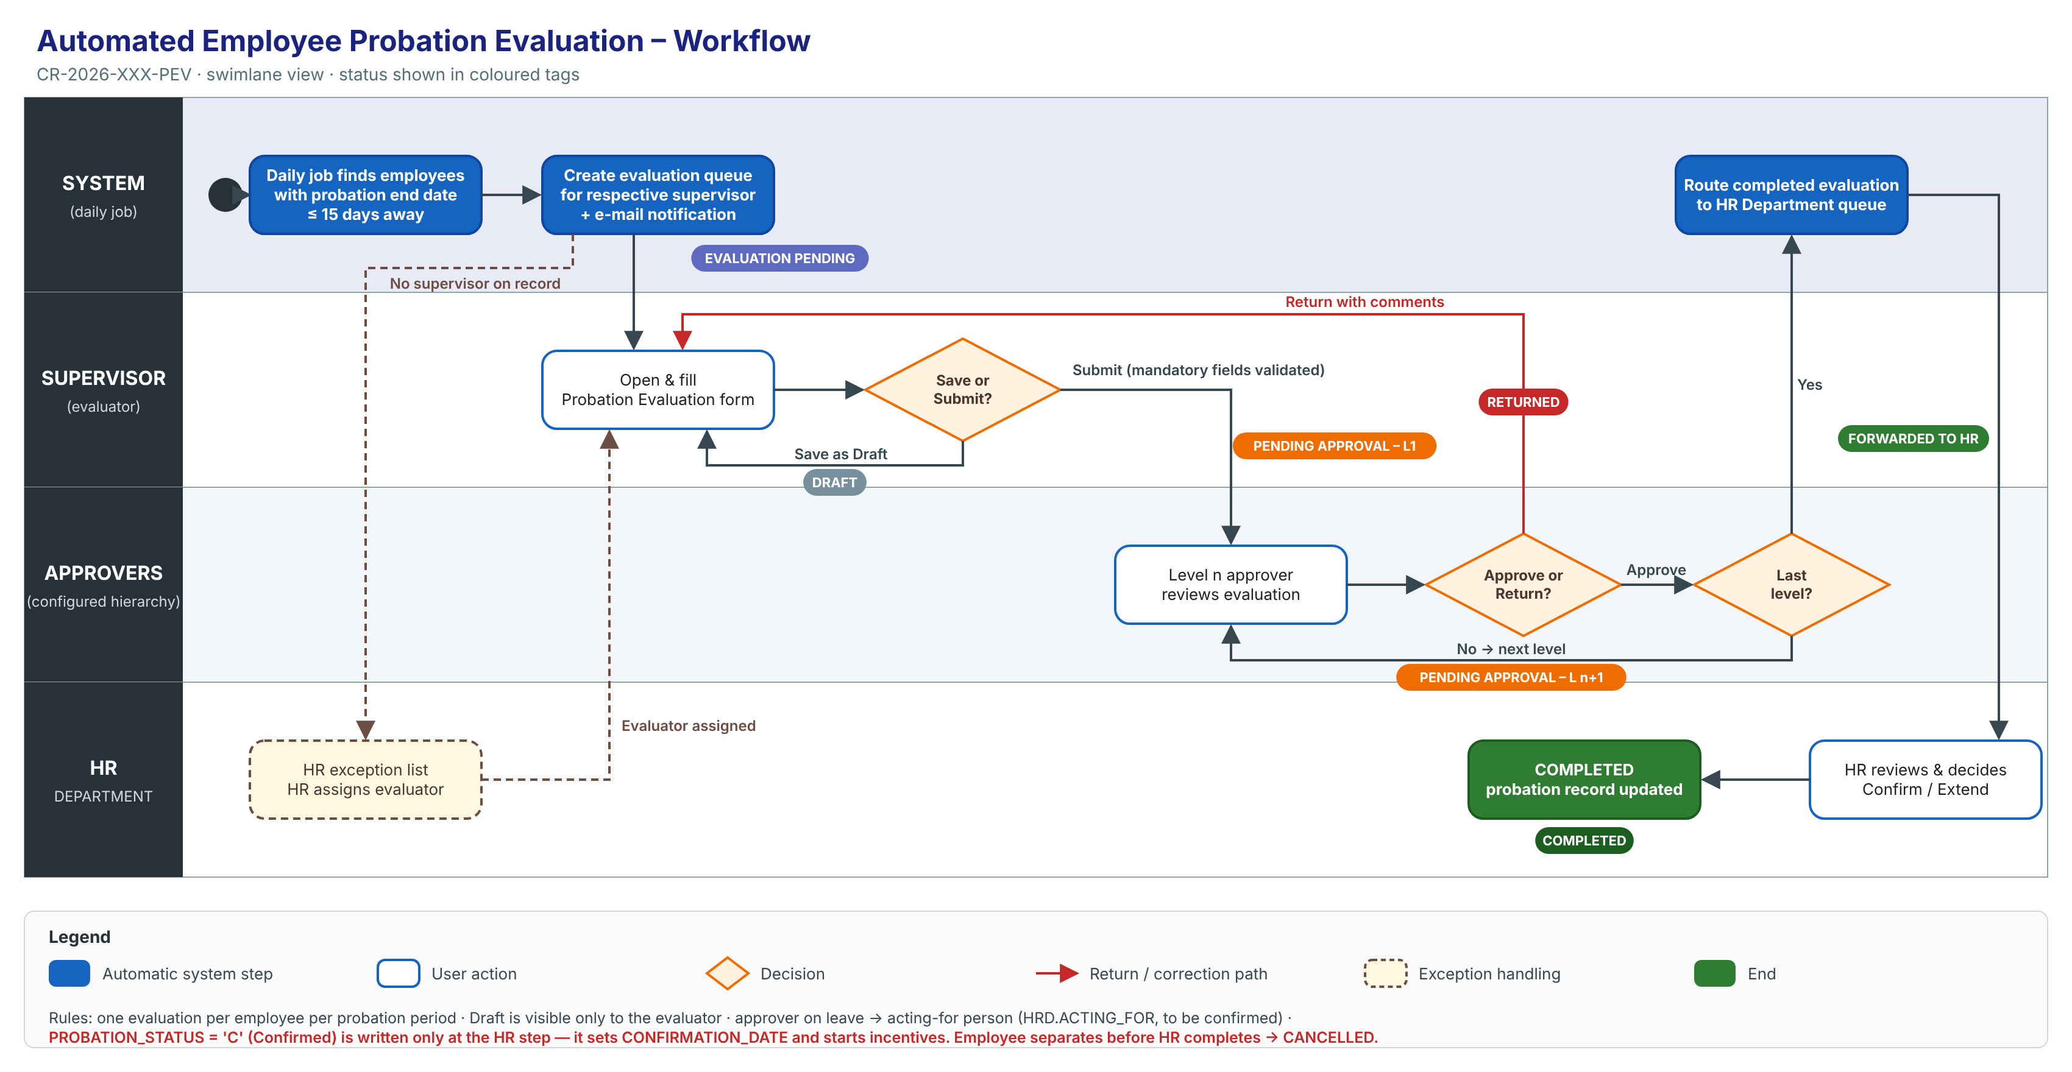
Editable source: `CR-2026-XXX-PEV_Workflow.svg`.
Step | Actor | Action | System result | Status after step
1 | System (daily job) | Finds employees whose probation end date is within 15 days and who have no evaluation yet | Creates an evaluation queue item for the respective supervisor and notifies them | Evaluation Pending
2a | Supervisor (evaluator) | Fills part of the form and clicks Save as Draft | Saves; the item stays in the supervisor's queue | Draft
2b | Supervisor | Completes the form and clicks Submit | Validates mandatory fields and routes to Level 1 | Pending Approval – Level 1
3a | Approver (Level n) | Approve | Moves to the next level | Pending Approval – Level n+1
3b | Approver | Return with comments | Back to the supervisor for correction | Returned
4 | System | Last level approves | Routes to the HR Department queue | Forwarded to HR
5 | HR | Processes the evaluation (confirm / extend, per HR policy) | Closes the evaluation and updates the probation record | Completed

Status names are proposed and need HR to confirm them.

2.1 Status model
Allowed statuses and transitions are defined in RULE-08 (section 5.1 below).

3. Functional Requirements
Each requirement below follows the client template: a summary, a GUI prototype (screen mock-up in the SKMCH APEX GUI template — title bar with page code, tabs, region headers, rating-scale panel, score bar, Preview/Save/Exit buttons; sample data is synthetic and form content is indicative until HR supplies the evaluation form) and the detailed functional requirements (FR-NNN) with acceptance criteria. Editable prototype sources: prototypes/src/.

3.1 Requirement 1: Automatic generation of the probation evaluation queue
Description: Every day, the system shall identify each employee on probation whose probation end date is within the next 15 days and who has no evaluation for the current probation period. For each one, it shall create a probation evaluation queue item assigned to the employee's respective supervisor.
- One evaluation only per employee per probation period. A re-run never creates a duplicate.
- If a day's run is missed, the next run picks up the employees that were missed.
- If the employee has no supervisor on record, the item goes to an HR exception list. HR can assign or reassign the evaluator.
- If the employee leaves (separation) before HR completes the evaluation, the evaluation is cancelled.
- The supervisor is notified by e-mail when an item is assigned.
- Probation end date: taken from the probation record (HRD.F_PROBATION_END_DATE). Respective supervisor: HRD.INFORMATION.MANAGER_MRNO (to be confirmed by HR).
Acceptance (summary):
- An employee whose probation ends on 25-Oct-2026 appears in their supervisor's queue on 10-Oct-2026.
- An employee whose probation ends on 26-Oct-2026 does not appear in the queue on 10-Oct-2026.
- An employee who has been confirmed or has left never appears in the queue.
Traceability: FR-001 – FR-006, RULE-01 – RULE-03.

3.1.1 Prototype (GUI): Supervisor pending tasks (queue)
Screen 1 – My Pending Tasks (supervisor)
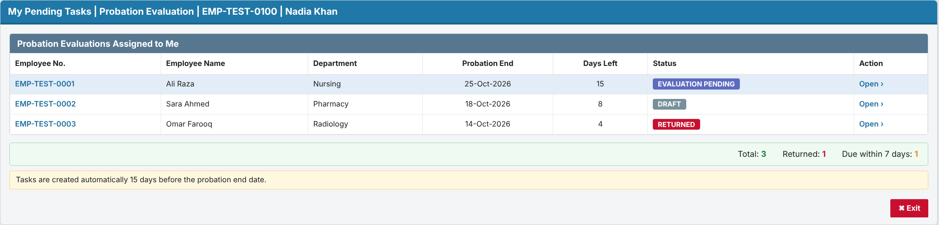

3.1.2 Detailed functional requirements

FR-001 Identify employees due for evaluation
Description: The system shall, once every day, identify each employee on probation whose probation end date is on or before 15 calendar days after the current date, is not earlier than the current date, and who has no evaluation for the current probation period (changed in v0.2, RV-05). Priority: Must Source: M-02 Business rules: RULE-01, RULE-03 Acceptance criteria:
- AC1: Given an employee on probation with a probation end date of 25-Oct-2026, when the daily process runs on 10-Oct-2026, then the employee is identified as due for evaluation.
- AC2 (negative): Given an employee on probation with a probation end date of 26-Oct-2026, when the daily process runs on 10-Oct-2026, then the employee is not identified.
- AC3 (negative): Given an employee who is not on probation (confirmed or separated), when the daily process runs, then the employee is not identified regardless of dates.
- AC4 (catch-up): Given the daily process did not run on 10-Oct-2026 and an employee's probation end date is 25-Oct-2026 with no evaluation, when the process runs on 12-Oct-2026, then the employee is identified.
Notes / open questions: Q-01 (calendar vs working days), Q-10 (catch-up for missed runs and go-live backlog).

FR-002 Generate evaluation queue item for respective supervisor
Description: The system shall create a probation evaluation queue item, assigned to the employee's respective supervisor, for each employee identified by FR-001. Priority: Must Source: M-02, M-03 Business rules: RULE-02, RULE-03 Acceptance criteria:
- AC1: Given employee EMP-TEST-0001 is identified and their supervisor on record is EMP-TEST-0100, when the daily process completes, then a probation evaluation queue item for EMP-TEST-0001 appears in EMP-TEST-0100's queue.
- AC2 (negative): Given employee EMP-TEST-0001 is identified, when the daily process completes, then no other user except the assigned supervisor (and HR monitoring, FR-017) sees the queue item.
Notes / open questions: Q-04 (source of "respective supervisor").

FR-003 Prevent duplicate evaluation queue items
Description: The system shall create no more than one active probation evaluation for the same employee and probation period. Priority: Must Source: M-02 (Inferred) Business rules: RULE-03 Acceptance criteria:
- AC1: Given a queue item already exists for EMP-TEST-0001's current probation period, when the daily process runs again (e.g. re-run of the same day), then no second queue item is created.
- AC2: Given an employee's probation period is extended by HR with a new end date, when the new trigger date is reached, then a new evaluation is created for the new period (subject to Q-08).
Notes / open questions: Q-08 (probation extension).

FR-004 Cancel evaluation when probation ends early
Description: The system shall cancel an open probation evaluation and remove it from all queues when the employee is no longer on probation (separation or early confirmation) before the evaluation is completed. Priority: Should Source: M-08 (Inferred) Business rules: RULE-08 Acceptance criteria:
- AC1: Given an evaluation in Draft for EMP-TEST-0002, when HR records EMP-TEST-0002's separation, then the evaluation status becomes Cancelled and it disappears from the supervisor's queue.
- AC2 (negative): Given an evaluation already Forwarded to HR, when the employee separates, then the evaluation is not cancelled automatically and remains with HR.
Notes / open questions: Q-11.

FR-005 Handle missing supervisor
Description: The system shall, when an identified employee has no respective supervisor on record, create the evaluation unassigned and show it on an HR exception list instead of a supervisor queue. Priority: Must Source: M-03 (Inferred) Business rules: RULE-02 Acceptance criteria:
- AC1: Given an identified employee with no supervisor on record, when the daily process runs, then the evaluation appears on the HR exception list with the reason "Supervisor not defined".
- AC2: Given an evaluation on the HR exception list, when an HR Administrator assigns an evaluator using FR-006, then the queue item moves to that evaluator's queue.
- AC3 (negative): Given an identified employee with no supervisor, when the daily process runs, then the process does not fail and continues for the other employees.
Notes / open questions: Q-04.

FR-006 Reassign evaluator
Description: The system shall allow an HR Administrator to assign or reassign an evaluation that is unassigned or not yet submitted to a different evaluator (changed in v0.2, RV-15). Priority: Should Source: M-03 (Inferred) Business rules: RULE-02 Acceptance criteria:
- AC1: Given an evaluation in Evaluation Pending or Draft, when an HR Administrator reassigns it to EMP-TEST-0101, then it leaves the old supervisor's queue and appears in EMP-TEST-0101's queue with any draft content kept.
- AC2 (negative): Given an evaluation in Pending Approval, when an HR Administrator tries to reassign the evaluator, then the action is not available.
Notes / open questions: Q-12 (supervisor change after queue generation).

3.2 Requirement 2: Evaluation entry with Save as Draft / Submit
Description: The system shall let the assigned evaluator open the evaluation from the queue and fill in the evaluation form.
- The form shows the employee's details: employee no., name, department, designation, joining date, probation start and end dates.
- Save as Draft: saves without validation and without routing. Only the evaluator can see a Draft.
- Submit: checks that all mandatory fields are filled. If any are missing, it blocks submission and highlights them. Otherwise it routes the evaluation to approval (Requirement 3).
- After Submit the form is read-only for the evaluator, unless an approver returns it.
- The form content (criteria, rating scale and recommendation values such as Confirm / Extend / Terminate) comes from HR's form design (pending from HR).
- A warning appears if the user leaves the page with unsaved changes. If another user changed the evaluation after it was opened, the save is rejected with "Changed by another user, reload".
Acceptance (summary):
- A Draft is saved and reopens with all values intact.
- Submit with a mandatory field empty is refused, and the status does not change.
- A user who is not the evaluator cannot open the form.
Traceability: FR-007 – FR-010, RULE-04, RULE-05, NFR-DAT-03.

3.2.1 Prototype (GUI): Probation Evaluation form
Screen 2 – Probation Evaluation: Evaluation Criteria tab (Save as Draft / Submit)
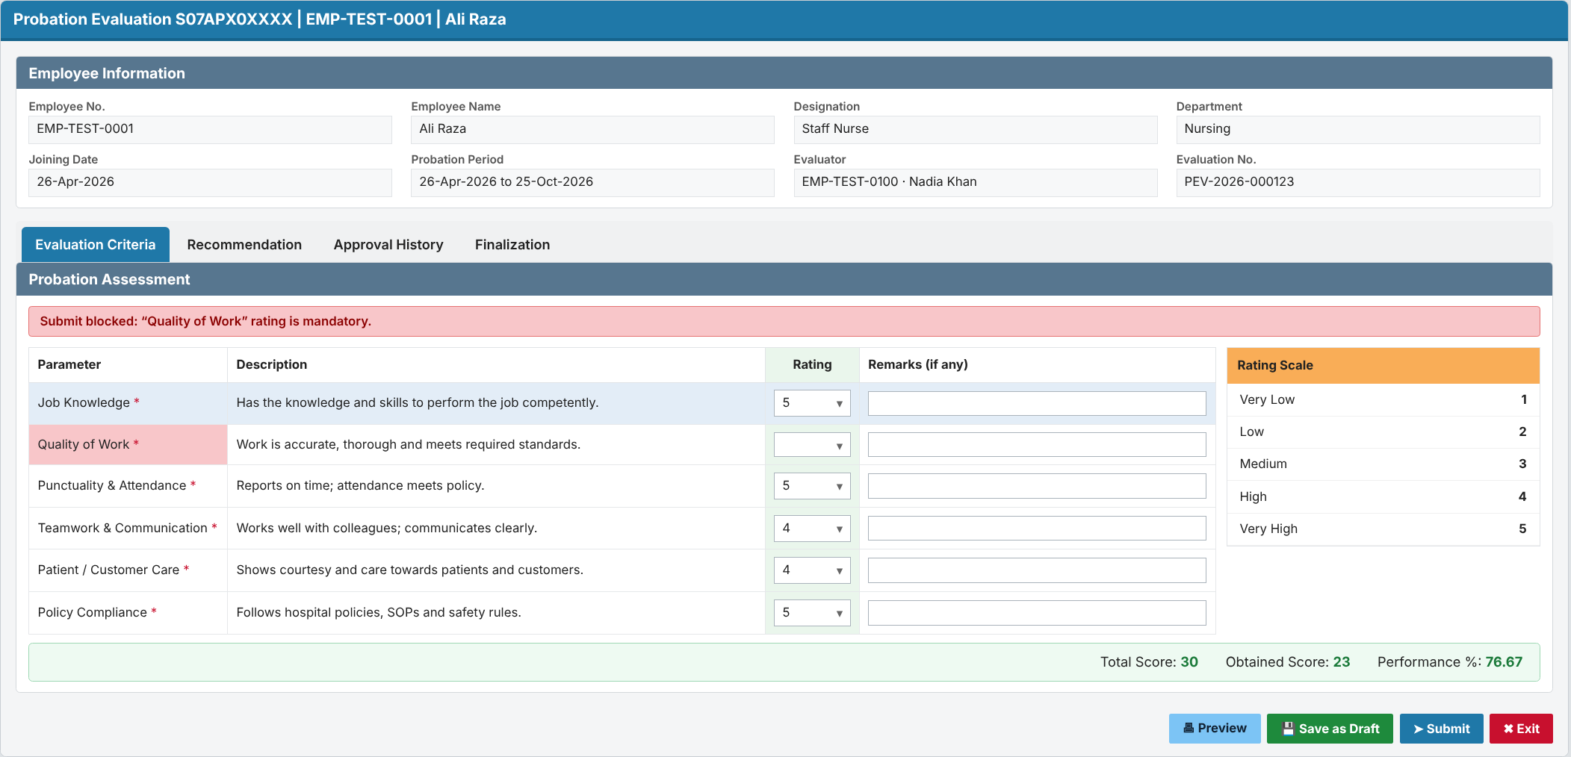
Screen 3 – Probation Evaluation: Recommendation tab
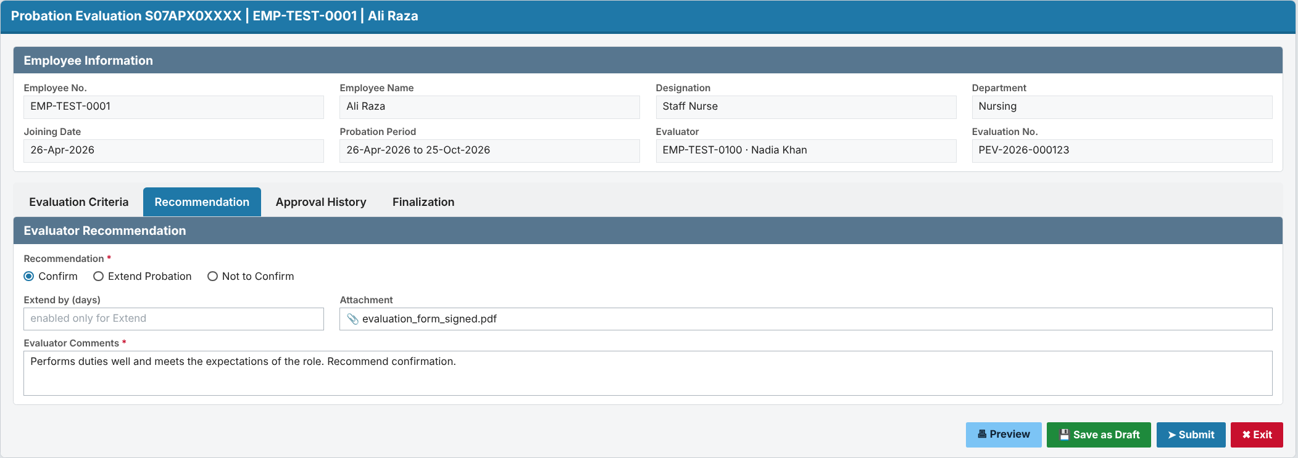

3.2.2 Detailed functional requirements

FR-007 Open evaluation from queue
Description: The system shall allow the assigned evaluator to open a probation evaluation from their queue showing the employee's basic details (employee number, name, department, designation, joining date, probation end date) and the evaluation form. Priority: Must Source: M-02, M-03 Business rules: - Acceptance criteria:
- AC1: Given a queue item assigned to the evaluator, when they open it, then the employee details and the evaluation form are shown.
- AC2 (negative): Given a user who is not the assigned evaluator, when they try to open the evaluation by URL, then access is denied.
Notes / open questions: Q-05 (form content).

FR-008 Save evaluation as Draft
Description: The system shall allow the evaluator to save a partially or fully completed evaluation as Draft without routing it, and to reopen and edit it later. Priority: Must Source: M-04 Business rules: RULE-04, RULE-05 Acceptance criteria:
- AC1: Given an evaluation with some fields filled, when the evaluator clicks Save as Draft, then the entries are saved, the status becomes Draft, and the item stays in the evaluator's queue.
- AC2: Given an evaluation in Draft, when the evaluator reopens it, then all previously saved values are shown and editable.
- AC3 (negative): Given an evaluation in Draft, when any approver or HR user looks at their queue, then the evaluation is not there.
Notes / open questions: -

FR-009 Submit evaluation for approval
Description: The system shall allow the evaluator to submit a completed evaluation for approval after validating that all mandatory fields are filled. Priority: Must Source: M-05 Business rules: RULE-05 Acceptance criteria:
- AC1: Given an evaluation with all mandatory fields filled, when the evaluator clicks Submit and confirms, then the evaluation is submitted and FR-011 routing starts.
- AC2 (negative): Given an evaluation with a mandatory field empty, when the evaluator clicks Submit, then submission is refused, the missing fields are highlighted, and the status is unchanged.
Notes / open questions: Q-05.

FR-010 Lock submitted evaluation
Description: The system shall prevent the evaluator from changing a submitted evaluation unless it has been returned to them. Priority: Must Source: M-05 (Inferred) Business rules: RULE-08 Acceptance criteria:
- AC1: Given a submitted evaluation, when the evaluator opens it, then it is read-only.
- AC2: Given an evaluation returned by an approver, when the evaluator opens it, then it is editable again and can be re-submitted.
Notes / open questions: Q-07.

3.3 Requirement 3: Routing through the configured approval hierarchy
Description: On Submit, the system shall route the evaluation to the approval hierarchy configured for probation evaluations, one level at a time in order.
- Approve (optional comments): moves the evaluation to the next level.
- Return (comments mandatory): sends it back to the evaluator (status Returned). The evaluator corrects it and re-submits.
- No one approves their own case. If the evaluator is also the approver at a level, that level is skipped and the reason is logged. If there is no next level, the evaluation goes to the HR exception list.
- If an approver's level cannot be resolved, the evaluation goes to the HR exception list. It is never lost.
- Approver on leave: the evaluation goes to their acting-for person (HRD.ACTING_FOR), to be confirmed by HR.
- The hierarchy levels (for example L1 = HOD, L2 = Director, by department or grade) are maintained by the HR Administrator. The levels are pending from HR.
- Recommended approach: reuse the existing HRD appraisal routing engine (PA_HIERARCHY, PA_PERFORM_APPRAISER, PKG_PERFORMANCE_APPRAISAL), which already supports Recommend / Approve / Final / Send-back and acting-for. The final decision is made at the design stage.
Acceptance (summary):
- After Level 1 approves, the evaluation appears in the Level 2 queue and leaves the Level 1 queue.
- A Return without comments is refused.
- The evaluated employee never receives their own evaluation in their queue.
Traceability: FR-011 – FR-014, RULE-06, RULE-09.

3.3.1 Prototype (GUI): Approver screen and hierarchy setup
Screen 4 – Approval view (Approve / Return to Evaluator)
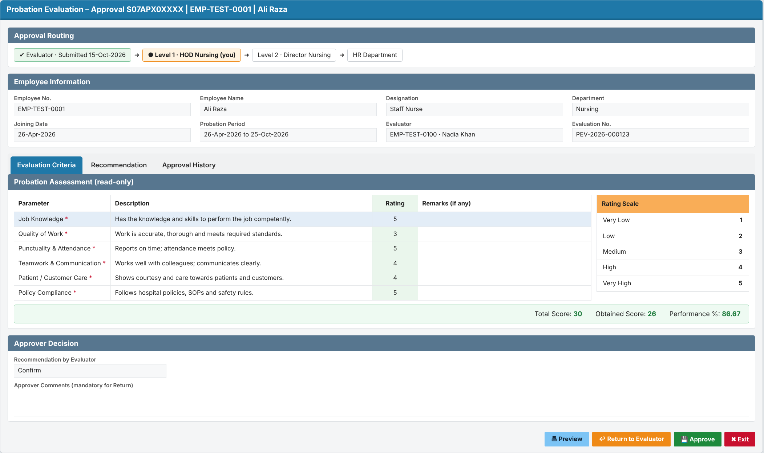
Screen 5 – Probation Approval Hierarchy Setup (HR Administrator)
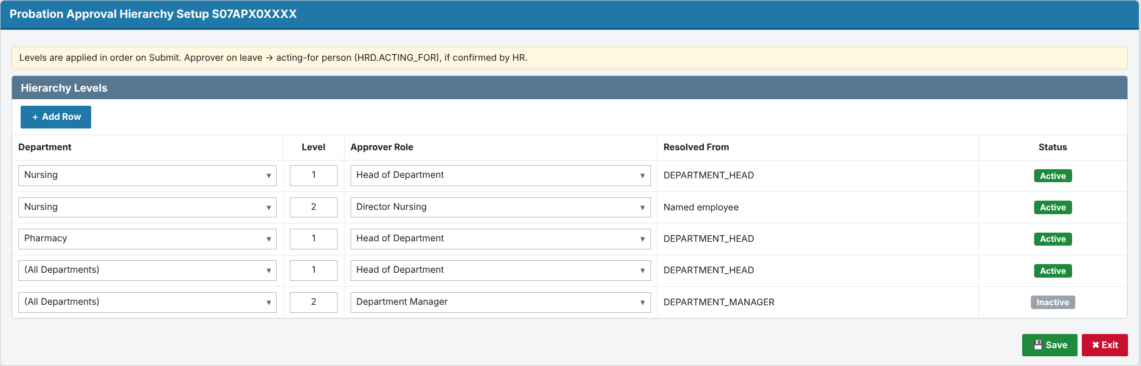

3.3.2 Detailed functional requirements

FR-011 Route to configured approval hierarchy
Description: The system shall route a submitted evaluation to the first level of the approval hierarchy configured for probation evaluations, resolving the approver for that level from the evaluated employee's department as on the submission date (changed in v0.2, RV-12; pending Q-16). Priority: Must Source: M-06 Business rules: RULE-06, RULE-09 Acceptance criteria:
- AC1: Given a configured hierarchy of Level 1 = HOD and Level 2 = Director, when an evaluation for an employee in Department D-TEST is submitted, then it appears in the D-TEST HOD's approval queue and the status shows Pending Approval – Level 1.
- AC2 (negative): Given a hierarchy level whose approver cannot be resolved, when the evaluation reaches that level, then it is placed on the HR exception list with the reason "Approver not defined for level n" and is not lost.
Notes / open questions: Q-15 (is there an existing approval hierarchy setup), Q-16 (hierarchy basis).

FR-012 Approve at a level
Description: The system shall allow the approver at the current level to approve the evaluation, with optional comments, and move it to the next configured level. Priority: Must Source: M-06 Business rules: RULE-06 Acceptance criteria:
- AC1: Given an evaluation at Level 1 of a 2-level hierarchy, when the Level 1 approver approves, then it moves to the Level 2 approver's queue and leaves the Level 1 queue.
- AC2 (negative): Given an evaluation at Level 2, when the Level 1 approver tries to approve it again, then the action is not available.
Notes / open questions: -

FR-013 Return evaluation to evaluator
Description: The system shall allow an approver to return an evaluation to the evaluator with mandatory comments. Priority: Should Source: M-06 (Inferred) Business rules: RULE-08 Acceptance criteria:
- AC1: Given an evaluation at any level, when the approver returns it with comments, then the status becomes Returned and it appears in the evaluator's queue with the comments shown.
- AC2 (negative): Given the approver leaves the comments empty, when they click Return, then the action is refused.
Notes / open questions: Q-07 (return vs reject, and where a re-submission restarts).

FR-014 Prevent self-approval
Description: The system shall prevent a user from approving an evaluation in which they are the evaluated employee or the evaluator. Priority: Must Source: M-06 (Inferred) Business rules: RULE-09 Acceptance criteria:
- AC1: Given the evaluator is also the resolved Level 1 approver, when the evaluation is submitted, then it moves to the next level and the history records "Skipped: approver is evaluator". If there is no next level, it is placed on the HR exception list (changed in v0.2, RV-06).
- AC2 (negative): Given the evaluated employee is a resolved approver, when routing runs, then the evaluation is never placed in that employee's queue.
Notes / open questions: Q-16.

3.4 Requirement 4: Automatic routing of the completed evaluation to HR
Description: When the last approval level approves, the system shall route the completed evaluation to the HR Department queue automatically. HR shall be able to process it and close it.
- HR sees the complete evaluation, the recommendation and the full approval trail.
- HR records the outcome (Confirm / Extend, per HR policy) and closes the evaluation (status Completed).
- Important (from the HRD code): the probation record (HRD.EMPLOYEE_PROBATION_HISTORY.PROBATION_STATUS) is set to Confirmed ('C') only at this HR step. Setting 'C' automatically:
- sets HRD.INFORMATION.CONFIRMATION_DATE;
- creates incentive/allowance queue entries;
- clears the HR probation alert.
- An extension updates the probation period instead (reason from HRD.PROBATION_REASONS).
- To be confirmed with HR:
- Does "after submission" mean after final approval (assumed here), or should HR see it as soon as the supervisor submits?
- Does this replace the current alert 001 / form S07FRM00362 process?
Acceptance (summary):
- After the last-level approval, the evaluation appears in the HR queue with status Forwarded to HR.
- HR cannot process an evaluation that is still pending approval.
- Confirmation date and incentives change only after HR confirms.
Traceability: FR-015, FR-016, RULE-07, IMP-15, IMP-34.

3.4.1 Prototype (GUI): HR queue and decision
Screen 6 – HR queue of completed evaluations
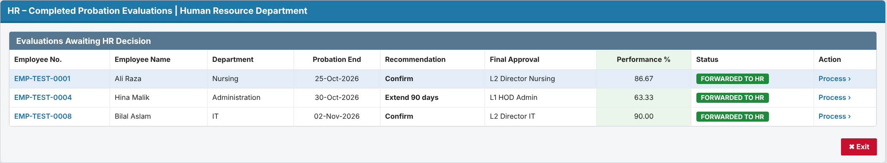
Screen 7 – HR Finalization (Confirm / Extend)
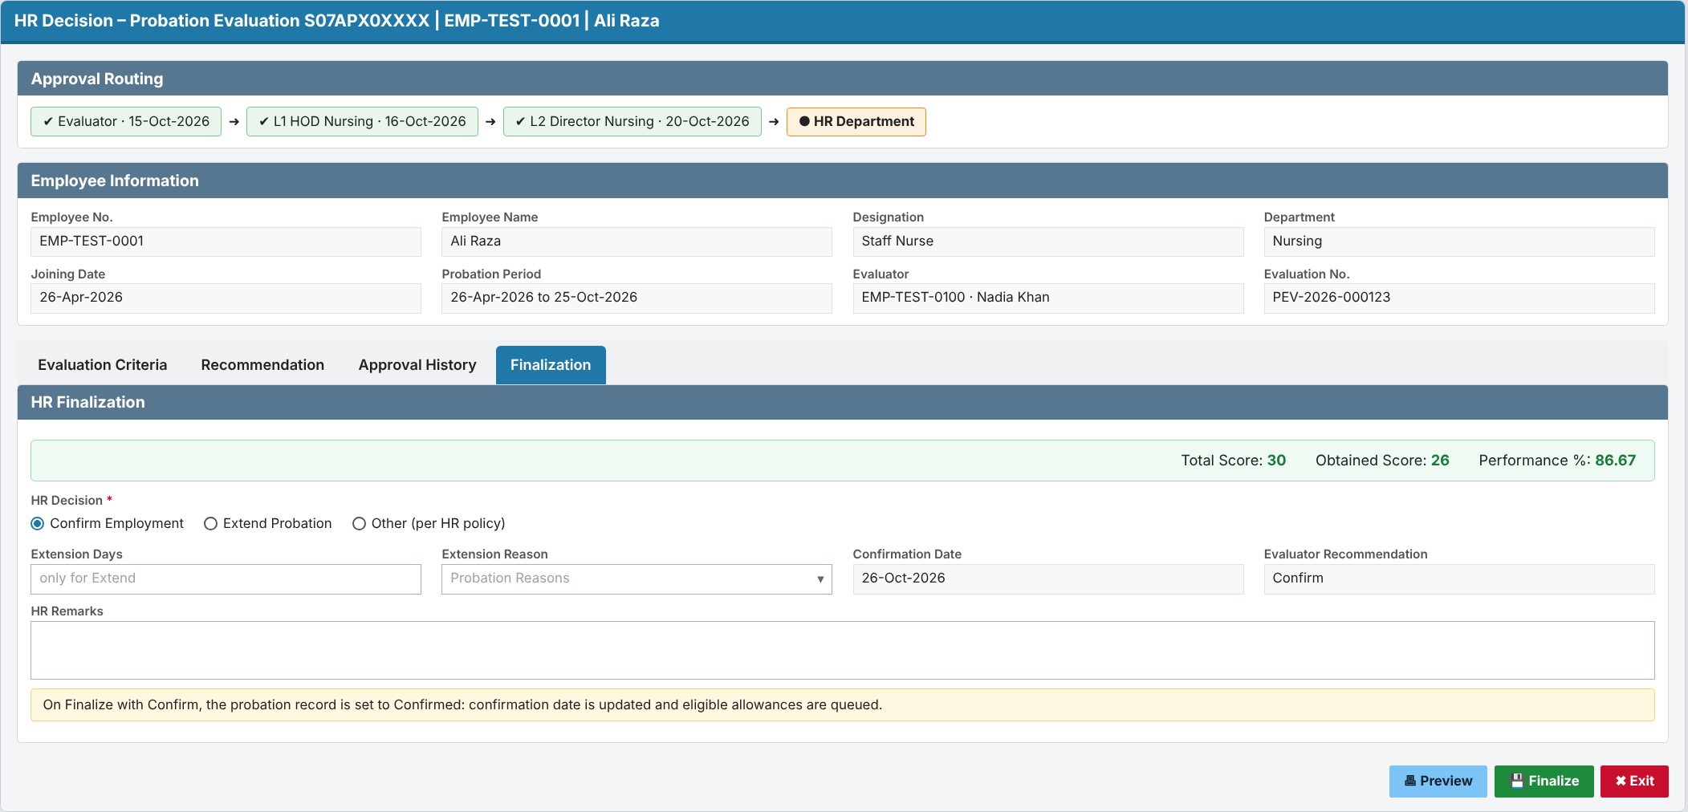

3.4.2 Detailed functional requirements

FR-015 Forward completed evaluation to HR
Description: The system shall automatically route the evaluation to the HR Department queue when the last level of the approval hierarchy approves it. Priority: Must Source: M-07 Business rules: RULE-07 Acceptance criteria:
- AC1: Given an evaluation at the last configured level, when that approver approves, then the evaluation appears in the HR Department queue and the status becomes Forwarded to HR.
- AC2 (negative): Given an evaluation still at an intermediate level, when HR views its queue, then the evaluation is not in HR's actionable queue (only on the monitoring view, FR-017).
Notes / open questions: Q-06, Q-17 ("after submission" timing).

FR-016 HR closes evaluation
Description: The system shall allow an HR user to mark a forwarded evaluation as processed, which completes the evaluation. Priority: Must Source: M-07, M-08 Business rules: RULE-08 Acceptance criteria:
- AC1: Given an evaluation Forwarded to HR, when an HR user marks it as processed, then the status becomes Completed and it leaves the HR queue.
- AC2 (negative): Given an evaluation in Pending Approval, when an HR user tries to mark it processed, then the action is not available.
Notes / open questions: Q-06 (HR actions and outcome values).

3.5 Requirement 5: Automatic status update throughout the workflow
Description: The system shall update the evaluation / probation request status automatically at every workflow event. Users cannot edit the status by hand. Every change is kept in an insert-only history.
- Status values (proposed): Evaluation Pending → Draft → Pending Approval – Level n → Returned → Forwarded to HR → Completed, plus Cancelled.
- History records the old status, new status, action, comments, user and date-time.
- HR has a monitoring screen of all evaluations, with filters by status, department, evaluator and end date. It flags evaluations as overdue when they are not with HR by the probation end date.
- Supervisors and approvers see the status of their own items.
Acceptance (summary):
- Submitting a Draft changes the status to Pending Approval – Level 1 with no manual step.
- The history shows each step in time order.
- No user can edit or delete history.
Traceability: FR-017 – FR-020, RULE-08, RULE-10, NFR-AUD-01/02.

3.5.1 Prototype (GUI): Monitoring and status history
Screen 8 – Probation Evaluation Monitoring and status history (HR)
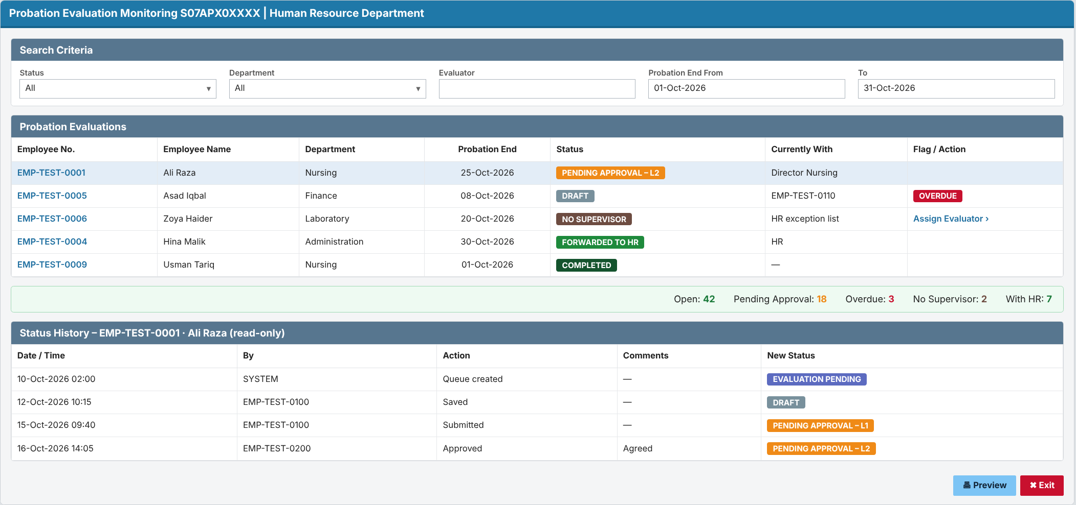

3.5.2 Detailed functional requirements

FR-017 Automatic probation request status update
Description: The system shall update the probation request status automatically at each workflow event: queue generated, saved as draft, submitted, approved at a level, returned, forwarded to HR, completed and cancelled. Priority: Must Source: M-08 Business rules: RULE-08 Acceptance criteria:
- AC1: Given an evaluation in Draft, when the evaluator submits it, then the probation request status changes to Pending Approval – Level 1 with no manual step.
- AC2: Given each event in the list, when it occurs, then the status changes to the value defined in RULE-08.
- AC3 (negative): Given a user tries to change the status directly (not through a workflow action), then the system does not allow it.
Notes / open questions: Q-09 (status values).

FR-018 Status history
Description: The system shall record every status change of a probation evaluation with old status, new status, action, comments, user and date-time. Priority: Must Source: M-08 Business rules: - Acceptance criteria:
- AC1: Given an evaluation that has gone through Draft, Submit and Level 1 approval, when an HR user views its history, then three entries are shown in time order with user and date-time.
- AC2 (negative): Given any user, when they try to edit or delete a history entry, then the action is not available.
Notes / open questions: -

FR-019 Probation evaluation monitoring view
Description: The system shall provide HR users with a list of all probation evaluations, filterable by status, department, evaluator and probation end date range. Priority: Should Source: M-08 (Inferred) Business rules: - Acceptance criteria:
- AC1: Given evaluations in several statuses, when an HR user filters by status "Pending Approval", then only those evaluations are listed with their current level and approver.
- AC2 (negative): Given a supervisor without the HR role, when they try to open the monitoring view, then access is denied.
Notes / open questions: -

FR-020 Overdue flag
Description: The system shall flag an evaluation as overdue when it is not Forwarded to HR or Completed by the probation end date. Priority: Should Source: M-02 (Inferred) Business rules: RULE-10 Acceptance criteria:
- AC1: Given an evaluation in Draft on the day after the probation end date, when HR opens the monitoring view, then the evaluation is shown as overdue.
- AC2 (negative): Given an evaluation Forwarded to HR before the probation end date, then it is never flagged overdue.
Notes / open questions: Q-18 (escalation and reminders).

4. Non-functional Requirements
ID | Category | Requirement | Measure / target | Source | Status
NFR-SEC-01 | Security | Access to evaluation, approval, HR and configuration functions is controlled by APEX authorization schemes per the access matrix (§5.3). | 100% of pages/actions protected; verified by role tests | Inferred | Proposed (not discussed in meeting)
NFR-SEC-02 | Security | Evaluation content (employee personal/performance data) is visible only to the evaluated employee's evaluator, the approvers in its routing path and HR. | No other user can see content via page, report or URL change | Inferred | Proposed (not discussed in meeting)
NFR-AUD-01 | Audit | Every evaluation record stores created by/on and modified by/on. | All rows | Inferred | Proposed (not discussed in meeting)
NFR-AUD-02 | Audit | Status history (FR-018) is retained and cannot be modified by any application user. | Insert-only | M-08 | Discussed
NFR-PERF-01 | Performance | The daily queue generation process completes for the full active employee population. | ≤ 5 minutes for up to 15,000 active employees | Inferred | Proposed (not discussed in meeting)
NFR-PERF-02 | Performance | Queue, evaluation and monitoring pages load quickly. | ≤ 3 s (95th percentile, hospital LAN, up to 1,000 open evaluations) | Inferred | Proposed (not discussed in meeting)
NFR-AVL-01 | Availability | If the daily process does not run on a day (outage), the next run picks up all employees missed. | No employee missed after a gap of up to 7 days | Inferred | Proposed (not discussed in meeting)
NFR-AVL-02 | Availability | Deployment needs no downtime of the existing HR application beyond a normal release window. | Within standard release window | Inferred | Proposed (not discussed in meeting)
NFR-DAT-01 | Data retention | Evaluations and history are retained as part of the employee's HR record and are not deleted by the application. | Per HR record-retention policy (Q-19) | Inferred | Proposed (not discussed in meeting)
NFR-DAT-02 | Data quality | At most one active evaluation exists per employee per probation period. | Enforced by the system (RULE-03) | Inferred | Proposed (not discussed in meeting)
NFR-DAT-03 | Data quality | The system rejects a save or workflow action on an evaluation that another user changed after it was opened, with the message "This evaluation was changed by another user. Reload and try again." A repeated Submit or Approve has no further effect (added in v0.2, RV-09). | 0 lost updates; 0 duplicate approvals in concurrency tests | Inferred | Proposed (not discussed in meeting)
NFR-USA-01 | Usability | Evaluation form usable on standard hospital desktop browsers and tablet width; English UI. | Chrome/Edge current versions; ≥ 768 px width | Inferred | Proposed (not discussed in meeting)
NFR-USA-02 | Usability | Unsaved changes warning when leaving the evaluation page. | Warning shown on navigation away with unsaved data | Inferred | Proposed (not discussed in meeting)
NFR-CMP-01 | Compliance | Workflow follows SKMCH HR probation policy (lead time, approval levels, HR outcome) and applicable labour law on probation. | HR sign-off of status model and rules | Inferred | Proposed (not discussed in meeting)
NFR-INT-01 | Integration | Employee, probation end date, supervisor and department are read from the HRD employee master in real time (no duplicated master data). | No copied master data except snapshot at queue generation | Inferred | Proposed (not discussed in meeting)
NFR-OPS-01 | Operations | The daily process logs start, end, employees processed and errors, and failures are visible to IT support. | Log entry every run; failure alert to IT support | Inferred | Proposed (not discussed in meeting)
NFR-OPS-02 | Operations | E-mail / in-app notifications are sent when a queue item is assigned to a user. A notification failure does not block the workflow action, and failures are logged and visible to IT support (changed in v0.2, RV-13). | Within 15 minutes of assignment | Inferred | Proposed (not discussed in meeting) (Q-18)

5. Business Rules, Data and Access

5.1 Business rules
ID | Rule | Applies to (FR) | Source
RULE-01 | Trigger date = probation end date − 15 calendar days. An employee is picked up on the first daily run on or after the trigger date and before the probation end date. | FR-001 | M-02 (calendar vs working days, Q-01)
RULE-02 | The evaluator is the employee's respective supervisor on record on the trigger date. If none is on record, the evaluation goes to the HR exception list. | FR-002, FR-005, FR-006 | M-03
RULE-03 | Only one active evaluation per employee per probation period. | FR-001, FR-003 | Inferred
RULE-04 | A Draft is never routed and is visible only to the evaluator. | FR-008 | M-04
RULE-05 | Mandatory-field validation applies on Submit only, not on Save as Draft. | FR-008, FR-009 | M-04, M-05
RULE-06 | A submitted evaluation passes through the configured hierarchy levels in order; the hierarchy in effect at submission time applies to that evaluation. | FR-011, FR-012 | M-06
RULE-07 | The evaluation goes to HR after approval at the last configured level (assumption A-02; Q-17). | FR-015 | M-07
RULE-08 | Allowed status transitions (proposed, Q-09): Evaluation Pending → Draft → Pending Approval – Level n → (Pending Approval – Level n+1 | Returned | Forwarded to HR); Returned → Draft/Pending Approval – Level 1; Forwarded to HR → Completed; any status before Forwarded to HR → Cancelled. No other transition is allowed. | FR-004, FR-010, FR-013, FR-016, FR-017 | M-08
RULE-09 | A user may not approve an evaluation in which they are the evaluated employee or the evaluator; such a level is skipped and the evaluation moves to the next level, with the reason recorded in history; if there is no next level, the evaluation goes to the HR exception list (changed in v0.2, RV-06; proposed, Q-16). | FR-011, FR-014 | Inferred
RULE-10 | An evaluation not Forwarded to HR or Completed by the probation end date is overdue. | FR-020 | Inferred

5.2 Data requirements
Data item | Business meaning | Mandatory | Validation / format | Example (synthetic) | Related FR
Evaluation number | Unique reference of the evaluation | Yes (system) | System generated | PEV-2026-000123 | FR-002
Employee | Employee being evaluated | Yes (system) | Must be on probation at generation | EMP-TEST-0001 | FR-001, FR-002
Probation start / end date | Probation period evaluated | Yes (system) | From employee record; end ≥ start | 26-Apr-2026 / 25-Oct-2026 | FR-001
Evaluator | Assigned supervisor | Yes | Active employee, not the evaluated employee | EMP-TEST-0100 | FR-002, FR-006
Evaluation criteria and ratings | Performance assessment | Yes on Submit | Per HR form design (Q-05) | Punctuality: 4 / 5 | FR-008, FR-009
Evaluator recommendation | Confirm / Extend / Terminate (values to be confirmed) | Yes on Submit | From LOV (Q-05) | Confirm | FR-009
Evaluator comments | Free-text remarks | Q-05 | Max 4,000 characters | "Meets expectations." | FR-009
Current status | Workflow status of the probation request | Yes (system) | RULE-08 values | Pending Approval – Level 1 | FR-017
Current approval level / approver | Where the evaluation is now | Yes when pending approval | From hierarchy | Level 1 / EMP-TEST-0200 | FR-011
Approver action and comments | Decision at a level | Action yes; comments mandatory on Return | Approve / Return | Return – "Add training needs." | FR-012, FR-013
Status history entry | Audit of each status change | Yes (system) | Insert-only | Draft → Pending Approval – L1, EMP-TEST-0100, 15-Oct-2026 10:22 | FR-018
Approval hierarchy configuration | Ordered levels and approver role per level | Yes | At least one level | L1 = HOD, L2 = Director | FR-011

5.3 User roles and access matrix
Function / screen | Evaluator (supervisor) | Approver | HR User | HR Administrator | Evaluated employee
Daily queue generation (system) | - | - | - | - | -
My queue (evaluations / approvals) | R | R | R | R | -
Evaluation form – edit (Draft / Submit) | C R U | - | - | - | - (Q-20)
Evaluation form – view submitted (changed in v0.2, RV-10) | R | R (own path) | R | R | - (Q-20)
Approve / Return | - | R A | - | - | -
HR queue – mark processed | - | - | R U | R U | -
Reassign evaluator / HR exception list | - | - | R | R U | -
Monitoring view and history | R (own) | R (own path) | R | R | -
Approval hierarchy configuration | - | - | R | C R U D | -

5.4 Reports and notifications
Report / notification | Audience | Trigger / frequency | Content | Related FR
New evaluation assigned (proposed) | Evaluator | Queue item created or reassigned | Employee, probation end date, link | FR-002, FR-006, NFR-OPS-02
Pending approval (proposed) | Approver at current level | Evaluation reaches the level | Employee, evaluator, link | FR-011, FR-012
Evaluation returned (proposed) | Evaluator | Return action | Approver comments, link | FR-013
Evaluation forwarded to HR (proposed) | HR Department | Last-level approval | Employee, recommendation, link | FR-015
Probation evaluation monitoring view | HR | On demand | All evaluations by status, overdue flag | FR-019, FR-020
Reminder / escalation before end date | Evaluator, approver, HR | To be defined (Q-18) | Pending items nearing end date | FR-020

6. System Interfaces

6.1 Hardware Interfaces
Interface | Detail
End-user devices | Existing hospital desktops/laptops with a supported browser (Chrome / Edge). The screens also work at tablet width (768 px and above). No new hardware is needed.
Servers | Existing Oracle Database and APEX/ORDS application servers. No new server. The daily job runs on the existing database scheduler.
Mail server | The existing hospital SMTP mail server sends the notification e-mails. No change.
Biometric / RFID devices | Not applicable. Attendance devices are not involved.
Printers | Optional: print/PDF of the completed evaluation on existing printers.

6.2 Software Interfaces
System / object | Direction | Data exchanged | Purpose | Related requirement
HRD employee master HRD.INFORMATION | Read | Employee no. (MRNO), name, department, designation, joining date, supervisor (MANAGER_MRNO), active status | Who is on probation and who evaluates them | R1, R2
Probation record HRD.EMPLOYEE_PROBATION_HISTORY (+ F_PROBATION_END_DATE, F_PROBATION_YN) | Read / Write (HR step only) | Probation start/end date, PROBATION_STATUS ('C' = Confirmed), period, reason | Eligibility; final confirm/extend | R1, R4, R5
Department setup DEFINITIONS.DEPARTMENT | Read | Department head / manager | Resolving approvers | R3
Approval engine PA_HIERARCHY, PA_PERFORM_APPRAISER, PKG_PERFORMANCE_APPRAISAL (recommended reuse) | Read / Write | Levels, routing, approve/return | Approval hierarchy | R3
Delegation HRD.ACTING_FOR | Read | Acting-for person and leave dates | Approver on leave | R3
Pending-task framework HRD.PKG_PENDING_TASKS / APEX inbox | Write | Queue counts and items per user | Supervisor, approver and HR queues | R1, R3, R4
Alerts / e-mail HRD.ALERTS, HRD.ALERT_RECIPIENTS, PKG_HR_ALERTS | Write | Notification e-mails | Assignment, return and forwarded-to-HR notifications | R1, R3, R4
Existing probation process: alert 001 (HR_ALERT_QUEUE), form S07FRM00362 (PKG_S07FRM00362, EVALUATION_ALERT_QUEUE) | Replace / integrate (HR to decide) | Probation alerts and confirm/extend decision | Avoid duplicate queues and decisions | R1, R4
Payroll / incentives (PKG_EMP_INCENTIVE, EMP_INCENTIVE_QUEUE via trigger) | Indirect (triggered on confirmation) | Allowance / incentive queue entries | Starts automatically only when HR confirms | R4
Oracle APEX | UI | All screens above | User interface | R1 – R5

Interface summary (from SRS)
System | Direction (in/out) | Data exchanged | Frequency | Related FR
HRD employee master / posting (same schema) | In | Employee status, probation dates, supervisor, department | Daily process and on page load | FR-001, FR-002, FR-007
E-mail (existing HRD mail mechanism, to be confirmed) | Out | Notifications in §5.4 | Event-driven | NFR-OPS-02
Payroll / ERP | Not applicable: HR's downstream action on confirmation is out of scope | - | - | -

7. Impact Analysis
Schema context used (changed in v0.3): (1) the full DDL exports supplied by the user on 09-Oct-2026: `HRD_SCHEMA.txt`, `DEFINITIONS_SCHEMA.txt`, `PAYROLL_SCHMA.txt`, `HIS.txt`, `REGISTRATION.txt` (tables, triggers, views, package specs **and bodies**); (2) the schema summary `schema/skm/*.md`. "Code-verified" below means the package body or trigger source was read. APEX applications are **not** in the export, so APEX pages stay `Likely` or `PROVISIONAL`.
Key finding (v0.3): HRD already has most of the building blocks this CR needs: a probation record with status (HRD.EMPLOYEE_PROBATION_HISTORY), a probation-expiry pending task (HRD.PKG_PENDING_TASKS.PROBATION_EXPIRE_QUEUE), an evaluation alert/confirmation queue (HRD.EVALUATION_ALERT_QUEUE, HRD.EMPLOYEE_EVALUATION_HISTORY), an acting-for/delegation table (HRD.ACTING_FOR) and a configurable performance-appraisal engine with templates, hierarchy, multi-level routing, send-back and HR distribution (HRD.PA_*, HRD.PKG_PERFORMANCE_APPRAISAL). The design stage must decide between Option A: configure a new PA type "Probation Evaluation" on the existing PA engine and Option B: new probation-evaluation tables (IMP-16 to IMP-20). Q-26 records this.

7.1 Business impact
ID | Area / department / process | Impact | Related FR | Patient-safety relevant (Y/N)
IMP-01 | HR Department: probation management process | Manual tracking of due evaluations is replaced by the system queue and monitoring view. The SOP needs updating. The existing probation-expiry queue and evaluation alert process (IMP-22, IMP-28) change or are replaced. | FR-001, FR-015, FR-019 | N
IMP-02 | All departments: supervisors | New queue task 15 days before each subordinate's probation end. Training and communication needed. | FR-002, FR-008, FR-009 | N
IMP-03 | Approvers (HODs and above) | New approval items in their queue. If Option A is chosen, they appear alongside performance appraisals. | FR-011, FR-012 | N
IMP-04 | Clinical departments | Indirect only: probation outcomes for clinical staff affect staffing. No clinical data is involved. | FR-015 | N (indirect staffing only)
IMP-34 | Payroll / incentives | Code-verified: setting EMPLOYEE_PROBATION_HISTORY.PROBATION_STATUS = 'C' (Confirmed) fires EMP_INCENTIVE_QUEUE, which calls PKG_EMP_INCENTIVE.P_INS_QUEUE for each eligible allowance, and EMP_PROBATION_HISTORY_INFO_UPD, which sets INFORMATION.CONFIRMATION_DATE = END_DATE + 1. Writing 'C' anywhere except the HR completion step would confirm the employee and start incentives early (added in v0.3). | FR-016, FR-017 | N

7.2 System impact
ID | Application / page / package / report / job / interface | Change type | Description | Related FR | Evidence | Confidence
IMP-05 | Pending-task (queue) framework HRD.PKG_PENDING_TASKS and the APEX inbox page that shows it | Modify | Add a probation-evaluation queue procedure that follows the framework's standard signature (P_USER_MRNO, P_ACTING_FOR, P_OBJECT_CODE, P_PROCESS_ID, P_TERMINAL, P_EVENT, P_ASSIGNMENT_ID), as TRAINING_EXPIRE_QUEUE, CONTRACT_EXPIRE_QUEUE and PROBATION_EXPIRE_QUEUE do. The inbox APEX page is not in the export. (changed in v0.3) | FR-002, FR-007, FR-011 | HRD_SCHEMA.md: PKG_PENDING_TASKS spec | Confirmed in schema (package spec); APEX page Likely
IMP-06 | APEX page "Probation Evaluation" | NEW (proposed) or reuse PA template page | Option A: a PA template whose PA_DEF_TEMPLATE.APEX_OBJECT_CODE points to the evaluation page. Option B: a new page. Either way the page has Save as Draft / Submit, approval actions and a history region. | FR-007 – FR-014, FR-018 | HRD_SCHEMA.md: PA_DEF_TEMPLATE | Likely
IMP-07 | APEX page "Probation Evaluation Monitoring" | NEW (proposed) | HR list with filters, overdue flag, exception list and reassignment. | FR-005, FR-006, FR-016, FR-019, FR-020 | None (APEX not in export) | PROVISIONAL – not verified
IMP-08 | Approval hierarchy setup | Reuse (Option A) / NEW (Option B) | Option A: the PA hierarchy setup (HRD.PA_HIERARCHY) and its existing setup screen. Option B: a new setup page. (changed in v0.3) | FR-011 | HRD_SCHEMA.md: PA_HIERARCHY | Confirmed in schema (table); page Likely
IMP-09 | Package HRD.PKG_PROBATION_EVALUATION | NEW (proposed) | Orchestration: queue generation (P_GENERATE_EVAL_QUEUE), save, submit, status update and history. Under Option A it calls PKG_PERFORMANCE_APPRAISAL for routing. | FR-001 – FR-018 | None (new) | NEW (proposed)
IMP-10 | Daily queue-generation job | NEW (proposed) or configure the alert framework | Either a new DBMS_SCHEDULER job, or a row in HRD.ALERTS (EXECUTION_UNIT, EXECUTE_JOB, PENDING_QUEUE, DAY_GAP) using the existing alert job. (changed in v0.3) | FR-001, NFR-AVL-01, NFR-OPS-01 | HRD_SCHEMA.md: ALERTS | Confirmed in schema (table)
IMP-11 | HRD.PKG_PERFORMANCE_APPRAISAL | Read-only / reuse (Option A) | Existing routing and finalisation: SET_HIERARCHY, SET_EMP_PERFORM_HIERARCHY, P_UPDATE_QUEUE, P_FINALIZE_APPRAISAL, SET_ROUTING_AS_PREVIOUS (send back), SET_ROUTING_AS_LEAVE / SET_EMP_ROUTING_AS_LEAVE (approver on leave), MOVE_TO_DEPARTMENT. (changed in v0.3) | FR-011 – FR-015 | HRD_SCHEMA.md: package spec | Confirmed in schema (package spec)
IMP-12 | APEX authorization schemes | NEW / Modify | Checks for Evaluator, Approver, HR User and HR Administrator. | NFR-SEC-01 | None (APEX not in export) | PROVISIONAL – not verified
IMP-13 | E-mail notifications | Read-only / configure | Existing alert e-mail configuration in HRD.ALERTS (SUBJECT, MAIL_TO_DEPT_HEAD) and HRD.ALERT_RECIPIENTS. Trigger SEND_EMAIL_SUBSTITUTE on ACTING_FOR shows an e-mail mechanism exists. (changed in v0.3) | NFR-OPS-02 | HRD_SCHEMA.md: ALERTS, ALERT_RECIPIENTS, ACTING_FOR | Confirmed in schema (tables); mail package Likely
IMP-22 | Existing probation-expiry alert: alert '001' in HRD.ALERTS, generated by PKG_HR_ALERTS.JOB_HR_ALERTS / GENRATE_EMAIL_ALERT / P_ALERT_QUEUE into HRD.HR_ALERT_QUEUE; counted for HR users only by PKG_PENDING_TASKS.PROBATION_EXPIRE_QUEUE (rights check PKG_HR_ALERTS.F_CHECK_HR_ALERT_RIGHTS); removed by trigger TR_PROBATION_EXPIRE_QUEUE_DEL (via PKG_HR_ALERTS.P_DEL_ALERT_QUEUE) when PROBATION_STATUS becomes 'C' | Modify / Retire (TO BE DECIDED) | The current process alerts HR, not the supervisor. The new supervisor queue either replaces alert 001 or runs alongside it as an HR monitoring alert (Q-24). Code-verified. (added in v0.3) | FR-001, FR-002, FR-003, FR-019 | HRD_SCHEMA.txt: PKG_HR_ALERTS body, PKG_PENDING_TASKS body, trigger source | Confirmed in schema (code-verified)
IMP-23 | Probation functions (code-verified: F_PROBATION_END_DATE = MAX(END_DATE) from EMPLOYEE_PROBATION_HISTORY; F_PROBATION_YN delegates to PKG_COMMON.F_CHECK_EMP_PROBATION_STATUS): HRD.F_PROBATION_END_DATE(P_MRNO), HRD.F_PROBATION_YN, HRD.F_PROBATION_CURRENT_STATUS(P_MRNO, P_EVENT), HRD.F_GET_PROBATION_PERIOD_DAYS, PKG_COMMON.F_CHECK_EMP_PROBATION_STATUS / F_CHECK_EMP_PROBATION | Read-only (reuse) | Reuse F_PROBATION_END_DATE and F_PROBATION_YN for RULE-01 and the eligibility check, so the end date is computed the same way everywhere. (added in v0.3) | FR-001, FR-004 | HRD_SCHEMA.md: function headers, PKG_COMMON spec | Confirmed in schema (signatures)
IMP-24 | Code that reads EMPLOYEE_PROBATION_HISTORY (from package bodies): PKG_COMMON, PKG_EMPLOYEE_INFO, PKG_EMP_INCENTIVE, PKG_HR_ALERTS, PKG_HR_DOCUMENT_RECORD, PKG_HR_EMPLOYEE_RECORD, LEAVE_AUTOMATION, EMAILS; functions F_PROBATION_CURRENT_STATUS, F_GET_PROBATION_PERIOD_DAYS; view V_HR_EMP_DOCUMENTS | Read-only (regression) | Leave rules, incentive and HR-document logic read probation status. They need regression testing if status values or write timing change. (added in v0.3) | FR-017 | HRD_SCHEMA.txt: package bodies | Confirmed in schema (code-verified)
IMP-25 | PA views HRD.VU_PA_PERFORM_QUEUE, HRD.VU_PA_ROUTING, HRD.VU_PERFORM_VAL_RATING, HRD.V_EMP_PROMOTION_REPORT and PKG_HR_PA_PENDING_TASK.APPRAISAL_PERFORMANCE_QUEUE | Modify / regression (Option A only) | These read PA_PERFORM_APPRAISER / PA_HIERARCHY. Under Option A, probation evaluations would appear in appraisal queues and reports unless they are filtered by PA type. (added in v0.3) | FR-011, FR-019 | HRD_SCHEMA.md: view SQL, package spec | Confirmed in schema
IMP-26 | View HRD.V_HR_EMP_DOCUMENTS | Read-only (regression) | Reads EMPLOYEE_EVALUATION_HISTORY and EMPLOYEE_EVALUATION_ATTACHMENT (source EMPLOYEE_EVALUATION_HISTORY_PROB). It is affected if these tables are reused. (added in v0.3) | FR-015, FR-018 | HRD_SCHEMA.md: view SQL | Confirmed in schema

7.3 Database impact
ID | Table / column / object | Change type | Description | Dependent objects | Data migration | Related FR | Evidence | Confidence
IMP-14 | HRD.INFORMATION: MRNO (VARCHAR2(14), PK), MANAGER_MRNO, DEPARTMENT_ID, SECTION_ID, DESIGNATION_ID, JOINING_DATE, PROBATION_PERIOD_DAYS (NUMBER(3)), CONFIRMATION_DATE, ACTIVE (H/Y/N) | Read-only | Employee master. It is the source of eligibility and of the evaluator (MANAGER_MRNO, "manager code of employee", pending Q-04). (changed in v0.3) | Triggers CURRENT_EMPLOYEE_UPDATE, INFORMATION_*; view HRD.V_INFORMATION | None | FR-001, FR-002, FR-007 | HRD_SCHEMA.md ### HRD.INFORMATION | Confirmed in schema
IMP-15 | HRD.EMPLOYEE_PROBATION_HISTORY: PK (MRNO, START_DATE), END_DATE, PROBATION_PERIOD, PROBATION_REASON_ID, PROBATION_STATUS VARCHAR2(1) default 'P' | Read / Modify (status) | Probably the "probation request" (Q-03). It holds one row per probation period, so it can identify the period (RULE-03). Writes to PROBATION_STATUS fire triggers. To avoid side effects (IMP-34), PROBATION_STATUS should change only at HR completion, and the intermediate workflow status should be kept in the evaluation record (Q-25). (changed in v0.3) | Triggers EMP_INCENTIVE_QUEUE (after update of PROBATION_STATUS), EMP_PROBATION_HISTORY_INFO_UPD (after update), TR_PROBATION_EXPIRE_QUEUE_DEL; FK to INFORMATION; EMPLOYEE_PROBATION_ATTACHMENT | Map the existing status values (Q-09) | FR-001, FR-003, FR-017 | HRD_SCHEMA.md ### HRD.EMPLOYEE_PROBATION_HISTORY | Confirmed in schema
IMP-16 | Evaluation header: Option A HRD.PA_PERFORM_MASTER (PA_PERFORM_STATUS_ID, RESEARCH_DATA_STATUS 'F' = HR queue) + HRD.PA_HIERARCHY (APPRAISEE_MRNO, PA_TYPE_ID, HR_DISTRIBUTE); Option B HRD_PROBATION_EVAL_MST NEW (proposed) | Reuse / NEW | One record per evaluation. Under Option A, a link to EMPLOYEE_PROBATION_HISTORY (MRNO, START_DATE) is still needed: either a new column or a small link table (Q-26). (changed in v0.3) | IMP-25 views | Go-live backlog (Q-10) | FR-002 – FR-017 | HRD_SCHEMA.md PA_PERFORM_MASTER, PA_HIERARCHY | Confirmed in schema (Option A objects)
IMP-17 | Evaluation content: Option A HRD.PA_DEF_TEMPLATE, PA_DEF_SECTION, PA_DEF_SECTION_PARAMETER, PA_DEF_RATING_VALUE, PA_PERFORM_SECTION_PARAM, PA_PERFORM_VAL_RATING; Option B HRD_PROBATION_EVAL_DTL NEW (proposed) | Reuse (configure data) / NEW | Criteria and ratings. Option A answers Q-05 by configuring a "Probation Evaluation" template. (changed in v0.3) | VU_PERFORM_VAL_RATING | Seed template data | FR-008, FR-009 | HRD_SCHEMA.md PA_* tables | Confirmed in schema (Option A objects)
IMP-18 | HRD_PROBATION_EVAL_HIS | NEW (proposed) | Insert-only status history. Needed under both options: PA keeps per-level status and value-text history, but not a full status history. | IMP-16 | None | FR-018, NFR-AUD-02 | None (new) | NEW (proposed)
IMP-19 | Approval levels: Option A HRD.PA_PERFORM_APPRAISER (APPRAISER_ROLE R=Recommend, A=Approve, F=Final, S=Send back; ORDER_BY; PA_STATUS_ID; EMPLOYEE_REIVEW); Option B HRD_PROBATION_APPROVAL_TRN NEW (proposed) | Reuse / NEW | Per-level actions and comments. The existing S role covers FR-013 (return). (changed in v0.3) | VU_PA_ROUTING, VU_PA_PERFORM_QUEUE | None | FR-011 – FR-014 | HRD_SCHEMA.md PA_PERFORM_APPRAISER | Confirmed in schema (Option A objects)
IMP-20 | Hierarchy definition: Option A HRD.PA_DEF_TYPE (new type row; PREVIOUS_ROUTING_HIERARCHY), HRD.PA_TYPE_PERIOD, HRD.PA_HIERARCHY; Option B HRD_PROBATION_HIERARCHY_MST NEW (proposed) | Reuse (configure) / NEW | Ordered approval levels. PA_TYPE_PERIOD is period-based (PA start/end and cut-off dates), while probation evaluations are rolling. The design must confirm that a rolling probation type fits (Q-26). (changed in v0.3) | PA_HIERARCHY FKs | Seed hierarchy | FR-011 | HRD_SCHEMA.md PA_DEF_TYPE, PA_TYPE_PERIOD | Confirmed in schema (Option A objects)
IMP-21 | Sequences and unique key on (MRNO, probation START_DATE) for the evaluation | NEW (proposed) | Keys and RULE-03 enforcement. Option A: PA keys are VARCHAR2 IDs built by PKG_PERFORMANCE_APPRAISAL.GET_PERFORM_ID / GET_HIERARCHY_ID. | IMP-16 | None | FR-003 | HRD_SCHEMA.md package spec | Likely
IMP-27 | Form package HRD.PKG_S07FRM00362 (P_GEN_EVALUATION_ALERT_QUEUE, P_INSERT_EVALUATION_DATA, P_DECISION, P_SEND_REMINDER, F_GET_EVALUATION_DATE; also FPPE HOD/proctor routing) with HRD.EVALUATION_ALERT_QUEUE (IS_CONFIRMED C/E/P/I, EXTENDED_DAYS, CONFIRMED_BY) and HRD.EMPLOYEE_EVALUATION_HISTORY (EVALUATION_STATUS C=Completed, E=Extend, P=Pending, I=In process; EVALUATION_TYPE → HRD.ALERTS) | Read / Modify / Retire (TO BE DECIDED) | An existing evaluation alert and confirmation mechanism, keyed by employee and alert type. Code-verified: PKG_S07FRM00362 (form S07FRM00362) generates the evaluation alert queue and records the confirm/extend decision, and PKG_HR_EMPLOYEE_RECORD reads the history. This is very likely today's evaluation/confirmation screen. It must be replaced or integrated, not duplicated (Q-24). Its C/E/P/I values are a natural basis for the HR outcome (Q-06). (added in v0.3) | V_HR_EMP_DOCUMENTS; EMPLOYEE_EVALUATION_ATTACHMENT | Possible migration of open rows | FR-015, FR-016, FR-017 | HRD_SCHEMA.txt: PKG_S07FRM00362 spec/body, table DDL | Confirmed in schema (code-verified)
IMP-28 | HRD.ACTING_FOR (EMP_MRNO, ACTOR_MRNO, LEAVE_FROM_DATE, LEAVE_TO_DATE, SUBSTITUTE_TYPE) and HRD.ACTING_FOR_USER_TASK_WISE | Read-only | Existing delegation while a superior is on leave. Use it for Q-21 (delegation); PKG_PENDING_TASKS procedures already take P_ACTING_FOR. (added in v0.3) | Trigger SEND_EMAIL_SUBSTITUTE | None | FR-011, FR-012 | HRD_SCHEMA.md | Confirmed in schema
IMP-29 | DEFINITIONS.DEPARTMENT: DEPARTMENT_HEAD, DEPARTMENT_MANAGER | Read-only | Approver resolution for an HOD level, and an alternative evaluator source (Q-04). (added in v0.3) | FK to HRD.INFORMATION (disabled) | None | FR-011 | DEFINITIONS_SCHEMA.md | Confirmed in schema
IMP-30 | HRD.ALERTS, HRD.ALERT_RECIPIENTS | Modify (configuration data) | New alert row(s) for the probation evaluation trigger and notifications, if the alert framework is used (IMP-10, IMP-13). (added in v0.3) | Alert job (not in export) | Seed rows | FR-001, NFR-OPS-02 | HRD_SCHEMA.md | Confirmed in schema
IMP-31 | HRD.PROBATION_REASONS | Read-only | Reason codes, for when HR extends probation (Q-08). (added in v0.3) | EMPLOYEE_PROBATION_HISTORY.PROBATION_REASON_ID | None | FR-003, FR-016 | HRD_SCHEMA.md | Confirmed in schema

Volume: one evaluation per probation period, roughly the number of new hires and extensions per year (A-05). Low growth.
Privacy note (v0.3): HRD.INFORMATION.MRNO has an FK to REGISTRATION.PATIENT(MRNO), so the employee code is also a patient record number. Evaluation screens and reports must not expose patient-registration data or link to it.

7.4 Risks
Risk | Likelihood | Impact | Mitigation
Intermediate workflow statuses written to EMPLOYEE_PROBATION_HISTORY.PROBATION_STATUS fire EMP_INCENTIVE_QUEUE and TR_PROBATION_EXPIRE_QUEUE_DEL early (incentive or salary change, lost expiry queue). | High if not designed for | High | Keep the workflow status in the evaluation record. Write PROBATION_STATUS = 'C' only when HR completes a confirmation; an extension updates END_DATE / adds a new period instead (Q-25). Run regression on IMP-24.
The new queue duplicates the existing PROBATION_EXPIRE_QUEUE / EVALUATION_ALERT_QUEUE, so supervisors get two items. | High | Medium | Decide replace or extend before design (Q-24).
Under Option A, probation evaluations leak into appraisal queues, scores and reports (IMP-25). | Medium | Medium | Filter by PA type in all PA views and packages, and run regression tests.
MANAGER_MRNO is incomplete or stale, so queues go to the wrong person or nobody. | Medium | High | HR exception list (FR-005), reassignment (FR-006), a data-quality report before go-live.
The daily job fails and nobody notices, so evaluations start late. | Low | High | Catch-up logic (NFR-AVL-01) and failure alerting (NFR-OPS-01).
Approvals stall at a level. | Medium | Medium | Overdue flag (FR-020), delegation via ACTING_FOR (Q-21), reminders (Q-18).
APEX pages and Oracle Forms (e.g. S07FRM00362) were not in the schema export, so screen-level dependencies are missed. | Medium | Medium | Export the APEX application and the form list, and re-run the screen dependency check before Gate 2.

8. Assumptions, Constraints and Dependencies

8.1 Assumptions
ID | Assumption | Needs confirmation from
A-01 | The current process is manual or not workflow-driven (As-Is in §1.3). | HR
A-02 | "After submission … routed to HR" means after final approval in the hierarchy, not immediately on the evaluator's Submit. | HR (Q-17)
A-03 | Proposed status values in RULE-08 are acceptable. | HR (Q-09)
A-04 | "15 days" means calendar days. | HR (Q-01)
A-05 | Evaluation volume is in the hundreds to low thousands per year. | HR
A-06 | Priorities not stated in the request are set as Must for the five points given and Should for inferred items. | SA / HR
A-07 | The workflow is built in the existing HRD APEX application and HRD schema. | SA
A-09 | The schema export (schema/skm/) reflects production. Package bodies and APEX pages were not included in it. (added in v0.3) | IT
A-08 | The active employee population is up to 15,000 (basis for NFR-PERF-01) (added in v0.2, RV-16). | HR / IT

8.2 Constraints
- Oracle Database / PL/SQL and Oracle APEX in the HRD schema, following HRD naming standards.
- No change to HR's downstream processes (confirmation, extension, termination) in this CR.

8.3 Dependencies
- HR to provide the evaluation form content (criteria, rating scale, recommendation values) (Q-05).
- HR to define the approval hierarchy levels for probation evaluations (Q-16).
- HRD schema snapshot to confirm the employee master, probation request and any existing workflow/queue objects (Q-03, Q-15).
- A later CR (payroll/benefits on confirmation) may consume the evaluation Completed event; not in this CR (added in v0.2, RV-19).

9. Open Points

9.1 Blocking points for HR
- Does "after submission" mean HR receives the evaluation after final approval (assumed here), or as soon as the supervisor submits?
- What are the approval hierarchy levels (by department or by grade)?
- Evaluation form content: what are the criteria, rating scale and recommendation values, and which fields are mandatory? Please share the current form.
- Who is the respective supervisor: MANAGER_MRNO, the department manager, or the HOD?
- Does this workflow replace the current alert 001 / form S07FRM00362 process?
- Are the 15 days calendar days or working days?
- Can an approver return the evaluation to the evaluator, and does approval then restart at Level 1?
- When an approver is on leave, should the evaluation go to the acting-for person?
The full list follows in 9.2.

9.2 Full list of open questions
ID | Question | Raised because (M-NN / FR) | Addressed to | Blocking?
Q-01 | Are the "15 days" calendar days or working days? If the trigger falls on a holiday, is the queue still generated that day? | M-02, FR-001 | HR | Yes
Q-02 | How is the probation evaluation done today (paper form, existing screen, e-mail)? | §1.3 | HR | No
Q-03 | Is HRD.EMPLOYEE_PROBATION_HISTORY (one row per probation period, PROBATION_STATUS default 'P') the "probation request"? What do its PROBATION_STATUS values mean? (changed in v0.3: table found in schema) | M-08, FR-017, IMP-15 | HR / IT | Yes
Q-04 | Is the "respective supervisor" HRD.INFORMATION.MANAGER_MRNO, or DEFINITIONS.DEPARTMENT.DEPARTMENT_MANAGER / DEPARTMENT_HEAD? (changed in v0.3: candidates found in schema) | M-03, FR-002, IMP-14, IMP-29 | HR / IT | Yes
Q-05 | What are the evaluation form fields, criteria, rating scale and recommendation values, and which are mandatory? Does it differ for clinical vs non-clinical staff? | FR-007, FR-009 | HR | Yes
Q-06 | What does HR do with the completed evaluation in the system: only acknowledge/close, or record a final decision (confirm / extend / terminate)? | M-07, FR-016 | HR | Yes
Q-07 | Can an approver return the evaluation to the evaluator, or reject it outright? After re-submission, does approval restart at Level 1? | M-06, FR-013 | HR | Yes
Q-08 | When probation is extended, should a new evaluation be generated 15 days before the new end date? | FR-003 | HR | No
Q-09 | Which probation request status values should be used (proposed list in RULE-08)? | M-08, FR-017 | HR | Yes
Q-10 | At go-live, should evaluations be created for employees whose probation end date is already within 15 days? | FR-001 | HR | No
Q-11 | Should an open evaluation be cancelled automatically if the employee separates or is confirmed early? | FR-004 | HR | No
Q-12 | If the supervisor changes after the queue is generated, should the evaluation move to the new supervisor automatically? | FR-006 | HR | No
Q-13 | Who attended the meeting / who is the HR business owner? | §1.5 | BA | No
Q-14 | What is the CR number for this change? | §1.7 | BA | No
Q-15 | Partly answered in v0.3: HRD has the pending-task framework PKG_PENDING_TASKS and the PA hierarchy and routing engine (PA_HIERARCHY, PA_PERFORM_APPRAISER, PKG_PERFORMANCE_APPRAISAL). Remaining question: which APEX inbox page shows pending tasks? | M-06, FR-011, IMP-05, IMP-11 | IT | No
Q-16 | What is the approval hierarchy for probation evaluations (levels, roles, by department or by employee grade)? What happens when the evaluator is also an approver? | M-06, FR-011, FR-014 | HR | Yes
Q-17 | Does "after submission, routed to HR" mean after final approval, or should HR receive it (for information) as soon as the evaluator submits? | M-07, FR-015 | HR | Yes
Q-18 | Are reminders or escalations needed (e.g. 7 and 3 days before probation end) and to whom? | FR-020, NFR-OPS-02 | HR | No
Q-19 | What is the retention period for probation evaluation records? | NFR-DAT-01 | HR | No
Q-20 | Can the evaluated employee see or acknowledge their evaluation? | §5.3 | HR | No
Q-21 | When the evaluator or an approver is on leave or has left, should approval go to their acting-for person (HRD.ACTING_FOR, as PKG_PERFORMANCE_APPRAISAL.SET_ROUTING_AS_LEAVE does for appraisals), or should HR reassign the level? (added in v0.2, RV-07; changed in v0.3) | M-06, FR-011, IMP-28 | HR | Yes
Q-22 | May the evaluator recall a submitted evaluation before Level 1 acts on it? (added in v0.2, RV-08) | M-05, FR-010 | HR | No
Q-23 | How should an employee be handled whose probation is shorter than 15 days, or whose probation end date is less than 15 days away when first recorded? (added in v0.2, RV-18) | FR-001 | HR | No
Q-24 | Today, alert 001 (HR_ALERT_QUEUE) shows probation expiries to HR, and form S07FRM00362 (PKG_S07FRM00362, EVALUATION_ALERT_QUEUE) records the confirm/extend decision. Should the new supervisor workflow replace these, feed them, or run alongside? (added in v0.3) | FR-001, FR-015, IMP-22, IMP-27 | HR / IT | Yes
Q-25 | Code shows PROBATION_STATUS = 'C' confirms the employee (sets CONFIRMATION_DATE, creates the incentive queue, clears alert 001). Proposal: write 'C' only on HR confirmation; an extension updates the probation period instead. What other PROBATION_STATUS values exist besides 'P' and 'C'? (added in v0.3) | FR-017, IMP-15, IMP-34 | IT / HR | Yes
Q-26 | Build on the existing PA engine as a new PA type "Probation Evaluation" (Option A), or with new probation tables (Option B)? To be settled at the design stage. (added in v0.3) | FR-007 – FR-016, IMP-16 – IMP-20 | SA | Yes (for design)

Appendix A. Minutes of meeting breakdown
M-ID | Original statement | Type | Mapped to
M-01 | "Automated Employee Probation Evaluation" (CR title / objective) | Information | BR-01
M-02 | "The system will automatically generate probation evaluation queue 15 days before the probation end date" | Requirement | BR-01, FR-001, FR-002, FR-003, FR-020, RULE-01, Q-01, Q-10
M-03 | "(Respective Supervisor)" — the queue is for the respective supervisor | Requirement | BR-01, FR-002, FR-005, FR-006, RULE-02, Q-04
M-04 | "The evaluator shall be able to save the evaluation as Draft" | Requirement | BR-02, FR-008, RULE-04, RULE-05
M-05 | "… or Submit it for approval" | Requirement | BR-02, FR-009, FR-010, RULE-05
M-06 | "The system shall route the evaluation through the configured approval hierarchy" | Requirement | BR-03, FR-011–FR-014, RULE-06, RULE-09, Q-07, Q-15, Q-16
M-07 | "After submission, the completed evaluation should automatically be routed to HR Department" | Requirement | BR-04, FR-015, FR-016, RULE-07, Q-06, Q-17
M-08 | "The system should automatically update the probation request status throughout the workflow" | Requirement | BR-05, FR-004, FR-017–FR-019, RULE-08, Q-03, Q-09

Appendix B. Requirement traceability
Requirement | Source (M-NN) | Impact items (IMP-NN)
FR-001 | M-02 | IMP-09, IMP-10, IMP-14, IMP-22, IMP-23, IMP-27, IMP-30
FR-002 | M-02, M-03 | IMP-02, IMP-05, IMP-09, IMP-14, IMP-16, IMP-22
FR-003 | M-02 | IMP-09, IMP-21, IMP-15, IMP-22, IMP-31
FR-004 | M-08 | IMP-09, IMP-16
FR-005 | M-03 | IMP-07, IMP-09
FR-006 | M-03 | IMP-07, IMP-09
FR-007 | M-02, M-03 | IMP-05, IMP-06
FR-008 | M-04 | IMP-06, IMP-16, IMP-17
FR-009 | M-05 | IMP-06, IMP-09, IMP-17
FR-010 | M-05 | IMP-06, IMP-09
FR-011 | M-06 | IMP-08, IMP-09, IMP-11, IMP-19, IMP-20, IMP-28, IMP-29, IMP-25
FR-012 | M-06 | IMP-06, IMP-09, IMP-19
FR-013 | M-06 | IMP-06, IMP-09, IMP-19
FR-014 | M-06 | IMP-09
FR-015 | M-07 | IMP-01, IMP-07, IMP-09, IMP-26, IMP-27
FR-016 | M-07, M-08 | IMP-07, IMP-09
FR-017 | M-08 | IMP-09, IMP-15, IMP-16, IMP-15, IMP-24, IMP-27, IMP-34
FR-018 | M-08 | IMP-06, IMP-18
FR-019 | M-08 | IMP-01, IMP-07
FR-020 | M-02 | IMP-07
NFR-SEC-01, NFR-SEC-02 | Inferred | IMP-12
NFR-AUD-01, NFR-AUD-02 | M-08 / Inferred | IMP-16, IMP-18
NFR-AVL-01, NFR-OPS-01 | Inferred | IMP-10
NFR-OPS-02 | Inferred | IMP-13
NFR-PERF-01 | Inferred | IMP-10
NFR-PERF-02 | Inferred | IMP-05, IMP-06, IMP-07
NFR-AVL-02 | Inferred | none (release process)
NFR-DAT-01 | Inferred | IMP-16, IMP-18
NFR-DAT-02 | Inferred | IMP-21
NFR-DAT-03 | Inferred (RV-09) | IMP-06, IMP-09
NFR-USA-01, NFR-USA-02 | Inferred | IMP-06, IMP-07
NFR-CMP-01 | Inferred | none (policy sign-off)
NFR-INT-01 | Inferred | IMP-14

