Shaukat Khanum Memorial Cancer Hospital & Research Centre
Information Systems

Technical Design Document (RFC)
Automated Employee Probation Evaluation

Document ID | CR-2026-XXX-PEV
Version | 0.1
Status | DRAFT
Date | 2026-10-09
Prepared by | Claude (AI draft) for Solution Architect
Source documents | CR v0.3 / SRS v0.3 (DRAFT)

Version History
Version | Date | Author | Change summary
0.1 | 2026-10-09 | Claude (AI draft) for Solution Architect | Initial design (dedicated probation tables)

Approvals
Role | Name | Decision | Signature | Date
Solution Architect (author)
Lead Architect
DBA
Development Lead
Approval is recorded by the named person only. AI-drafted documents remain DRAFT until then.

Design Document: Automated Employee Probation Evaluation
- CR: CR-2026-XXX-PEV · Version: 0.1 DRAFT (Solution Architect approval pending)
- Based on: CR v0.3 and SRS v0.3. Warning: the SRS is not yet approved, so this design may change.
- Schema checked against: HRD, DEFINITIONS, HIS and PAYROLL DDL exports, including package bodies. APEX applications were not in the export.
- Approach: dedicated probation tables plus one new package. Existing HRD objects are reused where they already fit.

1. Design Summary
- A daily job finds employees whose probation ends within 15 days and creates an evaluation for each one's supervisor.
- The supervisor fills in the evaluation (criteria ratings and a recommendation), then either saves it as a Draft or submits it.
- On Submit, the evaluation goes through the approval levels set up per department (HOD, then Director, and so on). Each approver can approve it or return it.
- After the last approval, it goes to HR, who finalize it as Confirm or Extend. Only at this step is the existing probation record updated.
- Every status change is logged. HR can see every evaluation on a monitoring screen.

2. Key Design Decisions
- DS-D1 Dedicated tables, not the PA appraisal engine. This keeps probation separate from the appraisal queues and reports, so VU_PA_* and PKG_PERFORMANCE_APPRAISAL are not affected.
- DS-D2 Workflow status kept in the new table, not in `EMPLOYEE_PROBATION_HISTORY.PROBATION_STATUS`. Writing 'C' to that column fires three triggers:
- EMP_INCENTIVE_QUEUE, which creates incentive/allowance queue entries;
- EMP_PROBATION_HISTORY_INFO_UPD, which sets INFORMATION.CONFIRMATION_DATE;
- TR_PROBATION_EXPIRE_QUEUE_DEL, which clears alert 001.
So 'C' is written only at HR finalize.
- DS-D3 All logic lives in `HRD.PKG_PROBATION_EVALUATION`. APEX pages only call package procedures.
- DS-D4 Queues use the existing pending-task framework: a new procedure in HRD.PKG_PENDING_TASKS, registered in HIS.USER_ASSIGNMENT. Items then appear in the existing inbox.
- DS-D5 Optimistic locking: a VERSION_NO column on the header. Every action passes the version it read; a mismatch raises an error.
- DS-D6 Approver on leave: the approval goes to the acting-for person from HRD.ACTING_FOR, which already exists.
- DS-D7 Existing process (alert 001 and form S07FRM00362): stays as it is until HR decides. The design does not change it.

3. DB Structure
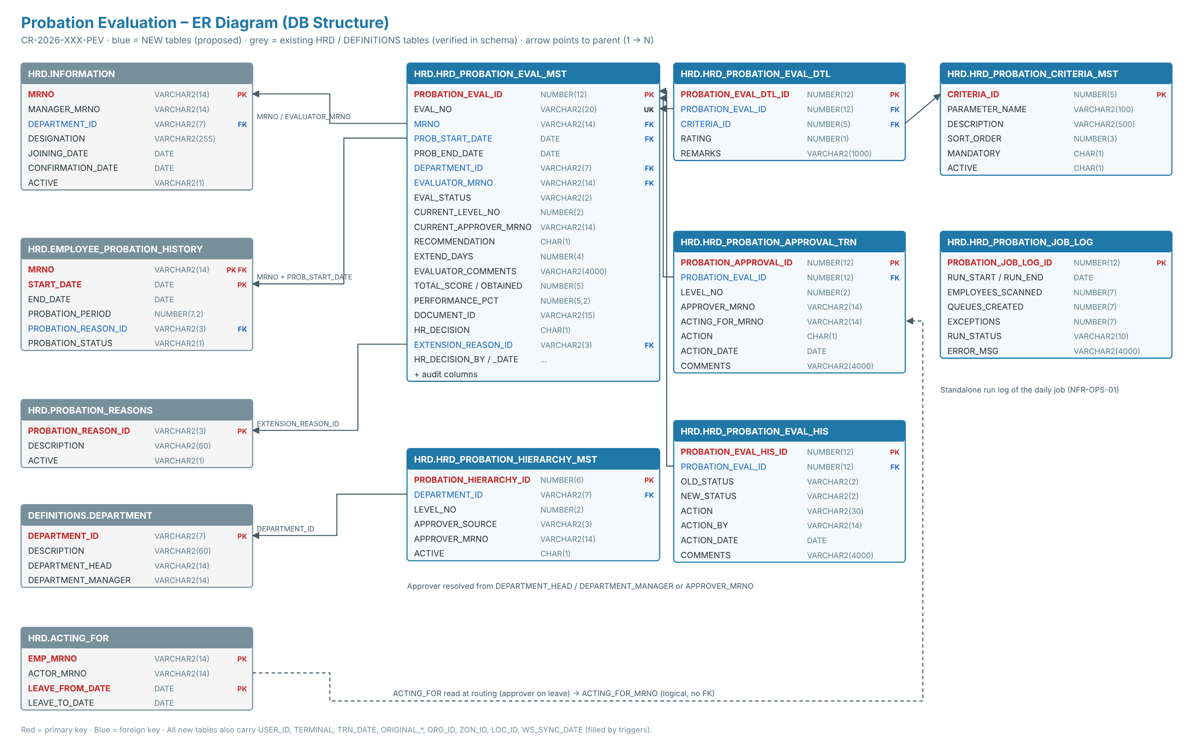
New tables. All follow the HRD audit-column pattern (USER_ID, TERMINAL, TRN_DATE, ORIGINAL_*, ORG_ID/ZON_ID/LOC_ID) and are filled by triggers.
- DS-01 `HRD.HRD_PROBATION_EVAL_MST`: evaluation header, one row per evaluation.
- Keys:
- PROBATION_EVAL_ID NUMBER(12) is the PK.
- EVAL_NO VARCHAR2(20) is unique, in the form PEV-YYYY-NNNNNN.
- MRNO VARCHAR2(14) + PROB_START_DATE is an FK to EMPLOYEE_PROBATION_HISTORY.
- Who and where: PROB_END_DATE, DEPARTMENT_ID VARCHAR2(7), EVALUATOR_MRNO (NULL = HR exception list).
- Workflow: EVAL_STATUS VARCHAR2(2) (EP / DR / PA / RT / FH / CM / CN), CURRENT_LEVEL_NO, CURRENT_APPROVER_MRNO.
- Evaluation:
- RECOMMENDATION (C = Confirm / E = Extend / N = Not to confirm), EXTEND_DAYS, EVALUATOR_COMMENTS VARCHAR2(4000).
- TOTAL_SCORE, OBTAINED_SCORE, PERFORMANCE_PCT.
- DOCUMENT_ID for the attachment, and SUBMITTED_DATE.
- HR decision: HR_DECISION (C / E / O), HR_EXTEND_DAYS, EXTENSION_REASON_ID (FK to PROBATION_REASONS), HR_DECISION_BY, HR_DECISION_DATE, HR_REMARKS.
- Control: EXCEPTION_REASON, and VERSION_NO for locking.
- One active evaluation per probation period is enforced by the unique index IDX_PROB_EVAL_ACTIVE_UK, which ignores cancelled rows.
- DS-02 `HRD.HRD_PROBATION_CRITERIA_MST`: evaluation parameters that HR maintains.
- Columns: CRITERIA_ID, PARAMETER_NAME, DESCRIPTION VARCHAR2(500), SORT_ORDER, MANDATORY, ACTIVE.
- The existing EVALUATION_CRITERIA_MASTER is too limited to reuse: its description is only VARCHAR2(55).
- DS-03 `HRD.HRD_PROBATION_EVAL_DTL`: one rating per criterion.
- Columns: PROBATION_EVAL_ID, CRITERIA_ID, RATING (1–5), REMARKS.
- Unique on (evaluation, criterion).
- DS-04 `HRD.HRD_PROBATION_HIERARCHY_MST`: approval levels.
- Columns: DEPARTMENT_ID (NULL = all departments), LEVEL_NO, APPROVER_SOURCE, APPROVER_MRNO, ACTIVE.
- APPROVER_SOURCE is DH (department head), DM (department manager) or EMP (named employee).
- DS-05 `HRD.HRD_PROBATION_APPROVAL_TRN`: one row per level per evaluation.
- Columns: LEVEL_NO, APPROVER_MRNO, ACTING_FOR_MRNO, ACTION, ACTION_DATE, COMMENTS.
- ACTION is P (pending), A (approved), R (returned) or S (skipped). Comments are mandatory on Return.
- DS-06 `HRD.HRD_PROBATION_EVAL_HIS`: status history.
- Columns: OLD_STATUS, NEW_STATUS, ACTION, ACTION_BY, ACTION_DATE, COMMENTS.
- Insert-only: trigger TRG_PROBATION_EVAL_HIS_BUD blocks updates and deletes.
- DS-07 `HRD.HRD_PROBATION_JOB_LOG`: daily job log.
- Columns: RUN_START, RUN_END, EMPLOYEES_SCANNED, QUEUES_CREATED, EXCEPTIONS, CANCELLED, RUN_STATUS, ERROR_MSG.
- DS-08 Supporting objects:
- 7 sequences (PROBATION_*_SEQ).
- Indexes on every FK and on the main searches: status, evaluator, approver, end date.
- Audit triggers TRG_<TABLE>_BI / _BU, copying the existing EMPLOYEE_PROBATION_HISTORY_INS pattern (SECURITY.GET_TERMINAL, SECURITY.CURRENTUSER, HIS.P_GET_CONTEXT_COL).
Existing objects used.
- Read:
- HRD.INFORMATION: MRNO, MANAGER_MRNO (evaluator), DEPARTMENT_ID, ACTIVE H/Y/N.
- DEFINITIONS.DEPARTMENT: DEPARTMENT_HEAD, DEPARTMENT_MANAGER.
- HRD.ACTING_FOR.
- HRD.PROBATION_REASONS.
- HRD.F_PROBATION_END_DATE, which returns MAX(END_DATE).
- Written at HR finalize only: HRD.EMPLOYEE_PROBATION_HISTORY.
- Confirm sets PROBATION_STATUS = 'C'.
- Extend sets a new END_DATE and PROBATION_REASON_ID, with PROBATION_STATUS staying 'P'.
- Seed data: HIS.USER_ASSIGNMENT (pending-task registration), HRD.ALERTS / ALERT_RECIPIENTS (notification set-up).
Data migration: none. An optional backlog run at go-live creates evaluations for employees who are already within 15 days of their probation end date.

4. Technical Details: Package HRD.PKG_PROBATION_EVALUATION (NEW)
All procedures use %TYPE parameters. The caller commits (an APEX page process or the job).
- `P_GENERATE_EVAL_QUEUE(P_RUN_DATE IN DATE DEFAULT TRUNC(SYSDATE))`: the daily job. FR-001 to FR-005.
- Write a log row (RUNNING).
- Do a set-based insert into EVAL_MST for active employees on probation where:
- F_PROBATION_END_DATE(MRNO) is between P_RUN_DATE and P_RUN_DATE + 15;
- and there is no non-cancelled evaluation for that MRNO and probation start date.
This also catches up on missed days.
- Set the evaluator from INFORMATION.MANAGER_MRNO. If it is NULL, set EXCEPTION_REASON = 'Supervisor not defined'.
- Insert one EVAL_DTL row for each active criterion, and one history row (action CREATED).
- Cancel open evaluations (status EP/DR/PA/RT) for employees whose INFORMATION.ACTIVE <> 'Y'. FR-004.
- Queue the notification e-mails, update the log to SUCCESS with counts, and commit. On error: roll back, log FAILED and re-raise.
- `P_SAVE_DRAFT(P_PROBATION_EVAL_ID, P_VERSION_NO, P_RECOMMENDATION, P_EXTEND_DAYS, P_COMMENTS, P_DOCUMENT_ID)` and `P_SAVE_RATING(P_PROBATION_EVAL_ID, P_CRITERIA_ID, P_RATING, P_REMARKS)`. FR-008.
- The caller must be the evaluator, and the status must be EP, DR or RT.
- Sets status DR, recalculates the scores and writes history.
- Mandatory fields are not checked.
- `P_SUBMIT(P_PROBATION_EVAL_ID, P_VERSION_NO)`. FR-009, FR-010, FR-011.
- Checks that every mandatory criterion is rated, that the recommendation and comments are filled, and that Extend has its days. Otherwise it raises -20801.
- Sets SUBMITTED_DATE, then calls P_ROUTE(level 1).
- `P_ROUTE(P_PROBATION_EVAL_ID, P_LEVEL_NO)` (internal). FR-011, FR-014, RULE-09.
- Read the active level from HIERARCHY_MST, using the department's own row or the default (NULL) row.
- Resolve the approver from DH / DM / EMP.
- If that approver is on leave, use the HRD.ACTING_FOR actor.
- If the approver is the evaluator or the employee, insert an S (skipped) row and move to the next level.
- If the approver cannot be resolved, place the evaluation on the HR exception list.
- If there is no next level, set status FH (Forwarded to HR).
- Otherwise set status PA, CURRENT_LEVEL_NO and CURRENT_APPROVER_MRNO, and insert an APPROVAL_TRN row with action P.
- `P_APPROVE(P_PROBATION_EVAL_ID, P_VERSION_NO, P_COMMENTS)`. FR-012.
- The caller must be the current approver or the acting-for person.
- Marks the level A, then calls P_ROUTE(level + 1).
- `P_RETURN(P_PROBATION_EVAL_ID, P_VERSION_NO, P_COMMENTS)`. FR-013.
- Comments are mandatory (-20803).
- Marks the level R, sets status RT and clears the current approver.
- On re-submit, approval restarts at level 1. This is pending HR confirmation (Q-07).
- `P_ASSIGN_EVALUATOR(P_PROBATION_EVAL_ID, P_EVALUATOR_MRNO)`: HR Administrator only. FR-005, FR-006.
- Allowed while the status is EP, DR or RT.
- `P_HR_FINALIZE(P_PROBATION_EVAL_ID, P_VERSION_NO, P_HR_DECISION, P_HR_EXTEND_DAYS, P_EXTENSION_REASON_ID, P_HR_REMARKS)`: HR role only, and the status must be FH. FR-015, FR-016, RULE-11.
- C (Confirm): UPDATE EMPLOYEE_PROBATION_HISTORY SET PROBATION_STATUS = 'C' for that MRNO and start date. The existing triggers then set the confirmation date, queue incentives and clear alert 001.
- E (Extend): update END_DATE = END_DATE + days and PROBATION_REASON_ID. This is pending HR's choice between extending the current period and adding a new one (Q-08).
- O (Other): no change to the probation record.
- In all cases: set status CM, fill the HR columns and write history.
- `P_LOG_STATUS(...)` (internal): inserts the EVAL_HIS row on every status change.
- `F_IS_OVERDUE(P_PROBATION_EVAL_ID) RETURN CHAR`: returns Y when the end date is before SYSDATE and the status is not FH, CM or CN. FR-020.
- Error codes:
Code | Meaning
-20800 | Not authorised for this action
-20801 | Mandatory fields missing
-20802 | Record changed by another user, reload
-20803 | Comments required for Return
-20804 | Invalid status for this action
-20805 | Extension days or reason missing

Modified package `HRD.PKG_PENDING_TASKS`:
- Add P_PROBATION_EVAL_QUEUE, with the framework's standard signature (P_USER_MRNO, P_ACTING_FOR, P_OBJECT_CODE, P_PROCESS_ID, P_TERMINAL, P_EVENT, P_ASSIGNMENT_ID).
- It counts the user's items and inserts the count into HIS.TMP_USER_ASSIGNMENT_VAL, the same as PROBATION_EXPIRE_QUEUE. The items counted are:
- as evaluator: status EP, DR or RT;
- as current approver: status PA;
- as HR (PKG_HR_ALERTS.F_CHECK_HR_ALERT_RIGHTS): status FH.
- Register it with one row in HIS.USER_ASSIGNMENT. SOURCE_NAME = the procedure name; OBJECT_CODE = the APEX page code.

5. GUI Pages (APEX, SKMCH GUI template)
The application ID and page numbers are to be confirmed. Page code S07APX0XXXX is a placeholder. Static IDs follow HRD standards (REG_, P<n>_, BTN_, DA_, LOV_).
- Page A: My Pending Tasks. This is the existing inbox, and it lists the new task type.
- Grid of evaluations assigned to the user, with days left and status. A row click opens Page B.
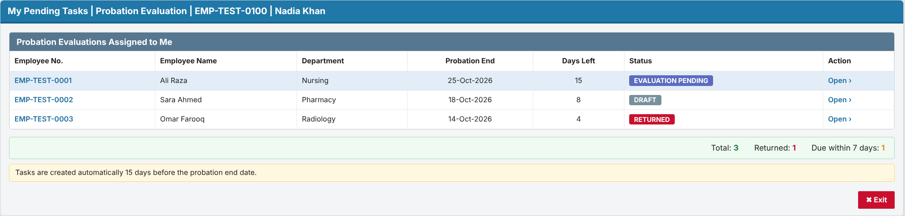
- Page B: Probation Evaluation (NEW).
- Header: region REG_EMPLOYEE_INFO (read-only).
- Tabs: Evaluation Criteria | Recommendation | Approval History | Finalization.
- Criteria tab: grid REG_CRITERIA with a rating select list (LOV_RATING 1–5) and remarks, the Rating Scale panel and the score bar.
- Buttons:
- BTN_SAVE_DRAFT calls P_SAVE_DRAFT / P_SAVE_RATING;
- BTN_SUBMIT calls P_SUBMIT;
- BTN_PREVIEW opens the print view;
- BTN_EXIT.
- Validation: the package raises the errors and they are shown inline. Missing mandatory cells are highlighted pink.
- Hidden item: P<n>_VERSION_NO for optimistic locking.
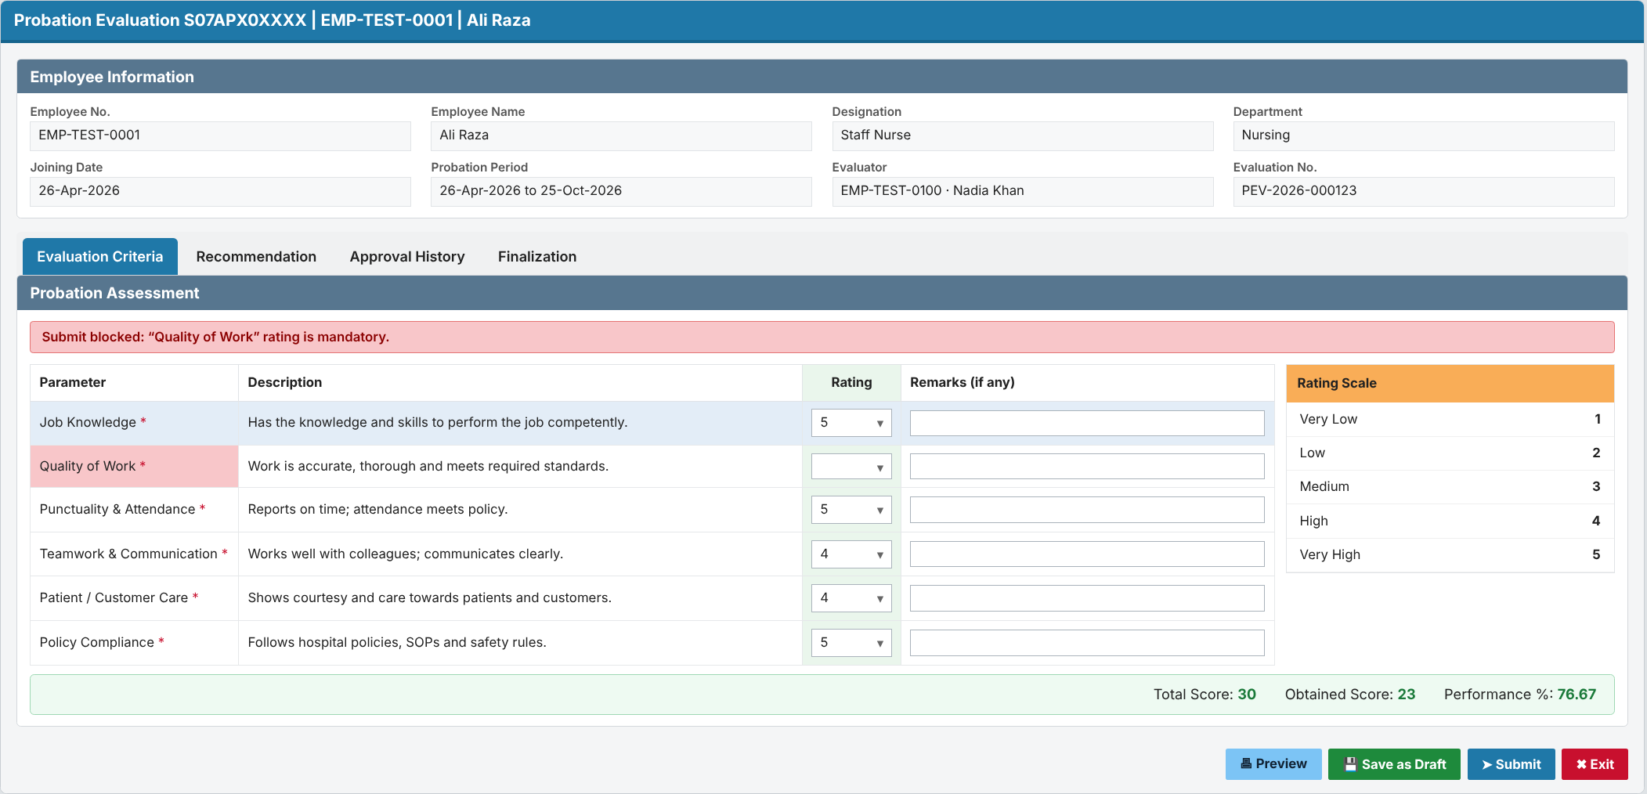
- Page B, Recommendation tab:
- Radio P<n>_RECOMMENDATION (C / E / N).
- P<n>_EXTEND_DAYS, enabled only for Extend through DA_TOGGLE_EXTEND.
- File upload P<n>_DOCUMENT_ID.
- Comments textarea (mandatory on Submit).
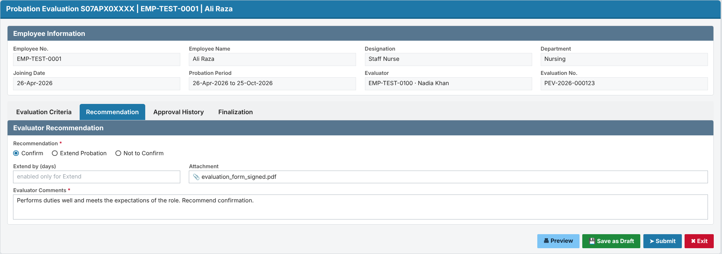
- Page C: Approval (NEW).
- Routing bar showing the evaluator and each level with its status.
- The evaluation shown read-only, and the approver comments.
- BTN_APPROVE calls P_APPROVE; BTN_RETURN calls P_RETURN.
- Authorization: the current approver or acting-for person only.
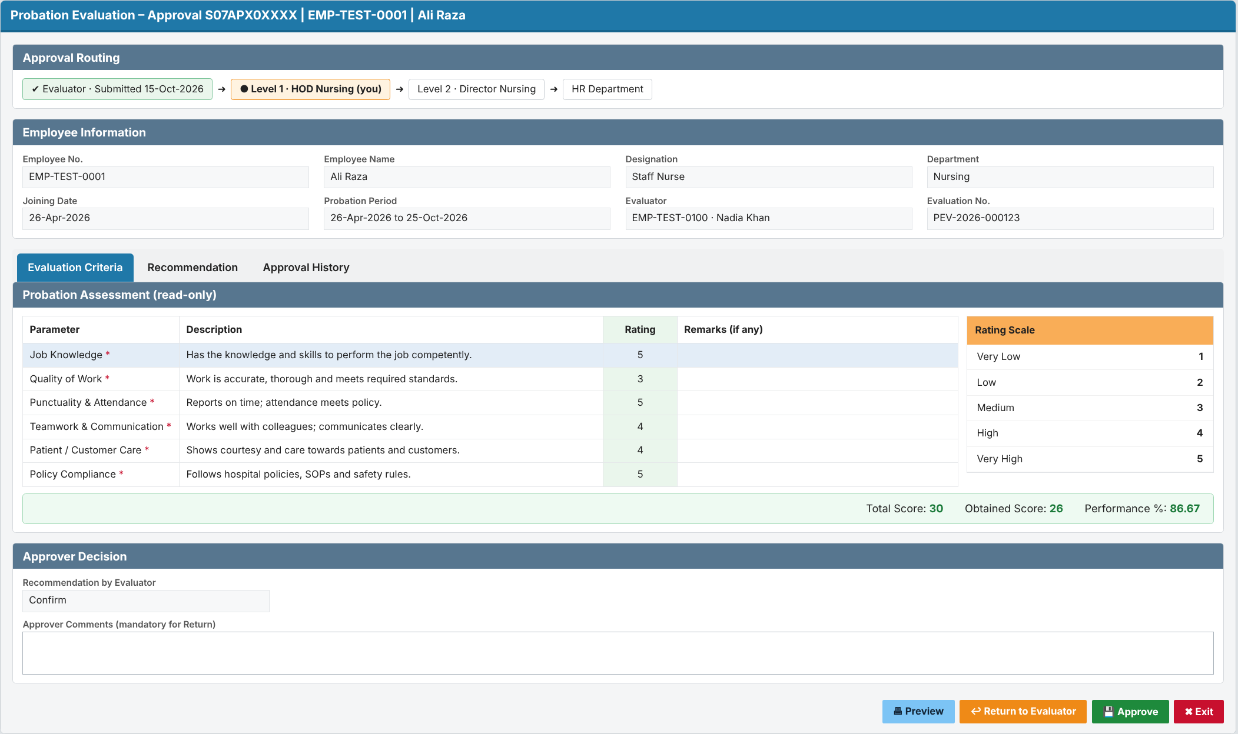
- Page D: Probation Approval Hierarchy Setup (NEW). Interactive Grid on HRD_PROBATION_HIERARCHY_MST.
- LOVs: department, approver source, employee.
- Authorization: HR Administrator.
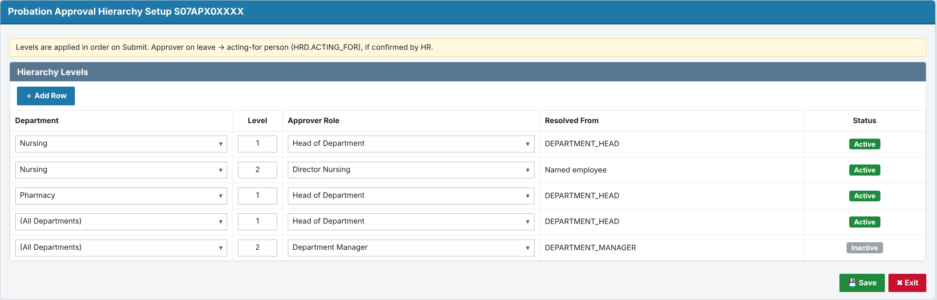
- Page E: HR queue (NEW). Report of evaluations with status FH, showing recommendation, final approver and performance %. "Process" opens Page F.
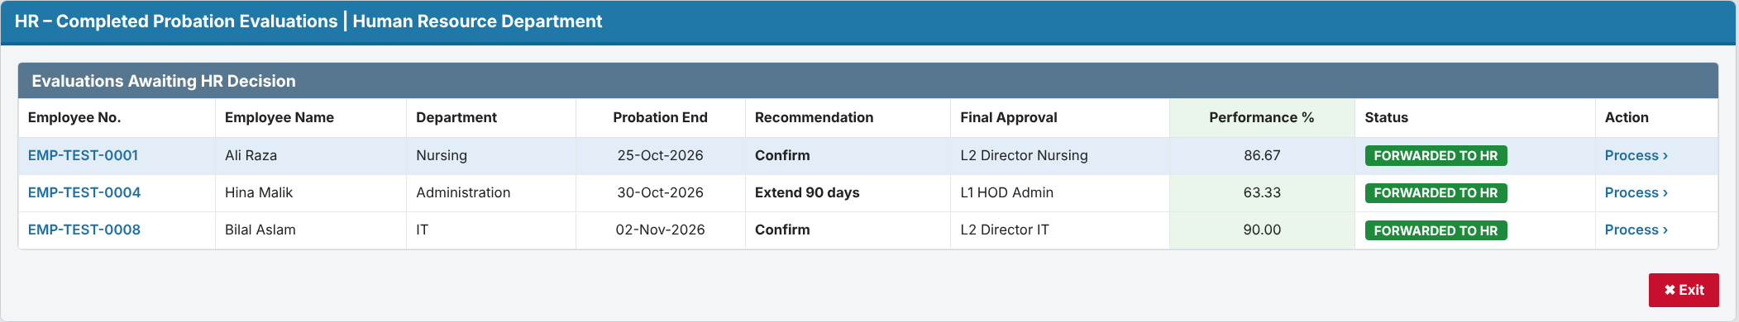
- Page F: HR Finalization (NEW). The Finalization tab of Page B in HR mode.
- Decision radio, extension days and reason (LOV_PROBATION_REASONS from HRD.PROBATION_REASONS), remarks.
- BTN_FINALIZE calls P_HR_FINALIZE.
- Authorization: HR User.
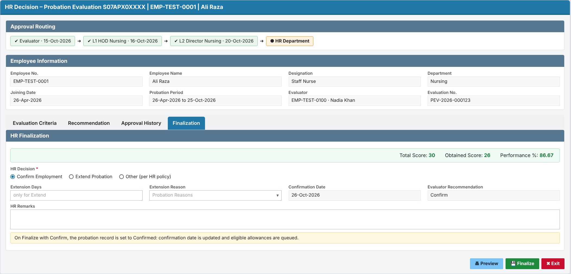
- Page G: Probation Monitoring (NEW).
- Filters and an evaluation grid with Overdue and No-supervisor flags. "Assign Evaluator" calls P_ASSIGN_EVALUATOR.
- Status-history report on HRD_PROBATION_EVAL_HIS.
- Authorization: HR User; assigning needs HR Administrator.
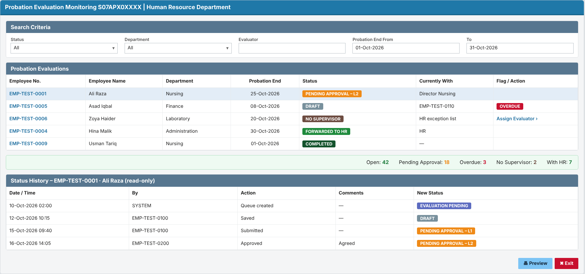

6. Jobs, Notifications and Security
- Job `HRD.JOB_PROBATION_EVAL_QUEUE` (DBMS_SCHEDULER):
- Runs daily at 02:00 and calls P_GENERATE_EVAL_QUEUE.
- A failed run is logged in HRD_PROBATION_JOB_LOG, and an alert row e-mails IT support.
- Notification e-mails:
- Sent for: evaluation assigned, pending approval, returned, and forwarded to HR.
- They use APEX_MAIL, with sender and recipients configured in HRD.ALERTS / ALERT_RECIPIENTS. The standard HRD mail API needs IT confirmation (Q-27).
- A mail failure is logged and does not roll back the workflow.
- Authorization schemes:
- AUTH_PROB_EVALUATOR: the logged-in MRNO equals EVALUATOR_MRNO.
- AUTH_PROB_APPROVER: the current approver or acting-for person.
- AUTH_PROB_HR_USER and AUTH_PROB_HR_ADMIN: security groups, to be confirmed by IT.
- Data access: pages query through the package and check the role, so a user who changes the URL cannot see other users' evaluations.
- Audit: audit columns on every table, the insert-only history table, and no physical delete (cancel sets status CN).
- Privacy: MRNO is also the patient MR number. The pages do not join or link to REGISTRATION data.

7. Requirement Coverage
- FR-001, FR-002, FR-003, FR-004, FR-005, FR-006 (queue generation, duplicates, cancel, exceptions, reassign): DS-01, DS-07, P_GENERATE_EVAL_QUEUE, P_ASSIGN_EVALUATOR, Page G.
- FR-007, FR-008, FR-009, FR-010 (evaluation form, Draft, Submit, lock): DS-01–03, P_SAVE_DRAFT, P_SAVE_RATING, P_SUBMIT, Page B.
- FR-011, FR-012, FR-013, FR-014 (routing, approve, return, no self-approval): DS-04, DS-05, P_ROUTE, P_APPROVE, P_RETURN, Pages C and D.
- FR-015 and FR-016 (forward to HR, HR finalize): P_ROUTE (status FH), P_HR_FINALIZE, Pages E and F.
- FR-017, FR-018, FR-019, FR-020 (status, history, monitoring, overdue): DS-06, P_LOG_STATUS, F_IS_OVERDUE, Page G.
- NFR-SEC-01, NFR-SEC-02: authorization schemes, plus role checks inside the package.
- NFR-AUD-01, NFR-AUD-02: audit triggers, plus the insert-only history table.
- NFR-PERF-01, NFR-PERF-02: set-based job SQL, indexes on status, evaluator, approver and end date.
- NFR-AVL-01: the job's date window catches up on missed days. NFR-AVL-02: new objects only; no downtime needed.
- NFR-DAT-01: no physical delete. NFR-DAT-02: unique index. NFR-DAT-03: VERSION_NO with error -20802.
- NFR-USA-01, NFR-USA-02: APEX Universal Theme pages in the SKMCH GUI template, plus the APEX "warn on unsaved changes" setting.
- NFR-CMP-01: status rules agreed with HR. NFR-INT-01: employee data read live from INFORMATION.
- NFR-OPS-01: job log and failure alert. NFR-OPS-02: non-blocking notification e-mails.

8. Change Inventory and Deployment
- Scripts, run in this order (no downtime: only new objects are added, plus one procedure in PKG_PENDING_TASKS):
Step | Script | What it does
0 | CR-2026-XXX-PEV_00_precheck.sql | Checks that no HRD_PROBATION_% objects exist, and backs up the current PKG_PENDING_TASKS source
1 | CR-2026-XXX-PEV_01_ddl.sql | Sequences, 7 tables, indexes, triggers (provided)
2 | CR-2026-XXX-PEV_02_pkg_probation_evaluation.pks / .pkb | New package
3 | CR-2026-XXX-PEV_03_pkg_pending_tasks.pkb | Adds P_PROBATION_EVAL_QUEUE (spec and body)
4 | CR-2026-XXX-PEV_04_seed.sql | Criteria from HR's form, default hierarchy, the HIS.USER_ASSIGNMENT row, alert rows
5 | CR-2026-XXX-PEV_05_job.sql | Creates the scheduler job
6 | APEX export | Pages B–G, authorization schemes, LOVs

- After deployment, verify:
- all new objects are VALID (USER_OBJECTS);
- a manual run of P_GENERATE_EVAL_QUEUE on test data creates the expected rows and a SUCCESS log row;
- the inbox shows the task count.
- Rollback: CR-2026-XXX-PEV_99_rollback.sql (provided). It drops the job, the package and the tables in reverse order, and redeploys the backed-up PKG_PENDING_TASKS.
- It does not revert probation records that HR has already finalized; those are business decisions.
- Retest these dependents (they read EMPLOYEE_PROBATION_HISTORY): PKG_COMMON, PKG_EMPLOYEE_INFO, PKG_EMP_INCENTIVE, PKG_HR_ALERTS, PKG_HR_DOCUMENT_RECORD, PKG_HR_EMPLOYEE_RECORD, LEAVE_AUTOMATION, EMAILS, V_HR_EMP_DOCUMENTS.

9. Risks and Open Questions
- Risk: probation status written too early. Mitigation: only P_HR_FINALIZE writes it; covered by code review and a unit test.
- Risk: duplicate queues with alert 001 / S07FRM00362. Needs HR's decision (Q-24) before go-live.
- Risk: stale `MANAGER_MRNO`. Mitigation: HR exception list, plus a data-quality report before go-live.
- Open questions:
- Q-05 (HR): criteria list and rating scale. Needed for the seed data.
- Q-07 (HR): after a Return, does approval restart at level 1?
- Q-08 (HR): for an extension, extend the current probation period or add a new one?
- Q-16 (HR): the actual hierarchy levels per department.
- Q-24 (HR): replace or keep alert 001 and S07FRM00362?
- Q-27 (IT): standard mail API and sender, and the security groups for the HR roles.

