Shaukat Khanum Memorial Cancer Hospital & Research Centre
Information Systems

Change Request
Automated Employee Probation Evaluation

Document ID | CR-2026-XXX-PEV
Version | 0.7
Status | DRAFT
Date | 2026-10-09
Prepared by | Claude (AI draft) for Business Analyst
Source documents | CR v0.7

Version History
Version | Date | Author | Change summary
0.7 | 2026-10-09 | Claude (AI draft) for Business Analyst | Jira attachment

Approvals
Role | Name | Decision | Signature | Date
Business Analyst (author)
Solution Architect
Business Owner / Department Head
Approval is recorded by the named person only. AI-drafted documents remain DRAFT until then.

Change Request: Automated Employee Probation Evaluation
Item | Value
CR No. | CR-2026-XXX-PEV (placeholder)
Module | HR (HRD), Oracle APEX
Requested by | HR Department
Version / Status | 0.7 / DRAFT
Date | 09-Oct-2026

1. Client Needs / Expectations
HR wants the employee probation evaluation to run automatically, on time and with full visibility, without manual follow-up:
- Every employee on probation is evaluated by their respective supervisor before the probation end date. The system starts the evaluation automatically 15 days before the probation end date.
- The evaluator can work on the evaluation over more than one sitting (Save as Draft) and send it when ready (Submit for approval).
- Every submitted evaluation goes through the approval hierarchy set up for the department (all departments; levels vary, e.g. supervisor, HOD, manager, director, then HR). If a department has not been set up yet, it follows the generic organizational leave hierarchy already defined in the system.
- Once approved, the completed evaluation reaches the HR Department automatically.
- HR and supervisors can see the current status of every probation evaluation at any time. The status updates itself at each step.
- The online evaluation form has four sections (the same content as today's Excel form):
- Evaluation criteria (standard parameters such as job knowledge and quality of work), each rated 1 to 5;
- Assignments completed during the probationary period, each rated 1 to 5;
- Employee's assessed training needs;
- Specific reasons and observations, with evidence, when the employee is not recommended for confirmation.
Expected benefits: no missed or late evaluations, a consistent approval path, no manual chasing by HR, and an audit trail of who did what and when.
Today: a probation-ending alert is e-mailed 15 or 30 days before the probation end date with an Excel probation evaluation form attached. The concerned person fills in the Excel form and sends it back as feedback. In the HRD system, the alert is configured as alert 001 (HRD.ALERTS / HRD.HR_ALERT_QUEUE, visible to HR users only), and HR records the confirm/extend decision on form S07FRM00362. There is no online form, approval routing or status tracking.

2. Workflow
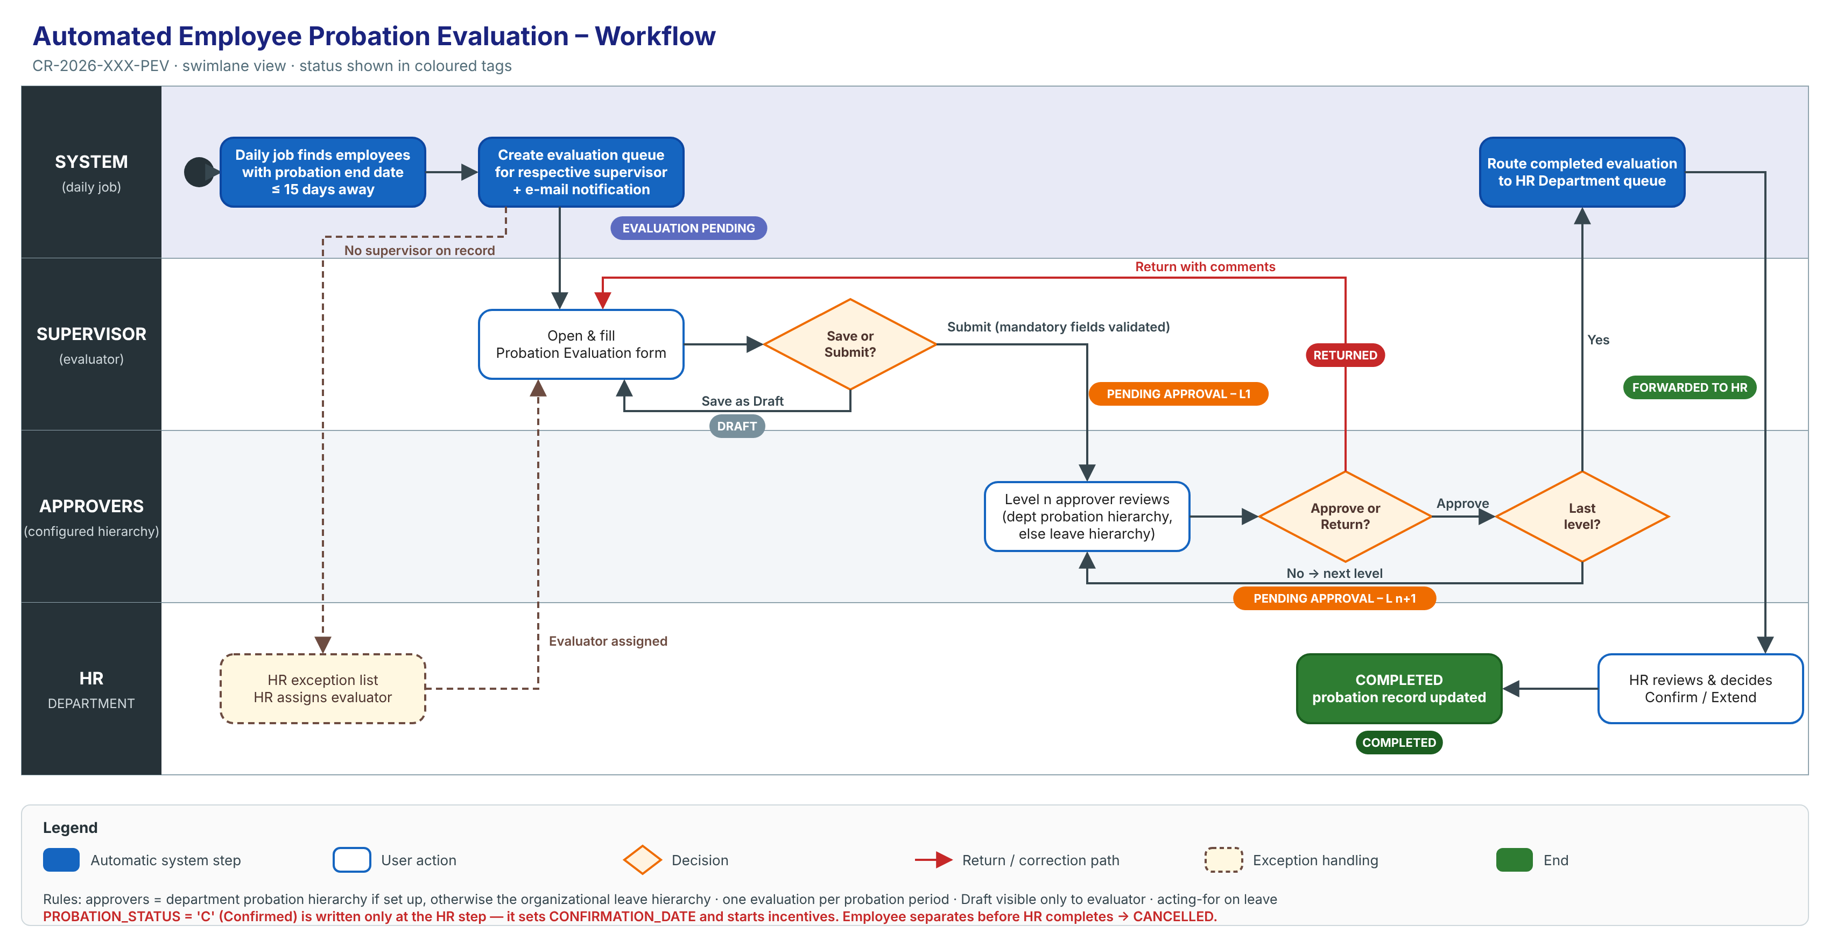
Step | Actor | Action | System result | Status after step
1 | System (daily job) | Finds employees whose probation end date is within 15 days and who have no evaluation yet | Creates an evaluation queue item for the respective supervisor and notifies them | Evaluation Pending
2a | Supervisor (evaluator) | Fills part of the form and clicks Save as Draft | Saves; the item stays in the supervisor's queue | Draft
2b | Supervisor | Completes the form and clicks Submit | Validates mandatory fields and routes to Level 1 | Pending Approval – Level 1
3a | Approver (Level n) | Approve | Moves to the next level | Pending Approval – Level n+1
3b | Approver | Return with comments | Back to the supervisor for correction | Returned
4 | System | Last level approves | Routes to the HR Department queue | Forwarded to HR
5 | HR | Processes the evaluation (confirm / extend, per HR policy) | Closes the evaluation and updates the probation record | Completed

Status names are proposed and need HR to confirm them.

3. Functional Requirements

Requirement 1: Automatic generation of the probation evaluation queue
Description: Every day, the system shall identify each employee on probation whose probation end date is within the next 15 days and who has no evaluation for the current probation period. For each one, it shall create a probation evaluation queue item assigned to the employee's respective supervisor.
- One evaluation only per employee per probation period. A re-run never creates a duplicate.
- If a day's run is missed, the next run picks up the employees that were missed.
- If the employee has no supervisor on record, the item goes to an HR exception list. HR can assign or reassign the evaluator.
- If the employee leaves (separation) before HR completes the evaluation, the evaluation is cancelled.
- The supervisor is notified by e-mail when an item is assigned.
- Probation end date: taken from the probation record (HRD.F_PROBATION_END_DATE). Respective supervisor: HRD.INFORMATION.MANAGER_MRNO (to be confirmed by HR).
Acceptance (summary):
- An employee whose probation ends on 25-Oct-2026 appears in their supervisor's queue on 10-Oct-2026.
- An employee whose probation ends on 26-Oct-2026 does not appear in the queue on 10-Oct-2026.
- An employee who has been confirmed or has left never appears in the queue.

Prototype: Supervisor pending tasks (queue)
Screen 1 – My Pending Tasks (supervisor)
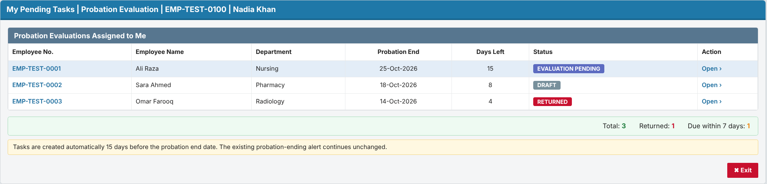

Requirement 2: Evaluation entry with Save as Draft / Submit
Description: The system shall let the assigned evaluator open the evaluation from the queue and fill in the evaluation form.
- The form shows the employee's details: employee no., name, department, designation, joining date, probation start and end dates.
- Save as Draft: saves without validation and without routing. Only the evaluator can see a Draft.
- Submit: checks that all mandatory fields are filled. If any are missing, it blocks submission and highlights them. Otherwise it routes the evaluation to approval (Requirement 3).
- After Submit the form is read-only for the evaluator, unless an approver returns it.
- The form has four tabs: Evaluation Criteria | Assignments | Training Needs | Recommendation.
- Evaluation Criteria: the standard parameters maintained by HR (e.g. Job Knowledge, Quality of Work, Punctuality & Attendance), each rated 1 to 5 with optional remarks, beside the Rating Scale panel and a score bar.
- Assignments: the evaluator lists the assignments completed during the probationary period and rates each one from 1 (Very Low) to 5 (Very High), with optional remarks. The system calculates the total, obtained score and performance %.
- Training Needs: the evaluator lists the employee's assessed training needs.
- Recommendation: Confirm, Extend Probation (with days) or Not to Confirm. When the employee is not recommended for confirmation (Extend or Not to Confirm), the evaluator must enter the specific reasons and observations and attach the evidence.
- A warning appears if the user leaves the page with unsaved changes. If another user changed the evaluation after it was opened, the save is rejected with "Changed by another user, reload".
Acceptance (summary):
- A Draft is saved and reopens with all values intact.
- Submit with a mandatory field empty is refused, and the status does not change.
- Submit with an unrated mandatory criterion, without any assignment, with an unrated assignment, or (when not recommending confirmation) without reasons and evidence is refused.
- A user who is not the evaluator cannot open the form.

Prototype: Probation Evaluation form (Evaluation Criteria, Assignments, Training Needs, Recommendation)
Screen 2 – Evaluation Criteria tab: standard parameters rated 1–5
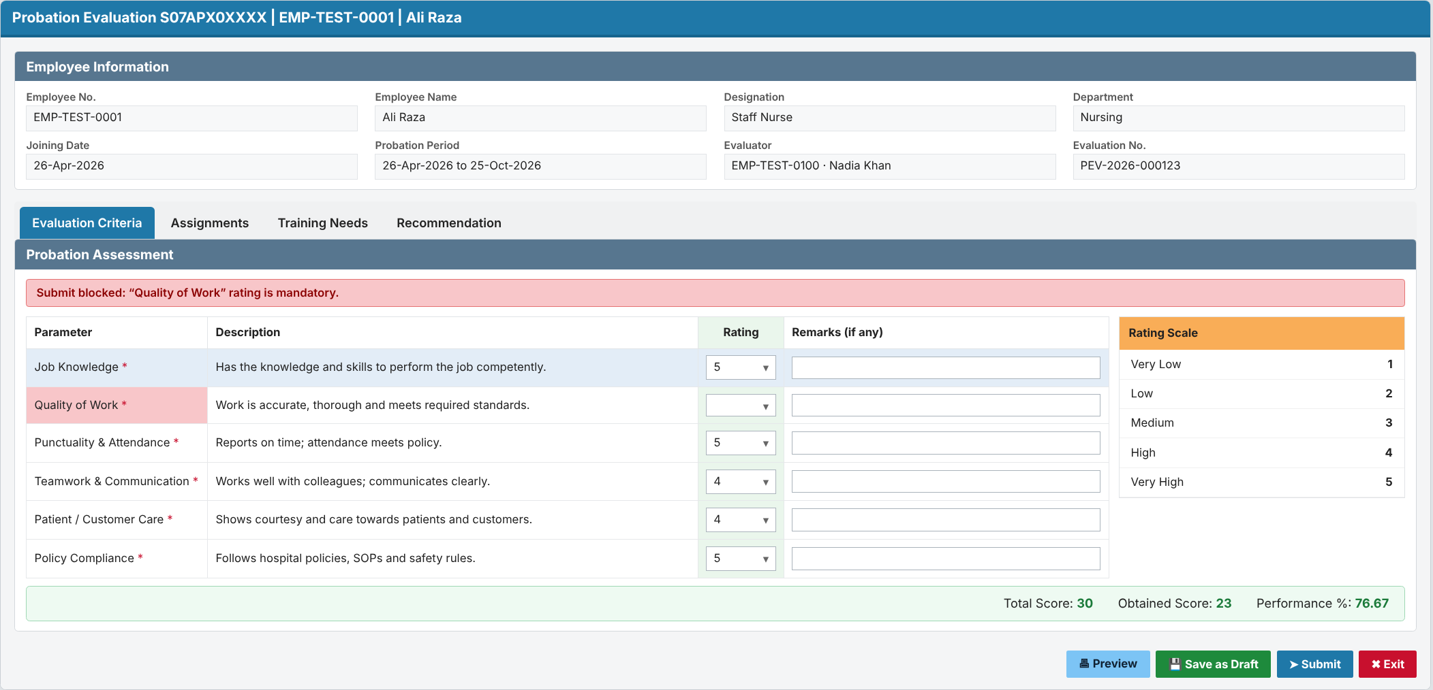
Screen 3 – Assignments tab: assignments completed during probation, rated 1–5
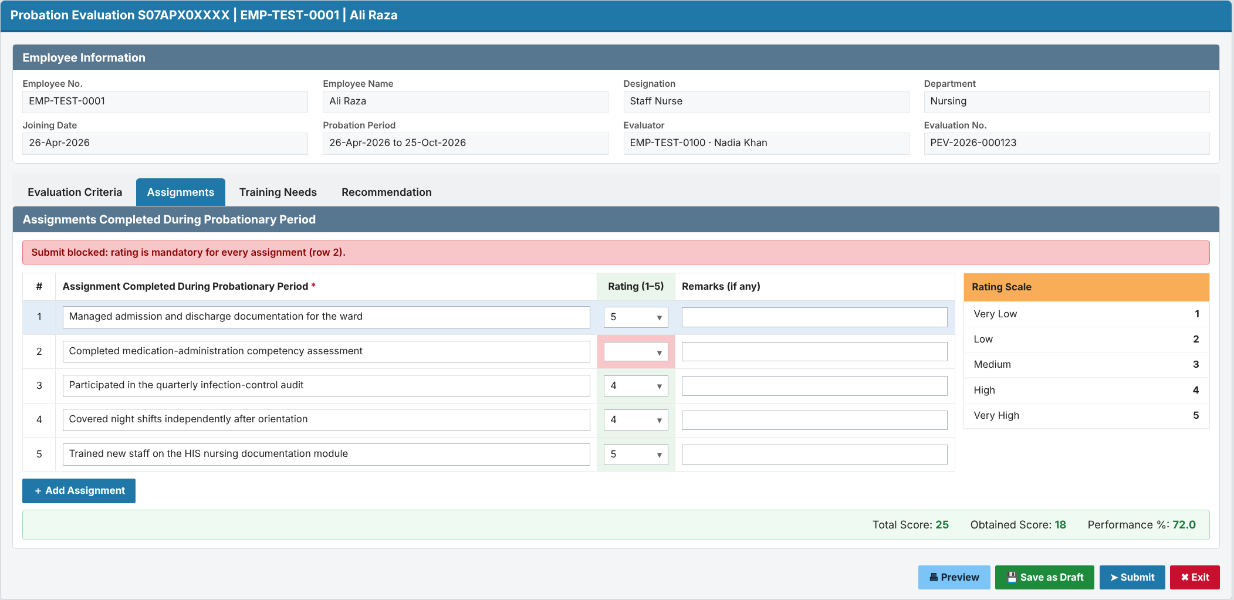
Screen 4 – Training Needs tab: employee's assessed training needs
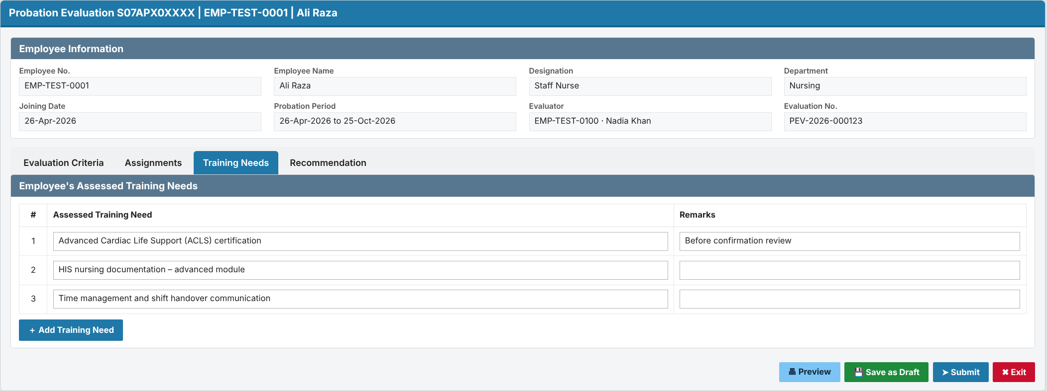
Screen 5 – Recommendation tab: reasons, observations and evidence when not recommended
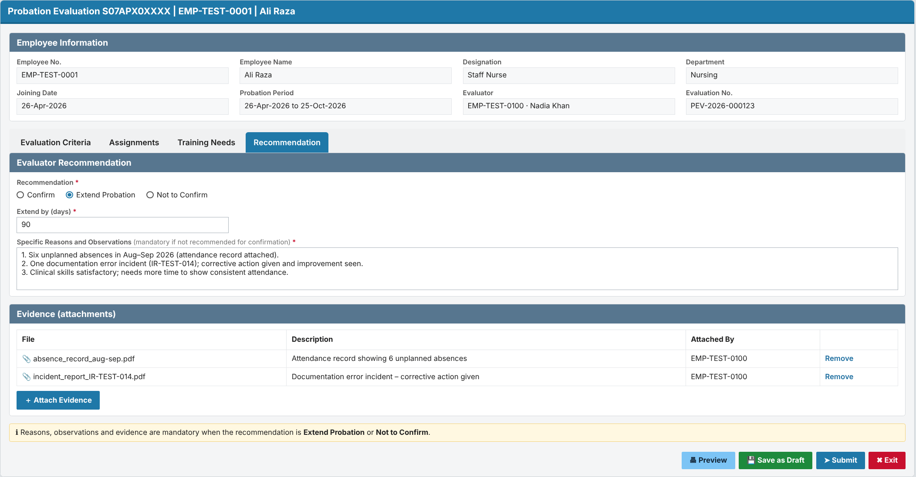

Requirement 3: Routing through the configured approval hierarchy
Description: On Submit, the system shall route the evaluation one level at a time in order:
- If a probation approval hierarchy is set up for the employee's department, it follows that hierarchy.
- If a department has not been set up yet, it follows the generic organizational leave hierarchy already defined in HRD (the same for all leave types). That is the employee's reporting chain, which varies by employee: for example supervisor → HOD → manager → director, then HR.
- The screen shows which route source is used.
- Approve (optional comments): moves the evaluation to the next level.
- Return (comments mandatory): sends it back to the evaluator (status Returned). The evaluator corrects it and re-submits. On re-submit it goes back only to the approver who returned it; earlier approvals stay valid.
- No one approves their own case. If the evaluator is also the approver at a level, that level is skipped and the reason is logged. If there is no next level, the evaluation goes to the HR exception list.
- If an approver's level cannot be resolved, the evaluation goes to the HR exception list. It is never lost.
- Approver on leave: the evaluation goes to their acting-for person (HRD.ACTING_FOR), to be confirmed by HR.
- The hierarchy levels (for example L1 = HOD, L2 = Director, by department or grade) are maintained by the HR Administrator. The levels are pending from HR.
- Approach (decided): dedicated probation tables: hierarchy levels in HRD_PROBATION_HIERARCHY_MST, per-level actions in HRD_PROBATION_APPROVAL_TRN (see the Design Document). Approver on leave → acting-for person from HRD.ACTING_FOR.
Acceptance (summary):
- After Level 1 approves, the evaluation appears in the Level 2 queue and leaves the Level 1 queue.
- A Return without comments is refused.
- The evaluated employee never receives their own evaluation in their queue.

Prototype: Approver screen and hierarchy setup
Screen 6 – Approval view (Approve / Return to Evaluator)
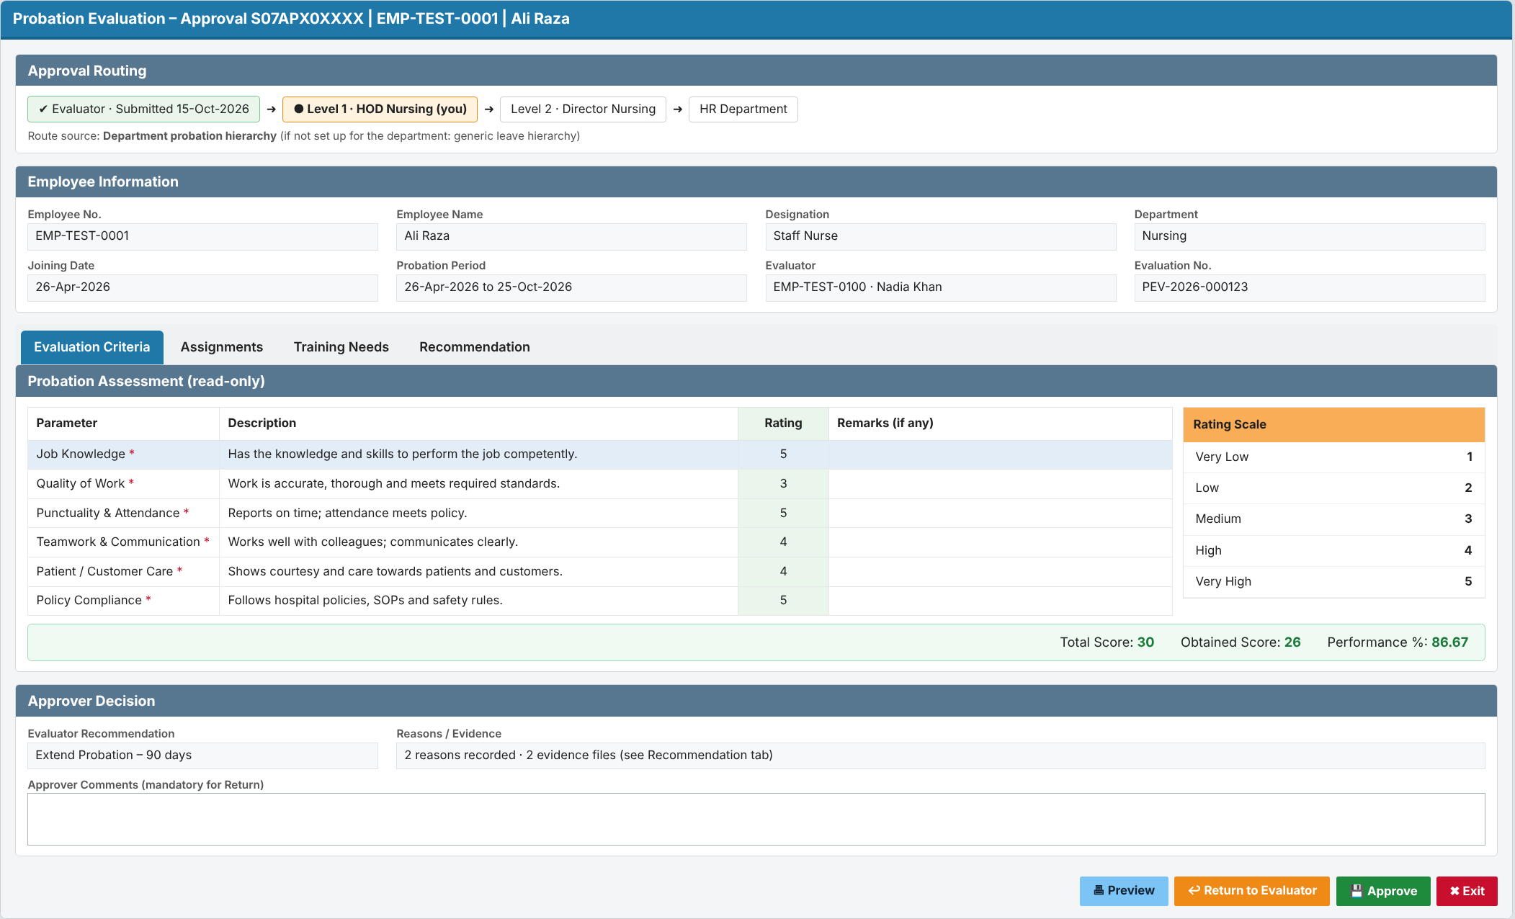
Screen 7 – Probation Approval Hierarchy Setup (HR Administrator)
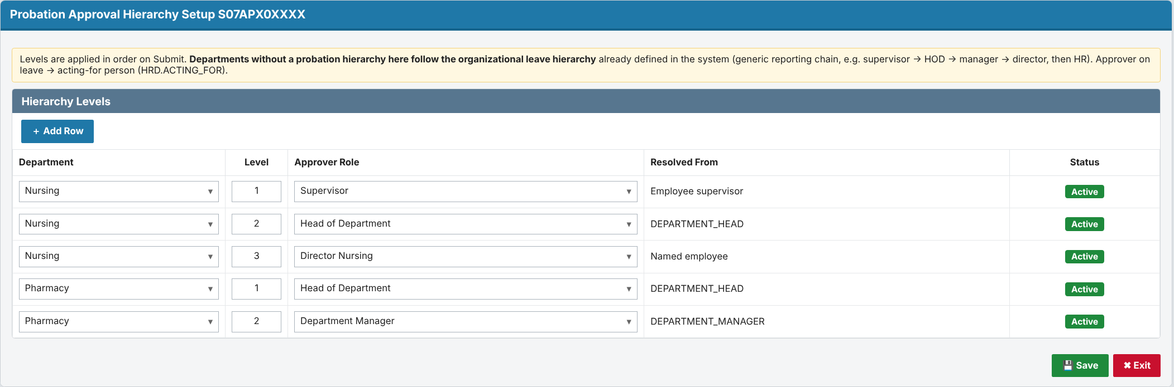

Requirement 4: Automatic routing of the completed evaluation to HR
Description: When the last approval level approves, the system shall route the completed evaluation to the HR Department queue automatically. HR shall be able to process it and close it.
- HR sees the complete evaluation, the recommendation and the full approval trail.
- HR records the outcome (Confirm / Extend, per HR policy) and closes the evaluation (status Completed).
- Important (from the HRD code): the probation record (HRD.EMPLOYEE_PROBATION_HISTORY.PROBATION_STATUS) is set to Confirmed ('C') only at this HR step. Setting 'C' automatically:
- sets HRD.INFORMATION.CONFIRMATION_DATE;
- creates incentive/allowance queue entries;
- clears the HR probation alert.
- Extension: recorded the same way as today's probation history. A new HRD.EMPLOYEE_PROBATION_HISTORY row is created for the extended period with status 'E' (Extended), the extension days and the reason (HRD.PROBATION_REASONS). A new evaluation is then generated 15 days before the new end date.
- The existing probation-ending alert (alert 001) and form S07FRM00362 remain unchanged. The new workflow runs alongside them.
Acceptance (summary):
- After the last-level approval, the evaluation appears in the HR queue with status Forwarded to HR.
- HR cannot process an evaluation that is still pending approval.
- Confirmation date and incentives change only after HR confirms.

Prototype: HR queue and decision
Screen 8 – HR queue of completed evaluations
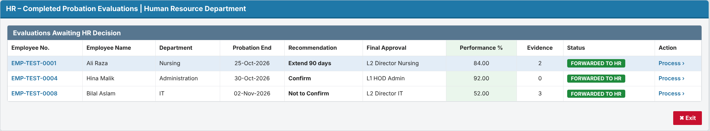
Screen 9 – HR Finalization (Confirm / Extend)
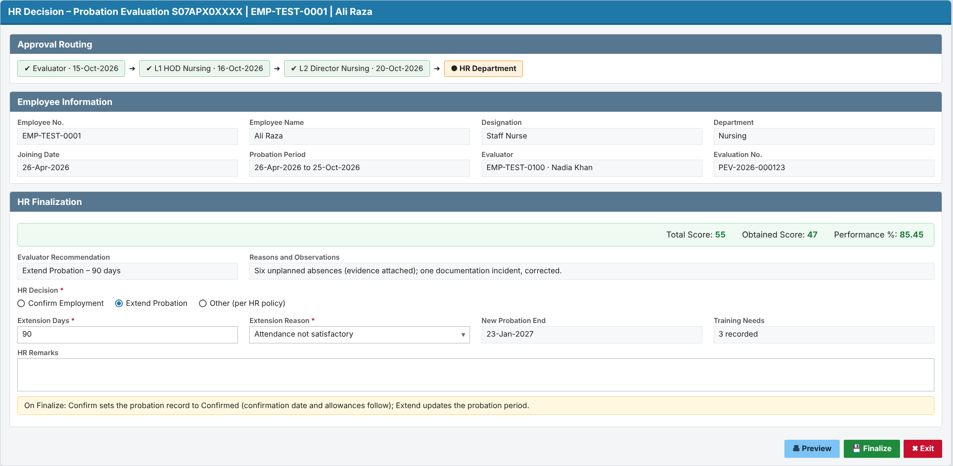

Requirement 5: Automatic status update throughout the workflow
Description: The system shall update the evaluation / probation request status automatically at every workflow event. Users cannot edit the status by hand. Every change is kept in an insert-only history.
- Status values (proposed): Evaluation Pending → Draft → Pending Approval – Level n → Returned → Forwarded to HR → Completed, plus Cancelled.
- History records the old status, new status, action, comments, user and date-time.
- HR has a monitoring screen of all evaluations, with filters by status, department, evaluator and end date. It flags evaluations as overdue when they are not with HR by the probation end date.
- Supervisors and approvers see the status of their own items.
Acceptance (summary):
- Submitting a Draft changes the status to Pending Approval – Level 1 with no manual step.
- The history shows each step in time order.
- No user can edit or delete history.

Prototype: Monitoring and status history
Screen 10 – Probation Evaluation Monitoring and status history (HR)
