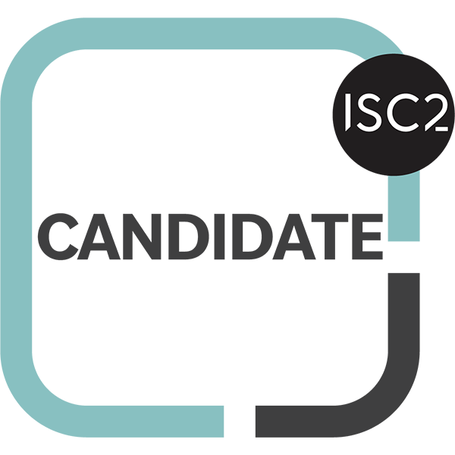
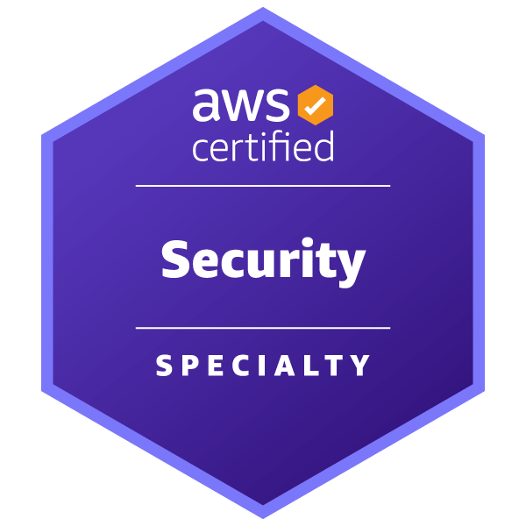
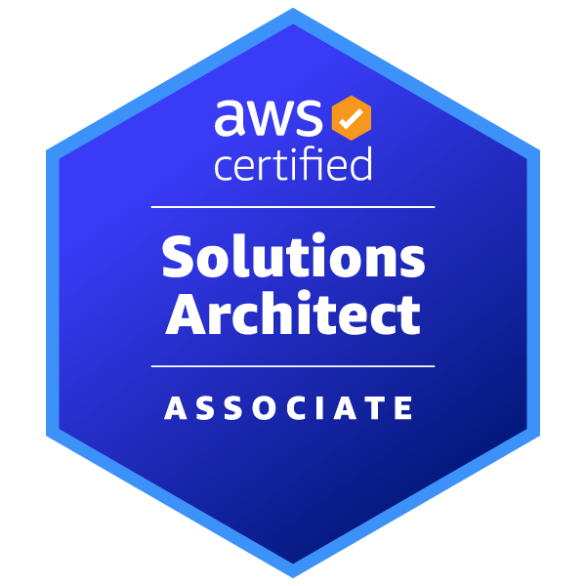
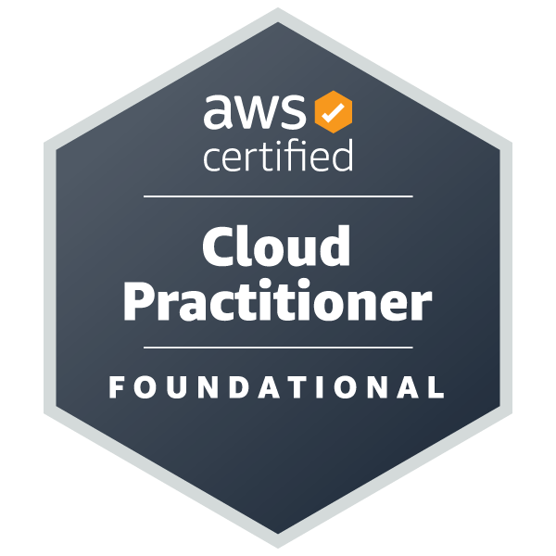
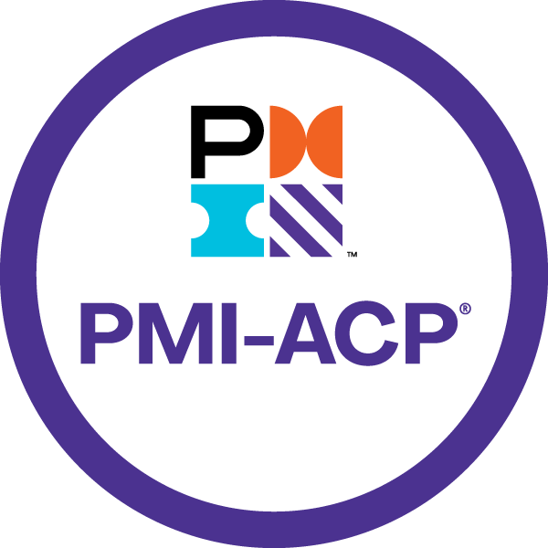
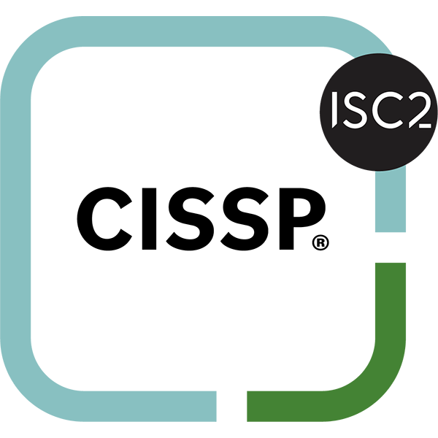
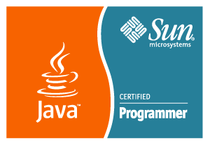
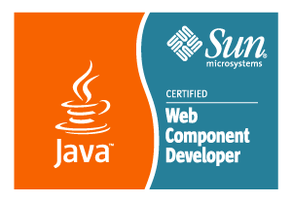

Praveen Palaniswamy

+1(804)614-7155

Praveen.palaniswamy@gmail.com
in.linkedin.com/in/praveenpalaniswamy/

Professional Summary

Dynamic and accomplished software engineering leader with 20 years of experience in application development, project management, enterprise integration and cloud infrastructure management.

Proven expertise in implementing robust software solutions, leading cross-functional teams, driving technological innovations and vendor management.

Skilled in software development methodologies, continuous delivery, and enterprise architecture.

Demonstrated success in managing large-scale projects, optimizing processes, and achieving strategic objectives.

Adept in applying capability maturity model, risk management and managing software development methodologies like TDD and agile.

Extensive domain knowledge in financial, telecom, governance, risk & compliance, and healthcare industry.

Experience

Senior Manager, Software Engineering - Capital One Bank, USA Aug 2019 – Current
Cyber Tech Aug 2022 - Current
- Owned data-in-transit and data-at-rest strategy with Cyber data loss prevention team across US, UK and Canada operations.
- Engineering Lead for Post Quantum Cryptography program.
- Led initiatives to improve crypto agility and standards for enterprise.
- Developed and implemented strategic OKRs for the cryptography pod, aligning team objectives with the organization's broader vision and goals.
- Led the process of defining, refining, and cascading key results to ensure cohesive execution of high-priority initiatives.
- Managed and built multiple high performing technical teams with operations and software engineering focus.
- Accountable for developing the roadmap and ensuring the timely delivery of high-quality products.
- Managed vendor relationships and support audit and CISO with incident management.

Card Tech Aug 2019 – Aug 2022
- Led and mentored technical teams for Card - Customer Resiliency projects, ensuring alignment with business objectives.
- In-house multi-billion dollar customer payments from BNY Mellon product.
- Owned multiple business domains including estate, finance and reporting.
- Provided architectural guidance and managed multiple technical teams, vendor relationships

Authorized Officer – UBS Business Solutions, USA Jun 2015 – Aug 2019
- Demonstrated leadership skills in improving app-dev tools and standardization.
- Architected solutions to align with enterprise goals and project needs.
- Managed project delivery with involvement into budgeting, resource management and project executions.
- Improved continuous delivery pipelines across IT applications and instrumental in process definitions.
- Participated in tool evaluation process for App development and early adopter on new technologies to demonstrate best practice.
- Designed and developed software components for data processing and report generation.

Application Owner/Technical Architect: CAI - Middleware Services Layer
Client Account Information application owns all customer and account data of wealth management division and supports in maintenance and integration of the data across WMA applications.
- Lead the development effort and project execution.
- Solution Architect for designing interfaces and integration points with applications.
- Managed resource for teams and handled multiple vendor/fulltime employee management.
Project FCM – FA COMPENSATION
IT Simplification effort across UBS Technology stack and cost reduction effort by porting out existing application from Mainframe/COBOL programming language to Distributed/SCALA language.
- Lead the project to auto-generate Java/Scala code from COBOL.
Project NNM - NET NEW MONEY
Projects vision was to reduce IT cost by porting out existing application from COBOL programming language to JAVA and executing in the existing Mainframe environment.
- Developed in-house library with reusable software components. Which will be used in similar port-out projects with in UBS.
- Successfully executed Java Language applications in Mainframe using IBM JZOS API

Technical Lead - Wipro Technologies, USA Aug 2012 – Jun 2015

Capital One Bank, USA.
Project: Anti-Money Laundering Technology Enhancement for Agents– AML TEA
TEA initiative is to facilitate the AML team of Capital One with money laundering investigation. NICE Actimize platform is used for case management. To complete the research and file SAR the Agents need information to build/validate case. TEA’s main objective is to integrate into enterprise SOA Layer and reduce the effort with the agent investigation.
- Integrate SAP Business objects reporting platform and Restful web services for data enrichment.

Capital One Bank, USA.
Project: GRC Platform - PRIME
Governance, Risk and Compliance team of Capital One corporate risk management offers services to internal business lines using IBM OpenPages GRC Platform. PRIME team is responsible for customization and to provide interface for managing organizational risk to internal business units like Credit Card, Banking and Financial Service.
- Integrated BPM Workflow, Batch process, IBM Cognos Reports, Single Sign On, Email notification into GRC Platform.

Cisco Systems Inc, USA. [ Project: WebEx – Social]
Cisco WebEx Social (formerly Cisco Quad) is an enterprise collaboration platform that combines the power of social networking, content creation, and real-time communications. The platform provides employees a quick way to connect with the people and resources on daily activities. WebEx Social helps break down organizational silos with easier collaboration across departments and geographies.

Cisco Systems Inc, USA. [Project: RPMgr – Resource Profile Manager]
Efficiently route the customer support calls for the Cisco System Inc product lines to be matched with agent skill profile.

Senior Software Engineer – Object Win Technology, Bangalore Dec 2011 – Aug 2012

Cisco Systems Inc, USA.
Project: RPMgr – Resource Profile Manager

Consultant – Tell-e Technologies, inc., San Jose Mar 2009 – Jul 2011

Chicago Mercantile Exchange (CME Group), Chicago.
Project: Referential Enhancements, CDS day2, COPPER

Intern Java Developer – Chicago Mercantile Exchange (CME Group), Chicago Jan 2008 – Dec 2008
Project: Product R21 – Re – Engineering, PPLUS 0

Internet Media Developer – Illinois Institute of Technology, Chicago

IIT Online, IIT, Chicago Oct 2006 – Dec 2007
Project: Blackboard

Entrepreneur - Career Support India, Coimbatore, India. Jun 2005 – Jun 2006
The Career Support India is a startup BPO/man-powering agency with BPO client base.

Education

Bachelor of Engineering in Computer Science and Engineering. - Anna University, Chennai, India.

Master of Science in Computer Science. - Illinois Institute of Technology, Chicago, Illinois.
Certification
- Sun Certified Java Programmer (SCJP) SUN SAI 212–035 certified programmer.
- Sun Certified Web Component Developer (SCWCD) for the Java 2 Platform, Enterprise Edition 5 - SUN SAI 212–083 certified developer.
- JCP (Java Community Process) - Java Expert Committee Member.
- Active Participant and Member in Online Technical Forums Including Sun Developer Network.
- Certified J2EE Architect (Training provided by EL-Link Technologies [P] Limited, Chennai).
- PMI Agile Certified Practitioner (PMI-ACP).
- AWS Certified Solutions Architect Associate.
- AWS Certified Security – Specialty.
- ISC2 provided CISSP - Certified Information Systems Security Professional.

