WSS simulation model review and proposed refinements
Technical report for Task Team Leader review | 4 October 2026

Purpose and overall conclusion
This report consolidates the issues identified during our review of the WSS Strategic Simulation Tool, the subsequent programming changes verified in the main branch, and the work that remains. It supports decisions on model methodology and the next development package. The tool compares business as usual with interventions affecting investment resources, costs and service coverage for water and sanitation.
The core corrections to available funding, unfunded expansion, funded asset replacement, and joint tariff and collection revenue are present in the reviewed code and passed the available checks. The release still needs repairs: in particular, borrowing capacity after the simulation target year can be overstated when continuing costs are dropped, and debt-enabled native PowerPoint exports can contain duplicate slide parts. Several contribution charts, input validations and disclosures also require correction.
Two methodological changes remain deliberately outside the implemented scope: revenue growth linked to newly delivered billed connections, and the dedicated correction for a false basic-service shortfall when safely managed service exceeds its target. These are proposals for review, not missing items that the developer was already required to deliver.

Decisions requested from the TTL
First, endorse completion of the verified accounting corrections while requiring the identified defects to be repaired before release sign-off. Second, review the proposed minimum-service interpretation of basic and safely managed targets. Third, decide whether to develop optional connection-based revenue, subject to explicit billing and baseline-funding assumptions. Fourth, review the proposed source-specific allocation controls for utility borrowing and the required disclosure of liabilities beyond the target year.

Evidence boundary
Implementation statements refer to repository yourstrulyalwiz/wss_simulation_new at commit ba4aba233c1257020f86fbaea9e4bd12d83921a6, reviewed on 3 October 2026 in New York time. This is a synthesis of that source review and the subsequent design discussion, not a fresh certification of later commits or the deployed Replit application. No application code is changed by this report. The earlier local experimental patch was not pushed or merged by the reviewer; verified main-branch changes refer to the later code supplied by the project owner. [1]

1 Status of the work
The following status distinguishes verified implementation, retained assumptions, unresolved defects and deferred methodology. “Verified” means supported by the source review and checks described in Section 10, rather than comprehensive operational validation.
Topic | Status at reviewed commit
Available funding credited once | Implemented and checked. No second subtraction after funded expansion reduces outstanding need.
Annual expansion and replacement | Implemented and checked. Carry unmet transitions; add only funded assets to the replacement base.
Tariff and collection interaction | Implemented and checked. Shared revenue base per sector; inactive-target validation still needs repair.
NRW revenue assumption | Retained as agreed. Existing additional-sales cash valuation remains; no demand or production-cost redesign.
Intervention categories and placeholders | Five categories present. Tariff is separate; energy and subsidy placeholders show Coming soon.
Individual and category contribution views | Present but defects remain in chart keys, category selection and geographic attribution.
US dollar display and outputs | Present and tested in selected outputs. Presentation conversion does not change the model currency.
Utility debt financing | Core schedule, sizing and cash integration present. Continuing-cost treatment, disclosure and export defects remain.
Revenue from new billed connections | Deferred and not confirmed for implementation. Proposed approach in Section 5.
False basic-service gap correction | Deferred and not implemented as a complete feature. Proposed approach in Section 6.

How to read the mathematics
Equations describe one sector and modeled geography unless stated otherwise. Time t is a forecast year, 0 the baseline and T the simulation target year. H denotes households, S safely managed households and B basic-only households. Illustrative examples use raw households and currency units; code generally uses millions of households and currency millions. Unit costs remain currency per household. Summation across geographies occurs after each local calculation. “Maintenance” in this report refers primarily to capital maintenance or replacement, not a complete utility operating-cost account.

2 Correcting available funding and outstanding expansion

The original problem
Available capital was used to finance connections and reduce the remaining service need. Subtracting that same capital again from the cost of the remaining need credited the money twice. This understated the financing gap. A related problem was treating repeated annual snapshots of outstanding work as separate new requirements. The two errors require a consistent annual ledger, rather than an isolated change to a final subtraction. [2]
Illustration: 100 connections at 1,000 each require 100,000. Funding of 40,000 delivers 40 connections, leaving 60 connections costing 60,000. Subtracting the 40,000 again reports 20,000, which is incorrect.

The implemented transition ledger
Targets are already phased over projection years using the existing target pathway; they are not generally equal annual installments. Household targets combine annual service shares with projected households. The correction preserves that interpolation. It separately tracks basic-to-SM upgrades and lower-service-to-basic entries, because an upgrade reduces the exclusive basic category without reducing total access.
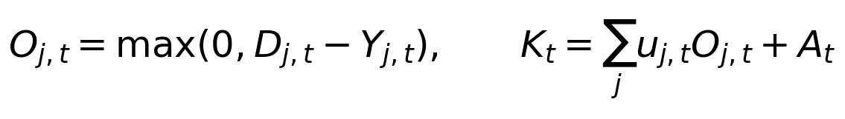
D is cumulative required transitions relative to baseline; j identifies the SM-upgrade or basic-entry transition; Y is cumulative delivered transitions; O is outstanding households; u is the applicable current unit cost; A is unpaid ancillary capital. The ledger also records annual additions, cancellations and advance delivery. Repricing households avoids carrying obsolete monetary costs when technology or unit costs change. Service contributions from external financing or physical improvements receive credit once, without being added again as cash.

Balances must not be summed as flows
Year | New planned cost | Funded cost | Closing expansion
1 | 20 million | 12 million | 8 million
2 | 20 million | 12 million | 16 million
3 | 20 million | 12 million | 24 million

At constant prices, planned cost totals 60 million and funded cost totals 36 million. The final outstanding balance is 24 million. Adding the closing snapshots gives 48 million and counts the same unfinished work repeatedly. This example excludes replacement and other costs.

3 Correcting the funded asset and replacement accounts

The original problem and the change
Unfunded planned expansion could enter the asset or cost accumulation used for later replacement. This generated maintenance obligations for infrastructure that had not been built. The implemented rule carries unfunded expansion as an outstanding service transition, while replacement is calculated only on opening existing and funded assets. Funded expansion is assumed delivered within the year; construction delays and delivery failures are outside this correction. [2]
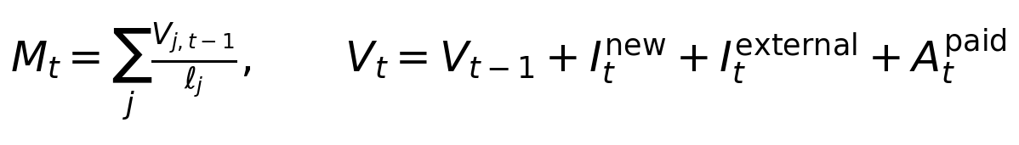
V is gross funded capital, ℓ asset life, M the replacement requirement, I newly funded expansion and A paid ancillary work. The expression summarizes the gross-stock convention, without depreciation or service deterioration. Replacement maintains the existing stock and is not added again as a new asset of equal value. New assets generate replacement from the following year. Physical NRW improvements that reuse infrastructure do not create a second full connection asset.
Illustration: opening funded stock of 100 million and a 10 percent replacement rate require 10 million. With 50 million available, 10 million goes to replacement and 40 million can fund expansion. Closing stock is 140 million and next-year replacement is 14 million. Any additional unfinanced target expansion does not increase this stock.

Separate current shortfalls from endline requirements
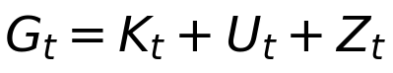
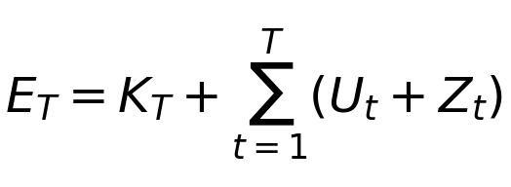
K is closing outstanding expansion, including legitimate unpaid ancillary capital; U is unpaid replacement in that year; Z is the recorded negative-cash shortfall. G is the current-year closing-gap measure. E is the endline requirement, which combines the final expansion balance with accumulated annual replacement and cash shortfalls. G must not be summed across years. Adjacent endline or subperiod balances are also not additive when they include earlier unpaid obligations.

What the correction does and does not establish
The ledger now capitalizes actual sector purchases, externally financed connections and paid ancillary work. The ancillary obligation is committed once and carried until paid. Its legacy magnitude and unit convention are preserved; this does not independently validate the treatment-cost calibration. Unpaid replacement remains a financing shortfall without reducing modeled coverage. Consequently, reported coverage does not establish that an undermaintained system could sustain that service in practice. Routine operating expenses also require separate consideration when interpreting utility surplus.

4 Correcting tariff and collection revenue

The original problem
The former tariff uplift calculation valued the tariff increase as if it were fully collected. It also needed to reconcile with collection improvements applied to the same billed revenue. Separate legacy volume and tariff inputs could imply different revenue bases for the two reforms. The change establishes a common base within each sector and geography, while retaining separate reform schedules and chart contributions. Water and sanitation do not need identical billed volumes. [3]
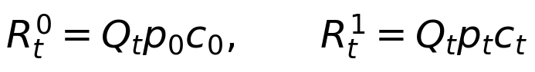
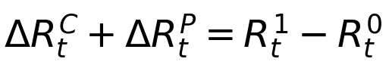
Q is annual billed volume, p the billed tariff per cubic meter and c the fraction of billed revenue collected. A disabled intervention leaves its rate at baseline. The tariff term therefore uses baseline collection when collection reform is off, and the scenario collection rate when it is on. Billed volume remains exogenous under the current implementation. Baseline collected revenue is a comparison quantity, not an additional funding injection.
Reforms enabled | Collected revenue | Additional cash
Neither | 800,000 | 0
Tariff only | 960,000 | 160,000
Collection only | 900,000 | 100,000
Both | 1,080,000 | 280,000

Example: Q = 1 million m³, tariff rises from 1.00 to 1.20 and collection from 80 to 90 percent. Joint additional cash is 280,000, comprising collection cash of 100,000 and tariff cash of 180,000. The 20,000 interaction is assigned to tariff under the collection-first convention. The joint benefit is not simply the sum of the two standalone benefits. Equal standalone results are possible for particular input changes but are not required by the formulas.

Remaining input and presentation refinements
The billed-revenue warning is a reconciliation requirement when legacy bases disagree. In the reviewed default sanitation inputs, the collection-derived volume was 70.08 MLD and the independent tariff volume 43.8 MLD. Wastewater collected is not necessarily wastewater billed; neither value should be chosen automatically. Water’s corresponding bases matched at 87.6 MLD. Show one shared revenue-baseline panel per sector, with inherited values in each reform panel. Validate baseline inputs always, but validate inactive reform targets only when enabled. These UI and validation refinements remain to be completed.

4 Continued NRW and presentation improvements

The agreed NRW assumption
We agreed to retain the existing interpretation that NRW improvements generate additional sales revenue, using the model’s existing cash valuation net of implementation costs. We did not request a new reduced-production or energy-savings calculation. NRW also has an existing physical service effect; cash and physical effects must remain separately accounted for. The implementation adjusted physical-flow caps and allocation alongside funded-asset accounting, so “no change to NRW methodology” does not mean that every NRW-related line of code remained unchanged. [1]
This remains a simplified scenario assumption rather than proof that all recovered water can be sold. Do not deduct NRW a second time from a quantity already defined as billed volume. If connection-based revenue is later introduced, check whether newly billed sales overlap the water already valued by NRW. Energy savings remain a Coming soon placeholder, with no calculation effect.

Five intervention categories
Category | Included interventions and treatment
Funding Mobilization | Financial commitments and injections. Utility debt contribution is attributed here for grouped outputs.
Operational Efficiency Improvements | Collection efficiency and NRW. Energy improvements is a noninteractive Coming soon placeholder.
Investment Planning and Delivery | Budget execution, capital cost efficiency and technology mix.
Tariff Reform | Standalone category, preserving its separate inputs and effect.
Household Financing and Affordability | Existing household microfinance and grants; subsidies is a Coming soon placeholder.

Category grouping sums existing contributions without changing model calculations or intervention order. Custom interventions remain a separate residual. Utility borrowing is distinct from household loans, with its panel below the categories and above custom interventions.

Contribution attribution and dollar display
Contributions are differences between successive full model runs in the established intervention order. Their totals must reconcile to the final scenario minus BAU. Financing and coverage effects are separate: additional cash can meet replacement needs without increasing coverage. Negative effects must remain visible; exclusive basic coverage can decline as households upgrade.

Dollar conversion uses a user-supplied exchange rate for monetary graphs and outputs, preserving the real-price basis. Engine calculations remain in local currency. Counts, percentages and volumes are not converted; existing dollar values must not be converted twice. Section 9 details remaining contribution-view defects.

5 Deferred proposal for revenue from new connections

Problem and rationale
Current billed volume grows through population-linked or configured fixed growth, rather than from the connections actually delivered by the model. Additional investment can therefore increase service coverage without feeding additional customer revenue into later investment resources. Conversely, a population-linked revenue path can imply more billed activity even when service expansion is unfunded. An optional connection-based mode would make this feedback explicit. It remains unconfirmed and unimplemented. [4]
Safely managed coverage is not synonymous with a billed utility connection. Basic-service households may already be customers, while some safely managed services may not generate the modeled utility revenue. Upgrading an already billed basic customer to SM should not create a whole new customer’s revenue without a change in billing status, consumption or tariff. SM-only billing can be offered as an explicit assumption, rather than imposed universally.
Input or assumption | Source and treatment
Delivered SM and basic households | Existing model output, by sector and geography.
Billed volume, baseline tariff and collection | Existing user inputs after revenue-base reconciliation; align reference year to baseline.
Reform targets and timing | Existing model inputs and schedules.
Shares of SM and basic households billed | New user data or explicit assumptions between zero and one.
Household share of billed volume | New user data or assumption; separate non-household volume.
Consumption per billed household | Derived from baseline household volume and modeled billed households.
Volume already represented in baseline funding | New user-confirmed assumption or external reference series.
Marginal operating cost per additional m³ | New user data or explicit simplifying assumption; zero must be disclosed.
Revenue timing | Proposed fixed assumption: delivered connections affect revenue in the following year.

Conditions for a robust application
Record each new value as observed or assumed, with its source, reference year and note. Do not silently assume 100 percent household volume or 100 percent SM billing. Calibrate from the model baseline year, not a future simulated customer count. If reference volume is dated later, use a baseline observation or a disclosed backcast. Limited and lower-service billing is outside the first version; flag data where that omission is material. Keep current exogenous mode as the default for existing scenarios.

5 Continued Dynamic revenue equations and integration
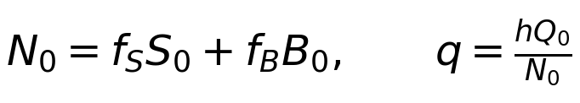
f denotes the billed share within each service level; h is the household share of baseline billed volume; q is calibrated annual consumption per billed household; Qnh is non-household volume under its own exogenous path. Use one common household consumption rate in the first version. Do not multiply the household component again by population growth. A positive household volume with zero billed households is invalid; a zero starting base with future billing needs an explicit consumption assumption.

Add only revenue not already included in funding
Define a fixed reference path Qr representing volume whose contribution is already assumed in baseline funding at baseline tariff and collection. The user must choose an existing exogenous path, fixed baseline volume or documented external series. The budget amount alone cannot establish this choice. Freeze the reference across BAU and all scenario passes. Let ΔQ be dynamic minus reference household volume and v the marginal variable operating cost per cubic meter; non-household paths are identical in both comparisons.
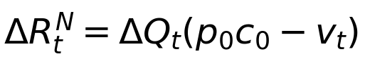
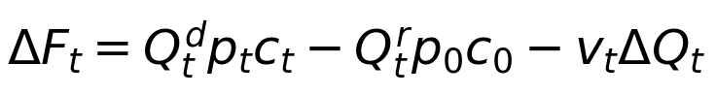
Total additional net cash equals the connection, collection and tariff terms summed once. Keep signed volume differences; falling below the funding reference can reduce available cash. The variable-cost offset does not eliminate fixed costs or funded assets. This is a proposed simplified incremental account, not a reconstruction of total utility profitability.
Worked example: dynamic volume 11,000 m³, reference 10,000, baseline tariff 1.00, scenario tariff 1.20, collection 80 to 90 percent, and marginal cost 0.20. Connection net cash is 600; collection cash 1,100; tariff cash 1,980; total 3,680. This equals collected revenue 11,880 minus reference revenue 8,000 minus incremental cost 200.

Annual order and compatibility with debt
Read previous-year delivered households; calculate billed volume and net cash; pass that cash once into the annual debt, replacement and expansion accounting; record this year’s funded households for next year. Apply the same mode to BAU and each cumulative intervention run. Keep tariff and collection chart bands separate, with no duplicate dynamic-revenue band. The earlier draft predates the debt module and assumes service-gap correction as a prerequisite: it must be updated before coding. We recommend keeping the new connection component outside eligible debt revenue initially; eligibility would require a separate decision and tests for loan-funded connection feedback. Check NRW overlap before enabling combined dynamic and NRW cases.

6 Deferred proposal for the false basic service gap

Problem and policy interpretation
The raw basic-only gap still compares the original basic-only target with projected basic-only households. With targets of 70 SM and 30 basic households out of 100, achieving 80 SM and 20 basic can show a basic shortfall of 10. All households already meet the basic minimum; insisting on 80 actual SM plus 30 basic implies 110 households. The proposed correction treats service targets as minimum achievements: SM overachievement can satisfy basic requirements, while basic overachievement cannot substitute for SM. [5]
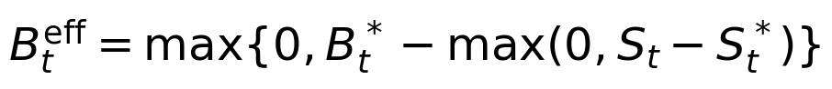
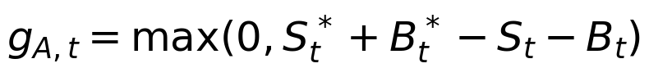
The adjusted basic-only shortfall gB is a reporting diagnostic. The at-least-basic access gap gA is the relevant basic-entry measure for the staged pathway. Validate that exclusive service categories sum to the projected population or household total and that combined targets do not exceed it. Original targets remain unchanged for reporting; do not lower the combined objective or move households merely to match chart categories.
Actual SM / basic | Adjusted basic gap | SM gap | At least basic gap
80 / 20 | 0 | 0 | 0
80 / 15 | 5 | 0 | 5
60 / 40 | 0 | 10 | 0
60 / 30 | 0 | 10 | 10
100 / 0 | 0 | 0 | 0

Avoid a second correction to financing
The current expansion ledger already uses combined SM-plus-basic targets for basic entries. It may already avoid the spurious financing obligation in a given case even though the displayed basic gap is wrong. Inspect and reconcile the outputs before changing costs. Do not subtract the SM surplus again from a combined-target ledger. In the 60 SM / 30 basic example, ten households still need basic access and ten upgrades are needed to meet SM: zero exclusive basic shortfall does not mean zero basic-entry cost.
Calculate gaps locally before aggregating; one area’s surplus cannot erase another’s deficit. Preserve the existing concurrent use of prior-year service pools, investment splits and transition costs. Do not introduce direct lower-to-SM connections or same-year two-step upgrades. Leave actual funded stock and legitimate replacement shortfalls intact. Apply consistent definitions to water, sanitation, BAU, dashboards and exports, with explicit field names and regression tests.

7 Utility debt financing already implemented

Purpose and scope
Utility borrowing brings forward infrastructure investment against future additional revenue and reduces later cash through debt service. It is separate from household microfinance. The reviewed implementation supports one loan per sector and modeled area, annual payments, a fixed annual real interest rate, an optional loan ceiling, principal grace and repayment within or beyond the target year. It is disabled by default. Interest is charged on outstanding principal, with no interest in the draw year under the model’s timing convention. [6]
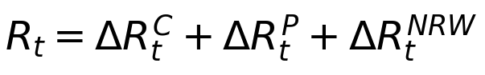
R is eligible signed net revenue from collection, tariff and NRW, including only the relevant sector’s NRW-linked cash. F is capital available before the new loan and its repayments and includes those sources once. M is protected replacement; C is the annual payment capacity; α is the current common allocation share. This assumes operating obligations and existing debt have already been accounted for in F. Budget execution, cost efficiency, commitments, injections and custom interventions do not independently create eligible revenue.

Annual repayment structures
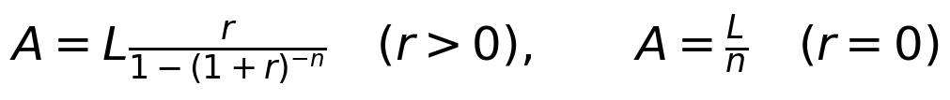
For an annuity, L is the loan, r the annual rate, n principal-payment years, A the constant payment, I interest, P principal repayment and D outstanding principal. During principal grace, principal is zero and annual interest is paid. Equal-principal mode instead uses P = L/n, so total payments decline as interest falls. A five-year loan of 1 million at 5 percent has annuity payments of 0.230975 million; equal-principal payments are 0.25, 0.24, 0.23, 0.22 and 0.21 million.
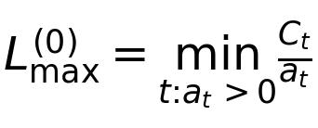
Here a is the payment on a unit loan. The model then reruns the scenario because loan-funded assets raise replacement needs, reducing repayment capacity. It resizes until the full schedule passes annual capacity checks. One reviewed example fell from an initial 4,328.060 million to 3,456.293 million after this feedback. This supports the normal-case mechanism but does not resolve the post-target defect described next.

8 Remaining debt servicing refinements

Preserve continuing costs beyond the target year
This is the highest-priority calculation repair. The financial tail currently removes all terminal custom cash when constructing recurring resources. Subtracting a negative custom cash flow adds it back, even if that cost is explicitly scheduled to continue. As a result, the model can label an unaffordable loan “verified feasible.” [1]
In the controlled review, a custom cost of 40,000 million was spread over 2040–2049, or 4,000 million annually. With a 2040 draw and maturity in 2045, the model accepted 2,719.542 million of debt and reported a 2041 payment and capacity of 628.146 million. Retaining the known 2041 cost reduced capacity to zero. These are stress-test values, not a country forecast.
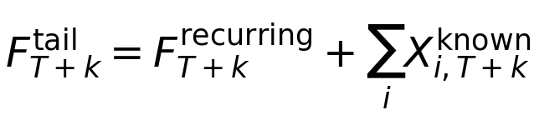
Build tail resources from components and their actual schedules. Keep continuing negative commitments until expiry; remove expired one-off inflows and unsupported positive receipts without deleting costs. Freeze the post-target physical asset stock under the agreed simplified tail, including assets funded in T, and continue their replacement requirement. Recompute capacity and loan size using the same tail logic shown in the repayment table.

Disclose the liability left after the simulation
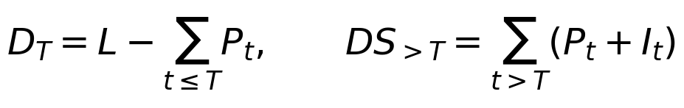
Show target-year closing principal, remaining principal, remaining interest, total post-target payments and installment counts. Also show whether maturity exceeds T, unspent restricted loan cash, minimum repayment headroom and any shortfall. In an ordinary review case, a 3,456.293 million loan drawn in 2026 and maturing in 2045 left 1,238.192 million after the 2040 payment. The engine and detailed Excel schedule contained the balance; dashboard and PowerPoint summaries did not disclose it explicitly.

Retain correct cash treatment
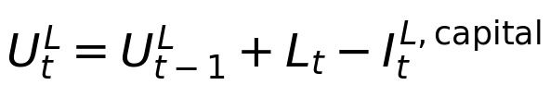
Unspent loan proceeds are restricted expansion cash: opening balance plus disbursement minus loan-funded capital spending equals closing balance. They cannot service the loan or become new eligible revenue. Deduct actual debt service once from ordinary cash; the allocation percentage defines a ceiling and is not an additional expense. Retain replacement protection and ordinary-funds-first investment treatment. Explain that model feasibility depends on entered assumptions and is not a lender’s credit assessment.

8 Continued Revenue source selection and allocation

Requested enhancement to the existing panel
The current panel already pools the three eligible revenue streams and applies one percentage. The later request is to allow separate source selection and allocation percentages, with an immediate display of annual cash committed to repayment and the resulting additional capital. This is an enhancement beyond the current pooled control; it has not yet been implemented or finalized as a programming specification.
Revenue source | Net annual cash | Selected share | Indicative allocation
Collection efficiency | 6 million | 50 percent | 3 million
Tariff reform | 10 million | 50 percent | 5 million
NRW | 4 million | Not selected | 0
Total | 20 million | Source specific | 8 million

Percentages apply to each source and need not sum to 100. Unselected positive cash remains available for direct investment. An unchecked NRW source must not remove NRW implementation costs from the overall cash account. With a stable annual payment capacity of 8 million, ten annual payments at 5 percent could support about 61.8 million before replacement feedback, other constraints and a loan ceiling. If actual service is 8 million, 12 million of the illustrated 20 million remains before other obligations; unused allocation is not automatically spent.

Proposed rule for signed sources and migration
The allocation rule needs explicit agreement because negative source cash and protected costs can make naive source-by-source percentages inconsistent with the current pooled calculation. The following recommendation preserves the current result when the same percentage is applied to every source. It allocates eligible net capacity proportionally across positive streams after aggregate negative cash and protected-resource limits have been recognized.
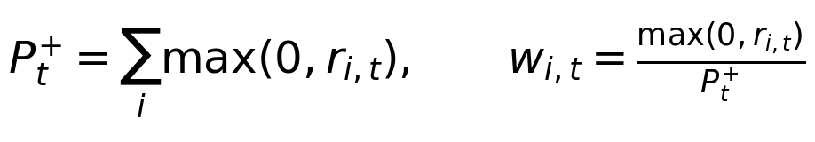
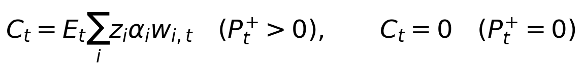
Use E from Section 7, computed from all signed eligible streams. z selects a source and αi is its percentage. The displayed source contribution to capacity is E × z × αi × w. If all sources are selected with the old common percentage, this reproduces the current capacity exactly. Losses remain recognized even when their source is deselected. This is a proposed allocation convention for review, not existing code or a previously agreed policy rule.
Place the source table in the existing utility debt panel below the intervention categories. Display selected-year source cash and eligible capacity, actual debt service, direct-investment cash, calculated proceeds and the complete repayment schedule. Keep loan settings and source selections separate for each sector and area. Preserve interaction attribution: tariff cash includes its interaction with collection improvement, so the source labels are an accounting convention rather than independent causal revenue estimates.

9 Remaining programming challenges in charts and exports

Repair native PowerPoint slide collisions first
The reviewed debt-enabled native deck appends slides after pruning or cloning template slides. New slide part names can collide with surviving parts. The controlled export contained duplicate slide21 and slide22 XML parts and their relationships, causing earlier content and later debt slides to resolve to the same parts. Allocate globally unique names or safely reorder creation and pruning. Test ZIP-part uniqueness, relationships and preservation of existing content for one and multiple debt schedule pages. A successful file save is insufficient. [1]

Repair category data keys in the live intervention charts
The aggregation helper stores data under stable keys such as category:tariff, but the chart reads the label Tariff Reform. This yields missing plotted data and zeros in the chart-specific Excel export. Use the stable key for values, percentage conversion and dataKey; use the label only for legends and headings. Verify that individual and grouped totals agree for both service levels and both count and share views.

Keep financing category selection independent of coverage
The results dashboard calculates grouped coverage and financing data separately, but uses the coverage band list for both. A category with no coverage effect can therefore disappear despite reducing the financing gap. Use each measure’s own bands, or an explicit union. Test a cash improvement that pays replacement without funding new households: its financing benefit must remain visible.

Preserve area specific intervention choices
Dashboard cumulative contribution requests currently copy the primary area’s toggles into every area, even though the summary uses each area’s actual selections. In the review fixture, urban reforms were off and rural tariff reform was on. The actual national SM result was 1.320701 million households; the dashboard contribution endpoint implied 1.202574 million, a difference of about 118,126 households. The native deck preserved the correct selections.
Build a union of enabled intervention keys across areas, but add each intervention only where that area originally enabled it. Reuse the backend cumulative-pass logic where practical. Check rural-only, urban-only and national views, including the debt marginal contribution. Do not change user selections merely to make contribution calculations easier.

Restore custom contributions to Excel and CSV
The whole-scenario export returns an empty breakdown when only custom interventions are active and does not append their marginal contribution later. Add the difference between the final built-in pass and the custom pass, then the separate debt pass in the established order. Keep custom effects outside the five categories and retain negative values. Match dashboard and native-deck results for custom-only and mixed scenarios.

9 Continued Input handling and output consistency

Prevent inactive inputs from blocking the baseline
The shared revenue base is always present after reconciliation. The current condition validates reform targets when a reform is enabled or a revenue base exists, so an old disabled tariff target below a newly edited baseline can block even BAU. Always validate the shared baseline; validate reform direction and target constraints when the reform is enabled. Apply the same rule to collection efficiency. Enabling an inconsistent setting should produce a clear error, while an inactive setting should not silently alter inputs or block calculation.

Make the shared baseline understandable
The two reform panels currently display editors for the same canonical revenue data. This can look like two independent assumptions. Consolidate the baseline into one sector-level panel and show inherited values next to each reform. Retain separate start years, end years and target values. Reconciliation should identify volume, units, anchor year, growth and tariff differences; normalize them before deciding whether old bases match. Save the resolved base independently of enabled toggles so partial contribution runs use identical assumptions.

Complete debt disclosures across all routes
The target-year debt summary described in Section 8 must be derived once in the backend and reused in the panel, results dashboard, Excel and both PowerPoint routes. Show closing principal in the annual table, rather than only opening principal. Keep outstanding debt distinct from unspent proceeds. Apply the same exchange rate and unit scaling as other monetary outputs. A loan ending by T should show zero post-target principal; a later maturity must show the residual liability.

Verify signed charts and colors
Negative contribution values are retained in data, but ordinary stacked-area charts still need visual acceptance checks. Confirm that negative basic coverage from upgrades and adverse cash effects are intelligible and reconcile with the final scenario. In the native deck, some colors include a leading hash while the RGB parser expects six bare hexadecimal characters, allowing silent fallback to template colors. Normalize color parsing and inspect the actual rendered series.

Keep definitions consistent and limitations visible
Update comments that describe exogenous billed-volume growth as growth “with coverage.” Use annual planned expansion, closing outstanding expansion, current unpaid replacement and endline requirement consistently across APIs, chart labels and exports. Do not silently change an old field’s meaning without updating consumers and saved-result handling. Show that debt affordability assumes baseline capital is net of operating obligations and existing debt; if the data are gross, a reconciled deduction is required before applying the capacity calculation.
These are implementation and disclosure repairs. They can proceed without approving dynamic connection revenue or the dedicated false-basic-gap methodology. The two deferred proposals should remain explicitly disabled or absent until their respective design and data decisions are made.

10 Verification and recommended development sequence

Evidence already obtained
The reviewed main snapshot passed 34 Python unit tests and the frontend TypeScript/Vite production build. The build used existing compatible dependencies, rather than a clean lockfile installation. Additional targeted checks covered annuity and equal-principal schedules, zero interest, grace, zero-capacity years, principal reconciliation, zero-allocation compatibility, replacement-driven resizing, restricted loan cash and financing-gap attribution. Selected Excel and both PowerPoint routes were generated and reopened; package inspection exposed the native deck defect. These extra checks are not a substitute for committed regression tests. [1]
The review did not test the deployed Replit instance, complete a full browser acceptance pass, or visually inspect every exported slide. No dedicated utility-debt test file was present in the reviewed snapshot. The report therefore supports targeted repair and review, rather than unconditional release sign-off.
Stage | Work package | Completion condition
1 | Debt tail and native PPT repairs | Known continuing costs retained; every debt year feasible; unique slide parts and content preserved.
2 | Chart, geography and validation repairs | Summary, individual/category contributions and exports reconcile; disabled inputs cannot block BAU.
3 | Debt disclosure and source controls | Complete target-year summary; source-allocation convention approved; migration preserves old results.
4 | False basic gap if approved | Minimum-service metrics pass all examples; existing correct transition costs are not reduced twice.
5 | Dynamic revenue if approved | Required data and funding reference resolved; lagged cash identity and NRW/debt interactions tested.
6 | Integrated release review | Regression suite, clean build, browser checks and all export routes pass against one documented commit.

Focused acceptance cases
Funding and assets: reproduce the 100-connection example, the 8/16/24-million backlog and the 100-to-140-million funded-stock example; test changing costs, no funding, negative cash and catch-up funding. Revenue: test all four tariff/collection combinations, differing schedules, zero volume, zero collection and conflicting legacy bases. Debt: test both schedules, zero interest, grace, zero allocation, continuing post-target costs, replacement feedback and final principal of zero.
Presentation and proposals: reconcile individual and category totals, area-specific scenarios, finance-only effects, custom effects and signed values across outputs. For false gaps, test 80/20, 80/15 and 60/30 against 70/30 while retaining replacement shortfalls. For dynamic revenue, verify that already billed upgrades add no customer volume, delivered connections affect next-year revenue only, and the 3,680 cash example reconciles. Add these as repeatable tests before relying on the revised results.

11 Sources and implementation traceability
Sources are the project code review, design instructions and subsequent discussion. Examples are illustrative unless identified as review reproductions. Implementation status applies to the reviewed commit.

Source documents
[1] WSS_Main_Code_Review_2026-10-03.md. Review of main commit ba4aba233c1257020f86fbaea9e4bd12d83921a6. Contains the eight reproduced defects, implementation status, verification boundaries and normal-case numerical checks.
[2] Replit_Annual_Expansion_and_Financing_Instructions.md. Supersedes the earlier narrow Replit_Financing_Gap_Fix.md. Defines funding credited once, outstanding transitions, funded stock and annual versus closing balances.
[3] Replit_Tariff_and_Collection_Revenue_Fix.md. Defines the canonical sector revenue base, collected-revenue identity, interaction attribution and separate financing/coverage contributions.
[4] Replit_Connection_Based_Revenue_Instructions.md and WSS_Connection_Based_Revenue_Approach.docx. Deferred proposal. Earlier instruction prerequisites and annual order must be reconciled with the current debt implementation before use.
[5] Replit_SM_Overachievement_and_Basic_Gap_Fix.md and WSS_Service_Target_Accounting_Brief.docx. Deferred proposal. Distinguishes adjusted basic-only reporting from the combined access transition used for costing.
[6] Replit_Utility_Debt_Financing_Instructions.md. Defines utility borrowing and supersedes Replit_Revenue_Allocation_to_Household_Loans.md. The latter should not be used to implement the utility debt feature.
[7] Replit_Intervention_Categories_UI_Instructions.md, Replit_Contribution_Visualization_Toggle.md and Replit_USD_Display_and_Export_Instructions.md. Presentation specifications. Source-specific debt allocation is a subsequent enhancement discussed in this report, not an implemented feature of those documents.

Code locations for the development handoff
Component | Relevant files in the reviewed repository
Expansion and funded assets | model/expansion_ledger.py; model/water_supply.py; docs/financing-ledger.md
Tariff and collection | model/utility_revenue.py; model/water_supply.py; RevenueBase.tsx
Utility debt | model/utility_debt.py; model/inputs.py; model/engine.py
UI and attribution | InterventionPanel.tsx; LiveInterventionChart.tsx; ResultsDashboard.tsx
Exports | export_data.py; deck_data.py; export_deck.py; export_pptx.py

Repository: https://github.com/yourstrulyalwiz/wss_simulation_new. Reviewed commit: ba4aba233c1257020f86fbaea9e4bd12d83921a6. Frontend components are under frontend/src/components. Develop from current main and preserve validated behavior; do not apply superseded patches blindly.

