**BUS PASSENGER TRACKER DATABASE**

**(Revising…)**

Initially submitted

as partial fulfillment of the requirements for the subject

Database Systems

*Authors*

Hannah Bella C. Arceño

Adrian Miguel Custodio

Abigail Dawn P. Davocol

Nhilbert Jay Valente

Mariefher Grace Villanueva

*Revised By*

Hannah Bella C. Arceño

June 23, 2021

**INTRODUCTION**

Buses are often the preferred mode of transportation among commuters especially in the provinces. But because of COVID-19 pandemic, bus stations needed to impose stricter transportation policies and monitor passengers as well as employees who may come into contact with passengers. When transportation restrictions slowly lifted, numerous terminals and bus operators slowly started to open. Yet with the threat of COVID-19 and possible transmission that could risk the lives of the commuters and their families, an efficient and easily accessible passenger tracker system can help.

Bus passenger tracker is a database system that aims to enable the contact tracers to efficiently access the needed information of passengers. In this way, It can minimize the surge of covid transmission.

**APPLICATION DOMAIN**

1. A person has a name, address, date of birth, age, multiple contact numbers, and a corresponding **id** to uniquely identify them.
2. A person may or may not have taken a vaccine.
3. A vaccine can be taken by many persons or none at all.
4. For each person, their vaccination status must be indicated. If they are vaccinated, the amount of doses and the recent date which those doses have been taken should be indicated.
5. Each vaccine has a brand, a manufacturer, and a corresponding **id**.
6. A person can either be an employee or passenger, ~~but not both~~.
7. Each employee has a designation. An employee is either a driver or a conductor.
8. A driver and a conductor operate one or many trips.
9. Each trip is defined by the route taken, the date, departure time, arrival time, and a corresponding id.
10. A trip can only depart to one route, but a route can have many trips happening on it.
11. Each route is defined by its route_id, origin and destination of the traveling bus,
12. A bus can take many trips but a trip can only be taken by one bus.
13. Each bus has a control number, plate number, and passenger capacity.
14. A passenger may pay for one or more trips and a trip can have many passengers. In a trip, each passenger has their own origin and destination, the due fare, and corresponding id.

**EER DIAGRAM**

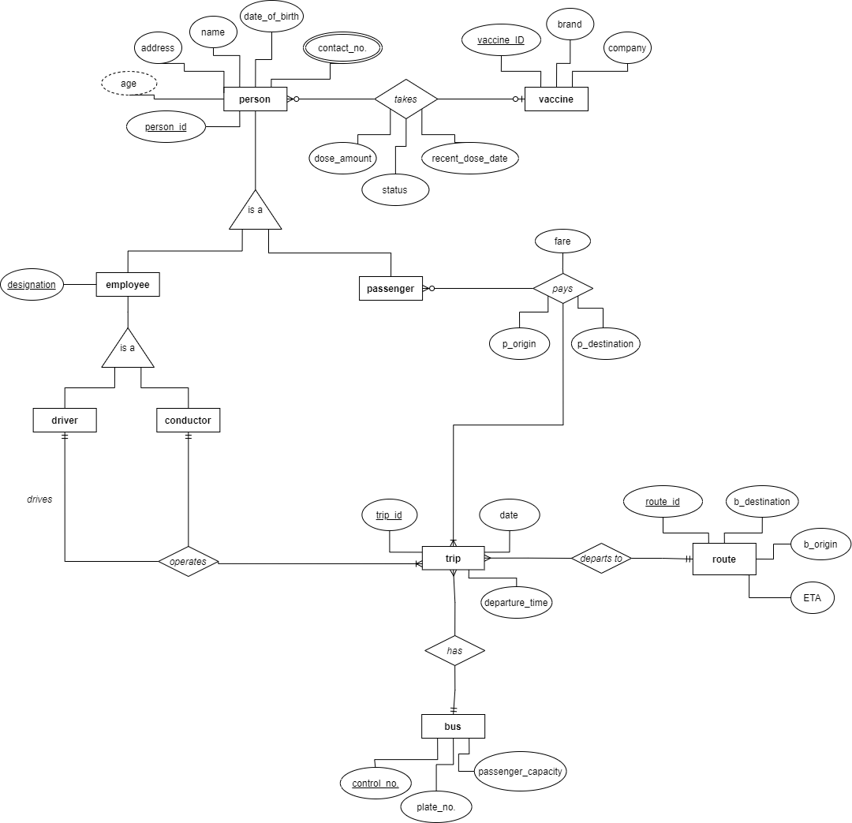

**NORMALIZATION**

**1NF**

*persons*

| **Person_ID** | First_Name | Middle_Name | Last_Name | Address | Date_of_birth |
| --- | --- | --- | --- | --- | --- |
| **1** | Maria | Fernando | Jena | Santa Anna | 2003-10-12 |
| **5** | San | Fernando | Pedro | New City | 1999-12-25 |
| **6** | Jane | Bustos | Marikit | Uptown road | 1976-01-09 |

*vaccination*

| **Person_ID** | Vaccine_ID | status | Dose_Amount | Recent_Dose_Date |
| --- | --- | --- | --- | --- |
| **1** | 2021100 | 1 | 2 | 2021-11-09 |
| **5** | 2021900 | 0 | NULL | NULL |
| **6** | 2021870 | 1 | 1 | 2021-07-18 |

*vaccines*

| **Vaccine_ID** | Brand | Company |
| --- | --- | --- |
| **2021100** | Pfizer | Pfizer |
| **2021900** | Oxford-AstraZeneca | Astrazeneca |
| **2021870** | Sinovac | Sinovac BioTech |

*employees*

| **Person_ID** | Designation |
| --- | --- |
| **15** | Driver |
| **11** | Conductor |
| **10** | Driver |

*contact*_no

| **Person_ID** | phone_no |
| --- | --- |
| **1** | 02799397562 |
| **5** | 02799397565 |
| **6** | 02799337562 |

*trips_payment*

| **Passenger_ID** | **Trip_ID** | P_Origin | P_Destination | Date | Fare |
| --- | --- | --- | --- | --- | --- |
| **1** | **134** | Terminal 3 | Jaro | 2020-01-06 | 145.50 |
| **5** | **135** | Terminal 5 | Terminal 7 | 2020-01-06 | 160.00 |
| **6** | **142** | Terminal 1 | CityMall B | 2020-01-06 | 125.00 |

*trips*

| **Trip_ID** | Departure_Time | Date | Control_No. | Route_ID | Driver_ID | Conductor_ID |
| --- | --- | --- | --- | --- | --- | --- |
| **134** | 5:30 | 2020-01-06 | C127 | 09 | 15 | 11 |
| **136** | 13:10 | 01-06-2020 | C126 | 08 | 10 | 21 |
| **145** | 2:45 | 01-06-2020 | C142 | 10 | 15 | 31 |

*bus*

| **Control_no.** | Plate_number | Passenger_Capacity |
| --- | --- | --- |
| **C127** | HDH-140 | 30 |
| **C126** | CDO-555 | 30 |
| **C142** | AHA-616 | 30 |

*route*

| **Route_ID** | B_origin | B_destination |
| --- | --- | --- |
| **09** | South terminal | New City |
| **08** | North terminal | Parker Terminal |
| **10** | West side | Old terminal |

**\*No dependencies found for 2NF and 3NF**

**RELATIONAL MODEL**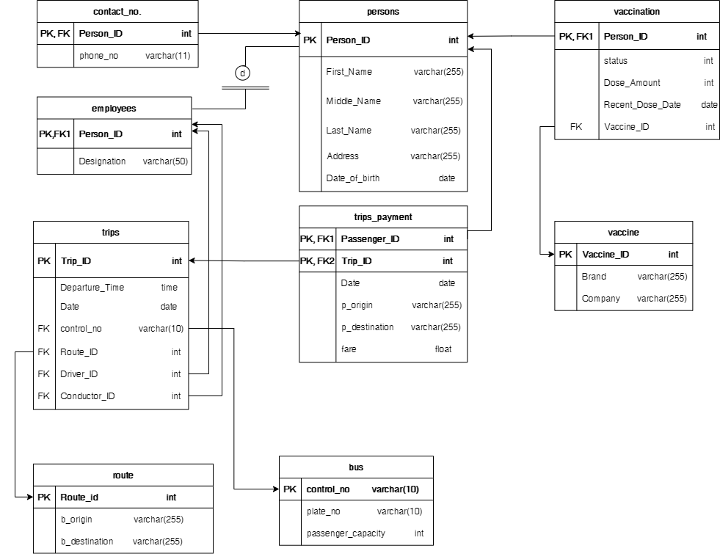

**SQL DDL**

1. Creating the database.

CREATE DATABASE passengerTracker;

CREATE TABLE persons (

Person_ID int NOT NULL AUTO_INCREMENT,

Last_Name varchar(255),

Middle_Name varchar(255),

First_Name varchar(255),

Address varchar(255),

Date_of_birth date

PRIMARY KEY(Person_ID)

);

1. CREATE VIEW persons_view AS

SELECT *, DATEDIFF(CURRENT_DATE,Date_of_birth) DIV 365.2425 AS   
 age

FROM persons;

CREATE TABLE bus (

control_no varchar(10) PRIMARY KEY,

plate_no varchar(10),

passenger _capacity int

);



CREATE TABLE route (

Route_ID int PRIMARY KEY,

b_origin varchar(255),

b_destination varchar(255)

);



CREATE TABLE vaccine (

Vaccine_ID int PRIMARY KEY,

Brand varchar(255),

Company varchar(255)

);



CREATE TABLE vaccination (

Person_ID int PRIMARY KEY,

status int NOT NULL DEFAULT ‘0’,

Dose_Amount int,

Recent_Dose_Date date,

Vaccine_ID int,

FOREIGN KEY (Person_ID) REFERENCES persons(Person_ID) ON DELETE  
 CASCADE,

FOREIGN KEY (Vaccine_ID) REFERENCES vaccine(Vaccine_ID) ON DELETE  
 CASCADE

);

CREATE TABLE trips (

Trip_id int PRIMARY KEY,

Departure_Time time(),

Date date,

control_no varchar(10)

int Primary Key,

Route_ID int,

driver_ID int,

conductor_ID int,

FOREIGN KEY (driver_ID) REFERENCES persons(Person_ID) ON DELETE CASCADE,

FOREIGN KEY (conductor_ID) REFERENCES persons(Person_ID) ON DELETE CASCADE,

FOREIGN KEY (control_no) REFERENCES bus (control_no) ON DELETE  
 CASCADE,

FOREIGN KEY (Route_ID) REFERENCES route (Route_ID) ON DELETE  
 CASCADE

);

CREATE TABLE trips_payment (

Passenger_ID int NOT NULL,

Trip_ID int NOT NULL,

p_origin varchar(255),

p_destination varchar(255),

fare float,

PRIMARY KEY(Passenger_ID, Trip_ID),

FOREIGN KEY (Trip_ID) REFERENCES trips(Trip_ID) ON DELETE CASCADE,

FOREIGN KEY (Passenger_ID) REFERENCES persons(Person_ID) ON DELETE  
 CASCADE

);



CREATE TABLE employees (

Person_ID int PRIMARY KEY,

Designation varchar(50),

FOREIGN KEY (Person_ID) REFERENCES persons(Person_ID) ON DELETE  
 CASCADE

);



CREATE TABLE contacts (

Person_ID int,

phone_no varchar(11),

PRIMARY KEY(Person_ID,phone_no),

FOREIGN KEY (Person_ID) REFERENCES persons(Person_ID) ON DELETE  
 CASCADE

);

**SQL DML**

1. Insert employees’ details to the database.

INSERT INTO persons(Person_ID, First_Name, Middle_Name, Last_Name, Address, Date_of_Birth) VALUES (‘1’,‘Ricardo’, ‘Santos’, ‘Dalisay’, ‘Sampaloc’, ‘1984-09-28’), (‘2’,‘Dominador’, ‘Santos’, ‘Dalisay’, ‘Sampaloc’, ‘1984-09-28’);

INSERT INTO employees(Person_ID, Designation) VALUES(‘1’,‘Conductor’),(‘2’,Driver);

1. Insert a passenger’s details to the database.

INSERT INTO persons (Person_ID, First_Name, Middle_Name, Last_Name, Address, Date_of_Birth)

VALUES (‘5’, ‘Maria’, ‘Fernando’, ‘Jena’, ‘Santa Anna’, ‘2003-10-12’);

1. Insert vaccine details to a database.

INSERT INTO vaccine (Vaccine_ID, Brand, Company)

VALUES (‘2021100’, ‘Pfizer’, ‘Pfizer’);

1. Insert vaccination details of all persons.  
     
   INSERT INTO vaccination (Person_ID) SELECT person_ID from persons
2. Insert bus information into database

INSERT INTO bus (Control_no, plate_no, Passenger_Capacity)

VALUES (‘C127’, ‘HDH-140’, ‘30’);

1. Insert a bus trip to the database.

INSERT INTO trips (Trip_ID, Departure_Time, Date, Control_No., Route_ID, Driver_ID, Conductor_ID)

VALUES (‘1’,‘05:30:00.0000000’, ‘2021-06-23’, ‘C127’, ‘09’, ‘1’, ‘2’);

1. Insert payment of passenger 3.

INSERT INTO trips_payment (Passenger_ID, Trip_ID, p_origin, p_destination, Fare)

VALUES (‘3’, ‘1’, ‘Terminal 3’, ‘Jaro’, ‘145.0000’);

1. Insert route details into database

INSERT INTO route (Route_ID, b_origin, b_destination)

VALUES (‘09’, ‘South Terminal’, ‘New City’)

1. Insert a person’s contact details into the database with multiple phone numbers.

INSERT INTO contacts (Person_ID, phone_no)

VALUES (‘1’, ‘02799397562’),(‘1’, ‘09595397562’)

1. Update an employee’s designation.

UPDATE employees

SET Designation = ‘Conductor’

WHERE Person_ID = ‘1’;

1. Update a person’s details.

UPDATE persons

SET Address = “Makati City”

WHERE First_Name = ‘Maria’ and Last_Name = ‘Jena’;

1. Update vaccination status for a person 2.

UPDATE vaccination

SET status = ‘1’, Vaccine_ID = ‘2021100’, Dose_Amount = ‘2’, Recent_Dose_Date = ‘2021-06-11’

WHERE Person_ID = 3;

1. Insert a new passenger and their vaccination details.

BEGIN;

INSERT INTO persons (First_Name, Middle_Name, Last_Name, Address,  
 Date_of_Birth) VALUES (‘Crispin’, ‘Basilio’, ‘Ibarra’, ‘San Diego’, ‘2000-6-12’);

INSERT INTO trips_payment(Passenger_ID, Trip_ID, p_origin, p_destination,fare)

VALUES(LAST_INSERT_ID(),'1','San Isidro','Miagao','1263.50');

INSERT INTO vaccination (person_ID, status, Vaccine_ID, Dose_Amount,   
 Recent_Dose_Date ) VALUES (LAST_INSERT_ID(), ‘1’,‘2021100’, ’1’, ‘2021-06-20’);

COMMIT;

1. Delete all details of a person.

DELETE FROM persons

WHERE First_Name = ‘Maria’ AND Middle_Name = ‘Fernando’ And Last_Name = ‘Jena’;

1. Delete a person’s contact number.

DELETE FROM contacts

WHERE Person_ID = ‘1’ AND phone_no = ‘02799397565’;

1. Delete a bus.

DELETE FROM bus

WHERE plate_no = ‘HDH-140’;

1. Delete a route.

DELETE FROM route

WHERE b_destination = ‘Old Terminal’;

**SAMPLE DATABASE QUERIES**

1. Names of the passengers and their end destination who took the bus with the control no. C127

SELECT CONCAT (p.First_Name, “ “, p. Middle_Name, “ “, p.Last_Name) AS Passenger_Name, tp.p_destination AS Destination

FROM persons_view AS p, trips_payment AS tp, trips AS t

WHERE p.Person_ID = tp.passenger_ID AND tp.Trip_id = t.Trip_id AND t.control_no = ‘C127’;

1. Names of the passengers, and their respective addresses who haven’t completed their vaccine shots.

SELECT CONCAT (First_Name, “ “, Middle_Name, “ “, Last_Name) AS Name_of_Vaccinated_Persons, Address

FROM persons_view AS p, vaccination

WHERE p.Person_ID = vaccination.Person_ID AND vaccination.status =’0’;

1. The destination of all buses and their control number.

SELECT r.b_destination, b.control_no

FROM route AS r, bus AS b, trips AS t

WHERE b.control_no = t.control_no AND r.Route_ID = t.Route_ID;

1. Change Ricardo Dalisay’s designation to driver.

UPDATE employees, persons

SET employees.Designation = ‘Driver’

WHERE employees.Person_ID = persons.Person_ID AND persons.First_Name = ‘Ricardo’ AND persons.Last_Name = ‘Dalisay’;

1. Delete Maria Jena in the passenger list.

DELETE trips_payment FROM trips_payment INNER JOIN persons ON  
trips_payment.Passenger_ID = persons.Person_ID AND persons.First_Name = ‘Maria’  
AND persons.Last_Name = ‘Jena’;

1. Find all passengers who have taken trips with Crispin Ibarra.

SELECT CONCAT(passengers.First_Name, “ ”, passengers.Last_Name) AS Name

FROM (SELECT * FROM persons_view   
 WHERE Person_ID NOT IN (SELECT Person_ID

FROM employees)) AS passengers INNER JOIN trips_payment ON passengers.Person_ID = Passenger_ID

WHERE Trip_ID IN (SELECT Trip_ID FROM trips_payment

WHERE Passenger_ID IN (SELECT Person_ID

FROM persons_view   
WHERE First_Name = ‘Crispin’ AND Last_Name = ‘Ibarra’));

1. Give the complete names of employees who have not taken a vaccine shot.

SELECT CONCAT (p.First_Name,“ ”, p. Middle_Name,” “, p.Last_Name) AS Employee_Name

FROM persons_view AS p, employees AS e, vaccination AS v

WHERE p.Person_ID = e.Person_ID AND v.Person_ID = p.Person_ID AND v.status=’0’;

1. Give the names of the passengers who are aged below 18.

SELECT CONCAT (First_Name, “ ”, Middle_Name, “ ”, Last_Name) AS Name

FROM persons_view

WHERE age<18;

1. Find the names of the employees who got vaccinated with either Pfizer or Sinovac.

SELECT CONCAT (First_Name, “ ”, Middle_Name, “ ”, Last_Name) AS Name

FROM persons_view AS p, vaccine AS v, vaccination AS pv

WHERE p.Person_ID = pv.Person_ID AND pv.Vaccine_ID = v.Vaccine_ID AND

v.Brand = ‘Pfizer’ OR v.Brand = ‘Sinovac’;

1. Change the bus capacity of Bus with plate number HDH-140 to 20.

UPDATE bus SET passenger_capacity = 20 WHERE plate_no = ‘HDH-140’;