
Another first for the most innovative, most usable office software package in the world
The Open Answer

OpenOffice.org Version 1 was the first product to deliver the benefits of open-source software to mass-market users, delivering essential everyday software tools completely free of charge. Translated into over 30 languages, available on all major computing platforms (Microsoft Windows, Mac OS X X11, GNU/Linux, Solaris), OpenOffice.org Version 1 is now in use by tens of millions of delighted users worldwide.
With Version 2, it gets even better
- the first office suite to use the new OASIS OpenDocument format, the future-proof international standard for office software
- easier to install, with a whole new look and feel, matched to the type of computer in use
- more intuitive, more easy to use than ever, with a host of new usability features
- introducing a major new component, Base: an easy-to-use database manager with a fully integrated database
- more compatible with other software packages; minor glitches, formatting, and font problems occasionally found with Microsoft Office files have been eliminated

But the licence is still the same: you may download OpenOffice.org Version 2 completely free of any licence fees, use it for any purpose – private, educational, government and public administration, commercial – and pass on copies free of charge to family, friends, students, employees, etc.
OpenOffice.org Version 2 is available now
- download today from http://download.openoffice.org
- order a CD-ROM from a distributor http://distribution.openoffice.org/cdrom
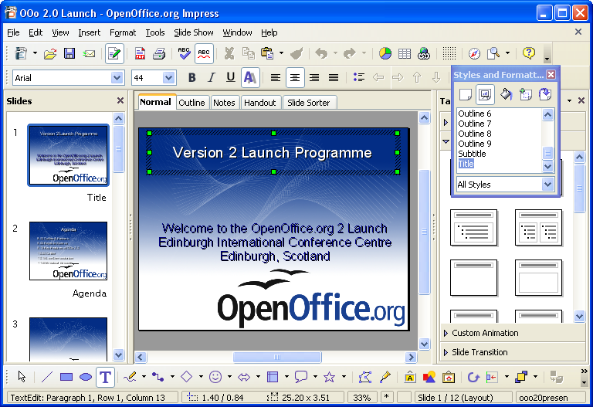Impress - OpenOffice.org's tool for creating dynamic presentations

Writer – for all your Documents
Quality Office Suite
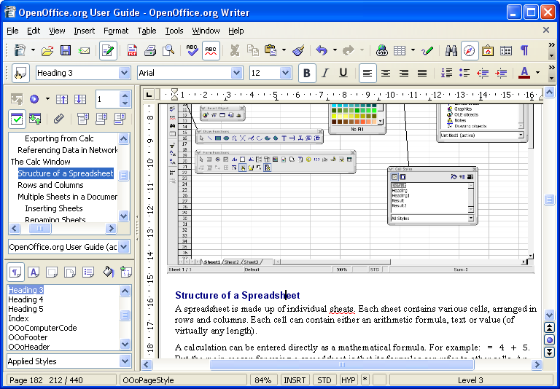
Writer is OpenOffice.org’s word processor: use it for anything from writing a quick letter to producing an entire book with embedded illustrations, cross-references, tables of contents, indexes, bibliographies... Auto-complete, auto-format, and real-time spelling check make light work of the hardest task. Writer is powerful enough to tackle desktop publishing tasks such as creating multi-column newsletters, brochures – the only limit is your imagination.
Calc – the all-purpose Spreadsheet
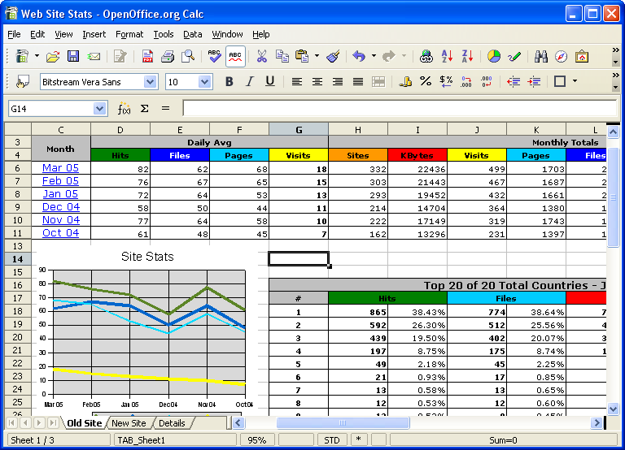
Use Calc to bring your numbers under control. This powerful spreadsheet has all the tools you need to calculate, analyse, summarise, and present your data in numerical reports or sizzling graphics. A fully-integrated help system makes entering complex formulas a breeze. Sophisticated decision-making tools are just a few mouse clicks away. Pull in external data using the Data Pilot, and sort it, filter it, and produce subtotals and statistical analyses. Use previews to select from thirteen categories of 2-D and 3-D charts including line, area, column, pie, XY, stock and net with dozens of variants.

