In addition to the rectangular river cross sections, the RRI Model can incorporate also arbitrary cross section directly. The followings explain the procedure to reflect cross section information to the model.

- Use “section.f90” program in the “etc” folder to prepare cross section files (e.g. sec_000001.txt) based on cross section coordinate information files (e.g. CS99C2.txt).
- Prepare a map file (e.g. sec_map.txt) to define which river grid cells should reflect which cross section files (e.g. sec_000001.txt).
- Change RRI_Input.txt setting to read sec_map.txt and the cross section files.
- (Optional) prepare and read river length file from the RRI_Input.txt

The followings explain the detailed step to reflect the cross section information.
- The following steps use “RRI-CUI/etc/section/section.f90” program. Suppose cross section coordinate information files are available in the following format.

CS99C2.txt
3.000000 25.35900
5.000000 25.27600
6.000000 24.65500
8.000000 23.83900
… …
(First column: x, second column: z)
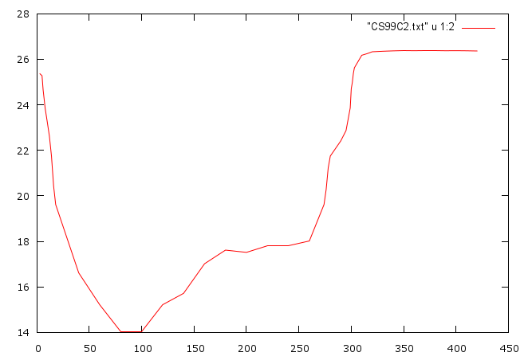
xllcorner_evp, yllcorner_evp
cellsize_rain (x, y) are specified
in RRI_Input.txt
Prepare “section.txt” file accordingly to be inputted to “section.f90” program.

section.txt
CS99C2.txt
sec_000001.txt]
0.03 ! Manning’s roughness in river
100 ! div
25. ! datum level
1 ! startx
30 ! endx

where the first two lines are input and output file names and the third line sets the Mannings’s roughness in the river. The fourth line defines “div”, which determines the number of divisions in depth directions, with 100 divisions in the above example. The fifth line is a datum level (m), which is the elevation of floodplain level identified from the cross section information (e.g. CS99C2.txt) as shown in the figure below. The RRI Model sets the defined cross section in a way that this datum level will be equal to the DEM elevation at each grid-cell.
③
①
②
③
①
②

For example, suppose the DEM of a grid-cell to set a river cross section is 24 m, while the estimated flood plain level read by the cross section file (i.e. elevation of in the above figure) is 25 m. In this case, a user has the following two options.
- Regardless the elevation information contained in the cross section data, prioritize the elevation of DEM 24 m and the floodplain level in the cross section will be at 24 m. For this option, please set the above “datum level” as 25 m. This means that the 25 m in the cross section will be regarded as the datum and this level will be the same as the DEM.
- If both absolute elevation information contained in the DEM and cross section files are reliable and they are generally consistent each other, the user may set “datum level” as 24 m to use the elevation information contained in the cross section file directly. This means that the level of 24 m in the cross section will be equal to the level in DEM.

For L6 (startx) and L7 (endx) in the “section.txt”, please set minimum and maximum x coordinates, which should be within a river grid-cell, as shown in the above figure and .

Based on the above setting, “section.f90” will automatically proceed the following steps.
STEP 1: The program measures depth (d) and levee height (h). The depth (d) is the elevation difference between the deepest position in the cross section and the level of ③ . The height (h) is the smaller elevation either ① or ② measured from ③.
STEP 2: It divides a cross section into the number of “div” (i.e. 100 in this case) from the deepest point to the datum level.
STEP 3: It outputs perimeters, widths and the Manning’s roughness parameters corresponding to each depth.

An example of output files by section.f90 (e.g. sec_000001.txt)
d
h
div
roughness
depth
width
perimeter
sec_000001.txt

100 10.98000 0.00000
0.11339 23.78646 23.77967 0.03000
0.22678 27.57293 27.55933 0.03000
0.34017 31.35939 31.33900 0.03000
0.45356 35.14586 35.11867 0.03000
…
11.11222 298.35455 295.76846 0.03000
11.22561 298.56949 295.95105 0.03000
11.33900 300.62881 298.00000 0.03000

* section.f90 reads the Manning’s roughness as a single parameter and set the constant value in the output file. However as shown in the above figure, the file can set different composite Manning’s roughness values depending on water depths. One may change the roughness values if necessary.

- Prepare a section map file (e.g. sec_map.txt”) to define the position of grid-cells to set cross section files. The “sec_map.txt” should have the same format (and size) as the dem.txt and contains numbers (greater than 1) at grid cells, whose numbers corresponding to cross section files. For example, if “sec_map.txt” indicates “5” at a particular grid cell, the RRI Model will find “sec_000005.txt” and reads and assigns the cross section information.

- By setting 1 in L83 of RRI_Input.txt, the model will read “./riv/sec_map.txt” and corresponding river cross section files (e.g. sec_******.txt).

- If necessary, a user may set river length at each grid-cell defined by “length.txt”, whose format and the matrix size must be the same as “dem.txt”. In that case, set 1 in the L80 and reads “./riv/length.txt” from the RRI_Input.txt. This can be activated when rivers are meandering or one would like to reflect distant information contained in cross sections.

(Reference) The method of RRI calculation depending on the datum level .
①
②
③
①
②
③
In case of left panel in the upper figure, the model will start exchange water between the river and slope cells once the river water exceeds the level of . As a result, the modeled river sections become smaller than the actual one indicated by the figure.
In case of right panel in the upper figure, the model does not exchange water between the river and slope cells unless the river water exceeds the level of . As a result, the modeled river sections become larger than the actual one indicated by the figure.

