A summary: Carbon Disclosure Project (CDP)

Established in the early 2000s, the Carbon Disclosure Project (CDP) is a non-profit organization aiming to encourage environmental disclosure and action among corporations and cities. CDP became one of the initial platforms to use investor pressure to promote corporate environmental disclosure, providing valuable resources for investors, customers, and policymakers for decision making. Today, CDP has emerged as the world’s biggest repository of environmental data submitted on a voluntary basis by companies.

**Who does it apply to:**

CDP allows customers and investors to formally request companies to disclose their environmental data. Companies can respond to this request by completing CDP’s online questionnaires about climate change, forests and water security. The responses are reviewed and scored by CDP, based on the company’s environmental impact and the comprehensiveness and transparency of its response. The evaluation is then shared with the requesting stakeholders and the reporting company, providing an opportunity for the company to identify areas for improvement.

Companies can also initiate voluntary disclosure without waiting for a CDP request, signalling their commitment to environmental action.

Companies have the choice to make questionnaire responses public. However, all companies that receive disclosure requests from investors are listed on the CDP website. Regardless of whether responses are public, scores are widely available via [CDP’s website](https://www.cdp.net/en/research).

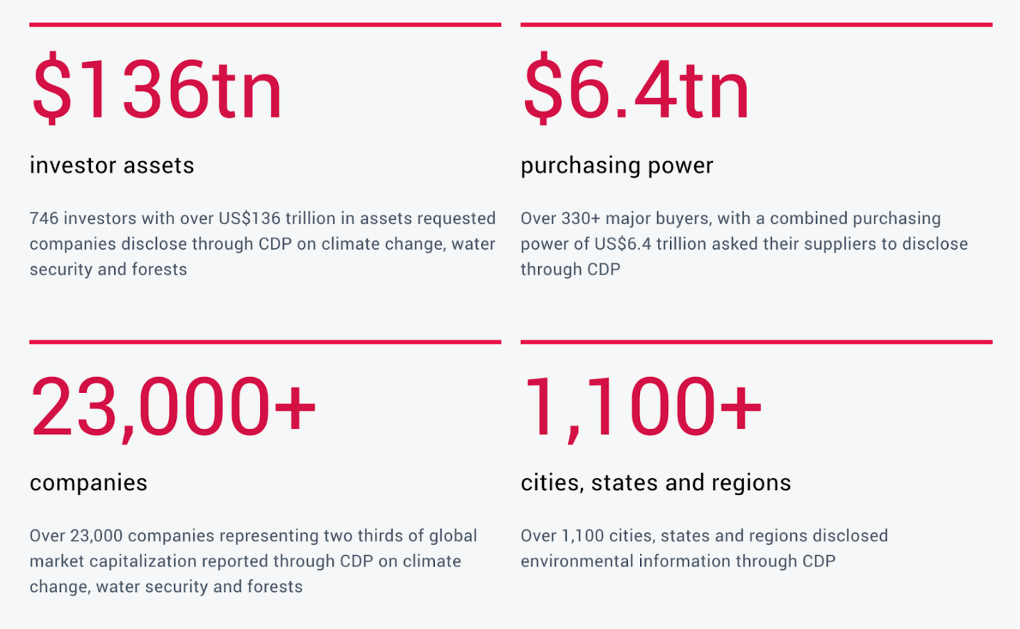*Source:*[*https://www.cdp.net/en/info/about-us/what-we-do*](https://www.cdp.net/en/info/about-us/what-we-do)*, accessed on 31 January 2024.*

**Sections relevant to carbon accounting:**

CDP has 3 questionnaires:

* Climate Change
* Forests
* Water

Each questionnaire requests disclosures on the company’s impacts, risks, strategies, metrics, targets, and governance, among other things, in the relevant environmental area. You can find the questionnaires [here](https://www.cdp.net/en/guidance/guidance-for-companies).

The Climate Change questionnaire, which has 15 modules, 150+ questions, covering from governance, risks and opportunities, strategy (following the TCFD Framework), requests disclosure on Scope 1 – 3 emissions data and a breakdown of those, emissions intensities, the methodology used, as well as reduction plans and initiatives.

Companies aren’t required to answer every question in the questionnaire, however, their responses will influence the scores received.

The questionnaire makes reference to other frameworks such as TCFD, and SDG. CDP has also announced that, from 2024, it will [incorporate the ISSB climate disclosure standard into its disclosure system](https://www.cdp.net/en/articles/companies/cdp-to-incorporate-issb-climate-related-disclosure-standard).

**What are CDP Scores?**

A CDP score is a snapshot of a company’s environmental disclosure and performance. The purpose of these scores is to demonstrate to organizations and their stakeholders how they are progressing towards operating in line with a 1.5-degree, deforestation-free, and water-secure future. By disclosing these scores over successive years, they can track their trajectory towards environmental sustainability.

The CDP assesses the responses received and provides a score from D- to A. This score represents the company’s progressive steps towards environmental stewardship. The scoring system takes into account factors like the depth and quality of disclosed data, the execution of environmental initiatives, and the company’s overall environmental performance.

At a high level summary, the grades represent:

* **Disclosure (D-/D score):** A company receives a D-/D score when it provides basic environmental data.
* **Awareness (C-/C score):** A company with a C-/C score shows an understanding of how environmental issues intersect with its business.
* **Management (B-/B score):** A B-/B score is awarded to companies that demonstrate good environmental management.
* **Leadership (A score):** Companies that show environmental leadership and implement best practices receive an A score.
* **Failure to disclose (F score):** An F score is given when a requested company fails to disclose through CDP.

To learn more see [CPD Scores Explained](https://www.cdp.net/en/scores/cdp-scores-explained). You can also search for a company’s score in [CDP Scores](https://www.cdp.net/en/scores).

**CDP’s Supply Chain Program**

CDP also offers a Supply Chain Program, designed to encourage and enable companies to engage with their suppliers to measure, manage, and disclose their environmental data. Companies can sign up to be a member of the program, and CDP will facilitate requesting their suppliers to report via CDP’s questionnaires. Learn more [here](https://www.cdp.net/en/supply-chain).

The detailed questionnaire (with 150+ questions!) can be quite overwhelming for suppliers, in order to respond:

1. They have to allocate resources and invest considerable time and effort to gather the required data.
2. Navigate the complex technical language and unfamiliarity with sustainability reporting standards.
3. Face the challenges of ensuring the accuracy and auditability of the reported data.
4. For those working with a limited budget, investing in resources and systems to meet the requirements may be difficult.
5. To accurately report on their emissions, these suppliers themselves need to engage with their suppliers too, and so the cycle continues.

These are some barriers that may lead to lower engagement from suppliers who aren’t sure how to approach it.

While the intention is there, to bring suppliers on board to disclose their environmental data and drive sustainable practices, we want to raise the question: **How do you practically support suppliers to do so?**

**The one missing step**

All of this is new to many companies – at Sumday, we help businesses engage by leading with education (and roping in the accountants, who know how to collect the right data and report!). We’re on a mission to empower accountants to support their businesses to do their carbon accounting.

Every Sumday customer, no matter their size, can pass on training, software and support to their suppliers (10 or 10,000 – up to you) so they can take you up on the help if they need it to really come along on this journey and provide you with the data you need.

Instead of just sending a questionnaire to fill, true engagement happens when you remove those barriers and offer a solution that embeds the process. To learn more, visit [Supplier Engagement](https://www.sumday.io/supplier-engagement). Get started on the carbon accounting journey now with a free trial [here](https://app.sumday.io/signup/landing).