Week 3 Report: Supervised Models on an Urdu News Dataset
Name:Yousaf Ali Raza

Dataset
Source: Urdu news dataset (file urdu_news.csv), [add the original source / link here]. The task is to read one Urdu news item and predict whether it is FAKE or TRUE.
  - Size: 10,106 raw rows and 3 columns (Sr. No., News Items, Label). After cleaning: 9,235 rows.
  - Cleaning: removed 22 empty rows, 1 stray header row, fixed labels with extra spaces, removed 869 repeated news texts, and dropped Sr. No. (just a row number).
  - Target: Label (FAKE = 1, TRUE = 0). Features: 500 TF-IDF word scores + word count + character count = 502 numeric columns (the text had to be turned into numbers).
  - Class balance: FAKE 4,637 (50.2 %) and TRUE 4,598 (49.8 %), so the data is balanced. Split: 80/20 with stratify=y, random_state=42 (7,388 train / 1,847 test). The scaler and the TF-IDF vocabulary were fitted on the training data only.

Results of the models

Model | Accuracy | Precision | Recall | F1
Logistic Regression | 0.832 | 0.842 | 0.818 | 0.830
Linear Regression (cut-off 0.5) | 0.808 | 0.830 | 0.776 | 0.802
Decision Tree (max_depth=10) | 0.779 | 0.805 | 0.739 | 0.771
KNN (K=5) | 0.656 | 0.607 | 0.893 | 0.723
Precision, recall and F1 are for the FAKE class (test set, 1,847 rows).

Confusion matrix of the best model (Logistic Regression)
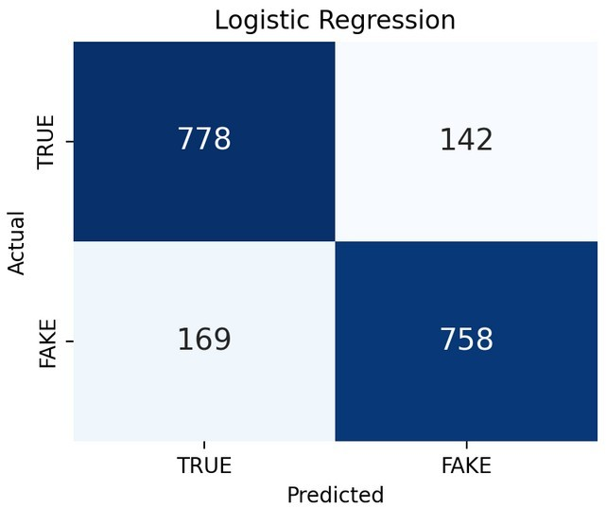
In simple words: of 920 real (TRUE) items the model got 778 right and wrongly called 142 of them FAKE. Of 927 fake items it caught 758 but let 169 pass as TRUE. So it is wrong about 311 times out of 1,847. The two kinds of mistake are fairly even. Errors are more common on very short headlines (about 77 % accuracy for the shortest quarter against about 90 % for the longest quarter), because short texts give the model few words to work with.
- Best K and best max_depth
  - KNN: K = 5 gave the best test accuracy (65.6 %), but every K from 1 to 15 stayed between 64 % and 66 %. K = 1 memorises the training data (100 % train accuracy) without helping on the test set. KNN struggles because there are 502 mostly-zero columns, so "nearest" neighbours are not truly similar.
  - Decision Tree: max_depth = 10 gave the best test accuracy (77.9 %). With no depth limit the tree has 100 % train accuracy but only 77.2 % test accuracy (a 23-point gap), which is overfitting. Depth 2–3 is too simple (about 75 %). Depth 10 is a good middle point.

Which metric matters most?
For fake-news detection a false negative (fake news marked TRUE) is worse than a false positive (real news marked FAKE), because a false story spreads and a wrongly flagged real story can be checked by a person. So recall for the FAKE class matters most. However, recall alone can be fooled: KNN has the highest recall (0.893) only because it calls too many items FAKE (its precision is just 0.607). I therefore choose models by F1, which balances both, and Logistic Regression is best on F1 (0.830). In the bonus test, I made FAKE rare (9 % of the test set): a useless model that always answers TRUE then scored 90.9 % accuracy, higher than Logistic Regression (84.3 %),

but its F1 was 0. So accuracy can mislead when classes are unbalanced, although it is fine on this balanced dataset.

What I learned and problems I faced
  - The dataset was text, not numbers, so I learned to use TF-IDF and to fit it only on training data to avoid data leakage.
  - The data was messy (stray header row, spaces in labels, many repeated sentences). Without removing repeats, the same sentence could be in both train and test and give fake-high scores.
  - Deep trees and K = 1 both memorise; a simple linear model (Logistic Regression) generalised best. Linear Regression works as a classifier only by cutting at 0.5, and about 15 % of its outputs fall outside 0–1.
  - Limitation: FAKE items are much longer on average than TRUE items in this dataset, so part of the score may come from text length rather than real fact-checking.

