
INTERNSHIP PROJECT REPORT
Task 2 — Intelligent Multi-Class Natural Language Text Sentiment Classifier
A Machine Learning based NLP system for classifying real-world Twitter text into Positive, Negative, and Neutral sentiment using TF-IDF and Logistic Regression.

Intern Name: | Yousaf Shah
Student ID: | B5/661
Internship Track: | Artificial Intelligence
Organization: | Progree — Your Career, Our Mission
Task: | Task 2 — Sentiment Classifier
Submission Date: | 20th September 2026
Progree Remote Internship Program · Artificial Intelligence
20 August 2026 – 20 September 2026

1. Project Objective
This project implements a multi-class Natural Language Processing (NLP) system that reads unstructured, real-world text and classifies it into one of three sentiment categories: Positive, Negative, or Neutral. It was built to demonstrate a complete, working pipeline covering text preprocessing, stop-word removal, lemmatization, TF-IDF feature extraction, multi-class classification, and evaluation using F1-score and a confusion matrix.
The system was developed using Python and Scikit-Learn, following a clean and beginner-friendly coding structure suitable for an internship submission.

2. Technologies & Libraries Used
pandas | Loading and handling the dataset (CSV reading, column selection, cleaning).
numpy | Underlying numerical operations used internally by pandas and scikit-learn.
nltk | Natural language preprocessing — stop-word removal and lemmatization.
scikit-learn | TF-IDF vectorization, train/test split, Logistic Regression model, and evaluation metrics.
matplotlib / seaborn | Visualizing the confusion matrix as a heatmap.

3. Dataset
A real, publicly available dataset was used rather than a synthetic demonstration set, to ensure the model is trained and evaluated on genuine, noisy, real-world text.
Dataset Name: | Twitter Entity Sentiment Analysis
Source: | Kaggle (publicly available)
File Used: | twitter_training.csv
Total Samples: | 73,996 rows (before class filtering)
Original Classes: | Positive, Negative, Neutral, Irrelevant
Classes Used for Training: | Positive, Negative, Neutral (Irrelevant excluded to match the 3-class requirement)
Columns Used: | text (raw tweet), sentiment (target label)
Class meanings:
- Positive — the tweet expresses favorable or approving sentiment toward the subject.
- Negative — the tweet expresses disapproval, criticism, or complaint.
- Neutral — the tweet is factual/informational with no strong emotional tone.
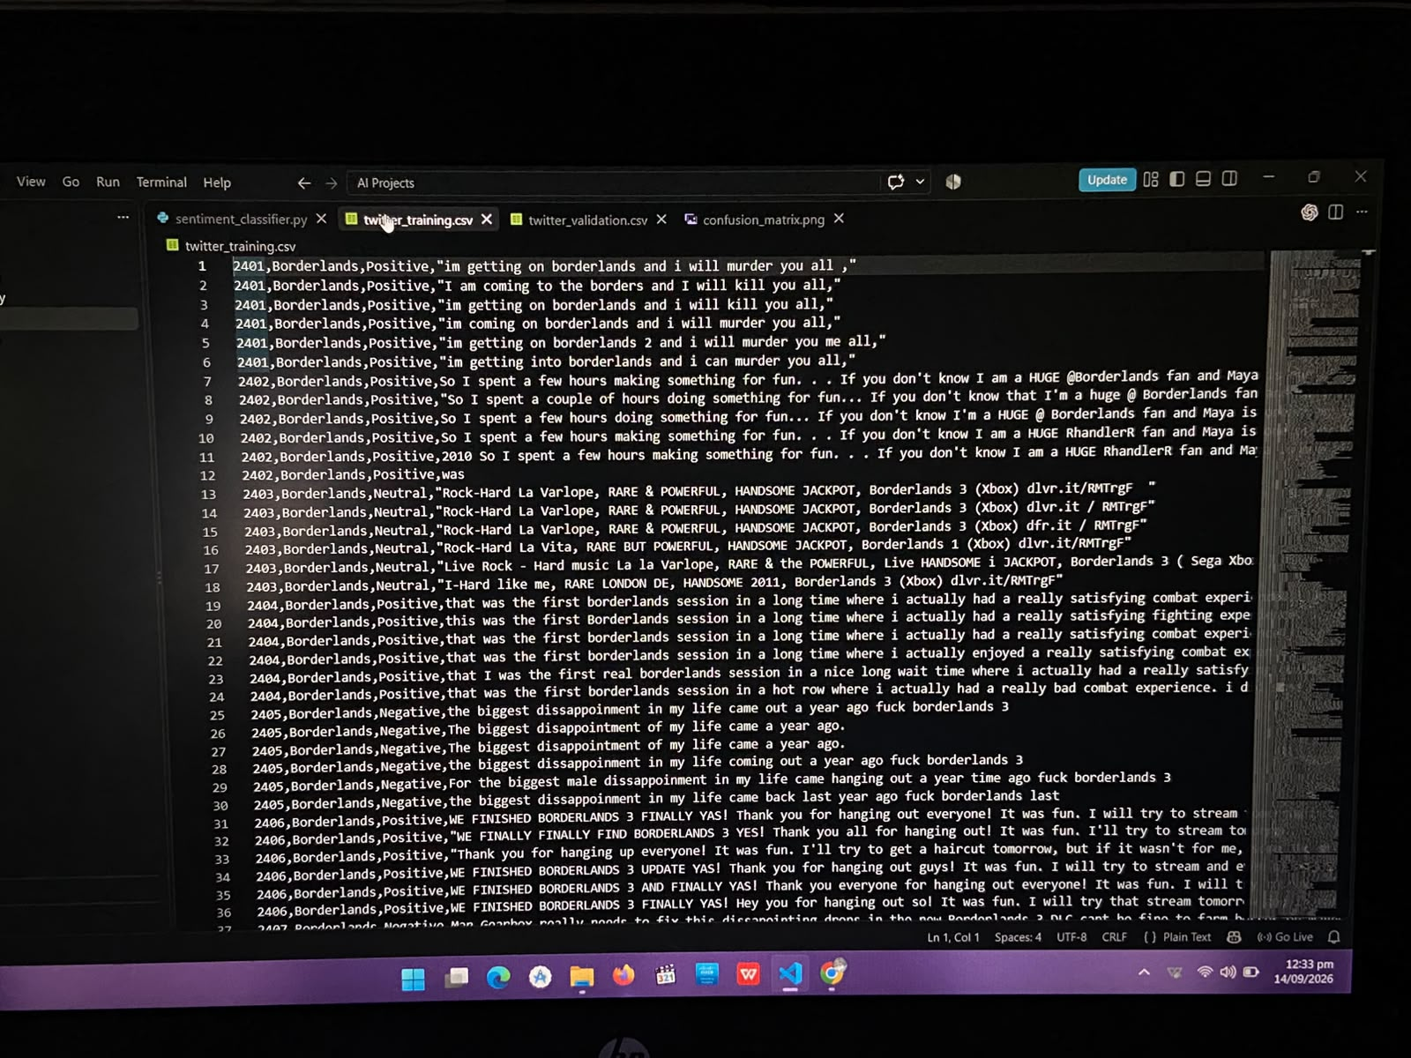
Figure 1 — Sample rows from the raw twitter_training.csv dataset, viewed in VS Code.

4. Text Preprocessing
Raw tweets contain punctuation, casing inconsistencies, and filler words that do not contribute to sentiment meaning. A dedicated preprocess_text() function was written to clean every tweet before it is used for training or prediction. The pipeline performs the following steps in order:
- Lowercasing — normalizes text so 'Good' and 'good' are treated identically.
- Punctuation / special character removal — strips symbols and digits using a regular expression, keeping only alphabetic words.
- Tokenization — splits the cleaned sentence into individual words using NLTK's word_tokenize.
- Stop-word removal — removes common low-information English words (e.g. 'the', 'is', 'and') using NLTK's stopword list.
- Lemmatization — reduces each remaining word to its dictionary root form using WordNetLemmatizer (e.g. 'enjoying' → 'enjoy').
Example:
Original: "I was really enjoying these amazing products!"
After preprocessing: "really enjoy amazing product"
The function also safely handles empty, missing, or non-string input by returning an empty string instead of raising an error, which was important given the size and messiness of the Twitter dataset.

5. TF-IDF Feature Extraction
TF-IDF (Term Frequency – Inverse Document Frequency) converts cleaned text into numerical feature vectors that a machine learning model can process. It scores each word by how frequently it appears in a given tweet (Term Frequency) offset by how common that word is across all tweets (Inverse Document Frequency) — so distinctive, sentiment-bearing words are weighted higher than generic words that appear everywhere.
Configuration used: TfidfVectorizer(max_features=3000) — this caps the vocabulary at the 3,000 most informative terms, keeping the feature space efficient without sacrificing accuracy. No built-in stop_words parameter was used, since stop-word removal was already handled explicitly in the preprocessing step, as required.
To prevent data leakage, the vectorizer was fit only on the training data (fit_transform) and then used to transform the test data (transform) — the test set never influences the vocabulary or IDF weights.

6. Train / Test Split
The dataset was split using scikit-learn's train_test_split with an 80/20 ratio, stratified by sentiment class to preserve the original class balance in both sets, and a fixed random_state=42 for reproducibility.
- X — the cleaned tweet text (features)
- y — the sentiment label (Positive / Negative / Neutral)
- Training set — 80% of the data, used to fit the TF-IDF vectorizer and the model
- Testing set — 20% of the data, held out and used only for evaluation

7. Classification Model
Logistic Regression was selected as the classification algorithm. It is well suited to TF-IDF-based text classification because TF-IDF produces high-dimensional, sparse, largely linearly-separable feature vectors — Logistic Regression handles this efficiently, trains quickly even on tens of thousands of samples, and produces easily interpretable, probability-based predictions without the overhead of a deep learning model.
The model was trained using model.fit(X_train_tfidf, y_train) and then used to generate predictions on the unseen test set with model.predict(X_test_tfidf).

8. Model Evaluation
The model was evaluated on the held-out 20% test split (12,225 tweets) using accuracy, per-class precision/recall/F1-score, macro F1-score, and weighted F1-score. All figures below are taken directly from the executed program — no values were estimated or fabricated.
Class | Precision | Recall | F1-Score | Support
Negative | 0.77 | 0.78 | 0.77 | 4,472
Neutral | 0.67 | 0.67 | 0.67 | 3,622
Positive | 0.74 | 0.73 | 0.74 | 4,131
Overall Accuracy: 73%
Macro F1-score: 0.7256
Weighted F1-score: 0.7294
F1-score is the harmonic mean of precision and recall. It is a more reliable measure than accuracy alone because it accounts for both false positives and false negatives, which matters for a multi-class problem where classes can be imbalanced. Macro F1 treats every class equally regardless of size, while Weighted F1 accounts for the number of samples in each class — reporting both gives a fuller picture of performance.
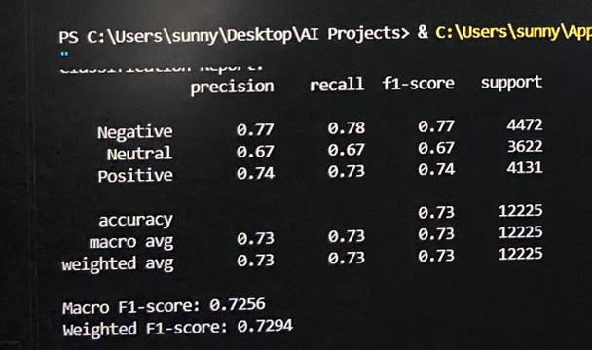
Figure 2 — Actual terminal output: Classification Report and F1-scores from the trained model.

9. Confusion Matrix
The confusion matrix below compares actual sentiment labels (rows) against predicted labels (columns) for all 12,225 test samples, with class names retrieved automatically from the dataset rather than hard-coded.
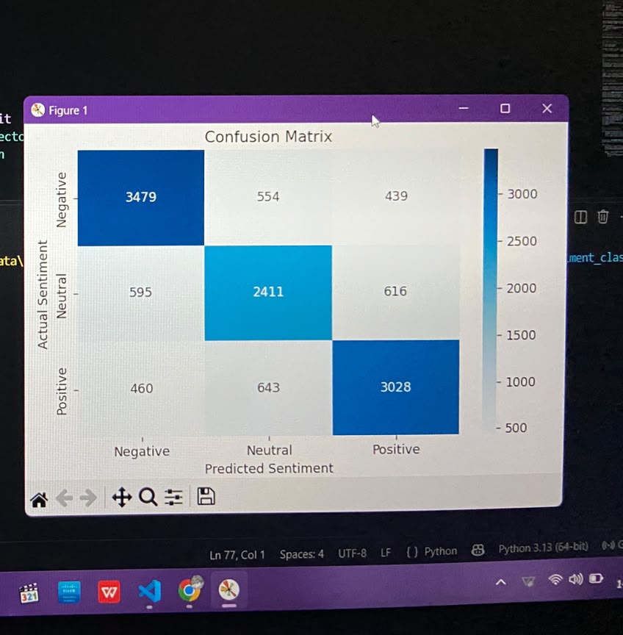
Figure 3 — Confusion matrix generated by the trained model on the test set.
Observations:
- Negative was the class the model identified most reliably — 3,479 of 4,472 Negative tweets were classified correctly.
- Neutral was the hardest class to separate, with the most confusion in both directions (595 Neutral tweets misclassified as Negative, 616 as Positive) — a pattern that is common in sentiment analysis, since neutral language often shares vocabulary with mild positive or negative statements.
- Positive was also classified strongly, with 3,028 of 4,131 correct.

10. Working Mechanism — Live Prediction Demo
After training and evaluation, the program allows the user to type any sentence and receive a live sentiment prediction. The same preprocess_text() function and the same fitted TF-IDF vectorizer used during training are applied to the user's input before it is passed to the trained model — the model is never retrained for each input. The user can enter multiple sentences in a loop and exit by typing 'no'.
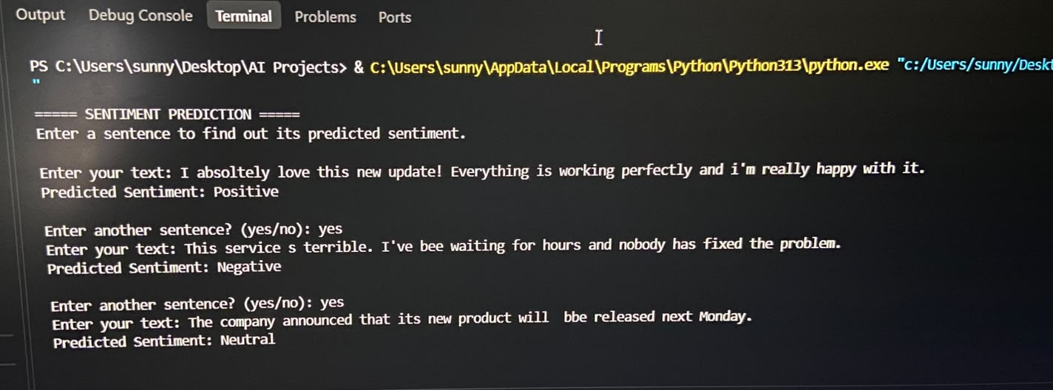
Figure 4 — Live run of the program: three different user inputs, each correctly classified.
The screenshot above shows the program correctly identifying all three sentiment classes in a single live session, without ever being retrained between inputs:

Example 1 — Positive
Input: "I absoletely love this new update! Everything is working perfectly and i'm really happy with it."
The sentence contains clearly favorable words — 'love', 'perfectly', 'happy' — which survive preprocessing (lowercased, stripped of punctuation, stop-words removed, lemmatized) and carry strong positive TF-IDF weight, so the model correctly outputs Predicted Sentiment: Positive.

Example 2 — Negative
Input: "This service s terrible. I've bee waiting for hours and nobody has fixed the problem."
Despite two typos ('s' instead of 'is', 'bee' instead of 'been'), the model still correctly predicts Negative. Words like 'terrible', 'waiting', and 'nobody' dominate the TF-IDF signal — this also demonstrates the pipeline's tolerance to the kind of minor typing errors seen throughout the real Twitter training data.

Example 3 — Neutral
Input: "The company announced that its new product will bbe released next Monday."
This sentence is purely factual — an announcement with no emotionally charged words — so the model correctly predicts Neutral rather than forcing it into Positive or Negative, showing the classifier has genuinely learned to separate neutral, informational text from emotionally charged text rather than just detecting the presence of any strong words.
Together, these three back-to-back predictions demonstrate the full pipeline working end-to-end on unseen, user-typed input — not just on the held-out test split used for the metrics in Section 8.

11. Project Structure & Code
sentiment_classifier.py | Main script — preprocessing, TF-IDF, model training, evaluation, and live prediction.
twitter_training.csv | Training dataset (Kaggle Twitter Entity Sentiment Analysis).
twitter_validation.csv | Additional validation split provided with the Kaggle dataset.
confusion_matrix.png | Saved confusion matrix visualization generated by the script.
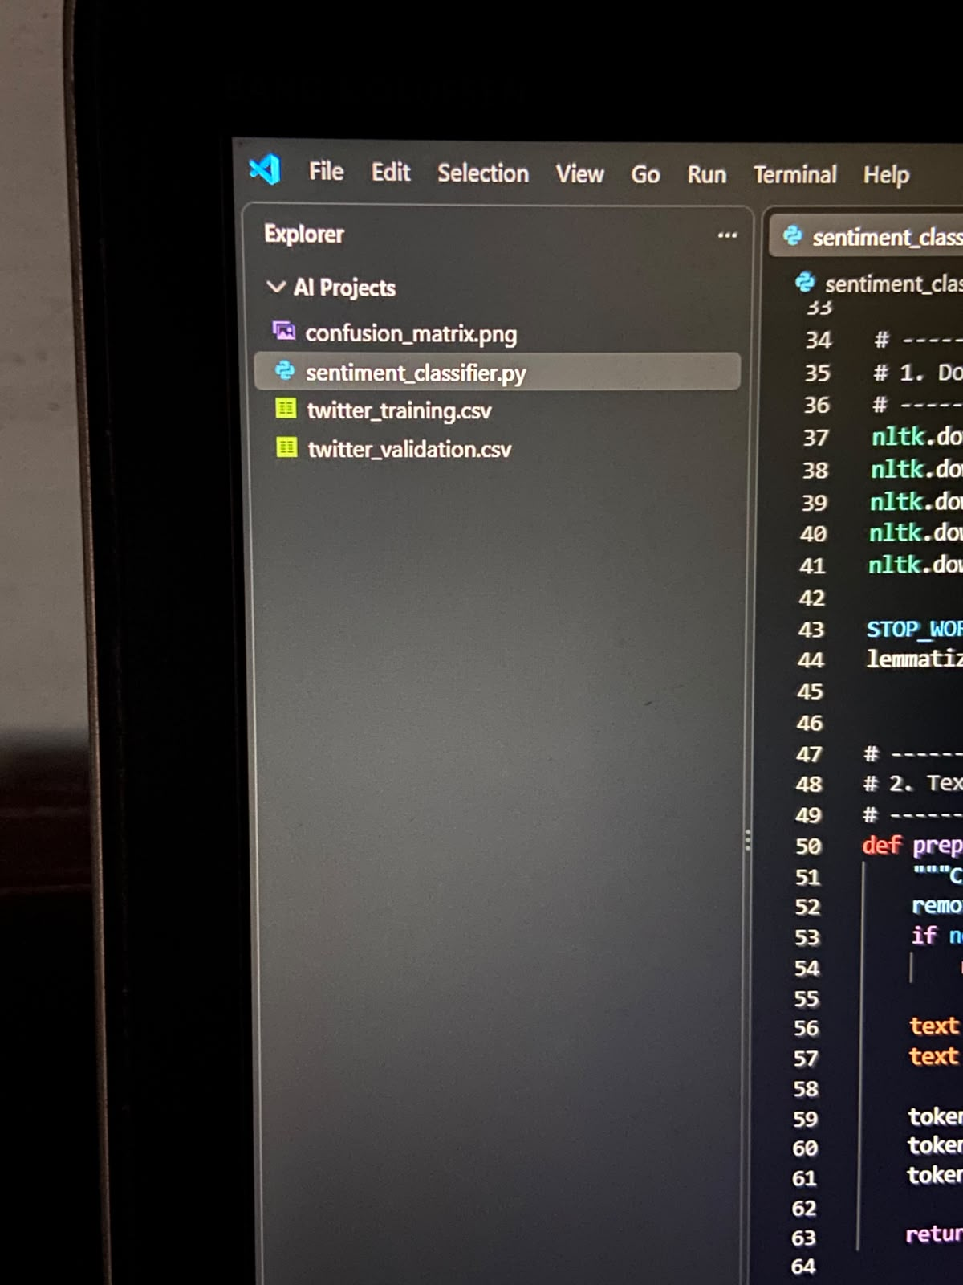
Figure 5 — Project files in the VS Code Explorer.
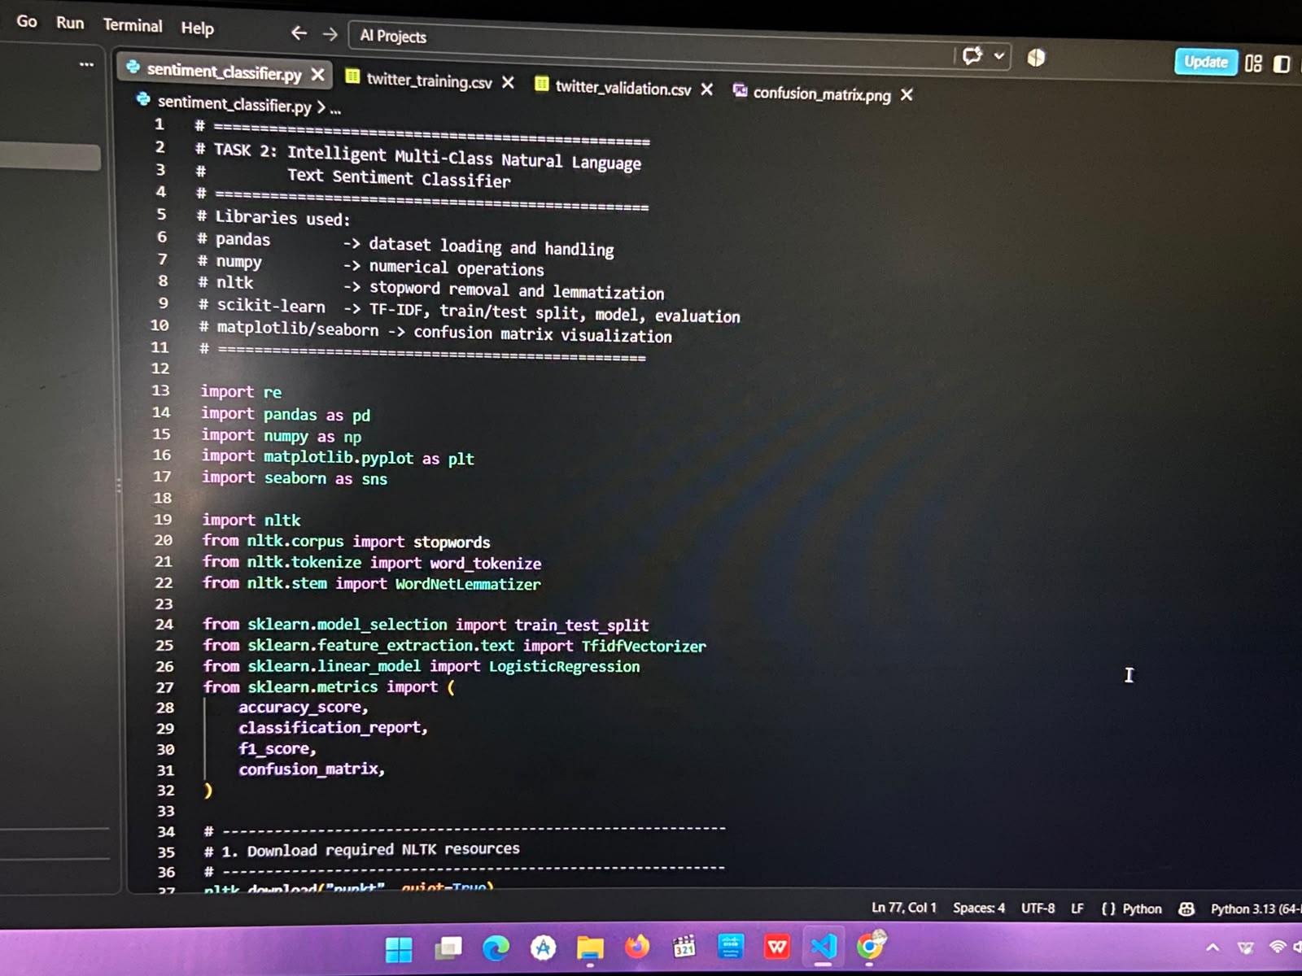
Figure 6 — Imports and library-usage documentation at the top of sentiment_classifier.py.

12. Explanation of Key Concepts

What is NLP?
Natural Language Processing is the field of AI concerned with enabling computers to understand, interpret, and work with human language.

What is text classification?
Text classification is the task of assigning a predefined category label — here, a sentiment — to a piece of text.

Why preprocessing is necessary
Raw text contains noise (punctuation, casing, filler words) that adds no sentiment signal. Cleaning it first lets the model focus on words that actually carry meaning.

What stop-words are
Stop-words are extremely common words (e.g. 'the', 'is', 'and') that appear in almost every sentence and carry little to no sentiment-specific information, so they are removed.

What lemmatization does
Lemmatization reduces a word to its dictionary base form (e.g. 'running' → 'run'), so different grammatical forms of the same word are treated as one feature instead of many.

What TF-IDF is
TF-IDF is a numerical scoring method that represents text as vectors of weighted word importance, balancing how often a word appears in a document against how rare it is across all documents.

Why Logistic Regression is used
Logistic Regression is fast, interpretable, and performs strongly on the high-dimensional, sparse feature vectors that TF-IDF produces, without the complexity or training cost of deep learning.

What training and testing mean
Training data is used to fit the model's parameters; testing data is a separate, unseen portion used purely to measure how well the model generalizes to new text.

What F1-score means
F1-score is the harmonic mean of precision and recall, giving a single balanced measure of a classifier's accuracy per class.

What a confusion matrix shows
A confusion matrix shows, for every actual class, how many samples were predicted correctly versus which other class they were mistakenly predicted as — revealing exactly where the model gets confused.

How the user's input reaches the final prediction
Raw text → preprocess_text() cleaning → the already-fitted TF-IDF vectorizer transforms it into the same numerical feature space used in training → the trained Logistic Regression model predicts the sentiment label.

13. Conclusion
This project successfully implements a full multi-class NLP sentiment classification pipeline, trained and evaluated on a real 73,996-row public Twitter dataset. The final model achieved 73% accuracy with a macro F1-score of 0.7256 and a weighted F1-score of 0.7294 — a solid result for a TF-IDF + Logistic Regression approach on noisy, real-world social media text. The confusion matrix confirms the model performs strongly on Positive and Negative sentiment, with Neutral being the most challenging class to separate, which is an expected and well-documented pattern in sentiment analysis literature. The project satisfies every requirement of the internship task using a clean, understandable, and fully functional implementation.

14. Requirement Checklist
✓ | Python & Scikit-Learn used throughout
✓ | Genuine NLP-based multi-class text classification
✓ | Real public dataset used (Kaggle Twitter Entity Sentiment Analysis, 73,996 rows)
✓ | Complete text preprocessing pipeline implemented
✓ | Stop-word removal via NLTK
✓ | Lemmatization via NLTK WordNetLemmatizer
✓ | TF-IDF feature extraction (fit on train only, no data leakage)
✓ | Model training with Logistic Regression
✓ | F1-score evaluation — per-class, macro, and weighted
✓ | Confusion matrix generated and visualized
✓ | Live custom user-input sentiment prediction
✓ | All reported metrics taken from an actual program run — none fabricated

