**1.1** Description of the current situation and opportunity

In many communities, especially those with limited financial resources, a large number of patients struggle to afford necessary medications or medical equipment. At the same time, many households have leftover or unused medications and tools (like crutches, wheelchairs, or blood pressure monitors) that are either wasted or stored without use. There is no centralized or safe system for matching these unused resources with the people who need them most.

This presents a major opportunity: creating a digital platform that allows individuals to donate their extra medical supplies safely, under pharmacist supervision, and help those in urgent need. By using a mobile application, we can bridge this gap, reduce waste, and improve healthcare accessibility in a simple, community-driven way.

———————————

**1.2 Related works**

There are several platforms, applications, and community-based initiatives related to health and donations; however, there is still no centralized and integrated digital system that directly focuses on the safe and organized donation of unused medications and reusable medical equipment, especially at the individual and local community level.

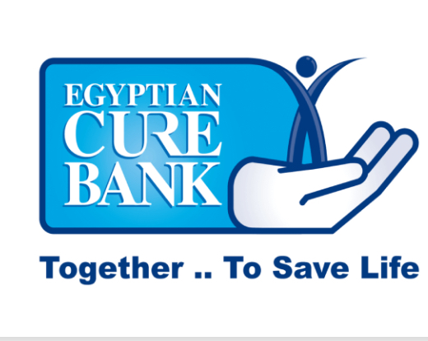

1. **Benk el-Dawa (Egyptian Cure Bank)**

is an Egyptian non-profit organization that provides free medicine and medical supplies to people in need. It collects donated medications and works with healthcare providers to support underprivileged patients across Egypt.

Advanteges:

* A non-profit organization that provides free medicines and medical supplies to patients in need.
* Participates in external relief campaigns (e.g., Gaza support), showing a broader humanitarian outreach.
* Offers digital donation options through its website and electronic payment methods.

Disadvanteges:

* Despite some expansion, its primary focus remains within Egypt.
* No dedicated mobile app to facilitate donations or access services.
* May face logistical challenges in distribution and follow-up, especially outside Egypt.

Access at date: 20/4/2025

Website: [www.egyptiancurebank.com](https://www.egyptiancurebank.com)

—————————

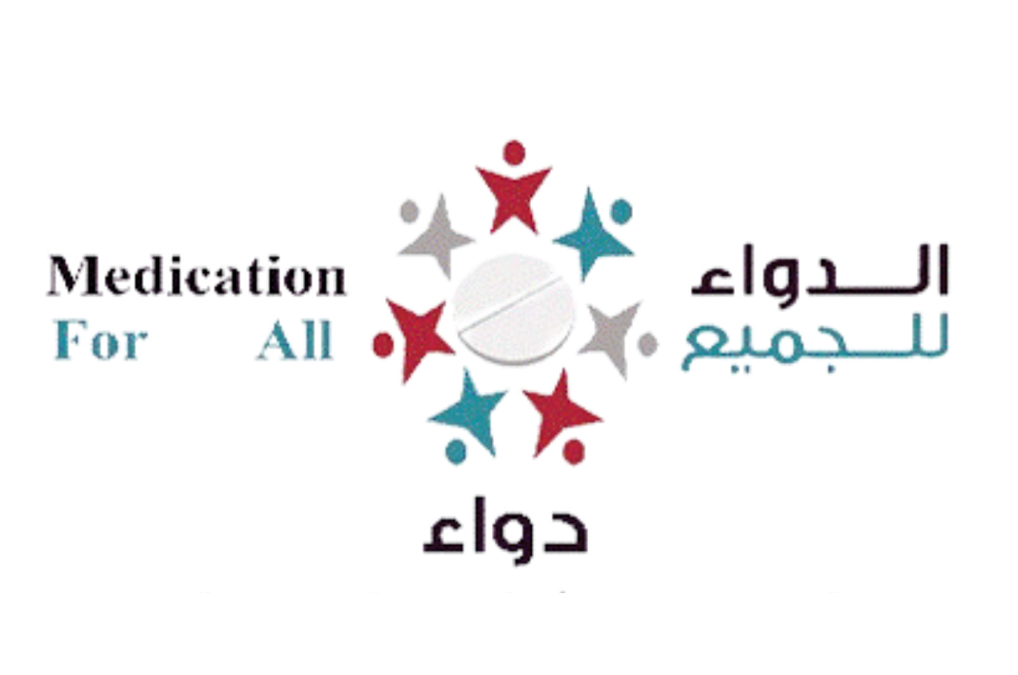

1. Edwaa: is a Saudi non-profit organization that provides free medicine to low-income patients. It collects donations and distributes medications safely to those in need, especially people with chronic illnesses.

Advanteges:

* Online donation platform available through their official website.
* Organized distribution of medications, especially for chronic disease patients.
* Provides medical supplies like Hajj kits and home delivery for those in need.

Disadvanteges:

* Limited information on donating medical equipment.
* No clear tracking system for donated medicines or equipment.

Access at date: 20/4/2025

Website: [edwaa.org.sa](https://edwaa.org.sa)

—————————

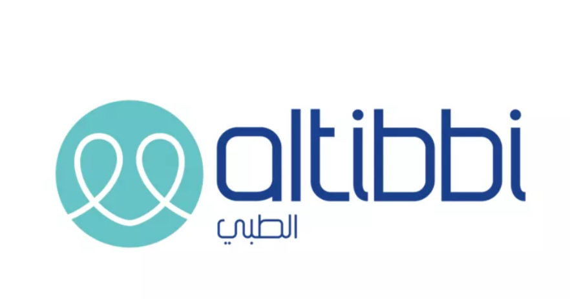

1. Altibbi – Digital Health Platform:

Altibbi is a leading digital health platform based in Jordan, offering reliable medical information and telemedicine services in Arabic. Users can consult certified doctors via voice or text calls, access medical content, and manage their health records anytime, anywhere.

Advanteges:

* 24/7 Instant Medical Consultations via text or voice calls.
* Reliable Medical Content with over 1.6 million articles in Arabic.
* Special services like “Al-Tibbi Mama” for pregnant women and mothers.

Disadvantages**:**

* Does not support donating medicines or medical equipment.
* Focus is on medical consultations rather than providing medical resources for the needy.
* Some services are paid or limited in certain countries.

Access at date: 20/4/2025

Website: <https://altibbi.com>

————————————

1.3 Problem Statement: Limitations of Current Systems

Current systems for donating medicines and medical equipment face challenges such as difficulty reaching beneficiaries and a lack of coordination between donors and recipients. Many patients in underserved areas lack essential medicines and equipment.