Hardware Security Project
Hardware Implementation of ASCON

Project done by:
Yousef Moayyad 20210286
Ibrahim Methaq 20210654
Ahmad Alhourani 20210166

Table of Contents
1. Introduction 3
2. Background on ASCON 3
3. Project Objectives 3
4. Tools Used 3
5. Phase I: Hardware Implementation 4
5.1 RTL Repository and Design Files 4
5.2 Security and Countermeasure Discussion 4
5.3 Hardware Simulation 5
5.4 Area and Power Evaluation 6
6. Phase II: Software Implementation 7
6.1 Software Program Structure 7
6.2 Test Vectors and Sample Runs 8
7. Phase III: Hardware/Software Verification 9
8. Results and Discussion 9
9. User Manual 10
10. Conclusion 11
11. GitHub Link 11
12. References 11
Appendix A: Source Code 13
Appendix B: Test Vectors 13

1. Introduction
ASCON is a lightweight cryptographic algorithm designed for constrained devices such as IoT systems, embedded platforms, and sensor networks. The aim of this project is to implement and verify ASCON using both hardware and software approaches. The hardware part uses a SystemVerilog RTL implementation, while the software part uses Python to generate encryption, decryption, and hashing outputs. The final verification compares the hardware simulation behavior and the software-generated outputs.
The project was divided into three main phases: hardware implementation, software implementation, and verification of the hardware implementation using software-based results. The implementation was tested using open-source tools including Verilator, Cocotb, Yosys, and Python.

2. Background on ASCON
ASCON is a family of lightweight cryptographic algorithms standardized in NIST SP 800-232 for constrained devices. The standard includes authenticated encryption with associated data, hashing, and extendable-output functions. Authenticated encryption protects the confidentiality and integrity of a message, while hashing produces a fixed-size digest of an input message.
In hardware security, correct cryptographic design is not enough by itself. Hardware implementations may leak information through timing, power consumption, electromagnetic leakage, or faulty computations. For this reason, real secure hardware designs may require countermeasures such as masking, constant-time execution, redundancy, and error detection.

3. Project Objectives
- Understand the ASCON algorithm, including encryption, decryption, and hashing.
- Download and use an RTL implementation of ASCON as a hardware crypto engine.
- Simulate the hardware design using Verilator and Cocotb.
- Synthesize the hardware implementation using Yosys and report the area results.
- Implement software test-vector generation using Python.
- Verify the outputs through software checks and hardware simulation results.
- Prepare project deliverables including source files, test vectors, screenshots, report, and GitHub repository.

4. Tools Used
Tool | Purpose in the Project
Ubuntu / WSL | Linux environment used to run the hardware and software commands.
Git | Used to download the ASCON Verilog repository.
Python 3.13 | Used to run the software ASCON implementation and Cocotb testbench.
uv | Used to install Python 3.13 and manage the virtual environment.
Cocotb | Python-based hardware verification testbench framework.
Verilator | SystemVerilog simulator used by Cocotb to simulate the RTL design.
Yosys | Open-source synthesis tool used to estimate hardware area.
GitHub | Used for final public repository submission.

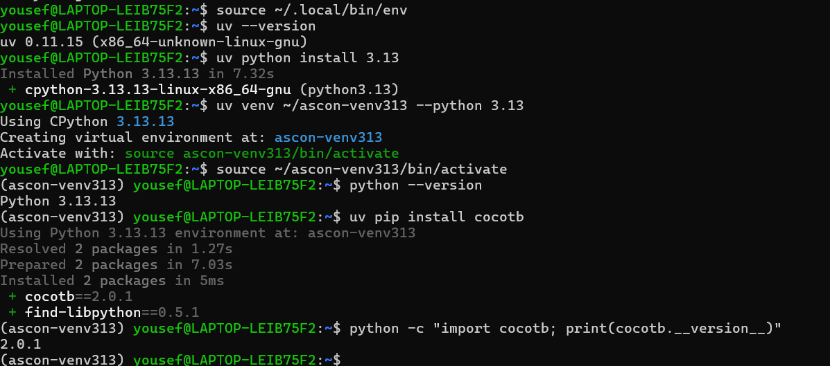

5. Phase I: Hardware Implementation
The hardware implementation was completed using the open-source ASCON Verilog repository. The repository contains a SystemVerilog RTL implementation, a Cocotb testbench, Python reference code, and Yosys synthesis files. The main hardware design was simulated and synthesized from the command line.

5.1 RTL Repository and Design Files
The ASCON Verilog repository contains the RTL design files and support scripts. The important files and folders used in this project are summarized below.
File/Folder | Description
rtl/ | SystemVerilog implementation of the ASCON hardware design.
rtl/ascon_core.sv | Top-level ASCON hardware core used as the main module.
rtl/asconp.sv | ASCON permutation module.
rtl/config.sv | Configuration parameters for the hardware design.
rtl/functions.sv | Helper SystemVerilog functions.
rtl/register.sv | Register module used by the core.
test.py | Cocotb testbench used for hardware verification.
ascon.py | Python reference implementation used by the tests and software phase.
syn/ | Yosys synthesis scripts and simple cell library files.
Makefile | Runs simulation and synthesis commands such as make sim and make syn.

5.2 Security and Countermeasure Discussion
The project description requires comparing the RTL implementation with secure hardware design requirements such as side-channel and fault-injection protection. The downloaded RTL core is mainly a functional ASCON hardware implementation. It successfully supports the ASCON operations tested by the provided testbench, but it should not be treated as a complete protected implementation against physical attacks.
The design uses synchronous RTL logic and a defined control flow, which helps with predictable operation. However, explicit side-channel countermeasures such as Boolean masking, power balancing, hiding, or threshold implementation were not identified in the basic project flow. Also, explicit fault-injection countermeasures such as duplicated computation, parity checking, temporal redundancy, or error-detection logic were not observed in the synthesis output.
Therefore, the design is suitable for functional hardware verification and area estimation, but a stronger security-focused hardware version would need extra countermeasure logic. Examples include masking sensitive intermediate values, adding redundancy for fault detection, verifying tags before releasing plaintext, and using implementation-level tests against side-channel leakage.

5.3 Hardware Simulation
The hardware implementation was simulated using Verilator and Cocotb. During setup, the tool versions had to be corrected: Cocotb 2.0.1 required a newer Verilator version, so Verilator was upgraded and the simulation was repeated. After the correction, the hardware testbench passed all tests.
cd ~/ASCON_Project/hardware/ascon-verilog
make clean
make sim
The final simulation result was TESTS=10, PASS=10, FAIL=0, and SKIP=0. This confirms that the RTL design passed the provided encryption, decryption, hashing, XOF, CXOF, decryption-failure, and backpressure tests.

Hardware simulation passed with TESTS=10, PASS=10, FAIL=0, SKIP=0.
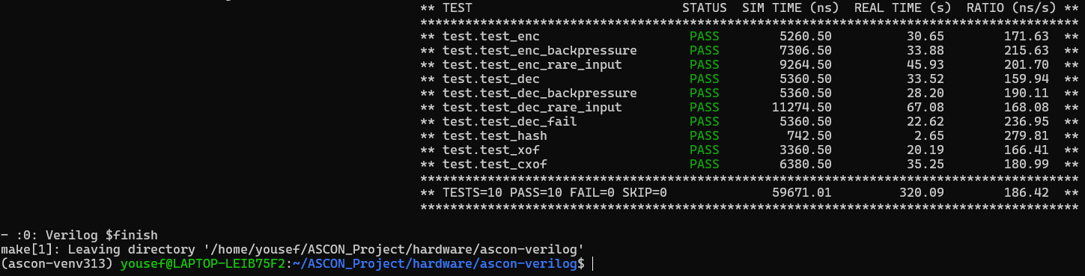

5.4 Area and Power Evaluation
The ASCON hardware design was synthesized using Yosys. The top module used for the final area report was ascon_core. The synthesis output reports the number of wires, ports, cells, and estimated chip area. The final top-module area result is shown in the table below.

Metric | Value
Top module | ascon_core
Number of wires | 14,446
Number of wire bits | 18,641
Number of public wires | 104
Number of public wire bits | 4,299
Number of ports | 51
Number of port bits | 1,727
Total number of cells | 15,649
DFFSR cells | 474
NAND cells | 7,262
NOR cells | 6,563
NOT cells | 1,350
Top module chip area | 67,882.000000
Internal asconp module cells | 7,536
Internal asconp chip area | 29,537.000000

Yosys synthesis output showing top-level ascon_core statistics.
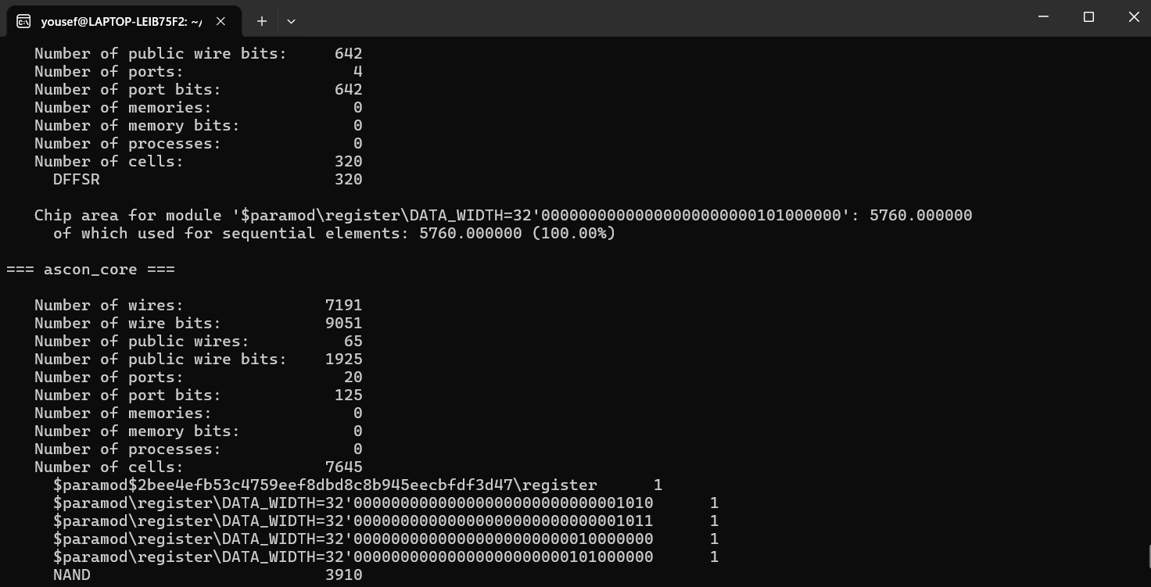
Yosys chip area lines for ascon_core and internal modules
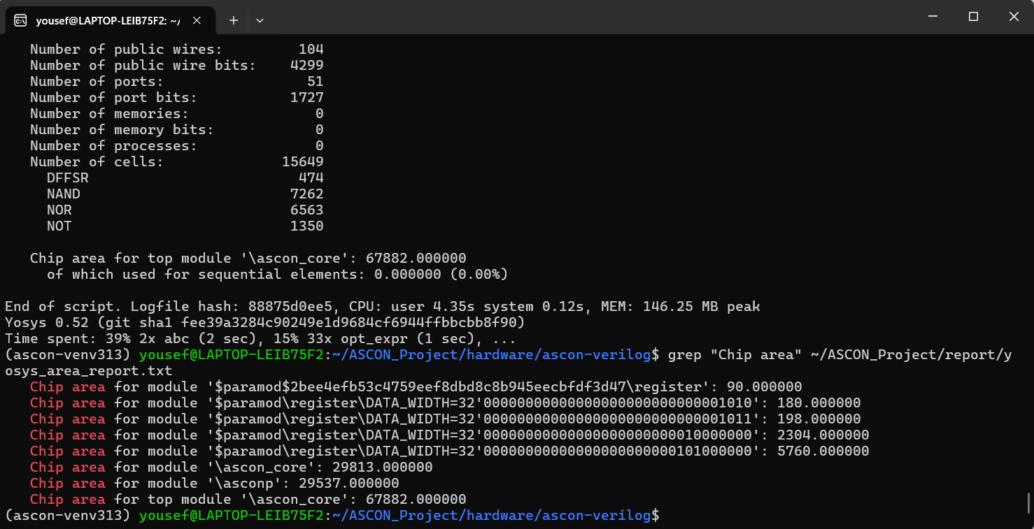

Power consumption was not directly measured on a physical FPGA board. Since this project used open-source simulation and synthesis tools, the report includes synthesis-based area results. Accurate power estimation would require mapping the design to a specific FPGA device using a vendor tool such as Vivado or Quartus and running a power analyzer with switching activity information.

6. Phase II: Software Implementation
The software implementation was written in Python. It uses the ASCON reference functions to perform authenticated encryption, decryption, and hashing. The software phase generated three custom test vectors.

6.1 Software Program Structure
The Python program imports the ASCON encryption, decryption, and hashing functions. For each vector, the program performs encryption to produce ciphertext and authentication tag, decryption to recover the original plaintext, and hashing to generate a digest.
Function/Step | Description
ascon_encrypt() | Encrypts the plaintext using key, nonce, and associated data. It produces ciphertext and tag.
ascon_decrypt() | Decrypts ciphertext with tag and checks whether the original plaintext is recovered.
ascon_hash() | Generates a 32-byte ASCON-Hash256 digest for the selected input.
DECRYPTION CHECK | Compares decrypted output with original plaintext. PASS means the software output is correct.

6.2 Test Vectors and Sample Runs
Three custom test vectors were generated. Each vector contains a key, nonce, associated data, plaintext, ciphertext, authentication tag, decrypted output, hash input, and hash output. The decrypted plaintext matched the original plaintext for all three vectors.

Software sample run showing V1 and V2 outputs.
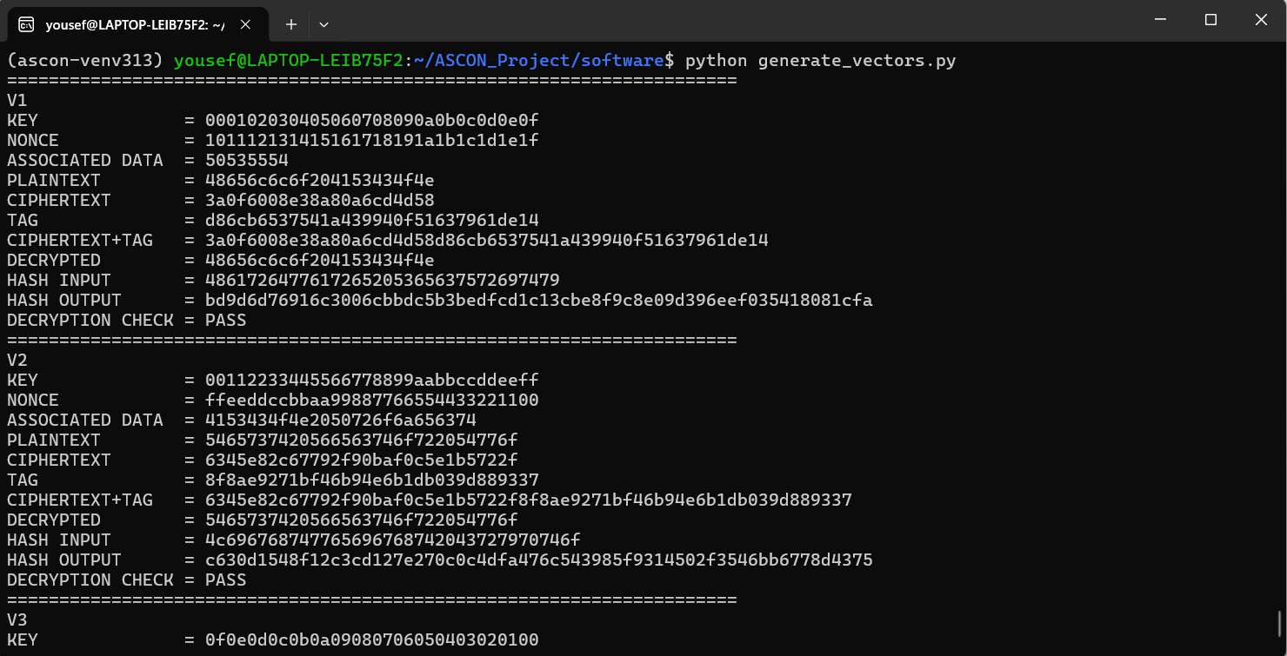

Software sample run showing V2 continuation and V3 outputs.
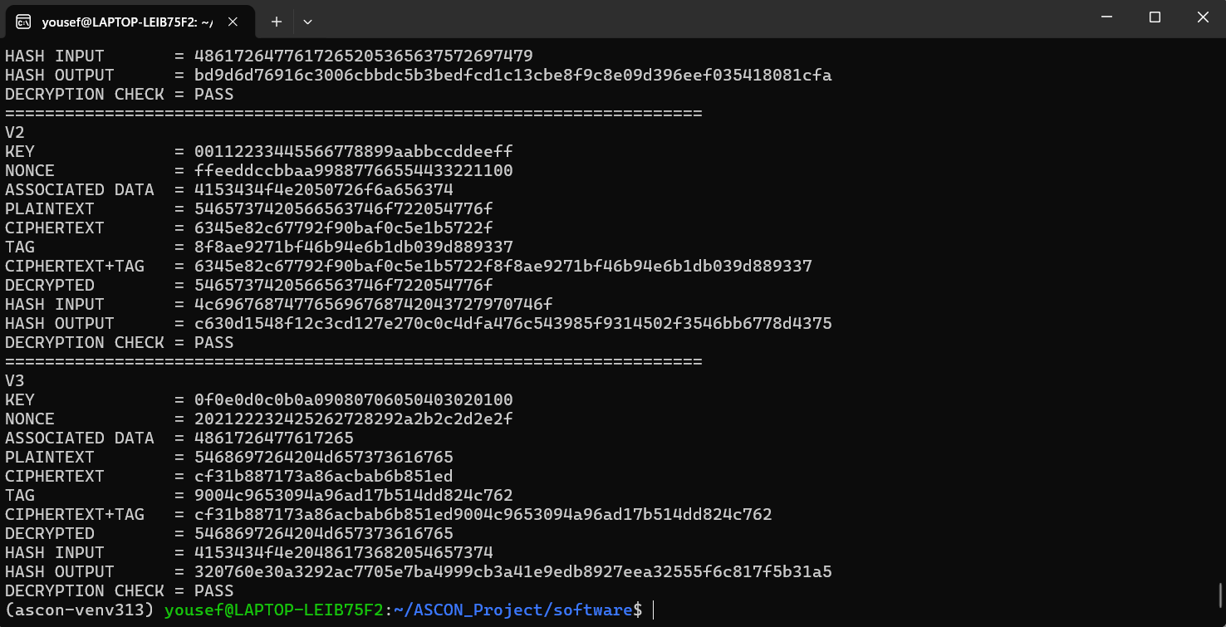

Vector | Encryption/Decryption Result | Hash Output
V1 | PASS | Generated
V2 | PASS | Generated
V3 | PASS | Generated

7. Phase III: Hardware/Software Verification
The hardware implementation was verified using the Cocotb testbench included with the ASCON Verilog project. The testbench runs the SystemVerilog RTL design using Verilator and checks the behavior of the hardware design. The simulation result showed that all ten hardware tests passed.
The software implementation was also verified using three custom vectors. For each vector, the Python program generated ciphertext, authentication tag, decrypted plaintext, and hash output. The decrypted plaintext matched the original plaintext in every case, so the software verification result was PASS for V1, V2, and V3.
Important note: the current hardware simulation verifies the RTL using the included Cocotb testbench and Python reference behavior. The custom vectors generated in Phase II are documented in this report. For a stricter one-to-one requirement, these custom vectors can be inserted directly into test.py so that the hardware output is compared line-by-line with the exact V1, V2, and V3 values.

Verification Item | Result
Hardware encryption test | PASS
Hardware decryption test | PASS
Hardware decryption failure test | PASS
Hardware hash test | PASS
Hardware XOF test | PASS
Hardware CXOF test | PASS
Hardware backpressure tests | PASS
Software vector V1 | PASS
Software vector V2 | PASS
Software vector V3 | PASS

8. Results and Discussion
The project successfully demonstrated hardware simulation, software test-vector generation, and synthesis-based area estimation for ASCON. The hardware testbench passed all provided tests, showing that the RTL core operated correctly under the tested cases. The software implementation generated custom test vectors and verified that decryption returns the original plaintext.
The synthesis results showed that the top-level ascon_core design used 15,649 total cells and had an estimated chip area of 67,882 using the selected simple cell library. The internal ASCON permutation module asconp used 7,536 cells and had an estimated area of 29,537. These values provide an area estimate for the implementation, but they are not the same as final FPGA resource utilization unless the design is mapped using a specific FPGA vendor tool.
The main limitation is that power was not directly measured. Another limitation is that the current report uses the provided hardware testbench and separately generated software custom vectors. Future work can add the exact generated vectors to the Cocotb testbench for direct V1, V2, and V3 hardware/software comparison.

9. User Manual
The following steps explain how to run the project from the terminal:
- Activate the Python environment:
source ~/ascon-venv313/bin/activate

- Run the hardware simulation:
cd ~/ASCON_Project/hardware/ascon-verilog
make clean
make sim

- Run hardware synthesis:
cd ~/ASCON_Project/hardware/ascon-verilog
make clean
make syn

- Run the software implementation:
cd ~/ASCON_Project/software
python generate_vectors.py

- Save the generated test vectors:
python generate_vectors.py > ~/ASCON_Project/test_vectors/test_vectors.txt

- View the saved test vectors:
cat ~/ASCON_Project/test_vectors/test_vectors.txt

User manual text file created for the project.
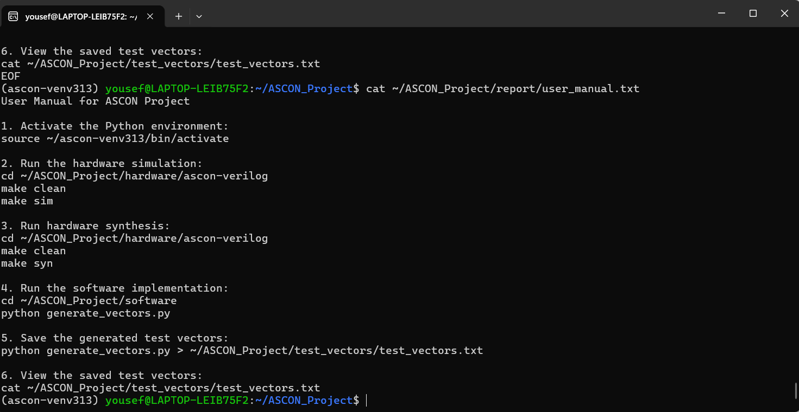

10. Conclusion
This project implemented and verified ASCON using both hardware and software methods. The hardware RTL design was simulated using Verilator and Cocotb, and all provided tests passed successfully. The design was synthesized using Yosys, producing area results for the top-level ascon_core module and the internal asconp module.
The Python software implementation generated three custom vectors for encryption, decryption, and hashing. All software vectors passed the decryption check. Overall, the project achieved the main functional goals of hardware simulation, software test-vector generation, and synthesis-based area evaluation. Future improvements include adding direct custom-vector hardware testbench verification and performing power analysis using Vivado or Quartus on a target FPGA.

11. GitHub Link
GitHub repository link: https://github.com/yousef-moayyad/ASCON-Hardware-Security-Project.git

12. References
- NIST, SP 800-232, Ascon-Based Lightweight Cryptography Standards for Constrained Devices: Authenticated Encryption, Hash, and Extendable Output Functions, August 2025. https://csrc.nist.gov/pubs/sp/800/232/final
- R. Primas, ascon-verilog: Hardware Design of Ascon. GitHub repository. https://github.com/rprimas/ascon-verilog
- Cocotb Documentation, Python-based verification framework. https://docs.cocotb.org/
- Yosys Open SYnthesis Suite. https://yosyshq.net/yosys/
- Verilator Documentation. https://verilator.org/guide/latest/

Appendix A: Source Code
The following Python code was used to generate the software test vectors.
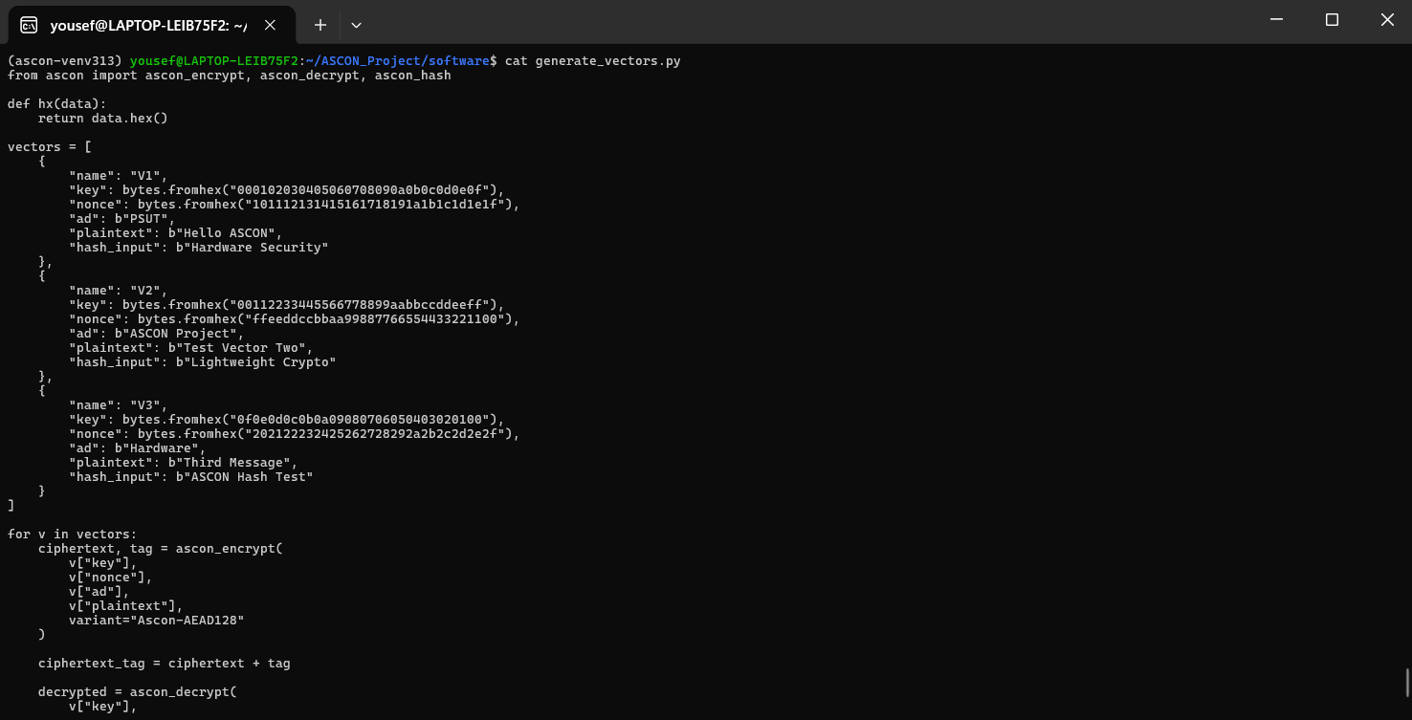
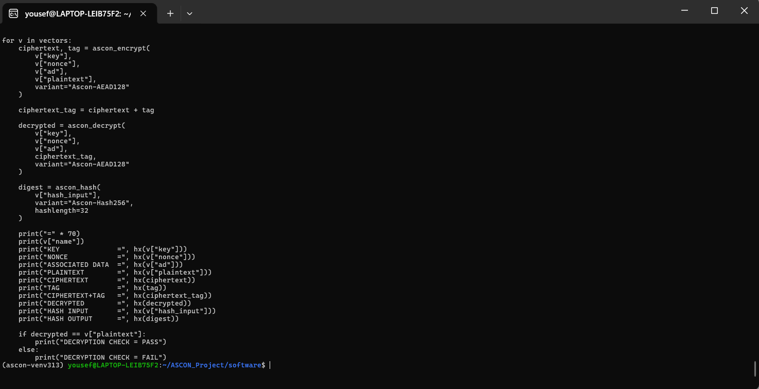

Appendix B: Test Vectors
Field | V1
KEY | 000102030405060708090a0b0c0d0e0f
NONCE | 101112131415161718191a1b1c1d1e1f
ASSOCIATED DATA | 50535554
PLAINTEXT | 48656c6c6f204153434f4e
CIPHERTEXT | 3a0f6008e38a80a6cd4d58
TAG | d86cb6537541a439940f51637961de14
CIPHERTEXT+TAG | 3a0f6008e38a80a6cd4d58d86cb6537541a439940f51637961de14
DECRYPTED | 48656c6c6f204153434f4e
HASH INPUT | 4861726477617265205365637572697479
HASH OUTPUT | bd9d6d76916c3006cbbdc5b3bedfcd1c13cbe8f9c8e09d396eef035418081cfa
DECRYPTION CHECK | PASS

Field | V2
KEY | 00112233445566778899aabbccddeeff
NONCE | ffeeddccbbaa99887766554433221100
ASSOCIATED DATA | 4153434f4e2050726f6a656374
PLAINTEXT | 5465737420566563746f722054776f
CIPHERTEXT | 6345e82c67792f90baf0c5e1b5722f
TAG | 8f8ae9271bf46b94e6b1db039d889337
CIPHERTEXT+TAG | 6345e82c67792f90baf0c5e1b5722f8f8ae9271bf46b94e6b1db039d889337
DECRYPTED | 5465737420566563746f722054776f
HASH INPUT | 4c696768747765696768742043727970746f
HASH OUTPUT | c630d1548f12c3cd127e270c0c4dfa476c543985f9314502f3546bb6778d4375
DECRYPTION CHECK | PASS

Field | V3
KEY | 0f0e0d0c0b0a09080706050403020100
NONCE | 202122232425262728292a2b2c2d2e2f
ASSOCIATED DATA | 4861726477617265
PLAINTEXT | 5468697264204d657373616765
CIPHERTEXT | cf31b887173a86acbab6b851ed
TAG | 9004c9653094a96ad17b514dd824c762
CIPHERTEXT+TAG | cf31b887173a86acbab6b851ed9004c9653094a96ad17b514dd824c762
DECRYPTED | 5468697264204d657373616765
HASH INPUT | 4153434f4e20486173682054657374
HASH OUTPUT | 320760e30a3292ac7705e7ba4999cb3a41e9edb8927eea32555f6c817f5b31a5
DECRYPTION CHECK | PASS

