**

Faculty of Computers and Artificial Intelligence

Computer Science Department

2021/2022

**CS 395 Selected Topics in CS-2**

**Research Project**

Report Submitted for Fulfillment of the Requirements and ILO’s for Selected Topics in CS-2 course for Fall 2021

Team No.

|  |  |  |  |
| --- | --- | --- | --- |
|  | ID | Name | Grade |
|  | 201900997 | يوسف مصطفى صابر |  |
|  | 201900818 | مصطفى سيد مصطفى سيد |  |
|  | 201900563 | فاطمه رضا عبدالمنعم عبد العزيز |  |
|  | 201900203 | ايمان اشرف احمد عبدالعزيز |  |
|  | 201900159 | آلاء إبراهيم عبدالعزيز محمد |  |
|  | 201900329 | سارة ابراهيم صلاح الدين احمد |  |
|  | 201900930 | هبة محمد عبد الفتاح حسن الخطيب |  |

**Paper details**

* Authors name : K. Clawson & S. Delicato & C. Bowerman

* paper name : Human Centric Facial Expression Recognition
* publisher name : Sunderland University Institutional Repository
* year of publication : 2018
* The dataset used : **FER-2013**
* The implemented algorithms : convolutional neural network (CNN) modelling
* The results : Accuracy **80%**

**General Information on the selected dataset :**

* Dataset name : **FER-2013**
* Dataset link : <https://www.kaggle.com/datasets/msambare/fer2013>
* Total number of samples :

The training set consists of **28,709** examples and

the test set consists of **3,589** examples

* The dimension of image : **48X48** pixel

* Number of classes : **seven** classes
* Labels of classes :

1. Angry
2. Disgust
3. Fear
4. Happy
5. Sad
6. Surprise
7. Neutral

**Implementation details**

* Number of images in training : **28,709**
* Number of images in testing : **7,178**
* Initial learning rate : **0.001**
* Optimizer : **adam**
* Regularization : **0.25**
* Batch size : **10**
* Number of epochs : **70**
* Accuracy : **80%**

**Block diagram**

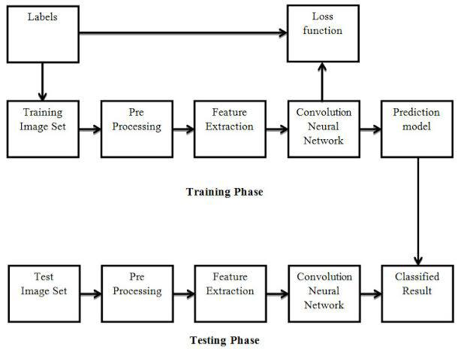

**Results details**

*Accuracy*

*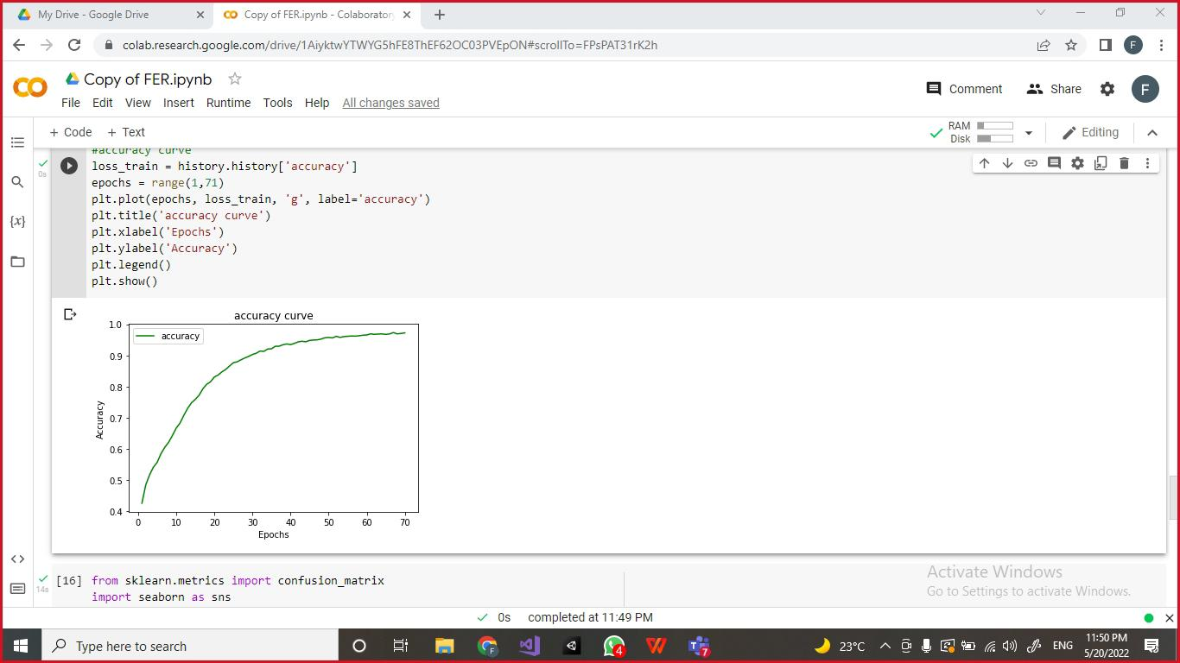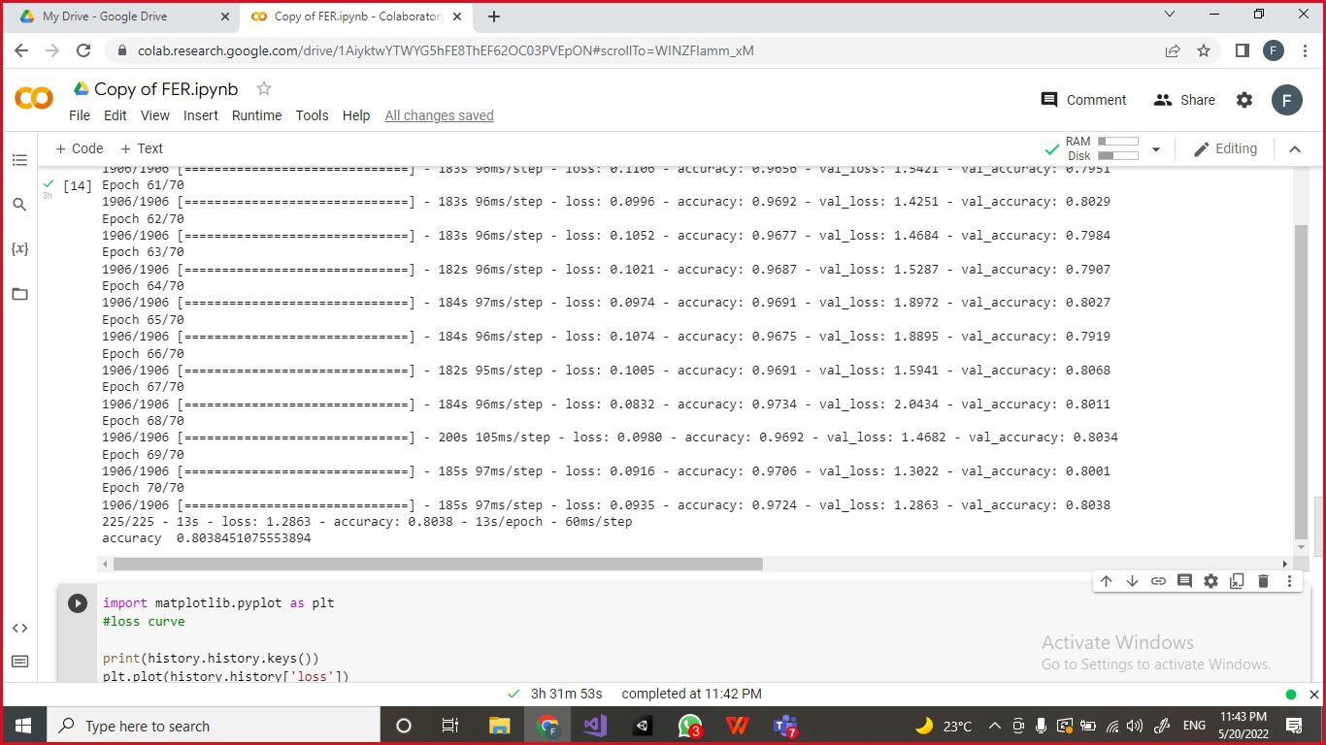Accuracy curve*

*Loss curve 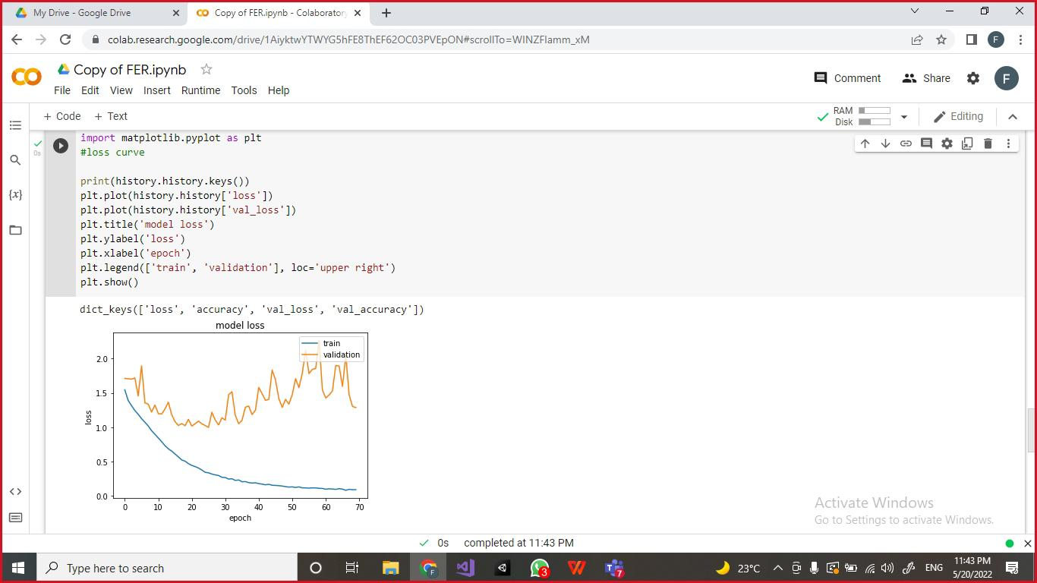*

*Convulsions matrix*

