**General**

In this section you will find the multiple HTML and CSS structures that were applied to the general style of the template.

**HTML Structure**

All the pages in this template are divided in three parts Top Bar, Side Bar and Content.

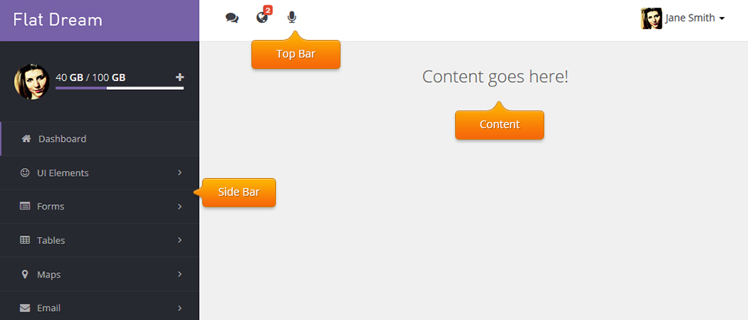

1. <!DOCTYPE html>
2. <html lang="en">
3. <body>
5. <div id="cl-wrapper">
6. <div class="cl-sidebar">
7. <!--Sidebar Menu-->
8. </div>
10. <div class="container-fluid" id="pcont">
12. <div id="head-nav" class="navbar navbar-default">
13. <!--Top Bar-->
14. </div>
16. <div class="cl-mcont">
17. <!--Content-->
18. </div>
19. </div>
20. </div>
21. </body>
22. </html>

**Basic Head Structure**

In the head we include the following elements in their respective order:

- Google Fonts (CSS)

- Bootstrap core (CSS)

- Gritter Notifications (CSS)

- Font Awesome 4 (CSS)

-- Plugins CSS --

- Template Style (CSS)

1. <!DOCTYPE html>
2. <html lang="en">
3. <head>
4. <meta charset="utf-8">
5. <meta name="viewport" content="width=device-width, initial-scale=1.0">
6. <meta name="description" content="">
7. <meta name="author" content="">
8. <link rel="shortcut icon" href="images/icon.png">
10. <title>Flat Dream</title>
11. <link href='http://fonts.googleapis.com/css?family=Open+Sans:400,300,600,400italic,700,800' rel='stylesheet' type='text/css'>
12. <link href='http://fonts.googleapis.com/css?family=Raleway:300,200,100' rel='stylesheet' type='text/css'>
14. <!-- Bootstrap core CSS -->
15. <link href="js/bootstrap/dist/css/bootstrap.css" rel="stylesheet">
16. <link rel="stylesheet" type="text/css" href="js/jquery.gritter/css/jquery.gritter.css" />
17. <link rel="stylesheet" href="fonts/font-awesome-4/css/font-awesome.min.css">
19. <!-- HTML5 shim and Respond.js IE8 support of HTML5 elements and media queries -->
20. <!--[if lt IE 9]>
21. <script src="../../assets/js/html5shiv.js"></script>
22. <script src="../../assets/js/respond.min.js"></script>
23. <![endif]-->
25. <link rel="stylesheet" type="text/css" href="js/jquery.nanoscroller/nanoscroller.css" />
26. <link href="css/style.css" rel="stylesheet" />
27. </head>

**Top Bar**

The top bar is divided in 2 sections Notifications and Profile Menu.

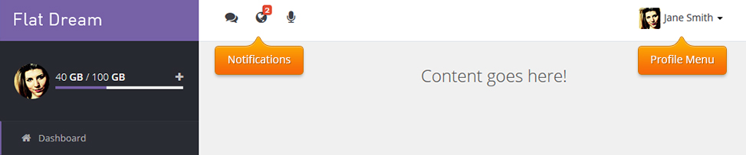

1. <!-- TOP BAR -->
2. <div id="head-nav" class="navbar navbar-default">
3. <div class="container-fluid">
4. <div class="navbar-collapse">
5. <ul class="nav navbar-nav navbar-right user-nav">
6. <!-- Right Profile Menu Items -->
7. </ul>
8. <ul class="nav navbar-nav not-nav">
9. <!-- Menu Notification Items -->
10. </ul>
12. </div>
13. </div>
14. </div>

**Sidebar**

This is the basic HTML structure for the sidebar.

1. <div class="cl-sidebar">
2. <div class="cl-toggle"><i class="fa fa-bars"></i></div>
3. <div class="cl-navblock">
4. <div class="menu-space">
5. <div class="content">
6. <!--LOGO-->
7. <div class="sidebar-logo">
8. <div class="logo">
9. <a href="index2.html"></a>
10. </div>
11. </div>
12. <div class="side-user">
13. <!-- User progress bar-->
14. </div>
15. <!--Menu-->
16. <ul class="cl-vnavigation">
17. <li><a href="#"><i class="fa fa-icon-name"></i>First Level Item</a>
18. <ul class="sub-menu">
19. <li><a href="#">Second Level Item</a></li>
20. </ul>
21. </li>
22. </ul>
23. </div>
24. </div>
25. </div>
26. </div>

**Content**

This is the basic HTML structure for the main container.

1. <div class="container-fluid" id="pcont">
2. <div class="cl-mcont">
3. <!-- Content goes here -->
4. </div>
5. </div>

**Sub-Header**

In this element you can put the page title, breadcrums, etc... Put it inside the .container-fluid div and before the .cl-mcont

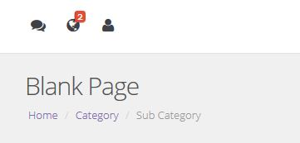

1. <div class="page-head">
2. <ol class="breadcrumb">
3. <li><a href="#">Home</a></li>
4. <li><a href="#">Category</a></li>
5. <li class="active">Sub Category</li>
6. </ol>
7. </div>
9. <div class="cl-mcont">
10. <!-- Content... -->
11. </div>
12. </div>

**Columns & Grid System**

This template uses Bootstrap 3 for almost all elements, if you don't know how to use it i highly recommend you to read [Bootstrap 3 Documentation](http://getbootstrap.com) before to get started. You can see it in action at ui-grid.html file.   
  
This is a basic example of bootstrap grid system:

.col-md-1

.col-md-1

.col-md-1

.col-md-1

.col-md-1

.col-md-1

.col-md-1

.col-md-1

.col-md-1

.col-md-1

.col-md-1

.col-md-1

.col-md-8

.col-md-4

.col-md-4

.col-md-4

.col-md-4

.col-md-6

.col-md-6

**HTML Code**

1. <div class="row">
2. <div class="col-md-1">.col-md-1</div>
3. <div class="col-md-1">.col-md-1</div>
4. <div class="col-md-1">.col-md-1</div>
5. <div class="col-md-1">.col-md-1</div>
6. <div class="col-md-1">.col-md-1</div>
7. <div class="col-md-1">.col-md-1</div>
8. <div class="col-md-1">.col-md-1</div>
9. <div class="col-md-1">.col-md-1</div>
10. <div class="col-md-1">.col-md-1</div>
11. <div class="col-md-1">.col-md-1</div>
12. <div class="col-md-1">.col-md-1</div>
13. <div class="col-md-1">.col-md-1</div>
14. </div>
15. <div class="row">
16. <div class="col-md-8">.col-md-8</div>
17. <div class="col-md-4">.col-md-4</div>
18. </div>
19. <div class="row">
20. <div class="col-md-4">.col-md-4</div>
21. <div class="col-md-4">.col-md-4</div>
22. <div class="col-md-4">.col-md-4</div>
23. </div>
24. <div class="row">
25. <div class="col-md-6">.col-md-6</div>
26. <div class="col-md-6">.col-md-6</div>
27. </div>

**Panels**

The panels boxes are a basic structural elements to wrap any HTML content with a visual standard box, they are divided in Head and Content.

Panel width is determinated by its parent element, usually a <div class="col-#-#"></div>:

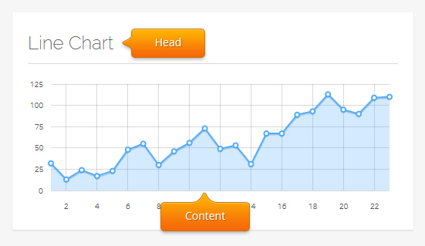

1. <div class="block-flat">
2. <div class="header">
3. <h3>Title</h3>
4. </div>
5. <div class="content">
6. <!-- Content -->
7. </div>
8. </div>

**Basic Javascript**

The javascript core functions are on js/behaviour/core.js, you must include this file in all the pages of your proyect.

**General Components**

These are the elements initialized in "core.js" method:

| **Component** | **Description** |
| --- | --- |
| Sidebar Functionality | Sidebar interactions |
| Tooltips | Initializes the tooltips, and can be used in any HTML Object with data-toggle="tooltip" attribute. Example:   1. <a data-original-title="I am a Tooltip" href="#" data-toggle="tooltip">Tooltip</a> |
| Popovers | Initializes the popovers, and can be used in any HTML Object with data-popover="popover" attribute. Example:   1. <a data-placement="top" data-content="content..." data-original-title="Title" data-popover="popover" href="#">Popover</a> |
| Nano Scroller | Initializes the NanoScroller plugin to use it with ".nscroller" class. |
| Nestable Lists | Initializes the Nestable Lists plugin to use it with ".dd" class. |
| Bootstrap Switch | Initializes the Switch plugin to use it with ".switch" class. |
| DateTime Picker | Initializes the DateTime Picker plugin to use it with ".datetime" class. |
| Select2 | Initializes the Select2 plugin to use it with ".select2" class. |
| Select2 - Tags | Initializes the Select2 Tags plugin option to use it with ".tags" class. |
| Bootstrap Slider | Initializes the Slider plugin to use it with ".bslider" class. |

**Plugins Includes**

Here are the required files for each plugin:

**Nano Scroller**

This plugin can be found in the dashboard chat and notification menu examples.

Visit the [Official Documentation](http://jamesflorentino.github.io/nanoScrollerJS/)

1. <!-- Nano Scroller -->
2. <script type="text/javascript" src="js/jquery.nanoscroller/jquery.nanoscroller.js"></script>
3. <link rel="stylesheet"type="text/css" href="js/jquery.nanoscroller/nanoscroller.css" />

**Spark Line**

This plugin can be found in the dashboard charts.

Visit the [Official Documentation](http://omnipotent.net/jquery.sparkline/)

1. <script type="text/javascript" src="js/jquery.sparkline/jquery.sparkline.min.js"></script>

**jQuery Flot Charts**

This plugin can be found in the dashboard charts.

Visit the [Official Documentation](http://www.flotcharts.org/)

1. <script type="text/javascript" src="js/jquery.flot/jquery.flot.js"></script>
2. <script type="text/javascript" src="js/jquery.flot/jquery.flot.pie.js"></script>
3. <script type="text/javascript" src="js/jquery.flot/jquery.flot.resize.js"></script>
4. <script type="text/javascript" src="js/jquery.flot/jquery.flot.labels.js"></script>

**Nestable Lists**

This plugin can be found in Nestable Lists page.

Visit the [Official Documentation](http://dbushell.github.io/Nestable/)

1. <script type="text/javascript" src="js/jquery.nestable/jquery.nestable.js"></script>

**Easy Pie Chart**

This plugin can be found in the dashboard charts.

Visit the [Official Documentation](http://rendro.github.io/easy-pie-chart/)

1. <script type="text/javascript" src="js/jquery.easypiechart/jquery.easy-pie-chart.js"></script>
2. <link rel="stylesheet"type="text/css" href="js/jquery.easypiechart/jquery.easy-pie-chart.css" />

**Bootstrap Switch**

This plugin can be found in the forms pages.

Visit the [Official Documentation](http://www.bootstrap-switch.org/)

1. <script type="text/javascript" src="js/bootstrap.switch/bootstrap-switch.min.js"></script>
2. <link rel="stylesheet"type="text/css" href="js/bootstrap.switch/bootstrap-switch.css" />

**Date Time Picker**

This plugin can be found in the forms pages.

Visit the [Official Documentation](http://www.malot.fr/bootstrap-datetimepicker)

1. <link rel="stylesheet"type="text/css" href="js/bootstrap.datetimepicker/css/bootstrap-datetimepicker.min.css" />
2. <script type="text/javascript" src="js/bootstrap.datetimepicker/js/bootstrap-datetimepicker.min.js"></script>

**Jquery Select2**

This plugin can be found in the forms pages.

Visit the [Official Documentation](http://ivaynberg.github.io/select2/)

1. <link rel="stylesheet"type="text/css" href="js/jquery.select2/select2.css" />
2. <script src="js/jquery.select2/select2.min.js" type="text/javascript"></script>

**Bootstrap Slider**

This plugin can be found in the forms pages.

Visit the [Official Documentation](http://www.eyecon.ro/bootstrap-slider)

1. <link rel="stylesheet"type="text/css" href="js/bootstrap.slider/css/slider.css" />
2. <script src="js/bootstrap.slider/js/bootstrap-slider.js" type="text/javascript"></script>

**Google Maps API**

This plugin can be found in maps page.

Visit the [Official Documentation](https://developers.google.com/maps/documentation/javascript/)

1. <script src="https://maps.googleapis.com/maps/api/js?v=3.exp&sensor=false"></script>

**Jquery Gritter Notifications**

This plugin can be found in UI Elements > General page.

Visit the [Official Documentation](https://github.com/jboesch/Gritter)

1. <link rel="stylesheet" type="text/css" href="js/jquery.gritter/css/jquery.gritter.css" />
2. <script type="text/javascript" src="js/jquery.gritter/js/jquery.gritter.min.js"></script>

**CKEditor**

This plugin can be found in UI Elements > General page.

Visit the [Official Documentation](http://ckeditor.com/)

1. <script src="js/ckeditor/ckeditor.js"></script>
2. <script src="js/ckeditor/adapters/jquery.js"></script>

**Fuel UX - Wizard**

We use this plugin just for wizzard complement and you can see it in Forms > Wizard page.

Visit the [Official Documentation](http://exacttarget.github.io/fuelux/#wizard)

1. <link href="js/fuelux/css/fuelux.css" rel="stylesheet">
2. <link href="js/fuelux/css/fuelux-responsive.min.css" rel="stylesheet">
3. <script type="text/javascript" src="js/fuelux/loader.min.js"></script>

**Data Tables**

This plugin can be found in Tables > Data Tables.

Visit the [Official Documentation](http://datatables.net)

1. <link rel="stylesheet"type="text/css" href="js/jquery.datatables/bootstrap-adapter/css/datatables.css" />
2. <script type="text/javascript" src="js/jquery.datatables/jquery.datatables.min.js"></script>
3. <script type="text/javascript" src="js/jquery.datatables/bootstrap-adapter/js/datatables.js"></script>

**jQuery Masked Input**

This plugin can be found in Forms > Masks.

Visit the [Official Documentation](http://digitalbush.com/projects/masked-input-plugin)

1. <script src="js/jquery.maskedinput/jquery.maskedinput.js" type="text/javascript"></script>

**Parsley**

This plugin can be found in Forms > Validation.

Visit the [Official Documentation](http://parsleyjs.org/)

1. <script src="js/jquery.parsley/parsley.js" type="text/javascript"></script>

**Prettify**

This plugin can be found in Typography.

Visit the [Official Documentation](http://code.google.com/p/google-code-prettify/)

1. <script type="text/javascript" src="js/prettify/run_prettify.js"></script>
2. <link type="text/css" rel="stylesheet" href="js/prettify/prettify.css" />

**Modernizr**

This plugin can be found in form elements

Visit the [Official Documentation](http://modernizr.com/)

1. <script src="js/modernizr.js" type="text/javascript"></script>

**Intro.js**

This plugin can be found in dashboard

Visit the [Official Documentation](http://usablica.github.io/intro.js/)

1. <link rel="stylesheet" type="text/css" href="js/intro.js/introjs.css" />
2. <script src="js/intro.js/intro.js" type="text/javascript"></script>

**Drop Zone**

This plugin can be found in form upload

Visit the [Official Documentation](http://www.dropzonejs.com/)

1. <link rel="stylesheet" type="text/css" href="js/dropzone/css/dropzone.css" />
2. <script type="text/javascript" src="js/dropzone/dropzone.js"></script>

**iCheck**

This plugin can be found in form elements

Visit the [Official Documentation](http://fronteed.com/iCheck/)

1. <link href="js/jquery.icheck/skins/square/blue.css" rel="stylesheet">
2. <script type="text/javascript" src="js/jquery.icheck/icheck.min.js"></script>

**Bootstrap-wysihtml5**

This plugin can be found in form text editors

Visit the [Official Documentation](https://github.com/jhollingworth/bootstrap-wysihtml5/)

1. <link rel="stylesheet" type="text/css" href="js/bootstrap.wysihtml5/src/bootstrap-wysihtml5.css"></link>
2. <script type="text/javascript" src="js/bootstrap.wysihtml5/lib/js/wysihtml5-0.3.0.js"></script>
3. <script type="text/javascript" src="js/bootstrap.wysihtml5/src/bootstrap-wysihtml5.js"></script>

**Summernote**

This plugin can be found in form text editors

Visit the [Official Documentation](http://hackerwins.github.io/summernote/)

1. <link rel="stylesheet" type="text/css" href="js/bootstrap.summernote/dist/summernote.css" />
2. <script type="text/javascript" src="js/bootstrap.summernote/dist/summernote.min.js"></script>

**Masonry**

This plugin can be found in gallery page

Visit the [Official Documentation](http://masonry.desandro.com/)

1. <script type="text/javascript" src="js/masonry.js"></script>

**Magnific Popup**

This plugin can be found in gallery page

Visit the [Official Documentation](http://dimsemenov.com/plugins/magnific-popup/)

1. <link rel="stylesheet" type="text/css" href="js/jquery.magnific-popup/dist/magnific-popup.css" />
2. <script type="text/javascript" src="js/jquery.magnific-popup/dist/jquery.magnific-popup.min.js"></script>

**jVectorMap**

This plugin can be found in vector maps page

Visit the [Official Documentation](http://jvectormap.com/)

1. <link rel="stylesheet" href="js/jquery.vectormaps/jquery-jvectormap-1.2.2.css" type="text/css" media="screen"/>
2. <script src="js/jquery.vectormaps/jquery-jvectormap-1.2.2.min.js"></script>

**Codemirror**

This plugin can be found in Code Editor

Visit the [Official Documentation](http://codemirror.net/doc/manual.html)

1. <link rel="stylesheet" type="text/css" href="js/jquery.codemirror/lib/codemirror.css">
2. <link rel="stylesheet" type="text/css" href="js/jquery.codemirror/theme/ambiance.css">
3. <script src="js/jquery.codemirror/lib/codemirror.js"></script>
4. <script src="js/jquery.codemirror/mode/xml/xml.js"></script>
5. <script src="js/jquery.codemirror/mode/css/css.js"></script>
6. <script src="js/jquery.codemirror/mode/htmlmixed/htmlmixed.js"></script>
7. <script src="js/jquery.codemirror/addon/edit/matchbrackets.js"></script>

**jPushMenu**

This plugin can be found in all pages

Visit the [Official Documentation](http://takien.github.io/jPushMenu/)

1. <link rel="stylesheet" type="text/css" href="js/jquery.pushmenu/css/jPushMenu.css" />
2. <script src="js/jquery.pushmenu/js/jPushMenu.js"></script>

**Nifty Modals**

This plugin can be found in UI modals

Visit the [Official Documentation](http://wp-dreams.com/nifty-modal-window-effects-with-css3-and-jquery/)

1. <link rel="stylesheet" type="text/css" href="js/jquery.niftymodals/css/component.css" />
2. <script src="js/jquery.niftymodals/js/jquery.modalEffects.js"></script>

**Full Calendar**

This plugin can be found in Calendar page

Visit the [Official Documentation](http://arshaw.com/fullcalendar/)

1. <link rel='stylesheet' type='text/css' href='js/jquery.fullcalendar/fullcalendar/fullcalendar.css' />
2. <link rel='stylesheet' type='text/css' href='js/jquery.fullcalendar/fullcalendar/fullcalendar.print.css' media='print' />
3. <script type='text/javascript' src='js/jquery.fullcalendar/fullcalendar/fullcalendar.js'></script>

**Date Range Picker**

This plugin can be found in Form Elements

Visit the [Official Documentation](https://github.com/dangrossman/bootstrap-daterangepicker)

1. <link rel="stylesheet" type="text/css" href="js/bootstrap.daterangepicker/daterangepicker-bs3.css" />
2. <script type="text/javascript" src="js/bootstrap.daterangepicker/moment.min.js"></script>
3. <script type="text/javascript" src="js/bootstrap.daterangepicker/daterangepicker.js"></script>

**Color Picker**

This plugin can be found in Form Elements

Visit the [Official Documentation](https://github.com/mjolnic/bootstrap-colorpicker/)

1. <link rel="stylesheet" type="text/css" href="js/bootstrap-colorpicker/dist/css/bootstrap-colorpicker.min.css">
2. <script type="text/javascript" src="js/bootstrap-colorpicker/dist/js/bootstrap-colorpicker.js"></script>

**Spinners**

This plugin can be found in Form Elements

Visit the [Official Documentation](https://github.com/istvan-ujjmeszaros/bootstrap-touchspin)

1. <script type="text/javascript" src="js/bootstrap.touchspin/bootstrap-touchspin/bootstrap.touchspin.js"></script>

**Jasny Extend**

This plugin can be found in Form Elements

Visit the [Official Documentation](http://jasny.github.io/bootstrap/)

1. <link rel="stylesheet" type="text/css" href="js/jasny.bootstrap/extend/css/jasny-bootstrap.min.css">
2. <script type="text/javascript" src="js/jasny.bootstrap/extend/js/jasny-bootstrap.min.js"></script>

**Multi Select**

This plugin can be found in Form Multiselect

Visit the [Official Documentation](https://github.com/davidstutz/bootstrap-multiselect)

1. <link rel="stylesheet" type="text/css" href="js/bootstrap.multiselect/css/bootstrap-multiselect.css"/>
2. <script type="text/javascript" src="js/bootstrap.multiselect/js/bootstrap-multiselect.js"></script>

**multiselect.js**

This plugin can be found in Form Multiselect

Visit the [Official Documentation](http://loudev.com)

1. <link rel="stylesheet" type="text/css" href="js/jquery.multiselect/css/multi-select.css" />
2. <script type="text/javascript" src="js/jquery.multiselect/js/jquery.multi-select.js"></script>
3. <script type="text/javascript" src="js/jquery.quicksearch/jquery.quicksearch.js"></script>

**X-Editable**

This plugin can be found in Tables X-Editable

Visit the [Official Documentation](http://vitalets.github.io/x-editable/)

1. <link rel="stylesheet" type="text/css" href="js/jquery.x-editable/dist/bootstrap3-editable/css/bootstrap-editable.css" />
2. <script type="text/javascript" src="js/jquery.x-editable/dist/bootstrap3-editable/js/bootstrap-editable.js"></script>
3. <script src="js/jquery.x-editable/src/inputs/combodate/lib/moment.min.js"></script>

**UI Elements**

For almost all ui elements is the same bootstrap documentation and it can be found in [Bootstrap CSS](http://getbootstrap.com/css) and [Bootstrap Components](http://getbootstrap.com/components) docs. For elements which part of their structure have changes, here is their respective documentation.

**Theme Alerts**

The theme alerts style structure changes just a little, you can change the alert icon (See icons docs section).

- To make rounded borders just put .rounded class in the main alert div container.

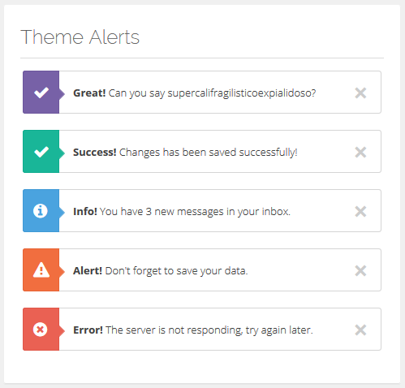

1. <div class="alert alert-success alert-white rounded">
2. <button data-dismiss="alert" class="close" type="button">×</button>
3. <div class="icon"><i class="icon-ok"></i></div>
4. <strong>Info!</strong> The page has been added.
5. </div>
7. <div class="alert alert-info alert-white rounded">
8. <button data-dismiss="alert" class="close" type="button">×</button>
9. <div class="icon"><i class="icon-info-sign"></i></div>
10. <strong>Info!</strong> The page has been added.
11. </div>
13. <div class="alert alert-warning alert-white rounded">
14. <button data-dismiss="alert" class="close" type="button">×</button>
15. <div class="icon"><i class="icon-warning-sign"></i></div>
16. <strong>Info!</strong> The page has been added.
17. </div>
19. <div class="alert alert-danger alert-white rounded">
20. <button data-dismiss="alert" class="close" type="button">×</button>
21. <div class="icon"><i class="icon-remove-sign"></i></div>
22. <strong>Error!</strong> The page has been added.
23. </div>

**Two Column Menu**

To make a Two Column Menu add .col-menu-2class to the ul.dropdown-menu main ul element, and divide the ul li elements in two divs with .col-sm-6 .no-padding classes:

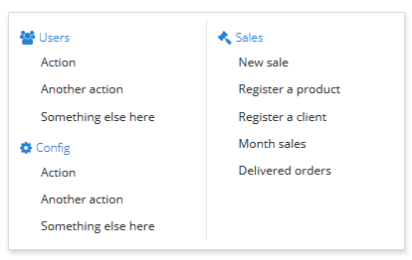

1. <ul class="dropdown-menu col-menu-2">
2. <div class="col-sm-6 no-padding">
3. <li class="dropdown-header"><i class="fa fa-#"></i>Menu Header</li>
4. <li><a href="#">Menu Item</a></li>
5. </div>
6. <div class="col-sm-6 no-padding">
7. <li class="dropdown-header"><i class="fa fa-#"></i>Menu Header</li>
8. <li><a href="#">Menu Item</a></li>
9. </div>
10. </ul>

**Gritter Notifications**

All Gritter Notification functionality can be found in their [official docs](https://github.com/jboesch/Gritter), however to make a theme styled notification you just add the .clean class via gritter plugin option: class_name.

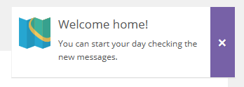

1. $.gritter.add({
2. title: 'Title',
3. text: 'Content',
4. class_name: 'clean',//<--------- Here
5. });

**Buttons**

Most of the buttons have the same bootstrap structure, and can be found in [Bootstrap Buttons Docs](http://getbootstrap.com/css/#buttons), for the rest:

**Rounded corners**

Just add ".btn-rad" class to the button.

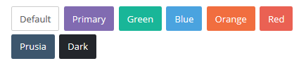

**Semi-transparent buttons**

Just add ".btn-transparent" class to the button.

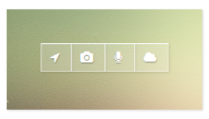

**Social Buttons**

Here is the HTML code for social buttons examples in respective order:

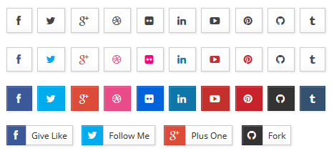

1. <button class="btn btn-default" type="button"><i class="icon-facebook"></i></button>
2. <button class="btn btn-default" type="button"><i class="icon-twitter"></i></button>
3. <button class="btn btn-default" type="button"><i class="icon-google-plus"></i></button>
4. <button class="btn btn-default" type="button"><i class="icon-dribbble"></i></button>
5. <button class="btn btn-default" type="button"><i class="icon-flickr"></i></button>
6. <button class="btn btn-default" type="button"><i class="icon-linkedin"></i></button>
7. <button class="btn btn-default" type="button"><i class="icon-youtube-play"></i></button>
8. <button class="btn btn-default" type="button"><i class="icon-pinterest"></i></button>
9. <button class="btn btn-default" type="button"><i class="icon-github"></i></button>
10. <button class="btn btn-default" type="button"><i class="icon-tumblr"></i></button>
12. <button class="btn btn-default btn-facebook" type="button"><i class="icon-facebook"></i></button>
13. <button class="btn btn-default btn-twitter" type="button"><i class="icon-twitter"></i></button>
14. <button class="btn btn-default btn-google-plus" type="button"><i class="icon-google-plus"></i></button>
15. <button class="btn btn-default btn-dribbble" type="button"><i class="icon-dribbble"></i></button>
16. <button class="btn btn-default btn-flickr" type="button"><i class="icon-flickr"></i></button>
17. <button class="btn btn-default btn-linkedin" type="button"><i class="icon-linkedin"></i></button>
18. <button class="btn btn-default btn-youtube" type="button"><i class="icon-youtube-play"></i></button>
19. <button class="btn btn-default btn-pinterest" type="button"><i class="icon-pinterest"></i></button>
20. <button class="btn btn-default btn-github" type="button"><i class="icon-github"></i></button>
21. <button class="btn btn-default btn-tumblr" type="button"><i class="icon-tumblr"></i></button>
23. <button class="btn btn-default btn-facebook bg" type="button"><i class="icon-facebook"></i></button>
24. <button class="btn btn-default btn-twitter bg" type="button"><i class="icon-twitter"></i></button>
25. <button class="btn btn-default btn-google-plus bg" type="button"><i class="icon-google-plus"></i></button>
26. <button class="btn btn-default btn-dribbble bg" type="button"><i class="icon-dribbble"></i></button>
27. <button class="btn btn-default btn-flickr bg" type="button"><i class="icon-flickr"></i></button>
28. <button class="btn btn-default btn-linkedin bg" type="button"><i class="icon-linkedin"></i></button>
29. <button class="btn btn-default btn-youtube bg" type="button"><i class="icon-youtube-play"></i></button>
30. <button class="btn btn-default btn-pinterest bg" type="button"><i class="icon-pinterest"></i></button>
31. <button class="btn btn-default btn-github bg" type="button"><i class="icon-github"></i></button>
32. <button class="btn btn-default btn-tumblr bg" type="button"><i class="icon-tumblr"></i></button>
34. <div class="btn-group">
35. <button class="btn btn-sm btn-default btn-facebook bg" type="button"><i class="icon-facebook"></i></button>
36. <button class="btn btn-sm btn-default" type="button">Give Like</button>
37. </div>
38. <div class="btn-group">
39. <button class="btn btn-sm btn-default btn-twitter bg" type="button"><i class="icon-twitter"></i></button>
40. <button class="btn btn-sm btn-default" type="button">Follow Me</button>
41. </div>
42. <div class="btn-group">
43. <button class="btn btn-sm btn-default btn-google-plus bg" type="button"><i class="icon-google-plus"></i></button>
44. <button class="btn btn-sm btn-default" type="button">Plus One</button>
45. </div>
46. <div class="btn-group">
47. <button class="btn btn-sm btn-default btn-github bg" type="button"><i class="icon-github"></i></button>
48. <button class="btn btn-sm btn-default" type="button">Fork</button>
49. </div>

**Icons**

This template use two kinds of icons sets, [Bootstrap](http://getbootstrap.com/components/#glyphicons) and [Font Awesome 4](http://fortawesome.github.io/Font-Awesome/examples/) Icons, see the official documentation for more information.

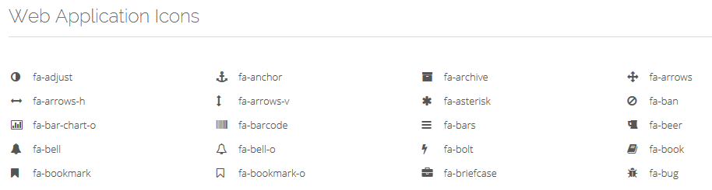

**Tabs & Accordions**

For all tabs you have to create a tab container div .tab-container the rest is the same bootstrap tabs, for more info go to [Bootstrap Tabs Docs](http://getbootstrap.com/javascript/#tabs):

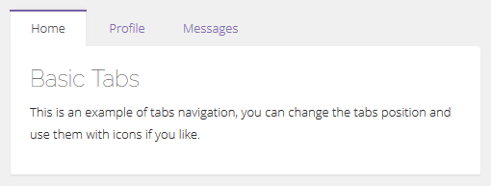

1. <div class="tab-container">
2. <ul class="nav nav-tabs">
3. <li class="active"><a href="#home" data-toggle="tab">Home</a></li>
4. <li><a href="#profile" data-toggle="tab">Profile</a></li>
5. <li><a href="#messages" data-toggle="tab">Messages</a></li>
6. </ul>
7. <div class="tab-content">
8. <div class="tab-pane active" id="home"></div>
9. <div class="tab-pane" id="profile"></div>
10. <div class="tab-pane" id="messages"></div>
11. </div>
12. </div>

**Bottom Tabs**

For bottom tabs position add .tab-bottomclass to the .tab-container div container, and put first the .tab-content div and next to it the tab navigation ul .nav .nav-tabs

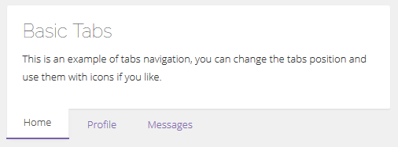

1. <div class="tab-container tab-bottom">
2. <div class="tab-content">
3. <div id="tab2-1" class="tab-pane active"></div>
4. <div id="tab2-2" class="tab-pane"></div>
5. <div id="tab2-3" class="tab-pane"></div>
6. </div>
7. <ul class="nav nav-tabs">
8. <li class="active"><a data-toggle="tab" href="#tab2-1">Home</a></li>
9. <li><a data-toggle="tab" href="#tab2-2">Profile</a></li>
10. <li><a data-toggle="tab" href="#tab2-3">Messages</a></li>
11. </ul>
12. </div>

**Left Tabs**

For left tabs position add .tab-leftclass to the .tab-container div container, keep the same basic order for .nav .nav-tabs and .tab-content.

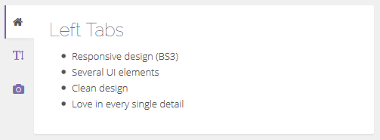

**Right Tabs**

For right tabs position add .tab-rightclass to the .tab-container div container, keep the same basic order for .nav .nav-tabs and .tab-content.

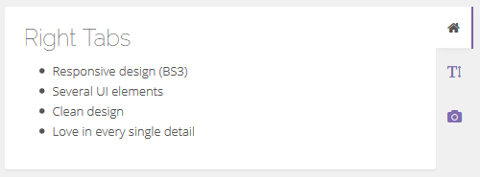

**Primary Color Accordion**

For primary color accordion style add .accordion-colorclass to the .panel-group .accordion div container, to see accordion documentation go to [Bootstrap Collapse](http://getbootstrap.com/javascript/#collapse).

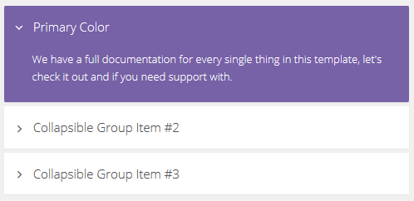

1. <div class="panel-group accordion accordion-color" id="accordion_id">
2. <!-- Accordion Elements -->
3. </div>

**Semi-Primary Accordion**

For primary color accordion style add .accordion-semiclass to the .panel-group .accordion div container.

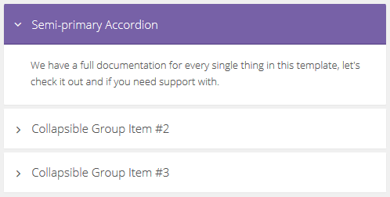

1. <div class="panel-group accordion accordion-semi" id="accordion_id">
2. <!-- Accordion Elements -->
3. </div>

**Custom State Color**

For primary color accordion style add .accordion-semiclass to the .panel-group .accordion div container and add the state color class to the .panel-heading div.

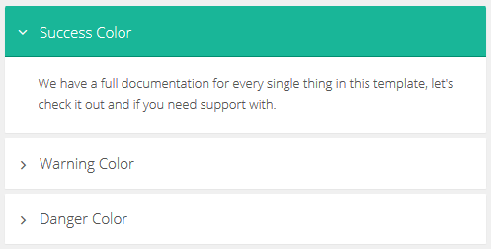

1. <div id="accordion4" class="panel-group accordion accordion-semi">
2. <div class="panel panel-default">
3. <div class="panel-heading **success**"><!-- Head Title --></div>
4. <div class="panel-collapse in" id="ac4-1"><!-- Content --></div>
5. </div>
6. <div class="panel panel-default">
7. <div class="panel-heading **warning**"><!-- Head Title --></div>
8. <div class="panel-collapse collapse" id="ac4-2"><!-- Content --></div>
9. </div>
10. <div class="panel panel-default">
11. <div class="panel-heading **danger**"><!-- Head Title --></div>
12. <div class="panel-collapse collapse" id="ac4-3"><!-- Content --></div>
13. </div>
14. </div>

**Change Log**

**Version 1.0 – 20 January 2014**

* Initial release

**Version 1.1 – 30 January 2014**

* Added: Calendar page
* Added: Tour plugin
* Added: Profile page
* Added: Date range picker
* Added: Color picker
* Added: Spinners
* Added: File Input
* Added: Multi Select
* Added: Form modals on bootstrap
* Added: Sign Up page
* Fixed: Minor bugs

**Version 1.1.2 – 12 February 2014**

* Updated: Bootstrap 3.1
* Added: Layouts
* Added: Media Lists
* Added: Forgot Password Page
* Added: Search Page
* Added: Chat Box
* Added: Porlets Actions
* Added: Clean Tiles
* Fixed: Minor bugs

**Version 1.1.3 – 22 February 2014**

* Added: Boxed Multi-select
* Added: Editable DataTables
* Added: X-Editable Table
* Added: Blanck Aside Header Page
* Fixed: Minor bugs

**Version 1.1.4 – 29 April 2014**

* Added: Email Compose Page
* Updated: Parsley 2.0
* Updated: Bootstrap Switch 3
* Fixed: Wizard Responsive
* Fixed: Minos bugs

**Version 1.1.5 – 17 June 2014**

* Fixed: Minos bugs