**WEEK9**

**ED DIAGRAM :**

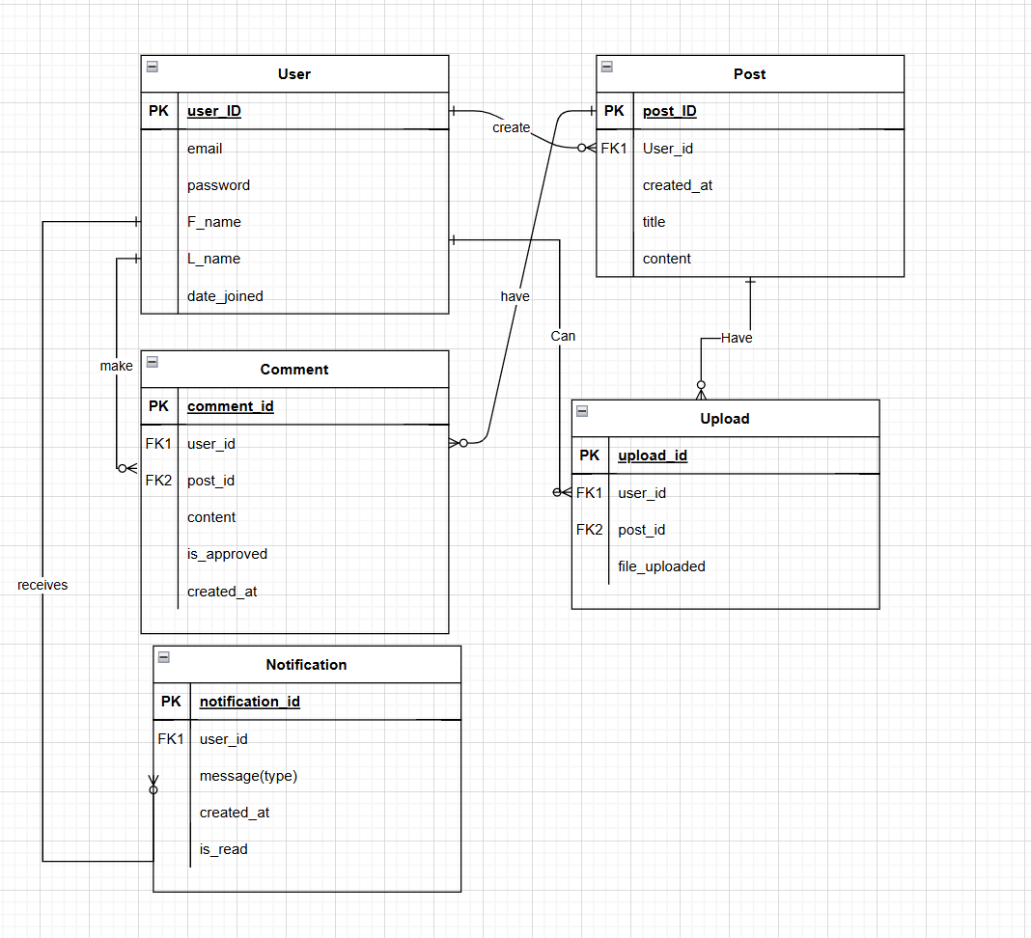

**Database Shema:**

**Notification table:**

**User table:**

**Post table:**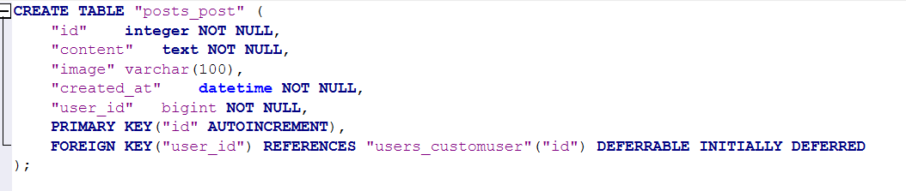

**Comment table:**

**Upload table:**

**CRUD Operations Implementation:**

| **Entity / Table** |  |  | **Create** |  |  |  |  | **Read** |  |  |  | **Update** |  |  |  | **Delete** |
| --- | --- | --- | --- | --- | --- | --- | --- | --- | --- | --- | --- | --- | --- | --- | --- | --- |
| **users** |  |  | **✔️** |  |  |  |  | **✔️** |  |  |  | **✔️** |  |  |  | **✔️** |
| **posts** |  |  | **✔️** |  |  |  |  | **✔️** |  |  |  | **✔️** |  |  |  | **✔️** |
| **notifications** |  |  | **✖️** |  |  |  |  | **✔️** |  |  |  | **✔️** |  |  |  | **✖️** |
| **Uploads** |  |  | **✔️** |  |  |  |  | **✔️** |  |  |  | **✖️** |  |  |  | **✔️** |

**Comments ✔️ ✔️ ✔️ ✔️**