What Is LiDAR and How Does It Work?
Andrey Ignatesko
Light Detection and Ranging, LiDAR, is a sensor that uses a laser to measure distances. It can be used in robotics, to help the robot know what objects are in its surroundings. It is considered active sensing since it produces its own light and detects the light reflected from nearby surfaces. A LiDAR system can be used to build a representation of the surrounding environment by adding up multiple measurements from different directions, which helps the robot know what objects it may encounter. It uses time of flight in order to measure distance. This works by having it emit a laser pulse toward an object, and some of that light reflects which the receiver measures. It measures the time between sending the pulse and detecting its return. The distance can be calculated using the equation.
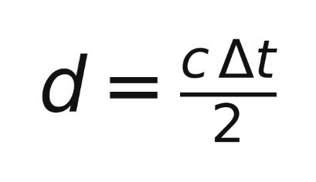
In this equation, d represents the distance to the object, c is the speed of light, which is 3 times 10^8 meters per second, and Delta t is the time it took. The result is divided by two because the light travels from the sensor to the object and then back to the sensor. A longer time means that the object is farther away. In order to create a map of its surroundings it needs to run measurements at different angles which it then combines to figure out the exact position of objects. The positions can be represented by x, y, and z coordinates, which creates a point cloud that describes the surfaces detected around the sensor. This makes it so robots can navigate their surroundings and detect obstacles. For example, a robot operating in a warehouse can use LiDAR to locate obstacles which would help it navigate the warehouse. Constant repeated scans allow the robot to constantly update its understanding of the surroundings as it moves, it also is used to tell the position of the robot itself.

