Uncovering Patterns in Road Accidents

A Data-Driven Safety Insight Report using Tableau

# 1. Introduction

This report explores accident trends using historical UK road accident data, identifying key risk factors that contribute to accident severity. The objective is to derive actionable insights that can help policymakers, urban planners, and transport authorities improve road safety.

Dataset Summary:

* - Records: 660,679 accidents
* - Key Fields: Severity, Date, Weather, Road Type, Light Conditions, District Area

# 2. Key Metrics Overview

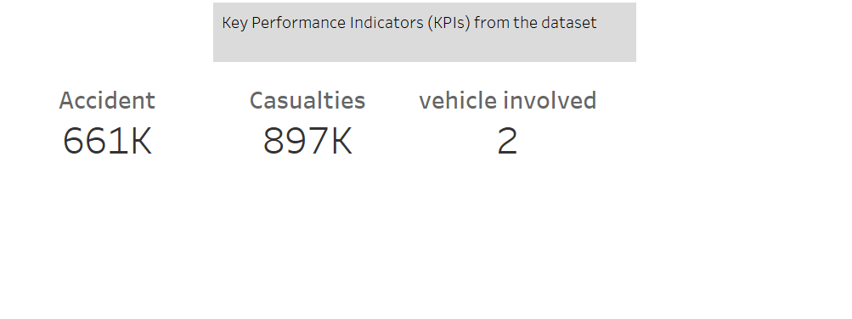

# 3. Temporal Analysis

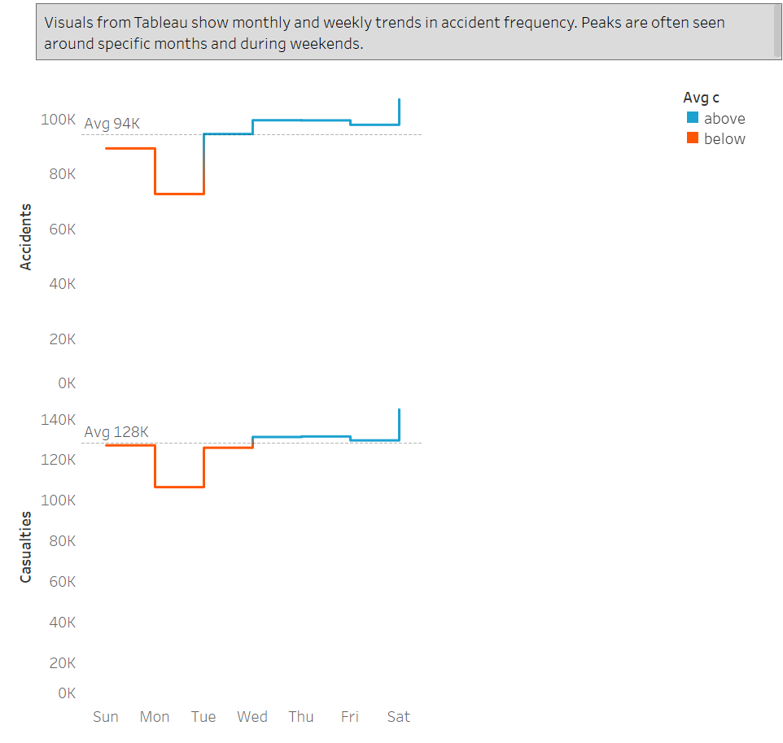

# 4. Environmental Conditions Impact

# 

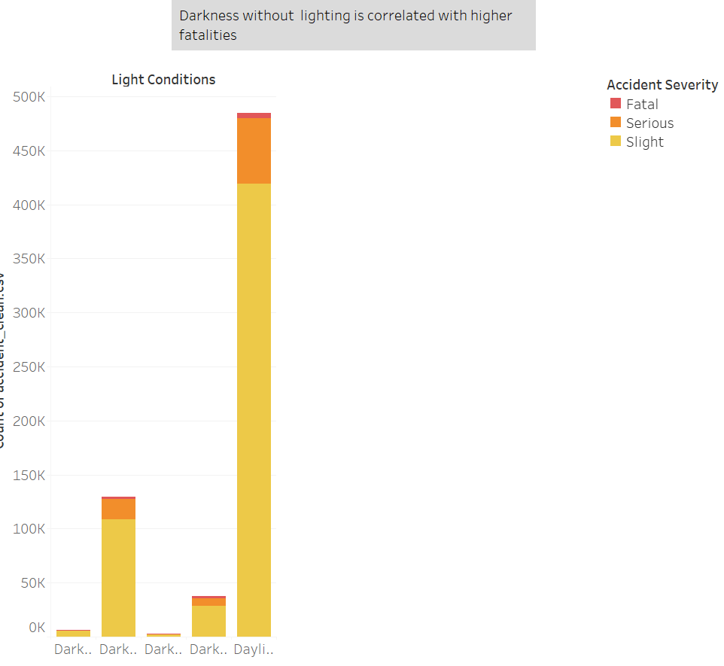

# 5. Spatial Patterns

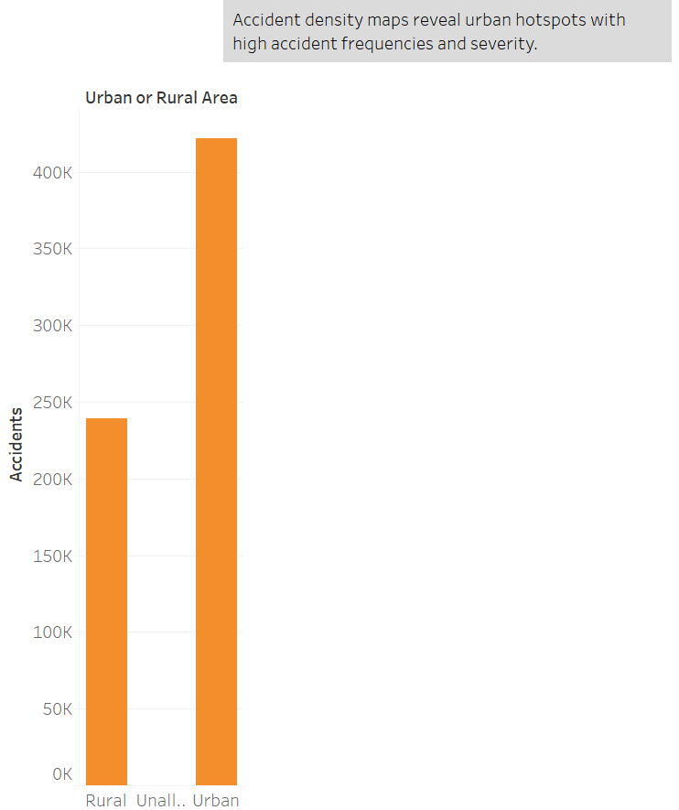.

# 6. Vehicle & Casualty Trends

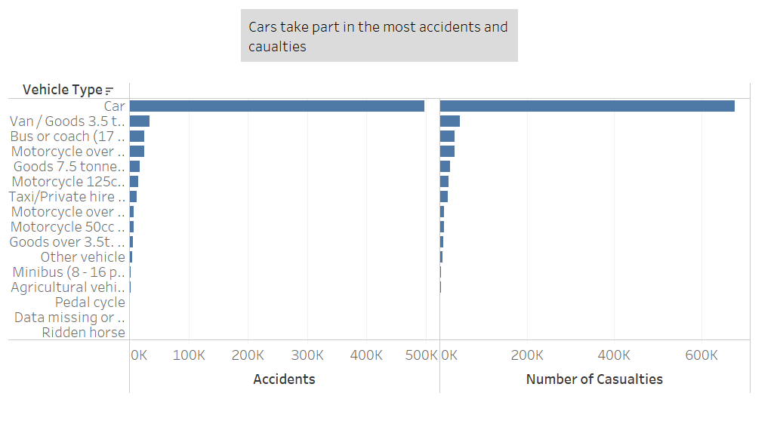

# 7. Summary of Findings

Summary Table:

* Wet Roads have higher severity in accidents so we should improve the quality of the roads.
* Nighttime cause more fatalities so we should add better lightening
* Urban Hotspots have the most number of accidents.
* More accidents happen on weekends.