**Login Form**

**Admin Dashboard**

* Number of files
* Number of users
* Number of file categories
* Number of departments

**Department Information – table with form**

* Department code
* Department name

**File Category Information – table with form**

* Category Name
* Description

**Department Users – table with form**

* Department code
* Full name
* Designation
* Profile Picture
* Username
* Password
* Account Status

**Approver Users – table with form**

* Full name
* Designation
* Profile Picture
* Username
* Password
* Account Status

**File Management**

* File Category
* Control Number
* Filename
* Description
* File size
* File type
* Date Uploaded
* Download File
* Department
* Status – pending, for review, approved
* Remarks

**File Comments**

* Control Number
* Comment
* Comment Date

**Settings**

* Files allowed
* File size max allowed

**Report – Number of File by Department**

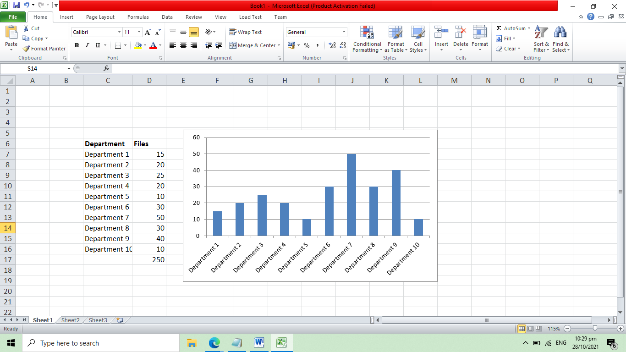

**Report – Files by status**

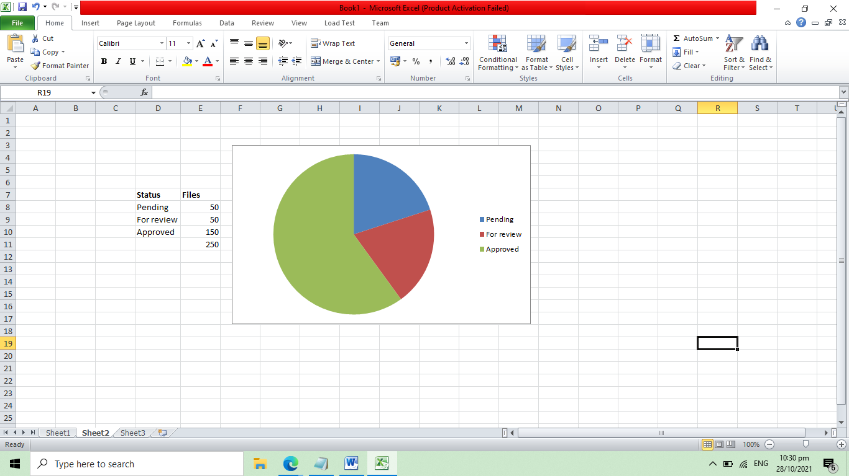

**Department User Account**

**Department Dashboard**

* Approved files
* Pending files
* For Review files

**List of Files**

* File Category
* Control Number – system generated
* Filename
* Description
* File size
* File type
* Date Uploaded
* Download File
* Department
* Status – pending, for review, approved
* Remarks

**Upload New File**

* File Category
* Control Number – system generated
* Filename
* Description
* File size
* File type
* Remarks

**Approver User Account**

**Approver Dashboard**

* Approved files
* Pending files
* For Review files

**List of Files**

* File Category
* Control Number – system generated
* Filename
* Description
* File size
* File type
* Date Uploaded
* Download File
* Department
* Status – pending, for review, approved
* Remarks

**Admin Account**

* Manage Organization (org_id, organization_name, description, username, password, representative_name)
* View Documents (doc_id, document_name, description, file_uploaded, uploaded_date, org_id, status)
* View Document Comments (comment_id, comments, date, approver_id)
* Manage Approver (approver_id, full_name, username, password, level(1,2,3))

**Approver Account**

* View Files – for approval/comments

**Organization Account**

* Upload Documents

**Flow of the System**

1. The organization will upload the file

* File status by default is pending for level 1

1. The level 1 approver will then check the file for feedback
2. The next level will proceed to level 2 approver for feedback
3. Next is level 3, if approved, the file will be update into accepted.