# Contents

1. Version Control System 2- Git and GitHub

# Version Control System (VCS)

Revision control, also known as version control and source control (and an aspect of software configuration management), is the management of changes to documents, computer programs, large web sites, and other collections of information. Changes are usually identified by a number or letter code, termed the "revision number", "revision level", or simply "revision". For example, an initial set of files is "revision 1". When the first change is made, the resulting set is "revision 2", and so on. Each revision is associated with a timestamp and the person making the change. Revisions can be compared, restored, and with some types of files, merged.

## Version control Concepts and terminologies

The following terms has a special meaning with respect to Version control systems:

* Repository (repo): The database storing the files.
* Server: The computer storing the repo.
* Client: The computer connecting to the repo.
* Working Set/Working Copy: Your local directory of files, where you make changes.

The following Actions could be executed against version control systems:

* Add: Put a file into the repo for the first time, i.e. begin tracking it with Version Control.
* Revision: What version a file is on (v1, v2, v3, etc.).
* Head: The latest revision in the repo.
* Check out: Download a file from the repo.
* Check in: Upload a file to the repository (if it has changed). The file gets a new revision number, and people can “check out” the latest one.
* Check-in Message: A short message describing what was changed.
* Change-log/History: A list of changes made to a file since it was created.
* Update/Sync: Synchronize your files with the latest from the repository. This lets you grab the latest revisions of all files.
* Revert: Throw away your local changes and reload the latest version from the repository.

## Git as a Reversion control System

Git is an open-source code management tool; it’s one of the fastest revision controls and it’s easy to use. The following steps will be used to setup a Git repository, add some files to it.

* 1. Setup Git you could go to the following link to download the latest Git software that is suitable for your system. <http://git-scm.com/downloads>
  2. **you can use this link https://windows.github.com/ to setup Git for windows(console + GUI).**

## Practice 1

Please Follow the Following Steps: During the following lab practice we will go through java application project and manage that repository under Git revision control as well as pushing this project to Github repository.

* + 1. Using your Java IDE; create a new project name SocialNW this project will contain a number of classes which represent your Project. (we can test now with simple java project that take number from the user and check if the number is prime or not )
    2. Create an empty directory on any path in your computer and open git command to initialize a repository inside it with

Git init.

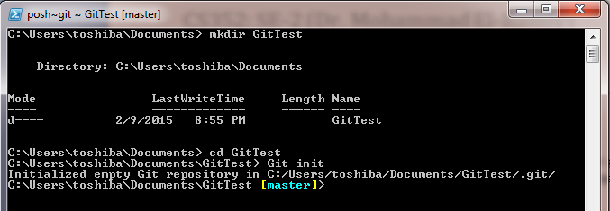

* + 1. Copy your project files into the repository/directory created in the previous step.

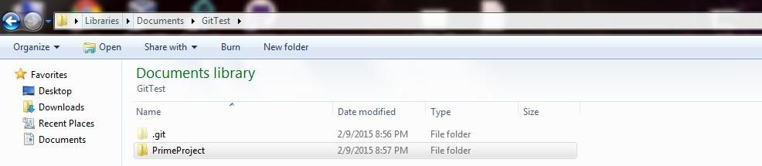

* + 1. To add these files to Git repository so that Git will track the changes happens to these files/projects you should add these files/projects to the repository through using Git Add <file or directory>

Git Add PrimeProject

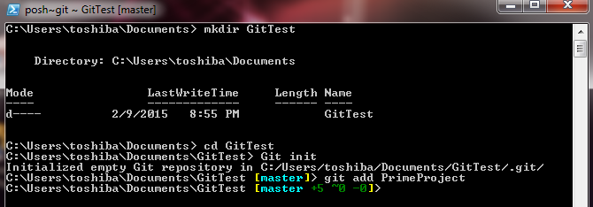

* + 1. To save a snapshot of your project at the current stage you could do that through Git Commit command. This command takes a description message to tag or identify the changes happens to that snapshot.

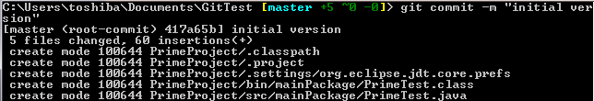

### You could use Git Status command to check the status of the repository at any certain point of time.

Git status

* + 1. remote command is used to link your local version of the repository to a remote repository hosted in a remote server for example GitHub repository.
    2. Before you link your local and remote repository you have to create a remote/online repository first the following steps will go through creating an online repository on GitHub:

1. Go to <https://github.com/>
2. Fill-in your information User name, Email and Password then Click SignUp For GitHub.

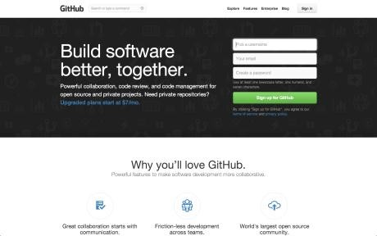

1. Next Step to customize your repository Github provide a free repository for public projects, you have to pay to get a private repo. A side note, BitBucket is another remote repo host provide up to 4 users with a private repo.
2. To create a new online repository u could do that from the plus icon from top right create a repository.

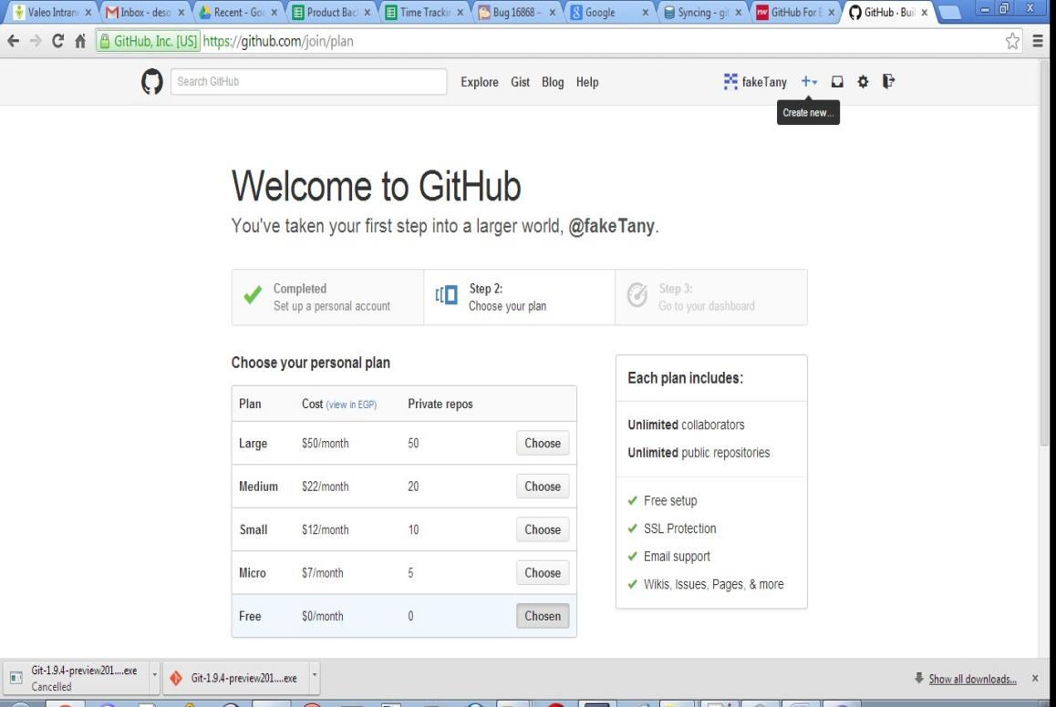

1. Give a name to a repo as well as a description for it and choose public and check add a readme file to that repository, this read me file is act as the home page for this repository it should contains project specific information and how to use it.

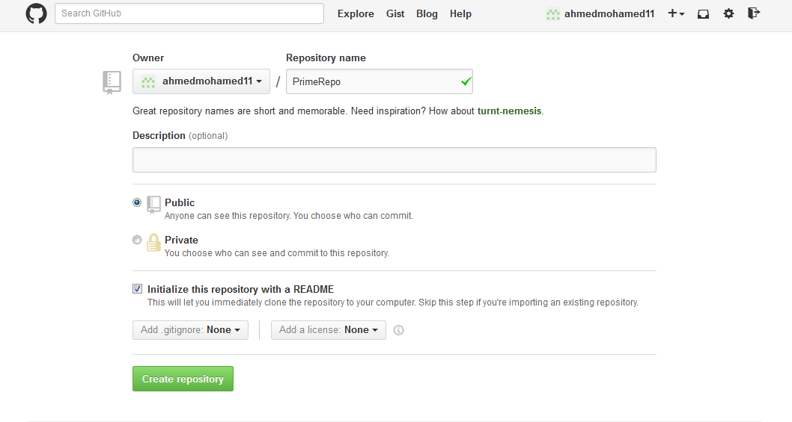

1. Now you have created a remote repository for your project please copy the link for that repo from the left hand side part titled with HTTPS Clone URL. Something like https://github.com/ahmedmohamed11/PrimeRepo.git

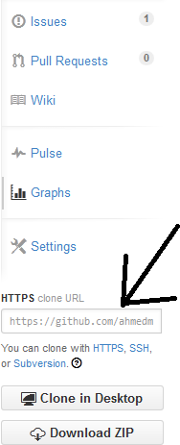

### Now to link the local and remote repositories we use the following Git command

git remote add origin https://github.com/ahmedmohamed11/PrimeRepo.git

1. To push/save your local changes to the remote repository we could use Git push command

Git push origin master

1. In push/save step you may be to get all the online repository(by pull to local repository)

to avoid conflict

Git pull origin master

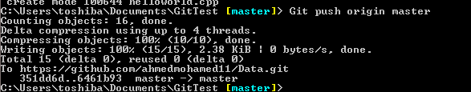

1. Also We could clone an already existed repository from remote host to our local

machine through using Git clone <remote repo git url> inside an new empty folder.

Git clone <https://github.com/ahmedmohamed11/PrimeRepo.giT>

#### Change Link between local repository and online Repository

1. To list your repository

git remote -v

1. To delete your origin repository

git remote rm origin

### To Add Now to link the local and remote repositories we use the following Git command

git remote add origin https://github.com/ahmedmohamed11/PrimeRepo.git

#### Collaborators

You can add you team to your repository so can everyone in your team able to push to the repository

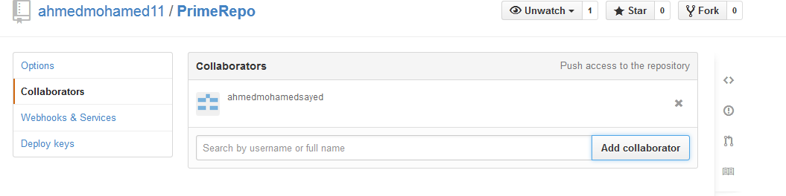

#### Branches

The main branch of a repository is usually named master, and represents a relatively stable version of the project you're working on. So far, all the changes you've made have been on the master branch.

If you're making an app or website, for example, you might have a bunch of different features or ideas in progress at any given time – some of which are ready to go, and others which are not. For this reason, master exists as a central point to fold other *branches* of work into.

**Tip**: If you really want to commit straight to master, the app won't stop you. However, this doesn't lend itself well to working collaboratively, and your changes will be harder to track and maintain as the project gets larger. A branch is just a separate version of the code.

1. To list your branches

git branch

1. Create new branch

git branch myBranch

1. Change to your branch(to work on your branch, not the master branch)

git checkout myBranch

1. At this step you can modify your code & commit your code to your branch by the following command

|  |
| --- |
| git add filename |
| git commit -m "message" |

1. Now we need to merge master with my branch to ensure that is no conflict (the conflict may be happen if the master is different from my branch which happen if the master had one or more commit after I create my branch. The conflict must be handle manually by editing your code)

Git merge master

1. Change to the master branch to merge the new branch with the master

Git checkout master

1. Merge master with the myBranch

Git merge myBranch

1. Push your updated code to the master

Git push origin master

## GitHub student pack

You can subscribe for free to GitHub student pack as it provides  many free development tools to students with GitHub account who are registered in university and > 18 yrs.

1. Go to [https://education.github.com/pack](https://education.github.com/pack" \t "_blank)
2. Press Students tab

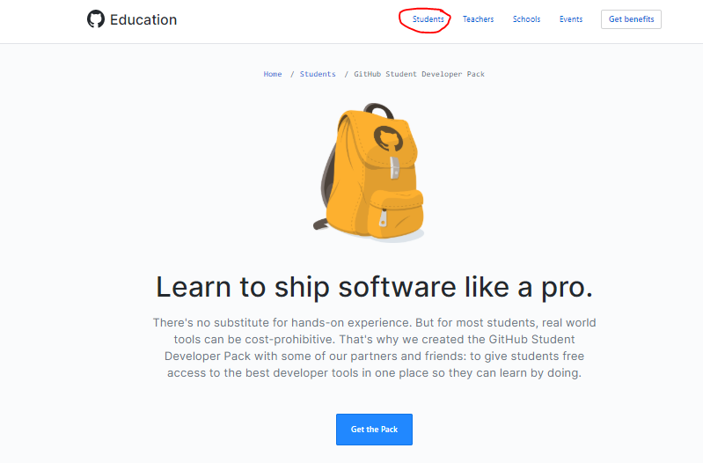

1. Choose Student **GitHub Student Developer Pack**



# 4-press get the pack.

# 

# Fill your information in the application and upload photo for your ID.

# 

# 5-You can find some of free development tools to use:

# Lab Task:

# Create account on <https://github.com/>

# Create your own remote/online repository.

# Upload two of your projects in programming 1 and 2 subjects (not projects of this term) to your repository.

# Take a snap shot of your repository after adding your projects and name your screenshot with this format Lab8\_GroupNumber\_Name\_ID.

# Send it to your lab TA.

# References

* + [1] <https://guides.github.com/activities/hello-world/>
  + [2] <http://betterexplained.com/articles/a-visual-guide-to-version-control/>
  + [3] <http://www.mountaingoatsoftware.com/agile/scrum/overview>
  + [4] [http://www.deepfriedbrainproject.com/2010/03/configuration-management-system- quick.html](http://www.deepfriedbrainproject.com/2010/03/configuration-management-system-quick.html)

### [5] <https://www.atlassian.com/git/tutorials/using-branches>

* + Useful videos
    - These are videos of Eng.Amr Samir, very brief but very useful
      * [https://www.youtube.com/watch?v=iIWM5k2d4cs](https://www.youtube.com/watch?v=iIWM5k2d4cs" \t "_blank)
      * [https://www.youtube.com/watch?v=dZh2U5g2NMs&t=20s](https://www.youtube.com/watch?v=dZh2U5g2NMs&t=20s" \t "_blank)
      * [https://www.youtube.com/watch?v=hFSaDki19HI&t=99s](https://www.youtube.com/watch?v=hFSaDki19HI&t=99s" \t "_blank)
    - <https://www.youtube.com/watch?v=6AWtiwvcDtU&t=326s>
    - <https://www.youtube.com/watch?v=1Jd1cBn8tW4>
    - <https://www.youtube.com/watch?v=tHDJ_CS3rmI>

# Author(s)

### Desoky & Ahmed