Chat Program - Project Documentation

Omar Yahya - 202000259

Seif Maged - 202000022

Yousef Sameh - 202000023

We created a simple LAN chatting program with GUI, we used Tkinter for the interface and created a login window and a chatroom window, for the back-end we used socket programming and threading to maintain the networking.

Login Window:

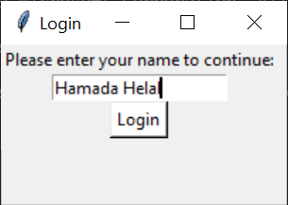

for the user to enter his/her name to connect with everyone in the chatroom.

Chatroom window:

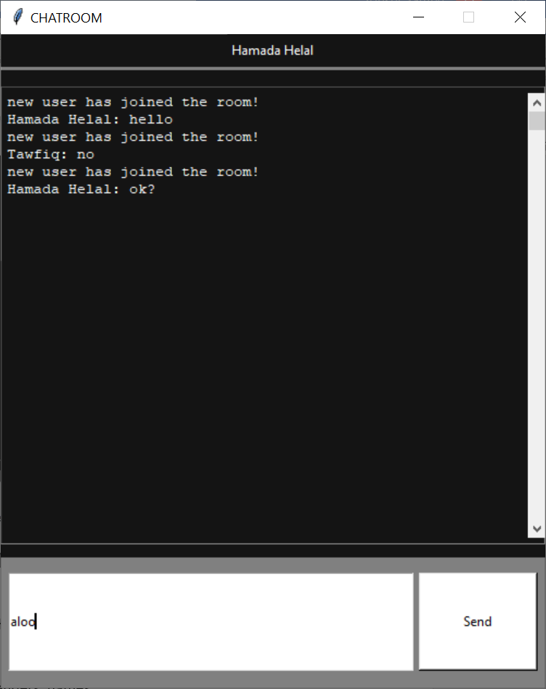

* Head containing the name of the user from the login window.
* Entry for user to type the msg.
* Button to send the msg.
* Messages will appear in the blank area with senders’ names.

Role of each member:

* Omar: login window/server
* Yousef: chatroom interface
* Seif: networking for client

Usage:

* Run server file first.
* Run client file in a separate terminal.
* Login by typing your name then pressing the button.
* The chatroom will appear, and you will be able to send and receive messages by typing and pressing the send button.