JDBC

Team members:

* Yousef mohamed fathy.
* Mohamed mohamed abdelhakem.
* Karim atef ahmed.
* Abdallah mohamed fawzy elsman.

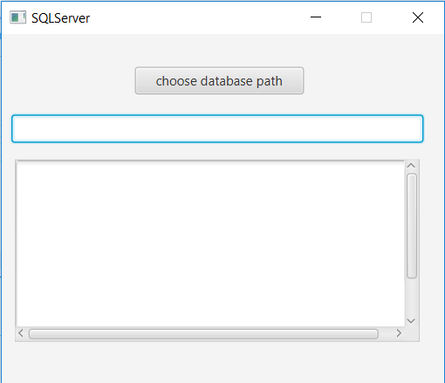

**Description**

Java Database Connectivity (JDBC) provides Java developers with a standard API

that is used to access databases, regardless of the driver and database product.

JDBC presents a uniform interface to databases, change vendors and your applications only need to change their driver.

**UML design**

**User guide**