

HOTEL MANAGEMENT SYSTEM

CSCI313 PROJECT

Youssef Ghonim 231001693

Omar Mohamed Elsahfie 231000166

Yassin Salah 231000798

Ramez Emad 231000291

Youssef Helmy 231000834
Table of Contents
- Introduction 3
1.1 Purpose of the document 3
1.2 Scope of the project 3
1.3 Technologies Used 3
1.4 Intended Audience 3
1.5 Overview of the document 4
- Functional Requirements 7
3.1 Guest/User Features 7
3.2 Admin/Staff Features 7
3.3 Room Management Features 8
3.4 Payment Processing Features 8
- Non-Functional Requirements 9
4.1 Reliability 9
4.2 Recoverability 9
4.3 Performance 9
4.4 Availability 9
4.5 Usability 9
4.6 Maintainability 9
- Diagrams 21
6.1 Use Case Diagram 21
6.1.1 Use Case Scenarios 22
6.2 Sequence Diagram 31
6.3 Class Diagram 38

1. Introduction
1.1 Purpose of the document
This document provides comprehensive documentation for the Hotel Management System (HMS) project. It serves as a complete reference for understanding the system's functionality, technical specifications, design decisions, and implementation details. The documentation is intended to guide developers, testers, administrators, and stakeholders through all aspects of the hotel management platform.
1.2 Scope of the project
The Hotel Management System is a web-based application designed to automate hotel operations including room booking, guest management, payment processing, and administrative tasks. The system covers the complete lifecycle from guest registration and room search to booking confirmation and payment processing. It supports multiple user roles including guests, hotel staff, and administrators, with appropriate permissions and functionalities for each role.
1.3 Technologies Used
- Backend Framework: Django 4.x (Python)
- Database: SQLite (development), PostgreSQL compatible
- Payment Gateway: Razorpay API integration
- Frontend: HTML5, CSS3, JavaScript, Bootstrap
- Image Processing: Pillow library
- Email Service: Django SMTP integration
- Version Control: Git
- Development Tools: VS Code/PyCharm
1.4 Intended Audience
- Hotel Management Staff: Front desk personnel, managers, and administrators who will use the system daily
- System Administrators: IT personnel responsible for deployment and maintenance
- Developers: Software engineers who may modify or extend the system
- Testers: Quality assurance professionals who need to understand system behavior
- Project Stakeholders: Hotel owners and investors who need to understand system capabilities
- Academic Evaluators: Instructors and graders assessing the project
1.5 Overview of the document
This document is structured to provide a complete understanding of the Hotel Management System. It begins with an introduction to the project, followed by detailed functional and non-functional requirements. The document includes comprehensive use case scenarios, sequence diagrams showing system interactions, and class diagrams illustrating the system architecture. Each section builds upon the previous to give readers a thorough understanding of the system from both user and technical perspectives.

3. Functional Requirements
3.1 Guest/User Features
3.1.1 User Registration and Authentication
- Users must be able to register using email, username, and password
- Existing users must be able to log in securely
- Password recovery functionality must be available
- User sessions must be managed securely
3.1.2 Hotel and Room Search
- Users must be able to search hotels by location (city, area)
- Search results must display available hotels with basic information
- Users must be able to filter results by price range, star rating, and amenities
- Each hotel listing must show room availability status
3.1.3 Room Booking Process
- Users must be able to select check-in and check-out dates
- The system must display available rooms for selected dates
- Users must be able to select room type and number of guests
- The system must calculate total price including taxes and fees
- Users must receive a booking confirmation with details
3.1.4 Profile Management
- Users must be able to create and update their profiles
- Profile must include personal information and contact details
- Users must be able to upload profile pictures
- Users must be able to view their booking history
3.2 Admin/Staff Features
3.2.1 Hotel Management
- Admin must be able to add new hotels to the system
- Admin must be able to update hotel information (name, location, description)
- Admin must be able to set hotel star ratings and categories
- Admin must be able to upload hotel images to galleries
3.2.2 Room Management
- Admin must be able to add different room types to hotels
- Admin must be able to set room prices and capacities
- Admin must be able to update room availability status
- Admin must be able to manage room amenities and features
3.2.3 Booking Management
- Admin must be able to view all bookings in the system
- Admin must be able to confirm or cancel bookings
- Admin must be able to process refunds when necessary
- Admin must be able to generate booking reports
3.3 Room Management Features
3.3.1 Availability Checking
- The system must check room availability in real-time
- Double-booking must be prevented through validation checks
- The system must show available rooms based on selected dates
- Room status must update automatically after bookings
3.3.2 Room Information Display
- Each room must display type, capacity, and amenities
- Room prices must be displayed clearly
- Images of each room type must be available
- Special features (AC, view, size) must be indicated
3.4 Payment Processing Features
3.4.1 Online Payment Integration
- The system must integrate with Razorpay payment gateway
- Multiple payment methods must be supported (credit/debit cards, net banking)
- Payment process must be secure and encrypted
- Payment status must be tracked and recorded
3.4.2 Payment Confirmation
- Users must receive payment confirmation immediately
- Booking status must update automatically after successful payment
- Receipts must be generated and stored
- Email confirmation must be sent after payment
3.4.3 Refund Processing
- The system must support refund processing for cancellations
- Refund status must be tracked and updated
- Users must be notified about refund progress
- Refund records must be maintained in the system

4. Non-Functional Requirements
4.1 Reliability
The system must maintain 99% uptime during operational hours. Critical functions such as booking and payment processing must have zero tolerance for failure. The system must handle concurrent user sessions without data corruption or loss. All financial transactions must be processed accurately and completely.
4.2 Recoverability
In case of system failure, recovery must be possible within 2 hours. Daily automated backups of the database must be performed. Transaction logs must be maintained for audit and recovery purposes. The system must have a disaster recovery plan for catastrophic failures.
4.3 Performance
Page load times must not exceed 3 seconds under normal load. The system must support at least 100 concurrent users without performance degradation. Database queries must be optimized for fast response times. Image loading and processing must not impact user experience.
4.4 Availability
The booking system must be available 24/7 for users worldwide. Scheduled maintenance windows must be minimal and announced in advance. The system must be accessible from all modern web browsers. Mobile accessibility must be ensured through responsive design.
4.5 Usability
The user interface must be intuitive and require minimal training. Error messages must be clear and suggest corrective actions. Navigation must be consistent throughout the application. The system must be accessible to users with disabilities (WCAG compliance).
4.6 Maintainability
The codebase must be well-documented with comments and documentation. The system architecture must allow for easy addition of new features. Database schema must be designed for scalability and future enhancements. Configuration settings must be externalized for easy maintenance.

6. Diagrams
6.1 Use Case Diagram
The use case diagram illustrates the interactions between different actors (users) and the system. The main actors are:
- Guest: Regular users who book rooms
- Admin: Hotel staff who manage the system
- System: Automated processes within the application
Primary Use Cases:
- Register Account: Guest creates a new user account
- Login: User authenticates to access the system
- Search Hotels: User searches for available hotels
- Book Room: Guest completes a room booking
- Make Payment: User processes payment for booking
- Manage Hotels: Admin adds/updates hotel information
- Manage Bookings: Admin views and manages reservations
- Update Profile: User modifies personal information
Secondary Use Cases:
- View Booking History
- Cancel Booking
- Process Refund
- Upload Hotel Images
- Generate Reports
Software Testing :
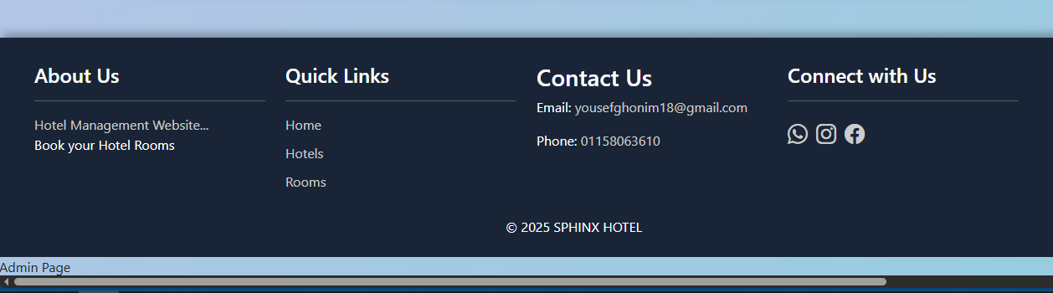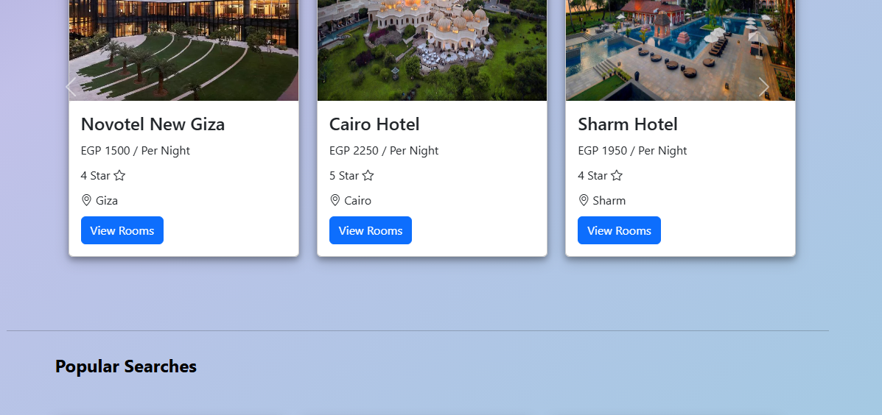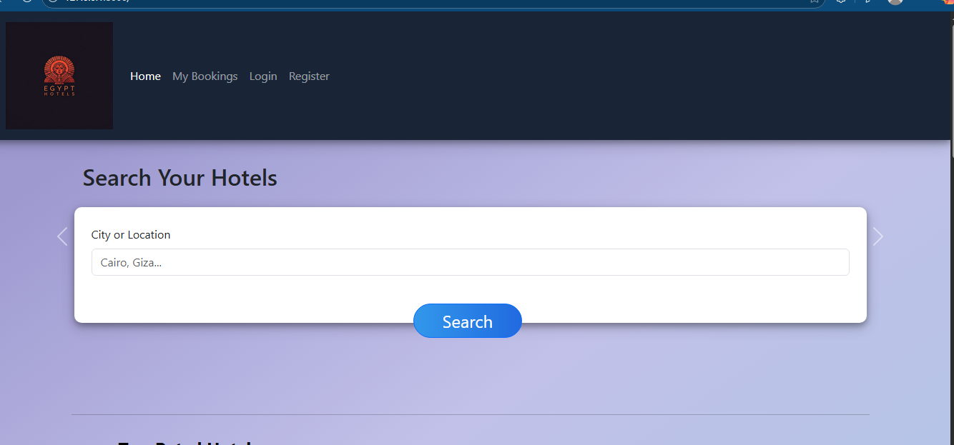

6.1.1 Use Case Scenarios
Use Case 1: Room Booking
Use Case Name: Book Hotel Room
Actors: Guest, System
Preconditions:
- User is registered and logged in
- System is operational
- Hotels are available in the database
Main Success Scenario:
- User navigates to the hotel search page
- User enters destination location and dates
- System displays available hotels
- User selects a hotel and views available rooms
- User selects a room type and confirms dates
- System displays booking summary with price
- User proceeds to payment page
- User enters payment details and confirms
- System processes payment and confirms booking
- User receives booking confirmation email
- System updates room availability
Alternative Flows:
- If no rooms available: System suggests alternative dates or hotels
- If payment fails: System prompts for alternative payment method
- If session expires: System redirects to login page
Postconditions:
- Booking is recorded in the database
- Room status is updated to "Booked"
- User receives confirmation with booking ID
Use Case 2: Hotel Management
Use Case Name: Manage Hotel Information
Actors: Admin, System
Preconditions:
- Admin is logged in with appropriate permissions
- Admin has necessary hotel information
Main Success Scenario:
- Admin navigates to hotel management dashboard
- Admin selects "Add New Hotel" option
- Admin enters hotel details (name, location, description)
- Admin sets hotel category and star rating
- Admin uploads hotel images
- System validates and saves hotel information
- Admin adds rooms to the hotel with details
- System confirms hotel creation
Alternative Flows:
- If validation fails: System highlights errors for correction
- If image upload fails: System suggests alternative formats
Postconditions:
- New hotel is added to the system
- Hotel is available for booking
- Images are stored in the media gallery
Use Case 3: Payment Processing

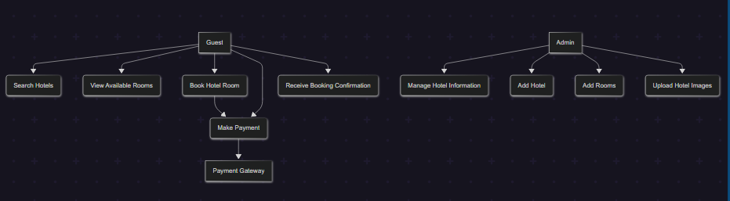
Use Case Name: Process Online Payment
Actors: Guest, System, Payment Gateway
Preconditions:
- User has completed booking details
- Booking total has been calculated
- User has valid payment method
Main Success Scenario:
- System displays payment page with amount
- User selects payment method
- User enters payment details securely
- System sends payment request to Razorpay gateway
- Payment gateway processes transaction
- System receives payment confirmation
- System updates booking status to "Paid"
- System generates and stores receipt
- System sends payment confirmation email
Alternative Flows:
- If payment declined: System shows error and retry option
- If gateway timeout: System shows pending status
Postconditions:
- Payment is recorded in the system
- Booking is confirmed
- Receipt is available for download
6.2 Sequence Diagram
Sequence Diagram 1: Room Booking Process

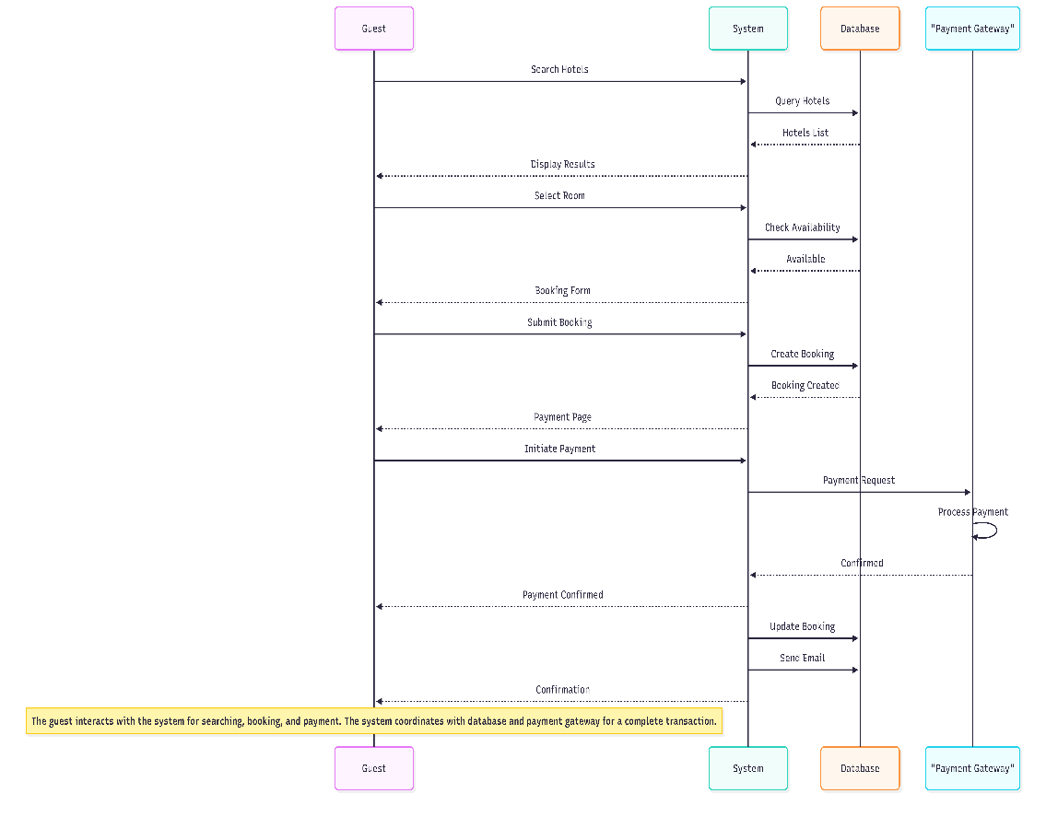

Description: This sequence shows the complete room booking process from search to confirmation. The guest interacts with the system to find and book a room, with the system coordinating with the database and payment gateway to complete the transaction.
6.3 Class Diagram
The class diagram represents the main entities and their relationships in the Hotel Management System:

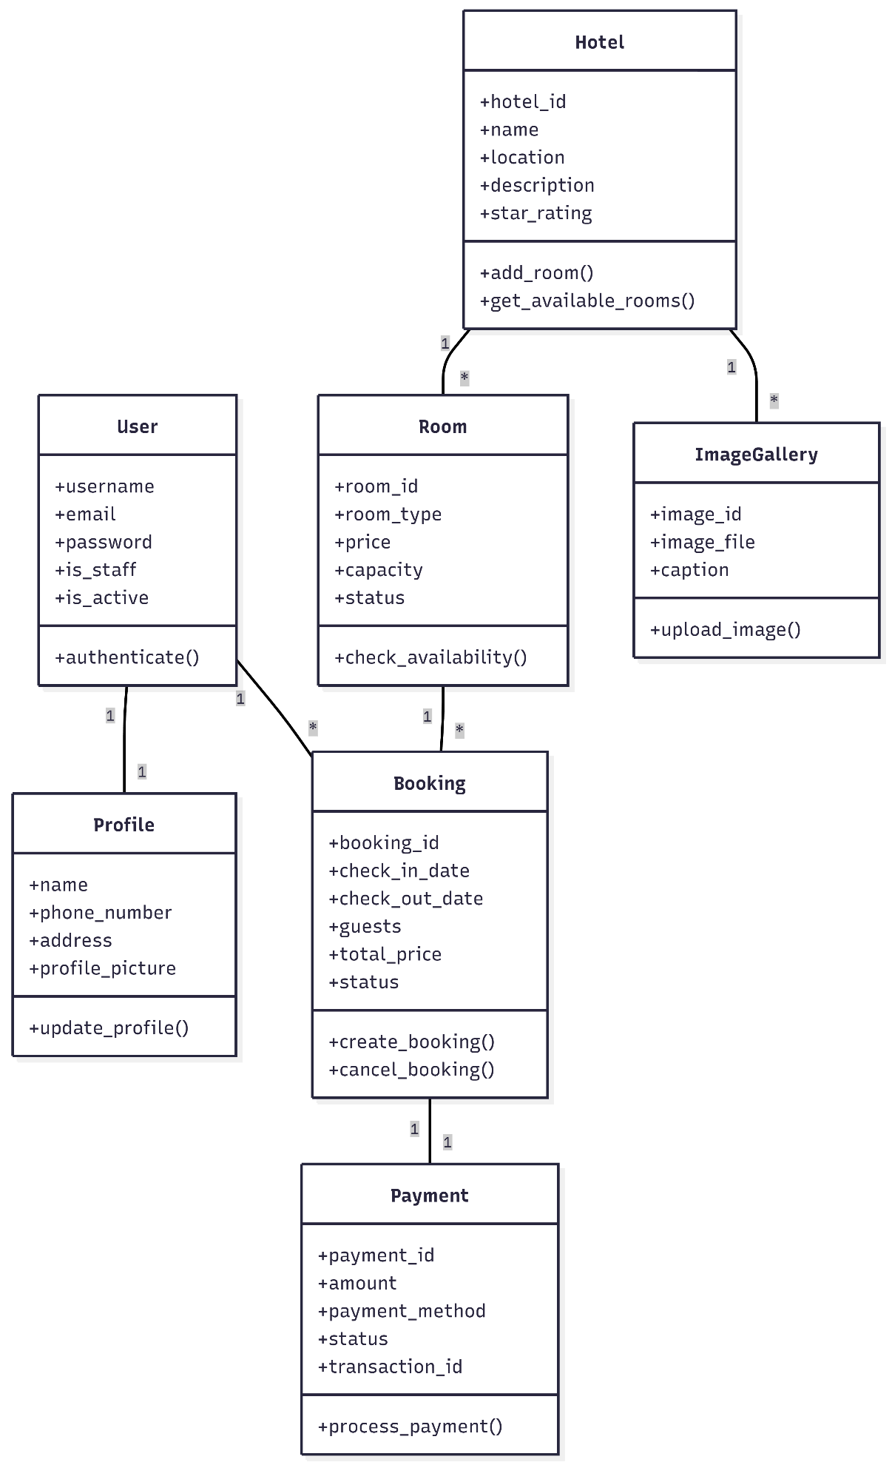
Core Classes:
- User (extends Django's AbstractUser)
  - Attributes: username, email, password, is_staff, is_active
  - Methods: authenticate(), get_full_name()
- Profile (One-to-One with User)
  - Attributes: user (ForeignKey), name, phone_number, address, profile_picture
  - Methods: update_profile(), get_complete_info()
- Hotel
  - Attributes: hotel_id, name, location, description, star_rating, created_at
  - Relationships: One-to-Many with Room, One-to-Many with ImageGallery
  - Methods: add_room(), get_available_rooms(), calculate_rating()
- Room
  - Attributes: room_id, hotel (ForeignKey), room_type, price, capacity, amenities, status
  - Relationships: Many-to-One with Hotel, One-to-Many with Booking
  - Methods: check_availability(), calculate_price(), update_status()
- Booking (CheckAvailable in code)
  - Attributes: booking_id, user (ForeignKey), room (ForeignKey), check_in_date, check_out_date, guests, total_price, status
  - Methods: create_booking(), cancel_booking(), calculate_duration()
- Payment
  - Attributes: payment_id, booking (ForeignKey), amount, payment_method, status, transaction_id, timestamp
  - Methods: process_payment(), refund(), generate_receipt()
- ImageGallery
  - Attributes: image_id, hotel (ForeignKey), image_file, caption, uploaded_at
  - Methods: upload_image(), resize_image(), get_image_url()
Relationships:
- User HAS-ONE Profile
- Hotel HAS-MANY Rooms
- Hotel HAS-MANY Images (through ImageGallery)
- Room BELONGS-TO Hotel
- Booking HAS-ONE Payment
- Booking BELONGS-TO User
- Booking BELONGS-TO Room
- Payment BELONGS-TO Booking
Class Diagram Notation:
Key Design Patterns:
- Model-View-Template (MVT): Django's architectural pattern
- Repository Pattern: For database abstraction
- Singleton Pattern: For configuration management
- Factory Pattern: For object creation in complex scenarios
Database Relationships:
- One-to-One: User ↔ Profile
- One-to-Many: Hotel → Rooms, Hotel → Images
- Many-to-One: Booking → User, Booking → Room
- Many-to-Many: (Future: Hotel ↔ Amenities)
This class structure provides a solid foundation for the Hotel Management System, ensuring scalability, maintainability, and efficient data management.

