
Youssef Ghonim 231001693

Omar Mohamed Elsahfie 231000166

Yassin Salah 231000798

Ramez Emad 231000291

Youssef Helmy

A CSCI 313 project

E-learning
System

Table of Contents
1.Introduction 3
1.1 Purpose of the document. 3
1.2 Scope of the project. 3
1.3 Technologies Used... 3
1.4 Intended Audience. 3
1.5 Overview of the document. 4
3. Functional Requirements....................................................................................7

4.Non-Functional Requirements............................................................................9
4.1 Reliability...............................................................................................................................9
4.2 Recoverability........................................................................................................................9
4.3 Performance...........................................................................................................................9
4.4 Availability............................................................................................................................9
4.5 Usability................................................................................................................................9
4.6 Maintainability......................................................................................................................9
6. Diagrams .......................................................................................................... 21
6.1. Use case Diagram .......................................................................................................... 21
6.1.1. Use case scenarios................................................................................................ 22
6.2. Sequence Diagram ......................................................................................................... 31

6.3 Class Diagram..................................................................................................................38

Course Title: Build Advanced E-Learning
Application Like Udemy
1. Introduction
1.1 Purpose
The purpose of this e-learning project is to guide learners on how to develop e-learning platform like Udemy. This platform enables instructors to upload courses, manage lessons, and interact with students, while learners can easily search for, enroll in, and complete courses online. The system reduces manual effort by automating tasks like course management, progress tracking, and certificate generation, ensuring a seamless experience for both educators and learners.
1.2 Scope
This e-learning platform project focuses on simplifying the way students and instructors interact. Learners can search for courses, view details, make payments, and track their learning progress. Instructors can create courses, upload videos, organize lessons, and monitor student performance. The platform provides features such as a review system, personalized recommendations, and analytics dashboards. This project benefits the education sector by enabling remote learning and democratizing access to quality education worldwide.
1.3 Technologies Used
- Programming Language: JavaScript for frontend
- Frontend Framework: React.js
- Backend Framework: Node.js with Express or Django
- Database Management: MySQL
- Cloud Storage:
- API Design:
- UI/UX Design Tools:
- Other Tools: GitHub for version control
1.4 Intended Audience
- Clients or Course Creators: Responsible for communicating needs, providing content, and suggesting improvements throughout the development process.
- Developers: Need a structured guide on essential tasks to build the platform efficiently.
- Software Testers: Ensure the platform's quality, reliability, and usability meets user expectations by identifying and resolving issues during testing phases.
- Project Managers: Oversee the project's timeline, resource allocation, and quality, while collaboration among team members.
- Scrum Masters: Facilitate Agile processes, manage sprints, and ensure continuous improvement by addressing obstacles and maintaining team focus.
1.5 Overview
This project results in a modern e-learning system that is scalable. Instructors benefit from tools that simplify course creation and management, allowing them to focus on teaching. Students experience a streamlined learning journey with features like course recommendations, quizzes, and certifications. The systemfosters an efficient educational ecosystem that enhances user satisfaction and promotes knowledge sharing.

Functional Requirements
3.1 Class User (Student):
3.1.1 Title: Course Enrolment Management
- Description: Students can search for courses, enrol in them, and withdraw if needed. They should also be notified of updates to their enrolled courses.
- Required Information:
  - Search courses.
  - Enrol in courses.
  - Withdraw from courses.
3.1.2 Title: User Registration and Login
- Description: Users (students) should be able to register and create accounts using email/password combinations or third-party authentication (e.g., Google, Facebook).
- Required Information:
  - Email.
  - Password.

3.1.3 Title: Course Progress Tracking
- Description: Students should be able to track their progress in each course, such as completed sections and remaining content, via progress bars or dashboards.
- Required Information:
  - Percentage of course completion.
3.1.4 Title: Reviews and Ratings
- Description: Students can leave reviews and rate courses they’ve completed, helping other users choose courses.
- Required Information:
  - Review text.
  - Rating (1–5 stars).

3.2 Class Course:
3.2.1 Title: Pricing Management
- Description: Students should be able to see course pricing based on factors like discounts, promotions, or free-tier options.
- Required Information:
  - Course price.
  - Discount (if applicable).
  - Total cost.
3.2.2 Title: Course Availability and Enrolment
- Description: The system should display all available courses in real-time and allow students to filter and enrol based on criteria such as category, skill level, and language.
- Required Information:
  - Category (e.g., Development, Design).
  - Skill level (e.g., Beginner, Intermediate).
  - Language options.

3.3 Class Instructor:
3.3.1 Title: Authentication Process
- Description: Instructors must log in securely with role-specific access, enabling them to manage their courses while protecting sensitive data.
- Required Information:
  - Username or email.
  - Password.
3.3.2 Title: Course Content Management
- Description: Instructors should be able to create, update, and delete courses. They can upload course materials such as videos, PDFs, and quizzes and organize them into sections.
- Required Information:
  - Course title.
  - Course description.
  - Upload content (videos, PDFs, etc.).

3.4 Class Admin:
3.4.1 Title: Platform Monitoring and Content Moderation
. Purpose:
To ensure the platform operates smoothly and adheres to quality and compliance standards.
. What it does:
- Allows admins to oversee platform activity, such as user engagement and flagged content (e.g., inappropriate reviews or courses).
- Enables admins to take corrective actions like banning users or removing problematic courses.
- Provides insights into system health and activity via a dashboard.

- Description: Admins should have access to tools for monitoring platform usage, reviewing flagged courses or reviews, and managing user accounts.
- Required Information:
  - Admin dashboard with reports.
  - User account status (active/banned).
3.4.2 Title: Revenue and Analytics Tracking
. Purpose:
To help admins understand the platform’s financial and operational performance.
. What it does:
- Tracks revenue generated from course purchases, allowing admins to monitor the platform's profitability.
- Displays analytics such as user engagement, the most popular courses, and instructor contributions.
- Helps with strategic decisions like promotional campaigns or improving specific platform areas.

- Description: Admins can track revenue generated by courses and overall platform performance metrics, including user engagement and top-performing courses.
- Required Information:
  - Revenue data.
  - Analytics reports.

Non-Functional Requirements
4.1 Usability
- The platform must feature a user-friendly interface that caters to both students and instructors, ensuring seamless navigation and interaction.
- A search function should allow users to quickly locate courses by title, category, or keywords, displaying results in an easy format.
4.2 Reliability
The platform should not have more than 5 issues a year on average.
If something goes wrong, the system should be fixed and working again within 3 hours.
4.3 Performance
- The system must handle many concurrent users without significant degradation in performance, maintaining smooth operation even during peak usage times.
- All pages, including course content, should load in under 3 seconds, ensuring optimal user experience and engagement.
4.4 Availability
- The platform should operate 24/7, provided there is an active internet connection, ensuring continuous learning opportunities and administrative management.
4.5 Maintainability
- The system should be designed to facilitate the future addition of features and functionalities with minimal disruption, supporting scalability and evolving user needs.
- Clear documentation should accompany the system to simplify maintenance and upgrades.
4.6 Compatibility
- The platform must be fully compatible with a variety of devices, including desktops, laptops, tablets, and smartphones.
- It should function seamlessly across popular web browsers such as Chrome, Firefox, Safari, and Edge.

Diagrams
6.1 Use Case Diagram

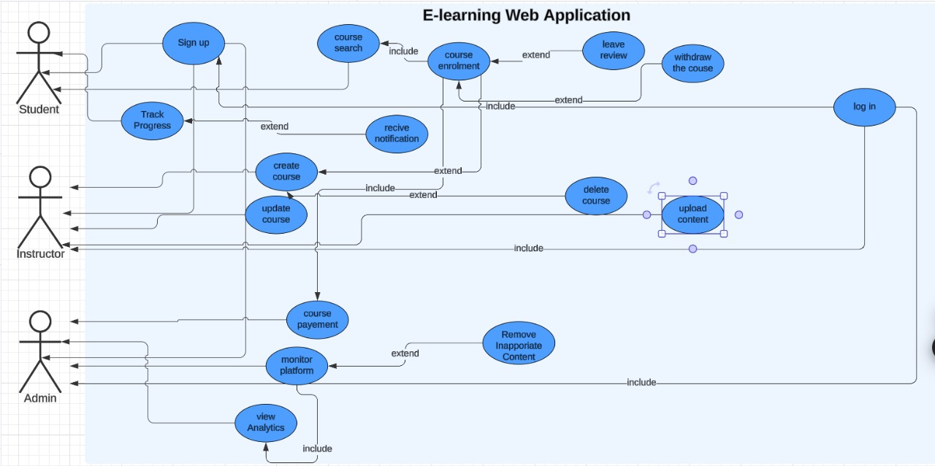

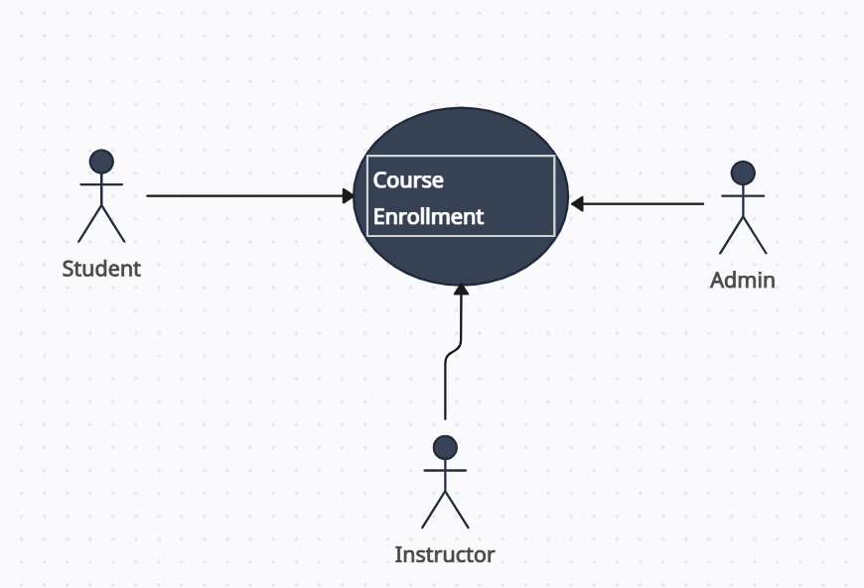
User case Name | Course Enrollment
Actors | Student, Instructor , Admin
Main Success scenario | 1. A student browses available courses.  2. The student selects a desired course and clicks on the "Enroll" button.  3. The system validates the student's account status (active and paid, if required).  4. The system confirms the enrollment and adds the course to the student's dashboard.  5. The student gains immediate access to the course materials.
Exceptions | - If the student's account is inactive, the system displays a message and prompts them to activate the account.  - If the course requires payment, the system redirects the student to the payment gateway.  - If the course is full, the system provides a notification and suggests similar courses.  - If the system encounters an error during enrollment, a generic error message is displayed, and the student is encouraged to contact support.
Actions | Display a success message confirming the enrollment. Add the course to the student's active courses.
Pre-Condition | The student must be logged into the system.
Post-Condition | The student can access the course materials and start learning.
Use case 1: Course Enrollment

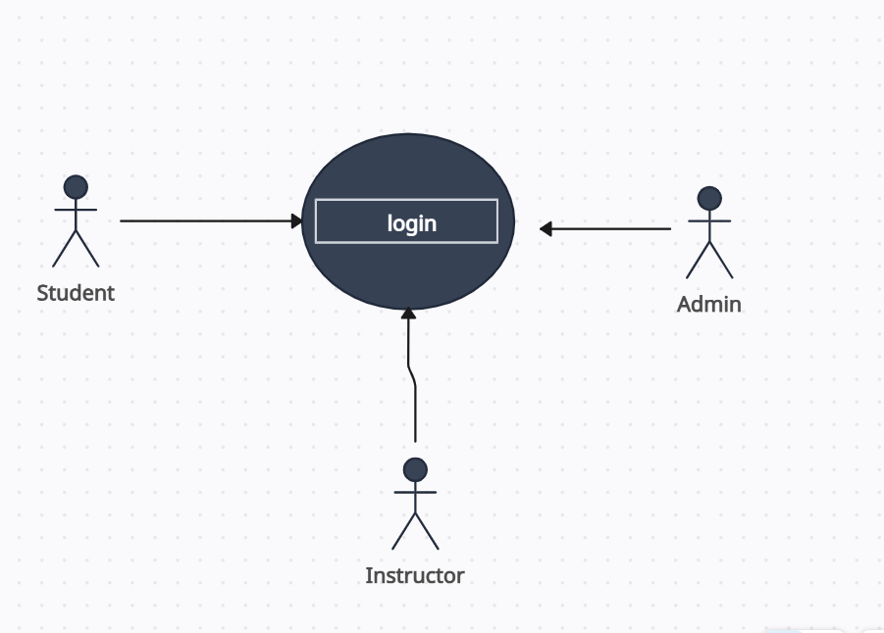

Use case 2: login
User case Name | Login
Actors | Student, Instructor, Admin
Main Success scenario | 1. The system displays the login form.  2. The user enters their login credentials (email/username and password).  3. The system validates the credentials.  4. Upon successful validation, the system grants access to the user.  5.The user is redirected to their respective dashboard based on their role (Administrator, Student, or Instructor)..
Exceptions | - - Login Form Fails to Load:  - Display an error message: "The login page failed to load. Please refresh the page or try again later."  - Incorrect Credentials:  - Notify the user: "The username or password you entered is incorrect. Please try again."  - No Matching User Found:  - Display an error: "We couldn’t find an account matching your details. Please check your username and password, or register for a new account."  - System Error During Login:  - Display a generic error: "An unexpected error occurred. Please try again later."
Actions | 1. Administrator Dashboard: Access to manage courses, users, and platform settings.  2. Student Dashboard: Access to enrolled courses, recommendations, and progress tracking.  3. Instructor Dashboard: Access to create and manage courses
Pre-Condition | 1.The user has an existing registered account.  2.The user has not been banned or restricted from using the platform.
Post-Condition | 1.The user is successfully logged into the system.  2.The user has access to their personalized dashboard and relevant features.

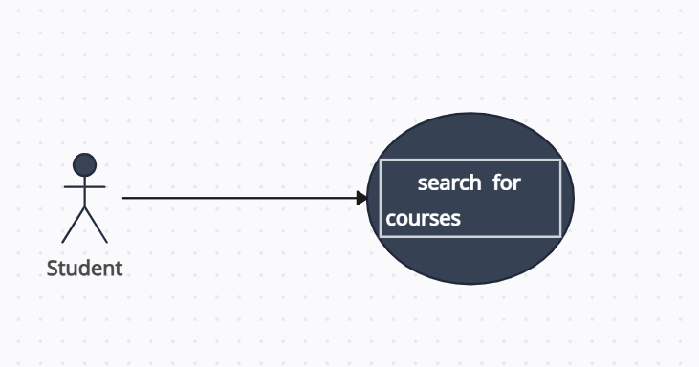
Use case 3 : search courses
User case Name | Search Courses
Actors | Students
Main Success scenario | 1. The user selects “Search Courses” from the menu or homepage.  2. The user enters search criteria, such as course title, category, instructor name, or keyword, and selects the desired course type (e.g., free or paid courses).  3.The system displays a list of all the courses that match the search criteria and indicates if any course is not currently available for enrollment, showing the next available start date.
Exceptions | - No Available Courses:  - Display a message: "No courses matching your search criteria are currently available. Please try different keywords or filters."  - Error in Course Search:  - Notify the user: "An error occurred while searching for courses. Please refresh the page or try again later."  - Invalid Search Criteria:  - Display an error message: "Invalid search criteria. Please check your input and try again."
Actions | he system analyzes the provided search criteria and searches for courses that match the user’s specifications, displaying:  - Course names, descriptions, and instructors  - Availability (open or closed for enrollment)  - Course start date and availability for the next session
Pre-Condition | 1.The user must be logged into the e-learning platform.  2.The platform should have an active list of courses available for students to enroll in.
Post-Condition | list of courses matching the search criteria is displayed

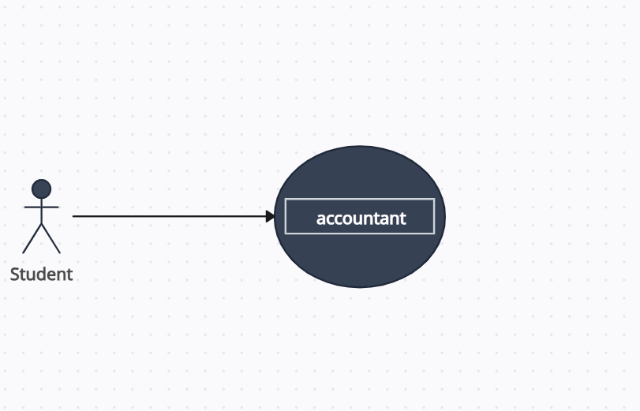
Use case 4: payment for courses
User case Name | Payment for Course Enrollment
Actors | Student, Accountant
Main Success scenario | - The student selects a course to enroll in and proceeds to the payment phase.  - The system displays the total amount due for the course, including any applicable discounts, taxes, or fees.  - The student enters their payment details (e.g., credit card number, billing address, payment method).  - The system securely processes the payment and verifies its successful completion.  - Upon successful payment, the system updates the student's enrollment status to "Paid" and grants access to the course materials.  - The student receives a payment confirmation message via email
Exceptions | Payment Failure:  If the payment fails to process, the system:  Displays an error message: "Payment processing failed. Please check your payment details and try again."  Asks the user to retry the payment or select an alternative payment method (e.g., PayPal, different credit card).  Provides a contact number for customer support to resolve payment  Payment success :  Display message “payment is successful “.
Actions | - The system processes the payment securely and handles exceptions as outlined.  - The system will retry the payment if requested by the user, ensuring a smooth payment process.
Pre-Condition | - The student must have selected a course and be ready to enroll.  - The user must have valid payment information ready for submission.  - The student is logged into their account to make the payment.
Post-Condition | 1. The student's course enrollment is confirmed.  2. The student has access to course materials and can begin learning.  3. The payment is processed, and the system reflects the updated course enrollment status as "Paid."

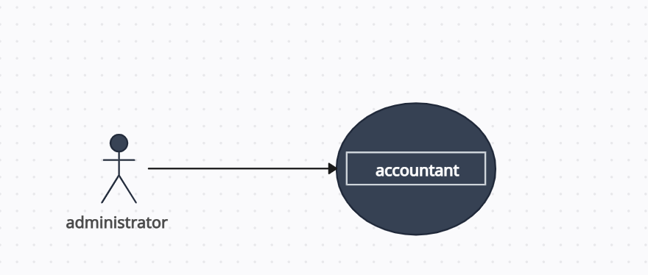
Use case 5: General Reports
User case Name | General Reports
Actors | administrator, Accountant
Main Success scenario | 1.The accountant accesses the reporting functionality within the e-learning platform (e.g., financial reports, course enrollment reports, revenue reports).  2.The accountant selects the specific category of report to generate (e.g., total course revenue, instructor earnings, student enrollment statistics).  3.The system retrieves the relevant data based on the selected report category.  4.The system generates the report and displays the data in an organized format (tables, graphs, etc.).  5.The accountant reviews and analyzes the report, using it for financial or operational analysis.
Exceptions | Insufficient Data:  - If there is insufficient data to generate the report, the system will:  - Display a warning message: "Insufficient data available to generate the requested report. Please try adjusting the filters or parameters."  - Ask the accountant to modify the report parameters (e.g., changing the date range, filtering by specific courses, or adjusting report categories).  - Provide alternative options for obtaining the desired report or suggest a different report that may have sufficient data.  Sufficient data  If it will create reports automatically.
Actions | - The system generates the requested report, ensuring that the data is accurately retrieved and displayed in a format that is useful for analysis (e.g., charts, tables).  - If the report is incomplete or there is insufficient data, the system guides the accountant to resolve the issue by adjusting parameters or selecting alternative reports.
Pre-Condition | - The accountant must have the necessary permissions or authorization to access the reporting feature.  - The accountant should have the required data available in the system (e.g., financial records, course data).
Post-Condition | 1. The requested report is generated and presented in a structured format.  2. The accountant can use the report for analysis, decision-making, or to generate further insights for business operations.

Sequence diagram

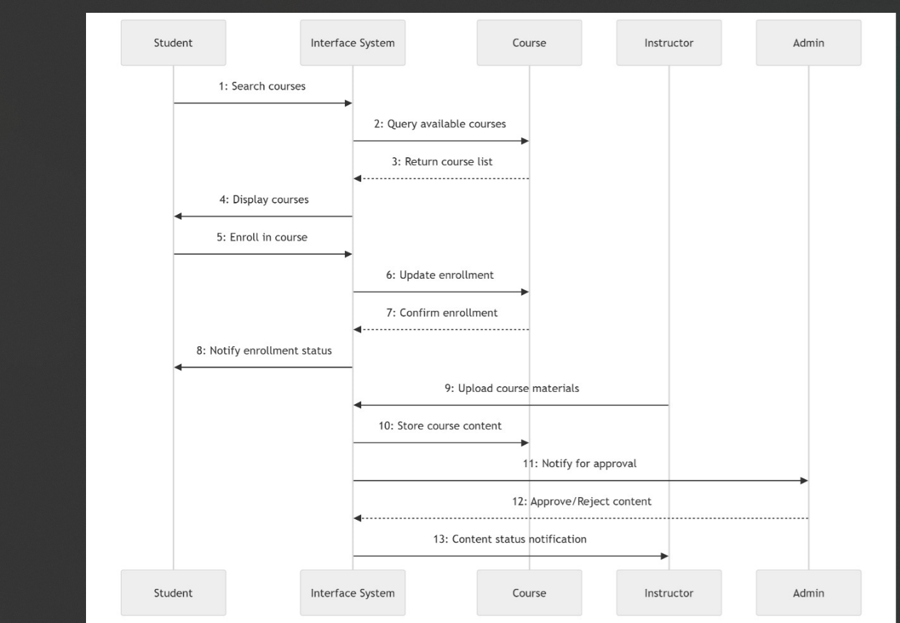

Class diagram
