# Verify & Cancel Prescription



EU/EEA

Crossborder Healthcare Private non-reimbursable prescription



Single-use prescription, valid for maximum one month from the prescription date



**Prescribing Doctor**

:

Dr. Chrysoula Liakou

**Registration number**

**Doctor Country Date**

:

060222

:

:

Greece

2025-08-19

: www.mobdoctor.eu/verify/P5XtZ1hYursjS

**Prescription code** : P5XtZ1hYursjS

Check the prescription’s authenticity, validate the doctor, then mark it as dispensed

**Patient Name** : Sahar Yousefi

**Address** : Van vollenhovenstraat 3-608, Rotterdam, Netherlands

**Date of Birth** : 1985-03-25

[Tobramycin/dexamethasone eye drops, 2025-08-19, 2 drops every 4 hours Frequency, For five days Use]

**Note:** Eye infection

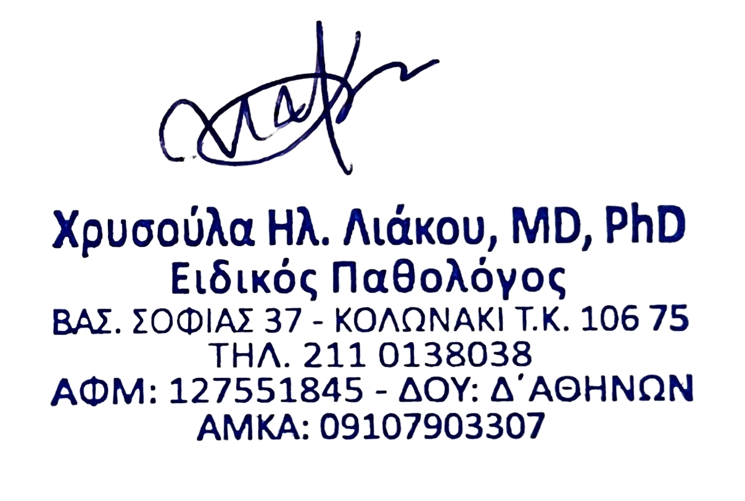

Dr. Chrysoula Liakou

# Acceptance of EU Prescriptions by French Pharmacists::

Under Directive 2011/24/EU and French law, including the Code de la Santé Publique and related regulations on medicines, French pharmacists are required to accept prescriptions issued in other EU countries, provided they meet the necessary standards. This includes the patient’s and prescriber’s details, dosage, and the common name of the medication.

Refusing a legitimate prescription violates EU law and national regulations, restricting cross-border healthcare rights. https://cbhc.hetcak.nl/en/frequently-asked-questions/

Mobidoctor, Tower Street, Tower Business Centre, Swatar, BKR 4013, Malta 00356 99761985, [help@mobidoctor.eu](mailto:help@mobidoctor.eu)