**Opportunity Mapping and Community Investment**

*NYC - Case Study*

**Introduction**

***What is this project about:***

This project brings together a lot of loose ends from experiences I’ve had over the last few years of my life. Working with BLRR and LOLA to engage community members to practice autonomy, envisioning a better future for themselves and demanding these visions come to fruition, and overall re-defining what it means to live and thrive in this society. I’ve been dancing around policy analysis and consultation for a while now, but never got to tie all of my efforts into one project like this So this project, although a “mock project”, allows me to apply all of the separate skills I’ve learned over the years, and bring all the side quests and sub-projects into one unified project that will exemplify my ability to accomplish this same thing across municipality and organization types.

This project aims to identify areas of opportunity in nyc. What do I mean by that? Whether due to redlining, racially motivated historical policies / deprivations, or simply the fundamental flaws of capitalism, this project seeks to chart a way forward. Rather than to complain about the issues, and demand solutions be drafted, this project seeks to demonstrate the ability of empirical evidence to help inform and design what the best solutions are for the situations that we find ourselves in that are having very real negative consequences for very real people. Its not about blaming, its not about debating. Its about providing solutions. “You say you want a revolution, well ya know, we’d all love to see the plan”.

In this specific project, this looks like mapping out the areas in nyc that suffer from things like poor school performance, high crime rates, low income, and overall sub-par standards of existence that are practically speaking, unnecessary. There is no reason why anyone should be suffering. There is enough to go around, and this project will take on the task of providing data-driven insights into WHERE collective resources need to be invested in order to maximize impact on communities and the health of the city / society overall.

**What happens if these policies are demonstrated to stakeholders and they simply ignore?**

Then we get the funding from elsewhere. Crowdsourced, grassroots, nonprofits, NGOs, etc. In this way, we aren’t relying on the government, but instead building an autonomous system with parallel institutions that relies on itself to be sustainable.

***Motivations:***

The pressure to complete this project comes from the very real financial situation I’ve found myself in: I’m almost out of money. I don’t want to settle for a job I hate, but I also need money now. As such, this project has been designed in a way that it will help me develop skills that are immediately useful and applicable to the freelance work I am looking for in the meantime, while simultaneously allowing me to create a portfolio item / capstone project which will demonstrate my ability to do the kind of job I am actually motivated to do (I.e. a Data Science Driven Policy Consultant for social impact organizations including everything from Governments to NGOs, from nonprofits to grassroots orgs.)

***Takeaways and Skills:***

Focus areas:

Economic and Social Development, Urban Planning, Policy Analysis, Data-Driven Research

Tech Skills:

Data science, feature engineering, Geospatial Analysis / GIS, Predictive Modeling, Impact Assessment / Policy Simulation, Causal Inference, Interactive Dashboards, Consulting Reports and Actionable Recommendation, Data Storytelling

**Research Scope**

**Central Research Question**

Does community investment lead to measurable reductions in crime

and improvement in social and economic well-being?

**Core Research Questions and Causal Hypotheses**

| ****Research Question**** | ****Causal Hypothesis**** | ****Expected Outcomes / Measures**** |
| --- | --- | --- |
| 1. **How does investment in green spaces affect health outcomes and crime rates?** | Increasing green space in a neighborhood leads to better health outcomes via things like increased exercise, cleaner air, and stronger community cohesion. These effects also contribute to reduced crime. | - Rates of preventable diseases (asthma, obesity) - Mental health proxies - social cohesion proxies  - crime rates |
| 2. **What is the effect of transit access on employment, income, and crime levels?** | Improved transit access lowers unemployment and raises median income by increasing access to a wider labor market, reducing reliance on illegal economic opportunities. | - Unemployment rates - Median household income  - crime rates |
| 3. **Does educational infrastructure investment improve educational performance, thus effecting crime rates?** | More investment in education infrastructure improves graduation rates and test performance. This improves future prospects and decreases idle time, thus decreasing potential crime. | - High school graduation rates - Standardized test scores  - crime rates |
| 4. **Does aggregated community investment improve long-term economic mobility, health, and crime rates?** | Higher levels of community investment improve long-term economic mobility by enhancing opportunities for education, employment, and stable health. | - Income growth by neighborhood - Economic mobility indices (e.g., Opportunity Atlas)  - Health Outcomes  - Crime Rates |
|  |  |  |

***REVISIT THESE DAGS - NEED SOME FORMATTING***

**Causal DAGs**

1. Clarify Hypotheses:

Map out how you believe variables causally relate to one another.

1. Identify Confounders:

Variables that influence both your treatment (cause) and outcome. Failing to control for them biases your estimates.

1. Design Analysis:

Guide which variables to control for when estimating the causal effect (using methods like regression, matching, or DoWhy).

1. Reveal Mediators:

Variables that are intermediate steps between cause and effect (e.g., Green Space → Social Cohesion → Crime).

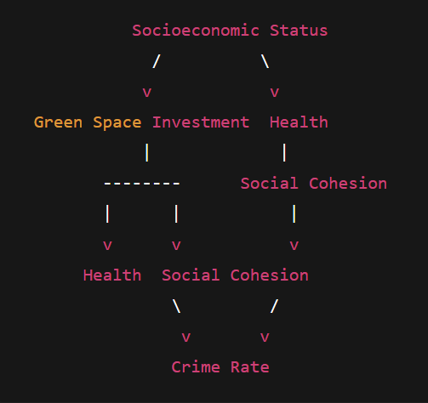

1. ***What is the effect of green spaces on health outcomes and crime?***

Treatment: Green Spaces

Outcome: Crime Rate

Confounder: Socioeconomic Status

Mediators: Health, Social Cohesion

| **Variable** | **Measurement** |
| --- | --- |
| Green Space Investment | % land as parks, number of parks per capita |
| Health | Rates of obesity, asthma, mental health proxies |
| Social Cohesion | Proxy measures like civic participation, trust metrics |
| Crime Rate | Violent and property crime rates |
| Socioeconomic Status (SES) | Poverty rate, income, education, racial composition |

1. ***What is the effect of* ***transit access on employment, income, and crime levels?*****

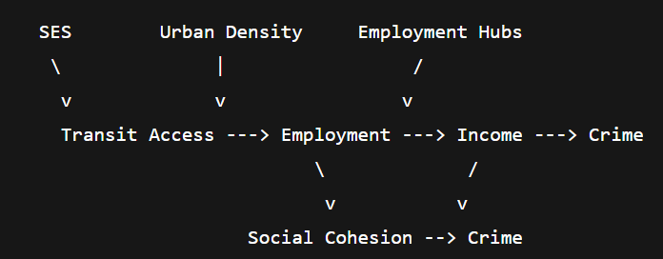Treatment: Transit Access

Outcome: Crime Rate, Income, Employment

Confounder: SES, Population Density, Pre Existing Employment Hubs

Mediators: Social Cohesion, Employment, Income

| **Variable** | **Measurement** |
| --- | --- |
| Transit Access | Transit stops, transit accessibility score |
| Employment | Unemployment rate |
| Income | Median household income |
| Social Cohesion | Civic participation |
| Crime | Crime rate |
| Employment Hubs | Proximity to major employers |

***3.* ***Does educational infrastructure investment improve educational attainment and crime rates?*****

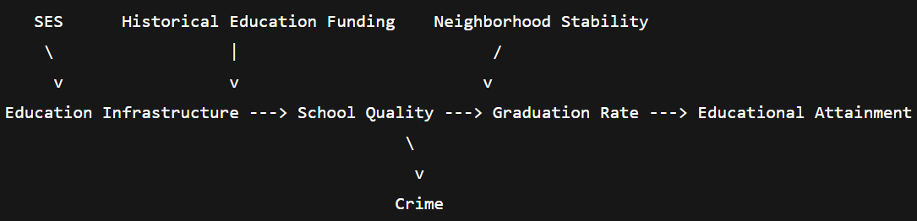

Treatment: Education Infrastructure

Outcome: Crime, Education Attainment

Confounder: SES, Historical Education Funding, Neighborhood Stability

Mediators: School/Education Quality, Graduation Rate, Education Attainment, Employment

| **Variable** | **Measurement** |
| --- | --- |
| Education Infrastructure | Schools, libraries per capita |
| School Quality | Test scores, school funding |
| Graduation Rate | High school graduation rate |
| Educational Attainment | % with high school, college degrees |
| Crime | Crime rate |
| Neighborhood Stability | Residential mobility/turnover rates |

***4.* ***Does aggregated community investment improve long-term economic mobility, health, and crime rates?*****

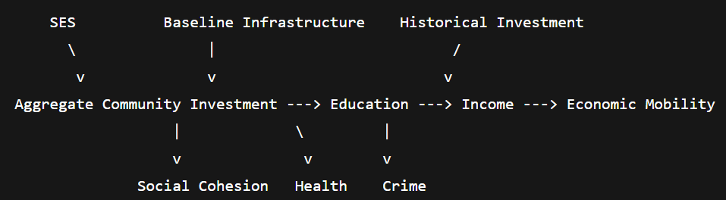

Treatment: Aggregate Community Investment -> Composite index of green space, transit, education infrastructure

Outcome: Crime, Health, economic mobility

Confounder: SES, Baseline Infrastructure, Historical Investment

Mediators: Education, Income, Social Cohesion

| **Variable** | **Description** |
| --- | --- |
| Aggregate Community Investment | Composite of prior investment indicators |
| Economic Mobility | Income growth across generations (Opportunity Atlas) |
| Health | Aggregate health outcomes |
| Income | Median household income |
| Social Cohesion | Community ties, civic engagement |
| Crime | Crime rate |

***Data Used:***

| **Data Type** | **Sources** |
| --- | --- |
| Demographics | US Census ACS (https://www.census.gov/acs) |
| Economic Indicators | Local unemployment, income levels (Bureau of Labor Stats, city data portals) |
| Financial Access | FDIC Bank Data (https://www.fdic.gov/bankfind/) |
| Public Infrastructure | Transit stops, parks, schools (City Open Data portals) |
| Investment Data | Municipal budgets, CRA (Community Reinvestment Act) reports |
| Social Outcomes | Crime data, school performance, health stats (local/state public data) |

***How to handle confounding variables during causal analysis***

What is a Confounder?

A confounder is a variable that:

Influences both the treatment and the outcome.

Creates a spurious (non-causal) association between the treatment and the outcome if not accounted for.

✅ Why SES is a Confounder in This Case

Research Question 3:

What is the causal effect of transit access on employment, income, and crime rates?

SES (which includes things like poverty rate, education levels, and racial composition):

Affects where transit infrastructure is built or improved

Simultaneously impacts employment, income, and crime rates.

Example:

Wealthier neighborhoods often already have better transit infrastructure.

Wealthier neighborhoods also tend to have lower crime rates, higher employment, and higher income — regardless of transit.

If you don't control for SES, you might falsely conclude that transit access alone causes these better outcomes, when in fact, SES is influencing both transit access and social outcomes independently.

✅ Visualized via DAG Path

lua

CopyEdit

SES --> Transit Access --> Employment/Income/Crime

\ ^

\-------------------------------/

Without controlling for SES, this backdoor path biases your estimation of the Transit Access → Crime/Income relationship.

✅ Controlling for SES

To estimate the true causal effect of transit access, you must adjust for SES variables like:

Poverty rate

Education level

Median income

Racial demographics

This way, you can block the confounding path and isolate the direct effect of transit access on your outcomes.

✅ Summary

SES is a confounder because it affects both:

Where transit investment occurs

Social and economic outcomes (employment, income, crime)

You must adjust for SES to ensure your causal estimates of transit access → outcomes are valid.