Sales Analysis & Forecasting Report

1. Executive Summary
This report presents an analysis of historical sales data to identify key performance trends, profitability drivers, and potential risks.
The objective is to help decision-makers better understand sales behavior, optimize pricing strategies, and plan future inventory using data-driven insights and sales forecasting.
The analysis covers total sales performance, profitability by category and region, the impact of discounts on profit, and future sales trends.

2. Data Overview
- Dataset Type: Retail sales transactions
- Time Period: Historical sales records
- Key Variables:
  - Sales
  - Profit
  - Category & Sub-Category
  - Region
  - Discount
  - Order Date
The dataset represents a realistic business scenario commonly found in small to medium-sized companies.

3. Overall Sales & Profit Performance
- Total Sales: $2,297,200.86
- Total Profit: $286,397.02
Despite strong overall sales, profit margins vary significantly across categories and regions, indicating opportunities for optimization.

4. Profitability by Category
Analysis of profit by product category shows noticeable differences in performance.
Key Observation:
- The Technology category generates the highest sales and contributes significantly to total profit.
- Other categories show lower profitability and require closer review of pricing and cost structures.
This insight suggests that business focus should prioritize high-performing categories while improving efficiency in weaker ones.

5. Profitability by Region
Regional analysis reveals uneven profit distribution.
Key Observation:
- Some regions achieve high sales volumes but still result in negative or low profit.
- This indicates potential issues such as excessive discounting, high logistics costs, or inefficient pricing strategies.
Regional performance should not be evaluated based on sales volume alone but on profitability.

6. Discount vs. Profit Analysis
The relationship between discount levels and profit was analyzed to understand pricing impact.
Key Finding:
- Higher discounts are strongly correlated with lower profit and, in some cases, direct losses.
- Discounts above a certain threshold reduce overall profitability instead of increasing revenue.
This highlights the importance of controlled discount strategies.

7. Sales Trend & Forecasting
Historical sales data was aggregated monthly to identify trends and forecast future performance.
Findings:
- Sales show clear seasonal and trend patterns.
- Based on historical behavior, short-term forecasting provides useful guidance for inventory planning and demand management.
Forecasting enables proactive decision-making rather than reactive responses.

Sales by Category:

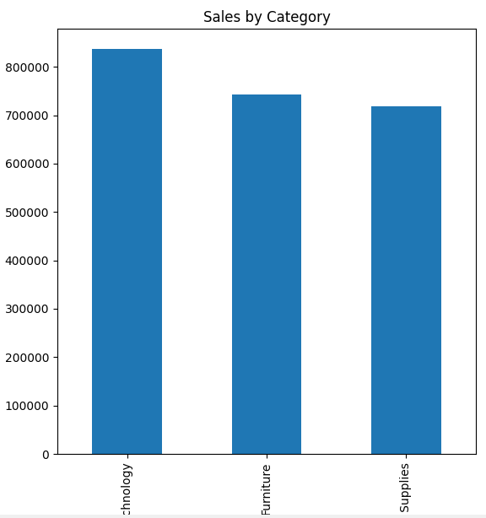

Profit by Region :

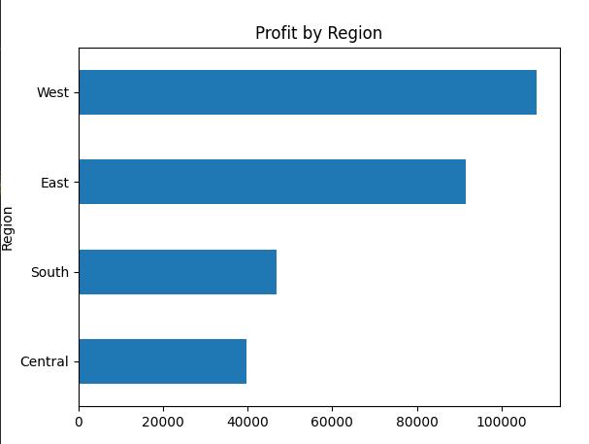
Discount vs Profit :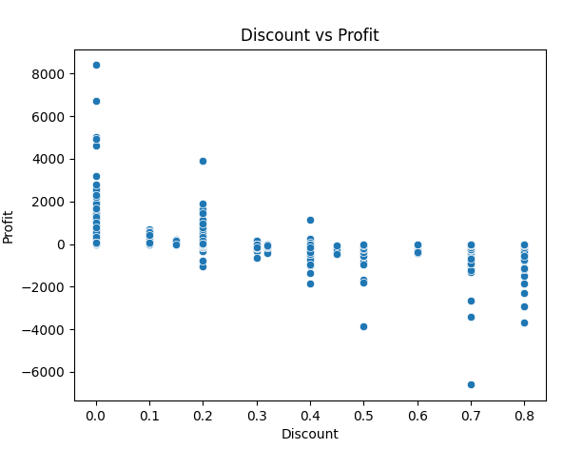

Monthly Sales Trend :
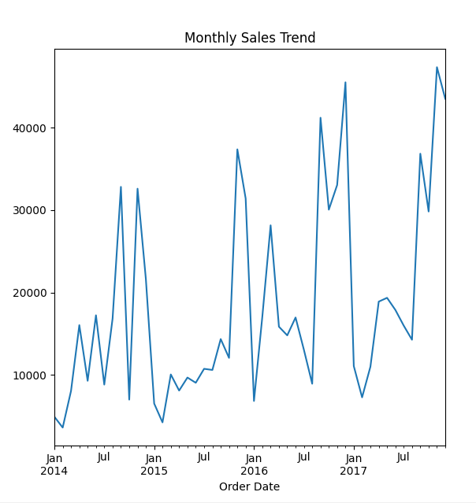

Prediction For Sales:
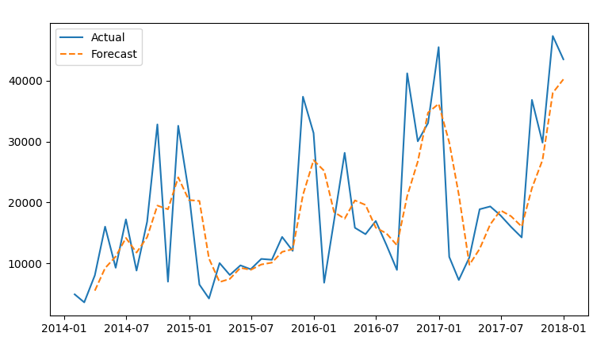

8. Key Insights
- Technology category generates the highest sales and profit contribution.
- Some regions report losses despite strong sales performance.
- High discount levels negatively impact profitability.
- Sales trends can be used effectively for short-term forecasting and planning.

9. Business Recommendations
Based on the analysis, the following actions are recommended:
- Reduce excessive discounts, especially those exceeding 20%, to protect profit margins.
- Focus marketing and inventory efforts on top-performing categories such as Technology.
- Review pricing and cost structures in low-profit or loss-making regions.
- Use monthly sales trends and forecasts to improve inventory planning and reduce overstock or shortages.
Implementing these recommendations can improve profitability and support sustainable business growth.

10. Tools Used
- Python
- Pandas
- Matplotlib
- Seaborn

