***Arab American University***

***Faculty of Engineering and Information Technology***

***Computer Systems Engineering***

**Engineering project management**

***Online ordering to healthy fast food restaurant***

***fall 2022/2023***

Instructor:

Dr. Rami Hodrob

Prepared by:

Yousef Ali / 201812451

Ali Abualrob / 201810976

Basil salahat / 201811775

**ABSTRACT**

Technology advancement recently has been entering all of our life’s aspects, in order to survive in the business market, we should keep up with these developments.

In this project, we are going to be evolving our restaurant by providing the service of remote ordering where people can order their preferences from the comfort of their homes and receive them with the least amount of effort.

Contents

1 **Chapter 1**: 4

**1.1** **Initiating and pre initiating** 4

**1.1.1** **Business case** 4

**1.1.2** **Project Charter** 8

**1.2** **Kick-off Meeting** 10

**2** **Chapter 2** 11

**2.1** **Requirement’s traceability matrix** 11

**2.2** **Project scope statement** 12

**2.3** **Work breakdown structure (WBS)** 13

**2.4** **Project schedule (Gantt chart)** 14

**2.5** **Organizational structure** 15

# **Chapter 1**:

## **Initiating and pre initiating**

### **Business case**

|  |
| --- |
| 1. **Introduction/ Background**   The main goal of our restaurant is to provide healthy meals for customers, we believe that we can expand our goal to include all customers from all of the country, not just by ordering our products but also providing delivery service for these orders that will make it easier for restaurant customers as well as the ability to gather new customers from all across the country. |
| 1. **Business Objective**   Online ordering and delivery service will increase our restaurant opportunities, anyone can view the list of dishes, prices, and discounts available anywhere, which will promote our restaurant, The app will contain rating service which will increase our customers satisfactions if we followed along with these reviews. |
| 1. **Current Situation and Problem/Opportunity Statement**   the restaurant currently does not have any website or application that informs people of the list of available dishes, discounts, and prices, which will lead to more demand for our services.  With our app we will be able to announce an upcoming dish which will lead to promote it for the public and then more promising future for the restaurant. |
| **4.0 Critical Assumption and Constraints**  The project must meet all agreed requirements and be easy to use for the customer and restaurant workers.  After it is available, it should not need much of maintenance (two maintenance operations at most every six months).  The project will return benefits in its second year of release.  Availability for all platforms and operating systems.  Delivery service workers should be on time.  There must be a user guide for the consumer. |
| **5.0 Analysis of Option and Recommendation**  There are three options for addressing this opportunity:  1. we ask a specific company to implement the app.  2. We hire multiple developers to do the work.  Based on discussions with stakeholders, we believe that option 2 is the best option |
| **6.0 Preliminary Project Requirements**  Core requirements for customers:   1. Order placement: With an easy-to-order feature, the user can place an order of selected dishes and healthy food with just a few simple taps on the screen. 2. Tracking of Drivers: With the real-time tracking feature, it becomes easy for the users to track delivery drivers and know their real-time location information. Users can check how much time a driver will take to reach their food parcel. 3. Payment gateway integration: must Integrate our app with Payment Gateways like PayPal, and make sure that it provides the users with multiple payment options.   Core requirements for drivers:   1. Driver’s profile: Through this feature, a driver can keep his profile updated. It contains his full name, address, email, contact number, photo, and other personal data. 2. Notification for orders: Through push notifications, drivers can get constant updates & alerts for new food orders online. It will help in the accurate delivery service of your restaurant. 3. Map for the delivery route: this allows drivers to choose the shortest and fastest routes to reach the location.   Core requirements for admin workers:   1. Monitoring every action: Monitor all the drivers, changes in the menu, deliveries, ratings & reviews of drivers, canceled orders, and other important data related to the driver’s performance. 2. make changes: make changes (add, delete, update, and get) in the menu, orders, and drivers. |
| **7.0 Budget Estimate and Financial Analysis**  The overall budget of this project is going to be $44,600 by the time the project is being able to serve people, this budget is going to be the summation of building the website for ordering food, which will cost 3 developers for 12 weeks, for a cost of $21,600 (60 hours a week * 12 weeks * 3 employees * $10 for hour of working) as well as renting the place for food preparation, costing 1000$ a month during the project lifetime, buying restaurant equipment will cost $10,000, promoting the project will cost $10,000.  Project benefits will be mainly from selling food as well as introducing delivery services  If we assume we will be selling 100 piece of meal a day for an average cost of 10$ for each meal, and selling it for 20$, would be 1000$ a day, after paying employees costs 400$ (10 employees * 8 * 5), the net revenue from meals will be 600$ a day, saving the revenue of delivery services for extra costs. |
| **8.0 Schedule Estimate**  The estimate time for this project is going to be 3 months without any flexibility. |
| **9.0 Potential Risks**  There are multiple risks that we should take into consideration, our first concern is not meeting the new clients’ expectations as well as not having the intended number of clients for our restaurant |
| **10.0 Exhibits**  Exhibit A: Financial Analysis |

### **Project Charter**

**Project Title**: Online ordering for the healthy fast-food restaurant

**Project Start Date:** 12 January 2023 **Projected Finish Date:** 12 April 2023

**Budget Information:** $50,000

**Project Manager:** Ali Abualrob, (00972)592937952, ali.rajeh2612@gmail.com.

**Project Objectives:** Creating an application for online orders that is easy to use and meets all basic requirements, enabling users to view the food menu, enter their orders, activate the payment way that is suitable for them and is available, as well as benefit from the delivery service when needed.

**Main Project Success Criteria:**

* Creating an application that works in all environments through which the user can view the list of available foods, their prices, and existing discounts, and then create his order, use the delivery service when needed, and choose the appropriate method to pay.
* The application includes the required requirements for users, drivers, and admins, with easy access, maintenance, and speed.

**Approach:**

* Develop a survey for stakeholders to determine requirements and features for users, admins, and drivers.
* Research for software to provide more security for our app.
* Determine a way to measure the value of the app in terms of costs and new revenues, both during the project and six months after project completion.
* The possibility of running it in all environments and various types of operating systems.

**Roles and Responsibilities**

|  |  |  |  |
| --- | --- | --- | --- |
| **Role** | **Name** | **Internal/External** | **Contact Information** |
| Sponsor, and Project Manager. | Ali Abualrob | Internal | ali.rajeh2612@gmail.com |
| Team member | Basil R Salahat | Internal | b.salahat1@student.aaup.edu |
| Team member | Yousef Kmail | Internal | yousef.kmail@gmail.com |
| Team member | Ahmad Mohammad | External | ahamd.mohammad@gmail.com |
| Team member | Amal Ahmad | External | amal.ahmad@gmail.com |
| Team member | Jan Joni | External | Jan.joni@gmail.com |

**Sign-off:** (Signatures of all above stakeholders. Can sign by their names in the table above.)

Ali Abualrob, Basil R Salahat, Yousef Kmail, Ahamd Mohammad, Amal Ahmad, Jan Joni.

**Comments:** (Handwritten or typed comments from the above stakeholders, if applicable)

“I will do my best to make this project a success and upgrade it to the best level” Ali Abualrob.

## **Kick-off Meeting**

**Date 28/11/2022**

**Meeting Objective:** Get the project off to a great start by introducing key stakeholders, reviewing project goals, and discussing future plans

**Agenda:**

* Introductions of attendees
* Background of project
* Review of project-related documents (i.e., business case, project charter)
* Discussion of project organizational structure
* Discussion of project scope, time, and cost goals
* Discussion of other important topics
* List of action items from meeting

|  |  |  |
| --- | --- | --- |
| **Action Item** | **Assigned To** | **Due Date** |
| Discuss project background | Yousef | 3/12/2022 |
| Define the goals of the project | Basil | 5/12/2022 |
| Define rules and responsibilities | Ali | 10/12/2022 |
| Define project scope | Yousef | 12/12/2022 |

**Date and time of next meeting: 28/12/2022**

# **Chapter 2**

## **Requirement’s traceability matrix**

|  |  |  |  |  |
| --- | --- | --- | --- | --- |
| Requirement No | Name | Category | Source | Status |
| R1 | Three developers | Human | Outbox.io company | Full-time to finish the required software |
| R2 | 30 tablets | Hardware | hp | Complete and meet the requirements |
| R3 | Fast internet inside the restaurant | Software | Paltel | 250 Mbps, fiber |
| R4 | Payment gateway integration | Software | PayPalHoldings | PayPal |
| R5 | delivery service | Service | Fast-delivery | Complete, drivers and cars |
| R6 | Database | Software | MongoDB | Complete, security |

## **Project scope statement**

|  |
| --- |
| **Project Title: Online ordering health fast food restaurant**  **Date: 1/4/2023** **Prepared by:** Basil Salahat |
| **Project Justification:**  The website's primary goal is to save clients time and effort by delivering restaurant services online. Users will be able to browse menus and place orders on the website. |
| **Product Characteristics and Requirements:**   1. The application interface must be user-friendly and simple so that users can quickly access the information they need. 2. The site must be highly secure to protect all user information, as it contains important personal and financial information for users. 3. The application's ability to handle a large number of requests and transactions simultaneously without crashing the site. 4. The application must be continuously updated and maintained, and new features used. 5. The ability of the site to adapt to all smart devices, as it must work on all types of screens of different sizes. |
| **Summary of Project Deliverables**  **Project management-related deliverables:** business case, charter, team contract, scope statement, WBS, schedule, cost baseline, status reports, final project presentation, final project report, lessons-learned report, and any other documents required to manage the project.  **Product-related deliverables:** research reports, design documents, software code, hardware, etc.   1. The customer's ability to track the order and find out its status. 2. Integration with online payment systems like PayPal. 3. Reports and analyses that support decision-making. 4. Customer service department to handle inquiries. 5. The user's ability to add notes, like information about diseases, to each order. |
| **Project Success Criteria:**   1. Increased sales and profits. 2. Increased user satisfaction with the restaurant and services. 3. Lower costs and increased efficiency. 4. The number of customers increased. |

## **Work breakdown structure (WBS)**

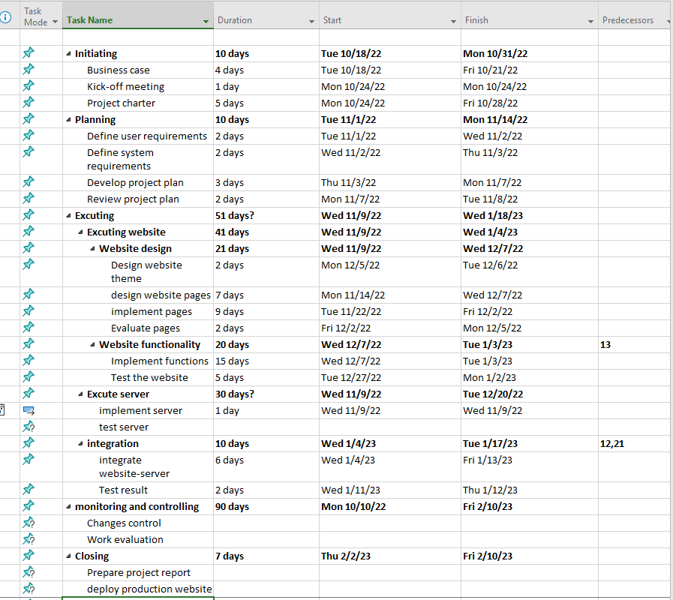

## **Project schedule (Gantt chart)**

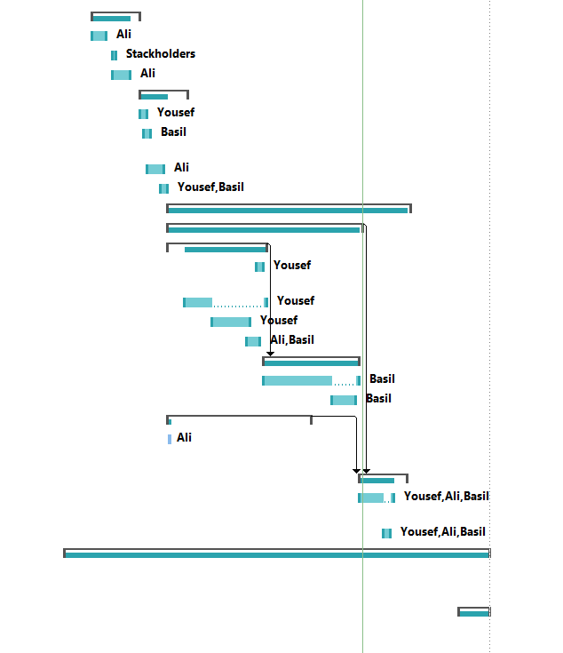

## **Organizational structure**

