**Virtual Appointments – Overview**

1. ***How to turn on the Virtual Functionality***
   * Third piece of ^ZAFU(0,99,SiteNumber,0,1) is set to a 1
2. ***Virtual Appointment Configuration***
   * Under Preferences menu.
   * Vox entries will be defaulted into the screen.

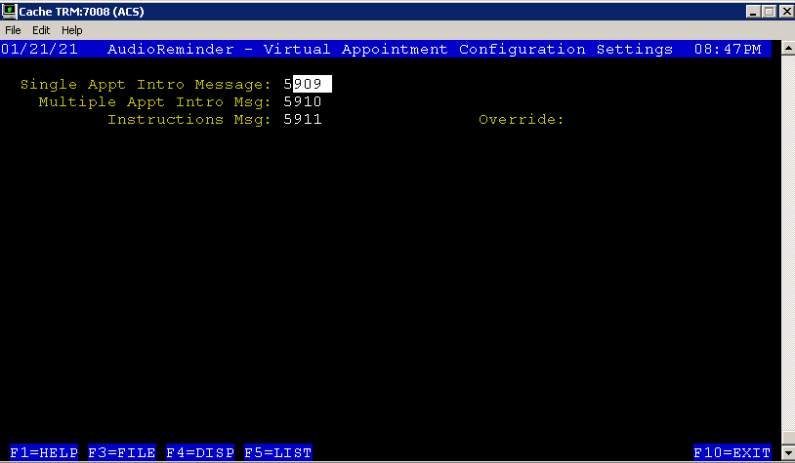

* The following are the vox files that have been recorded:
  + Introduction Message for 1 appointment –
    - 5909 – *This is a Tele-Health appointment; please do not come into the office for this appointment*.
  + Introduction Message for Multiple appointments –
    - 5910 – *These are Tele-Health appointments; please do not come into the office for these appointments*.
  + Introduction Message –
    - 5911 – *Your provider will send you an email link to connect to the Virtual Medical Room for this appointment with your computer, tablet, or smart phone. Please ensure you are in a safe and private location where you have Internet access and are able to speak freely with your provider.*

1. ***Edit Dictionary Master Entry***

* Per Dictionary entry, a Virtual Instructions Message can be set up as an override

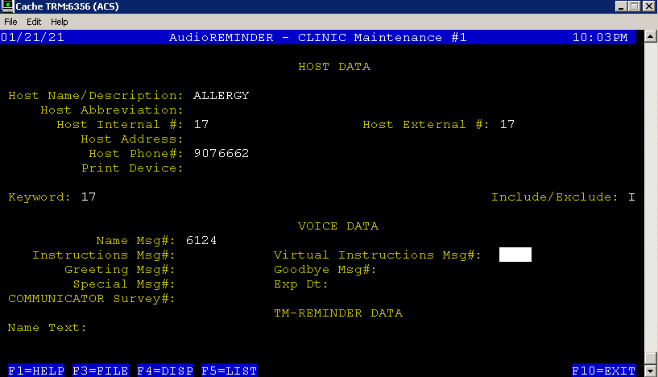

1. ***How to determine if an appointment is Virtual? 2 ways***

* DOD Compiler has been updated to read new ‘Detail Codes’ that will now be sent in the last field of the record of the CHCS scrape. The codes were “HC” or “TELEMED”
* On the Execute Test Screens a new field was added so that an appointment could be flagged as a ‘Virtual appointment’
  + Execute a Test Call – 1 appointment

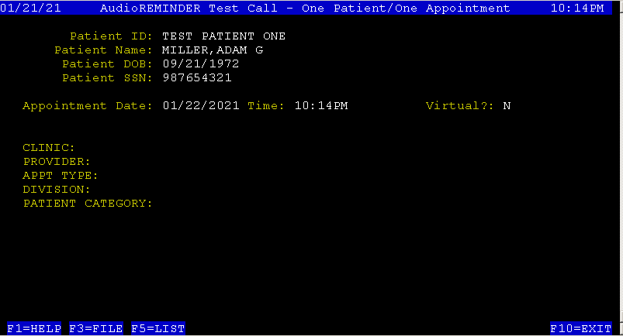

* + Execute a Test Call – 1 patient 2 appointments

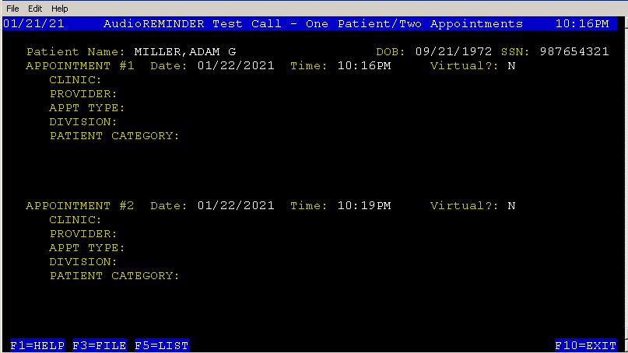

* + Execute a Test Call – 2 patient 1 appointment

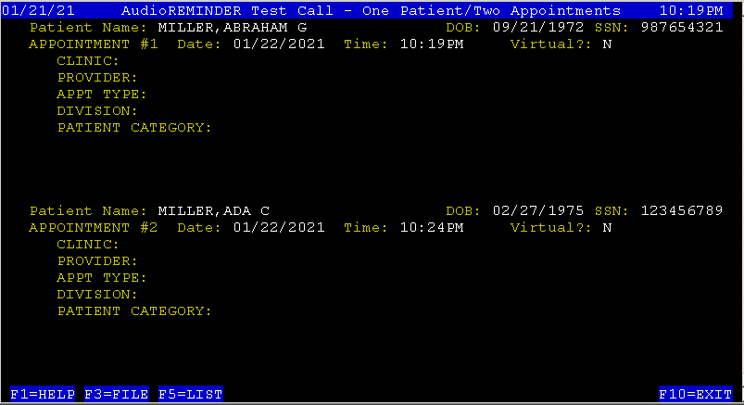

* + Execute a Test Text

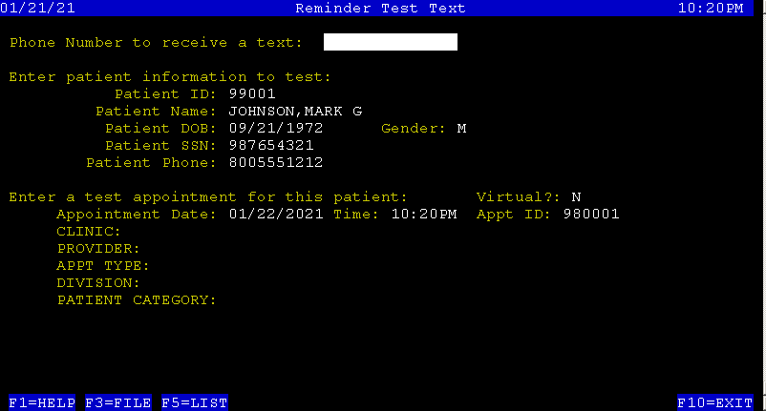

* + Execute a Test Email

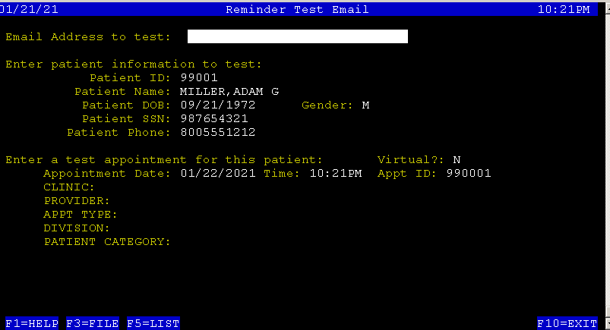

1. ***Calling Scripts info…..***
   * Application does not have the ability to speak a different Virtual script for Virtual Telephone Appts vs Video Virtual Appts.
   * After the Greeting message, then a new message will be spoken to say how many “Virtual” appointments and how many “In Office” appointments are being referenced in this call.
   * If the Household has both “In Office” and “Virtual Appts” then:
     + the Virtual appointment information will be spoken first
     + a summary of all the appointments will NOT be spoken
   * In the script the speaking of the appointment information will only change for the “Virtual” appointments and not for the “In Office” appointments. i.e. the appointment play order will be used for the “In Office” appts, but for the “Virtual” appointments the order will be to speak the Patient’s ID, followed appointment #, “ON” Date information, then “AT” Time information.

**[Example of a Virtual Appointment]**

[***Hello***: “Hello”]

[***Greeting*:** “this is the Columbus Air Force Base Clinic's automated appointment reminder system.”]

**[Virtual Notification: “**This household has one Virtual appointment, please listen carefully.”]

[***Reminder message***: “We are calling to remind you that...”]

[***Patient’s ID***: “Adam”]

[***Number of Appts***: “has 1 Virtual Appointment.”]

[***Virtual Intro Appointment Msg***: “This is a Tele-health Appointment, please do not come into the office for this appointment.”]

[***Appt #***: “The appointment is”]

[***Date:*** “ON THURSDAY JULY NINE”]

[***Time:*** “at TWO PM”]

[***Menu Options***:

“ To Confirm this appointment, press 1

To Cancel this appointment, press 3

To Repeat this appointment, press 4

To hear these choices again, press 9.”]

[patient selected 1]

[“Appointment Confirmed”]

[***Virtual*** ***Instructions***: “Your Provider will send you an email link to connect to the Virtual Medical Room for this appointment with your computer, tablet, or smart

phone.  Please ensure you are in a safe and private location where you have internet access and are able to speak freely with your provider**.”  ]**

[***Please Call msg***: “If you have a question about an appointment, please call... EIGHT ZERO ZERO EIGHT EIGHT NINE NINE ZERO ZERO ZERO To repeat this phone #, press 1 now.” ]

[***Good-bye***: “Thank you for using the Columbus Air Force Base Clinic's Appointment Reminder System. Goodbye.”]

1. ***Texts***

There are 2 formats for a text message:

1. Text displays the “at” location and the “with” provider/clinic/etc in the message. For this type if an appointment is a Virtual appointment then the format of the text will be changed as follows:

* The length of the format will still be 160 characters
* The “at” location will be removed from the message
* The “Your appt” will be replaced with “Your Virtual appt”

**Before format:**

Your appt at xxxxxxxxx1xxxxxxxxx2 with xxxxxxxxx1xxxxxxxxx2 is Fri May 20 at 10:00am.   
Reply: C to Confirm, X to Cancel, R to Reschedule. Questions: 800-111-3333

**After format:**

Your Virtual appt with xxxxxxxxx1xxxxxxxxx2 is Fri May 20 at 10:00am. Reply: C to Conf  
irm, X to Cancel, R to Reschedule. Questions: 800-111-3333

1. The other format displays a greeting message because the site did not set up an “at” location or a “with” provider/clinic/etc OR there is no name message found for the “at” location and the “with” provider/clinic/etc. For this type, if an appointment is a Virtual appointment, then the format of the text will be changed as follows:

* The length of the format will still be 160 characters
* Sites have had to work on determining how long their greeting message can be thus I don’t want to change it.
* The “Your” word will be changed to “Virtual” and the “is “ will be removed.

**Before format:**

This is the Northeastern Tribal HealthCare System. Your appt is Fri May 20 at 10:00am.   
Reply: C to Confirm, X to Cancel, R to Reschedule. Questions: 800-111-3333

**After format:**:

This is the Northeastern Tribal HealthCare System. Virtual appt Fri May 20 10:00am.   
Reply: C to Confirm, X to Cancel, R to Reschedule. Questions: 800-111-3333

1. ***Reports – All Activity Reports***
   * The activity reports have a new field called Vir. This field will contain a “Y” if the appointment was Virtual.

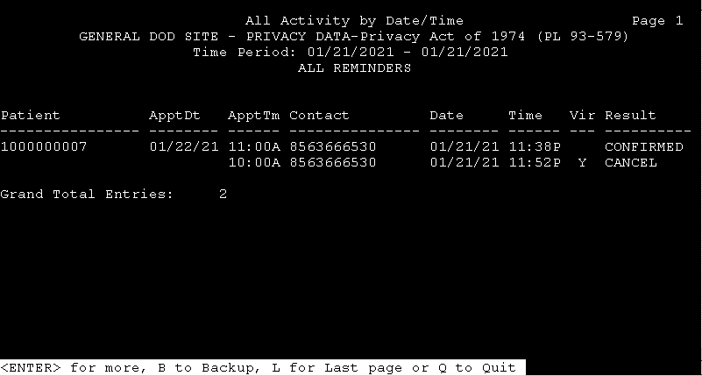

1. ***Statistics*** 
   * Category 900 – Virtual Appts Queued - has been added to count how many appointments were Virtual.

Statistical Report Page 1

GENERAL DOD SITE

AudioREMINDER

Time Period: 1/21/2021 - 1/21/2021

JAN TOT

21

Outgoing Calls 2 2

Connected 2 2

Response 2 2

Appts Found 5 5

Appts Queued 2 2

Appts To Call 2 2

Appts Filtered 3 3

Dict Excluded 3 3

Communication Queue 2 2

Completed 2 2

Final Calls 2 2

Final Appts 2 2

Successful 2 2

Confirm 1 1

Call 1 1

Cancel 1 1

Call 1 1

Virtual Appts Queued 1 1