

ENCS336, COMPUTER ORGANIZATION

AND ASSEMBLY LANGUAGE

Orga (336)

Prepared by:

Yousef sharbeh-1202057

Firas qaq -1201921

anas shalabi-1203261

Instructor

Dr.Mohammad Hellal

BIRZEIT

March – 2023

The Idea of project:

1) Prompt the user to input N and the size of the number.

2) Use the input size to determine how many bytes are needed to store each number.

3) Request inputting the first number, then the second and so on until N numbers

are input.

4) Validate the user's input to ensure that it is a decimal number and within the predetermined size.

5) Convert each input number from a string to a BCD format with the predefined size.

6) Calculate the summation and average of the numbers.

7) Print the summation and average of the numbers.

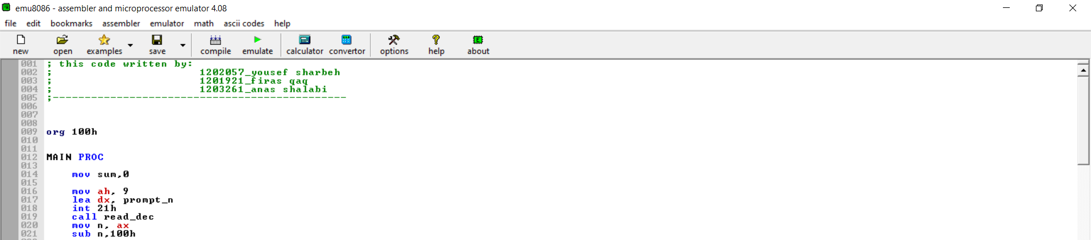

** this print on the screen “ enter the number of integers to read: “ to read num of integer the user want to enter.

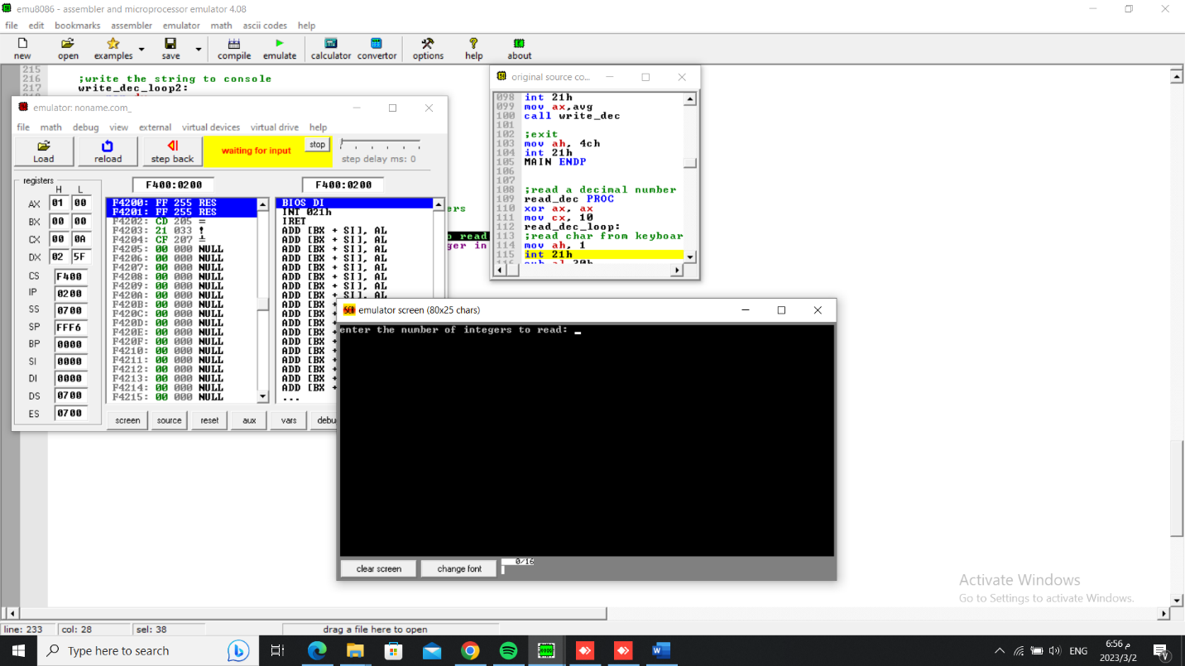

**And let’s say we entered 3.



** this to read size of integers.

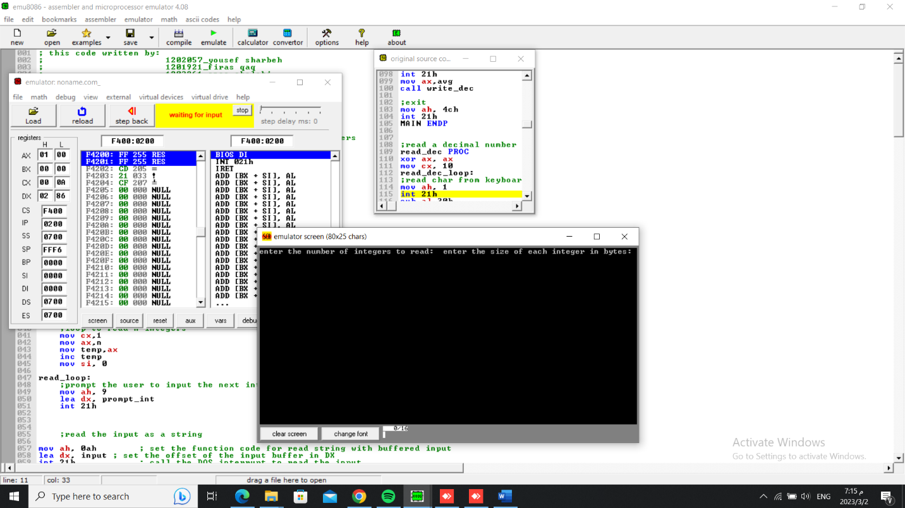

** and let’s say the size is 2

---------------------------------------------------------------------------------------------------------------------



This allocate memory for the integer array.

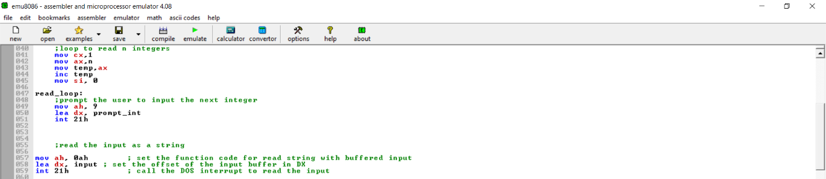

** this to read the integer number.

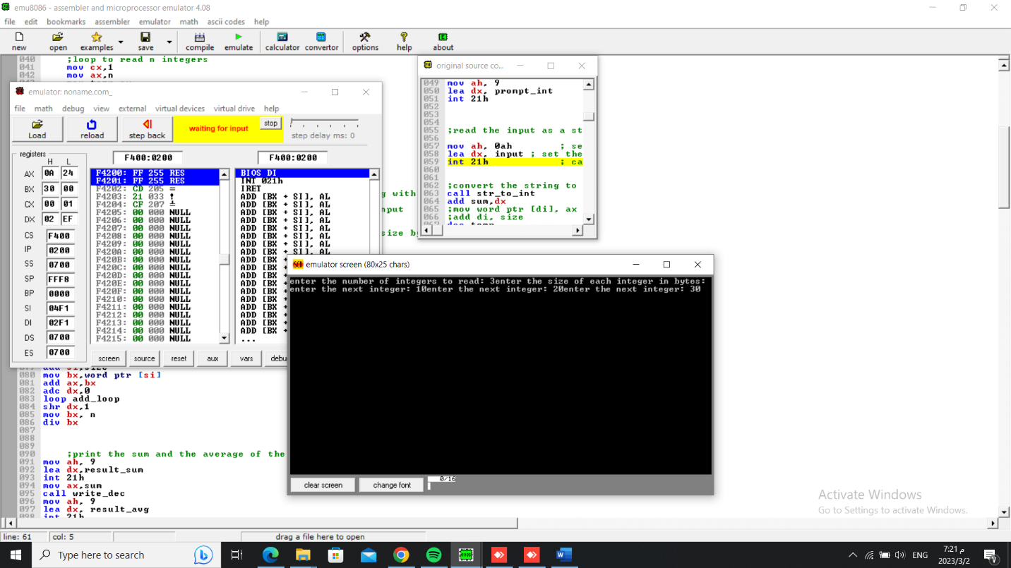

Let’s say we entered 10,20,30.

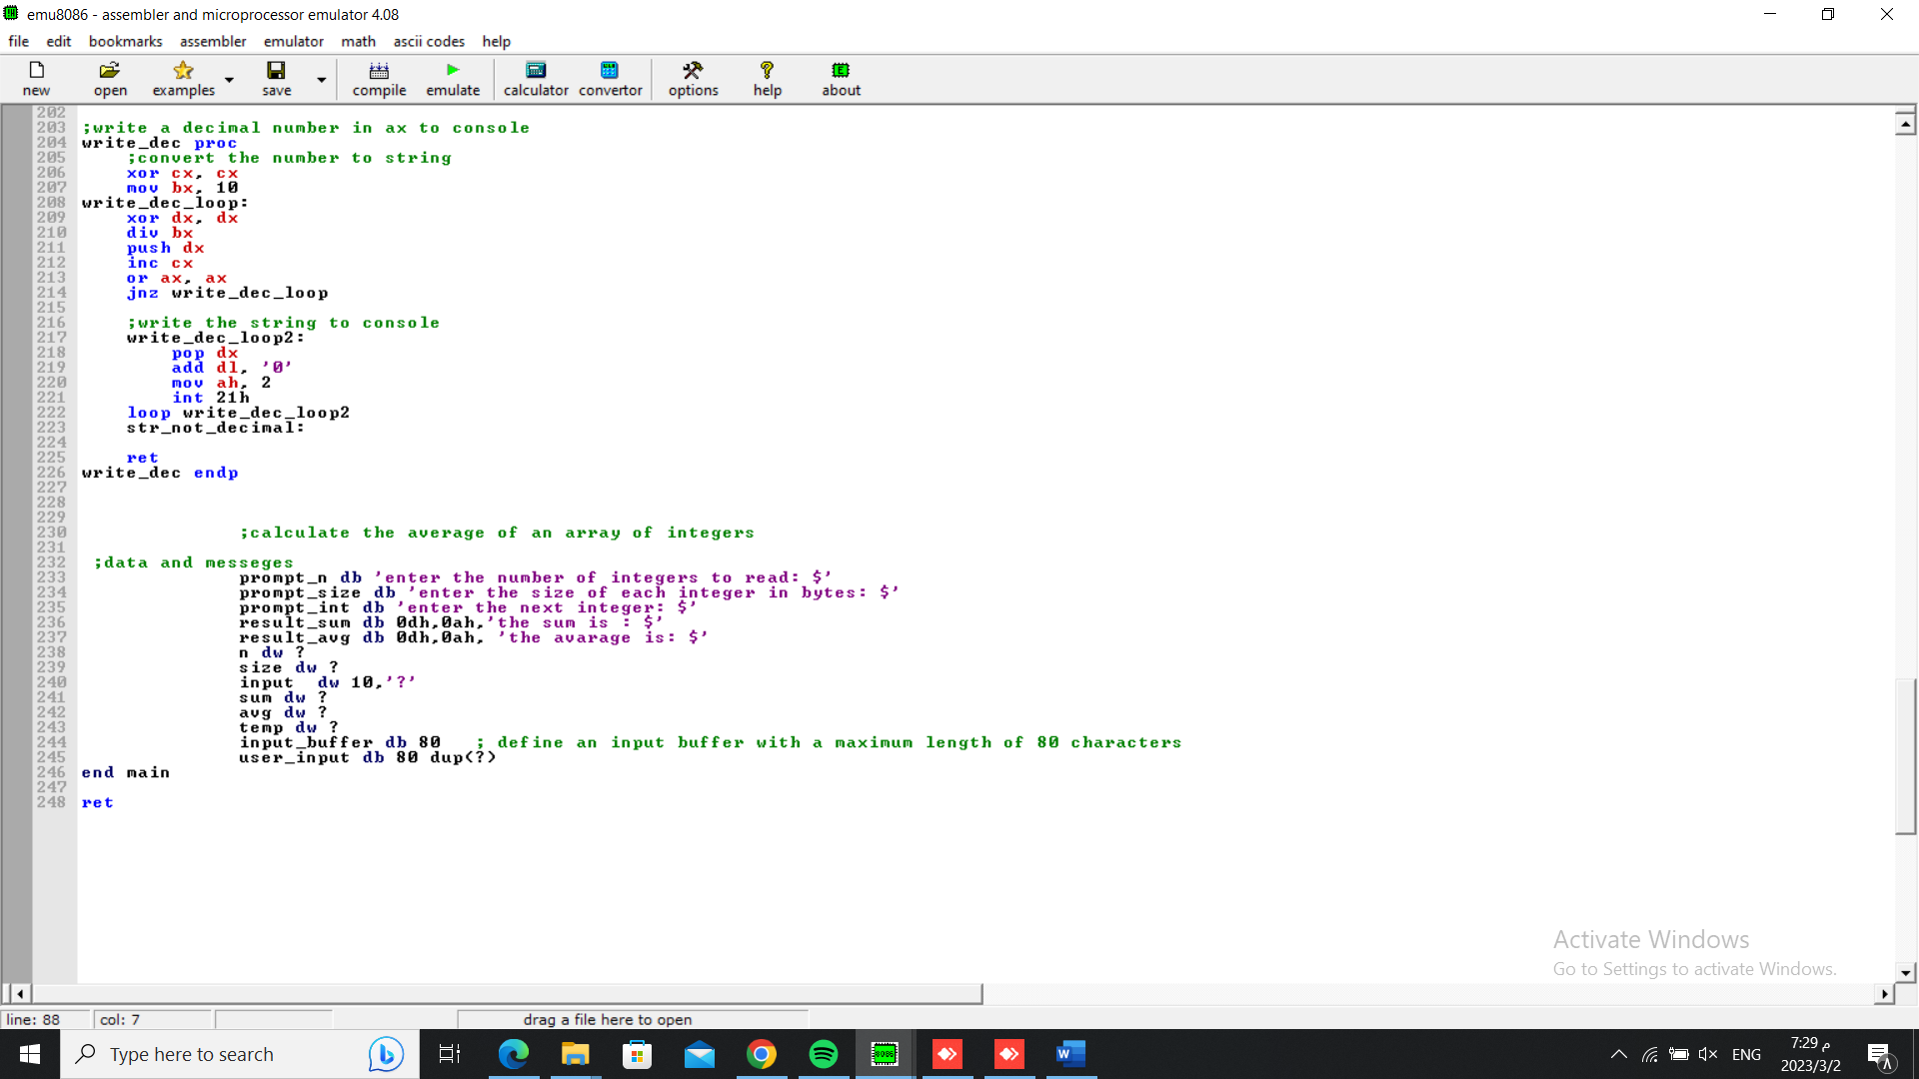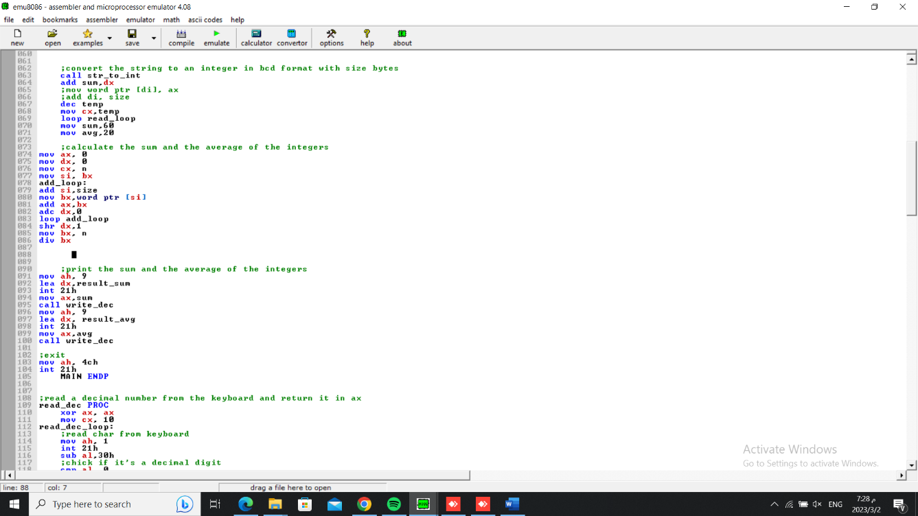

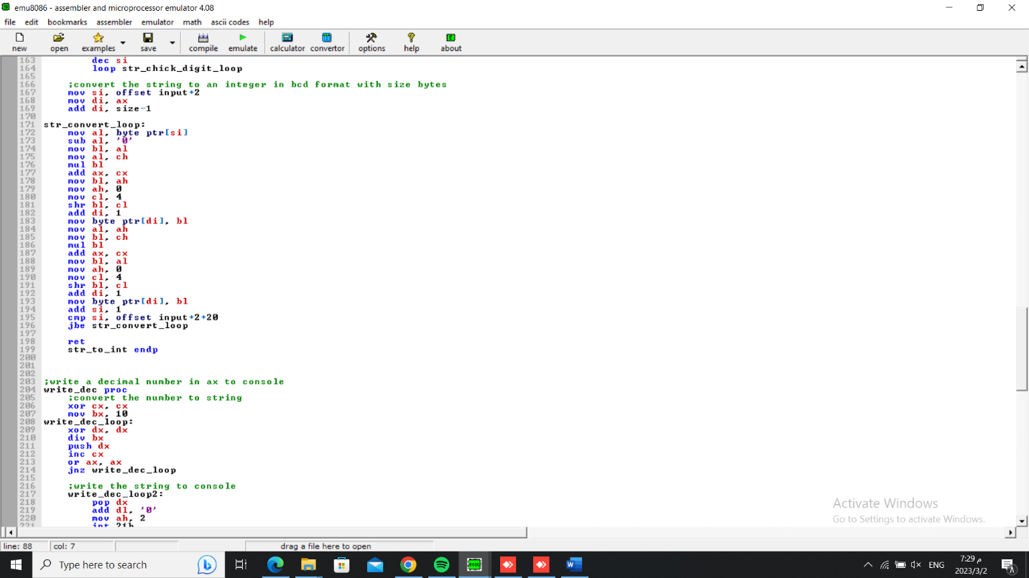

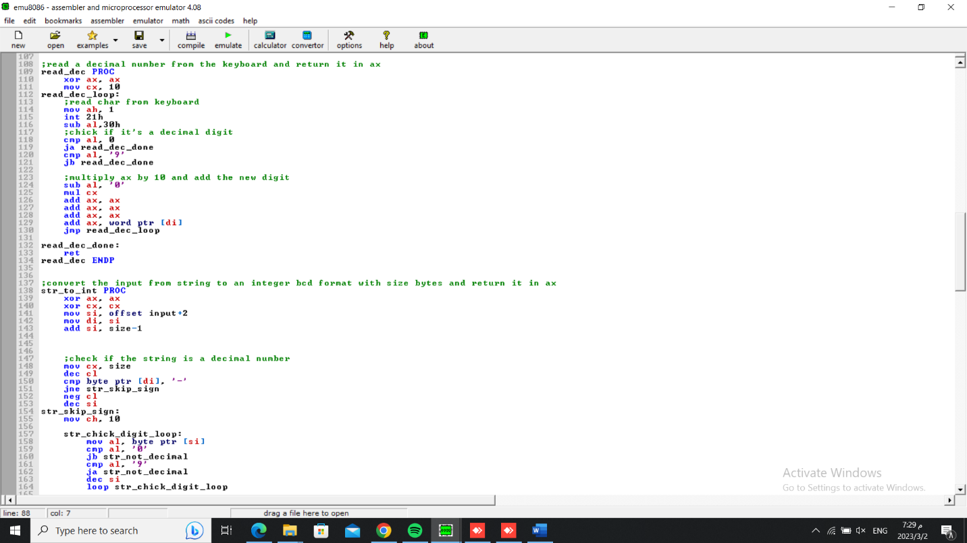

*** the rest of code do this:

*Take these integer from keybord as string then check if its decimal or not

* using str_to_int convert the string to an integer in bcd format with size bytes.

* calculate the sum , the result in bcd is 0110 0001 and in the screen 60.

*calculate the average, the result in bcd is 0010 0000 and on the screen 20.

