Cable Nets
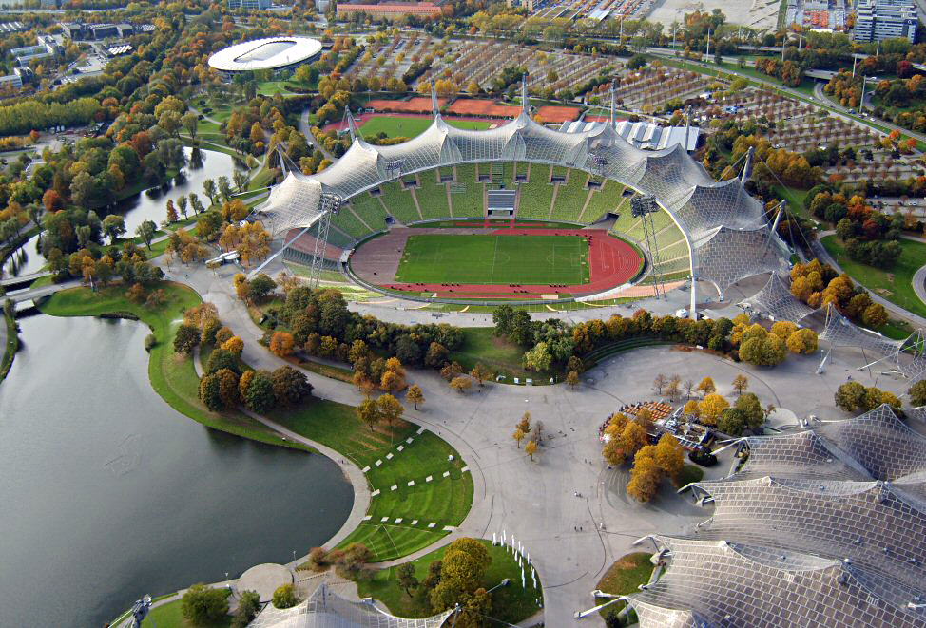
Figure 1. Olympiastadion Munich
Olympiastadion (Munich) - Wikipedia

Membranes
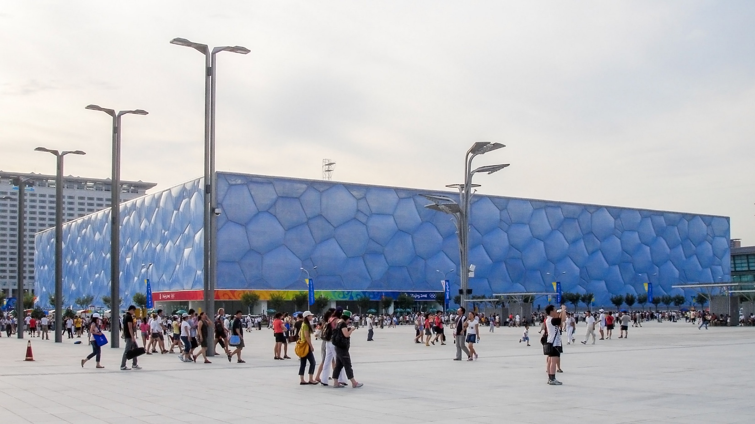
Figure 2. Water Cube
Water Cube - Wikipedia

Gridshells
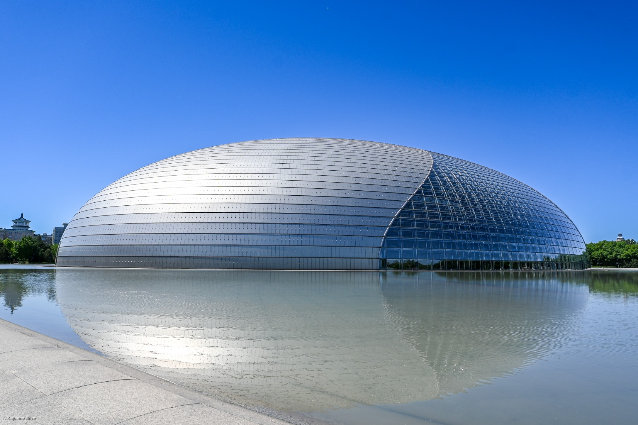
Figure 3. National Centre for the Performing Arts (China)
National Centre for the Performing Arts (China) - Wikipedia

Thin Shells
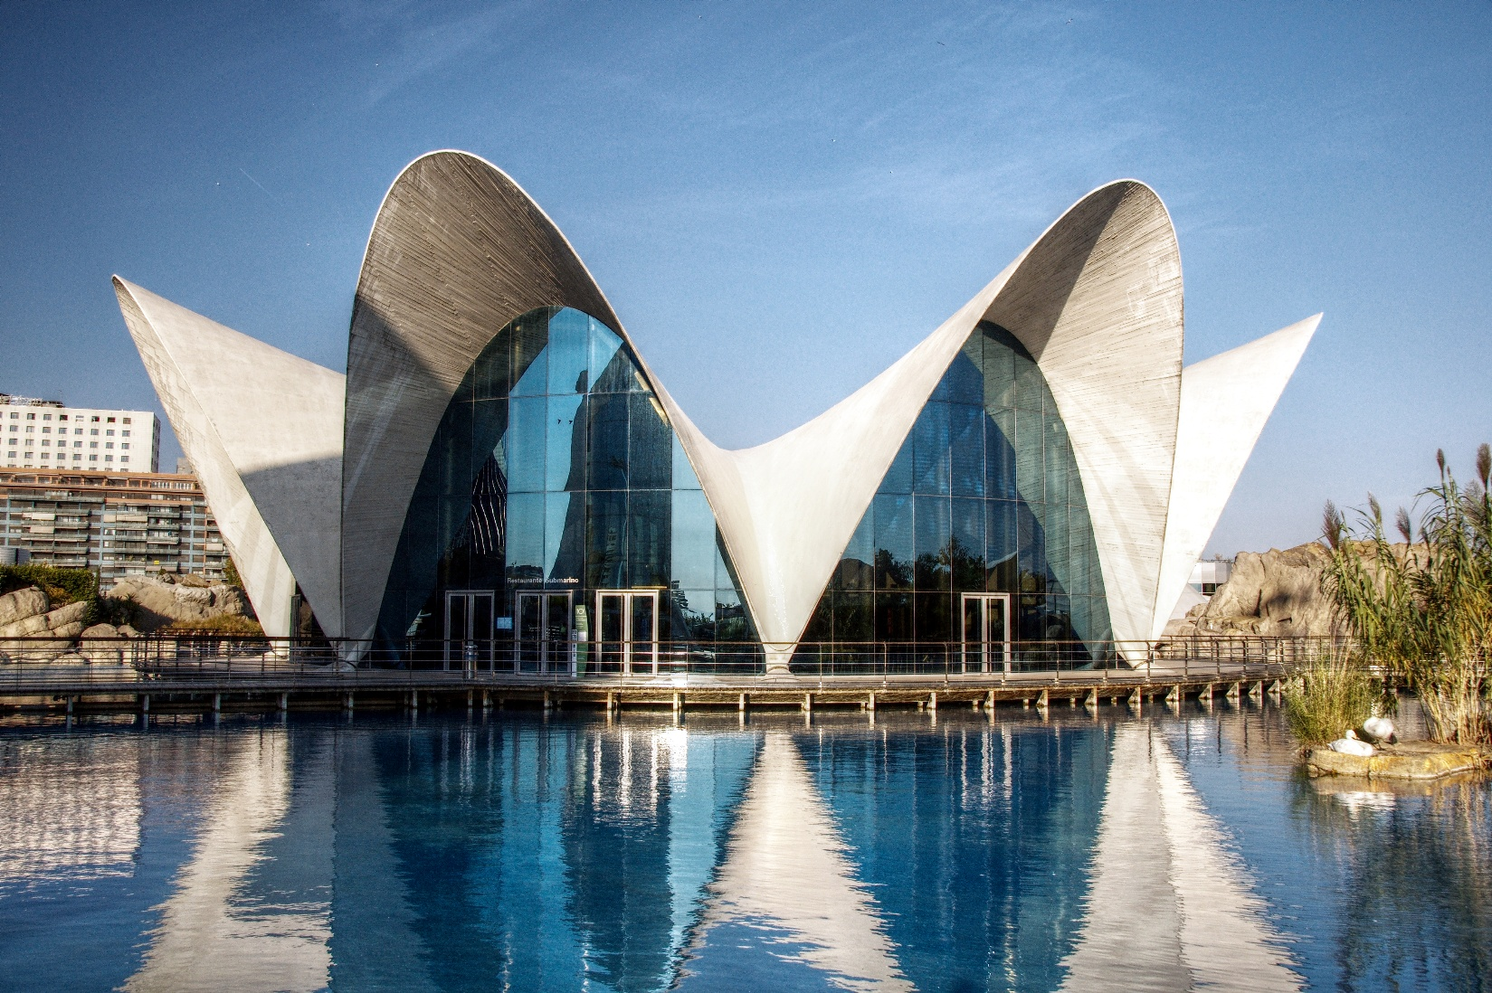
Figure 4. Los Manantiales
Félix Candela - Wikipedia

Tensegrities
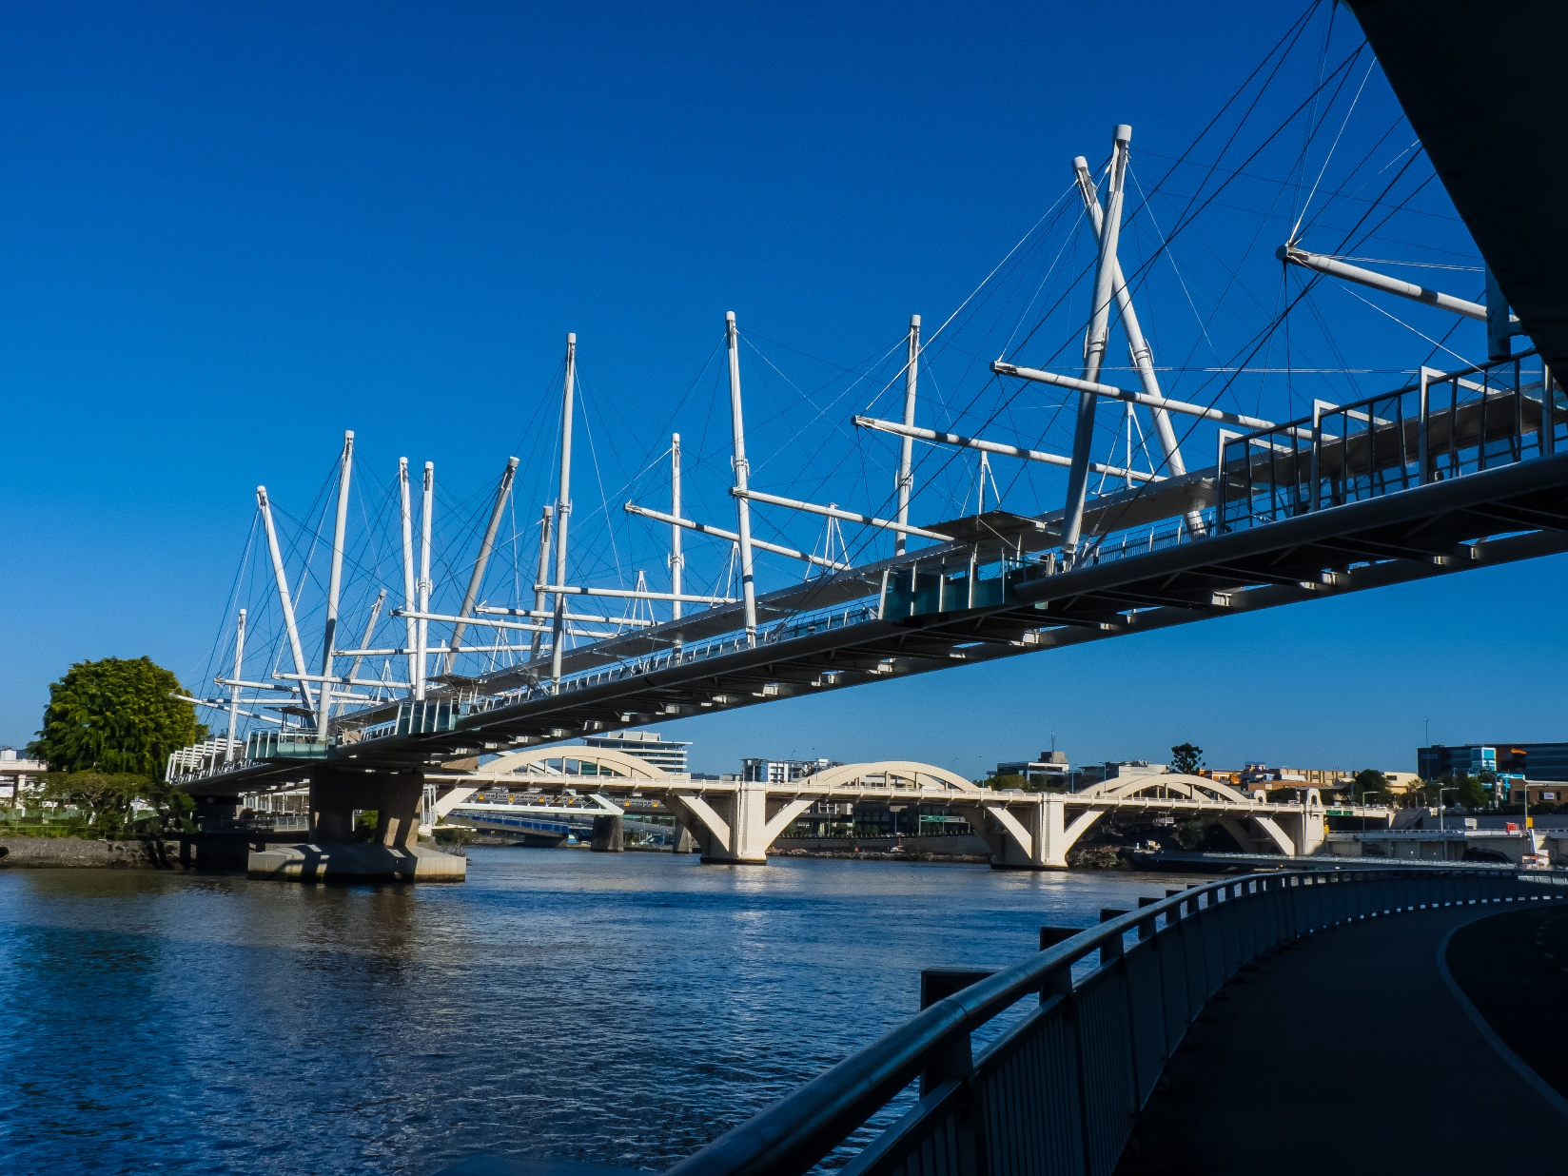
Figure 5. Kurilpa Bridge
Kurilpa Bridge - Wikipedia

