Algorithms DS-A Assignment 3

Group Members:
Yousha Saibi 22L-7482
Omer Hafeez 22i-1859
Hafsa Shakeel 22i-1966

Language Used: Python

Reason: We used the TKINTER library for GUI which was a good option because it was easy to build and no heavy framework was needed. It was also easy to implement the algorithms as python has good string functions.
Drawback: Python is slow compared to C/C++.
Python Libraries used:
- tkinter (GUI)
- time (tracking complexity)
- re (regex matching)

User Guide:
- Make sure py and text files are in the same directory.
- Enter python word_search_with_tkinter.py in the terminal.
- Wait for the search app to appear. Select the options and enter the pattern.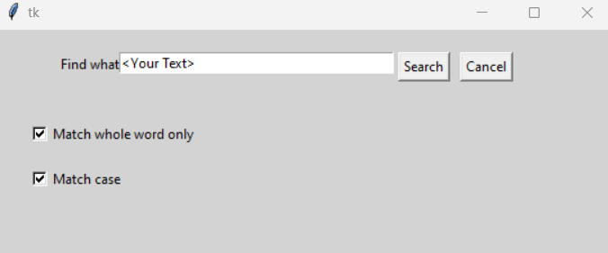
- Results:
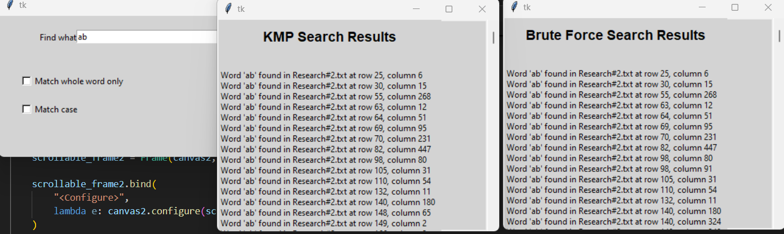
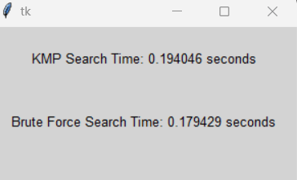

KMP(M+N) > Brute Force(MN)?
Reason for KMP taking more time than Brute Force is that the space complexity is higher in KMP and the LSP(longest prefix suffix ) overheads for creating M size array is greater for every row match so combined time complexity is higher than brute force.

References:
https://www.geeksforgeeks.org/python-gui-tkinter/
https://www.geeksforgeeks.org/tkinter-cheat-sheet/
https://www.activestate.com/wp-content/uploads/2021/02/Tkinter-CheatSheet.pdf
https://www.geeksforgeeks.org/kmp-algorithm-for-pattern-searching/
https://www.geeksforgeeks.org/brute-force-approach-and-its-pros-and-cons/

