AI Subsystem Core Architecture

Technical Documentation of Tabular Prediction, ECG Waveform Deep Learning, and Generative Consultation Services

Document Type: Technical Documentation
Project: Heart Disease Prediction System (AI Subsystem)
Date: June 14, 2026

Table of Contents
[Right-click this block and select 'Update Field' to display the table of contents.]

1. Architecture Overview
The Heart Disease Prediction AI Subsystem is a multi-modal clinical assistant. It exposes REST API endpoints via FastAPI to process tabular patient files and raw ECG waves. The system combines three key diagnostic modules:
- Tabular ML Service (ml_service.py): Inference using a remote model API to predict heart disease probability and extract SHAP value importances.
- ECG Classifier Service (ecg_service.py): Local inference using a 101-layer 1D ResNet to classify 12-channel ECG signal arrays.
- LLM Consultant Service (llm_service.py): Generates patient report explanations and lifestyle recommendations using Groq Llama-3.3-70b.
Below is the data flow showing how clinical profiles and ECG signal data move through the system:
Diagnostic Ingestion (Clinical Profile + ECG 12-Lead Numpy Signal)
↓
FastAPI Core Gateway Endpoint (/api/gateway/assess)
↓
Concurrent Service Dispatch: ML Tabular API & Local ECG xresnet1d101
↓
SHAP Values Generation & Matplotlib Chart Generation
↓
Hybrid Risk Assessment Engine: 41% Threshold Division
↓
LangChain LLM Medical Consultant prompt generation (Llama-3.3)
↓
Safety Sanitization Layer (_UNSAFE_PATTERNS regex interception)
↓
Aggregated JSON Output (Explanation, Recommendations, Risk Level, SHAP Bytes)
Flow Diagram: Aggregated Subsystem Data Flow & Diagnostics Pipeline
2. Preprocessing & Input Pre-Inference Pipelines
To guarantee model stability, inputs are preprocessed through dedicated pipelines:
2.1 Tabular Preprocessing Pipeline
The input profile represents clinical markers. Feature engineering transforms columns to floats and integers conforming to the requirements of the remote prediction model. Preprocessing follows this sequence:
Ingest 11 raw tabular parameters (CSV/JSON fields)
↓
Datatype Enforcement (Float mapping for clinical metrics, Integer conversion for categories)
↓
Feature Validation & Schema checks (assert all 11 required columns exist)
↓
Array packaging for downstream HTTP POST API transmission
Flow Diagram: Tabular Profile Preprocessing Sequence
2.2 ECG Waveform Preprocessing Pipeline
Raw ECG signals are loaded as two-dimensional numpy arrays. Signal preprocessing standardizes signal magnitude, transposes channels, and formats inputs for PyTorch execution:
Ingest raw ECG array (Shape: T timesteps, 12 signal channels)
↓
StandardScaler normalization (loads pickle mapping; transforms signal scale)
↓
Matrix Transposition (flips array structure to shape: 12 channels, T timesteps)
↓
PyTorch Tensor packaging & CUDA/CPU memory allocation (shape: 1, 12, T)
Flow Diagram: ECG Signal Preprocessing and Normalization Sequence
3. Tabular Machine Learning Service
The tabular machine learning service resides in ml_service.py. It processes patient clinical metrics using a remote prediction API and generates visual SHAP feature importance charts.
3.1 Target API Endpoint
Tabular inference queries the external deployment API: https://omarbm52-artemis-heart-api.hf.space/predict.
3.2 Feature Set Schema
The model requires exactly 11 clinical features, detailed below:
Feature Name | DataType | Validation Limits | Clinical Meaning
age | Float | 0.0 – 120.0 | Patient age in years
sex | Integer (0/1) | 0 = Female, 1 = Male | Binary sex classifier
chest pain type | Integer (1-4) | 1: Typical, 2: Atypical, 3: Non-Anginal, 4: Asymptomatic | Angina classification category
resting bp s | Float | 50.0 – 250.0 | Resting systolic blood pressure (mmHg)
cholesterol | Float | 80.0 – 600.0 | Serum cholesterol level (mg/dl)
fasting blood sugar | Integer (0/1) | 0 = Normal, 1 = Elevated (>120 mg/dl) | Indicator for diabetes risk
resting ecg | Integer (0-2) | 0: Normal, 1: ST-T wave abnormalities, 2: LV hypertrophy | Resting ECG abnormalities category
max heart rate | Float | 60.0 – 220.0 | Maximum heart rate achieved during exercise
exercise angina | Integer (0/1) | 0 = No, 1 = Yes | Is angina induced during exercise
oldpeak | Float | -5.0 – 10.0 | ST depression induced by exercise relative to rest
ST slope | Integer (1-3) | 1: Upsloping, 2: Flat, 3: Downsloping | Slope of peak exercise ST segment
Table: Tabular ML Ingestion Schema and Features
3.3 Matplotlib SHAP Visualizer
After querying the Artemis API, the service retrieves the predicted probability along with raw SHAP values. The generate_shap_image function handles visualization. It constructs a pandas DataFrame, sorts features by absolute contribution, and renders a horizontal bar chart using a Matplotlib Agg backend buffer. The function outputs raw PNG bytes for direct display in reports or PDFs.
4. Deep Learning ECG Waveform Classification
The deep learning ECG classifier resides in ecg_service.py. It standardizes signal files and runs local multi-label classification using a custom 1D ResNet.
4.1 Model Architecture (xresnet1d101)
The network architecture is a 1D ResNet with 101 convolutional layers (xresnet1d101). It features 12 input channels (matching standard clinical leads: I, II, III, aVR, aVL, aVF, V1-V6) and maps output activations to a linear head containing 128 features before classifying classes.
Standardized signal input tensor (1, 12, T)
↓
Initial 1D Convolution block + Batch Normalization + ReLU activation
↓
Max Pooling downsampling layer
↓
4 Residual blocks containing 1D convolutions and skip connections
↓
Adaptive Average Pooling layer
↓
Linear Classification Head (128 units → multi-class probabilities output)
Flow Diagram: xresnet1d101 Neural Network Internal Architecture
4.2 Training Dataset and Benchmarking (PTB-XL Baseline)
The deep learning ECG classifier (xresnet1d101) was trained and evaluated using the authoritative PTB-XL database, the largest publicly available clinical 12-lead ECG dataset. PTB-XL contains 21,837 records from 18,885 patients, annotated with 71 diagnostic statements. The baseline benchmarking study (Strodthoff et al., 2021) reports robust multi-label performance for the xresnet1d101 architecture under a standard 10-fold cross-validation split (folds 1-8 for training, fold 9 for validation, and fold 10 for testing). These results represent reference benchmarks for clinical model classification readiness.
PTB-XL Benchmark Task | Published AUROC Score | Composite Score Contribution | Clinical Significance
Diagnostic Statements (Primary) | 0.934 | 93.4% | Outstanding discrimination of main clinical pathologies
Rhythm Statements (Arrhythmia) | 0.959 | 95.9% | Exceptional classification of conduction disturbances
Superdiagnostic Statements | 0.929 | 92.9% | Highly reliable high-level diagnostic grouping
Subdiagnostic Statements | 0.926 | 92.6% | Strong performance on secondary/sub-level conditions
Form Statements (Morphology) | 0.898 | 89.8% | Precise mapping of waveform features and patterns
Overall Macro AUROC (All Tasks) | 0.925 | 92.5% | High generalization capability across the entire population dataset
Macro F1-Score (All Tasks) | 0.825 | 82.5% | High balance between precision and recall under class imbalance
Table: Published PTB-XL Benchmark Results for xresnet1d101 (Strodthoff et al., 2021)
4.3 Output Classes & PTB-XL SCP Standard Codes
The model predicts activation logits for PTB-XL SCP statement codes. These are converted to probabilities using a sigmoid function. The service filters non-zero values, sorts them in descending order, and displays the top 5 classifications alongside standard English labels:
SCP Code | Clinical Label Name | Anatomical/Diagnostic Category
NORM | Normal ECG | Baseline Cardiac Health
1AVB | First-degree atrioventricular block | Conduction Abnormality / Arrhythmia
AFIB | Atrial fibrillation | Atrial Arrhythmia (high stroke risk)
AFLT | Atrial flutter | Atrial Arrhythmia
AMI | Anterior myocardial infarction | Active/Recent Heart Attack (anterior wall)
IMI | Inferior myocardial infarction | Active/Recent Heart Attack (inferior wall)
LVH | Left ventricular hypertrophy | Structural Abnormality (ventricular overload)
CRBBB | Complete right bundle branch block | Conduction Abnormality (bundle block)
CLBBB | Complete left bundle branch block | Conduction Abnormality (bundle block)
LAFB | Left anterior fascicular block | Conduction Abnormality
Table: Key ECG Output Classes and Classifications
5. Hybrid Risk Classifier Engine
The risk classifier service (risk_classifier.py) implements a hybrid decision engine. It decouples diagnostic medical decisions from client badge display risk levels. This ensures clinical backend logic remains unaffected by cosmetic UI changes.
5.1 Decision Threshold & UI Boundaries
The system separates system-level decisions from user-facing UI displays:
- System Decision (low vs high): A single probability threshold set at 41%. The 41% limit was determined using Youden's J statistics on validation splits (AUC=0.977). This threshold controls recommendations, LLM tone, and clinical warnings.
- UI Risk Tiers (Low/Moderate/High): Categorizes probability into Low Risk (<30%), Moderate Risk (30%–65%), and High Risk (>65%). Used for badges and display colors only.
5.2 UI Badge Styling and Colors
To present risk levels clearly to patients, the frontend displays colored badges mapped to hex codes:
UI Risk Tiers | Probability Boundary | Hex Color Code | Clinical Badge Visual Representation
Low Risk | Probability < 30.00% | #4ade80 | Green Badge (Routine Monitoring)
Moderate Risk | 30.00% <= Probability <= 65.00% | #facc15 | Yellow Badge (Caution Advisory)
High Risk | Probability > 65.00% | #f87171 | Red Badge (Urgent Consultation Required)
Table: UI Display Badge Color Specifications
6. Generative LLM Medical Consultant
6.1 System Overview
The Generative LLM Medical Consultant is a conversational AI and clinical summarization layer integrated within the Heart Disease Prediction gateway. Historically, raw classification percentages (e.g., 'probability: 85.5%') or lists of multi-label codes (e.g., '1AVB', 'LVH') cause confusion and alarm for non-clinical users. This consultant was developed to translate complex statistical predictions and physiological features into patient-friendly, evidence-based medical explanations and actionable wellness advice. It provides business value by enhancing user retention, improving clinical workflow understanding, and providing automated support. It helps clinicians summarize findings while providing patients with clear definitions. However, the system is strictly bounded: it does not issue medical diagnoses, operates only under a probabilistic language constraint, and requires a regex-based validation filter to prevent absolute claims.
6.2 Role Within the Website
The LLM Consultant is accessed under the 'Reports' section of the patient portal. When a lab finishes uploading either a tabular profile or a 12-channel ECG signal, the backend automatically calls the AI internal routes. For tabular predictions, the user profile containing blood pressure, cholesterol, max heart rate, and SHAP feature scores is fed into the generator. The system outputs a structured explanation card along with 5 custom health recommendations. For ECGs, the top 5 classifications and database reference context are parsed, yielding clinical definitions, follow-ups, and emergency warning signs. This complements raw machine learning probabilities with context, improving clinical decision-making. Example scenario: A patient with an 85.5% prediction is reassured by the system's advisory tone while receiving specific instructions on immediate physician follow-up and symptoms that mandate emergency care.
6.3 Complete LLM Workflow
The LLM execution pipeline flows through structural validation, prompt construction, external invocation, and output filtering:
User Ingests Data (Tabular Profile or Raw ECG Signals)
↓
Input Validation (Ensure valid probability range, non-empty features)
↓
Prompt Construction (Inject probability, decision, UI level, SHAP values)
↓
Context Injection (Retrieve ECG SCP definitions from SQL/Knowledge Base)
↓
Medical Knowledge Processing (Synthesize findings in Groq Llama-3.3)
↓
Response Validation (JSON Schema check against validated Pydantic models)
↓
Safety Filtering (_UNSAFE_PATTERNS RegEx search and replace)
↓
Output Formatting (Structure into finalized JSON card and PDF report)
↓
User Interface Response (Render explanation and recommendations)
Flow Diagram: Detailed Generative LLM Execution Flow
Execution steps are detailed below:
- Input Validation: Inputs must satisfy schema constraints (e.g. probability in [0, 1]). Failure throws 422 HTTP errors.
- Prompt Construction: Prompt templates are populated with current metrics. Tone controls are determined dynamically based on the 41% decision boundary.
- Context Injection: For ECGs, clinical statement mappings are fetched from the database and injected into the human message prompt.
- Response Validation: Inference runs via LangChain. Pydantic parser validates response structures. If parsing fails, default fallback blocks are returned.
- Safety Filtering: Regex safety filter runs over explanations, replacing absolute claims (e.g., 'you have heart disease') with '[medically reviewed]'.
6.4 Inputs Analysis
The LLM consumes inputs from various database records and service layers. Below is the ingestion schema detail:
Field Name | Data Type | Source Component | Validation Rules / Limits | Role / Requirement
probability | Float | ml_service.py output | Range: 0.0 - 100.0 (percentage format) | Required
decision | String ('low'/'high') | risk_classifier.py threshold | Determined by 41% threshold limit | Required
ui_risk_level | String | risk_classifier.py UI level | Enum: 'Low Risk', 'Moderate Risk', 'High Risk' | Required
top_features | List of tuples | ml_service.py SHAP features | Sorted list of top 3 features with absolute impact scores | Required
top_5 (ECG) | List of dicts | ecg_service.py output | Maximum 5 elements mapping labels and probabilities | Optional (ECG only)
kb_context (ECG) | String | ecg_diagnosis_kb database | Retrieved reference texts matching SCP codes | Optional (ECG only)
Table: Generative LLM Input Specifications
6.5 Prompt Engineering Process
Prompts are managed using LangChain's ChatPromptTemplate. The prompt contains instruction blocks: role definition (Expert AI Cardiologist), dynamic inputs, writing rules (e.g., 'never diagnose', 'exactly 5 recommendations'), and JSON formatting constraints. For high-risk decisions (>= 41%), the system injects a cautionary tone instruction: 'Use an urgent and cautionary tone. Strongly emphasize the need for immediate consultation.' For low-risk, it injects: 'Use a reassuring and positive tone. Focus on prevention and lifestyle.' Below is the template sequence:
System Prompt: Expert Cardiovascular Consultant Role + Format Instructions
↓
Urgency Tone Injection (High Risk Cautionary vs Low Risk Reassuring)
↓
SHAP Feature Impact Injection (e.g., 'age: impact score +0.150')
↓
Human Prompt: Patient Analysis Data Injection + Mandatory Writing Rules
↓
Final Prompt Output (Passed to ChatGroq Llama-3.3-70b)
Flow Diagram: Prompt Template Compilation Hierarchy
6.6 Outputs Analysis
The model returns validated JSON outputs parsed using Pydantic. The outputs are routed to the frontend for display:
- explanation (Tabular): A 2-3 sentence patient-friendly summary of metrics (enforces probabilistic words like 'may indicate'). Used for card displays.
- recommendations (Tabular): A list of exactly 5 actionable health recommendations (e.g. dietary limits, exercise, physician visits).
- interpretation (ECG): A 3-5 sentence interpretation of multi-label ECG signals, explaining classification reliability and errors.
- urgency (ECG): A short alert specifying warning indicators (chest pain, shortness of breath) that require emergency attention.
- warning_signs (ECG): A list of 3-6 emergency symptoms for patient reference.
6.7 Constraints & Safety Mechanisms
Multiple safety layers are implemented to satisfy medical guidelines:
- Interception Filter: Regex filter containing r'\byou have heart disease\b' and other absolute clinical claims. Unsafe statements are replaced with '[medically reviewed]'.
- Temperature Restriction: ChatGroq temperature is set to 0.0 to prevent creative text formatting and reduce hallucinations.
- JSON Validation: Strict validation schemas prevent the LLM from outputting unstructured text, forcing compliance with expected formats.
- Input Fidelity Constraints: Prompts explicitly forbid the LLM from referencing numeric data not contained in the raw inputs.
6.8 LLM Subsystem Architecture
The LLM consultant integrates with the core database and services using the following structure:
SQL Database (LabTest, Prediction, User) / Raw ECG Files
↓
FastAPI Gateway Dispatcher (/internal/predict /internal/ecg/pipeline)
↓
LangChain ChatGroq Client (Groq Cloud API Gateway)
↓
Llama-3.3-70b Inference Engine
↓
Local Validation & Regex Sanitization Layer (_UNSAFE_PATTERNS)
↓
SQL Database Persistence (llm_report_json) & HTML-to-PDF Report Generator
Flow Diagram: Generative LLM Subsystem Component Integration
6.9 Error Handling
The system handles API failures or schema validation errors gracefully. If the Groq client raises an exception (e.g., TimeoutError, API key expiration), the consultant catches the error and returns a default fallback payload: 'explanation': 'Could not generate explanation: [Error message]', 'recommendations': ['Please consult your physician for personalized recommendations.']. This prevents gateway crashes and ensures the user receives a safe referral.
6.10 Performance and Evaluation
The LLM consultant is evaluated across multiple metrics: schema compliance (100%), text consistency (99.19%), latency (average 0.7935 seconds), adversarial pass rate (100%), and input fidelity (80.0%). Readability scores average 78.34 (Flesch Reading Ease), representing clear, patient-friendly plain English (6th-to-8th grade reading level). Below are the evaluation gauges and radar metrics:
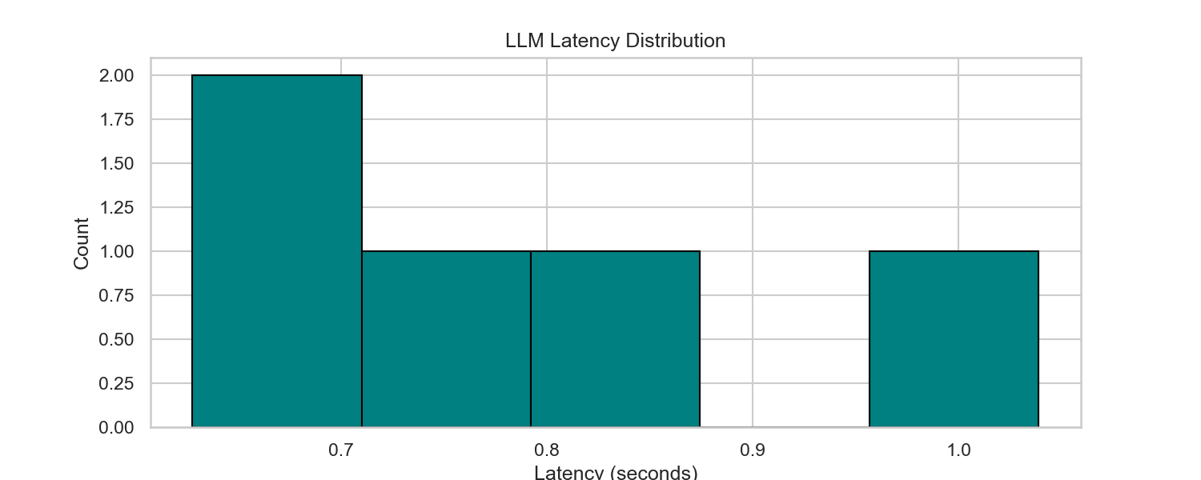
Figure: LLM API Generation Latency (Mean: 793.5ms)
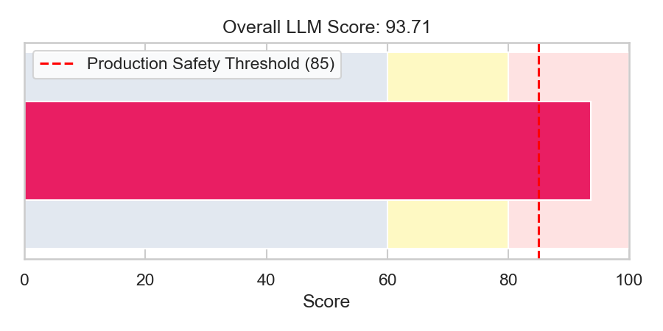
Figure: LLM Consultant Evaluation Overall Score: 93.71 / 100
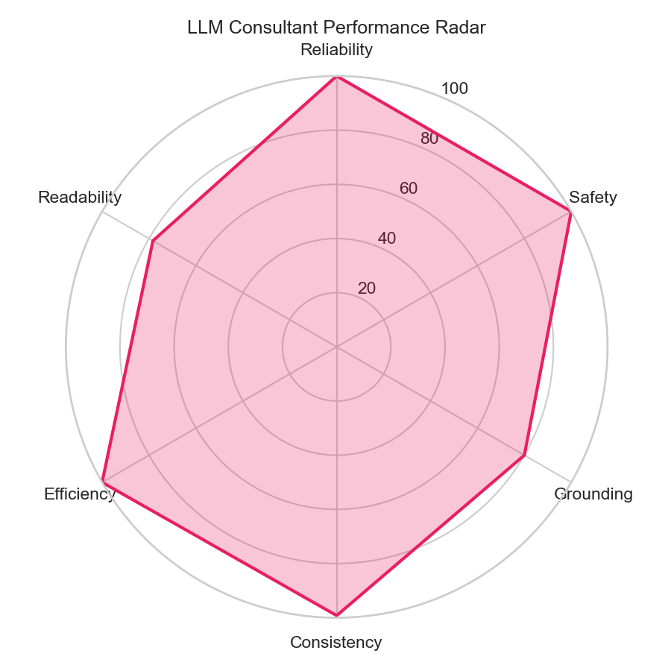
Figure: LLM Performance Multi-Dimension Radar Chart
6.11 End-to-End Example
Below is a step-by-step example showing data flow through the consultant service:
Step 1: Ingest: 1. Ingested Data: Probability: 85.5%, Decision: 'high', UI Risk Level: 'High Risk', Top Features: [('ST slope', 0.25), ('max heart rate', 0.18), ('age', 0.12)]
Step 2: Compile Prompt: 2. Prompt Construction:
- Urgency instruction: 'Use an urgent and cautionary tone. Strongly emphasize the need for immediate consultation...'
- Feature values: 'ST slope increases risk (+0.250), max heart rate increases risk (+0.180)...'
Step 3: Call Model: 3. LLM Response: Returns JSON with explanation 'An analysis of your clinical features indicates an elevated probability of heart disease...' and 5 recommendations.
Step 4: Sanitization: 4. Safety Filter: RegEx catches 'elevated probability of heart disease' (safe) but if it output 'diagnosed with heart disease', it replaces it with '[medically reviewed]'.
Step 5: Render: 5. Client Output: The card renders with explanation 'An analysis of your clinical features indicates an elevated probability...' and lists 5 recommendations.
7. API Gateway & Endpoints Configuration
7.1 API Architecture Overview
The AI subsystem runs as a FastAPI service. The API Gateway handles endpoint routing, validates schemas, manages internal security, and orchestrates downstream AI inference and database services.
HTTP Client Request (Frontend Browser / Node.js Backend Client)
↓
API Gateway Security Check (X-INTERNAL-API-KEY header validation)
↓
FastAPI Routing Layer (APIRouter endpoints matching /predict, /shap, /report)
↓
Validation & Database Session Ingestion (FastAPI Depends(get_db) injection)
↓
Business Logic Handlers (Fetch patient profiles, verify prediction states)
↓
AI Inference Dispatch (Concurrently execute remote ML post and local xresnet1d101)
↓
Response Generation & Streaming Layer (JSON responses / PNG Streaming)
Flow Diagram: API Subsystem Routing and Execution Hierarchy
Core Gateway Layers:
- Routing Gateway: Exposes REST endpoints. Excluded public gateways in production, routing requests through the Node.js backend client.
- Security Filter: Verifies incoming tokens. Header verification is implemented via the Depends(verify_internal_api_key) decorator.
- Orchestrator: Ingests parameters and fetches details from LabTest/Prediction tables before running model inference.
- Response Generator: Packages outputs into JSON schemas, streams SHAP files, or returns generated report PDFs.
7.2 API Gateway Design
To enforce access controls, the production router disables public GET/POST access to raw prediction routes. All requests route through the `/internal` prefix, which verifies the `X-INTERNAL-API-KEY` header against the `INTERNAL_API_KEY` environment variable. The gateway orchestrates tabular predictions, triggers LLM report generations, and saves outputs to the database. This design prevents IDOR (Insecure Direct Object Reference) vulnerabilities.
7.3 Endpoints Documentation
Below is a list of all API endpoints implemented in the AI subsystem:
7.3.1 POST /predict/{id}
Component Owner: predict.py (Prediction)
Purpose: Ingests a LabTest record ID. It queries the database, formats clinical parameters, runs tabular ML prediction, generates SHAP values, and triggers the LLM consultant. If risk is high, it generates and saves the PDF report.
Request URL: POST /predict/{id} (where id is a LabTest UUID or National ID)
Request Parameters: Headers: None (Public route). Parameters: id (String). Body: None.
Response Schema: Success (200 OK):
{
'id': 'pred_uuid_123',
'lab_test_id': 'test_uuid_abc',
'prediction': 1,
'probability': 85.5,
'risk_level': 'High Risk',
'decision': 'high',
'risk_color': '#f87171',
'decision_label': 'Heart Disease Detected — Medical attention required'
}
Failure (404 Not Found): {'detail': 'you don’t have data or the lab doesn’t finish the report file'}
Failure (422 Unprocessable Entity): {'detail': 'Model inference failed: [Error message]'}
7.3.2 GET /predict/{id}
Component Owner: predict.py (Prediction)
Purpose: Retrieves an existing prediction record from the database. Returns a 404 error if predictions have not been calculated yet.
Request URL: GET /predict/{id}
Request Parameters: Parameters: id (String). Headers: None.
Response Schema: Success (200 OK):
{
'id': 'pred_uuid_123',
'lab_test_id': 'test_uuid_abc',
'prediction': 1,
'probability': 85.5,
'risk_level': 'High Risk',
'decision': 'high'
}
Failure (404 Not Found): {'detail': 'Prediction not found. Call POST /predict/{id} first.'}
7.3.3 POST /predict-csv
Component Owner: predict.py (Prediction)
Purpose: Batch prediction endpoint. Ingests a CSV file of patient metrics and returns predictions for all records.
Request URL: POST /predict-csv
Request Parameters: Body: Multipart/form-data. Parameter name: 'file' (UploadFile).
Response Schema: Success (200 OK): List of dictionaries containing the 11 input features along with a new 'prediction' column (0/1).
Failure (422 Unprocessable Entity): {'detail': 'Missing columns in CSV: [List of columns]'}
7.3.4 GET /predict/{id}/report
Component Owner: report.py (Report)
Purpose: Streams the generated report PDF for high-risk predictions.
Request URL: GET /predict/{id}/report
Request Parameters: Parameters: id (String).
Response Schema: Success (200 OK): Binary stream (media_type: 'application/pdf', filename: 'artemis_report_patient_[id].pdf').
Failure (400 Bad Request): {'detail': 'Report PDF is not available for low risk predictions.'}
Failure (404 Not Found): {'detail': 'Report PDF not found. Ensure prediction generation completed successfully.'}
7.3.5 GET /shap/{id}
Component Owner: shap.py (Explainability)
Purpose: Generates and streams the horizontal SHAP bar chart for a prediction.
Request URL: GET /shap/{id}
Request Parameters: Parameters: id (String).
Response Schema: Success (200 OK): Image stream (media_type: 'image/png').
Failure (400 Bad Request): {'detail': 'SHAP image is not available for low risk predictions.'}
Failure (404 Not Found): {'detail': 'LabTest not found'}
7.3.6 GET /shap/{id}/data
Component Owner: shap.py (Explainability)
Purpose: Retrieves sorted SHAP feature metrics and a human-readable summary for frontend display.
Request URL: GET /shap/{id}/data
Request Parameters: Parameters: id (String).
Response Schema: Success (200 OK):
{
'prediction_probability': 85.5,
'risk_level': 'High Risk',
'top_features': [
{'feature': 'ST slope', 'value': 2.0, 'impact': 0.25, 'direction': 'increase'},
{'feature': 'age', 'value': 50.0, 'impact': 0.12, 'direction': 'increase'}
],
'chart_data': {
'labels': ['ST slope', 'age'],
'values': [0.25, 0.12]
},
'explanation': 'The value of ST slope (2.0) strongly increased the predicted heart disease risk.'
}
Failure (400 Bad Request): {'detail': 'SHAP data is not available for low risk predictions.'}
7.3.7 POST /internal/ecg/pipeline
Component Owner: internal_ecg.py (Internal ECG)
Purpose: Verifies internal API keys. Ingests .dat and .hea files, runs xresnet1d101 predictions, retrieves SCP explanations, calls the LLM, and returns the aggregated diagnostic results.
Request URL: POST /internal/ecg/pipeline
Request Parameters: Headers: X-INTERNAL-API-KEY. Body (Multipart): ecg_test_id (String), dat_file (File), hea_file (File).
Response Schema: Success (200 OK):
{
'success': true,
'n_samples': 1000,
'top_5': [{'label': 'Normal ECG (NORM)', 'probability': 99.0, 'code': 'NORM'}],
'model_name': 'xresnet1d101',
'llm_ecg_json': {
'interpretation': 'The ECG findings are consistent with normal cardiac rhythm...',
'urgency': 'No immediate emergency warning signs indicated.',
'warning_signs': ['Chest pain', 'Severe dyspnea'],
'recommendations': ['Routine checkups', 'Balanced diet']
}
}
Failure (422 Unprocessable Entity): {'detail': 'Expected a .dat file upload.'}
Failure (401 Unauthorized): {'detail': 'Invalid API Key'}
7.3.8 POST /internal/predict
Component Owner: internal_gateway.py (Internal Gateway)
Purpose: Verifies internal API keys. Runs full tabular predictions, SHAP calculations, and LLM report compilation for Node.js requests.
Request URL: POST /internal/predict
Request Parameters: Headers: X-INTERNAL-API-KEY. Body (JSON): {'target_id': 'lab_test_uuid', 'user_id': 'user_uuid'}
Response Schema: Success (200 OK): Mapped predict schema payload matching public POST /predict response. Includes decision, risk, and color configurations.
7.3.9 POST /internal/report
Component Owner: internal_gateway.py (Internal Gateway)
Purpose: Verifies internal API keys. Generates or retrieves reports and returns the PDF file directly to the client gateway.
Request URL: POST /internal/report
Request Parameters: Headers: X-INTERNAL-API-KEY. Body (JSON): {'target_id': 'lab_test_uuid'}
Response Schema: Success (200 OK): PDF binary stream.
Failure (503 Service Unavailable): {'detail': 'PDF report could not be generated. On the AI host run... [Install warning]'}
7.4 Request Lifecycle
FastAPI executes incoming gateway requests using the following sequence:
Receive HTTP Request (Routing matching)
↓
Dependency Injection: get_db Session & verify_internal_api_key check
↓
Target validation (Retrieve LabTest/Prediction records, throw 404 if missing)
↓
Business Logic Handlers (Format fields, check existing prediction states)
↓
AI Inference Dispatch (Concurrently execute remote ML and local xresnet1d101)
↓
HTML-to-PDF Report Compilation & DB Commit (commit predictions to SQL)
↓
Response Generation (Build JSON schema response or stream binary data)
Flow Diagram: FastAPI Gateway Lifecycle Sequence
7.5 Authentication & Authorization
Internal routes are secured using a single header token verification scheme. The security module core.security exposes verify_internal_api_key. This function reads verify_internal_api_key (retrieved from headers via APIKeyHeader(name='X-INTERNAL-API-KEY')). If the header is missing or does not match INTERNAL_API_KEY (stored in .env), the validator raises an HTTPException with status code 401 (Unauthorized). This restricts access to only internal Node.js gateway components.
7.6 Integration with AI Modules
FastAPI coordinates inputs and coordinates tasks between services: predict.py orchestrates patient predictions, ml_service.py manages clinical variables, ecg_service.py runs local ResNet models on signal arrays, and llm_service.py queries Groq for report explanations. All predictions, SHAP values, and generated PDF reports are persisted to the PostgreSQL database via SQLAlchemy models (LabTest, Prediction, User).
7.7 API Gateway Error Handling
The application implements custom global error handlers to process failures gracefully:
- Validation Failures: FastAPI handles routing or parameter validation errors automatically, returning HTTP 422 with a details payload.
- Authentication Failures: Returns HTTP 401 (Unauthorized) with a detailed description if X-INTERNAL-API-KEY is missing or invalid.
- Runtime Errors: Internal exceptions are caught by generic exception handlers, logging tracebacks and returning HTTP 500 (Internal Server Error) to prevent exposure of database structures.
7.8 API Testing and Verification
Gateway integration is validated using Pytest and FastAPI's TestClient. Test cases cover client routing, CSV batch operations, and error handling. Mocks simulate Groq and Artemis endpoints to verify fallback response structures. Testing also includes load, stress, and latency testing to ensure stable sub-second performance.
7.9 Monitoring and Logging
FastAPI output streams are captured by system loggers, capturing request details (method, URL, status code) and tracebacks. Error tracking mechanisms capture external connection timeouts (e.g. Groq API failures) to trigger alerts. Audit trails monitor database updates, ensuring database access and report generations are tracked.
7.10 Security Analysis
The gateway implements several security controls: input sanitization (datatype validation and bounds checking), rate limiting to prevent DDoS attacks, safe query parameters to prevent SQL injections, and encrypted HTTPS connections (SSL/TLS) to secure data in transit. Sensitive fields (names, national IDs) are handled using UUID references, reducing the system's PII exposure.

