Energy Waste — Meter-by-Meter Detail
Full supporting detail for every meter listed in the Energy Waste & Savings Opportunities summary
This appendix lists every meter flagged in the summary report, in the same three groups: 144 for overnight standby, 39 for weekend usage, and 115 for spike days (some meters appear in more than one group). For standby and weekend entries, the chart shows the meter's typical weekday power (solid) against its typical weekend power (dashed) across the day, with the overnight window (12am–5am) shaded pink and the daytime window (9am–5pm) shaded blue. For spike-day entries, the chart shows daily energy across the whole period, with flagged spike days marked in red against the meter's typical day (grey dashed) and its spike threshold (red dotted).
As in the summary report, these are statistical estimates from meter data, not a certified audit — use this list to prioritise where to look on-site.

A. Overnight Standby (144 meters)
DD93710161470_0 Grid connect  Overnight 12.69 kW | Daytime 14.21 kW | Ratio 89% | Est. 157 kWh/day  Overnight power stays at 89% of this meter's own typical daytime power (best-performing similar Grid connect meters achieve about 43%). That gap works out to an estimated 157 kWh/day that could potentially be avoided if it idled down the way comparable meters do. | 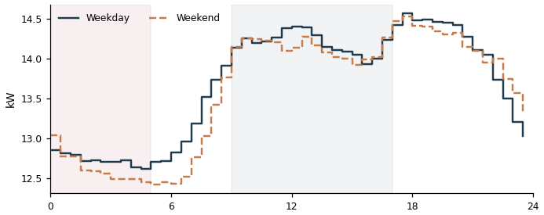

DD93710159602_3 Grid connect  Overnight 11.85 kW | Daytime 13.75 kW | Ratio 86% | Est. 141 kWh/day  Overnight power stays at 86% of this meter's own typical daytime power (best-performing similar Grid connect meters achieve about 43%). That gap works out to an estimated 141 kWh/day that could potentially be avoided if it idled down the way comparable meters do. | 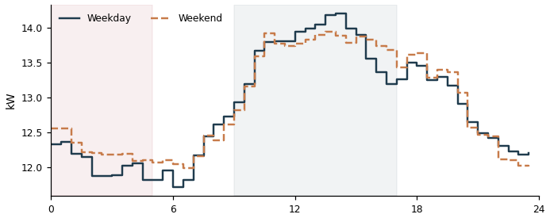

DD33710148566_3 Lighting & Power  Overnight 8.72 kW | Daytime 13.26 kW | Ratio 66% | Est. 121 kWh/day  Overnight power stays at 66% of this meter's own typical daytime power (best-performing similar Lighting & Power meters achieve about 28%). That gap works out to an estimated 121 kWh/day that could potentially be avoided if it idled down the way comparable meters do. | 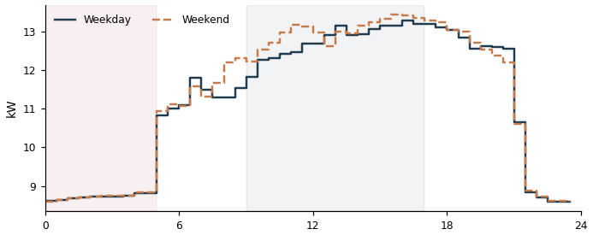

DD33710148566_4 Lighting & Power  Overnight 8.00 kW | Daytime 11.87 kW | Ratio 67% | Est. 113 kWh/day  Overnight power stays at 67% of this meter's own typical daytime power (best-performing similar Lighting & Power meters achieve about 28%). That gap works out to an estimated 113 kWh/day that could potentially be avoided if it idled down the way comparable meters do. | 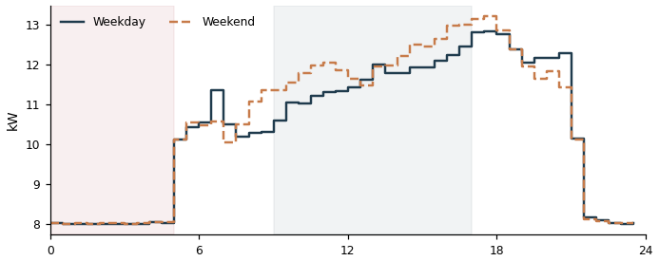

DD13710149684_1 Air conditioning  Overnight 4.49 kW | Daytime 5.33 kW | Ratio 84% | Est. 107 kWh/day  Overnight power stays at 84% of this meter's own typical daytime power (best-performing similar Air conditioning meters achieve about 0%). That gap works out to an estimated 107 kWh/day that could potentially be avoided if it idled down the way comparable meters do. | 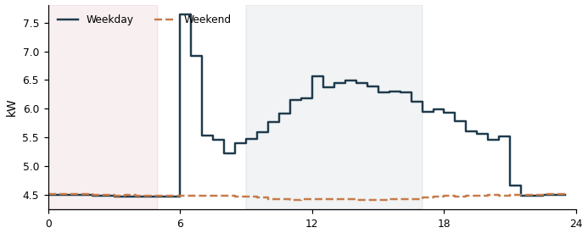

DD13710149684_2 Air conditioning  Overnight 4.41 kW | Daytime 6.31 kW | Ratio 70% | Est. 105 kWh/day  Overnight power stays at 70% of this meter's own typical daytime power (best-performing similar Air conditioning meters achieve about 0%). That gap works out to an estimated 105 kWh/day that could potentially be avoided if it idled down the way comparable meters do. | 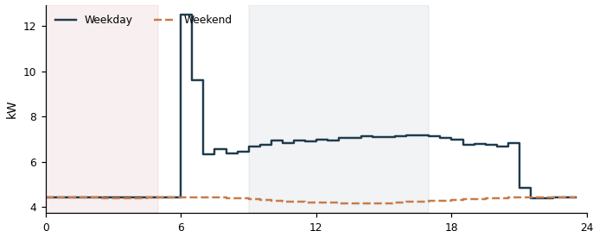

DD93710159602_4 Grid connect  Overnight 9.17 kW | Daytime 11.17 kW | Ratio 82% | Est. 104 kWh/day  Overnight power stays at 82% of this meter's own typical daytime power (best-performing similar Grid connect meters achieve about 43%). That gap works out to an estimated 104 kWh/day that could potentially be avoided if it idled down the way comparable meters do. | 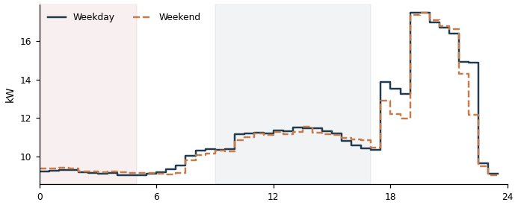

DD93710161470_1 Grid connect  Overnight 8.16 kW | Daytime 9.62 kW | Ratio 85% | Est. 96 kWh/day  Overnight power stays at 85% of this meter's own typical daytime power (best-performing similar Grid connect meters achieve about 43%). That gap works out to an estimated 96 kWh/day that could potentially be avoided if it idled down the way comparable meters do. | 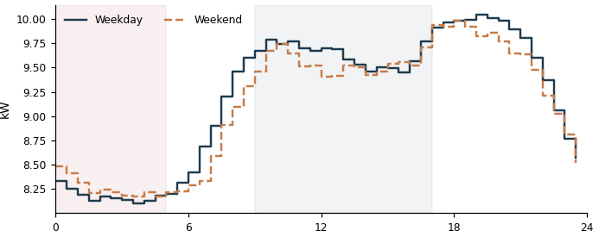

DD93710161470_2 Grid connect  Overnight 7.25 kW | Daytime 8.93 kW | Ratio 81% | Est. 81 kWh/day  Overnight power stays at 81% of this meter's own typical daytime power (best-performing similar Grid connect meters achieve about 43%). That gap works out to an estimated 81 kWh/day that could potentially be avoided if it idled down the way comparable meters do. | 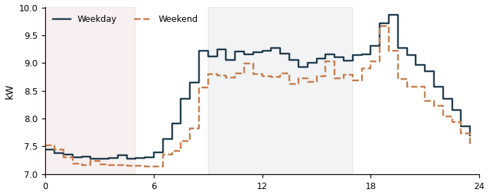

DD33710148566_5 Lighting & Power  Overnight 6.25 kW | Daytime 11.01 kW | Ratio 57% | Est. 77 kWh/day  Overnight power stays at 57% of this meter's own typical daytime power (best-performing similar Lighting & Power meters achieve about 28%). That gap works out to an estimated 77 kWh/day that could potentially be avoided if it idled down the way comparable meters do. | 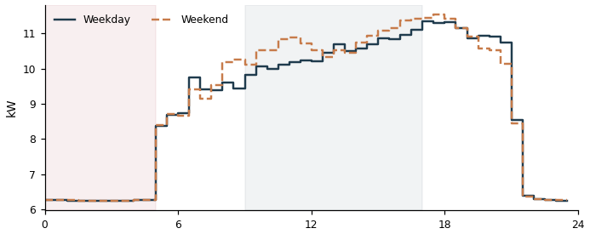

DD93710159602_5 Grid connect  Overnight 7.37 kW | Daytime 9.97 kW | Ratio 74% | Est. 73 kWh/day  Overnight power stays at 74% of this meter's own typical daytime power (best-performing similar Grid connect meters achieve about 43%). That gap works out to an estimated 73 kWh/day that could potentially be avoided if it idled down the way comparable meters do. | 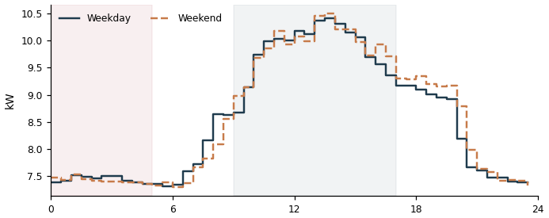

DD25335317259_0 Grid connect  Overnight 5.00 kW | Daytime 5.19 kW | Ratio 96% | Est. 66 kWh/day  Overnight power stays at 96% of this meter's own typical daytime power (best-performing similar Grid connect meters achieve about 43%). That gap works out to an estimated 66 kWh/day that could potentially be avoided if it idled down the way comparable meters do. | 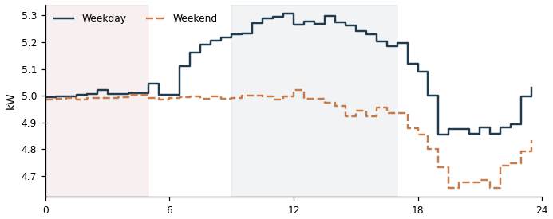

DD43710142219_0 Grid connect  Overnight 4.81 kW | Daytime 4.98 kW | Ratio 97% | Est. 64 kWh/day  Overnight power stays at 97% of this meter's own typical daytime power (best-performing similar Grid connect meters achieve about 43%). That gap works out to an estimated 64 kWh/day that could potentially be avoided if it idled down the way comparable meters do. | 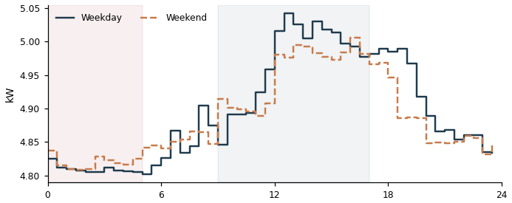

DD23710148637_0 Grid connect  Overnight 5.73 kW | Daytime 7.13 kW | Ratio 80% | Est. 63 kWh/day  Overnight power stays at 80% of this meter's own typical daytime power (best-performing similar Grid connect meters achieve about 43%). That gap works out to an estimated 63 kWh/day that could potentially be avoided if it idled down the way comparable meters do. | 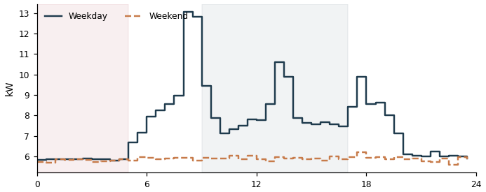

DD43710142219_5 Grid connect  Overnight 5.64 kW | Daytime 7.17 kW | Ratio 79% | Est. 61 kWh/day  Overnight power stays at 79% of this meter's own typical daytime power (best-performing similar Grid connect meters achieve about 43%). That gap works out to an estimated 61 kWh/day that could potentially be avoided if it idled down the way comparable meters do. | 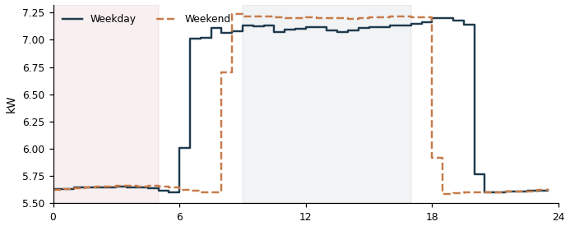

DDB3710147364_0 Grid connect  Overnight 4.34 kW | Daytime 4.88 kW | Ratio 89% | Est. 53 kWh/day  Overnight power stays at 89% of this meter's own typical daytime power (best-performing similar Grid connect meters achieve about 43%). That gap works out to an estimated 53 kWh/day that could potentially be avoided if it idled down the way comparable meters do. | 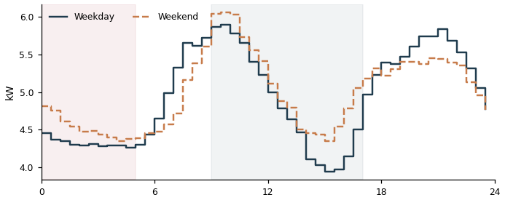

DD33710148727_2 Lighting & Power  Overnight 3.75 kW | Daytime 6.47 kW | Ratio 58% | Est. 47 kWh/day  Overnight power stays at 58% of this meter's own typical daytime power (best-performing similar Lighting & Power meters achieve about 28%). That gap works out to an estimated 47 kWh/day that could potentially be avoided if it idled down the way comparable meters do. | 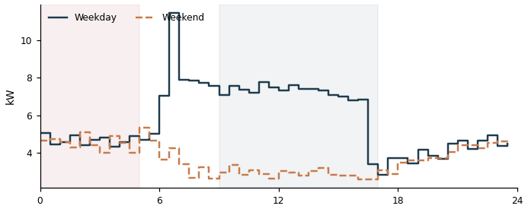

DD43710148726_0 Lighting & Power  Overnight 2.71 kW | Daytime 2.91 kW | Ratio 93% | Est. 46 kWh/day  Overnight power stays at 93% of this meter's own typical daytime power (best-performing similar Lighting & Power meters achieve about 28%). That gap works out to an estimated 46 kWh/day that could potentially be avoided if it idled down the way comparable meters do. | 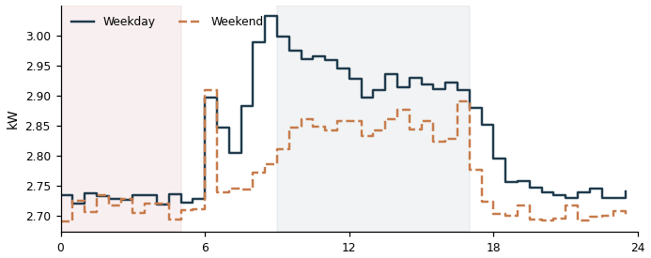

DD43710142219_4 Grid connect  Overnight 4.54 kW | Daytime 6.30 kW | Ratio 72% | Est. 43 kWh/day  Overnight power stays at 72% of this meter's own typical daytime power (best-performing similar Grid connect meters achieve about 43%). That gap works out to an estimated 43 kWh/day that could potentially be avoided if it idled down the way comparable meters do. | 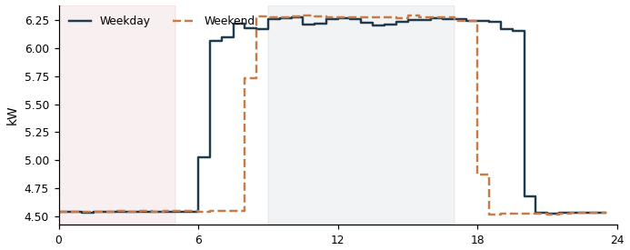

DD43710136454_5 Grid connect  Overnight 2.97 kW | Daytime 2.70 kW | Ratio 110% | Est. 43 kWh/day  Overnight power stays at 110% of this meter's own typical daytime power (best-performing similar Grid connect meters achieve about 43%). That gap works out to an estimated 43 kWh/day that could potentially be avoided if it idled down the way comparable meters do. | 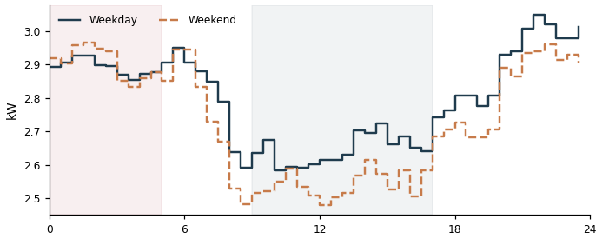

DDB3710147364_1 Grid connect  Overnight 3.67 kW | Daytime 4.37 kW | Ratio 84% | Est. 43 kWh/day  Overnight power stays at 84% of this meter's own typical daytime power (best-performing similar Grid connect meters achieve about 43%). That gap works out to an estimated 43 kWh/day that could potentially be avoided if it idled down the way comparable meters do. | 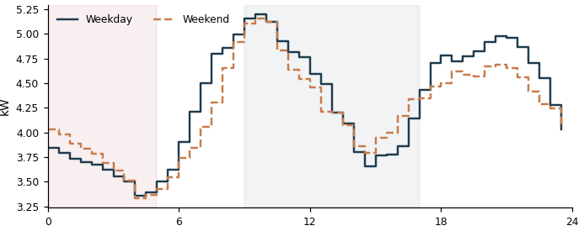

DD53710134734_3 Grid connect  Overnight 3.15 kW | Daytime 3.26 kW | Ratio 97% | Est. 42 kWh/day  Overnight power stays at 97% of this meter's own typical daytime power (best-performing similar Grid connect meters achieve about 43%). That gap works out to an estimated 42 kWh/day that could potentially be avoided if it idled down the way comparable meters do. | 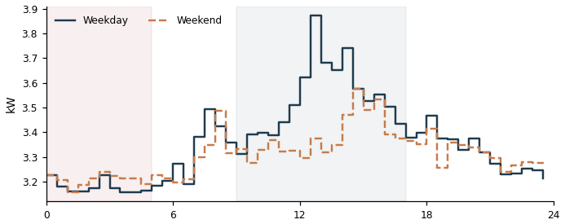

DDB3710147364_2 Grid connect  Overnight 3.59 kW | Daytime 4.60 kW | Ratio 78% | Est. 38 kWh/day  Overnight power stays at 78% of this meter's own typical daytime power (best-performing similar Grid connect meters achieve about 43%). That gap works out to an estimated 38 kWh/day that could potentially be avoided if it idled down the way comparable meters do. | 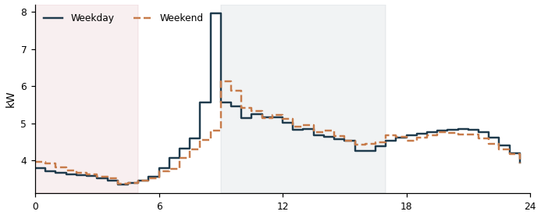

DD63710153384_3 Grid connect  Overnight 3.64 kW | Daytime 4.76 kW | Ratio 76% | Est. 38 kWh/day  Overnight power stays at 76% of this meter's own typical daytime power (best-performing similar Grid connect meters achieve about 43%). That gap works out to an estimated 38 kWh/day that could potentially be avoided if it idled down the way comparable meters do. | 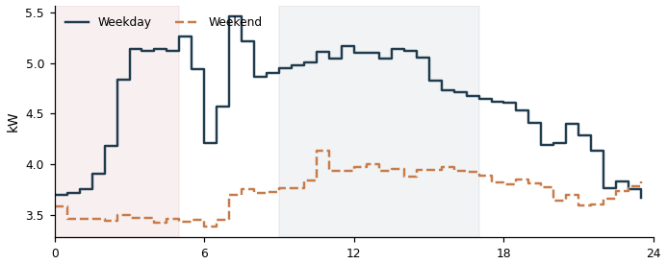

DD25335317259_1 Grid connect  Overnight 2.84 kW | Daytime 2.92 kW | Ratio 97% | Est. 38 kWh/day  Overnight power stays at 97% of this meter's own typical daytime power (best-performing similar Grid connect meters achieve about 43%). That gap works out to an estimated 38 kWh/day that could potentially be avoided if it idled down the way comparable meters do. | 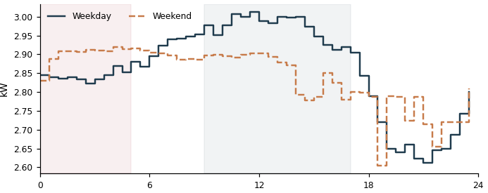

DD63710153384_5 Grid connect  Overnight 3.39 kW | Daytime 4.21 kW | Ratio 81% | Est. 38 kWh/day  Overnight power stays at 81% of this meter's own typical daytime power (best-performing similar Grid connect meters achieve about 43%). That gap works out to an estimated 38 kWh/day that could potentially be avoided if it idled down the way comparable meters do. | 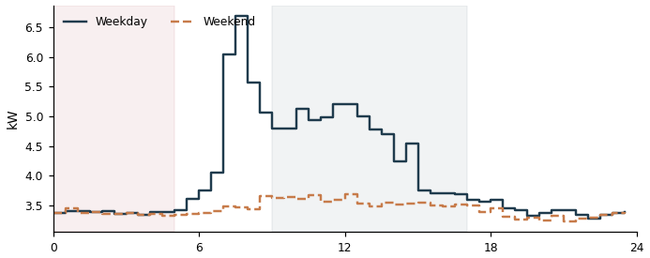

DD43710148726_1 Lighting & Power  Overnight 2.26 kW | Daytime 2.60 kW | Ratio 87% | Est. 37 kWh/day  Overnight power stays at 87% of this meter's own typical daytime power (best-performing similar Lighting & Power meters achieve about 28%). That gap works out to an estimated 37 kWh/day that could potentially be avoided if it idled down the way comparable meters do. | 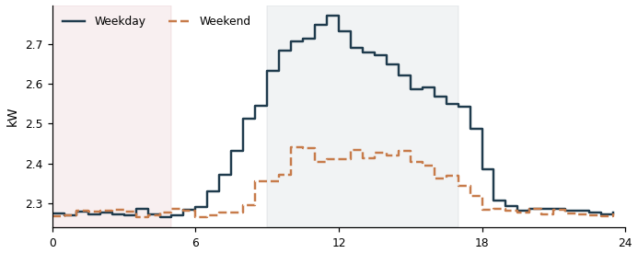

DD23710148637_1 Grid connect  Overnight 3.36 kW | Daytime 4.27 kW | Ratio 79% | Est. 36 kWh/day  Overnight power stays at 79% of this meter's own typical daytime power (best-performing similar Grid connect meters achieve about 43%). That gap works out to an estimated 36 kWh/day that could potentially be avoided if it idled down the way comparable meters do. | 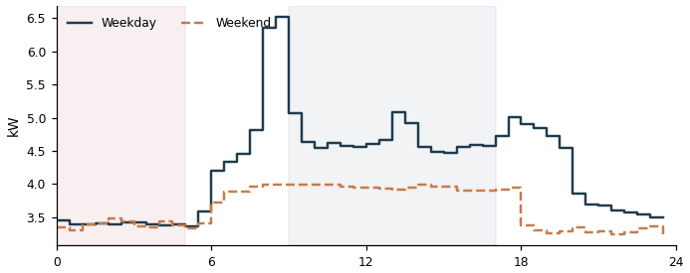

DD43710136454_3 Grid connect  Overnight 2.40 kW | Daytime 2.11 kW | Ratio 114% | Est. 36 kWh/day  Overnight power stays at 114% of this meter's own typical daytime power (best-performing similar Grid connect meters achieve about 43%). That gap works out to an estimated 36 kWh/day that could potentially be avoided if it idled down the way comparable meters do. | 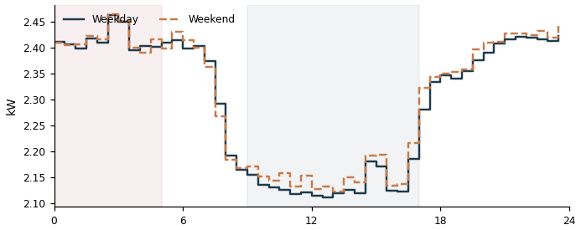

DD43710142219_3 Grid connect  Overnight 3.80 kW | Daytime 5.41 kW | Ratio 70% | Est. 35 kWh/day  Overnight power stays at 70% of this meter's own typical daytime power (best-performing similar Grid connect meters achieve about 43%). That gap works out to an estimated 35 kWh/day that could potentially be avoided if it idled down the way comparable meters do. | 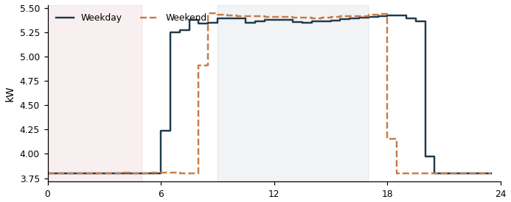

DD33710136504_1 Grid connect  Overnight 2.73 kW | Daytime 2.96 kW | Ratio 92% | Est. 35 kWh/day  Overnight power stays at 92% of this meter's own typical daytime power (best-performing similar Grid connect meters achieve about 43%). That gap works out to an estimated 35 kWh/day that could potentially be avoided if it idled down the way comparable meters do. | 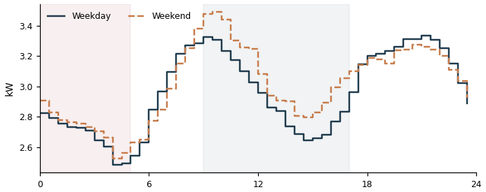

DDF3710147031_3 Lighting & Power  Overnight 1.99 kW | Daytime 2.05 kW | Ratio 97% | Est. 34 kWh/day  Overnight power stays at 97% of this meter's own typical daytime power (best-performing similar Lighting & Power meters achieve about 28%). That gap works out to an estimated 34 kWh/day that could potentially be avoided if it idled down the way comparable meters do. | 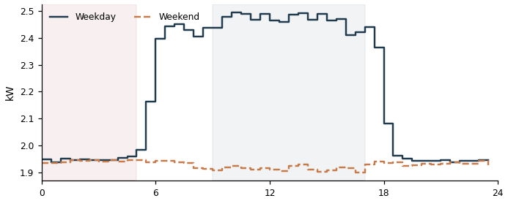

DD03710152752_2 Grid connect  Overnight 3.64 kW | Daytime 5.24 kW | Ratio 69% | Est. 33 kWh/day  Overnight power stays at 69% of this meter's own typical daytime power (best-performing similar Grid connect meters achieve about 43%). That gap works out to an estimated 33 kWh/day that could potentially be avoided if it idled down the way comparable meters do. | 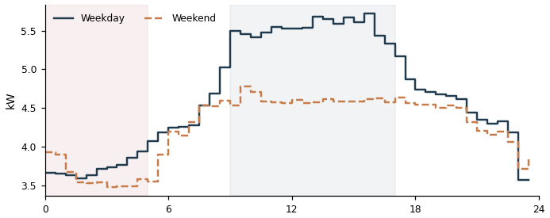

DDA3710148716_2 Air conditioning  Overnight 1.36 kW | Daytime 4.76 kW | Ratio 29% | Est. 32 kWh/day  Overnight power stays at 29% of this meter's own typical daytime power (best-performing similar Air conditioning meters achieve about 0%). That gap works out to an estimated 32 kWh/day that could potentially be avoided if it idled down the way comparable meters do. | 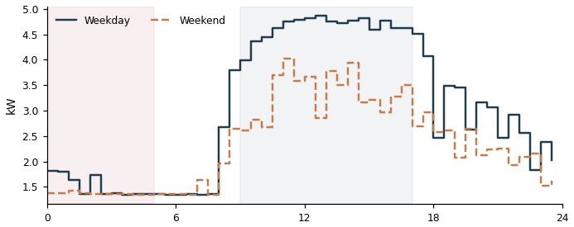

DD33710148566_0 Lighting & Power  Overnight 2.56 kW | Daytime 4.51 kW | Ratio 57% | Est. 32 kWh/day  Overnight power stays at 57% of this meter's own typical daytime power (best-performing similar Lighting & Power meters achieve about 28%). That gap works out to an estimated 32 kWh/day that could potentially be avoided if it idled down the way comparable meters do. | 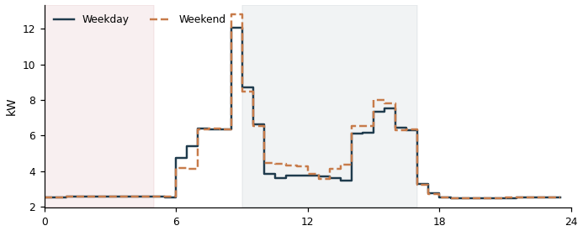

DD43710142219_1 Grid connect  Overnight 2.50 kW | Daytime 2.90 kW | Ratio 86% | Est. 30 kWh/day  Overnight power stays at 86% of this meter's own typical daytime power (best-performing similar Grid connect meters achieve about 43%). That gap works out to an estimated 30 kWh/day that could potentially be avoided if it idled down the way comparable meters do. | 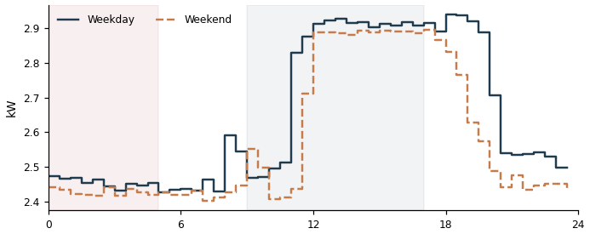

DDA3710148716_0 Air conditioning  Overnight 1.24 kW | Daytime 5.00 kW | Ratio 25% | Est. 29 kWh/day  Overnight power stays at 25% of this meter's own typical daytime power (best-performing similar Air conditioning meters achieve about 0%). That gap works out to an estimated 29 kWh/day that could potentially be avoided if it idled down the way comparable meters do. | 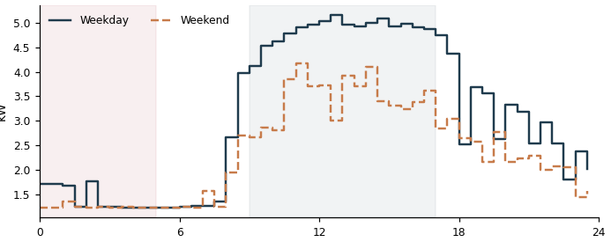

DD23710147328_0 Grid connect  Overnight 2.30 kW | Daytime 2.52 kW | Ratio 91% | Est. 29 kWh/day  Overnight power stays at 91% of this meter's own typical daytime power (best-performing similar Grid connect meters achieve about 43%). That gap works out to an estimated 29 kWh/day that could potentially be avoided if it idled down the way comparable meters do. | 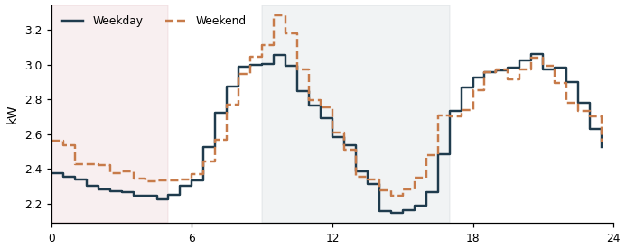

DDC3710136170_3 Air conditioning  Overnight 1.21 kW | Daytime 1.40 kW | Ratio 87% | Est. 29 kWh/day  Overnight power stays at 87% of this meter's own typical daytime power (best-performing similar Air conditioning meters achieve about 0%). That gap works out to an estimated 29 kWh/day that could potentially be avoided if it idled down the way comparable meters do. | 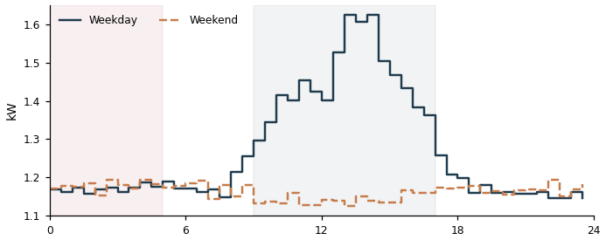

DDA3710148716_1 Air conditioning  Overnight 1.23 kW | Daytime 5.17 kW | Ratio 24% | Est. 29 kWh/day  Overnight power stays at 24% of this meter's own typical daytime power (best-performing similar Air conditioning meters achieve about 0%). That gap works out to an estimated 29 kWh/day that could potentially be avoided if it idled down the way comparable meters do. | 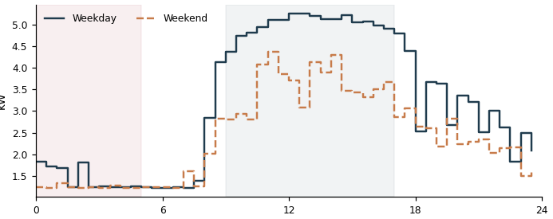

DD43710148726_2 Lighting & Power  Overnight 1.70 kW | Daytime 1.89 kW | Ratio 90% | Est. 28 kWh/day  Overnight power stays at 90% of this meter's own typical daytime power (best-performing similar Lighting & Power meters achieve about 28%). That gap works out to an estimated 28 kWh/day that could potentially be avoided if it idled down the way comparable meters do. | 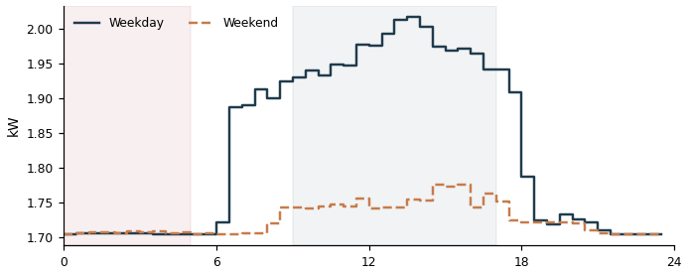

DD43710154692_1 Grid connect  Overnight 2.55 kW | Daytime 3.18 kW | Ratio 80% | Est. 28 kWh/day  Overnight power stays at 80% of this meter's own typical daytime power (best-performing similar Grid connect meters achieve about 43%). That gap works out to an estimated 28 kWh/day that could potentially be avoided if it idled down the way comparable meters do. | 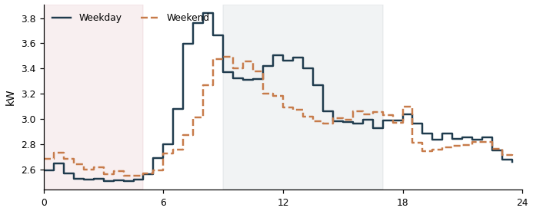

DD73710136497_0 Grid connect  Overnight 2.23 kW | Daytime 2.45 kW | Ratio 91% | Est. 28 kWh/day  Overnight power stays at 91% of this meter's own typical daytime power (best-performing similar Grid connect meters achieve about 43%). That gap works out to an estimated 28 kWh/day that could potentially be avoided if it idled down the way comparable meters do. | 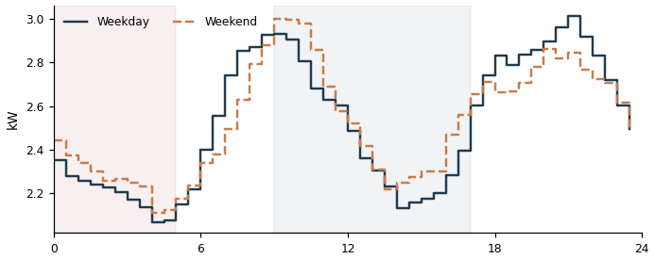

DD43710154692_0 Grid connect  Overnight 2.38 kW | Daytime 2.87 kW | Ratio 83% | Est. 27 kWh/day  Overnight power stays at 83% of this meter's own typical daytime power (best-performing similar Grid connect meters achieve about 43%). That gap works out to an estimated 27 kWh/day that could potentially be avoided if it idled down the way comparable meters do. | 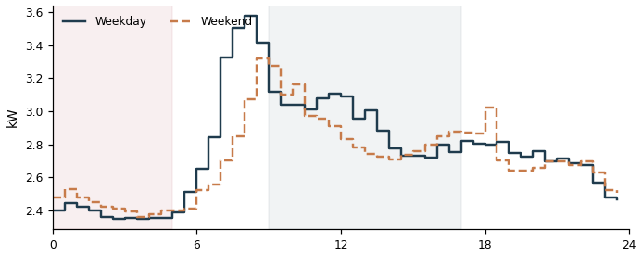

DDB3710136329_0 Grid connect  Overnight 1.14 kW | Daytime 0.06 kW | Ratio 1969% | Est. 27 kWh/day  Overnight power stays at 1969% of this meter's own typical daytime power (best-performing similar Grid connect meters achieve about 43%). That gap works out to an estimated 27 kWh/day that could potentially be avoided if it idled down the way comparable meters do. | 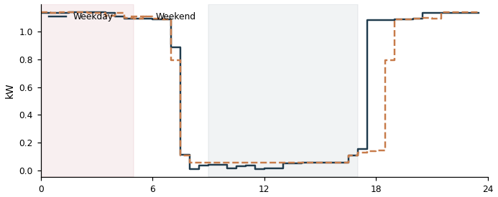

DDF3710131630_3 Grid connect  Overnight 2.44 kW | Daytime 3.19 kW | Ratio 77% | Est. 25 kWh/day  Overnight power stays at 77% of this meter's own typical daytime power (best-performing similar Grid connect meters achieve about 43%). That gap works out to an estimated 25 kWh/day that could potentially be avoided if it idled down the way comparable meters do. | 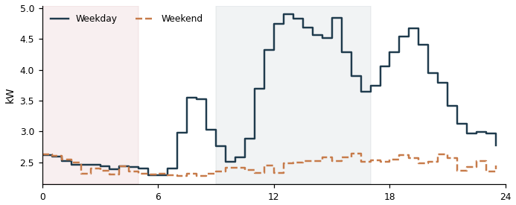

DD33710136504_0 Grid connect  Overnight 2.00 kW | Daytime 2.22 kW | Ratio 90% | Est. 25 kWh/day  Overnight power stays at 90% of this meter's own typical daytime power (best-performing similar Grid connect meters achieve about 43%). That gap works out to an estimated 25 kWh/day that could potentially be avoided if it idled down the way comparable meters do. | 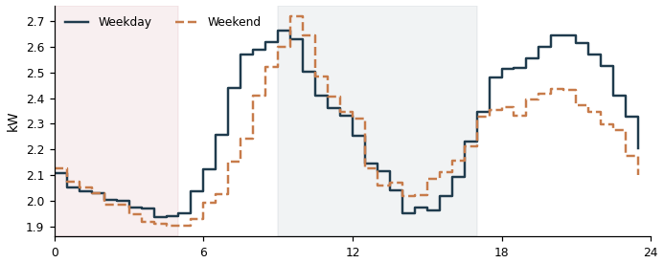

DD43710154692_2 Grid connect  Overnight 2.22 kW | Daytime 2.75 kW | Ratio 81% | Est. 25 kWh/day  Overnight power stays at 81% of this meter's own typical daytime power (best-performing similar Grid connect meters achieve about 43%). That gap works out to an estimated 25 kWh/day that could potentially be avoided if it idled down the way comparable meters do. | 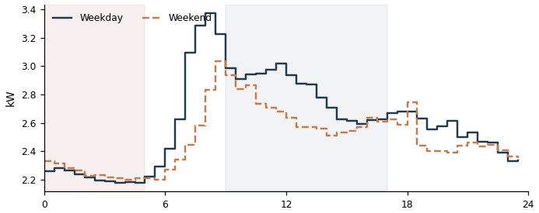

DDF3710147031_5 Lighting & Power  Overnight 1.36 kW | Daytime 1.33 kW | Ratio 102% | Est. 24 kWh/day  Overnight power stays at 102% of this meter's own typical daytime power (best-performing similar Lighting & Power meters achieve about 28%). That gap works out to an estimated 24 kWh/day that could potentially be avoided if it idled down the way comparable meters do. | 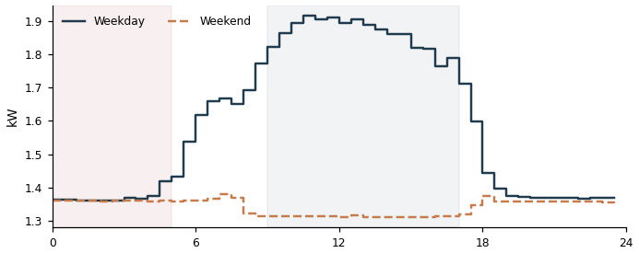

DD63710152870_0 Grid connect  Overnight 1.76 kW | Daytime 1.81 kW | Ratio 97% | Est. 23 kWh/day  Overnight power stays at 97% of this meter's own typical daytime power (best-performing similar Grid connect meters achieve about 43%). That gap works out to an estimated 23 kWh/day that could potentially be avoided if it idled down the way comparable meters do. | 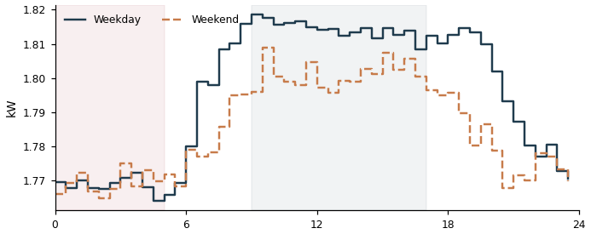

DD63710153384_0 Grid connect  Overnight 1.94 kW | Daytime 2.25 kW | Ratio 86% | Est. 23 kWh/day  Overnight power stays at 86% of this meter's own typical daytime power (best-performing similar Grid connect meters achieve about 43%). That gap works out to an estimated 23 kWh/day that could potentially be avoided if it idled down the way comparable meters do. | 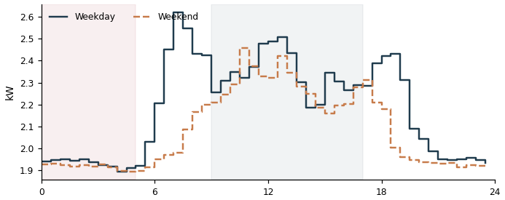

DD73710136497_1 Grid connect  Overnight 1.91 kW | Daytime 2.21 kW | Ratio 87% | Est. 23 kWh/day  Overnight power stays at 87% of this meter's own typical daytime power (best-performing similar Grid connect meters achieve about 43%). That gap works out to an estimated 23 kWh/day that could potentially be avoided if it idled down the way comparable meters do. | 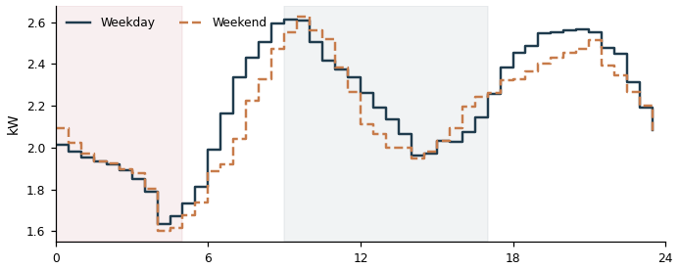

DD63710153384_4 Grid connect  Overnight 2.31 kW | Daytime 3.18 kW | Ratio 73% | Est. 22 kWh/day  Overnight power stays at 73% of this meter's own typical daytime power (best-performing similar Grid connect meters achieve about 43%). That gap works out to an estimated 22 kWh/day that could potentially be avoided if it idled down the way comparable meters do. | 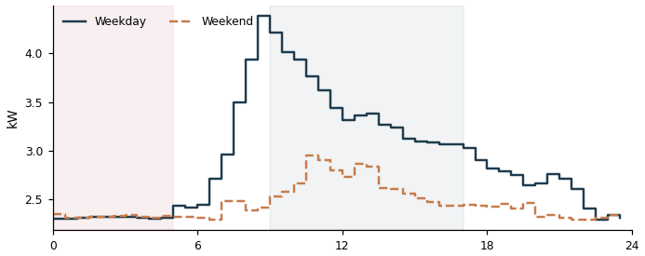

DDF3710131630_4 Grid connect  Overnight 2.13 kW | Daytime 2.81 kW | Ratio 76% | Est. 22 kWh/day  Overnight power stays at 76% of this meter's own typical daytime power (best-performing similar Grid connect meters achieve about 43%). That gap works out to an estimated 22 kWh/day that could potentially be avoided if it idled down the way comparable meters do. | 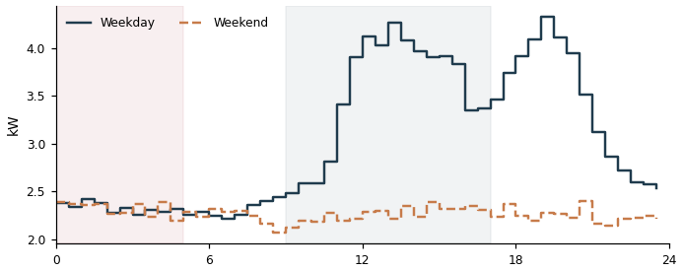

DD63710153384_1 Grid connect  Overnight 2.05 kW | Daytime 2.65 kW | Ratio 78% | Est. 22 kWh/day  Overnight power stays at 78% of this meter's own typical daytime power (best-performing similar Grid connect meters achieve about 43%). That gap works out to an estimated 22 kWh/day that could potentially be avoided if it idled down the way comparable meters do. | 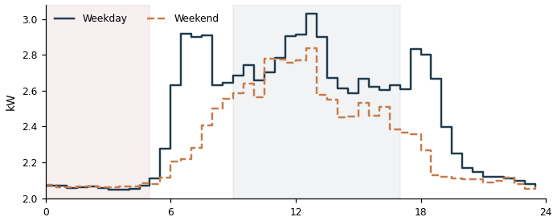

DD43710136454_4 Grid connect  Overnight 1.32 kW | Daytime 0.97 kW | Ratio 137% | Est. 22 kWh/day  Overnight power stays at 137% of this meter's own typical daytime power (best-performing similar Grid connect meters achieve about 43%). That gap works out to an estimated 22 kWh/day that could potentially be avoided if it idled down the way comparable meters do. | 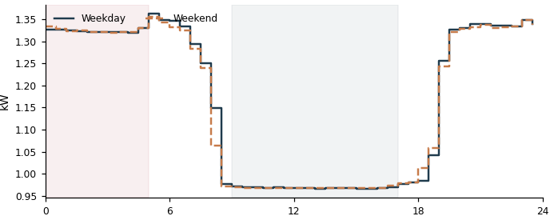

DD73710136497_2 Grid connect  Overnight 1.91 kW | Daytime 2.37 kW | Ratio 81% | Est. 21 kWh/day  Overnight power stays at 81% of this meter's own typical daytime power (best-performing similar Grid connect meters achieve about 43%). That gap works out to an estimated 21 kWh/day that could potentially be avoided if it idled down the way comparable meters do. | 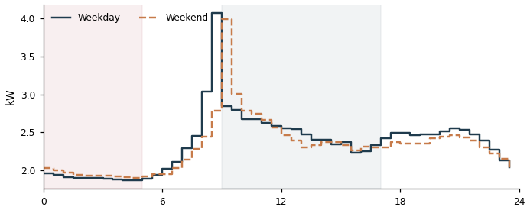

DD43710136402_1 Grid connect  Overnight 1.65 kW | Daytime 1.77 kW | Ratio 93% | Est. 21 kWh/day  Overnight power stays at 93% of this meter's own typical daytime power (best-performing similar Grid connect meters achieve about 43%). That gap works out to an estimated 21 kWh/day that could potentially be avoided if it idled down the way comparable meters do. | 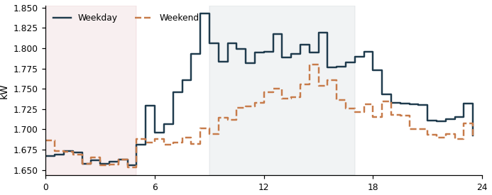

DD23710147328_1 Grid connect  Overnight 1.68 kW | Daytime 1.95 kW | Ratio 86% | Est. 20 kWh/day  Overnight power stays at 86% of this meter's own typical daytime power (best-performing similar Grid connect meters achieve about 43%). That gap works out to an estimated 20 kWh/day that could potentially be avoided if it idled down the way comparable meters do. | 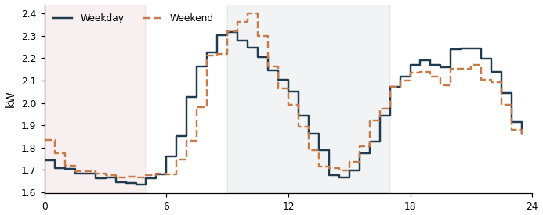

DD63710152870_2 Grid connect  Overnight 1.52 kW | Daytime 1.63 kW | Ratio 93% | Est. 20 kWh/day  Overnight power stays at 93% of this meter's own typical daytime power (best-performing similar Grid connect meters achieve about 43%). That gap works out to an estimated 20 kWh/day that could potentially be avoided if it idled down the way comparable meters do. | 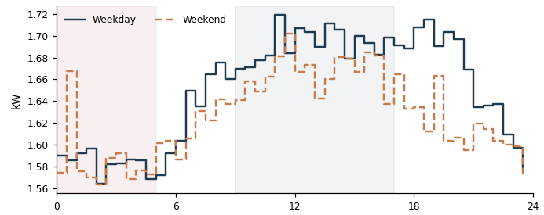

DD23710147328_2 Grid connect  Overnight 1.77 kW | Daytime 2.22 kW | Ratio 80% | Est. 19 kWh/day  Overnight power stays at 80% of this meter's own typical daytime power (best-performing similar Grid connect meters achieve about 43%). That gap works out to an estimated 19 kWh/day that could potentially be avoided if it idled down the way comparable meters do. | 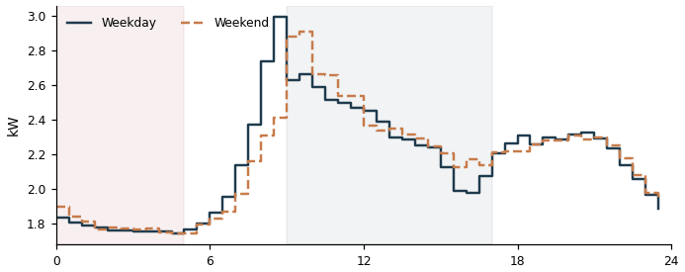

DDF3710131630_2 Grid connect  Overnight 1.61 kW | Daytime 1.89 kW | Ratio 85% | Est. 19 kWh/day  Overnight power stays at 85% of this meter's own typical daytime power (best-performing similar Grid connect meters achieve about 43%). That gap works out to an estimated 19 kWh/day that could potentially be avoided if it idled down the way comparable meters do. | 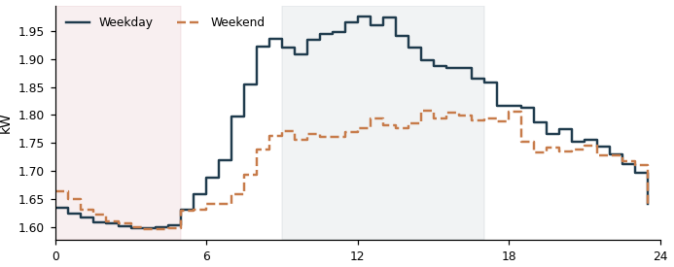

DDF3710131630_0 Grid connect  Overnight 1.65 kW | Daytime 2.08 kW | Ratio 79% | Est. 18 kWh/day  Overnight power stays at 79% of this meter's own typical daytime power (best-performing similar Grid connect meters achieve about 43%). That gap works out to an estimated 18 kWh/day that could potentially be avoided if it idled down the way comparable meters do. | 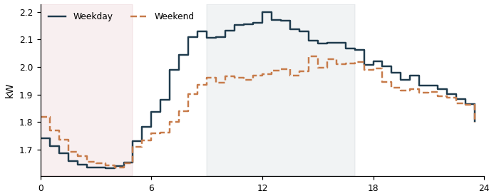

DDF3710147031_4 Lighting & Power  Overnight 1.00 kW | Daytime 0.98 kW | Ratio 101% | Est. 17 kWh/day  Overnight power stays at 101% of this meter's own typical daytime power (best-performing similar Lighting & Power meters achieve about 28%). That gap works out to an estimated 17 kWh/day that could potentially be avoided if it idled down the way comparable meters do. | 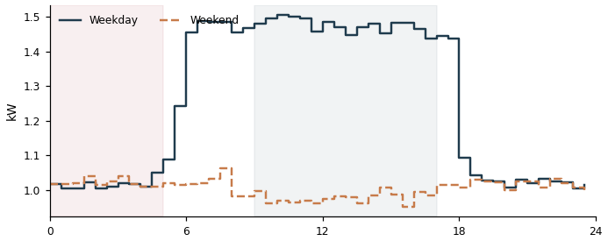

DD33710136504_2 Grid connect  Overnight 1.44 kW | Daytime 1.77 kW | Ratio 81% | Est. 16 kWh/day  Overnight power stays at 81% of this meter's own typical daytime power (best-performing similar Grid connect meters achieve about 43%). That gap works out to an estimated 16 kWh/day that could potentially be avoided if it idled down the way comparable meters do. | 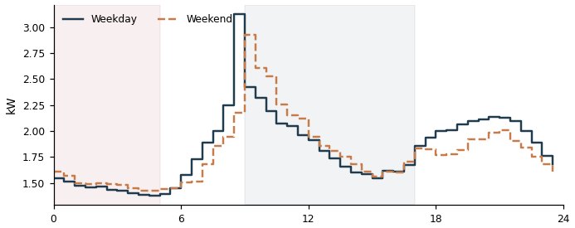

DDB3710148383_0 Grid connect  Overnight 1.16 kW | Daytime 1.13 kW | Ratio 103% | Est. 16 kWh/day  Overnight power stays at 103% of this meter's own typical daytime power (best-performing similar Grid connect meters achieve about 43%). That gap works out to an estimated 16 kWh/day that could potentially be avoided if it idled down the way comparable meters do. | 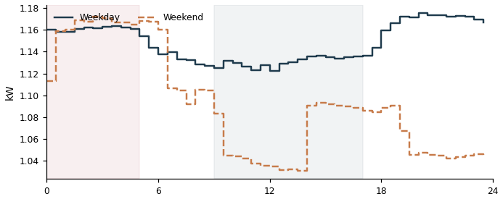

DD53710136492_2 Grid connect  Overnight 1.42 kW | Daytime 1.80 kW | Ratio 79% | Est. 15 kWh/day  Overnight power stays at 79% of this meter's own typical daytime power (best-performing similar Grid connect meters achieve about 43%). That gap works out to an estimated 15 kWh/day that could potentially be avoided if it idled down the way comparable meters do. | 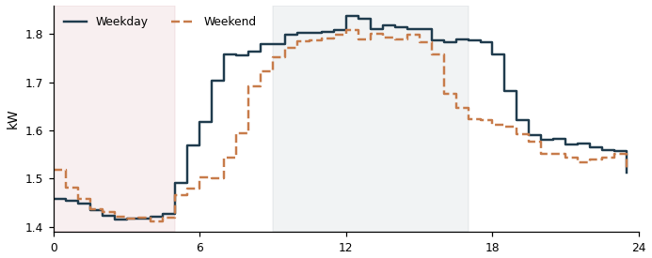

DD43710154692_4 Grid connect  Overnight 1.09 kW | Daytime 1.09 kW | Ratio 99% | Est. 15 kWh/day  Overnight power stays at 99% of this meter's own typical daytime power (best-performing similar Grid connect meters achieve about 43%). That gap works out to an estimated 15 kWh/day that could potentially be avoided if it idled down the way comparable meters do. | 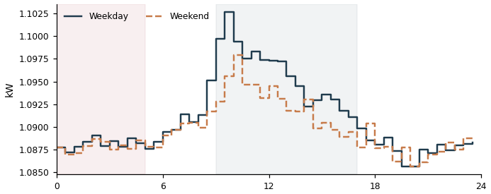

DD53710134734_4 Grid connect  Overnight 1.23 kW | Daytime 1.44 kW | Ratio 85% | Est. 14 kWh/day  Overnight power stays at 85% of this meter's own typical daytime power (best-performing similar Grid connect meters achieve about 43%). That gap works out to an estimated 14 kWh/day that could potentially be avoided if it idled down the way comparable meters do. | 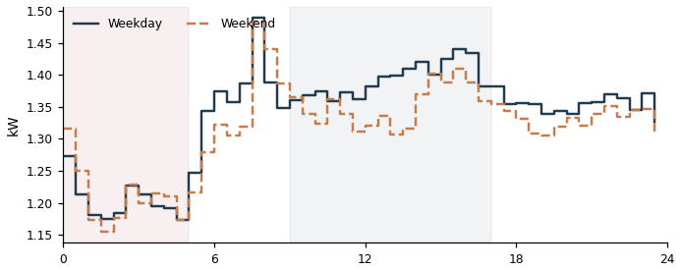

DD73710136266_0 Air conditioning  Overnight 0.59 kW | Daytime 1.66 kW | Ratio 35% | Est. 14 kWh/day  Overnight power stays at 35% of this meter's own typical daytime power (best-performing similar Air conditioning meters achieve about 0%). That gap works out to an estimated 14 kWh/day that could potentially be avoided if it idled down the way comparable meters do. | 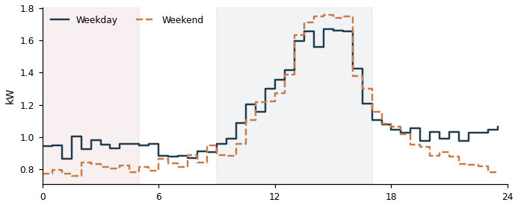

DD63710152870_1 Grid connect  Overnight 0.99 kW | Daytime 0.98 kW | Ratio 101% | Est. 14 kWh/day  Overnight power stays at 101% of this meter's own typical daytime power (best-performing similar Grid connect meters achieve about 43%). That gap works out to an estimated 14 kWh/day that could potentially be avoided if it idled down the way comparable meters do. | 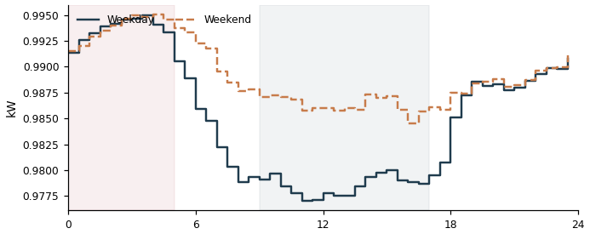

DD63710153384_2 Grid connect  Overnight 1.53 kW | Daytime 2.29 kW | Ratio 67% | Est. 13 kWh/day  Overnight power stays at 67% of this meter's own typical daytime power (best-performing similar Grid connect meters achieve about 43%). That gap works out to an estimated 13 kWh/day that could potentially be avoided if it idled down the way comparable meters do. | 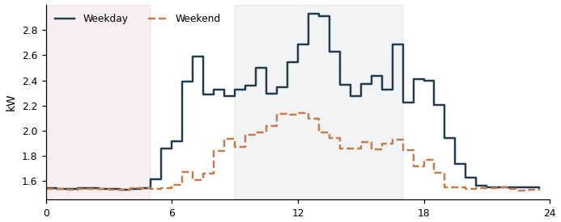

DD73710136266_2 Air conditioning  Overnight 0.54 kW | Daytime 1.35 kW | Ratio 40% | Est. 13 kWh/day  Overnight power stays at 40% of this meter's own typical daytime power (best-performing similar Air conditioning meters achieve about 0%). That gap works out to an estimated 13 kWh/day that could potentially be avoided if it idled down the way comparable meters do. | 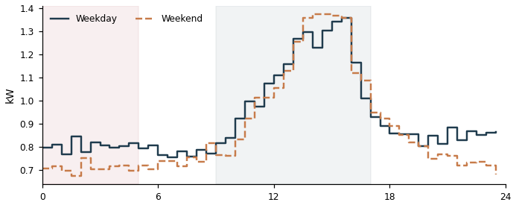

DDB3710141068_1 Lighting & Power  Overnight 0.98 kW | Daytime 1.67 kW | Ratio 59% | Est. 12 kWh/day  Overnight power stays at 59% of this meter's own typical daytime power (best-performing similar Lighting & Power meters achieve about 28%). That gap works out to an estimated 12 kWh/day that could potentially be avoided if it idled down the way comparable meters do. | 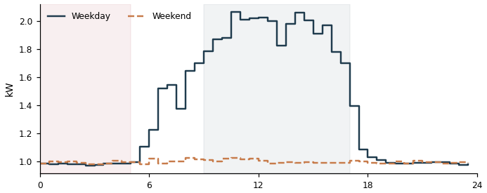

DD73710136266_1 Air conditioning  Overnight 0.52 kW | Daytime 1.36 kW | Ratio 38% | Est. 12 kWh/day  Overnight power stays at 38% of this meter's own typical daytime power (best-performing similar Air conditioning meters achieve about 0%). That gap works out to an estimated 12 kWh/day that could potentially be avoided if it idled down the way comparable meters do. | 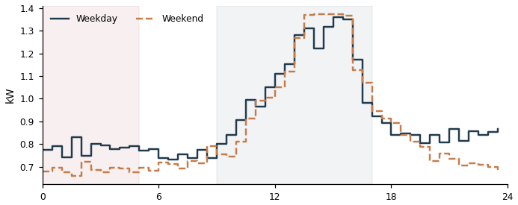

DD53710134734_5 Grid connect  Overnight 1.01 kW | Daytime 1.15 kW | Ratio 87% | Est. 12 kWh/day  Overnight power stays at 87% of this meter's own typical daytime power (best-performing similar Grid connect meters achieve about 43%). That gap works out to an estimated 12 kWh/day that could potentially be avoided if it idled down the way comparable meters do. | 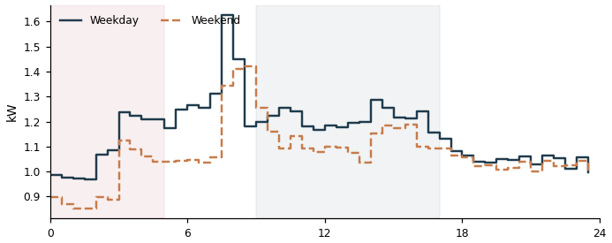

DD83710147339_2 Air conditioning  Overnight 0.50 kW | Daytime 3.79 kW | Ratio 13% | Est. 12 kWh/day  Overnight power stays at 13% of this meter's own typical daytime power (best-performing similar Air conditioning meters achieve about 0%). That gap works out to an estimated 12 kWh/day that could potentially be avoided if it idled down the way comparable meters do. | 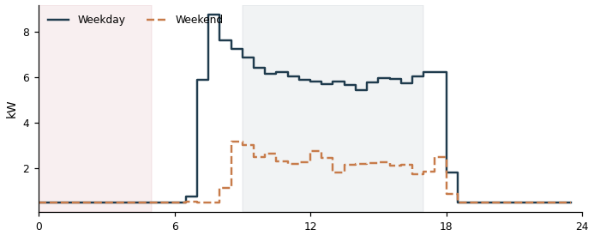

DD43710136402_2 Grid connect  Overnight 0.94 kW | Daytime 1.12 kW | Ratio 84% | Est. 11 kWh/day  Overnight power stays at 84% of this meter's own typical daytime power (best-performing similar Grid connect meters achieve about 43%). That gap works out to an estimated 11 kWh/day that could potentially be avoided if it idled down the way comparable meters do. | 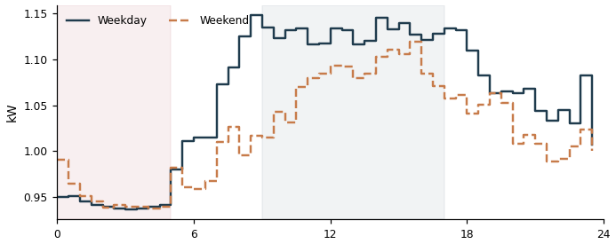

DD25335317259_2 Grid connect  Overnight 0.85 kW | Daytime 0.94 kW | Ratio 90% | Est. 10 kWh/day  Overnight power stays at 90% of this meter's own typical daytime power (best-performing similar Grid connect meters achieve about 43%). That gap works out to an estimated 10 kWh/day that could potentially be avoided if it idled down the way comparable meters do. | 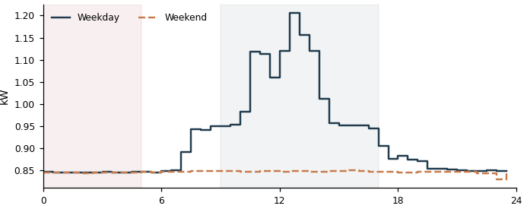

DD33710147083_0 Air conditioning  Overnight 0.45 kW | Daytime 5.16 kW | Ratio 9% | Est. 10 kWh/day  Overnight power stays at 9% of this meter's own typical daytime power (best-performing similar Air conditioning meters achieve about 0%). That gap works out to an estimated 10 kWh/day that could potentially be avoided if it idled down the way comparable meters do. | 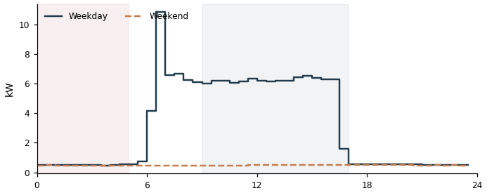

DD23710148637_2 Grid connect  Overnight 0.96 kW | Daytime 1.30 kW | Ratio 74% | Est. 10 kWh/day  Overnight power stays at 74% of this meter's own typical daytime power (best-performing similar Grid connect meters achieve about 43%). That gap works out to an estimated 10 kWh/day that could potentially be avoided if it idled down the way comparable meters do. | 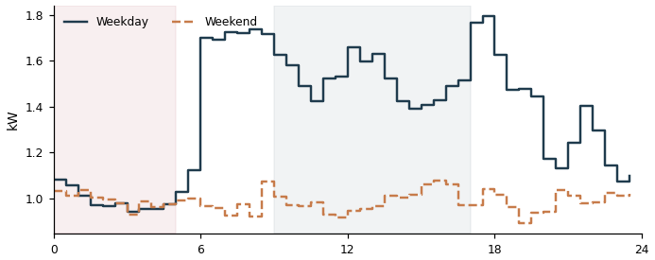

DDF3710131630_1 Grid connect  Overnight 1.16 kW | Daytime 1.75 kW | Ratio 66% | Est. 9 kWh/day  Overnight power stays at 66% of this meter's own typical daytime power (best-performing similar Grid connect meters achieve about 43%). That gap works out to an estimated 9 kWh/day that could potentially be avoided if it idled down the way comparable meters do. | 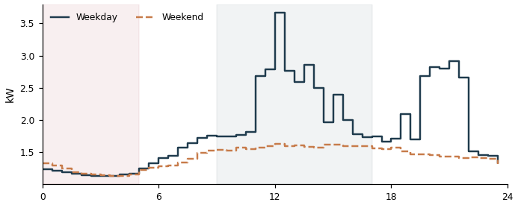

DD63710136344_4 Grid connect  Overnight 0.69 kW | Daytime 0.69 kW | Ratio 101% | Est. 9 kWh/day  Overnight power stays at 101% of this meter's own typical daytime power (best-performing similar Grid connect meters achieve about 43%). That gap works out to an estimated 9 kWh/day that could potentially be avoided if it idled down the way comparable meters do. | 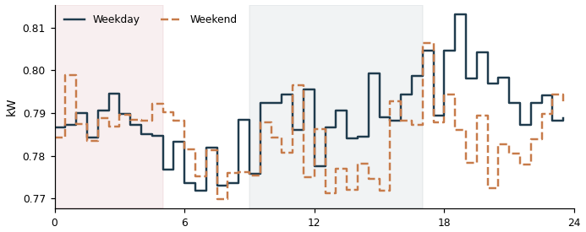

DD63710136344_3 Grid connect  Overnight 0.67 kW | Daytime 0.73 kW | Ratio 93% | Est. 9 kWh/day  Overnight power stays at 93% of this meter's own typical daytime power (best-performing similar Grid connect meters achieve about 43%). That gap works out to an estimated 9 kWh/day that could potentially be avoided if it idled down the way comparable meters do. | 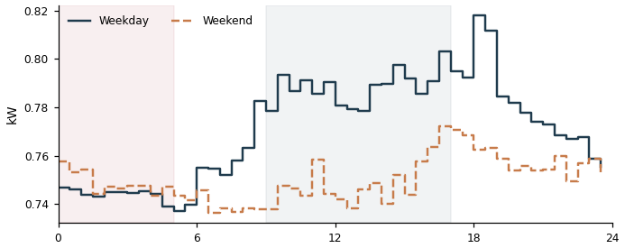

DD53710136492_0 Grid connect  Overnight 0.98 kW | Daytime 1.45 kW | Ratio 68% | Est. 8 kWh/day  Overnight power stays at 68% of this meter's own typical daytime power (best-performing similar Grid connect meters achieve about 43%). That gap works out to an estimated 8 kWh/day that could potentially be avoided if it idled down the way comparable meters do. | 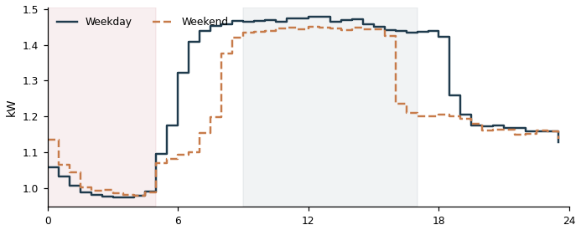

DD83710131752_3 Grid connect  Overnight 0.55 kW | Daytime 0.55 kW | Ratio 100% | Est. 7 kWh/day  Overnight power stays at 100% of this meter's own typical daytime power (best-performing similar Grid connect meters achieve about 43%). That gap works out to an estimated 7 kWh/day that could potentially be avoided if it idled down the way comparable meters do. | 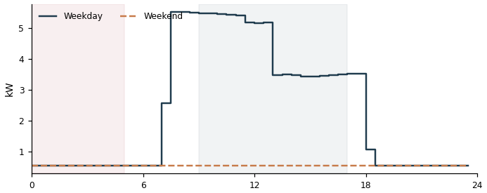

DD83710147339_1 Air conditioning  Overnight 0.27 kW | Daytime 3.24 kW | Ratio 8% | Est. 6 kWh/day  Overnight power stays at 8% of this meter's own typical daytime power (best-performing similar Air conditioning meters achieve about 0%). That gap works out to an estimated 6 kWh/day that could potentially be avoided if it idled down the way comparable meters do. | 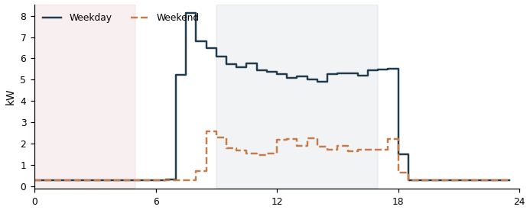

DDD3710149679_1 Grid connect  Overnight 0.52 kW | Daytime 0.65 kW | Ratio 81% | Est. 6 kWh/day  Overnight power stays at 81% of this meter's own typical daytime power (best-performing similar Grid connect meters achieve about 43%). That gap works out to an estimated 6 kWh/day that could potentially be avoided if it idled down the way comparable meters do. | 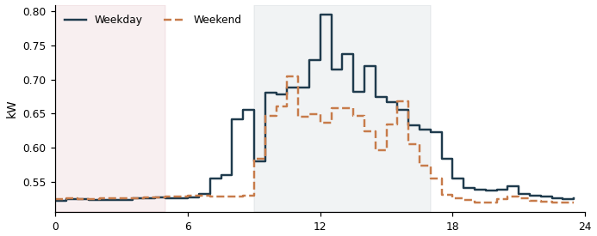

DD63710136344_0 Grid connect  Overnight 0.44 kW | Daytime 0.47 kW | Ratio 93% | Est. 6 kWh/day  Overnight power stays at 93% of this meter's own typical daytime power (best-performing similar Grid connect meters achieve about 43%). That gap works out to an estimated 6 kWh/day that could potentially be avoided if it idled down the way comparable meters do. | 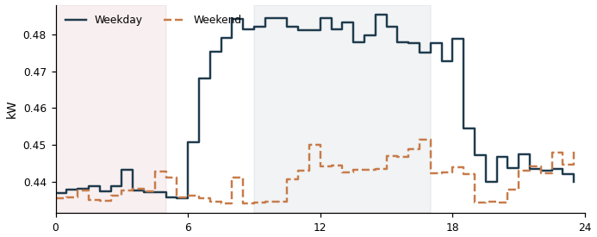

DD43710154692_3 Grid connect  Overnight 0.41 kW | Daytime 0.45 kW | Ratio 89% | Est. 5 kWh/day  Overnight power stays at 89% of this meter's own typical daytime power (best-performing similar Grid connect meters achieve about 43%). That gap works out to an estimated 5 kWh/day that could potentially be avoided if it idled down the way comparable meters do. | 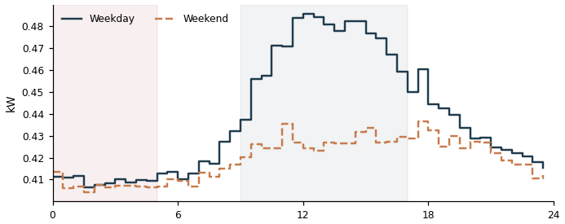

DD03710131908_5 Grid connect  Overnight 0.43 kW | Daytime 0.54 kW | Ratio 81% | Est. 5 kWh/day  Overnight power stays at 81% of this meter's own typical daytime power (best-performing similar Grid connect meters achieve about 43%). That gap works out to an estimated 5 kWh/day that could potentially be avoided if it idled down the way comparable meters do. | 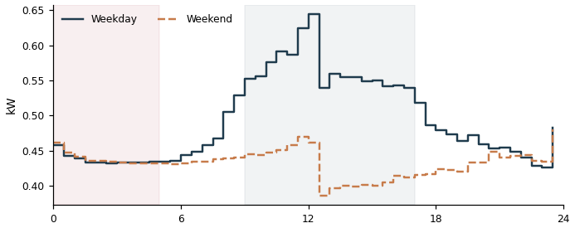

DDC3710151033_5 Grid connect  Overnight 0.38 kW | Daytime 0.43 kW | Ratio 89% | Est. 5 kWh/day  Overnight power stays at 89% of this meter's own typical daytime power (best-performing similar Grid connect meters achieve about 43%). That gap works out to an estimated 5 kWh/day that could potentially be avoided if it idled down the way comparable meters do. | 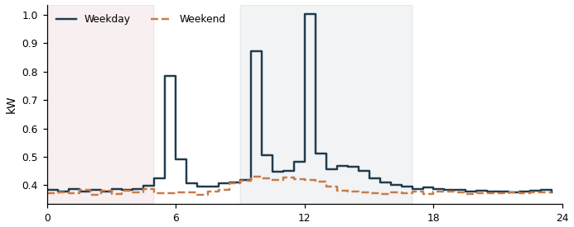

DDE3710136072_0 Air conditioning  Overnight 0.18 kW | Daytime 0.55 kW | Ratio 34% | Est. 4 kWh/day  Overnight power stays at 34% of this meter's own typical daytime power (best-performing similar Air conditioning meters achieve about 0%). That gap works out to an estimated 4 kWh/day that could potentially be avoided if it idled down the way comparable meters do. | 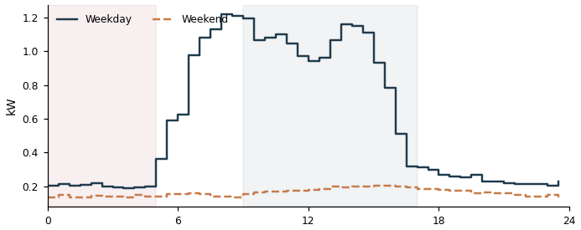

DD03710131908_4 Grid connect  Overnight 0.34 kW | Daytime 0.37 kW | Ratio 91% | Est. 4 kWh/day  Overnight power stays at 91% of this meter's own typical daytime power (best-performing similar Grid connect meters achieve about 43%). That gap works out to an estimated 4 kWh/day that could potentially be avoided if it idled down the way comparable meters do. | 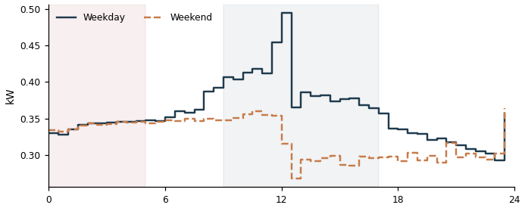

DD83710151237_3 Air conditioning  Overnight 0.16 kW | Daytime 0.29 kW | Ratio 57% | Est. 4 kWh/day  Overnight power stays at 57% of this meter's own typical daytime power (best-performing similar Air conditioning meters achieve about 0%). That gap works out to an estimated 4 kWh/day that could potentially be avoided if it idled down the way comparable meters do. | 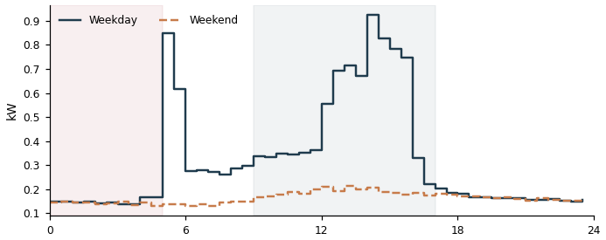

DD63710136344_1 Grid connect  Overnight 0.26 kW | Daytime 0.26 kW | Ratio 101% | Est. 4 kWh/day  Overnight power stays at 101% of this meter's own typical daytime power (best-performing similar Grid connect meters achieve about 43%). That gap works out to an estimated 4 kWh/day that could potentially be avoided if it idled down the way comparable meters do. | 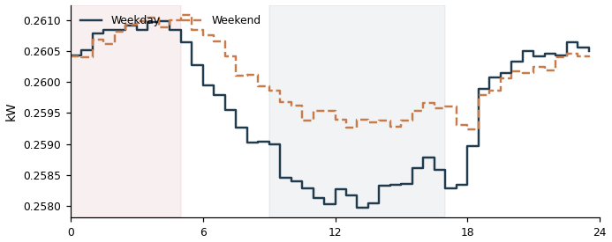

DD03710131908_0 Grid connect  Overnight 0.27 kW | Daytime 0.29 kW | Ratio 93% | Est. 4 kWh/day  Overnight power stays at 93% of this meter's own typical daytime power (best-performing similar Grid connect meters achieve about 43%). That gap works out to an estimated 4 kWh/day that could potentially be avoided if it idled down the way comparable meters do. | 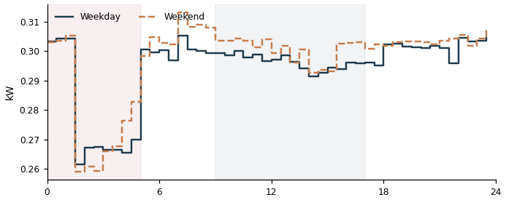

DD33710161970_0 Grid connect  Overnight 0.26 kW | Daytime 0.25 kW | Ratio 101% | Est. 3 kWh/day  Overnight power stays at 101% of this meter's own typical daytime power (best-performing similar Grid connect meters achieve about 43%). That gap works out to an estimated 3 kWh/day that could potentially be avoided if it idled down the way comparable meters do. | 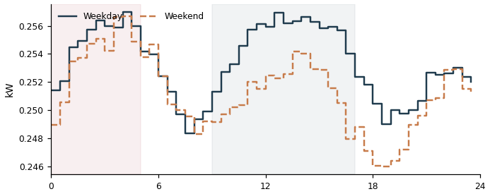

DD43710136454_2 Grid connect  Overnight 0.29 kW | Daytime 0.34 kW | Ratio 84% | Est. 3 kWh/day  Overnight power stays at 84% of this meter's own typical daytime power (best-performing similar Grid connect meters achieve about 43%). That gap works out to an estimated 3 kWh/day that could potentially be avoided if it idled down the way comparable meters do. | 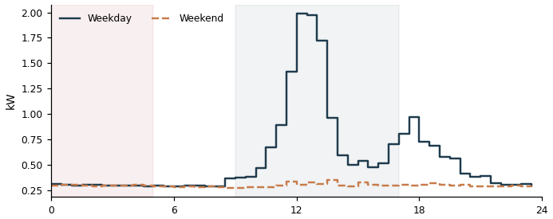

DD03710131908_3 Grid connect  Overnight 0.25 kW | Daytime 0.26 kW | Ratio 96% | Est. 3 kWh/day  Overnight power stays at 96% of this meter's own typical daytime power (best-performing similar Grid connect meters achieve about 43%). That gap works out to an estimated 3 kWh/day that could potentially be avoided if it idled down the way comparable meters do. | 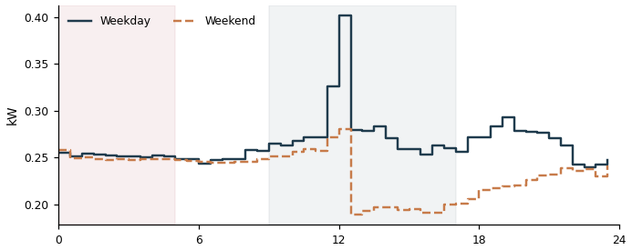

DD43710150291_3 Grid connect  Overnight 0.24 kW | Daytime 0.25 kW | Ratio 99% | Est. 3 kWh/day  Overnight power stays at 99% of this meter's own typical daytime power (best-performing similar Grid connect meters achieve about 43%). That gap works out to an estimated 3 kWh/day that could potentially be avoided if it idled down the way comparable meters do. | 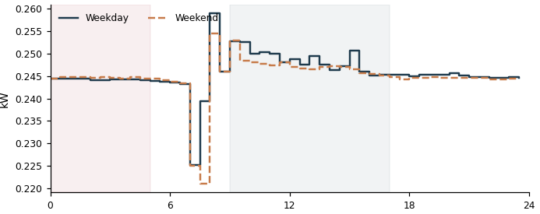

DD03710152752_3 Grid connect  Overnight 0.32 kW | Daytime 0.44 kW | Ratio 73% | Est. 3 kWh/day  Overnight power stays at 73% of this meter's own typical daytime power (best-performing similar Grid connect meters achieve about 43%). That gap works out to an estimated 3 kWh/day that could potentially be avoided if it idled down the way comparable meters do. | 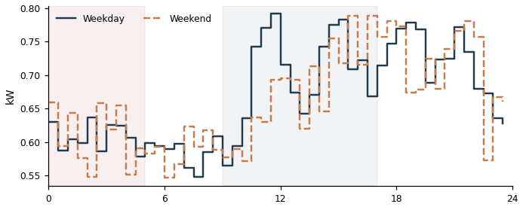

DDB3710136329_1 Grid connect  Overnight 0.23 kW | Daytime 0.23 kW | Ratio 100% | Est. 3 kWh/day  Overnight power stays at 100% of this meter's own typical daytime power (best-performing similar Grid connect meters achieve about 43%). That gap works out to an estimated 3 kWh/day that could potentially be avoided if it idled down the way comparable meters do. | 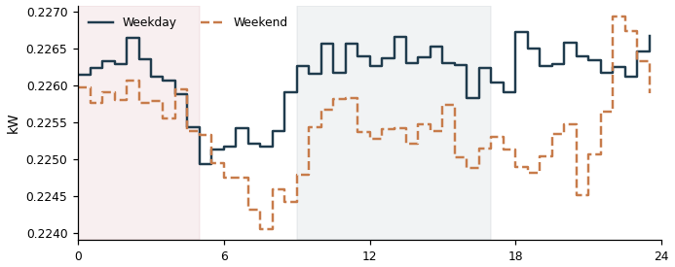

DD33710161970_1 Grid connect  Overnight 0.20 kW | Daytime 0.20 kW | Ratio 101% | Est. 3 kWh/day  Overnight power stays at 101% of this meter's own typical daytime power (best-performing similar Grid connect meters achieve about 43%). That gap works out to an estimated 3 kWh/day that could potentially be avoided if it idled down the way comparable meters do. | 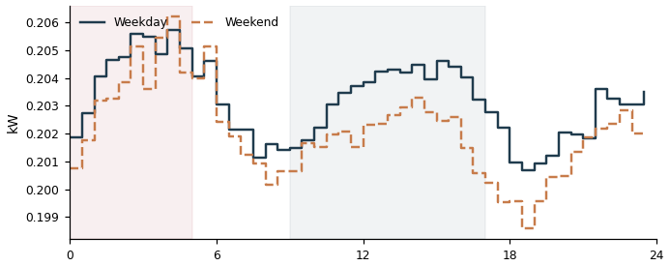

DDC3710136355_1 Grid connect  Overnight 0.20 kW | Daytime 0.21 kW | Ratio 99% | Est. 3 kWh/day  Overnight power stays at 99% of this meter's own typical daytime power (best-performing similar Grid connect meters achieve about 43%). That gap works out to an estimated 3 kWh/day that could potentially be avoided if it idled down the way comparable meters do. | 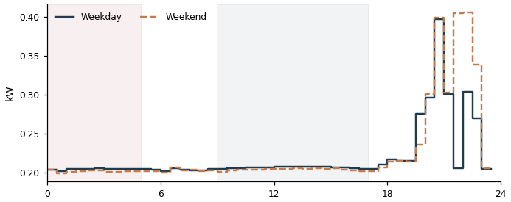

DDE3710147026_3 Air conditioning  Overnight 0.12 kW | Daytime 0.20 kW | Ratio 59% | Est. 3 kWh/day  Overnight power stays at 59% of this meter's own typical daytime power (best-performing similar Air conditioning meters achieve about 0%). That gap works out to an estimated 3 kWh/day that could potentially be avoided if it idled down the way comparable meters do. | 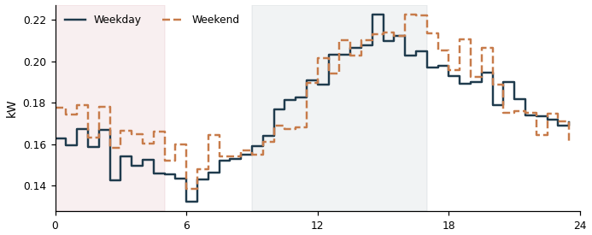

DDB3710148383_2 Grid connect  Overnight 0.20 kW | Daytime 0.21 kW | Ratio 94% | Est. 3 kWh/day  Overnight power stays at 94% of this meter's own typical daytime power (best-performing similar Grid connect meters achieve about 43%). That gap works out to an estimated 3 kWh/day that could potentially be avoided if it idled down the way comparable meters do. | 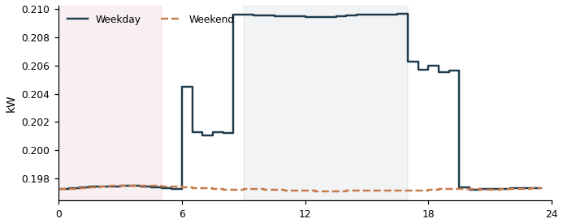

DD83710147339_0 Air conditioning  Overnight 0.12 kW | Daytime 3.24 kW | Ratio 4% | Est. 3 kWh/day  Overnight power stays at 4% of this meter's own typical daytime power (best-performing similar Air conditioning meters achieve about 0%). That gap works out to an estimated 3 kWh/day that could potentially be avoided if it idled down the way comparable meters do. | 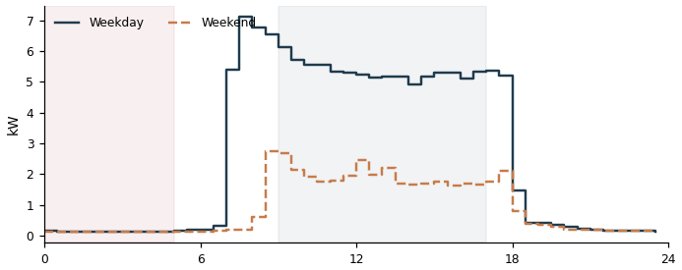

DD43710133558_2 Grid connect  Overnight 0.23 kW | Daytime 0.30 kW | Ratio 76% | Est. 2 kWh/day  Overnight power stays at 76% of this meter's own typical daytime power (best-performing similar Grid connect meters achieve about 43%). That gap works out to an estimated 2 kWh/day that could potentially be avoided if it idled down the way comparable meters do. | 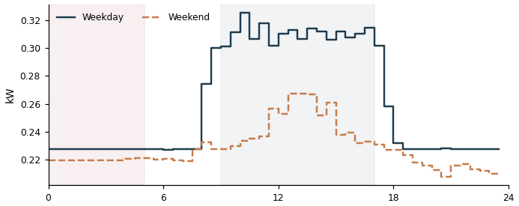

DD23710134143_1 Air conditioning  Overnight 0.08 kW | Daytime 0.11 kW | Ratio 75% | Est. 2 kWh/day  Overnight power stays at 75% of this meter's own typical daytime power (best-performing similar Air conditioning meters achieve about 0%). That gap works out to an estimated 2 kWh/day that could potentially be avoided if it idled down the way comparable meters do. | 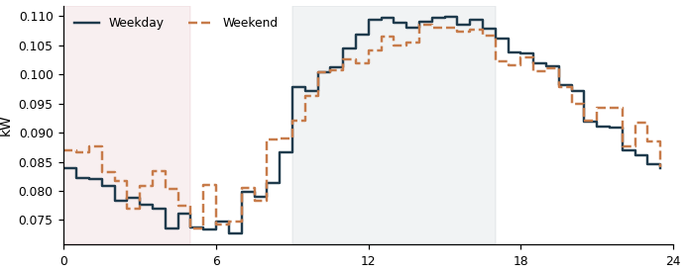

DD33710148405_3 Air conditioning  Overnight 0.08 kW | Daytime 0.52 kW | Ratio 15% | Est. 2 kWh/day  Overnight power stays at 15% of this meter's own typical daytime power (best-performing similar Air conditioning meters achieve about 0%). That gap works out to an estimated 2 kWh/day that could potentially be avoided if it idled down the way comparable meters do. | 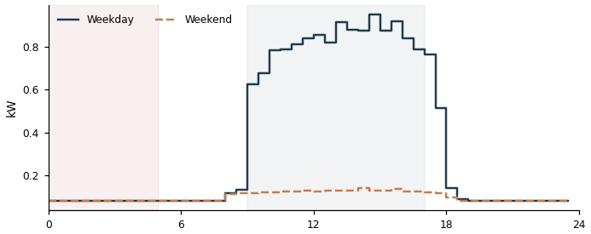

DD43710148528_0 Air conditioning  Overnight 0.08 kW | Daytime 0.51 kW | Ratio 15% | Est. 2 kWh/day  Overnight power stays at 15% of this meter's own typical daytime power (best-performing similar Air conditioning meters achieve about 0%). That gap works out to an estimated 2 kWh/day that could potentially be avoided if it idled down the way comparable meters do. | 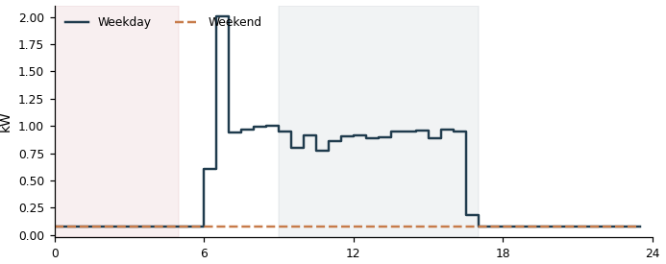

DDC3710136170_4 Air conditioning  Overnight 0.07 kW | Daytime 0.31 kW | Ratio 24% | Est. 2 kWh/day  Overnight power stays at 24% of this meter's own typical daytime power (best-performing similar Air conditioning meters achieve about 0%). That gap works out to an estimated 2 kWh/day that could potentially be avoided if it idled down the way comparable meters do. | 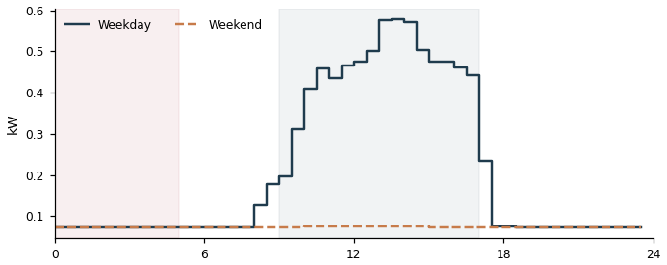

DD43710148528_3 Air conditioning  Overnight 0.07 kW | Daytime 0.89 kW | Ratio 8% | Est. 2 kWh/day  Overnight power stays at 8% of this meter's own typical daytime power (best-performing similar Air conditioning meters achieve about 0%). That gap works out to an estimated 2 kWh/day that could potentially be avoided if it idled down the way comparable meters do. | 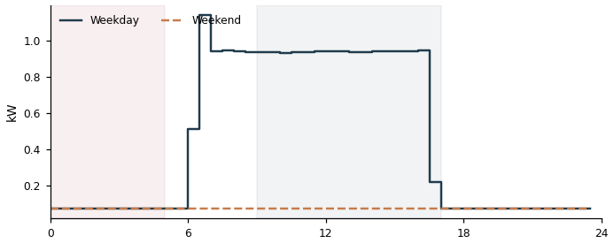

DD33710136324_1 Air conditioning  Overnight 0.06 kW | Daytime 0.06 kW | Ratio 99% | Est. 2 kWh/day  Overnight power stays at 99% of this meter's own typical daytime power (best-performing similar Air conditioning meters achieve about 0%). That gap works out to an estimated 2 kWh/day that could potentially be avoided if it idled down the way comparable meters do. | 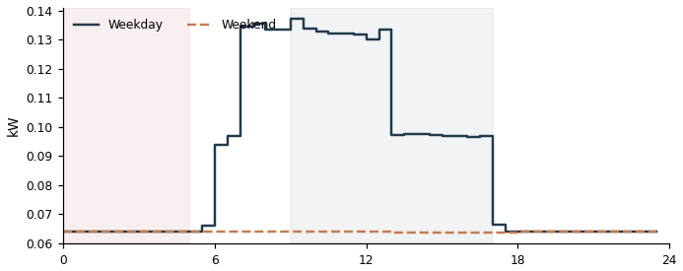

DD63710147032_0 Lighting & Power  Overnight 0.16 kW | Daytime 0.36 kW | Ratio 44% | Est. 1 kWh/day  Overnight power stays at 44% of this meter's own typical daytime power (best-performing similar Lighting & Power meters achieve about 28%). That gap works out to an estimated 1 kWh/day that could potentially be avoided if it idled down the way comparable meters do. | 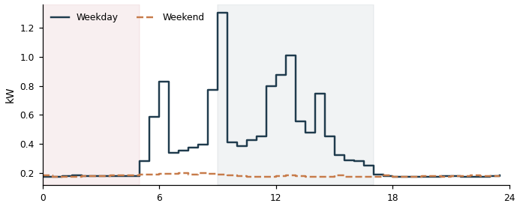

DDE3710147026_0 Air conditioning  Overnight 0.06 kW | Daytime 0.44 kW | Ratio 14% | Est. 1 kWh/day  Overnight power stays at 14% of this meter's own typical daytime power (best-performing similar Air conditioning meters achieve about 0%). That gap works out to an estimated 1 kWh/day that could potentially be avoided if it idled down the way comparable meters do. | 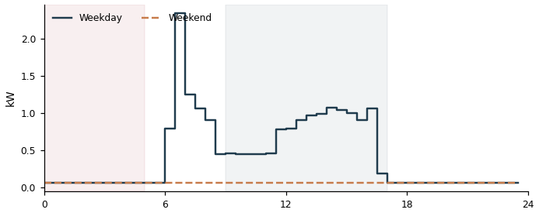

DDE3710136072_1 Air conditioning  Overnight 0.05 kW | Daytime 0.25 kW | Ratio 20% | Est. 1 kWh/day  Overnight power stays at 20% of this meter's own typical daytime power (best-performing similar Air conditioning meters achieve about 0%). That gap works out to an estimated 1 kWh/day that could potentially be avoided if it idled down the way comparable meters do. | 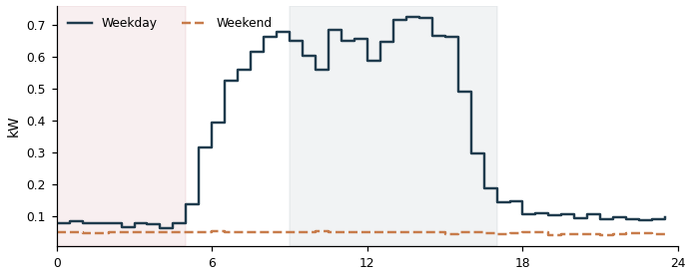

DD03710152752_5 Grid connect  Overnight 0.10 kW | Daytime 0.13 kW | Ratio 80% | Est. 1 kWh/day  Overnight power stays at 80% of this meter's own typical daytime power (best-performing similar Grid connect meters achieve about 43%). That gap works out to an estimated 1 kWh/day that could potentially be avoided if it idled down the way comparable meters do. | 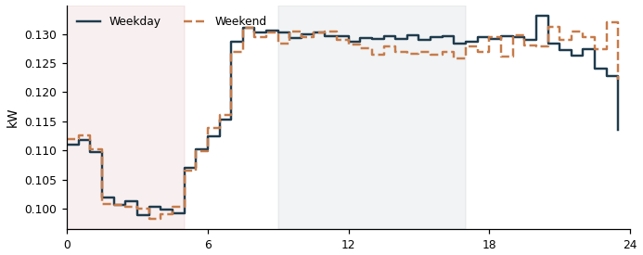

DDE3710136072_3 Air conditioning  Overnight 0.05 kW | Daytime 1.42 kW | Ratio 4% | Est. 1 kWh/day  Overnight power stays at 4% of this meter's own typical daytime power (best-performing similar Air conditioning meters achieve about 0%). That gap works out to an estimated 1 kWh/day that could potentially be avoided if it idled down the way comparable meters do. | 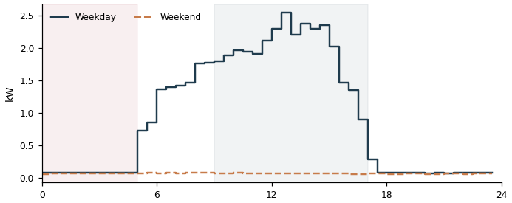

DD33710148032_3 Air conditioning  Overnight 0.05 kW | Daytime 0.52 kW | Ratio 9% | Est. 1 kWh/day  Overnight power stays at 9% of this meter's own typical daytime power (best-performing similar Air conditioning meters achieve about 0%). That gap works out to an estimated 1 kWh/day that could potentially be avoided if it idled down the way comparable meters do. | 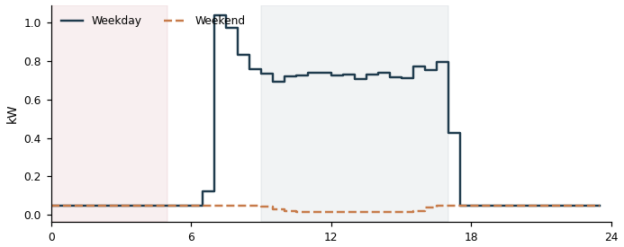

DD33710147083_3 Air conditioning  Overnight 0.04 kW | Daytime 0.76 kW | Ratio 5% | Est. 1 kWh/day  Overnight power stays at 5% of this meter's own typical daytime power (best-performing similar Air conditioning meters achieve about 0%). That gap works out to an estimated 1 kWh/day that could potentially be avoided if it idled down the way comparable meters do. | 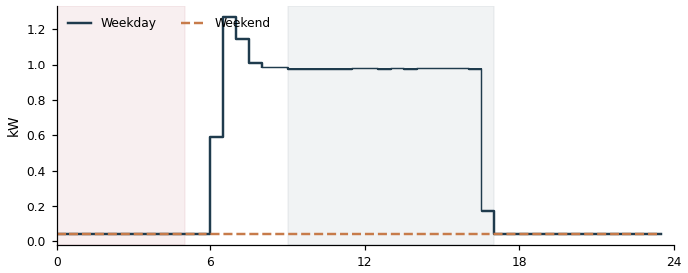

DDF3710159693_0 Grid connect  Overnight 0.06 kW | Daytime 0.07 kW | Ratio 95% | Est. 1 kWh/day  Overnight power stays at 95% of this meter's own typical daytime power (best-performing similar Grid connect meters achieve about 43%). That gap works out to an estimated 1 kWh/day that could potentially be avoided if it idled down the way comparable meters do. | 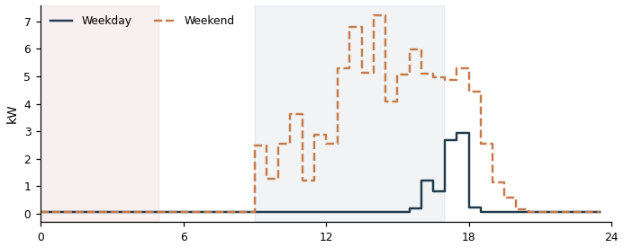

DD33710147083_1 Air conditioning  Overnight 0.04 kW | Daytime 1.29 kW | Ratio 3% | Est. 1 kWh/day  Overnight power stays at 3% of this meter's own typical daytime power (best-performing similar Air conditioning meters achieve about 0%). That gap works out to an estimated 1 kWh/day that could potentially be avoided if it idled down the way comparable meters do. | 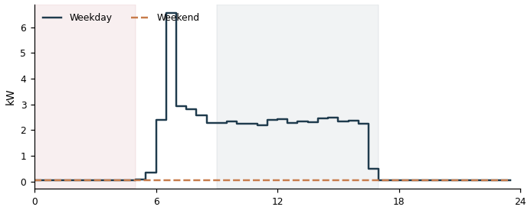

DD33710147083_2 Air conditioning  Overnight 0.04 kW | Daytime 1.30 kW | Ratio 3% | Est. 1 kWh/day  Overnight power stays at 3% of this meter's own typical daytime power (best-performing similar Air conditioning meters achieve about 0%). That gap works out to an estimated 1 kWh/day that could potentially be avoided if it idled down the way comparable meters do. | 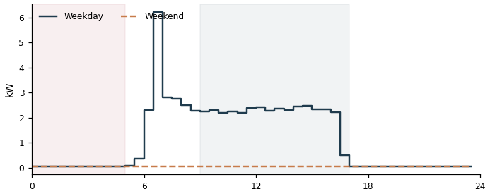

DDE3710136072_2 Air conditioning  Overnight 0.03 kW | Daytime 0.30 kW | Ratio 11% | Est. 1 kWh/day  Overnight power stays at 11% of this meter's own typical daytime power (best-performing similar Air conditioning meters achieve about 0%). That gap works out to an estimated 1 kWh/day that could potentially be avoided if it idled down the way comparable meters do. | 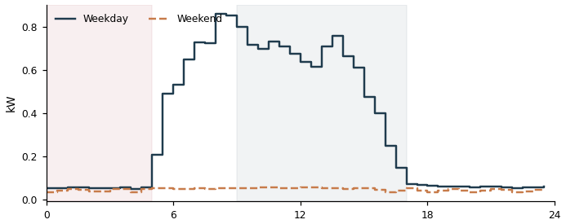

DD43710150291_5 Grid connect  Overnight 0.06 kW | Daytime 0.06 kW | Ratio 100% | Est. 1 kWh/day  Overnight power stays at 100% of this meter's own typical daytime power (best-performing similar Grid connect meters achieve about 43%). That gap works out to an estimated 1 kWh/day that could potentially be avoided if it idled down the way comparable meters do. | 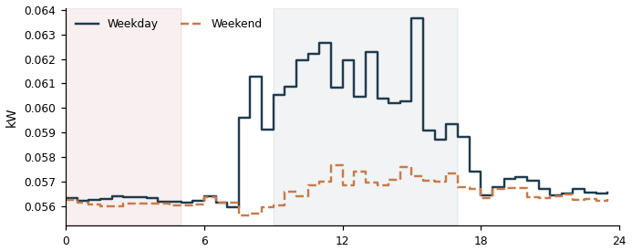

DD63710147032_4 Air conditioning  Overnight 0.03 kW | Daytime 0.21 kW | Ratio 15% | Est. 1 kWh/day  Overnight power stays at 15% of this meter's own typical daytime power (best-performing similar Air conditioning meters achieve about 0%). That gap works out to an estimated 1 kWh/day that could potentially be avoided if it idled down the way comparable meters do. | 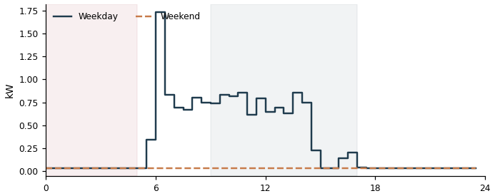

DDF3710148720_0 Air conditioning  Overnight 0.03 kW | Daytime 0.13 kW | Ratio 24% | Est. 1 kWh/day  Overnight power stays at 24% of this meter's own typical daytime power (best-performing similar Air conditioning meters achieve about 0%). That gap works out to an estimated 1 kWh/day that could potentially be avoided if it idled down the way comparable meters do. | 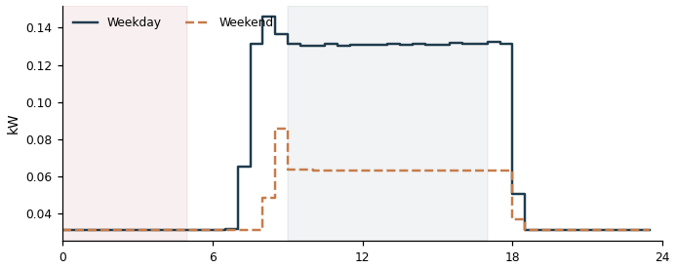

DD13710131574_2 Grid connect  Overnight 0.05 kW | Daytime 0.05 kW | Ratio 95% | Est. 1 kWh/day  Overnight power stays at 95% of this meter's own typical daytime power (best-performing similar Grid connect meters achieve about 43%). That gap works out to an estimated 1 kWh/day that could potentially be avoided if it idled down the way comparable meters do. | 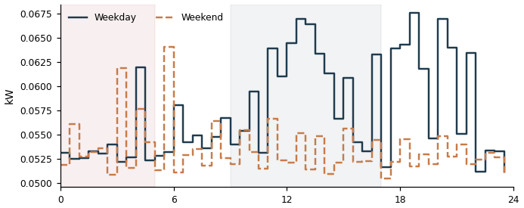

DD63710147032_5 Air conditioning  Overnight 0.03 kW | Daytime 0.18 kW | Ratio 15% | Est. 1 kWh/day  Overnight power stays at 15% of this meter's own typical daytime power (best-performing similar Air conditioning meters achieve about 0%). That gap works out to an estimated 1 kWh/day that could potentially be avoided if it idled down the way comparable meters do. | 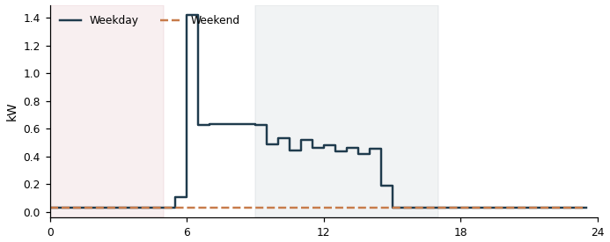

DDF3710148720_1 Air conditioning  Overnight 0.02 kW | Daytime 0.26 kW | Ratio 7% | Est. 0 kWh/day  Overnight power stays at 7% of this meter's own typical daytime power (best-performing similar Air conditioning meters achieve about 0%). That gap works out to an estimated 0 kWh/day that could potentially be avoided if it idled down the way comparable meters do. | 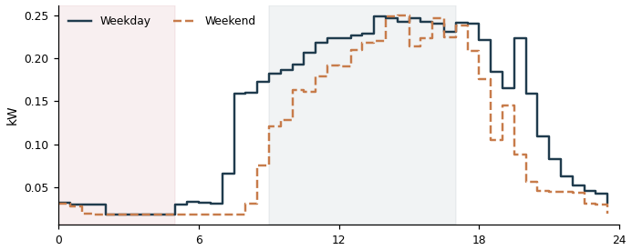

DDB3710149676_4 Air conditioning  Overnight 0.02 kW | Daytime 0.12 kW | Ratio 13% | Est. 0 kWh/day  Overnight power stays at 13% of this meter's own typical daytime power (best-performing similar Air conditioning meters achieve about 0%). That gap works out to an estimated 0 kWh/day that could potentially be avoided if it idled down the way comparable meters do. | 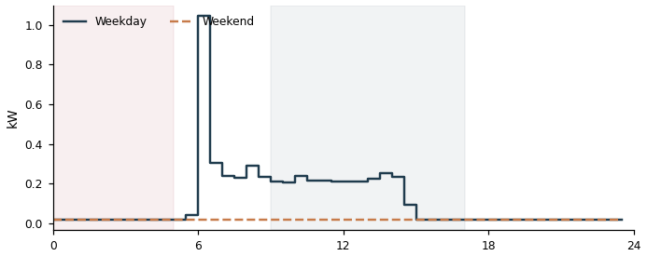

DDB3710149676_3 Air conditioning  Overnight 0.02 kW | Daytime 0.14 kW | Ratio 11% | Est. 0 kWh/day  Overnight power stays at 11% of this meter's own typical daytime power (best-performing similar Air conditioning meters achieve about 0%). That gap works out to an estimated 0 kWh/day that could potentially be avoided if it idled down the way comparable meters do. | 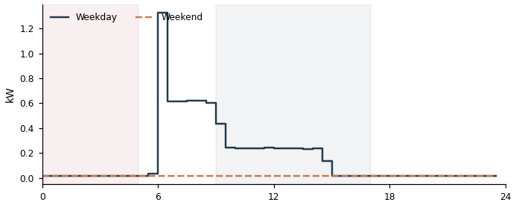

DD23710134143_0 Air conditioning  Overnight 0.01 kW | Daytime 0.20 kW | Ratio 6% | Est. 0 kWh/day  Overnight power stays at 6% of this meter's own typical daytime power (best-performing similar Air conditioning meters achieve about 0%). That gap works out to an estimated 0 kWh/day that could potentially be avoided if it idled down the way comparable meters do. | 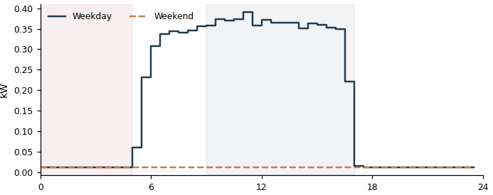

DD73710136266_4 Air conditioning  Overnight 0.01 kW | Daytime 0.70 kW | Ratio 2% | Est. 0 kWh/day  Overnight power stays at 2% of this meter's own typical daytime power (best-performing similar Air conditioning meters achieve about 0%). That gap works out to an estimated 0 kWh/day that could potentially be avoided if it idled down the way comparable meters do. | 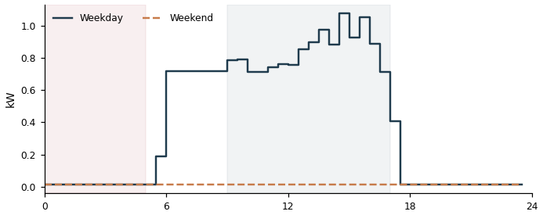

DD33710136324_3 Air conditioning  Overnight 0.01 kW | Daytime 0.24 kW | Ratio 4% | Est. 0 kWh/day  Overnight power stays at 4% of this meter's own typical daytime power (best-performing similar Air conditioning meters achieve about 0%). That gap works out to an estimated 0 kWh/day that could potentially be avoided if it idled down the way comparable meters do. | 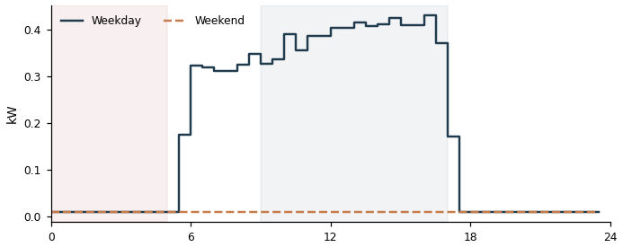

DD83710136482_0 Air conditioning  Overnight 0.01 kW | Daytime 1.20 kW | Ratio 1% | Est. 0 kWh/day  Overnight power stays at 1% of this meter's own typical daytime power (best-performing similar Air conditioning meters achieve about 0%). That gap works out to an estimated 0 kWh/day that could potentially be avoided if it idled down the way comparable meters do. | 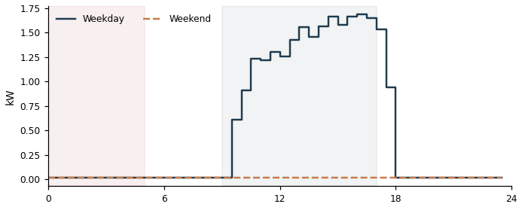

DD83710136482_3 Air conditioning  Overnight 0.01 kW | Daytime 0.23 kW | Ratio 4% | Est. 0 kWh/day  Overnight power stays at 4% of this meter's own typical daytime power (best-performing similar Air conditioning meters achieve about 0%). That gap works out to an estimated 0 kWh/day that could potentially be avoided if it idled down the way comparable meters do. | 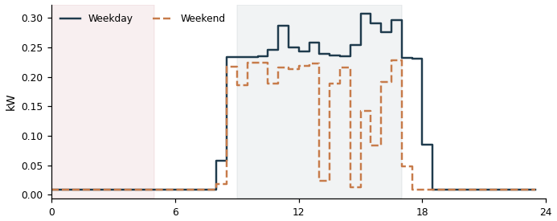

DD33710148032_5 Air conditioning  Overnight 0.01 kW | Daytime 0.25 kW | Ratio 3% | Est. 0 kWh/day  Overnight power stays at 3% of this meter's own typical daytime power (best-performing similar Air conditioning meters achieve about 0%). That gap works out to an estimated 0 kWh/day that could potentially be avoided if it idled down the way comparable meters do. | 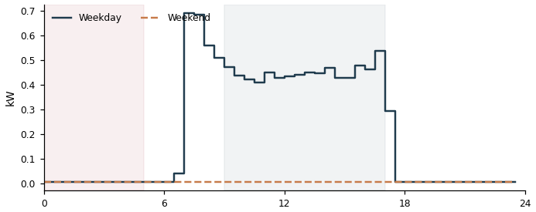

DD73710150170_4 Air conditioning  Overnight 0.01 kW | Daytime 0.23 kW | Ratio 3% | Est. 0 kWh/day  Overnight power stays at 3% of this meter's own typical daytime power (best-performing similar Air conditioning meters achieve about 0%). That gap works out to an estimated 0 kWh/day that could potentially be avoided if it idled down the way comparable meters do. | 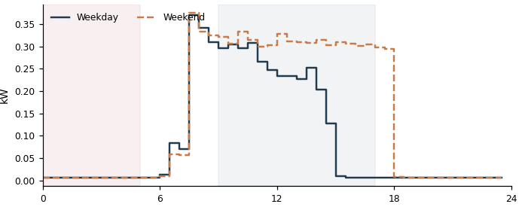

DD73710150170_3 Air conditioning  Overnight 0.01 kW | Daytime 0.26 kW | Ratio 2% | Est. 0 kWh/day  Overnight power stays at 2% of this meter's own typical daytime power (best-performing similar Air conditioning meters achieve about 0%). That gap works out to an estimated 0 kWh/day that could potentially be avoided if it idled down the way comparable meters do. | 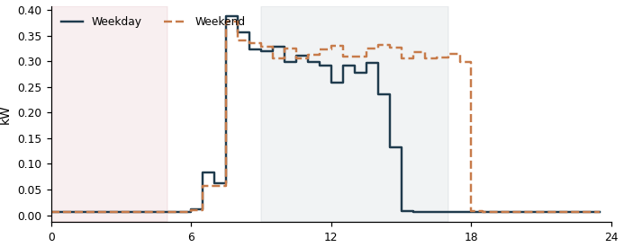

DD33710148032_4 Air conditioning  Overnight 0.01 kW | Daytime 0.28 kW | Ratio 2% | Est. 0 kWh/day  Overnight power stays at 2% of this meter's own typical daytime power (best-performing similar Air conditioning meters achieve about 0%). That gap works out to an estimated 0 kWh/day that could potentially be avoided if it idled down the way comparable meters do. | 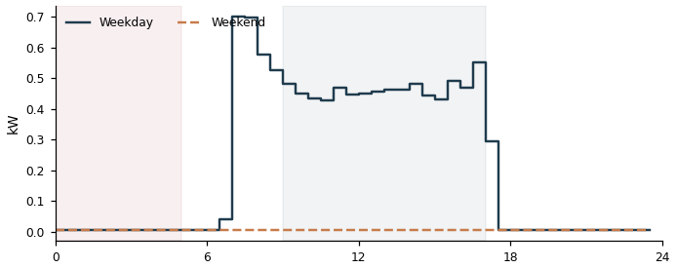

DD83710136482_1 Air conditioning  Overnight 0.01 kW | Daytime 0.43 kW | Ratio 1% | Est. 0 kWh/day  Overnight power stays at 1% of this meter's own typical daytime power (best-performing similar Air conditioning meters achieve about 0%). That gap works out to an estimated 0 kWh/day that could potentially be avoided if it idled down the way comparable meters do. | 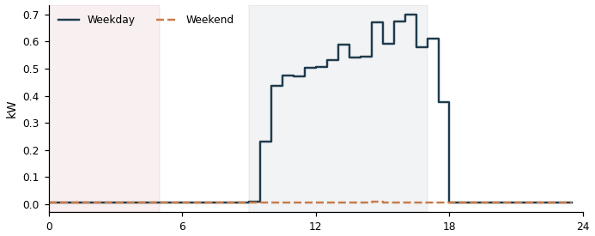

B. Weekend Usage (39 meters)
DDC3710136170_3 Air conditioning
Weekday 31 kWh/day | Weekend 28 kWh/day | Weekend = 90% of weekday
This meter is clearly scheduled around the working week, yet weekend energy use (28 kWh/day) is 90% of its weekday level (31 kWh/day) — well above the roughly 49% a typical weekday-scheduled meter drops to. This suggests equipment may keep running on weekends when the site may not need it to.

DDF3710147031_3 Lighting & Power
Weekday 53 kWh/day | Weekend 47 kWh/day | Weekend = 89% of weekday
This meter is clearly scheduled around the working week, yet weekend energy use (47 kWh/day) is 89% of its weekday level (53 kWh/day) — well above the roughly 49% a typical weekday-scheduled meter drops to. This suggests equipment may keep running on weekends when the site may not need it to.

DD63710153384_5 Grid connect
Weekday 99 kWh/day | Weekend 87 kWh/day | Weekend = 88% of weekday
This meter is clearly scheduled around the working week, yet weekend energy use (87 kWh/day) is 88% of its weekday level (99 kWh/day) — well above the roughly 49% a typical weekday-scheduled meter drops to. This suggests equipment may keep running on weekends when the site may not need it to.

DD53710134734_0 Grid connect  Weekday 193 kWh/day | Weekend 168 kWh/day | Weekend = 87% of weekday  This meter is clearly scheduled around the working week, yet weekend energy use (168 kWh/day) is 87% of its weekday level (193 kWh/day) — well above the roughly 49% a typical weekday-scheduled meter drops to. This suggests equipment may keep running on weekends when the site may not need it to. | 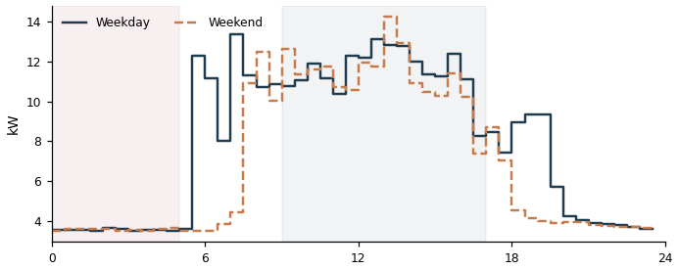

DD13710147065_1 Grid connect  Weekday 13 kWh/day | Weekend 11 kWh/day | Weekend = 86% of weekday  This meter is clearly scheduled around the working week, yet weekend energy use (11 kWh/day) is 86% of its weekday level (13 kWh/day) — well above the roughly 49% a typical weekday-scheduled meter drops to. This suggests equipment may keep running on weekends when the site may not need it to. | 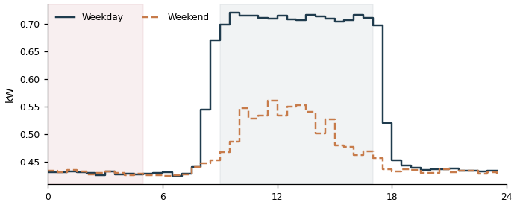

DD53710134734_2 Grid connect  Weekday 153 kWh/day | Weekend 132 kWh/day | Weekend = 86% of weekday  This meter is clearly scheduled around the working week, yet weekend energy use (132 kWh/day) is 86% of its weekday level (153 kWh/day) — well above the roughly 49% a typical weekday-scheduled meter drops to. This suggests equipment may keep running on weekends when the site may not need it to. | 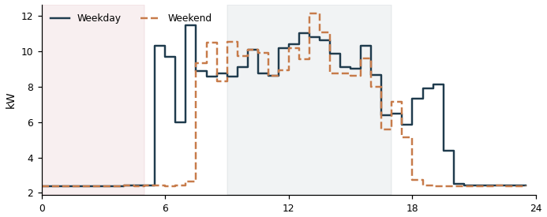

DD53710134734_1 Grid connect  Weekday 182 kWh/day | Weekend 157 kWh/day | Weekend = 86% of weekday  This meter is clearly scheduled around the working week, yet weekend energy use (157 kWh/day) is 86% of its weekday level (182 kWh/day) — well above the roughly 49% a typical weekday-scheduled meter drops to. This suggests equipment may keep running on weekends when the site may not need it to. | 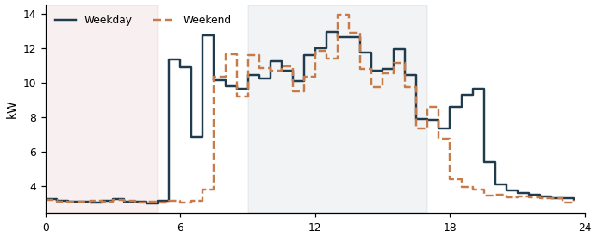

DD63710153384_2 Grid connect
Weekday 51 kWh/day | Weekend 43 kWh/day | Weekend = 84% of weekday
This meter is clearly scheduled around the working week, yet weekend energy use (43 kWh/day) is 84% of its weekday level (51 kWh/day) — well above the roughly 49% a typical weekday-scheduled meter drops to. This suggests equipment may keep running on weekends when the site may not need it to.

DDF3710147031_4 Lighting & Power
Weekday 30 kWh/day | Weekend 25 kWh/day | Weekend = 84% of weekday
This meter is clearly scheduled around the working week, yet weekend energy use (25 kWh/day) is 84% of its weekday level (30 kWh/day) — well above the roughly 49% a typical weekday-scheduled meter drops to. This suggests equipment may keep running on weekends when the site may not need it to.

DD23710148637_1 Grid connect
Weekday 104 kWh/day | Weekend 86 kWh/day | Weekend = 83% of weekday
This meter is clearly scheduled around the working week, yet weekend energy use (86 kWh/day) is 83% of its weekday level (104 kWh/day) — well above the roughly 49% a typical weekday-scheduled meter drops to. This suggests equipment may keep running on weekends when the site may not need it to.

DDD3710149679_0 Grid connect  Weekday 40 kWh/day | Weekend 33 kWh/day | Weekend = 83% of weekday  This meter is clearly scheduled around the working week, yet weekend energy use (33 kWh/day) is 83% of its weekday level (40 kWh/day) — well above the roughly 49% a typical weekday-scheduled meter drops to. This suggests equipment may keep running on weekends when the site may not need it to. | 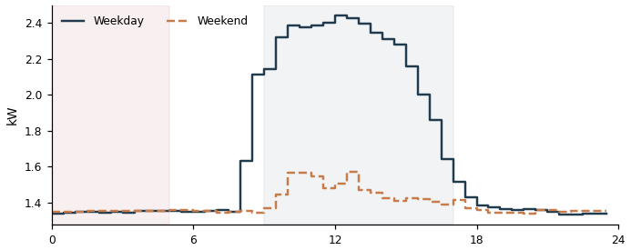

DD93710152906_0 Grid connect  Weekday 53 kWh/day | Weekend 44 kWh/day | Weekend = 82% of weekday  This meter is clearly scheduled around the working week, yet weekend energy use (44 kWh/day) is 82% of its weekday level (53 kWh/day) — well above the roughly 49% a typical weekday-scheduled meter drops to. This suggests equipment may keep running on weekends when the site may not need it to. | 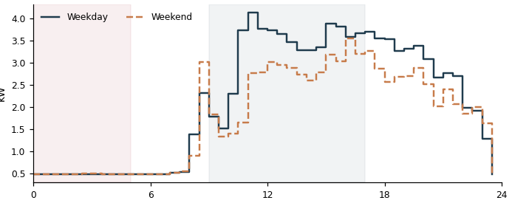

DD63710153384_3 Grid connect
Weekday 111 kWh/day | Weekend 90 kWh/day | Weekend = 81% of weekday
This meter is clearly scheduled around the working week, yet weekend energy use (90 kWh/day) is 81% of its weekday level (111 kWh/day) — well above the roughly 49% a typical weekday-scheduled meter drops to. This suggests equipment may keep running on weekends when the site may not need it to.

DD63710136344_5 Grid connect  Weekday 29 kWh/day | Weekend 23 kWh/day | Weekend = 80% of weekday  This meter is clearly scheduled around the working week, yet weekend energy use (23 kWh/day) is 80% of its weekday level (29 kWh/day) — well above the roughly 49% a typical weekday-scheduled meter drops to. This suggests equipment may keep running on weekends when the site may not need it to. | 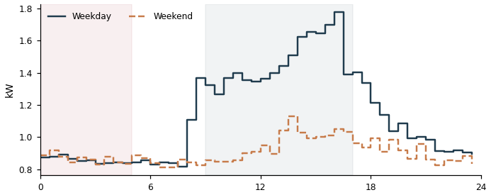

DD63710152870_5 Grid connect  Weekday 9 kWh/day | Weekend 7 kWh/day | Weekend = 80% of weekday  This meter is clearly scheduled around the working week, yet weekend energy use (7 kWh/day) is 80% of its weekday level (9 kWh/day) — well above the roughly 49% a typical weekday-scheduled meter drops to. This suggests equipment may keep running on weekends when the site may not need it to. | 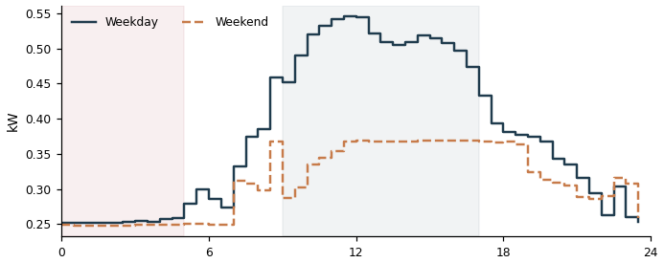

DD23710148637_0 Grid connect
Weekday 182 kWh/day | Weekend 144 kWh/day | Weekend = 80% of weekday
This meter is clearly scheduled around the working week, yet weekend energy use (144 kWh/day) is 80% of its weekday level (182 kWh/day) — well above the roughly 49% a typical weekday-scheduled meter drops to. This suggests equipment may keep running on weekends when the site may not need it to.

DD13710149684_1 Air conditioning
Weekday 136 kWh/day | Weekend 107 kWh/day | Weekend = 79% of weekday
This meter is clearly scheduled around the working week, yet weekend energy use (107 kWh/day) is 79% of its weekday level (136 kWh/day) — well above the roughly 49% a typical weekday-scheduled meter drops to. This suggests equipment may keep running on weekends when the site may not need it to.

DD03710131709_2 Grid connect  Weekday 48 kWh/day | Weekend 37 kWh/day | Weekend = 79% of weekday  This meter is clearly scheduled around the working week, yet weekend energy use (37 kWh/day) is 79% of its weekday level (48 kWh/day) — well above the roughly 49% a typical weekday-scheduled meter drops to. This suggests equipment may keep running on weekends when the site may not need it to. | 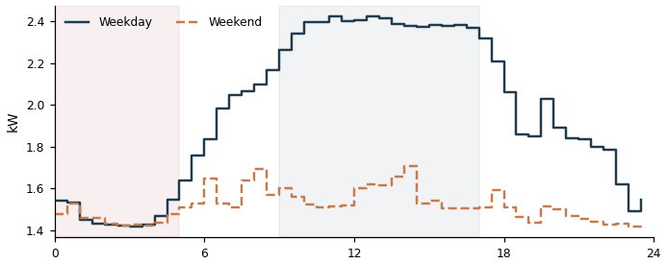

DDF3710131630_3 Grid connect
Weekday 79 kWh/day | Weekend 60 kWh/day | Weekend = 76% of weekday
This meter is clearly scheduled around the working week, yet weekend energy use (60 kWh/day) is 76% of its weekday level (79 kWh/day) — well above the roughly 49% a typical weekday-scheduled meter drops to. This suggests equipment may keep running on weekends when the site may not need it to.

DD63710152870_4 Grid connect  Weekday 9 kWh/day | Weekend 7 kWh/day | Weekend = 76% of weekday  This meter is clearly scheduled around the working week, yet weekend energy use (7 kWh/day) is 76% of its weekday level (9 kWh/day) — well above the roughly 49% a typical weekday-scheduled meter drops to. This suggests equipment may keep running on weekends when the site may not need it to. | 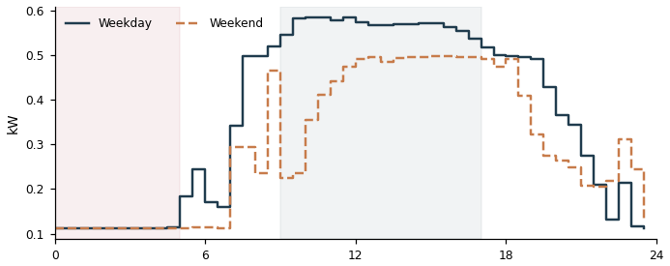

DDD3710148556_0 Grid connect  Weekday 110 kWh/day | Weekend 83 kWh/day | Weekend = 76% of weekday  This meter is clearly scheduled around the working week, yet weekend energy use (83 kWh/day) is 76% of its weekday level (110 kWh/day) — well above the roughly 49% a typical weekday-scheduled meter drops to. This suggests equipment may keep running on weekends when the site may not need it to. | 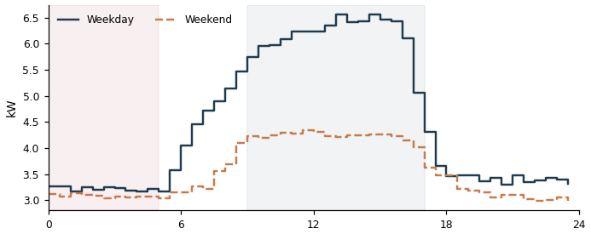

DDD3710148556_1 Grid connect  Weekday 114 kWh/day | Weekend 86 kWh/day | Weekend = 75% of weekday  This meter is clearly scheduled around the working week, yet weekend energy use (86 kWh/day) is 75% of its weekday level (114 kWh/day) — well above the roughly 49% a typical weekday-scheduled meter drops to. This suggests equipment may keep running on weekends when the site may not need it to. | 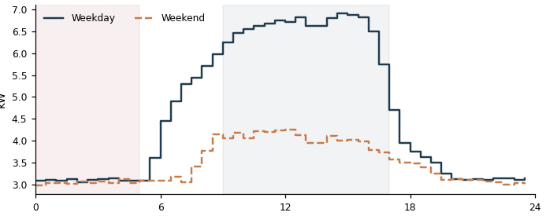

DD23710148637_2 Grid connect
Weekday 33 kWh/day | Weekend 24 kWh/day | Weekend = 75% of weekday
This meter is clearly scheduled around the working week, yet weekend energy use (24 kWh/day) is 75% of its weekday level (33 kWh/day) — well above the roughly 49% a typical weekday-scheduled meter drops to. This suggests equipment may keep running on weekends when the site may not need it to.

DD03710152752_0 Grid connect  Weekday 78 kWh/day | Weekend 58 kWh/day | Weekend = 74% of weekday  This meter is clearly scheduled around the working week, yet weekend energy use (58 kWh/day) is 74% of its weekday level (78 kWh/day) — well above the roughly 49% a typical weekday-scheduled meter drops to. This suggests equipment may keep running on weekends when the site may not need it to. | 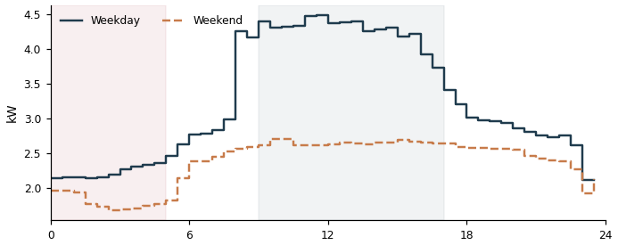

DD03710152752_1 Grid connect  Weekday 49 kWh/day | Weekend 36 kWh/day | Weekend = 74% of weekday  This meter is clearly scheduled around the working week, yet weekend energy use (36 kWh/day) is 74% of its weekday level (49 kWh/day) — well above the roughly 49% a typical weekday-scheduled meter drops to. This suggests equipment may keep running on weekends when the site may not need it to. | 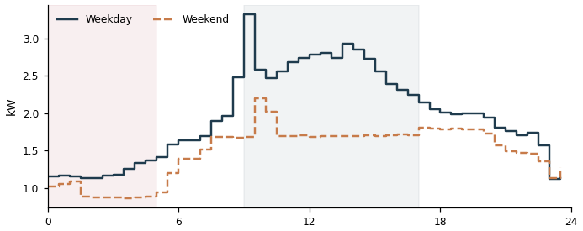

DDF3710131630_4 Grid connect
Weekday 75 kWh/day | Weekend 55 kWh/day | Weekend = 73% of weekday
This meter is clearly scheduled around the working week, yet weekend energy use (55 kWh/day) is 73% of its weekday level (75 kWh/day) — well above the roughly 49% a typical weekday-scheduled meter drops to. This suggests equipment may keep running on weekends when the site may not need it to.

DDB3710141068_1 Lighting & Power
Weekday 33 kWh/day | Weekend 24 kWh/day | Weekend = 73% of weekday
This meter is clearly scheduled around the working week, yet weekend energy use (24 kWh/day) is 73% of its weekday level (33 kWh/day) — well above the roughly 49% a typical weekday-scheduled meter drops to. This suggests equipment may keep running on weekends when the site may not need it to.

DDD3710148556_2 Grid connect  Weekday 103 kWh/day | Weekend 75 kWh/day | Weekend = 73% of weekday  This meter is clearly scheduled around the working week, yet weekend energy use (75 kWh/day) is 73% of its weekday level (103 kWh/day) — well above the roughly 49% a typical weekday-scheduled meter drops to. This suggests equipment may keep running on weekends when the site may not need it to. | 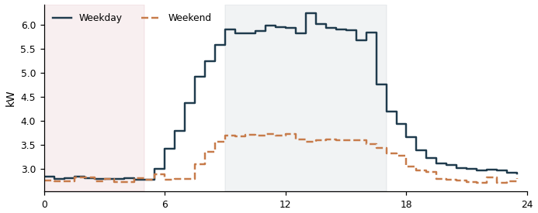

DDF3710131630_1 Grid connect
Weekday 55 kWh/day | Weekend 39 kWh/day | Weekend = 71% of weekday
This meter is clearly scheduled around the working week, yet weekend energy use (39 kWh/day) is 71% of its weekday level (55 kWh/day) — well above the roughly 49% a typical weekday-scheduled meter drops to. This suggests equipment may keep running on weekends when the site may not need it to.

DD33710136208_2 Power  Weekday 6 kWh/day | Weekend 4 kWh/day | Weekend = 69% of weekday  This meter is clearly scheduled around the working week, yet weekend energy use (4 kWh/day) is 69% of its weekday level (6 kWh/day) — well above the roughly 49% a typical weekday-scheduled meter drops to. This suggests equipment may keep running on weekends when the site may not need it to. | 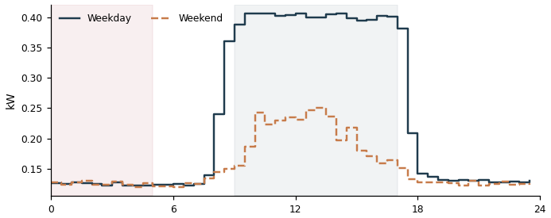

DD13710149684_2 Air conditioning
Weekday 154 kWh/day | Weekend 104 kWh/day | Weekend = 68% of weekday
This meter is clearly scheduled around the working week, yet weekend energy use (104 kWh/day) is 68% of its weekday level (154 kWh/day) — well above the roughly 49% a typical weekday-scheduled meter drops to. This suggests equipment may keep running on weekends when the site may not need it to.

DDB3710148786_2 Grid connect  Weekday 6 kWh/day | Weekend 4 kWh/day | Weekend = 68% of weekday  This meter is clearly scheduled around the working week, yet weekend energy use (4 kWh/day) is 68% of its weekday level (6 kWh/day) — well above the roughly 49% a typical weekday-scheduled meter drops to. This suggests equipment may keep running on weekends when the site may not need it to. | 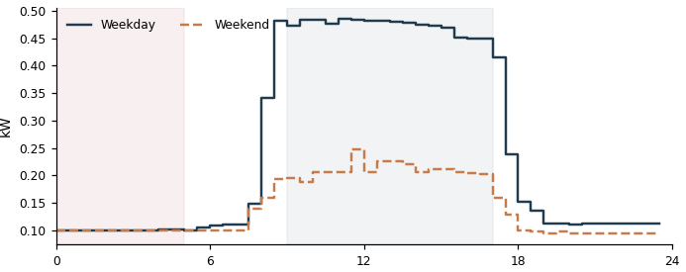

DD43710136402_4 Grid connect  Weekday 219 kWh/day | Weekend 147 kWh/day | Weekend = 67% of weekday  This meter is clearly scheduled around the working week, yet weekend energy use (147 kWh/day) is 67% of its weekday level (219 kWh/day) — well above the roughly 49% a typical weekday-scheduled meter drops to. This suggests equipment may keep running on weekends when the site may not need it to. | 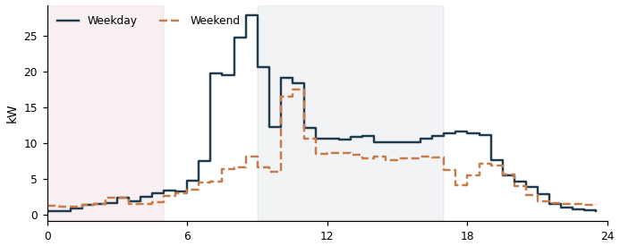

DDC3710136170_0 Grid connect  Weekday 125 kWh/day | Weekend 83 kWh/day | Weekend = 67% of weekday  This meter is clearly scheduled around the working week, yet weekend energy use (83 kWh/day) is 67% of its weekday level (125 kWh/day) — well above the roughly 49% a typical weekday-scheduled meter drops to. This suggests equipment may keep running on weekends when the site may not need it to. | 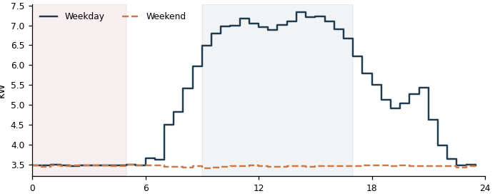

DD13710131574_1 Grid connect  Weekday 7 kWh/day | Weekend 4 kWh/day | Weekend = 64% of weekday  This meter is clearly scheduled around the working week, yet weekend energy use (4 kWh/day) is 64% of its weekday level (7 kWh/day) — well above the roughly 49% a typical weekday-scheduled meter drops to. This suggests equipment may keep running on weekends when the site may not need it to. | 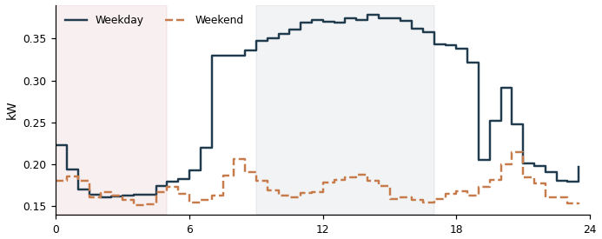

DD33710148727_2 Lighting & Power
Weekday 138 kWh/day | Weekend 88 kWh/day | Weekend = 63% of weekday
This meter is clearly scheduled around the working week, yet weekend energy use (88 kWh/day) is 63% of its weekday level (138 kWh/day) — well above the roughly 49% a typical weekday-scheduled meter drops to. This suggests equipment may keep running on weekends when the site may not need it to.

DD73710150283_0 Grid connect  Weekday 36 kWh/day | Weekend 23 kWh/day | Weekend = 62% of weekday  This meter is clearly scheduled around the working week, yet weekend energy use (23 kWh/day) is 62% of its weekday level (36 kWh/day) — well above the roughly 49% a typical weekday-scheduled meter drops to. This suggests equipment may keep running on weekends when the site may not need it to. | 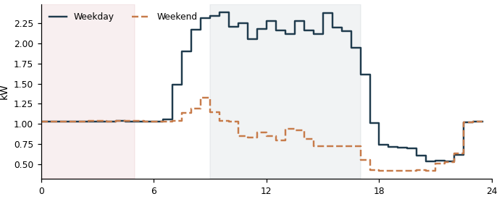

DD03710131709_1 Grid connect  Weekday 96 kWh/day | Weekend 59 kWh/day | Weekend = 62% of weekday  This meter is clearly scheduled around the working week, yet weekend energy use (59 kWh/day) is 62% of its weekday level (96 kWh/day) — well above the roughly 49% a typical weekday-scheduled meter drops to. This suggests equipment may keep running on weekends when the site may not need it to. | 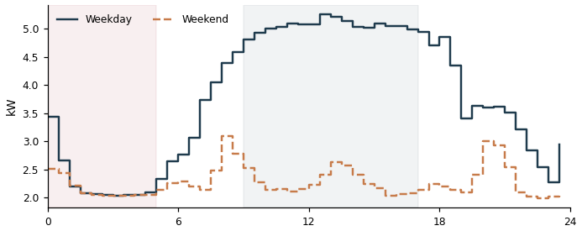

DD43710136402_5 Grid connect  Weekday 223 kWh/day | Weekend 137 kWh/day | Weekend = 61% of weekday  This meter is clearly scheduled around the working week, yet weekend energy use (137 kWh/day) is 61% of its weekday level (223 kWh/day) — well above the roughly 49% a typical weekday-scheduled meter drops to. This suggests equipment may keep running on weekends when the site may not need it to. | 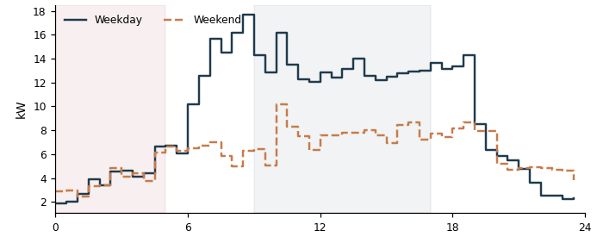

C. Spike Days (115 meters)
DD33710161970_1 Grid connect  Typical day 5 kWh | Spike threshold 521 kWh | 13 spike days | Total excess 8,577 kWh  On 13 of 251 valid days, this meter used far more energy than its own typical day (5 kWh) — above a threshold of 521 kWh. Together those spike days used an estimated 8,577 kWh more than a normal day for this meter would have. | 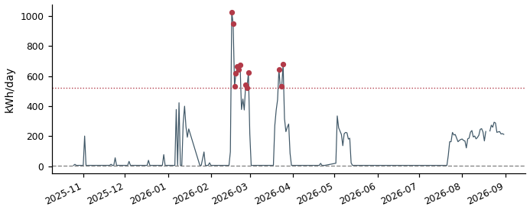

DD33710161970_0 Grid connect  Typical day 6 kWh | Spike threshold 499 kWh | 13 spike days | Total excess 8,106 kWh  On 13 of 251 valid days, this meter used far more energy than its own typical day (6 kWh) — above a threshold of 499 kWh. Together those spike days used an estimated 8,106 kWh more than a normal day for this meter would have. | 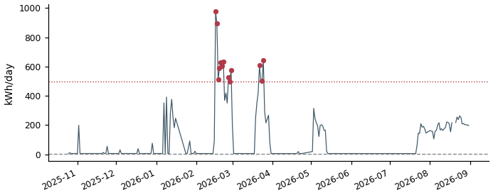

DD33710161970_4 Grid connect  Typical day 243 kWh | Spike threshold 711 kWh | 13 spike days | Total excess 7,689 kWh  On 13 of 251 valid days, this meter used far more energy than its own typical day (243 kWh) — above a threshold of 711 kWh. Together those spike days used an estimated 7,689 kWh more than a normal day for this meter would have. | 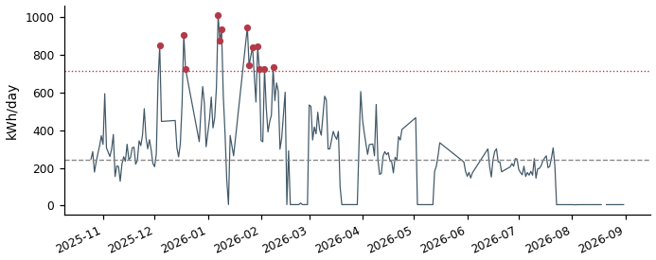

DD33710161970_3 Grid connect  Typical day 222 kWh | Spike threshold 654 kWh | 13 spike days | Total excess 7,237 kWh  On 13 of 251 valid days, this meter used far more energy than its own typical day (222 kWh) — above a threshold of 654 kWh. Together those spike days used an estimated 7,237 kWh more than a normal day for this meter would have. | 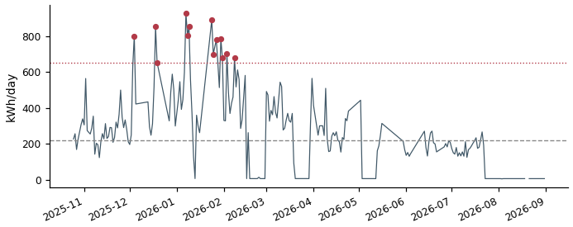

DD33710161970_5 Grid connect  Typical day 225 kWh | Spike threshold 660 kWh | 13 spike days | Total excess 7,199 kWh  On 13 of 252 valid days, this meter used far more energy than its own typical day (225 kWh) — above a threshold of 660 kWh. Together those spike days used an estimated 7,199 kWh more than a normal day for this meter would have. | 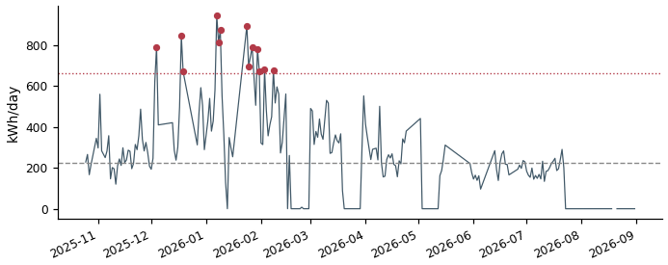

DD13710148400_0 Electric vehicle  Typical day 33 kWh | Spike threshold 284 kWh | 15 spike days | Total excess 4,716 kWh  On 15 of 301 valid days, this meter used far more energy than its own typical day (33 kWh) — above a threshold of 284 kWh. Together those spike days used an estimated 4,716 kWh more than a normal day for this meter would have. | 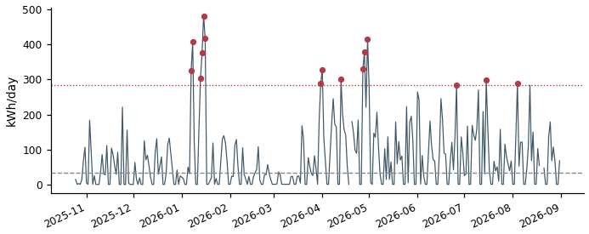

DD43710136402_5 Grid connect  Typical day 211 kWh | Spike threshold 382 kWh | 15 spike days | Total excess 3,071 kWh  On 15 of 288 valid days, this meter used far more energy than its own typical day (211 kWh) — above a threshold of 382 kWh. Together those spike days used an estimated 3,071 kWh more than a normal day for this meter would have. | 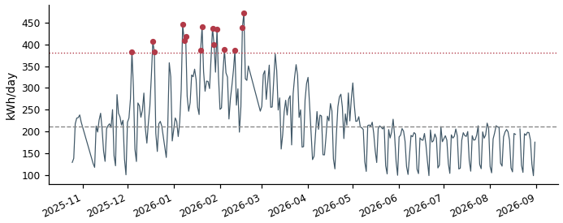

DD83710131752_3 Grid connect  Typical day 13 kWh | Spike threshold 148 kWh | 15 spike days | Total excess 2,694 kWh  On 15 of 295 valid days, this meter used far more energy than its own typical day (13 kWh) — above a threshold of 148 kWh. Together those spike days used an estimated 2,694 kWh more than a normal day for this meter would have. | 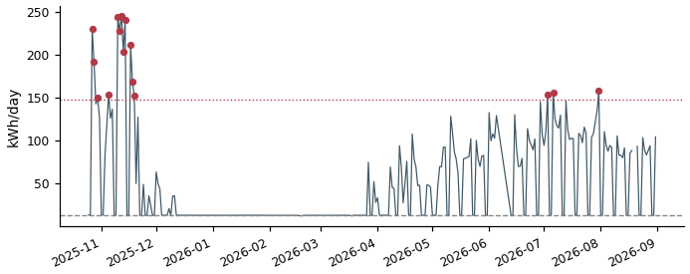

DDF3710159693_2 Grid connect  Typical day 49 kWh | Spike threshold 135 kWh | 15 spike days | Total excess 1,805 kWh  On 15 of 301 valid days, this meter used far more energy than its own typical day (49 kWh) — above a threshold of 135 kWh. Together those spike days used an estimated 1,805 kWh more than a normal day for this meter would have. | 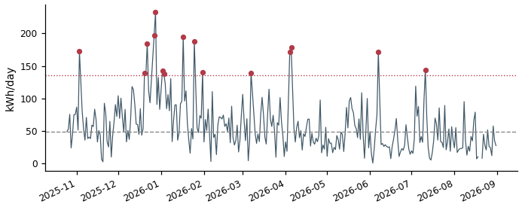

DDB3710136329_3 Grid connect  Typical day 183 kWh | Spike threshold 281 kWh | 15 spike days | Total excess 1,803 kWh  On 15 of 294 valid days, this meter used far more energy than its own typical day (183 kWh) — above a threshold of 281 kWh. Together those spike days used an estimated 1,803 kWh more than a normal day for this meter would have. | 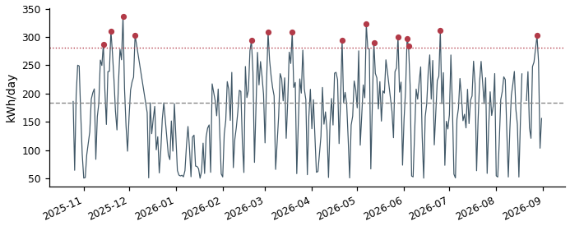

DD83710147339_0 Air conditioning  Typical day 64 kWh | Spike threshold 142 kWh | 15 spike days | Total excess 1,802 kWh  On 15 of 300 valid days, this meter used far more energy than its own typical day (64 kWh) — above a threshold of 142 kWh. Together those spike days used an estimated 1,802 kWh more than a normal day for this meter would have. | 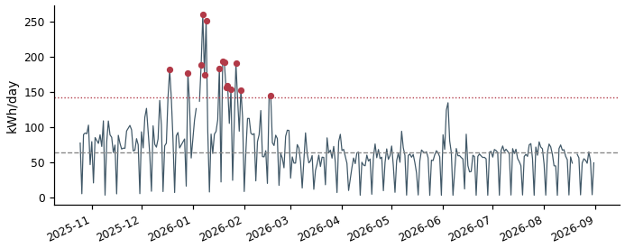

DDF3710159693_0 Grid connect  Typical day 55 kWh | Spike threshold 135 kWh | 15 spike days | Total excess 1,775 kWh  On 15 of 301 valid days, this meter used far more energy than its own typical day (55 kWh) — above a threshold of 135 kWh. Together those spike days used an estimated 1,775 kWh more than a normal day for this meter would have. | 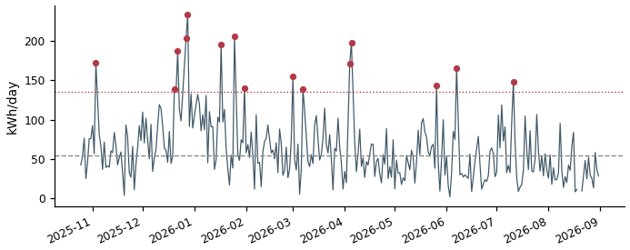

DDF3710159693_1 Grid connect  Typical day 48 kWh | Spike threshold 130 kWh | 15 spike days | Total excess 1,745 kWh  On 15 of 301 valid days, this meter used far more energy than its own typical day (48 kWh) — above a threshold of 130 kWh. Together those spike days used an estimated 1,745 kWh more than a normal day for this meter would have. | 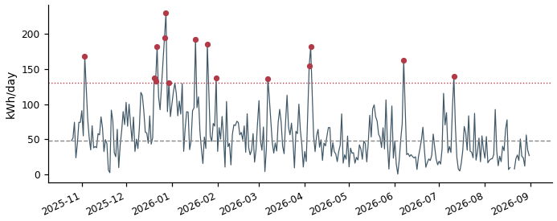

DD83710147339_1 Air conditioning  Typical day 67 kWh | Spike threshold 138 kWh | 15 spike days | Total excess 1,647 kWh  On 15 of 300 valid days, this meter used far more energy than its own typical day (67 kWh) — above a threshold of 138 kWh. Together those spike days used an estimated 1,647 kWh more than a normal day for this meter would have. | 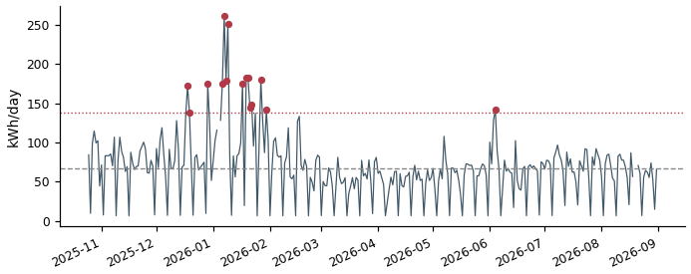

DD83710147339_2 Air conditioning  Typical day 77 kWh | Spike threshold 149 kWh | 15 spike days | Total excess 1,646 kWh  On 15 of 300 valid days, this meter used far more energy than its own typical day (77 kWh) — above a threshold of 149 kWh. Together those spike days used an estimated 1,646 kWh more than a normal day for this meter would have. | 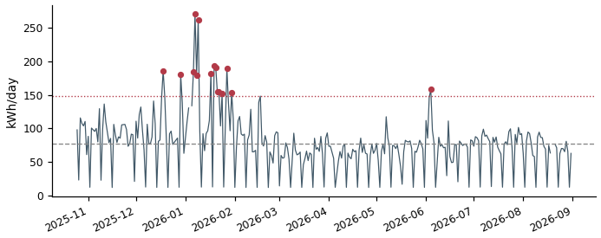

DD83710131752_5 Grid connect  Typical day 62 kWh | Spike threshold 148 kWh | 15 spike days | Total excess 1,623 kWh  On 15 of 295 valid days, this meter used far more energy than its own typical day (62 kWh) — above a threshold of 148 kWh. Together those spike days used an estimated 1,623 kWh more than a normal day for this meter would have. | 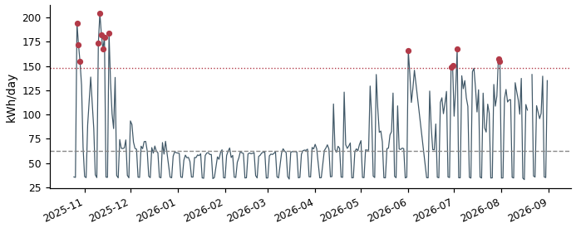

DDC3710136355_5 Grid connect  Typical day 2 kWh | Spike threshold 101 kWh | 15 spike days | Total excess 1,551 kWh  On 15 of 301 valid days, this meter used far more energy than its own typical day (2 kWh) — above a threshold of 101 kWh. Together those spike days used an estimated 1,551 kWh more than a normal day for this meter would have. | 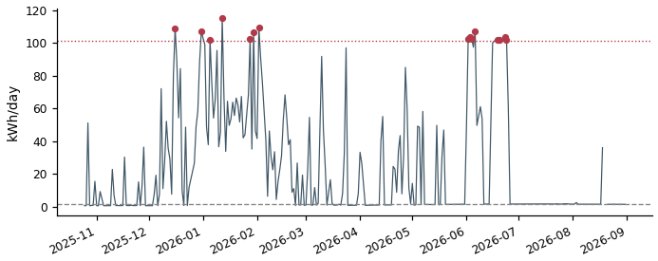

DDC3710136355_4 Grid connect  Typical day 2 kWh | Spike threshold 98 kWh | 15 spike days | Total excess 1,548 kWh  On 15 of 301 valid days, this meter used far more energy than its own typical day (2 kWh) — above a threshold of 98 kWh. Together those spike days used an estimated 1,548 kWh more than a normal day for this meter would have. | 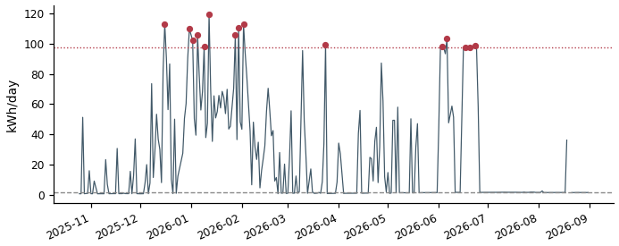

DDC3710136355_3 Grid connect  Typical day 1 kWh | Spike threshold 95 kWh | 15 spike days | Total excess 1,507 kWh  On 15 of 301 valid days, this meter used far more energy than its own typical day (1 kWh) — above a threshold of 95 kWh. Together those spike days used an estimated 1,507 kWh more than a normal day for this meter would have. | 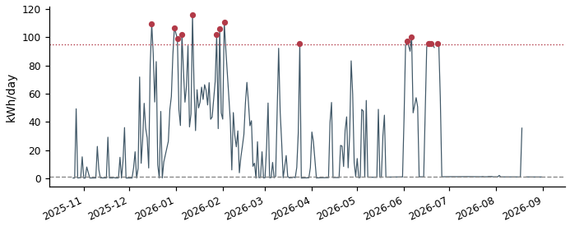

DDB3710136192_1 Electric vehicle  Typical day 57 kWh | Spike threshold 130 kWh | 15 spike days | Total excess 1,368 kWh  On 15 of 299 valid days, this meter used far more energy than its own typical day (57 kWh) — above a threshold of 130 kWh. Together those spike days used an estimated 1,368 kWh more than a normal day for this meter would have. | 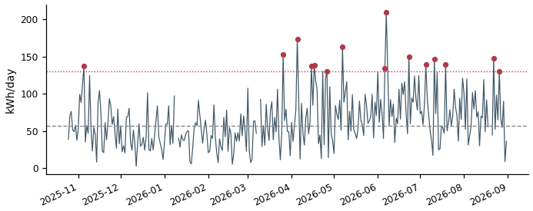

DDB3710136192_2 Electric vehicle  Typical day 55 kWh | Spike threshold 121 kWh | 15 spike days | Total excess 1,338 kWh  On 15 of 299 valid days, this meter used far more energy than its own typical day (55 kWh) — above a threshold of 121 kWh. Together those spike days used an estimated 1,338 kWh more than a normal day for this meter would have. | 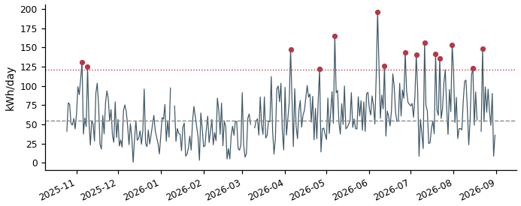

DDB3710136192_0 Electric vehicle  Typical day 58 kWh | Spike threshold 116 kWh | 15 spike days | Total excess 1,271 kWh  On 15 of 299 valid days, this meter used far more energy than its own typical day (58 kWh) — above a threshold of 116 kWh. Together those spike days used an estimated 1,271 kWh more than a normal day for this meter would have. | 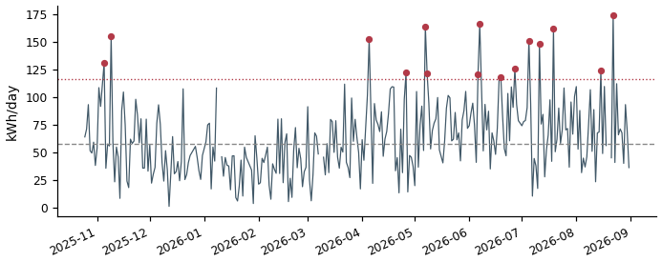

DDA3710148716_3 Electric vehicle  Typical day 14 kWh | Spike threshold 70 kWh | 16 spike days | Total excess 1,194 kWh  On 16 of 302 valid days, this meter used far more energy than its own typical day (14 kWh) — above a threshold of 70 kWh. Together those spike days used an estimated 1,194 kWh more than a normal day for this meter would have. | 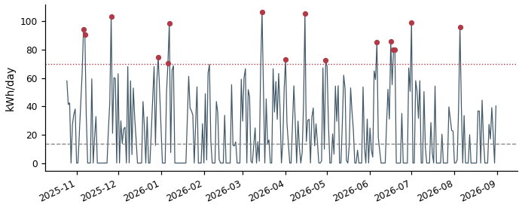

DD83710131752_1 Grid connect  Typical day 45 kWh | Spike threshold 106 kWh | 15 spike days | Total excess 1,028 kWh  On 15 of 295 valid days, this meter used far more energy than its own typical day (45 kWh) — above a threshold of 106 kWh. Together those spike days used an estimated 1,028 kWh more than a normal day for this meter would have. | 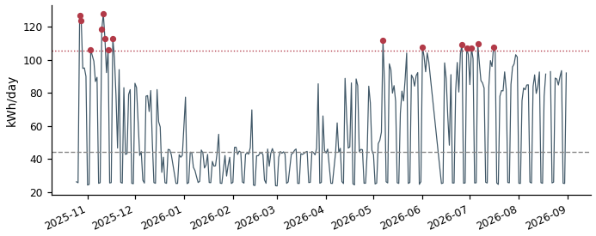

DDA3710148716_1 Air conditioning  Typical day 77 kWh | Spike threshold 138 kWh | 15 spike days | Total excess 1,007 kWh  On 15 of 301 valid days, this meter used far more energy than its own typical day (77 kWh) — above a threshold of 138 kWh. Together those spike days used an estimated 1,007 kWh more than a normal day for this meter would have. | 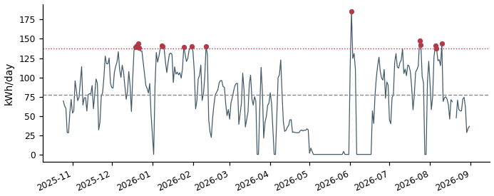

DDA3710148716_0 Air conditioning  Typical day 75 kWh | Spike threshold 134 kWh | 15 spike days | Total excess 990 kWh  On 15 of 301 valid days, this meter used far more energy than its own typical day (75 kWh) — above a threshold of 134 kWh. Together those spike days used an estimated 990 kWh more than a normal day for this meter would have. | 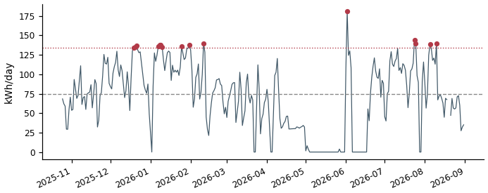

DD83710131752_4 Grid connect  Typical day 27 kWh | Spike threshold 81 kWh | 15 spike days | Total excess 980 kWh  On 15 of 295 valid days, this meter used far more energy than its own typical day (27 kWh) — above a threshold of 81 kWh. Together those spike days used an estimated 980 kWh more than a normal day for this meter would have. | 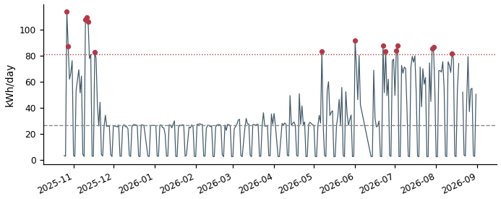

DDA3710148716_2 Air conditioning  Typical day 72 kWh | Spike threshold 130 kWh | 15 spike days | Total excess 973 kWh  On 15 of 301 valid days, this meter used far more energy than its own typical day (72 kWh) — above a threshold of 130 kWh. Together those spike days used an estimated 973 kWh more than a normal day for this meter would have. | 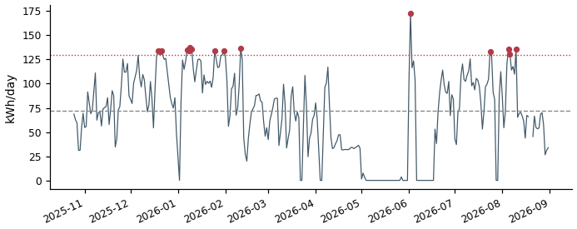

DD83710136482_0 Air conditioning  Typical day 18 kWh | Spike threshold 75 kWh | 15 spike days | Total excess 968 kWh  On 15 of 301 valid days, this meter used far more energy than its own typical day (18 kWh) — above a threshold of 75 kWh. Together those spike days used an estimated 968 kWh more than a normal day for this meter would have. | 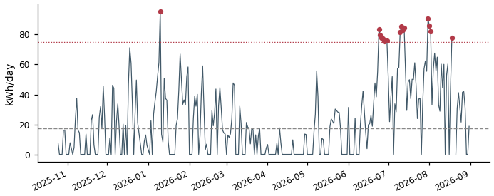

DD23710152475_1 Grid connect  Typical day 80 kWh | Spike threshold 121 kWh | 15 spike days | Total excess 870 kWh  On 15 of 301 valid days, this meter used far more energy than its own typical day (80 kWh) — above a threshold of 121 kWh. Together those spike days used an estimated 870 kWh more than a normal day for this meter would have. | 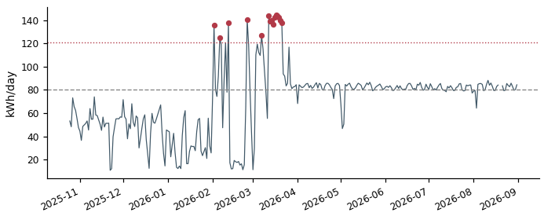

DD23710152475_2 Grid connect  Typical day 28 kWh | Spike threshold 78 kWh | 15 spike days | Total excess 863 kWh  On 15 of 301 valid days, this meter used far more energy than its own typical day (28 kWh) — above a threshold of 78 kWh. Together those spike days used an estimated 863 kWh more than a normal day for this meter would have. | 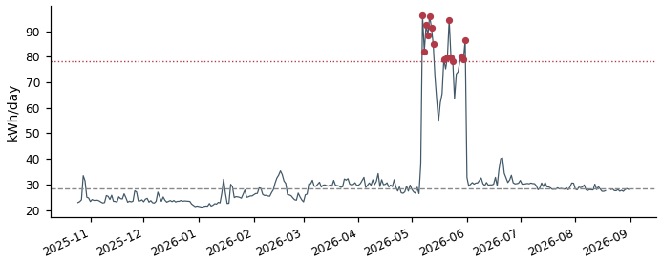

DD83710147339_3 Air conditioning  Typical day 19 kWh | Spike threshold 64 kWh | 15 spike days | Total excess 835 kWh  On 15 of 300 valid days, this meter used far more energy than its own typical day (19 kWh) — above a threshold of 64 kWh. Together those spike days used an estimated 835 kWh more than a normal day for this meter would have. | 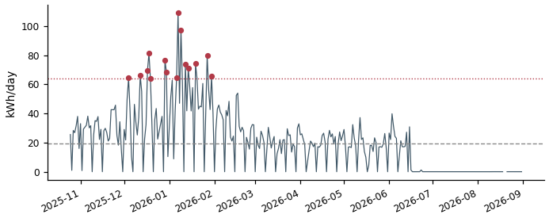

DD83710147339_5 Air conditioning  Typical day 20 kWh | Spike threshold 63 kWh | 15 spike days | Total excess 825 kWh  On 15 of 301 valid days, this meter used far more energy than its own typical day (20 kWh) — above a threshold of 63 kWh. Together those spike days used an estimated 825 kWh more than a normal day for this meter would have. | 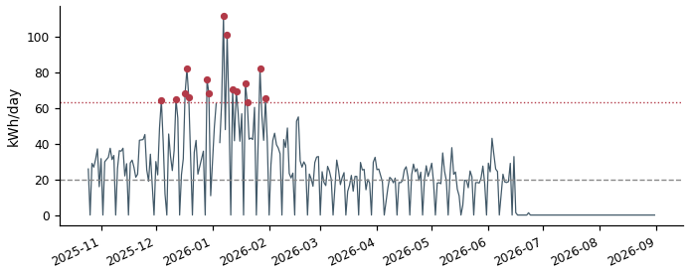

DD83710147339_4 Air conditioning  Typical day 19 kWh | Spike threshold 63 kWh | 15 spike days | Total excess 825 kWh  On 15 of 301 valid days, this meter used far more energy than its own typical day (19 kWh) — above a threshold of 63 kWh. Together those spike days used an estimated 825 kWh more than a normal day for this meter would have. | 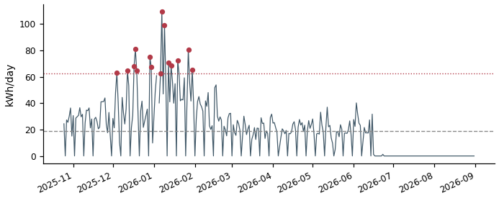

DDE3710159631_2 Grid connect  Typical day 128 kWh | Spike threshold 191 kWh | 10 spike days | Total excess 821 kWh  On 10 of 266 valid days, this meter used far more energy than its own typical day (128 kWh) — above a threshold of 191 kWh. Together those spike days used an estimated 821 kWh more than a normal day for this meter would have. | 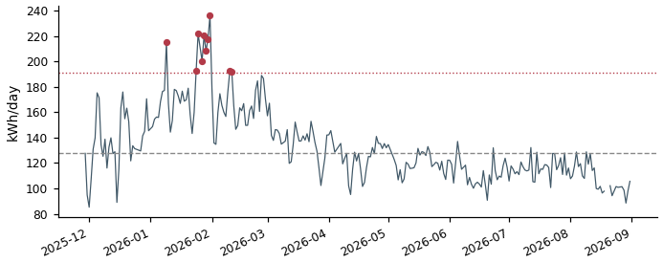

DD33710147083_0 Air conditioning  Typical day 70 kWh | Spike threshold 114 kWh | 15 spike days | Total excess 812 kWh  On 15 of 301 valid days, this meter used far more energy than its own typical day (70 kWh) — above a threshold of 114 kWh. Together those spike days used an estimated 812 kWh more than a normal day for this meter would have. | 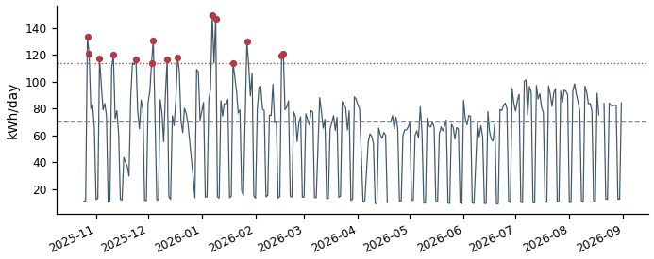

DD83710131752_0 Grid connect  Typical day 43 kWh | Spike threshold 88 kWh | 15 spike days | Total excess 787 kWh  On 15 of 295 valid days, this meter used far more energy than its own typical day (43 kWh) — above a threshold of 88 kWh. Together those spike days used an estimated 787 kWh more than a normal day for this meter would have. | 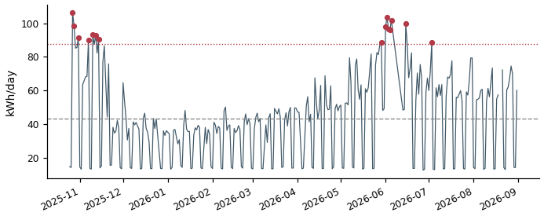

DDE3710159631_0 Grid connect  Typical day 107 kWh | Spike threshold 160 kWh | 12 spike days | Total excess 778 kWh  On 12 of 266 valid days, this meter used far more energy than its own typical day (107 kWh) — above a threshold of 160 kWh. Together those spike days used an estimated 778 kWh more than a normal day for this meter would have. | 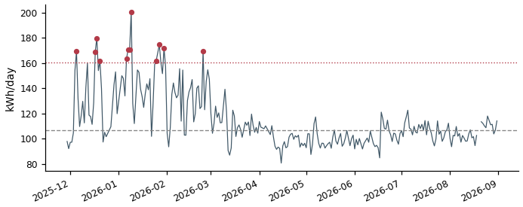

DD53710161362_1 Grid connect  Typical day 20 kWh | Spike threshold 60 kWh | 14 spike days | Total excess 776 kWh  On 14 of 268 valid days, this meter used far more energy than its own typical day (20 kWh) — above a threshold of 60 kWh. Together those spike days used an estimated 776 kWh more than a normal day for this meter would have. | 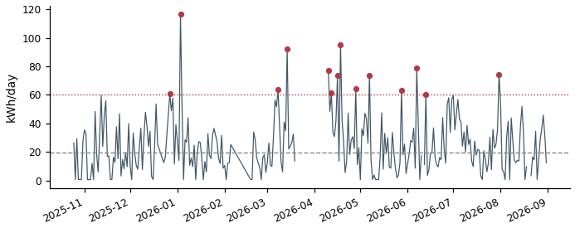

DDF3710131630_3 Grid connect  Typical day 72 kWh | Spike threshold 119 kWh | 15 spike days | Total excess 775 kWh  On 15 of 301 valid days, this meter used far more energy than its own typical day (72 kWh) — above a threshold of 119 kWh. Together those spike days used an estimated 775 kWh more than a normal day for this meter would have. | 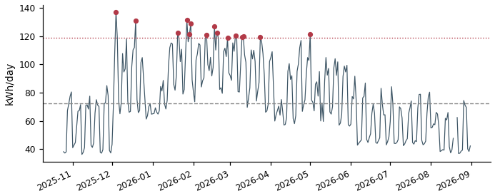

DDE3710136072_3 Air conditioning  Typical day 24 kWh | Spike threshold 64 kWh | 15 spike days | Total excess 768 kWh  On 15 of 301 valid days, this meter used far more energy than its own typical day (24 kWh) — above a threshold of 64 kWh. Together those spike days used an estimated 768 kWh more than a normal day for this meter would have. | 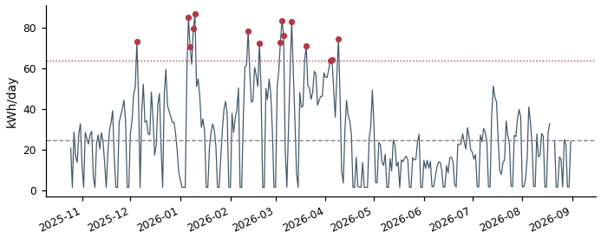

DD53710161362_0 Grid connect  Typical day 20 kWh | Spike threshold 60 kWh | 14 spike days | Total excess 749 kWh  On 14 of 268 valid days, this meter used far more energy than its own typical day (20 kWh) — above a threshold of 60 kWh. Together those spike days used an estimated 749 kWh more than a normal day for this meter would have. | 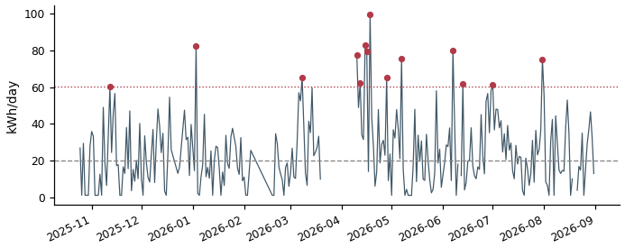

DD53710161362_2 Grid connect  Typical day 20 kWh | Spike threshold 59 kWh | 14 spike days | Total excess 723 kWh  On 14 of 268 valid days, this meter used far more energy than its own typical day (20 kWh) — above a threshold of 59 kWh. Together those spike days used an estimated 723 kWh more than a normal day for this meter would have. | 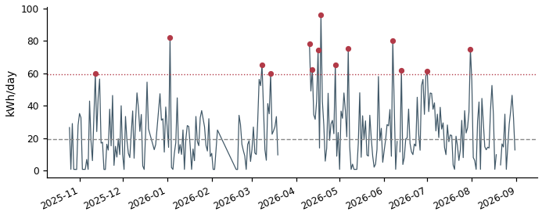

DD43710148726_3 Lighting & Power  Typical day 103 kWh | Spike threshold 155 kWh | 12 spike days | Total excess 718 kWh  On 12 of 266 valid days, this meter used far more energy than its own typical day (103 kWh) — above a threshold of 155 kWh. Together those spike days used an estimated 718 kWh more than a normal day for this meter would have. | 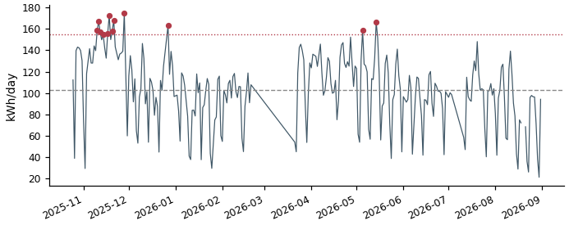

DDE3710136072_0 Air conditioning  Typical day 14 kWh | Spike threshold 51 kWh | 15 spike days | Total excess 671 kWh  On 15 of 301 valid days, this meter used far more energy than its own typical day (14 kWh) — above a threshold of 51 kWh. Together those spike days used an estimated 671 kWh more than a normal day for this meter would have. | 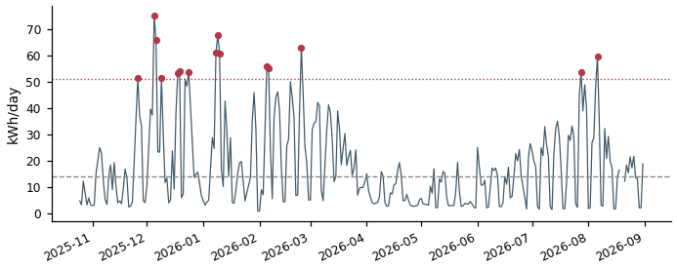

DD83710131752_2 Grid connect  Typical day 33 kWh | Spike threshold 71 kWh | 15 spike days | Total excess 655 kWh  On 15 of 295 valid days, this meter used far more energy than its own typical day (33 kWh) — above a threshold of 71 kWh. Together those spike days used an estimated 655 kWh more than a normal day for this meter would have. | 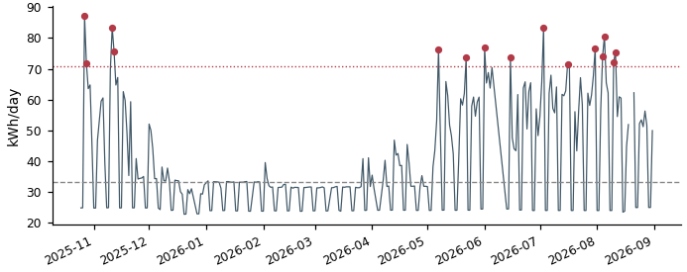

DDF3710131630_4 Grid connect  Typical day 68 kWh | Spike threshold 106 kWh | 15 spike days | Total excess 650 kWh  On 15 of 301 valid days, this meter used far more energy than its own typical day (68 kWh) — above a threshold of 106 kWh. Together those spike days used an estimated 650 kWh more than a normal day for this meter would have. | 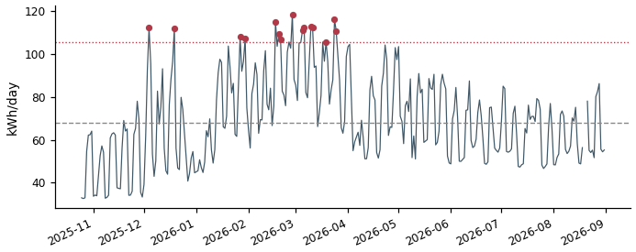

DDF3710131630_0 Grid connect  Typical day 49 kWh | Spike threshold 80 kWh | 15 spike days | Total excess 633 kWh  On 15 of 301 valid days, this meter used far more energy than its own typical day (49 kWh) — above a threshold of 80 kWh. Together those spike days used an estimated 633 kWh more than a normal day for this meter would have. | 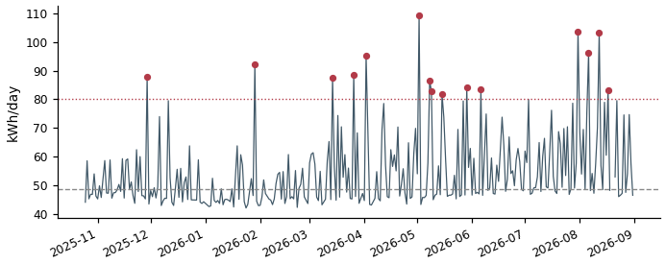

DD33710148405_4 Air conditioning  Typical day 8 kWh | Spike threshold 37 kWh | 15 spike days | Total excess 593 kWh  On 15 of 301 valid days, this meter used far more energy than its own typical day (8 kWh) — above a threshold of 37 kWh. Together those spike days used an estimated 593 kWh more than a normal day for this meter would have. | 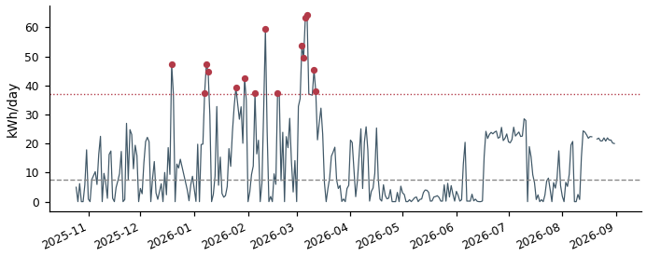

DD33710148405_0 Air conditioning  Typical day 23 kWh | Spike threshold 58 kWh | 15 spike days | Total excess 589 kWh  On 15 of 301 valid days, this meter used far more energy than its own typical day (23 kWh) — above a threshold of 58 kWh. Together those spike days used an estimated 589 kWh more than a normal day for this meter would have. | 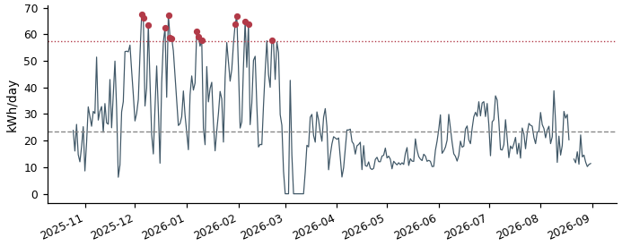

DD33710148405_1 Air conditioning  Typical day 23 kWh | Spike threshold 56 kWh | 15 spike days | Total excess 584 kWh  On 15 of 301 valid days, this meter used far more energy than its own typical day (23 kWh) — above a threshold of 56 kWh. Together those spike days used an estimated 584 kWh more than a normal day for this meter would have. | 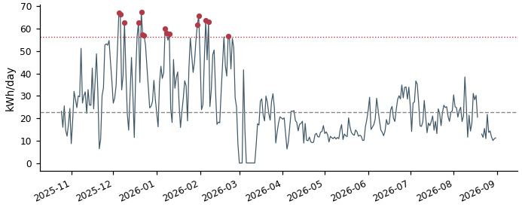

DD33710148405_5 Air conditioning  Typical day 8 kWh | Spike threshold 37 kWh | 15 spike days | Total excess 579 kWh  On 15 of 301 valid days, this meter used far more energy than its own typical day (8 kWh) — above a threshold of 37 kWh. Together those spike days used an estimated 579 kWh more than a normal day for this meter would have. | 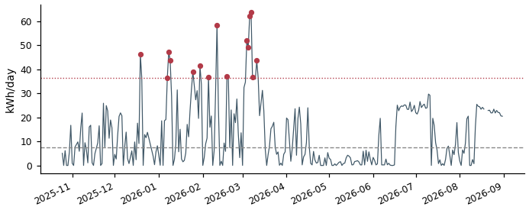

DD33710148405_2 Air conditioning  Typical day 23 kWh | Spike threshold 57 kWh | 15 spike days | Total excess 578 kWh  On 15 of 301 valid days, this meter used far more energy than its own typical day (23 kWh) — above a threshold of 57 kWh. Together those spike days used an estimated 578 kWh more than a normal day for this meter would have. | 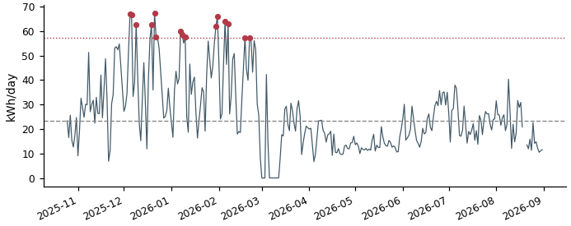

DD63710153384_4 Grid connect  Typical day 74 kWh | Spike threshold 111 kWh | 12 spike days | Total excess 575 kWh  On 12 of 288 valid days, this meter used far more energy than its own typical day (74 kWh) — above a threshold of 111 kWh. Together those spike days used an estimated 575 kWh more than a normal day for this meter would have. | 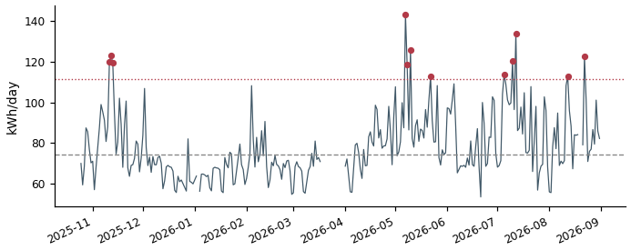

DD83710136482_2 Air conditioning  Typical day 9 kWh | Spike threshold 38 kWh | 15 spike days | Total excess 566 kWh  On 15 of 301 valid days, this meter used far more energy than its own typical day (9 kWh) — above a threshold of 38 kWh. Together those spike days used an estimated 566 kWh more than a normal day for this meter would have. | 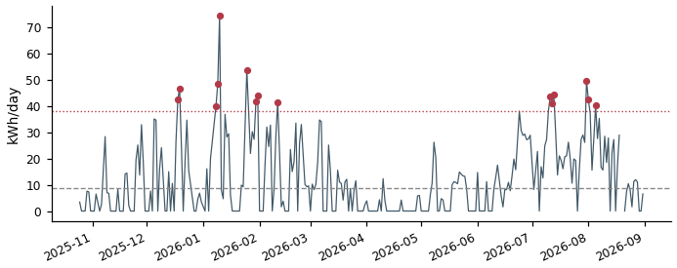

DD33710148405_3 Air conditioning  Typical day 9 kWh | Spike threshold 37 kWh | 15 spike days | Total excess 560 kWh  On 15 of 301 valid days, this meter used far more energy than its own typical day (9 kWh) — above a threshold of 37 kWh. Together those spike days used an estimated 560 kWh more than a normal day for this meter would have. | 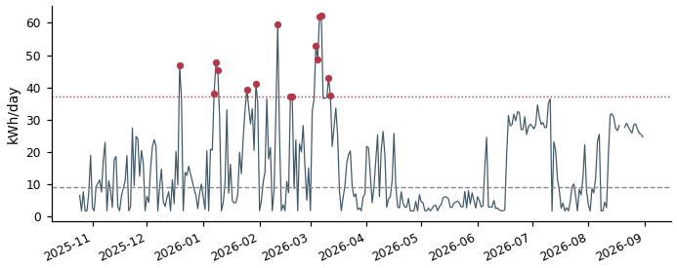

DD33710148727_1 Lighting & Power  Typical day 56 kWh | Spike threshold 84 kWh | 15 spike days | Total excess 555 kWh  On 15 of 301 valid days, this meter used far more energy than its own typical day (56 kWh) — above a threshold of 84 kWh. Together those spike days used an estimated 555 kWh more than a normal day for this meter would have. | 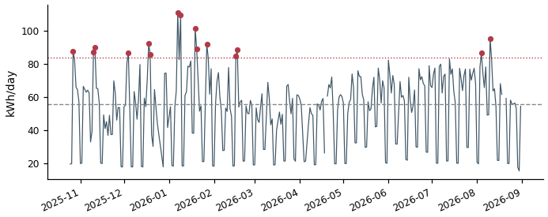

DD73710150283_0 Grid connect  Typical day 34 kWh | Spike threshold 60 kWh | 14 spike days | Total excess 549 kWh  On 14 of 281 valid days, this meter used far more energy than its own typical day (34 kWh) — above a threshold of 60 kWh. Together those spike days used an estimated 549 kWh more than a normal day for this meter would have. | 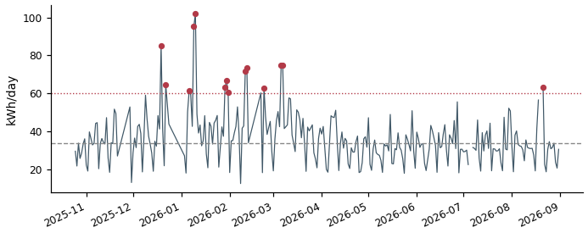

DDE3710136072_5 Air conditioning  Typical day 21 kWh | Spike threshold 51 kWh | 15 spike days | Total excess 539 kWh  On 15 of 301 valid days, this meter used far more energy than its own typical day (21 kWh) — above a threshold of 51 kWh. Together those spike days used an estimated 539 kWh more than a normal day for this meter would have. | 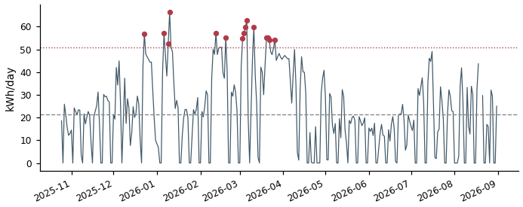

DD33710147083_1 Air conditioning  Typical day 27 kWh | Spike threshold 52 kWh | 15 spike days | Total excess 536 kWh  On 15 of 301 valid days, this meter used far more energy than its own typical day (27 kWh) — above a threshold of 52 kWh. Together those spike days used an estimated 536 kWh more than a normal day for this meter would have. | 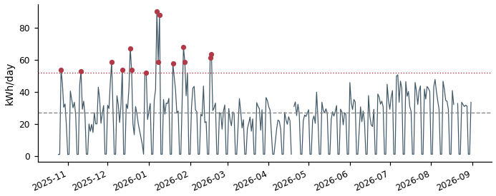

DDF3710131630_5 Grid connect  Typical day 26 kWh | Spike threshold 57 kWh | 15 spike days | Total excess 530 kWh  On 15 of 301 valid days, this meter used far more energy than its own typical day (26 kWh) — above a threshold of 57 kWh. Together those spike days used an estimated 530 kWh more than a normal day for this meter would have. | 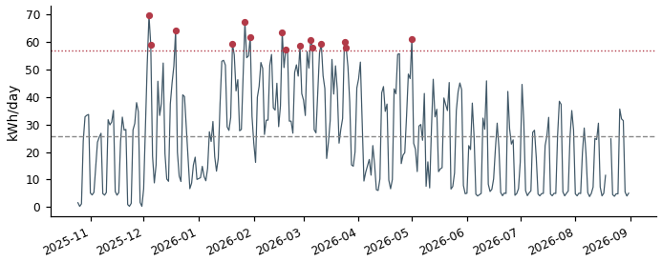

DD33710147083_2 Air conditioning  Typical day 26 kWh | Spike threshold 51 kWh | 15 spike days | Total excess 525 kWh  On 15 of 301 valid days, this meter used far more energy than its own typical day (26 kWh) — above a threshold of 51 kWh. Together those spike days used an estimated 525 kWh more than a normal day for this meter would have. | 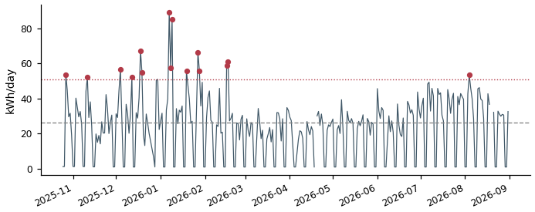

DD43710148726_5 Lighting & Power  Typical day 64 kWh | Spike threshold 96 kWh | 13 spike days | Total excess 494 kWh  On 13 of 266 valid days, this meter used far more energy than its own typical day (64 kWh) — above a threshold of 96 kWh. Together those spike days used an estimated 494 kWh more than a normal day for this meter would have. | 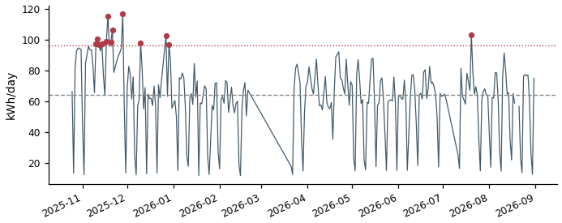

DD63710147032_4 Air conditioning  Typical day 7 kWh | Spike threshold 24 kWh | 15 spike days | Total excess 494 kWh  On 15 of 301 valid days, this meter used far more energy than its own typical day (7 kWh) — above a threshold of 24 kWh. Together those spike days used an estimated 494 kWh more than a normal day for this meter would have. | 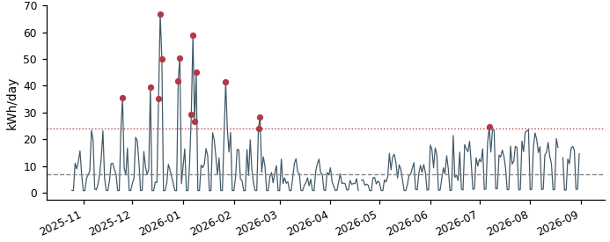

DD43710136454_3 Grid connect  Typical day 55 kWh | Spike threshold 87 kWh | 12 spike days | Total excess 485 kWh  On 12 of 240 valid days, this meter used far more energy than its own typical day (55 kWh) — above a threshold of 87 kWh. Together those spike days used an estimated 485 kWh more than a normal day for this meter would have. | 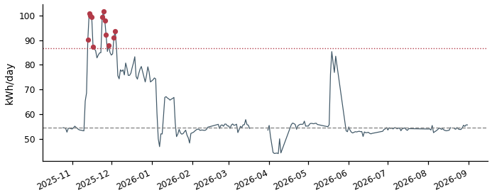

DD63710147032_1 Lighting & Power  Typical day 26 kWh | Spike threshold 42 kWh | 15 spike days | Total excess 482 kWh  On 15 of 301 valid days, this meter used far more energy than its own typical day (26 kWh) — above a threshold of 42 kWh. Together those spike days used an estimated 482 kWh more than a normal day for this meter would have. | 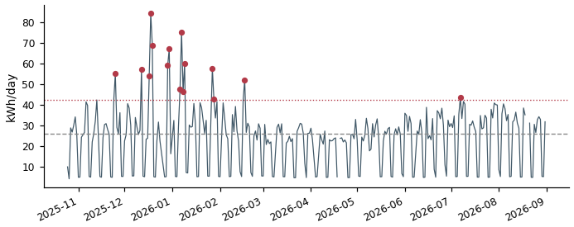

DDC3710136170_3 Air conditioning  Typical day 30 kWh | Spike threshold 47 kWh | 15 spike days | Total excess 481 kWh  On 15 of 301 valid days, this meter used far more energy than its own typical day (30 kWh) — above a threshold of 47 kWh. Together those spike days used an estimated 481 kWh more than a normal day for this meter would have. | 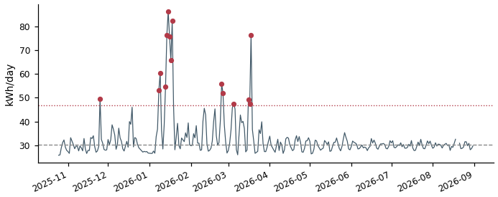

DD23710152475_0 Grid connect  Typical day 42 kWh | Spike threshold 65 kWh | 15 spike days | Total excess 475 kWh  On 15 of 301 valid days, this meter used far more energy than its own typical day (42 kWh) — above a threshold of 65 kWh. Together those spike days used an estimated 475 kWh more than a normal day for this meter would have. | 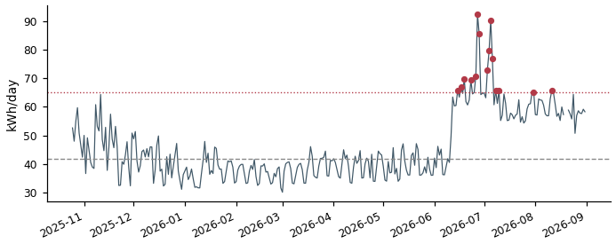

DDF3710131630_2 Grid connect  Typical day 44 kWh | Spike threshold 66 kWh | 15 spike days | Total excess 464 kWh  On 15 of 301 valid days, this meter used far more energy than its own typical day (44 kWh) — above a threshold of 66 kWh. Together those spike days used an estimated 464 kWh more than a normal day for this meter would have. | 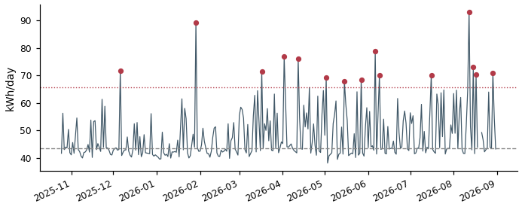

DDE3710136072_1 Air conditioning  Typical day 8 kWh | Spike threshold 32 kWh | 15 spike days | Total excess 451 kWh  On 15 of 301 valid days, this meter used far more energy than its own typical day (8 kWh) — above a threshold of 32 kWh. Together those spike days used an estimated 451 kWh more than a normal day for this meter would have. | 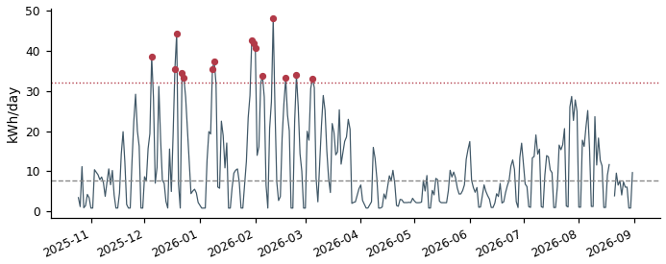

DDC3710136170_4 Air conditioning  Typical day 4 kWh | Spike threshold 20 kWh | 15 spike days | Total excess 448 kWh  On 15 of 301 valid days, this meter used far more energy than its own typical day (4 kWh) — above a threshold of 20 kWh. Together those spike days used an estimated 448 kWh more than a normal day for this meter would have. | 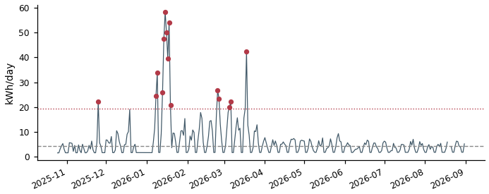

DD73710150283_2 Grid connect  Typical day 37 kWh | Spike threshold 62 kWh | 14 spike days | Total excess 448 kWh  On 14 of 281 valid days, this meter used far more energy than its own typical day (37 kWh) — above a threshold of 62 kWh. Together those spike days used an estimated 448 kWh more than a normal day for this meter would have. | 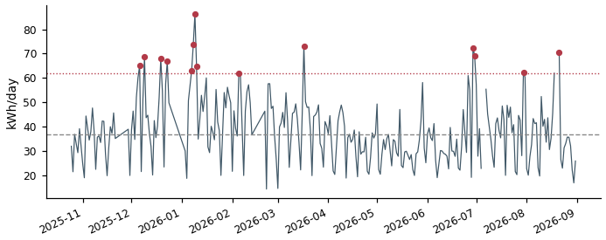

DDE3710136072_4 Air conditioning  Typical day 18 kWh | Spike threshold 43 kWh | 15 spike days | Total excess 447 kWh  On 15 of 301 valid days, this meter used far more energy than its own typical day (18 kWh) — above a threshold of 43 kWh. Together those spike days used an estimated 447 kWh more than a normal day for this meter would have. | 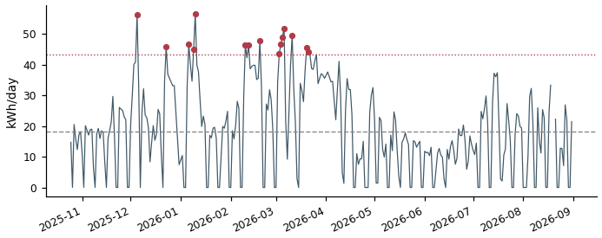

DDB3710141068_0 Lighting & Power  Typical day 26 kWh | Spike threshold 50 kWh | 15 spike days | Total excess 447 kWh  On 15 of 293 valid days, this meter used far more energy than its own typical day (26 kWh) — above a threshold of 50 kWh. Together those spike days used an estimated 447 kWh more than a normal day for this meter would have. | 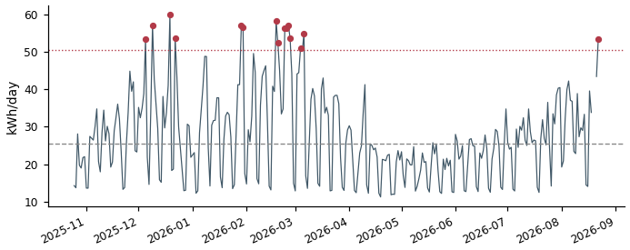

DD83710136482_1 Air conditioning  Typical day 8 kWh | Spike threshold 33 kWh | 15 spike days | Total excess 444 kWh  On 15 of 301 valid days, this meter used far more energy than its own typical day (8 kWh) — above a threshold of 33 kWh. Together those spike days used an estimated 444 kWh more than a normal day for this meter would have. | 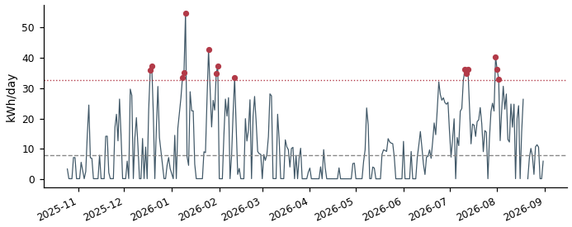

DDE3710159631_1 Grid connect  Typical day 49 kWh | Spike threshold 74 kWh | 14 spike days | Total excess 422 kWh  On 14 of 266 valid days, this meter used far more energy than its own typical day (49 kWh) — above a threshold of 74 kWh. Together those spike days used an estimated 422 kWh more than a normal day for this meter would have. | 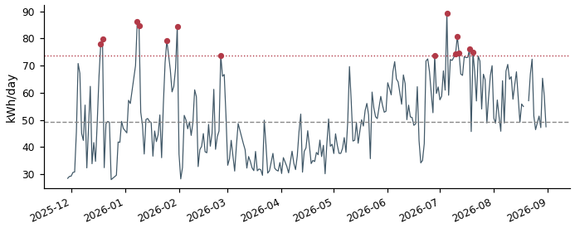

DD25335317259_2 Grid connect  Typical day 23 kWh | Spike threshold 46 kWh | 15 spike days | Total excess 419 kWh  On 15 of 301 valid days, this meter used far more energy than its own typical day (23 kWh) — above a threshold of 46 kWh. Together those spike days used an estimated 419 kWh more than a normal day for this meter would have. | 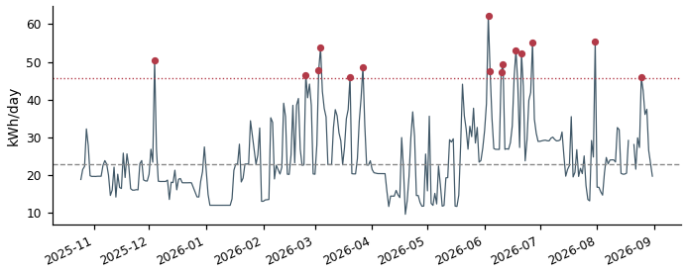

DD03710131908_3 Grid connect  Typical day 6 kWh | Spike threshold 32 kWh | 15 spike days | Total excess 417 kWh  On 15 of 288 valid days, this meter used far more energy than its own typical day (6 kWh) — above a threshold of 32 kWh. Together those spike days used an estimated 417 kWh more than a normal day for this meter would have. | 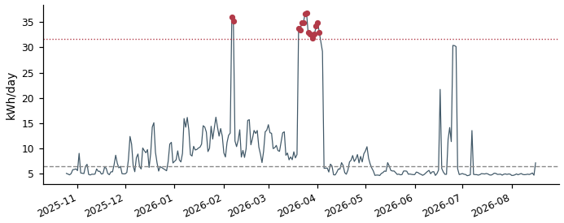

DDE3710136072_2 Air conditioning  Typical day 8 kWh | Spike threshold 28 kWh | 15 spike days | Total excess 399 kWh  On 15 of 301 valid days, this meter used far more energy than its own typical day (8 kWh) — above a threshold of 28 kWh. Together those spike days used an estimated 399 kWh more than a normal day for this meter would have. | 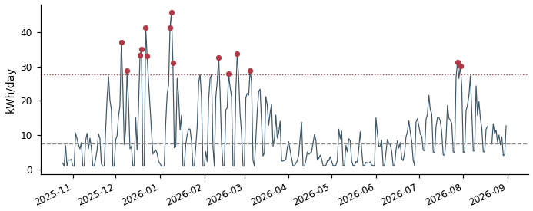

DD63710147032_5 Air conditioning  Typical day 5 kWh | Spike threshold 21 kWh | 15 spike days | Total excess 383 kWh  On 15 of 301 valid days, this meter used far more energy than its own typical day (5 kWh) — above a threshold of 21 kWh. Together those spike days used an estimated 383 kWh more than a normal day for this meter would have. | 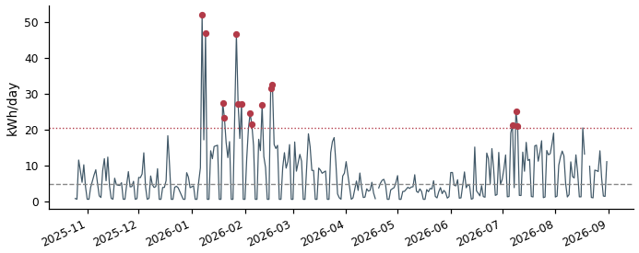

DD93710152906_3 Grid connect  Typical day 78 kWh | Spike threshold 116 kWh | 8 spike days | Total excess 376 kWh  On 8 of 301 valid days, this meter used far more energy than its own typical day (78 kWh) — above a threshold of 116 kWh. Together those spike days used an estimated 376 kWh more than a normal day for this meter would have. | 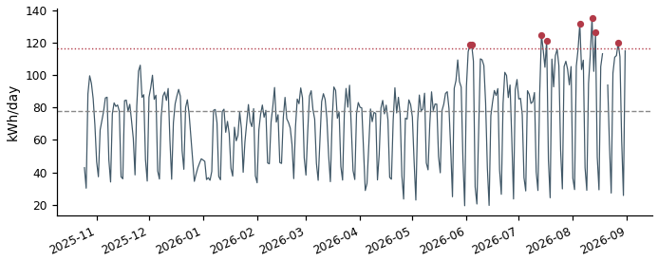

DD23710148637_2 Grid connect  Typical day 30 kWh | Spike threshold 53 kWh | 15 spike days | Total excess 371 kWh  On 15 of 301 valid days, this meter used far more energy than its own typical day (30 kWh) — above a threshold of 53 kWh. Together those spike days used an estimated 371 kWh more than a normal day for this meter would have. | 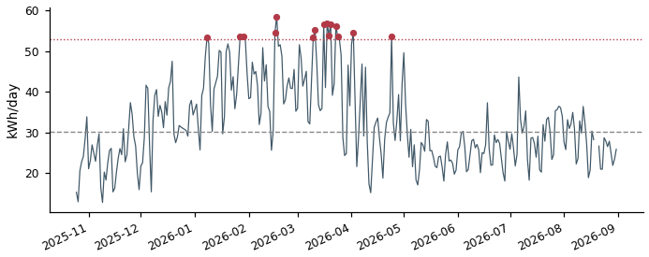

DD73710150170_0 Air conditioning  Typical day 25 kWh | Spike threshold 48 kWh | 13 spike days | Total excess 365 kWh  On 13 of 253 valid days, this meter used far more energy than its own typical day (25 kWh) — above a threshold of 48 kWh. Together those spike days used an estimated 365 kWh more than a normal day for this meter would have. | 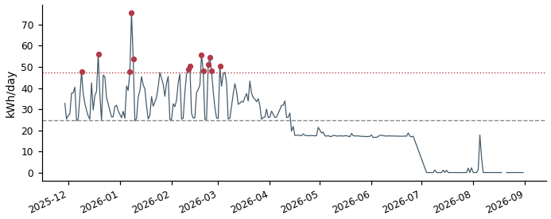

DD43710136454_0 Grid connect  Typical day 31 kWh | Spike threshold 56 kWh | 12 spike days | Total excess 363 kWh  On 12 of 240 valid days, this meter used far more energy than its own typical day (31 kWh) — above a threshold of 56 kWh. Together those spike days used an estimated 363 kWh more than a normal day for this meter would have. | 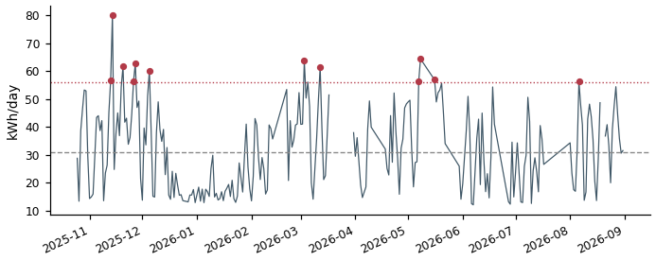

DD63710147032_2 Lighting & Power  Typical day 41 kWh | Spike threshold 62 kWh | 12 spike days | Total excess 362 kWh  On 12 of 301 valid days, this meter used far more energy than its own typical day (41 kWh) — above a threshold of 62 kWh. Together those spike days used an estimated 362 kWh more than a normal day for this meter would have. | 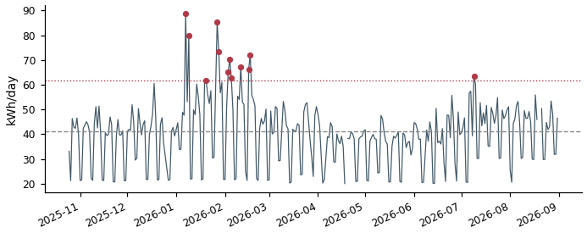

DD33710148566_0 Lighting & Power  Typical day 96 kWh | Spike threshold 145 kWh | 7 spike days | Total excess 361 kWh  On 7 of 296 valid days, this meter used far more energy than its own typical day (96 kWh) — above a threshold of 145 kWh. Together those spike days used an estimated 361 kWh more than a normal day for this meter would have. | 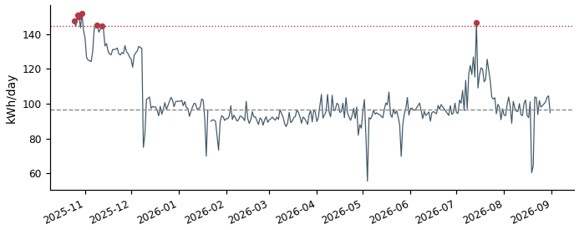

DD13710147065_0 Grid connect  Typical day 1 kWh | Spike threshold 20 kWh | 15 spike days | Total excess 361 kWh  On 15 of 301 valid days, this meter used far more energy than its own typical day (1 kWh) — above a threshold of 20 kWh. Together those spike days used an estimated 361 kWh more than a normal day for this meter would have. | 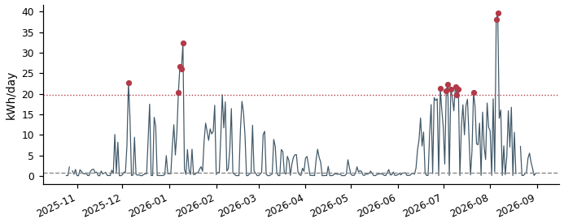

DDB3710149676_4 Air conditioning  Typical day 3 kWh | Spike threshold 14 kWh | 15 spike days | Total excess 361 kWh  On 15 of 301 valid days, this meter used far more energy than its own typical day (3 kWh) — above a threshold of 14 kWh. Together those spike days used an estimated 361 kWh more than a normal day for this meter would have. | 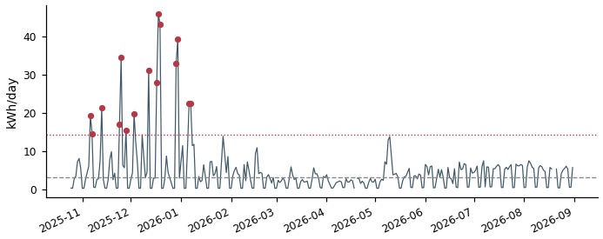

DD73710150283_1 Grid connect  Typical day 37 kWh | Spike threshold 57 kWh | 14 spike days | Total excess 358 kWh  On 14 of 281 valid days, this meter used far more energy than its own typical day (37 kWh) — above a threshold of 57 kWh. Together those spike days used an estimated 358 kWh more than a normal day for this meter would have. | 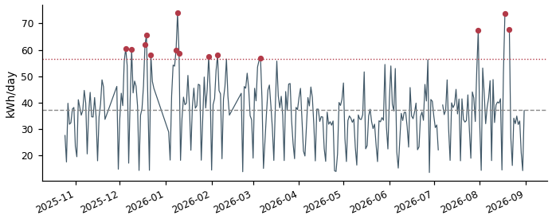

DDF3710131630_1 Grid connect  Typical day 52 kWh | Spike threshold 78 kWh | 11 spike days | Total excess 357 kWh  On 11 of 301 valid days, this meter used far more energy than its own typical day (52 kWh) — above a threshold of 78 kWh. Together those spike days used an estimated 357 kWh more than a normal day for this meter would have. | 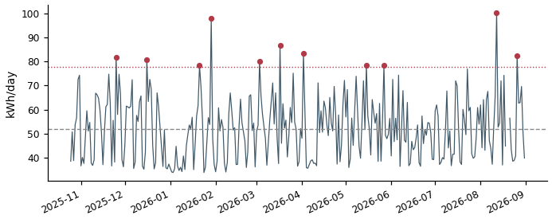

DD73710136266_0 Air conditioning  Typical day 24 kWh | Spike threshold 45 kWh | 13 spike days | Total excess 355 kWh  On 13 of 248 valid days, this meter used far more energy than its own typical day (24 kWh) — above a threshold of 45 kWh. Together those spike days used an estimated 355 kWh more than a normal day for this meter would have. | 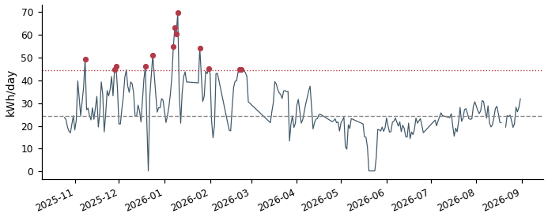

DD53710136492_1 Grid connect  Typical day 32 kWh | Spike threshold 51 kWh | 15 spike days | Total excess 354 kWh  On 15 of 294 valid days, this meter used far more energy than its own typical day (32 kWh) — above a threshold of 51 kWh. Together those spike days used an estimated 354 kWh more than a normal day for this meter would have. | 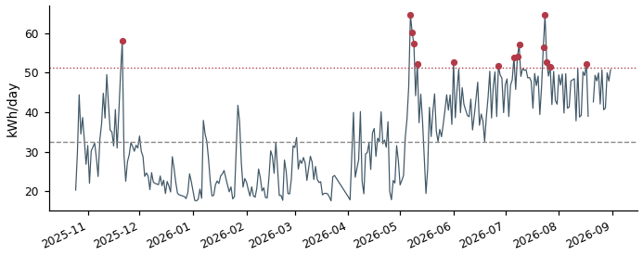

DDD3710148556_2 Grid connect  Typical day 95 kWh | Spike threshold 142 kWh | 7 spike days | Total excess 349 kWh  On 7 of 297 valid days, this meter used far more energy than its own typical day (95 kWh) — above a threshold of 142 kWh. Together those spike days used an estimated 349 kWh more than a normal day for this meter would have. | 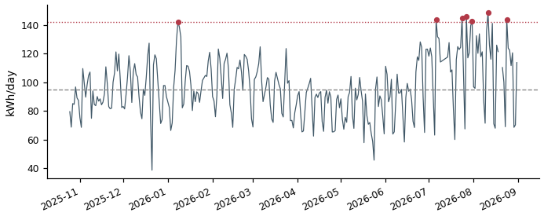

DDB3710149676_3 Air conditioning  Typical day 4 kWh | Spike threshold 19 kWh | 15 spike days | Total excess 347 kWh  On 15 of 301 valid days, this meter used far more energy than its own typical day (4 kWh) — above a threshold of 19 kWh. Together those spike days used an estimated 347 kWh more than a normal day for this meter would have. | 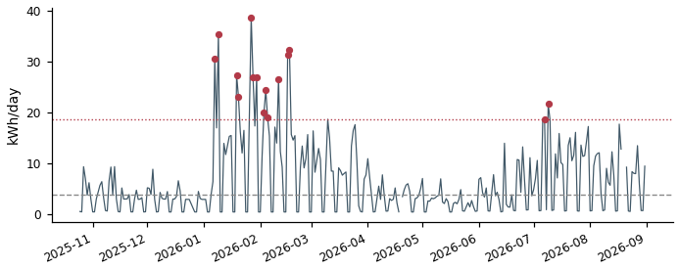

DD83710151237_5 Air conditioning  Typical day 5 kWh | Spike threshold 21 kWh | 15 spike days | Total excess 333 kWh  On 15 of 299 valid days, this meter used far more energy than its own typical day (5 kWh) — above a threshold of 21 kWh. Together those spike days used an estimated 333 kWh more than a normal day for this meter would have. | 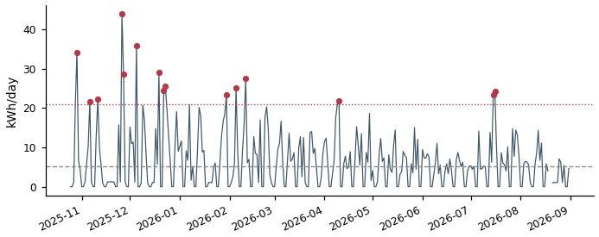

DD63710153384_5 Grid connect  Typical day 95 kWh | Spike threshold 142 kWh | 6 spike days | Total excess 329 kWh  On 6 of 288 valid days, this meter used far more energy than its own typical day (95 kWh) — above a threshold of 142 kWh. Together those spike days used an estimated 329 kWh more than a normal day for this meter would have. | 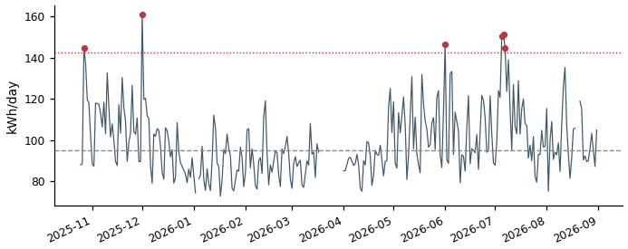

DDB3710148786_0 Grid connect  Typical day 5 kWh | Spike threshold 21 kWh | 15 spike days | Total excess 322 kWh  On 15 of 294 valid days, this meter used far more energy than its own typical day (5 kWh) — above a threshold of 21 kWh. Together those spike days used an estimated 322 kWh more than a normal day for this meter would have. | 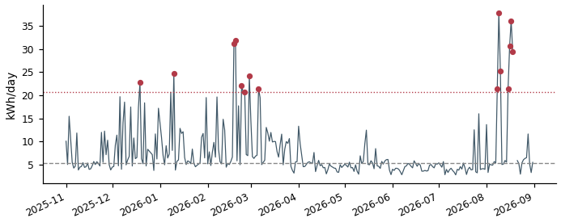

DD43710136454_2 Grid connect  Typical day 16 kWh | Spike threshold 36 kWh | 12 spike days | Total excess 301 kWh  On 12 of 240 valid days, this meter used far more energy than its own typical day (16 kWh) — above a threshold of 36 kWh. Together those spike days used an estimated 301 kWh more than a normal day for this meter would have. | 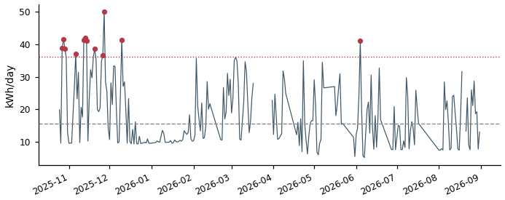

DDB3710141068_2 Lighting & Power  Typical day 33 kWh | Spike threshold 50 kWh | 14 spike days | Total excess 296 kWh  On 14 of 293 valid days, this meter used far more energy than its own typical day (33 kWh) — above a threshold of 50 kWh. Together those spike days used an estimated 296 kWh more than a normal day for this meter would have. | 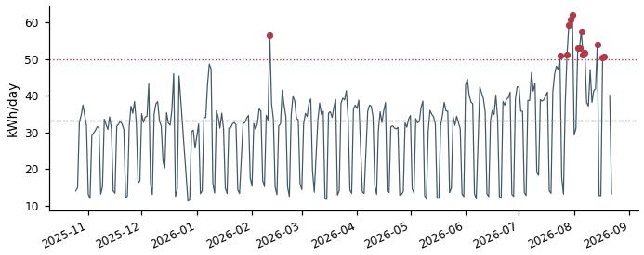

DD33710148032_2 Grid connect  Typical day 31 kWh | Spike threshold 47 kWh | 15 spike days | Total excess 284 kWh  On 15 of 301 valid days, this meter used far more energy than its own typical day (31 kWh) — above a threshold of 47 kWh. Together those spike days used an estimated 284 kWh more than a normal day for this meter would have. | 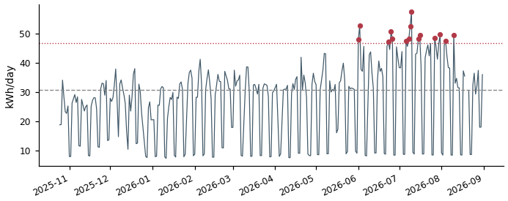

DD73710136266_1 Air conditioning  Typical day 20 kWh | Spike threshold 35 kWh | 13 spike days | Total excess 278 kWh  On 13 of 248 valid days, this meter used far more energy than its own typical day (20 kWh) — above a threshold of 35 kWh. Together those spike days used an estimated 278 kWh more than a normal day for this meter would have. | 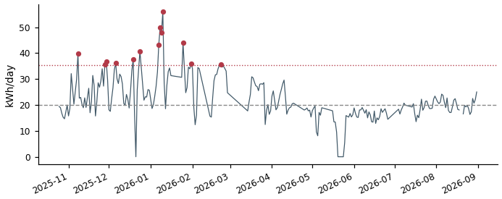

DD73710136266_2 Air conditioning  Typical day 20 kWh | Spike threshold 35 kWh | 13 spike days | Total excess 267 kWh  On 13 of 248 valid days, this meter used far more energy than its own typical day (20 kWh) — above a threshold of 35 kWh. Together those spike days used an estimated 267 kWh more than a normal day for this meter would have. | 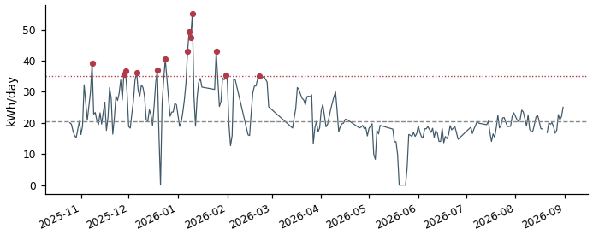

DDC3710136170_2 Grid connect  Typical day 77 kWh | Spike threshold 115 kWh | 5 spike days | Total excess 261 kWh  On 5 of 301 valid days, this meter used far more energy than its own typical day (77 kWh) — above a threshold of 115 kWh. Together those spike days used an estimated 261 kWh more than a normal day for this meter would have. | 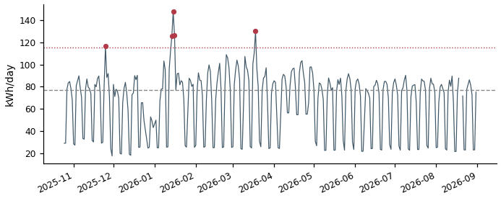

DD63710152870_4 Grid connect  Typical day 9 kWh | Spike threshold 20 kWh | 15 spike days | Total excess 259 kWh  On 15 of 294 valid days, this meter used far more energy than its own typical day (9 kWh) — above a threshold of 20 kWh. Together those spike days used an estimated 259 kWh more than a normal day for this meter would have. | 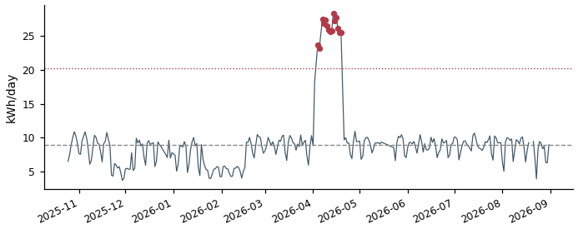

DDF3710148720_2 Air conditioning  Typical day 2 kWh | Spike threshold 13 kWh | 15 spike days | Total excess 242 kWh  On 15 of 301 valid days, this meter used far more energy than its own typical day (2 kWh) — above a threshold of 13 kWh. Together those spike days used an estimated 242 kWh more than a normal day for this meter would have. | 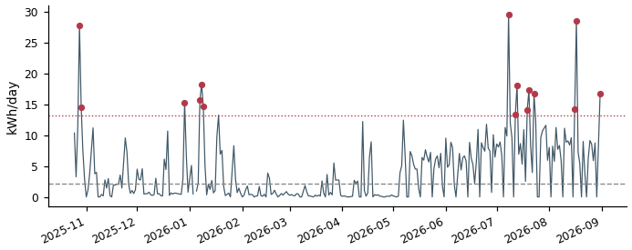

DD83710136482_3 Air conditioning  Typical day 6 kWh | Spike threshold 15 kWh | 15 spike days | Total excess 228 kWh  On 15 of 301 valid days, this meter used far more energy than its own typical day (6 kWh) — above a threshold of 15 kWh. Together those spike days used an estimated 228 kWh more than a normal day for this meter would have. | 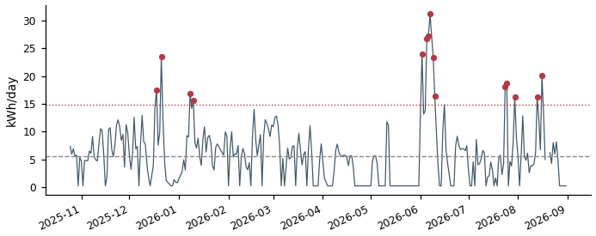

DD63710152870_5 Grid connect  Typical day 9 kWh | Spike threshold 17 kWh | 15 spike days | Total excess 223 kWh  On 15 of 294 valid days, this meter used far more energy than its own typical day (9 kWh) — above a threshold of 17 kWh. Together those spike days used an estimated 223 kWh more than a normal day for this meter would have. | 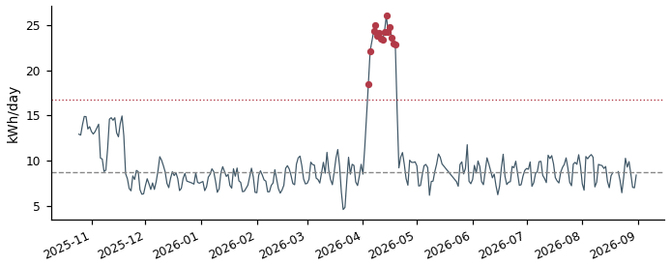

DD83710151237_3 Air conditioning  Typical day 7 kWh | Spike threshold 18 kWh | 15 spike days | Total excess 218 kWh  On 15 of 299 valid days, this meter used far more energy than its own typical day (7 kWh) — above a threshold of 18 kWh. Together those spike days used an estimated 218 kWh more than a normal day for this meter would have. | 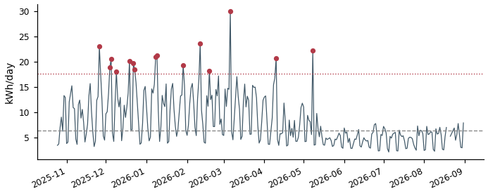

DDF3710148720_1 Air conditioning  Typical day 4 kWh | Spike threshold 14 kWh | 15 spike days | Total excess 215 kWh  On 15 of 301 valid days, this meter used far more energy than its own typical day (4 kWh) — above a threshold of 14 kWh. Together those spike days used an estimated 215 kWh more than a normal day for this meter would have. | 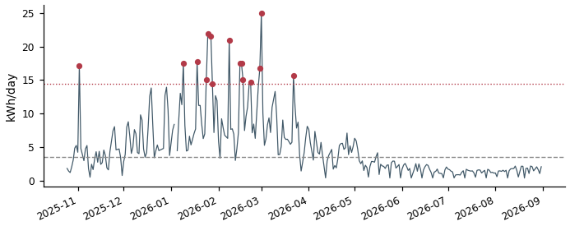

DDB3710149676_1 Air conditioning  Typical day 3 kWh | Spike threshold 14 kWh | 15 spike days | Total excess 209 kWh  On 15 of 301 valid days, this meter used far more energy than its own typical day (3 kWh) — above a threshold of 14 kWh. Together those spike days used an estimated 209 kWh more than a normal day for this meter would have. | 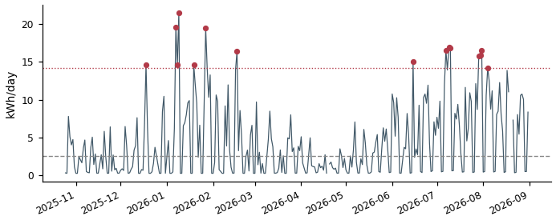

DD13710149684_1 Air conditioning  Typical day 130 kWh | Spike threshold 195 kWh | 3 spike days | Total excess 204 kWh  On 3 of 301 valid days, this meter used far more energy than its own typical day (130 kWh) — above a threshold of 195 kWh. Together those spike days used an estimated 204 kWh more than a normal day for this meter would have. | 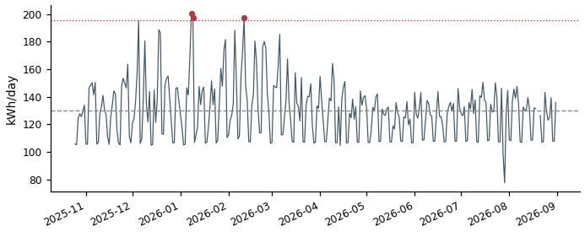

DD43710148528_0 Air conditioning  Typical day 10 kWh | Spike threshold 20 kWh | 14 spike days | Total excess 203 kWh  On 14 of 274 valid days, this meter used far more energy than its own typical day (10 kWh) — above a threshold of 20 kWh. Together those spike days used an estimated 203 kWh more than a normal day for this meter would have. | 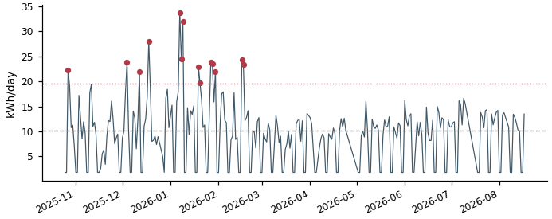

DD73710136266_4 Air conditioning  Typical day 9 kWh | Spike threshold 22 kWh | 13 spike days | Total excess 203 kWh  On 13 of 248 valid days, this meter used far more energy than its own typical day (9 kWh) — above a threshold of 22 kWh. Together those spike days used an estimated 203 kWh more than a normal day for this meter would have. | 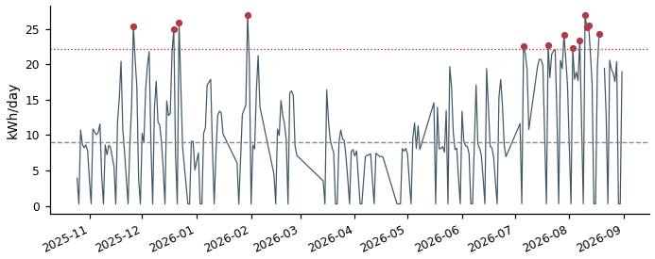

DD13710147065_2 Grid connect  Typical day 12 kWh | Spike threshold 22 kWh | 15 spike days | Total excess 202 kWh  On 15 of 301 valid days, this meter used far more energy than its own typical day (12 kWh) — above a threshold of 22 kWh. Together those spike days used an estimated 202 kWh more than a normal day for this meter would have. | 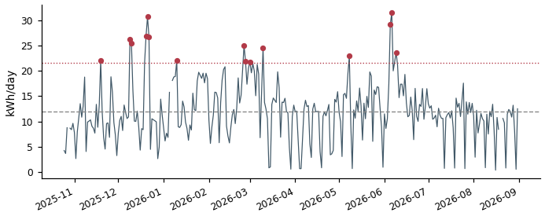

DD33710136324_3 Air conditioning  Typical day 4 kWh | Spike threshold 13 kWh | 16 spike days | Total excess 202 kWh  On 16 of 302 valid days, this meter used far more energy than its own typical day (4 kWh) — above a threshold of 13 kWh. Together those spike days used an estimated 202 kWh more than a normal day for this meter would have. | 