Where Your Energy Is Being Wasted
A plain-language guide to overnight standby, weekend, and spike-day energy waste, built on your meters' normal behaviour profiles
Based on the 417-meter behaviour analysis, covering 25 Oct 2025 – 27 Aug 2026.

1. Executive Summary
Now that we know what “normal” looks like for each meter, we can go a step further and ask: where does actual use depart from what a well-run version of that same meter would look like? We looked at three specific, common ways energy gets wasted — and quantified all three.
~3,281 kWh  estimated per day sitting in overnight standby draw that similar meters avoid | ~887 kWh  estimated per weekend day where “weekday-only” equipment doesn't scale down | ~120,000 kWh  total excess used on unusually high “spike” days across the whole period

Added together, that's on the order of 1.4 million kWh a year of potentially recoverable energy across the fleet — for reference, at an illustrative rate of $0.25/kWh, that's roughly $360,000/year. Replace that rate with your actual tariff for an accurate figure. These are statistical estimates from meter data, not a certified energy audit — they tell you where to look, not a guaranteed saving.

2. How We Found This
For each meter, we already know its own normal pattern — what's typical for it specifically, not a one-size-fits-all rule. We used that baseline to look for three everyday signs of waste:
- Standby waste — a meter that barely drops overnight compared with similar, well-managed meters of the same type.
- Weekend waste — equipment that's clearly scheduled to run on weekdays, but still uses nearly as much energy on weekends as during the week.
- Spike days — individual days where a meter used far more energy than is typical for that same meter, even accounting for its own normal ups and downs.
All three are compared against each meter's own history, or its closest peers of the same equipment type — never a single fleet-wide number — so a naturally larger or smaller site isn't unfairly flagged.

3. Meters Grouped by Everyday Behaviour
Before looking for waste, it helps to see the different “kinds” of meters in the fleet. We grouped every meter by the behaviour pattern it actually showed in the data:
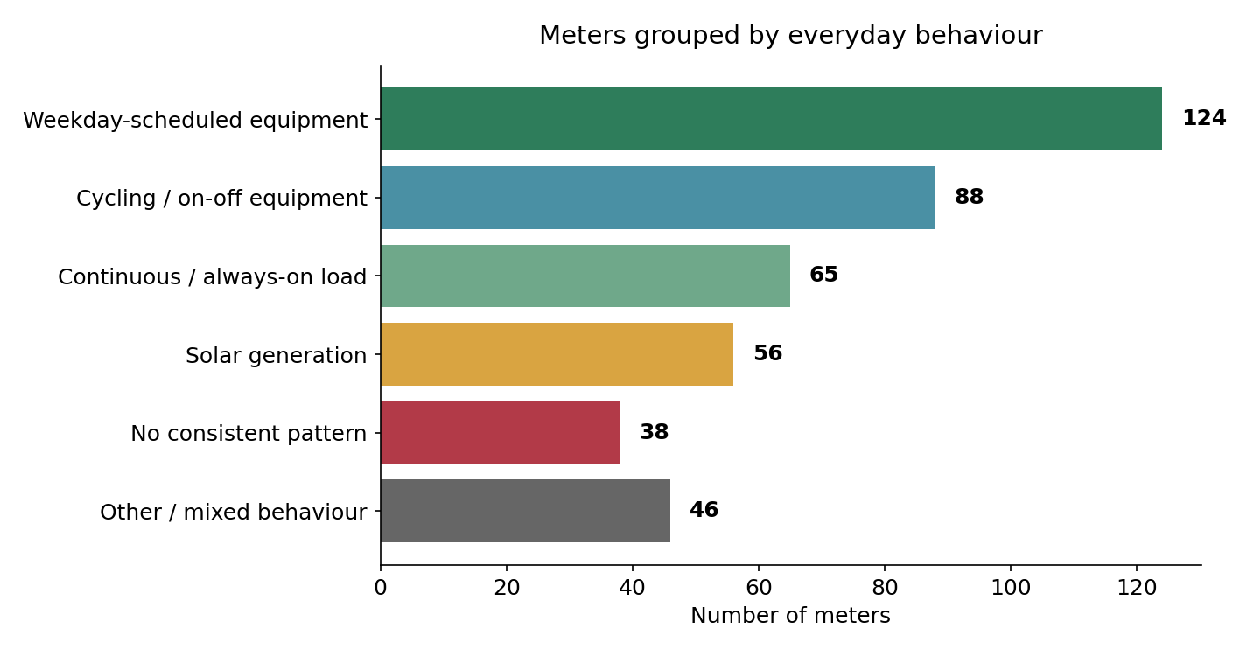
Group | Meters | What it means
Weekday-scheduled equipment | 124 | Runs mainly during business hours — prime group for standby & weekend checks
Cycling / on-off equipment | 88 | Pumps, chargers, compressors switching on and off in a rhythm
Continuous / always-on load | 65 | Fridges, servers, base site load — expected to run steadily
Solar generation | 56 | Generates rather than consumes — excluded from waste checks below
No consistent pattern | 38 | No repeatable schedule found — harder to judge, worth a manual look
Other / mixed behaviour | 46 | Doesn't fit neatly into the groups above

4. Opportunity 1 — Overnight Standby
We compared each meter's overnight power to its own daytime level, then compared that ratio against the best-performing quarter of similar meters (same equipment category). Of 240 meters where this comparison is meaningful, 144 sit notably above what their peers already achieve — meaning they hold a high power draw overnight when the equivalent equipment elsewhere drops much lower.
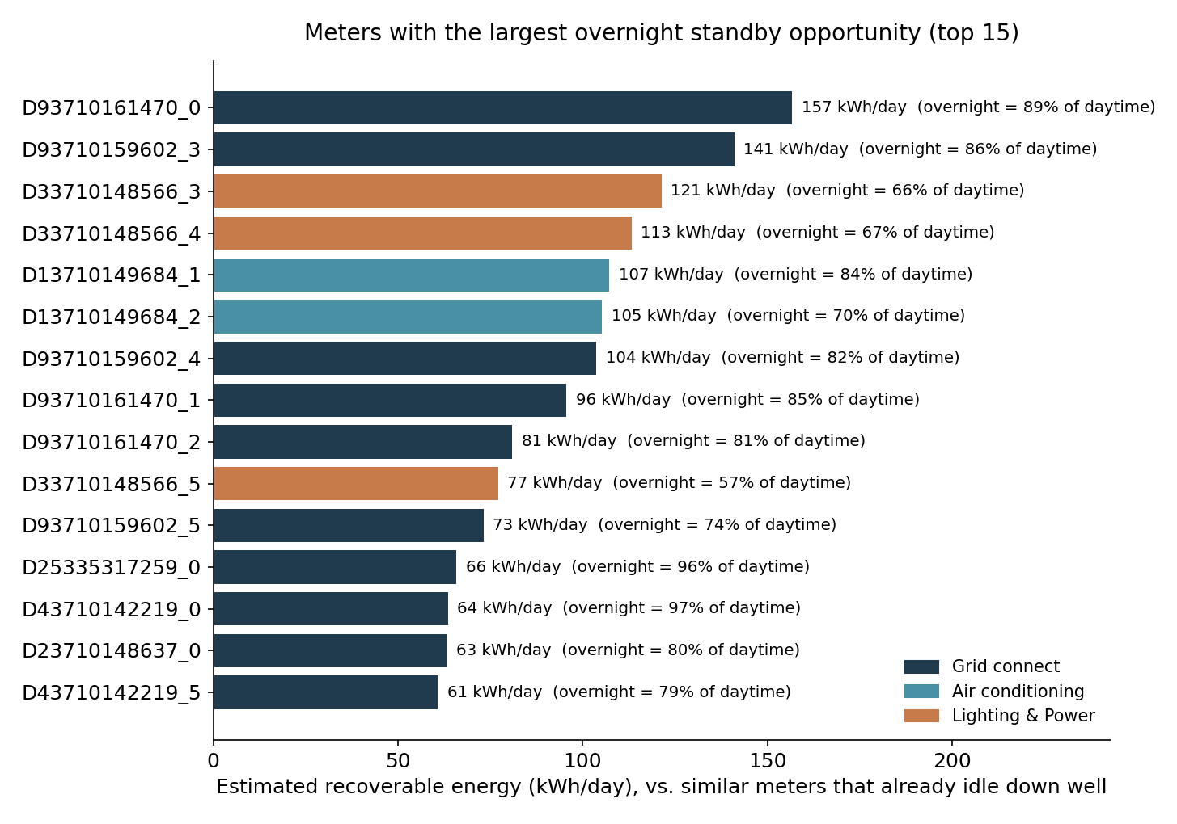

Meters to check first
Meter | Category | Overnight vs. daytime | Estimated opportunity
DD93710161470_0 | Grid connect | 89% | 157 kWh/day
DD93710159602_3 | Grid connect | 86% | 141 kWh/day
DD33710148566_3 | Lighting & Power | 66% | 121 kWh/day
DD33710148566_4 | Lighting & Power | 67% | 113 kWh/day
DD13710149684_1 | Air conditioning | 84% | 107 kWh/day
DD13710149684_2 | Air conditioning | 70% | 105 kWh/day
DD93710159602_4 | Grid connect | 82% | 104 kWh/day
DD93710161470_1 | Grid connect | 85% | 96 kWh/day
DD93710161470_2 | Grid connect | 81% | 81 kWh/day
DD33710148566_5 | Lighting & Power | 57% | 77 kWh/day
Several rows above are different channels on the same physical installation (for example, three phases of one grid connection) — that's expected, since a schedule or shutdown issue usually affects the whole site at once, not just one channel.
A high percentage here means the meter is using nearly as much power at 2am as it does at 2pm. That's not automatically a fault — some equipment genuinely needs to run continuously — but for the categories above (mostly grid-connect site power, lighting and air conditioning), it's usually worth checking whether equipment is being left on, whether a timer or BMS schedule has failed, or whether a night setback exists at all.

5. Opportunity 2 — Weekend Usage
Among the 110 meters clearly scheduled around the working week, a typical one drops to about 49% of its weekday energy on weekends. 39 meters in total still use well over half their weekday energy on Saturdays and Sundays — the ten with the smallest drop-off are shown below.
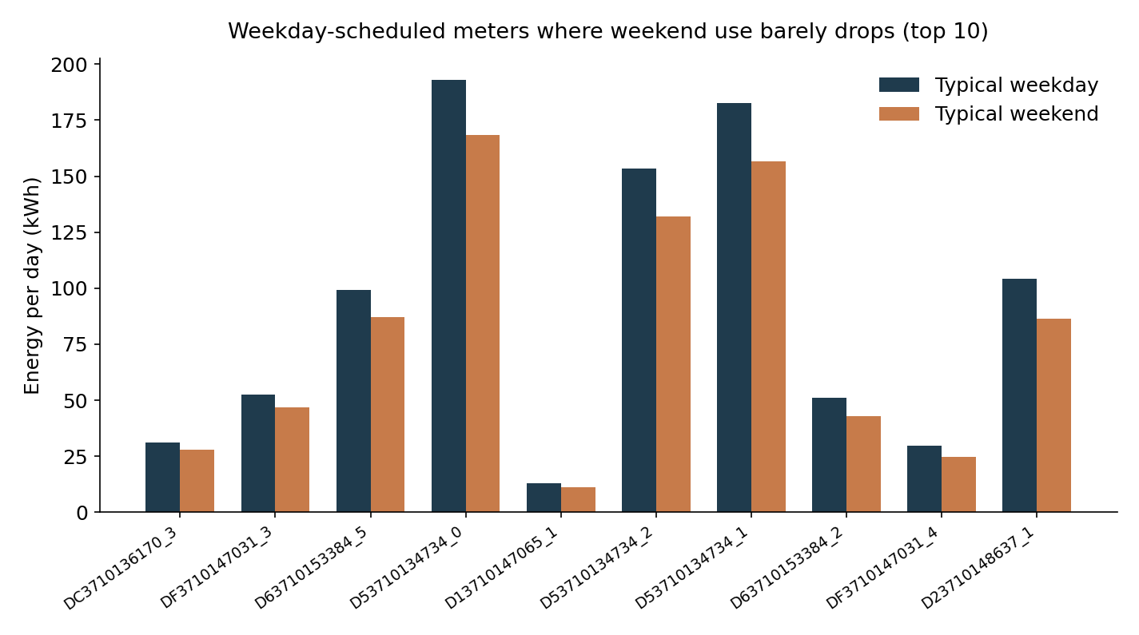
Meter | Category | Weekday (kWh) | Weekend (kWh) | Weekend as % of weekday
DDC3710136170_3 | Air conditioning | 31 | 28 | 90%
DDF3710147031_3 | Lighting & Power | 53 | 47 | 89%
DD63710153384_5 | Grid connect | 99 | 87 | 88%
DD53710134734_0 | Grid connect | 193 | 168 | 87%
DD13710147065_1 | Grid connect | 13 | 11 | 86%
DD53710134734_2 | Grid connect | 153 | 132 | 86%
DD53710134734_1 | Grid connect | 182 | 157 | 86%
DD63710153384_2 | Grid connect | 51 | 43 | 84%
If a site is meant to be unoccupied or idle on weekends, this gap is the clearest, easiest-to-action saving in this report — it usually points to a schedule, timer, or building-management setting that isn't switching over for the weekend.

6. Opportunity 3 — Spike Days
Spike days are dates where a specific meter used far more energy than is typical for that same meter — not compared to other meters, just to its own history. Here's a worked example on one air-conditioning meter, showing how spike days (red) stand out clearly above its normal day-to-day range, and cluster in Melbourne's hottest months:
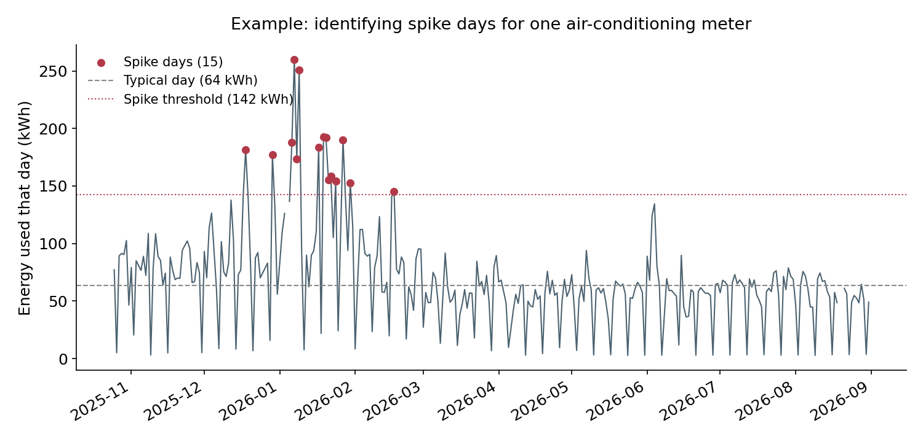

Meters with the largest spike-day impact
Meter | Category | Spike days | Extra energy used on those days
DD33710161970_1 | Grid connect | 13 of 251 | 8,577 kWh
DD33710161970_0 | Grid connect | 13 of 251 | 8,106 kWh
DD33710161970_4 | Grid connect | 13 of 251 | 7,689 kWh
DD33710161970_3 | Grid connect | 13 of 251 | 7,237 kWh
DD33710161970_5 | Grid connect | 13 of 252 | 7,199 kWh
DD13710148400_0 | Electric vehicle | 15 of 301 | 4,716 kWh
DD43710136402_5 | Grid connect | 15 of 288 | 3,071 kWh
DD83710131752_3 | Grid connect | 15 of 295 | 2,694 kWh
The top five rows are five channels on one installation — the same 13 dates drove all of them, so this is really one site with a strong recurring event, not five separate problems.
A spike day isn't necessarily a problem — a hot day driving up air-conditioning use is expected and reasonable. But a meter with frequent, large spikes is worth a look: it may indicate equipment cycling harder than it should, a fault causing it to run inefficiently, or simply a pattern worth knowing about for demand planning.

7. Recommendations & Next Steps
- Start with Section 4's top meters — overnight standby is usually the simplest fix (timer, schedule, or shutdown check) and the estimate above suggests it's the single largest opportunity.
- For Section 5's meters, confirm whether the site is actually meant to be unoccupied on weekends; if so, check the building/equipment schedule.
- For Section 6, cross-check spike dates against known hot/cold snaps, special events, or maintenance records — spikes that don't line up with an obvious cause are worth a site visit.
- These are estimates from statistical patterns in the meter data, not a certified energy audit. Treat this as a prioritised list of where to look first, and confirm on-site before assuming a fault.
- The frozen/stuck-reading issue covered in the earlier report can distort short-term comparisons — the estimates here already exclude those periods.

