Electricity Meter Behaviour Analysis
A plain-language summary of what “normal” looks like across your metered sites
Prepared from 10 months of 5-minute meter readings (25 Oct 2025 – 27 Aug 2026) across 622 metered circuits at two organisations.

1. Executive Summary
We looked at electricity readings taken every 5 minutes, for up to 10 months, across 622 individual metered circuits, to work out what “normal” electricity use looks like for each one — when it's typically busy, when it's quiet, and how consistent that pattern is. Two things came out of this that matter for you:
- Most meters do have an understandable, describable pattern of use. Only a small number (3%) show no repeatable pattern at all.
- There is a widespread, recurring data-reliability issue: readings from almost every channel get “stuck” on one value for a period, sometimes for several days, and this keeps happening throughout the year — not just once. This is worth raising with your meter or data provider.
The rest of this report explains both findings in plain terms, with the numbers behind them.

2. What We Did
Two organisations' worth of metered circuits — things like grid connections, air conditioning units, solar panels, EV chargers and hot water systems — report a power reading every 5 minutes. We used those readings to build a picture of typical behaviour for each individual circuit: what time of day it's usually busiest, whether weekdays differ from weekends, and whether that pattern holds steady across the year or changes with the seasons.
Of 622 circuits on record, usable reading files existed for 427. We've fully analysed 417 of those so far; the remaining 10 (about 2%) are still being processed and will be added shortly. All figures below are based on the 417 already analysed.

3. Finding 1 — Most Meters Have an Understandable Pattern
For every meter, we asked: does this circuit have one steady, repeatable pattern of use, or does its behaviour change over time, or does it have no describable pattern at all? Here is what we found:
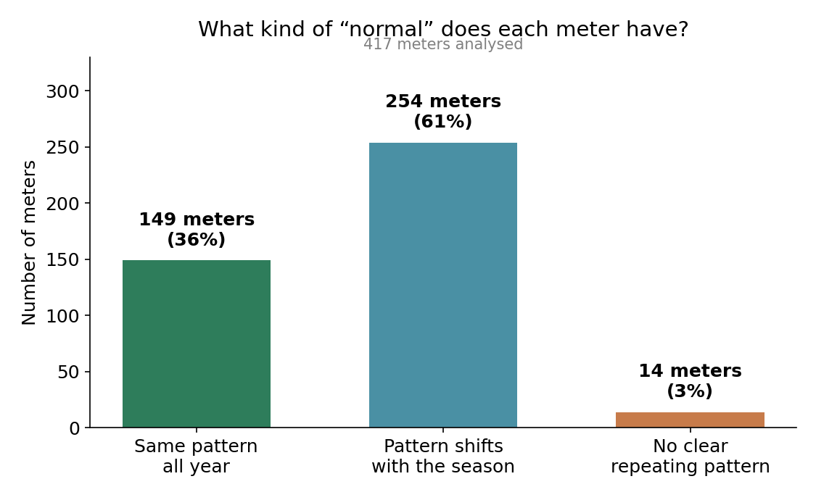
149 (36%)  Same pattern all year — a steady, reliable “normal” | 254 (61%)  Real pattern, but it shifts between warm and cool months | 14 (3%)  No repeatable pattern found — worth a manual look

The “shifts with the season” group is the largest, and that's expected rather than concerning: air conditioning uses more power in extreme weather, solar panels generate more in summer daylight, and pool pumps or heating run on different schedules through the year. Treating these as one fixed year-round “normal” would actually be misleading — the more accurate description is “normal for summer” and “normal for winter” separately.

By equipment type
Some equipment types are far more season-driven than others. Every single solar-generation channel, for example, falls into the “shifts with season” group — exactly as you'd expect from a system whose output depends on daylight and weather.
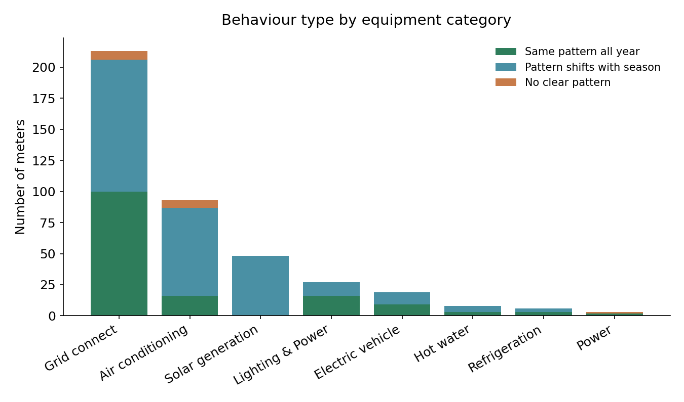
Equipment type | Meters analysed | Same pattern all year | Shifts with season | No clear pattern
Grid connect (whole-site power) | 213 | 100 | 106 | 7
Air conditioning | 93 | 16 | 71 | 6
Solar generation | 48 | 0 | 48 | 0
Lighting & Power | 27 | 16 | 11 | 0
Electric vehicle | 19 | 9 | 10 | 0
Hot water | 8 | 3 | 5 | 0
Refrigeration | 6 | 3 | 3 | 0
Power | 3 | 2 | 0 | 1

4. Finding 2 — A Recurring Data Reliability Issue
This is the most important operational finding in this report. While building these profiles, we found that readings from almost every meter occasionally get “stuck” — the exact same value repeats for hours or even days in a row, across several different measurements at once (power, voltage and current all frozen together). This is not realistic electricity behaviour; it looks like the meter or its communication link fails silently and keeps reporting its last known reading.
96%  of the 417 meters had at least one “stuck reading” episode | 99  meters had at least one episode lasting more than 2 days

Two details point to a shared cause rather than individual faulty meters: first, when one circuit on a site freezes, the other circuits on that same physical meter almost always freeze at exactly the same time (true for 81 of the 86 affected installations); second, these events cluster — large numbers of meters go stale within the same hour, on the same day, again and again across the year.
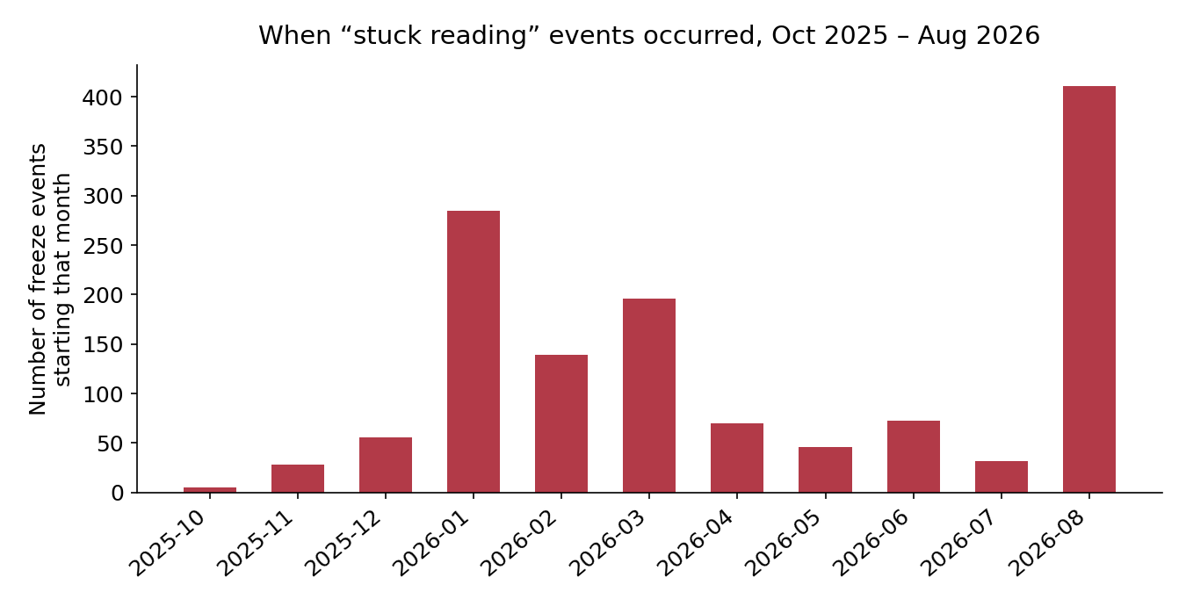

The largest events
When | Scale | Duration | Note
18–20 Aug 2026 | up to 355 channels at once | ~2.4 days | The largest shared event found
28–31 Mar 2026 | up to 72 channels at once | up to 3.5 days | Second-largest shared event
23–30 Jan 2026 | 3 channels, one installation | 6.7 days | Longest single freeze found
22–28 May 2026 | 6 channels, one installation | 6.3 days | Whole installation frozen together
We identified and excluded every one of these stuck-reading periods before calculating the “normal” patterns in this report, so the findings above are not distorted by this issue. But the missing/stuck data is itself worth acting on — it represents real information you are not receiving during those windows, and the recurring, sitewide nature of it suggests a shared infrastructure or communications problem worth raising with your metering or data provider, particularly the 18–20 August event, which affected up to 355 channels simultaneously.

5. What “Normal” Looks Like, Day to Day
Beyond the season-vs-stable split, we looked for specific, recognisable everyday behaviours — the kind of thing a site manager would recognise. A single meter can show more than one of these at once (for example, “always on” plus “busier on weekdays”).
Everyday pattern | Meters showing it | What it usually means
Busier during the day than overnight | 282 | Typical for most business and site loads
Very low overnight usage | 90 | No significant unnecessary overnight draw
Always on, rarely fully idle | 71 | Continuous equipment — fridges, servers, always-on circuits
Regular on/off cycling | 116 | Pumps, compressors, EV chargers switching in a repeatable rhythm
Midday solar production | 53 | Matches expected solar panel behaviour
One clear peak time each day | 112 | A defined morning, midday, afternoon, evening or overnight peak
Mainly active on weekdays | ~130 | Site scales down on weekends
Same energy on weekends, different timing | 13 | Worth an operational look — routine shifts but doesn't reduce

6. How Complete Is the Data?
Meter readings are taken every 5 minutes, so a full record for the ~10-month period is roughly 88,000 readings per meter. Most meters are close to complete:
- 339 of 417 meters (81%) have at least 95% of their expected readings.
- 66 meters (16%) are missing a moderate amount — between 5% and 20% of readings.
- 12 meters (3%) have significant gaps, generally matching a small number of installations already known to have had extended outages earlier in the project.
Missing readings were never assumed to be zero usage — they are treated as “we don't know,” and excluded from every calculation above, so a gap in the data cannot masquerade as quiet or normal behaviour.

7. Limitations and Suggested Next Steps
- This report describes typical behaviour; it does not diagnose or flag individual events as faults. It's the reference point future monitoring can be compared against.
- Because so many equipment types genuinely behave differently by season, “normal” for those meters is best understood as two profiles (warm months and cool months) rather than one number.
- The recurring “stuck reading” issue (Section 4) is the most actionable item here — we'd recommend raising it with your meter or data provider, starting with the 18–20 August event.
- The 14 meters with no repeatable pattern are worth a quick manual check — they may simply be rarely-used or spare circuits, but it's worth confirming rather than assuming.
- 10 remaining meters are still being processed and will be folded into an updated version of this report.

