# **Configuring a Small Network with Cisco Routers and Switches in CISCO PACKET TRACER**

## **GROUP MEMBERS:**

* Mariam Zaheer
* Yousra Zaheer
* Syeda Maira Abid gardezi
* Muhammad Danial Muzaffar

## **Introduction**

The objective of this project was to design and configure a small network using Cisco routers and switches. The network consists of one router, three switches, and six PCs. The goal was to establish connectivity between all devices and test the network's functionality.

**Network Design and Configuration**

The network was designed with the following components:

- One Cisco 2911 router

- Three Cisco 2960-24TT switches

- Six PCs (PC-PT)

The connections between devices were made using straight-through cables. The PCs were connected to the switches, and the switches were connected to the router.

The IP addresses, subnet masks, and default gateways were assigned to each PC as follows:

| PC | IP Address | Subnet Mask | Default Gateway |

| --- | --- | --- | --- |

| PC1 | 10.1.1.2 | 255.255.255.0 | 10.1.1.1 |

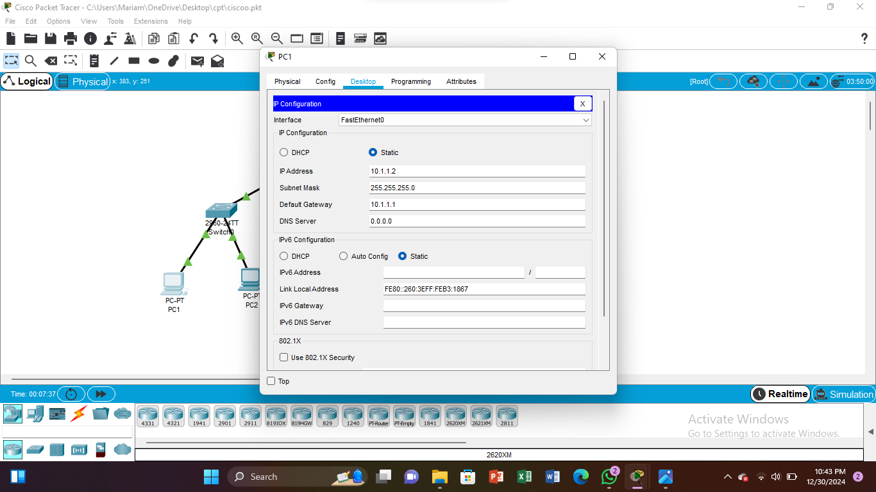

| PC2 | 10.1.1.3 | 255.255.255.0 | 10.1.1.1 |

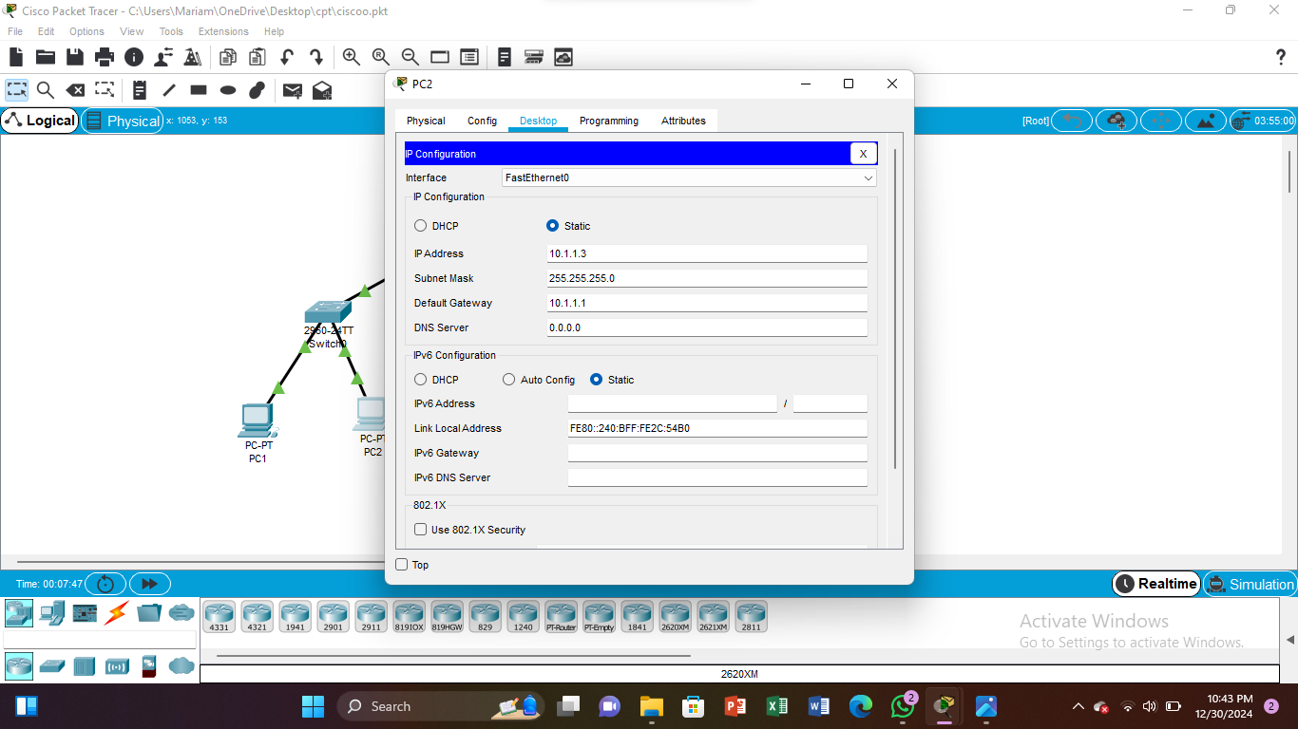

| PC3 | 192.168.2.2 | 255.255.255.0 | 192.168.2.1 |

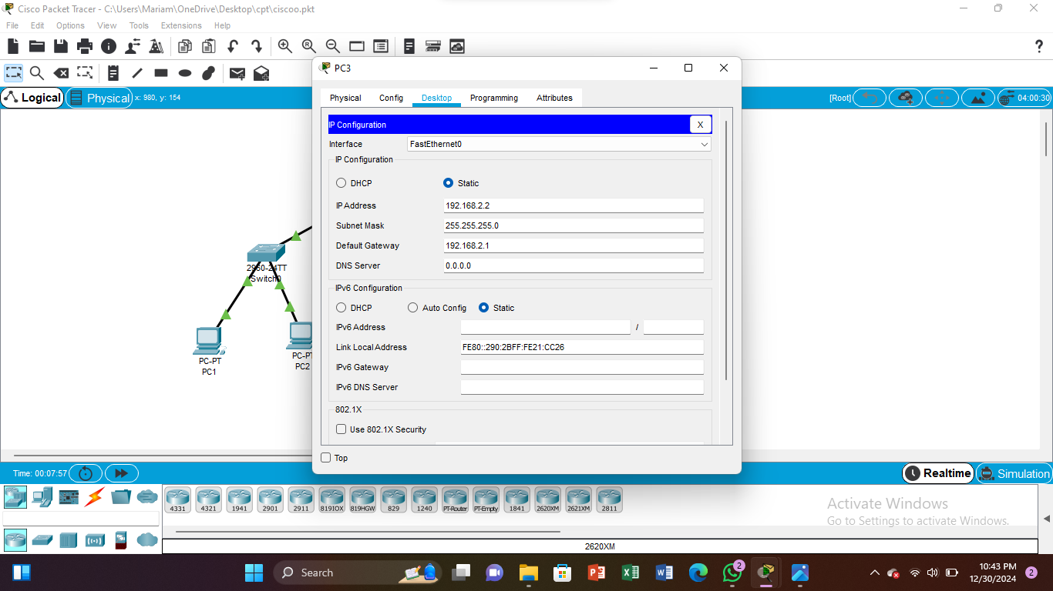

| PC4 | 192.168.2.3 | 255.255.255.0 | 192.168.2.1 |

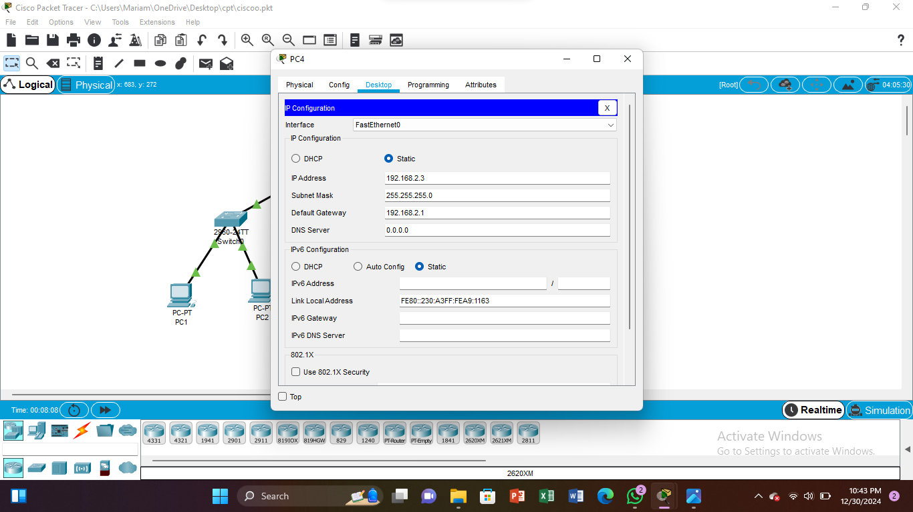

| PC5 | 192.168.4.2 | 255.255.255.0 | 192.168.4.1 |

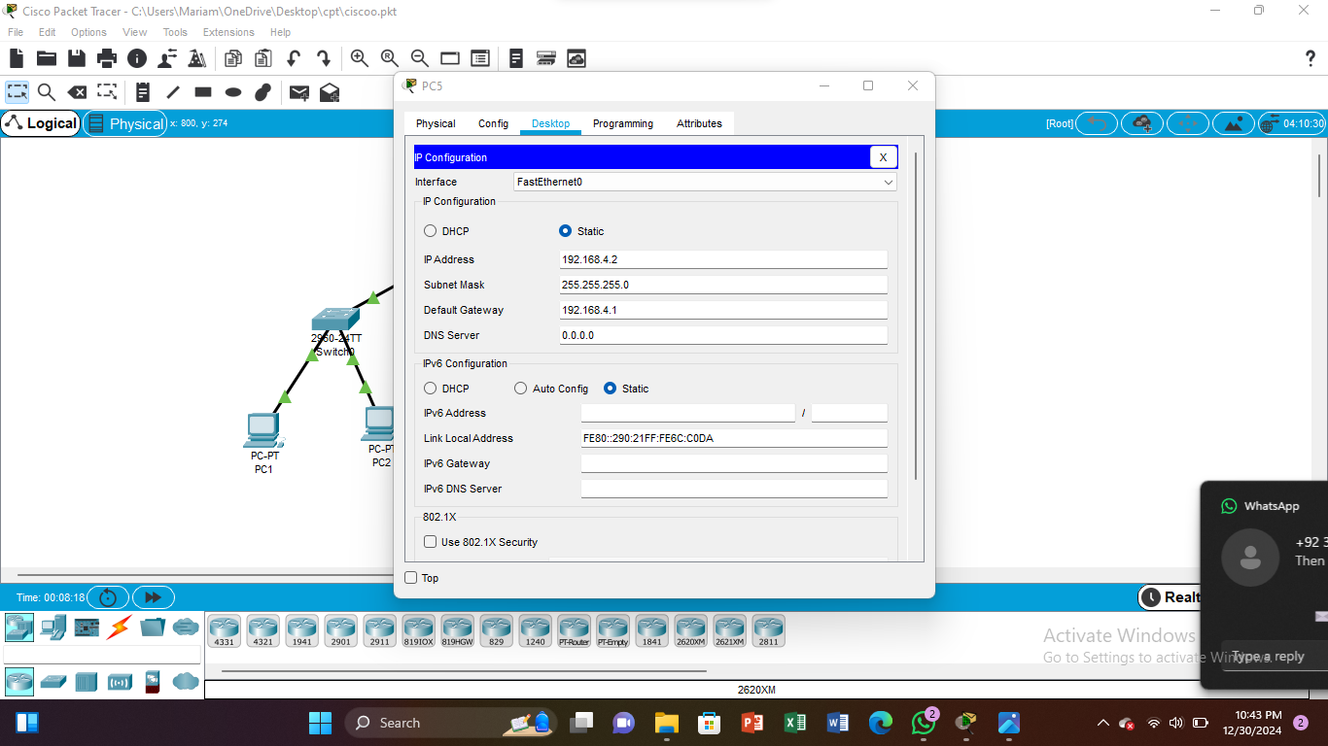

| PC6 | 192.168.4.3 | 255.255.255.0 | 192.168.4.1 |

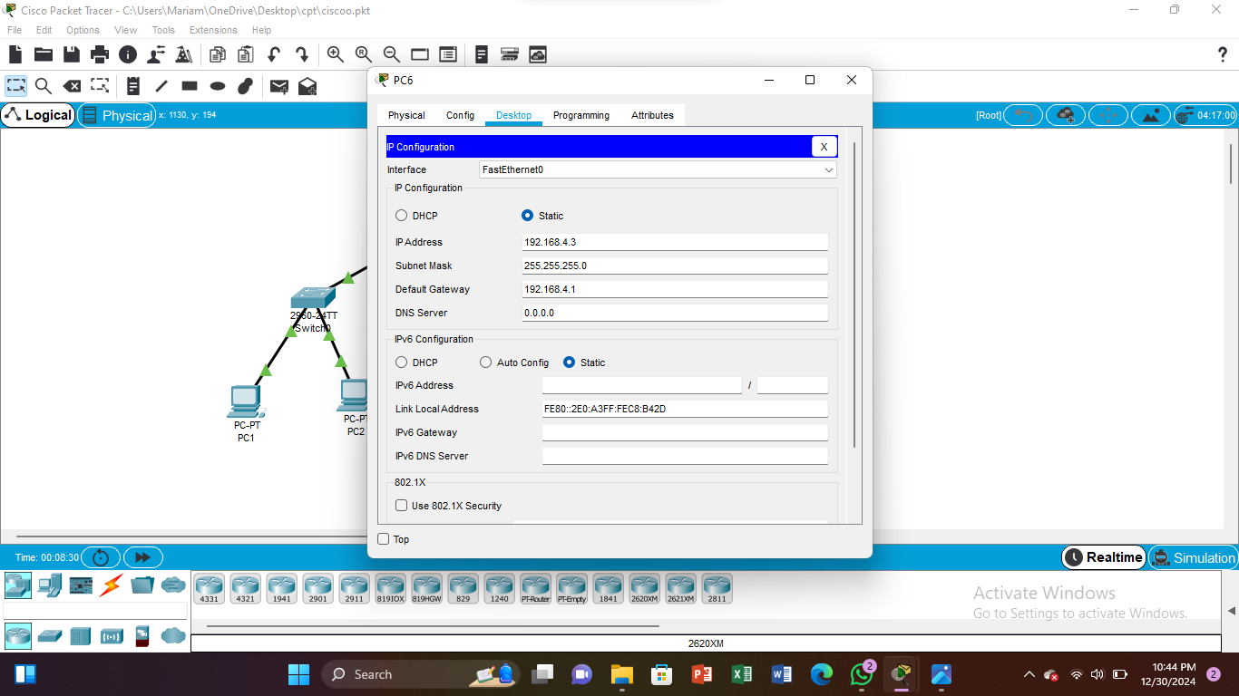

**Network Topology**

The network topology is as follows:

- PC1 and PC2 are connected to Switch 1

- PC3 and PC4 are connected to Switch 2

- PC5 and PC6 are connected to Switch 3

- Switch 1, Switch 2, and Switch 3 are connected to the router

**Testing and Verification**

To test the network's connectivity, ping tests were performed between PCs. The results showed that all PCs were able to communicate with each other.

Additionally, a message was sent between two PCs to test the network's functionality. The message was successfully sent and received, confirming that the network was functioning correctly.

**Conclusion**

In this project, a small network was designed and configured using Cisco routers and switches. The network was tested and verified to ensure that all devices were able to communicate with each other. The results showed that the network was functioning correctly, and all PCs were able to send and receive messages.