**4-bit full adder**



Digital Logic Design Project

22/05/2023

**Timeline:**

**Yousra Amr Ali**

2022/05494

**Mariam Jan George**

2022/06056

**Members:**

Dr. Khaled Hussein

**Supervisor:**

**Contents**

Idea 3

Objective 4

K-maps 4

Boolean Function 5

Code of Truth Table 6

Truth Table 8

Simulator 9

Simulator with IC 10

Hardware Data Sheet 11

Components of Hardware 12

**4 – Bit full adder**

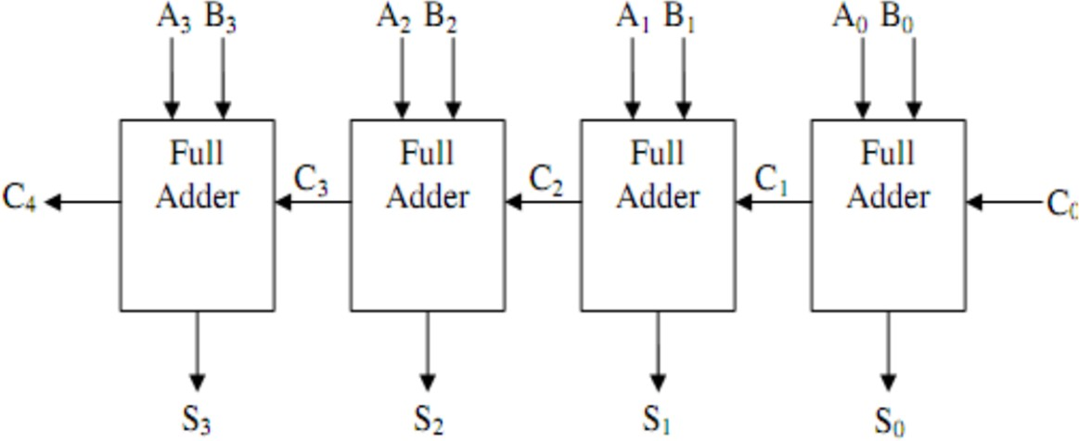

**Idea**

* A four bit full Adders is a Logical Circuit that takes Carry and two expressions with four bits as its inputs (A and B) and a carry-in bit (C-in), and as a result shows the Four bits and two outputs: the sum of the two numbers (S) and a carry-out bit (C-out)." The Circuit of Four bit Full Adder consists of the XOR Gate, AND Gate and OR Gate. We have learnt about them in detail.
* 4-bit full adder is used to minimize the total delay of the adder, the area used to implement the adder, and its average power consumption.

**Objective**

* 4-bit full adder performs the function of 4-bit addition that gives a sum and two bits of carry as output.

**K-maps & Full adder Diagram**

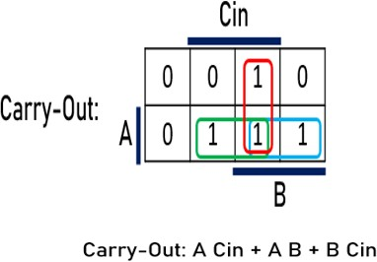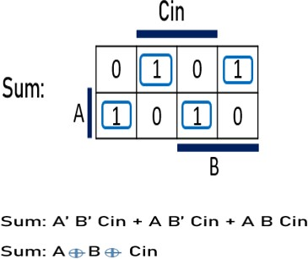

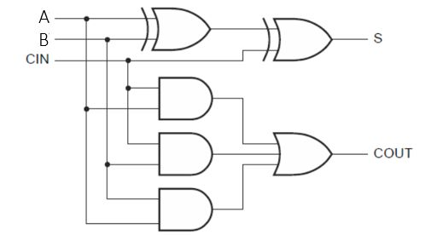

**Boolean Function**

**S0 = A0 ⊕ B0 ⊕ Cin**

**Cout0 = A Cin + A B + B Cin**

**S1 = A1 ⊕ B1 ⊕ Cout0**

**Cout1 = A Cin + A B + B Cin**

**S2 = A2 ⊕ B2 ⊕ Cout1**

**Cout2 = A Cin + A B + B Cin**

**S3 = A3 ⊕ B3 ⊕ Cout2**

**Cout3 = A Cin + A B + B Cin**

**Code of Truth Table**

#include <iostream>

#include <iomanip>

using namespace std;

void generateTruthTable() {

int a[4], b[4], carryIn, carryOut, sum[4];

cout << setw(4) << "A3" << setw(4) << "A2" << setw(4) << "A1" << setw(4) << "A0"

<< setw(4) << "B3" << setw(4) << "B2" << setw(4) << "B1" << setw(4) << "B0"

<< setw(8) << "CarryIn"

<< setw(10) << "CarryOut"

<< setw(8) << "Sum3" << setw(8) << "Sum2" << setw(8) << "Sum1" << setw(8) << "Sum0" << endl;

for (int i = 0; i < 16; ++i) {

a[3] = (i & 8) >> 3;

a[2] = (i & 4) >> 2;

a[1] = (i & 2) >> 1;

a[0] = (i & 1);

for (int j = 0; j < 16; ++j) {

b[3] = (j & 8) >> 3;

b[2] = (j & 4) >> 2;

b[1] = (j & 2) >> 1;

b[0] = (j & 1);

carryIn = 0;

carryOut = 0;

for (int k = 0; k < 4; ++k) {

sum[k] = a[k] ^ b[k] ^ carryIn;

carryOut = (a[k] & b[k]) | ((a[k] ^ b[k]) & carryIn);

carryIn = carryOut;

}

cout << setw(4) << a[3] << setw(4) << a[2] << setw(4) << a[1] << setw(4) << a[0]

<< setw(4) << b[3] << setw(4) << b[2] << setw(4) << b[1] << setw(4) << b[0]

<< setw(8) << carryIn

<< setw(10) << carryOut

<< setw(8) << sum[3] << setw(8) << sum[2] << setw(8) << sum[1] << setw(8) << sum[0] << endl;

}

}

}

int main() {

generateTruthTable();

}

**Code of Truth Table**

**Truth Table**

**de of Truth Table**

A3 A2A1 A0 B3 B2 B1 B0 CIn COut S3 S2 S1 S0

0 0 0 0 0 0 0 0 0 0 0 0 0 0

0 0 0 0 0 0 0 1 0 0 0 0 0 1

0 0 0 0 0 0 1 0 0 0 0 0 1 0

0 0 0 0 0 0 1 1 0 0 0 0 1 1

0 0 0 0 0 1 0 0 0 0 0 1 0 0

0 0 0 0 0 1 0 1 0 0 0 1 0 1

0 0 0 0 0 1 1 0 0 0 0 1 1 0

0 0 0 0 0 1 1 1 0 0 0 1 1 1

0 0 0 0 1 0 0 0 0 0 1 0 0 0

0 0 0 0 1 0 0 1 0 0 1 0 0 1

0 0 0 0 1 0 1 0 0 0 1 0 1 0

0 0 0 0 1 0 1 1 0 0 1 0 1 1

0 0 0 0 1 1 0 0 0 0 1 1 0 0

0 0 0 0 1 1 0 1 0 0 1 1 0 1

0 0 0 0 1 1 1 0 0 0 1 1 1 0

0 0 0 0 1 1 1 1 0 0 1 1 1 1

0 0 0 1 0 0 0 0 0 0 0 0 0 1

0 0 0 1 0 0 0 1 0 0 0 0 1 0

0 0 0 1 0 0 1 0 0 0 0 0 1 1

0 0 0 1 0 0 1 1 0 0 0 1 0 0

0 0 0 1 0 1 0 0 0 0 0 1 0 1

0 0 0 1 0 1 0 1 0 0 0 1 1 0

0 0 0 1 0 1 1 0 0 0 0 1 1 1

0 0 0 1 0 1 1 1 0 0 1 0 0 0

0 0 0 1 1 0 0 0 0 0 1 0 0 1

0 0 0 1 1 0 0 1 0 0 1 0 1 0

0 0 0 1 1 0 1 0 0 0 1 0 1 1

0 0 0 1 1 0 1 1 0 0 1 1 0 0

0 0 0 1 1 1 0 0 0 0 1 1 0 1

0 0 0 1 1 1 0 1 0 0 1 1 1 0

0 0 0 1 1 1 1 0 0 0 1 1 1 1

0 0 0 1 1 1 1 1 1 1 0 0 0 0

0 0 1 0 0 0 0 0 0 0 0 0 1 0

0 0 1 0 0 0 0 1 0 0 0 0 1 1

0 0 1 0 0 0 1 0 0 0 0 1 0 0

0 0 1 0 0 0 1 1 0 0 0 1 0 1

0 0 1 0 0 1 0 0 0 0 0 1 1 0

0 0 1 0 0 1 0 1 0 0 0 1 1 1

0 0 1 0 0 1 1 0 0 0 1 0 0 0

0 0 1 0 0 1 1 1 0 0 1 0 0 1

0 0 1 0 1 0 0 0 0 0 1 0 1 0

0 0 1 0 1 0 0 1 0 0 1 0 1 1

0 0 1 0 1 0 1 0 0 0 1 1 0 0

0 0 1 0 1 0 1 1 0 0 1 1 0 1

0 0 1 0 1 1 0 0 0 0 1 1 1 0

0 0 1 0 1 1 0 1 0 0 1 1 1 1

0 0 1 0 1 1 1 0 1 1 0 0 0 0

0 0 1 0 1 1 1 1 1 1 0 0 0 1

0 0 1 1 0 0 0 0 0 0 0 0 1 1

0 0 1 1 0 0 0 1 0 0 0 1 0 0

0 0 1 1 0 0 1 0 0 0 0 1 0 1

0 0 1 1 0 0 1 1 0 0 0 1 1 0

0 0 1 1 0 1 0 0 0 0 0 1 1 1

0 0 1 1 0 1 0 1 0 0 1 0 0 0

0 0 1 1 0 1 1 0 0 0 1 0 0 1

0 0 1 1 0 1 1 1 0 0 1 0 1 0

0 0 1 1 1 0 0 0 0 0 1 0 1 1

0 0 1 1 1 0 0 1 0 0 1 1 0 0

0 0 1 1 1 0 1 0 0 0 1 1 0 1

0 0 1 1 1 0 1 1 0 0 1 1 1 0

0 0 1 1 1 1 0 0 0 0 1 1 1 1

0 0 1 1 1 1 0 1 1 1 0 0 0 0

0 0 1 1 1 1 1 0 1 1 0 0 0 1

0 0 1 1 1 1 1 1 1 1 0 0 1 0

0 1 0 0 0 0 0 0 0 0 0 1 0 0

0 1 0 0 0 0 0 1 0 0 0 1 0 1

0 1 0 0 0 0 1 0 0 0 0 1 1 0

0 1 0 0 0 0 1 1 0 0 0 1 1 1

0 1 0 0 0 1 0 0 0 0 1 0 0 0

0 1 0 0 0 1 0 1 0 0 1 0 0 1

0 1 0 0 0 1 1 0 0 0 1 0 1 0

0 1 0 0 0 1 1 1 0 0 1 0 1 1

0 1 0 0 1 0 0 0 0 0 1 1 0 0

0 1 0 0 1 0 0 1 0 0 1 1 0 1

0 1 0 0 1 0 1 0 0 0 1 1 1 0

0 1 0 0 1 0 1 1 0 0 1 1 1 1

0 1 0 0 1 1 0 0 1 1 0 0 0 0

0 1 0 0 1 1 0 1 1 1 0 0 0 1

0 1 0 0 1 1 1 0 1 1 0 0 1 0

0 1 0 0 1 1 1 1 1 1 0 0 1 1

0 1 0 1 0 0 0 0 0 0 0 1 0 1

0 1 0 1 0 0 0 1 0 0 0 1 1 0

0 1 0 1 0 0 1 0 0 0 0 1 1 1

0 1 0 1 0 0 1 1 0 0 1 0 0 0

0 1 0 1 0 1 0 0 0 0 1 0 0 1

0 1 0 1 0 1 0 1 0 0 1 0 1 0

0 1 0 1 0 1 1 0 0 0 1 0 1 1

0 1 0 1 0 1 1 1 0 0 1 1 0 0

0 1 0 1 1 0 0 0 0 0 1 1 0 1

0 1 0 1 1 0 0 1 0 0 1 1 1 0

0 1 0 1 1 0 1 0 0 0 1 1 1 1

0 1 0 1 1 0 1 1 1 1 0 0 0 0

0 1 0 1 1 1 0 0 1 1 0 0 0 1

0 1 0 1 1 1 0 1 1 1 0 0 1 0

0 1 0 1 1 1 1 0 1 1 0 0 1 1

0 1 0 1 1 1 1 1 1 1 0 1 0 0

0 1 1 0 0 0 0 0 0 0 0 1 1 0

0 1 1 0 0 0 0 1 0 0 0 1 1 1

0 1 1 0 0 0 1 0 0 0 1 0 0 0

0 1 1 0 0 0 1 1 0 0 1 0 0 1

0 1 1 0 0 1 0 0 0 0 1 0 1 0

0 1 1 0 0 1 0 1 0 0 1 0 1 1

0 1 1 0 0 1 1 0 0 0 1 1 0 0

0 1 1 0 0 1 1 1 0 0 1 1 0 1

0 1 1 0 1 0 0 0 0 0 1 1 1 0

0 1 1 0 1 0 0 1 0 0 1 1 1 1

0 1 1 0 1 0 1 0 1 1 0 0 0 0

0 1 1 0 1 0 1 1 1 1 0 0 0 1

0 1 1 0 1 1 0 0 1 1 0 0 1 0

0 1 1 0 1 1 0 1 1 1 0 0 1 1

0 1 1 0 1 1 1 0 1 1 0 1 0 0

0 1 1 0 1 1 1 1 1 1 0 1 0 1

0 1 1 1 0 0 0 0 0 0 0 1 1 1

0 1 1 1 0 0 0 1 0 0 1 0 0 0

0 1 1 1 0 0 1 0 0 0 1 0 0 1

0 1 1 1 0 0 1 1 0 0 1 0 1 0

0 1 1 1 0 1 0 0 0 0 1 0 1 1

0 1 1 1 0 1 0 1 0 0 1 1 0 0

0 1 1 1 0 1 1 0 0 0 1 1 0 1

0 1 1 1 0 1 1 1 0 0 1 1 1 0

0 1 1 1 1 0 0 0 0 0 1 1 1 1

0 1 1 1 1 0 0 1 1 1 0 0 0 0

0 1 1 1 1 0 1 0 1 1 0 0 0 1

0 1 1 1 1 0 1 1 1 1 0 0 1 0

0 1 1 1 1 1 0 0 1 1 0 0 1 1

0 1 1 1 1 1 0 1 1 1 0 1 0 0

0 1 1 1 1 1 1 0 1 1 0 1 0 1

0 1 1 1 1 1 1 1 1 1 0 1 1 0

1 0 0 0 0 0 0 0 0 0 1 0 0 0

1 0 0 0 0 0 0 1 0 0 1 0 0 1

1 0 0 0 0 0 1 0 0 0 1 0 1 0

1 0 0 0 0 0 1 1 0 0 1 0 1 1

1 0 0 0 0 1 0 0 0 0 1 1 0 0

1 0 0 0 0 1 0 1 0 0 1 1 0 1

1 0 0 0 0 1 1 0 0 0 1 1 1 0

1 0 0 0 0 1 1 1 0 0 1 1 1 1

1 0 0 0 1 0 0 0 1 1 0 0 0 0

1 0 0 0 1 0 0 1 1 1 0 0 0 1

1 0 0 0 1 0 1 0 1 1 0 0 1 0

1 0 0 0 1 0 1 1 1 1 0 0 1 1

1 0 0 0 1 1 0 0 1 1 0 1 0 0

1 0 0 0 1 1 0 1 1 1 0 1 0 1

1 0 0 0 1 1 1 0 1 1 0 1 1 0

1 0 0 0 1 1 1 1 1 1 0 1 1 1

1 0 0 1 0 0 0 0 0 0 1 0 0 1

1 0 0 1 0 0 0 1 0 0 1 0 1 0

1 0 0 1 0 0 1 0 0 0 1 0 1 1

1 0 0 1 0 0 1 1 0 0 1 1 0 0

1 0 0 1 0 1 0 0 0 0 1 1 0 1

1 0 0 1 0 1 0 1 0 0 1 1 1 0

1 0 0 1 0 1 1 0 0 0 1 1 1 1

1 0 0 1 0 1 1 1 1 1 0 0 0 0

1 0 0 1 1 0 0 0 1 1 0 0 0 1

1 0 0 1 1 0 0 1 1 1 0 0 1 0

1 0 0 1 1 0 1 0 1 1 0 0 1 1

1 0 0 1 1 0 1 1 1 1 0 1 0 0

1 0 0 1 1 1 0 0 1 1 0 1 0 1

1 0 0 1 1 1 0 1 1 1 0 1 1 0

1 0 0 1 1 1 1 0 1 1 0 1 1 1

1 0 0 1 1 1 1 1 1 1 1 0 0 0

1 0 1 0 0 0 0 0 0 0 1 0 1 0

1 0 1 0 0 0 0 1 0 0 1 0 1 1

1 0 1 0 0 0 1 0 0 0 1 1 0 0

1 0 1 0 0 0 1 1 0 0 1 1 0 1

1 0 1 0 0 1 0 0 0 0 1 1 1 0

1 0 1 0 0 1 0 1 0 0 1 1 1 1

1 0 1 0 0 1 1 0 1 1 0 0 0 0

1 0 1 0 0 1 1 1 1 1 0 0 0 1

1 0 1 0 1 0 0 0 1 1 0 0 1 0

1 0 1 0 1 0 0 1 1 1 0 0 1 1

1 0 1 0 1 0 1 0 1 1 0 1 0 0

1 0 1 0 1 0 1 1 1 1 0 1 0 1

1 0 1 0 1 1 0 0 1 1 0 1 1 0

1 0 1 0 1 1 0 1 1 1 0 1 1 1

1 0 1 0 1 1 1 0 1 1 1 0 0 0

1 0 1 0 1 1 1 1 1 1 1 0 0 1

1 0 1 1 0 0 0 0 0 0 1 0 1 1

1 0 1 1 0 0 0 1 0 0 1 1 0 0

1 0 1 1 0 0 1 0 0 0 1 1 0 1

1 0 1 1 0 0 1 1 0 0 1 1 1 0

1 0 1 1 0 1 0 0 0 0 1 1 1 1

1 0 1 1 0 1 0 1 1 1 0 0 0 0

1 0 1 1 0 1 1 0 1 1 0 0 0 1

1 0 1 1 0 1 1 1 1 1 0 0 1 0

1 0 1 1 1 0 0 0 1 1 0 0 1 1

1 0 1 1 1 0 0 1 1 1 0 1 0 0

1 0 1 1 1 0 1 0 1 1 0 1 0 1

1 0 1 1 1 0 1 1 1 1 0 1 1 0

1 0 1 1 1 1 0 0 1 1 0 1 1 1

1 0 1 1 1 1 0 1 1 1 1 0 0 0

1 0 1 1 1 1 1 0 1 1 1 0 0 1

1 0 1 1 1 1 1 1 1 1 1 0 1 0

1 1 0 0 0 0 0 0 0 0 1 1 0 0

1 1 0 0 0 0 0 1 0 0 1 1 0 1

1 1 0 0 0 0 1 0 0 0 1 1 1 0

1 1 0 0 0 0 1 1 0 0 1 1 1 1

1 1 0 0 0 1 0 0 1 1 0 0 0 0

1 1 0 0 0 1 0 1 1 1 0 0 0 1

1 1 0 0 0 1 1 0 1 1 0 0 1 0

1 1 0 0 0 1 1 1 1 1 0 0 1 1

1 1 0 0 1 0 0 0 1 1 0 1 0 0

1 1 0 0 1 0 0 1 1 1 0 1 0 1

1 1 0 0 1 0 1 0 1 1 0 1 1 0

1 1 0 0 1 0 1 1 1 1 0 1 1 1

1 1 0 0 1 1 0 0 1 1 1 0 0 0

1 1 0 0 1 1 0 1 1 1 1 0 0 1

1 1 0 0 1 1 1 0 1 1 1 0 1 0

1 1 0 0 1 1 1 1 1 1 1 0 1 1

1 1 0 1 0 0 0 0 0 0 1 1 0 1

1 1 0 1 0 0 0 1 0 0 1 1 1 0

1 1 0 1 0 0 1 0 0 0 1 1 1 1

1 1 0 1 0 0 1 1 1 1 0 0 0 0

1 1 0 1 0 1 0 0 1 1 0 0 0 1

1 1 0 1 0 1 0 1 1 1 0 0 1 0

1 1 0 1 0 1 1 0 1 1 0 0 1 1

1 1 0 1 0 1 1 1 1 1 0 1 0 0

1 1 0 1 1 0 0 0 1 1 0 1 0 1

1 1 0 1 1 0 0 1 1 1 0 1 1 0

1 1 0 1 1 0 1 0 1 1 0 1 1 1

1 1 0 1 1 0 1 1 1 1 1 0 0 0

1 1 0 1 1 1 0 0 1 1 1 0 0 1

1 1 0 1 1 1 0 1 1 1 1 0 1 0

1 1 0 1 1 1 1 0 1 1 1 0 1 1

1 1 0 1 1 1 1 1 1 1 1 1 0 0

1 1 1 0 0 0 0 0 0 0 1 1 1 0

1 1 1 0 0 0 0 1 0 0 1 1 1 1

1 1 1 0 0 0 1 0 1 1 0 0 0 0

1 1 1 0 0 0 1 1 1 1 0 0 0 1

1 1 1 0 0 1 0 0 1 1 0 0 1 0

1 1 1 0 0 1 0 1 1 1 0 0 1 1

1 1 1 0 0 1 1 0 1 1 0 1 0 0

1 1 1 0 0 1 1 1 1 1 0 1 0 1

1 1 1 0 1 0 0 0 1 1 0 1 1 0

1 1 1 0 1 0 0 1 1 1 0 1 1 1

1 1 1 0 1 0 1 0 1 1 1 0 0 0

1 1 1 0 1 0 1 1 1 1 1 0 0 1

1 1 1 0 1 1 0 0 1 1 1 0 1 0

1 1 1 0 1 1 0 1 1 1 1 0 1 1

1 1 1 0 1 1 1 0 1 1 1 1 0 0

1 1 1 0 1 1 1 1 1 1 1 1 0 1

1 1 1 1 0 0 0 0 0 0 1 1 1 1

1 1 1 1 0 0 0 1 1 1 0 0 0 0

1 1 1 1 0 0 1 0 1 1 0 0 0 1

1 1 1 1 0 0 1 1 1 1 0 0 1 0

1 1 1 1 0 1 0 0 1 1 0 0 1 1

1 1 1 1 0 1 0 1 1 1 0 1 0 0

1 1 1 1 0 1 1 0 1 1 0 1 0 1

1 1 1 1 0 1 1 1 1 1 0 1 1 0

1 1 1 1 1 0 0 0 1 1 0 1 1 1

1 1 1 1 1 0 0 1 1 1 1 0 0 0

1 1 1 1 1 0 1 0 1 1 1 0 0 1

1 1 1 1 1 0 1 1 1 1 1 0 1 0

1 1 1 1 1 1 0 0 1 1 1 0 1 1

1 1 1 1 1 1 0 1 1 1 1 1 0 0

1 1 1 1 1 1 1 0 1 1 1 1 0 1

1 1 1 1 1 1 1 1 1 1 1 1 1 0

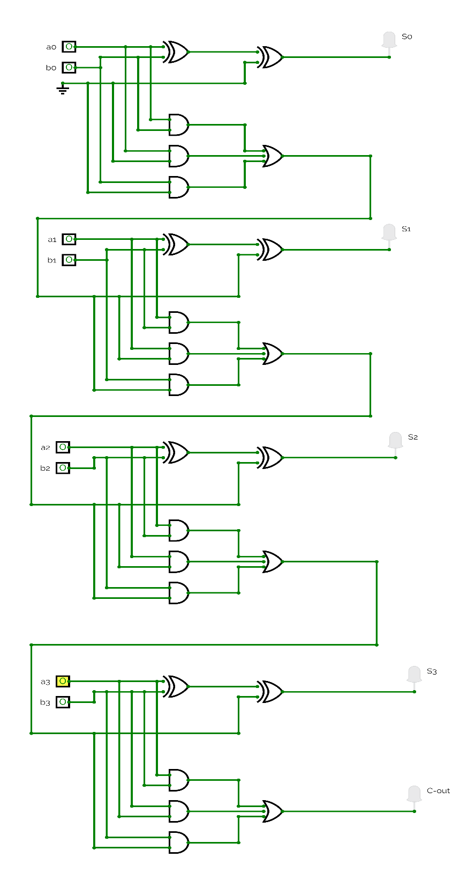

**Simulator**

Circuit’s link:

[https://circuitverse.org/simulator/embed/ﬁnalsimulatoryarab](https://circuitverse.org/simulator/embed/finalsimulatoryarab)

**Simulator with IC**

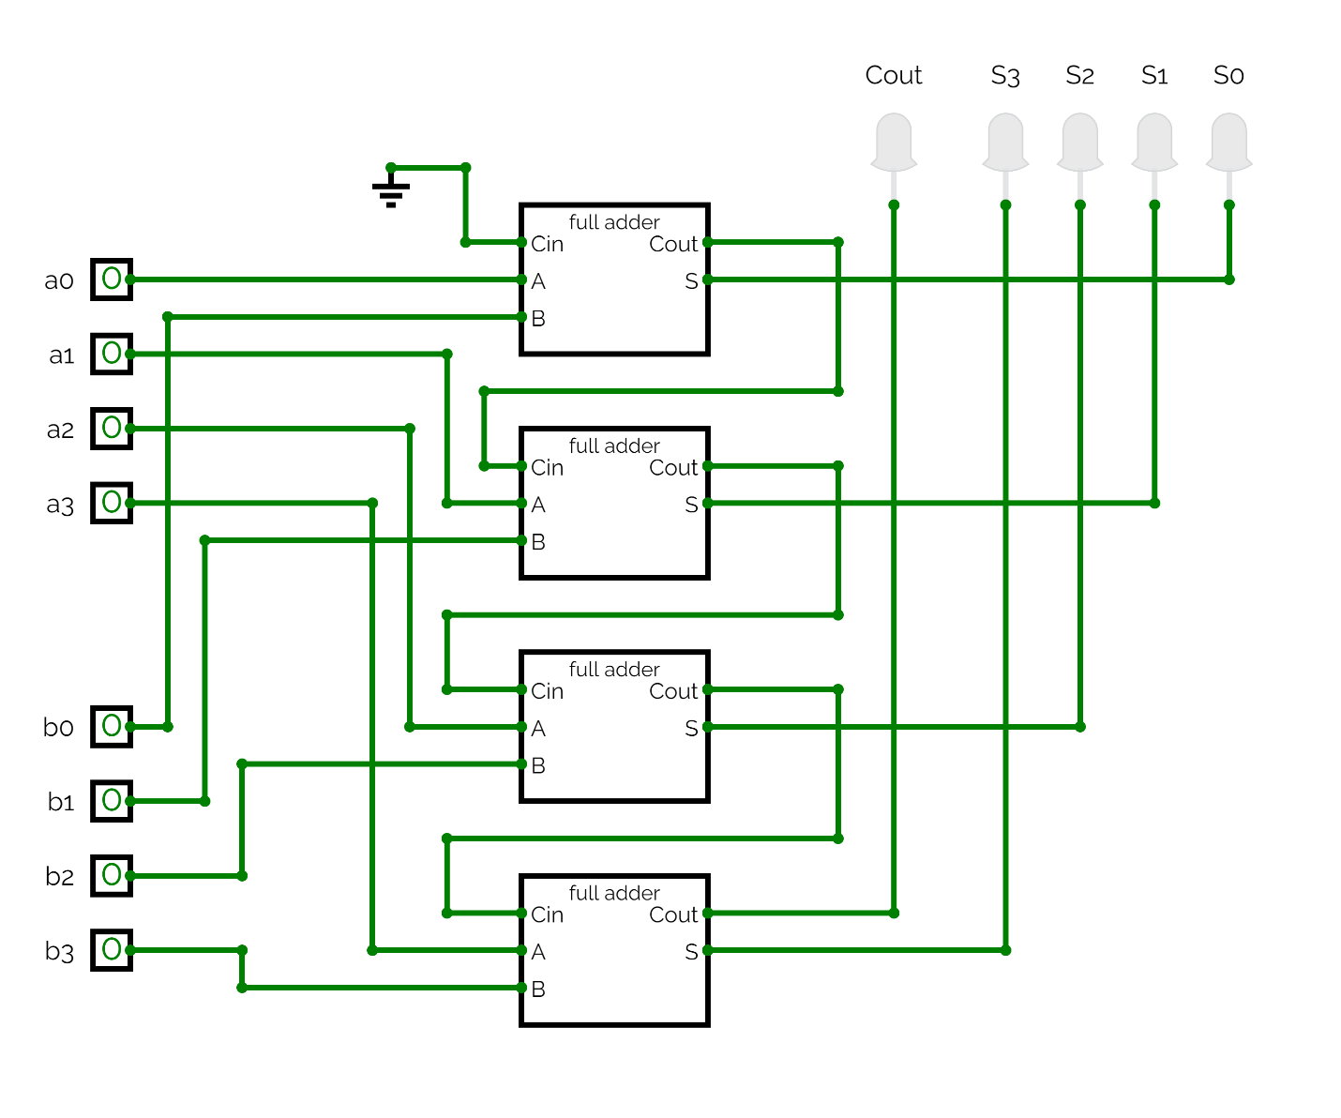Circuit’s Link:

<https://circuitverse.org/simulator/embed/4-bitfulladder_with_ic>

**Hardware Data Sheet**

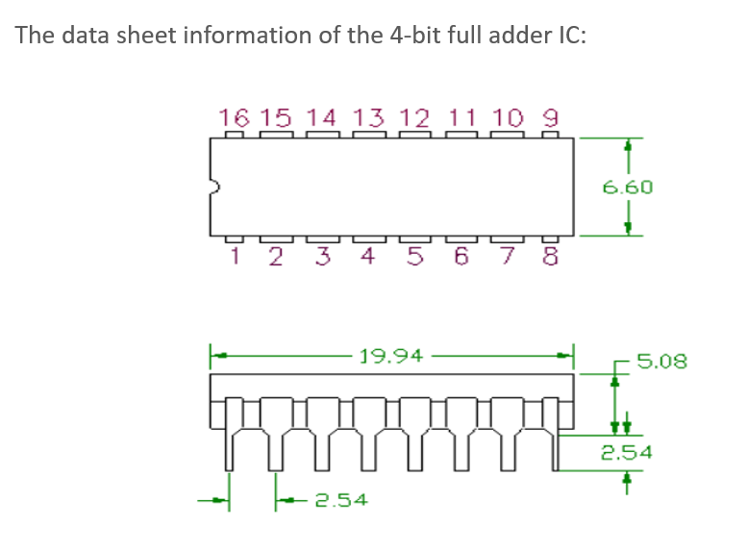

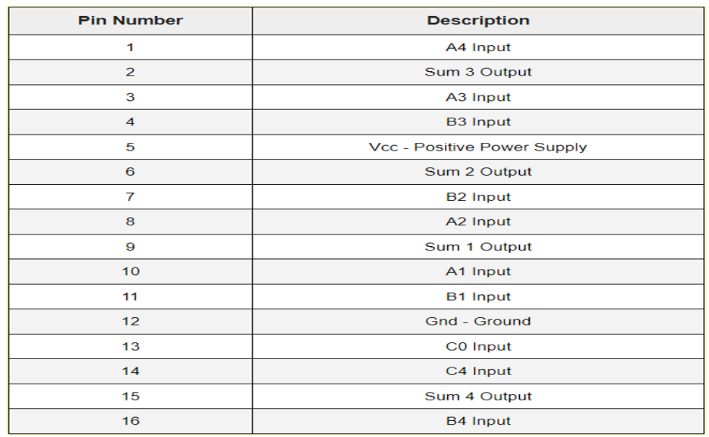

**Components of Hardware**

* switches 4 bit
* 13 resistor 1k
* IC of 4-bit full adder
* A power supply of 6 volts
* Connection wires
* Breadboard

