Node.js Server – Concept 2

In the second project, you will again bring up a Node.js Server running on IBM Bluemix on the internet, but this time, the application includes a framework for publishing HTML web pages. You will make make changes to a web site and edit the application to pass and display a new counter.

- Web browsers can make requests to your server at the Bluemix URL your server is brought up on.
- The server uses the Express Framework code to accept the requests, increments and pass an internal counter, and display the Index HTML page in the browser.
- In the web browser, a HTML formatted page is displayed with a title and counter.
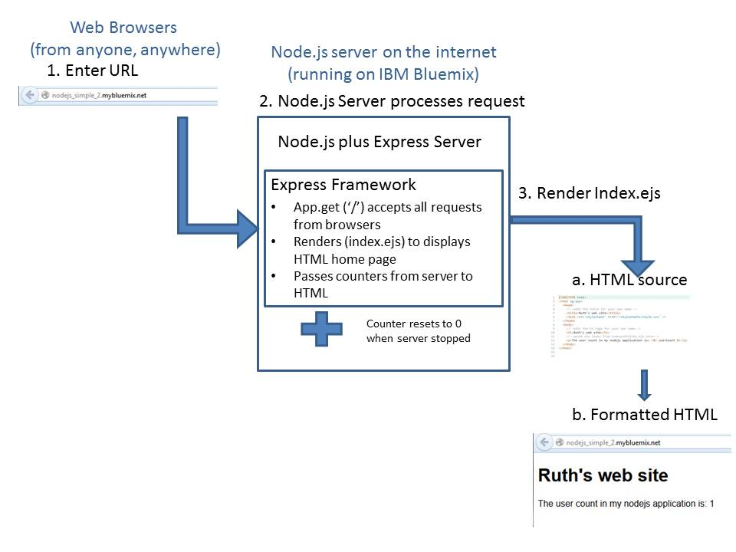
- You will also make some changes to the code. You make changes in the DevOps Services Integrated Development Environment, and deploy the new version of the application back to Bluemix. The code you write is javascript, and the example walks you through adding another counter.
- You will also modify the HTML pages (again using DevOps Services). You can link static HTML pages, upload pictures, and do other HTML formatting to your site.

