Update the Website

1 On a separate tab in your browser, go to DevOps Services at https://hub.jazz.net/ and SIGN IN.
2 Open the sample project rewillen | NodeJS_Simple_2 in your browser. Note: if you are working from a hardcopy type: ibm.biz/nodejs2 or Explore for “rewillen”.
3 Click on FORK PROJECT, provide a unique name for your project, and click CREATE.
4 Click on EDIT CODE
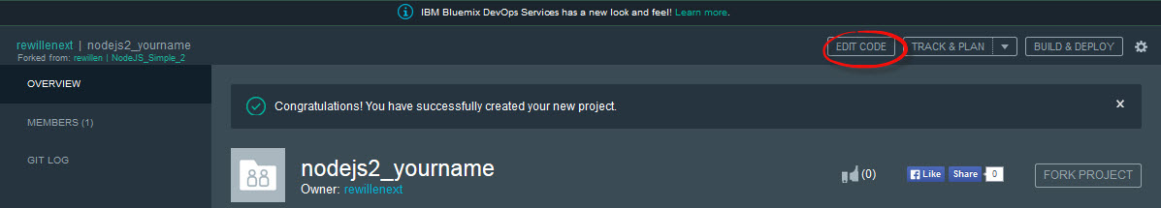
5 Open the views folder, and then Click on index.ejs to edit the HTML
6 Edit the <title> and <h1> tags to say your name <h1>Your name web site</h1>
7 Optional – Set a new Host Name for your application using the same steps at card 1.
8 Click to turn on Live Edit and then click OK on the message box to Re-deploy your application to enable live edit mode.
9 Follow the URL Link to check that the changes are displayed.
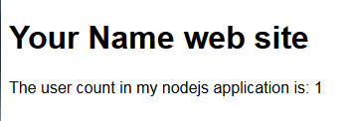
10 Back in DevOps Services, click on app.js. Add a new variable, userbytwo and initialize it to 0.
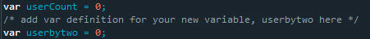

11 Increment userbytwo like this: userbytwo = userbytwo + 2;
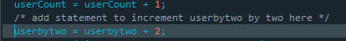

12 Update the render command to add userbytwo as a variable to pass to the HTML page for display like this: res.render('index', {userCount: userCount, userbytwo: userbytwo}); Your app.get code block should now look like this:
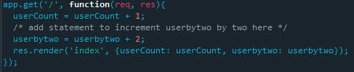
13 Return to the views folder, and then Click on index.ejs
14 Copy and paste line 9. Update the text and change usercount to userbytwo to also display your new variable.
15 Use Live Edit to Restart your application. Check that the changes are displayed.
16 Experiment with displaying additional information from your node.js server on the HTML page.

