Add Linked Web pages to a Node.js Application

1 Go to DevOps Services at https://hub.jazz.net/ and SIGN IN.
2 You can either continue with the project you used for Card 3, or start a new project. To continue:
Use My Projects to find your project of my name | myname-NodeJS_Simple_2, and EDIT CODE. OR to start a new project: Go to rewillen | NodeJS_Simple_2 , and FORK Project
3 Open the views folder, then Click on indexwithhtml.ejs and copy lines 9-15.

4 Click on index.ejs and paste the content after line 8. Index.ejs should now look like indexwithlinks.ejs.
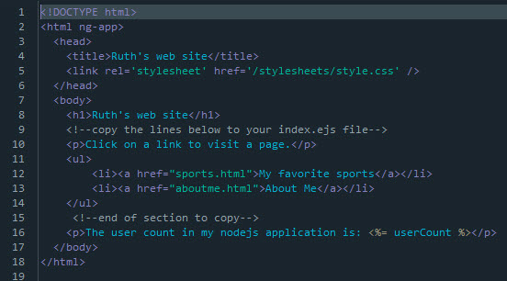
5 Use Live Edit Quick Restart to update your application.
6 Follow the URL link to your application. In your application, test the links to My favorite sports and About Me pages
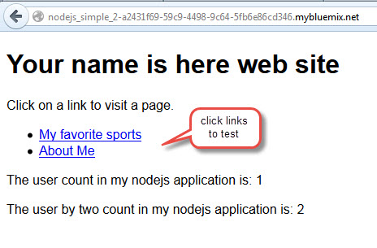

7 Back in DevOps Services, Click on public directory.
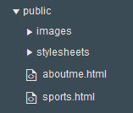
9 Edit the text in aboutme.html.
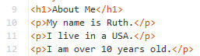

10 Edit the img line in aboutme.html to reference a picture which will be uploaded in the next steps.
11In the public folder, Click on images.
12 Select File, Import, File or zip archive.
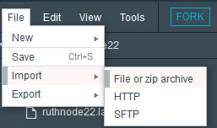
13 Navigate and select your image to upload.
14 Edit sports.html. Insert links to your favorite sports and games.
15 Use the Live Edit Quick Restart to update your website. Check that your image displays and your new links work.
16 Experiment with any HTML features that you want. You may want to look at the My First Website CoderDojo HTML exercises for additional ideas, then move to the NodeJS_Simple_3 project.

