Note: Follow Bluemix-sushi-prereqs for directions to get IDs. This may take up to 24 hours.

Create a Website using Node.js

1 Go to DevOps Services at https://hub.jazz.net/ and SIGN IN.
2 Open the sample project rewillen | NodeJS_Simple_2 in your browser. Note: if you are working from a hardcopy type: ibm.biz/nodejs2 or Explore for “rewillen”.
3 Click on FORK PROJECT, provide a unique name for your project, and click CREATE.
4 Click on EDIT CODE
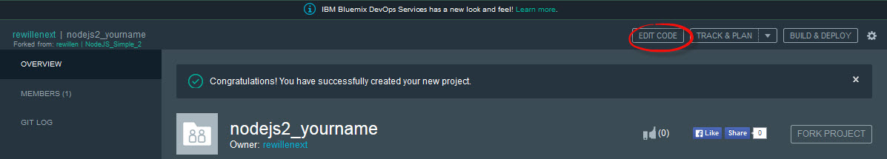
5 Open the views folder, and then Click on index.ejs to edit the HTML
6 Edit the <title> and <h1> tags to say your name <h1>Your name web site</h1>
7 (Optional Step) If you want an easy to remember URL for your website, click the upside down triangle to bring up a configuration screen and complete steps 8 and 9.
8 (Optional Step) Click the pencil icon.
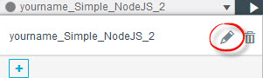
9 (Optional Step) Provide a unique, easy to remember Host name and click SAVE. This will be the URL for your application.
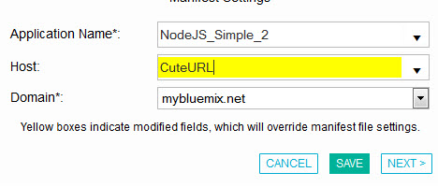
10 Click to turn on Live Edit and then click OK on the message box to Re-deploy your application to enable live edit mode.
11 Wait for the deployment to complete and the status to show running. Click on the URL link icon to view your application.
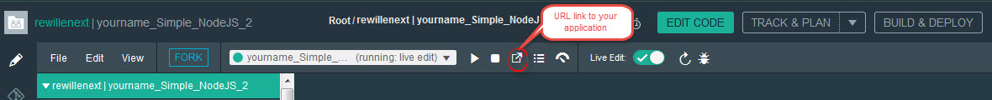
12 A separate browser tab will open with your application.
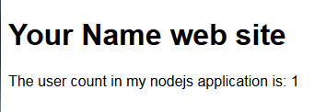
13 Refresh the application in the browser. * What happens? The count should be incremented.
