Add Node.js code to your Website

1 Go to DevOps Services at https://hub.jazz.net/ and SIGN IN.
2 You can either continue with the project you used for Card 1, or start a new project. To continue:
Use My Projects to find your project of my name | myname-NodeJS_Simple_2, Open the application and EDIT CODE OR to start a new project: Go to rewillen | NodeJS_Simple_2 , and FORK like card 1.
3 Click on app.js to open the node.js application code.
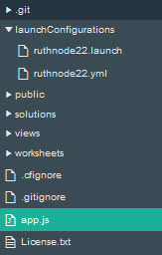
4 Add a new variable, userbytwo and initialize it to 0.
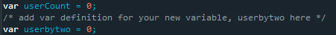
5 Increment userbytwo like this: userbytwo = userbytwo + 2;
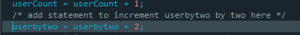
6 Update the render command to add userbytwo as a variable to pass to the HTML page for display like this: res.render('index', {userCount: userCount, userbytwo: userbytwo}); Your app.get code block should now look like this:
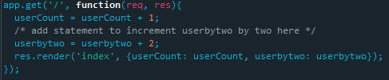
7 Return to the views folder, and then Click on index.ejs
8 Copy and paste line 14. Update the text and change usercount to userbytwo to also display your new variable.
9 Use Live Edit to Restart your application.
10 Use the URL link to see your application changes. Refresh the application in the browser and watch the counters increase.
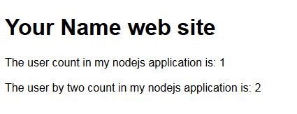
11 Stop your application.
12 To restart you’re application, click the Deploy button.
13 Follow the URL link again to open the application running in a separate tab. * What happens to the count? The count should be reset to 1 visit.

