Using the code repository
1 In your web browser, go to IBM Bluemix™ at https://ibm.biz/bluemix4kids and LOG IN.
2 On a separate tab in your browser, go to DevOps Services at https://hub.jazz.net/ and SIGN IN.
3 Open your DevOps Services project in your browser.
4 Click the git icon on the left column
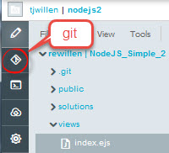
5 The Repository view will open. You will see the files you have changed, and the actual code changes are highlighted. Click the Select All box to select the changed files.
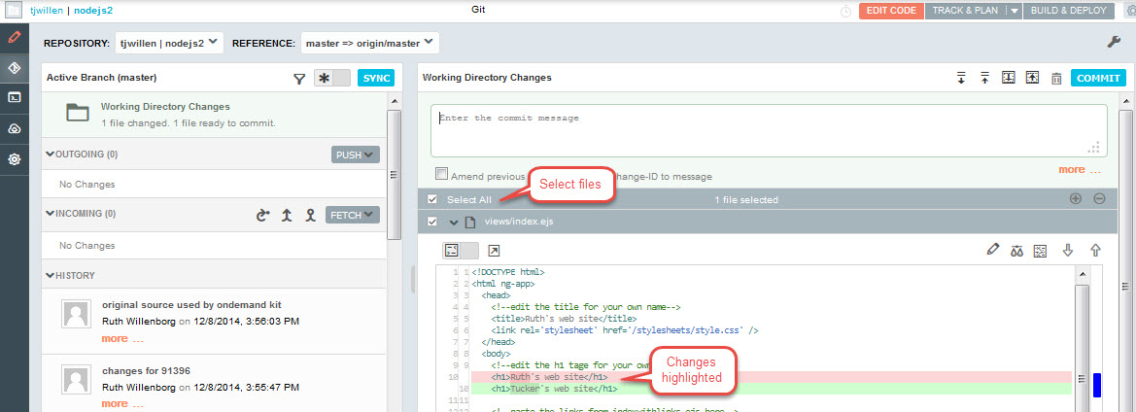
6 Type in a description of your changes in the box that says “Enter the commit message”.
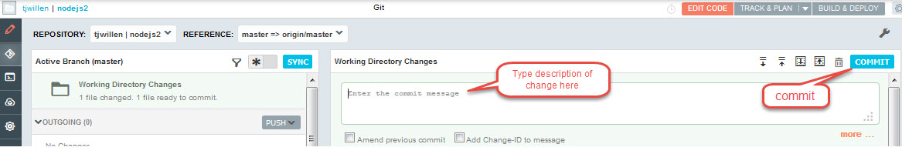
7 Click on the COMMIT button on the right. Your changes are now ready to be pushed to the master repository where others will be able to see them.
8 You will see your changes under OUTGOING on the left panel. Click the PUSH button.
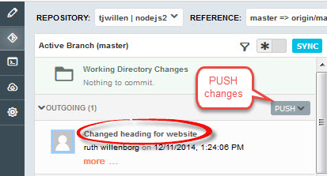
9 Wait until you see the Push Result green box.

10 You can now use the Automatic Build & Deploy capabilities to deploy your code from the repository. Build & Deploy only uses files in the repository. Click BUILD & DEPLOY on the far right.
11 Click SIMPLE to turn on the automated Build and Deploy. A build and deploy should automatically happen for any changes pushed to the repository. You can also use the REQUEST DEPLOY button.
