**S Overview (1)**

**Ch .1**

**“Agricultural Association”**

[**Agricultural association**](https://www.lawinsider.com/dictionary/agricultural-association)**means an association that engages in any activity in connection with the marketing or selling of the agricultural products of its members, or with the harvesting, preserving, drying, processing, canning, packing, storing, handling, shipping, or utilization thereof, or the man- ufacturing or marketing of the by-products thereof; or in con- nection with the manufacturing, selling, or supplying to its members of machinery, equipment, or supplies, or in the financing of these activities. In the application of the defini- tion of agricultural association, "agricultural products" includes horticultural, viticultural, forestry, dairy, livestock, poultry, bee, and farm products.**

**This project was created to manage an Agricultural Association in across the republic level.**

**It helps both of the following:**

**1)Manger: -where the Manger will have the subsystem is a mange supervisor one of manger mange all the supervisor & Manger is mange of Association one of Association have one manger**

**he signatures all of the paper and mange all operation in organizations.**

**2)Association:- The association in every province and every center has at least one association, and it has a relationship with agricultural supplies because it manages that, and each association has something that distinguishes it, which is its own number, as well as the area of ​​each association separately.**

**3) Agricultural supplies: -are one of the most important things that exist and are indispensable in any association because they belong to the affairs of farmers and depend on the area of ​​​​each association and each person, and according to the crops.**

**4)Supervisors; - Supervisors are people who have to take care of pond affairs, where every person has a specific pond to take care of, and he must know the crops and the area and inform the director about it.**

**5) Docks: - The docks are a group of places, they are in a specific place, they are called a certain name, and for each group they have a specific supervisor. In all the ponds, more than one type of crop can be grown, and each pond has a different area with different crops.**

**6) Owner: - The owner is a person who owns one or more plots of land, and each piece has a different area, a different crop, and a unique number for it. The national number must also be found.**

**7) Lands:- Lands must have a person who owns them, and each land must have boundaries and a unique number for it.**

**8)crops:- Crops In every piece of land there is the same crop or a backward crop, and each crop has a specific timing and a number that distinguishes this crop.**

**Problem statement:**

The problems of the agricultural association may multiply, for example, the transfer of ownership of a piece of land from one person to another in the event of purchase or in the event of the death of the owner and the children inherit, as well as the distribution of agricultural supplies according to the area.

Agricultural confinement on land and lack of employees.

**Objective :**

The goals of the project are to be able to solve all problems, for example, the existence of an entity for the owner and inheritance to the children The Farmers' Association shall work for such purposes as protecting farmers' rights and interests, enhancing farmers' knowledge and skills, promoting the modernization of agriculture, increasing crop yields, improving farmers' livelihood, and developing the rural economy. The Farmers Association is a legal person.

**Ch.2**

Requirements

**Requirements, which are adding a new piece of land, adding a new owner, transferring a new ownership, or adding land to any other association, modifying its ownership in general, and so on. Knowing the agricultural requirements in each season, the quantity and types of crops required, re-bequeathing the land to the person’s son. And the employment of a new person in his place and in relation to the basin is when a new piece of land is added to the urban space, it is automatically added according to the basin that belongs to him, and the land is added to this person.**

**MANGER: To make an inventory every year to know the areas, comparisons with crops, and the closeness of the supervisors and the management of farmers’ conditions in full, and the one responsible for managing the association.**

**Supervisors; - Supervisors manage the agricultural inventory with the director and pay more attention to the ponds and problems and add each piece of land to its own basin and its urban area and give violations to the building on the agricultural lands under the supervision of the director.**

**Association: The association has a number that distinguishes each one from the other for ease of knowing the private spaces and all the information and its manager or the honorees and the crops in it**

**Agricultural supplies: Agricultural services must be available in each gathering and they are not disbursed except by order of the director according to the area of ​​each person and the crop he cultivates.**

**Docks: - The docks are a group of places, they are in a specific place, they are called a certain name, and for each group they have a specific supervisor. In all the ponds, more than one type of crop can be grown, and each pond has a different area with different crops.**

**Owner: - The owner is a person who owns one or more plots of land, and each piece has a different area, a different crop, and a unique number for it. The national number must also be found. which are adding a new piece of land, adding a new owner, transferring a new ownership, or adding land to any other association, modifying its ownership in general,**

**Lands:- Lands must have a person who owns them, and each land must have boundaries and a unique number for it.**

**crops:- Crops In every piece of land there is the same crop or a backward crop, and each crop has a specific timing and a number that distinguishes this crop.**

***SCHEMA***

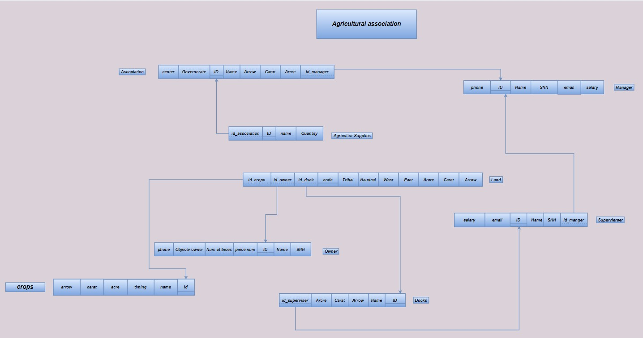

**CH.4**

**Coding**

**create table Association**

**( id int not null IDENTITY(1,1) PRIMARY KEY,**

**name varchar(50) not null ,**

**Governorate varchar(50) not null ,**

**center varchar(50) not null,**

**Arrow int DEFAULT '0' ,**

**carat int DEFAULT '0' ,**

**Arcre int DEFAULT '0' ,**

**id_manger int not null FOREIGN KEY REFERENCES Manger(id)**

**)**

**-------------------------------------------**

**create table Manger**

**(**

**id int not null IDENTITY(1,1) PRIMARY KEY,**

**name varchar(50) not null ,**

**snn varchar(14) not null ,**

**phone varchar(11) null,**

**salary numeric(7) not null ,**

**email varchar(50) null**

**)**

**--------------------------------------------------------------**

**create table superviser**

**(id int not null IDENTITY(1,1) PRIMARY KEY,**

**name varchar(50) not null ,**

**snn varchar(14) not null,**

**email varchar(50) null,**

**salary numeric(7) not null ,**

**id_manger int not null FOREIGN KEY REFERENCES Manger(id)**

**)**

**------------------------------------------------**

**create table docks**

**(code int not null IDENTITY(1,1) PRIMARY KEY,**

**name varchar(50) not null ,**

**Arrow int DEFAULT '0' ,**

**carat int DEFAULT '0' ,**

**Arcre int DEFAULT '0' ,**

**id_superviser int not null FOREIGN KEY REFERENCES superviser(id)**

**)**

**------------------------------------------------**

**create table Agricultur_Supplies**

**(id int not null IDENTITY(1,1) PRIMARY KEY,**

**name varchar(50) not null ,**

**Quantity int not null ,**

**id_Association int not null FOREIGN KEY REFERENCES Association(id)**

**)**

**------------------------------------------**

**create table Land**

**(**

**code int not null IDENTITY(1,1) PRIMARY KEY,**

**Arrow int DEFAULT '0' ,**

**carat int DEFAULT '0' ,**

**Arcre int DEFAULT '0' ,**

**Tribal varchar(50) not null,**

**Nautical varchar(50) not null,**

**West varchar(50) not null,**

**East varchar(50) not null,**

**id_docks int not null FOREIGN KEY REFERENCES docks(code),**

**id_owner int not null FOREIGN KEY REFERENCES Owner(id),**

**id_crops int not null FOREIGN KEY REFERENCES crops(id)**

**)**

**----------------------------------------------**

**create table Owner**

**(id int not null IDENTITY(1,1) PRIMARY KEY,**

**name varchar(50) not null ,**

**Numofbices int not null check (Numofbices >= 0),**

**piecenum int not null ,**

**snn varchar(50) not null ,**

**phone varchar(50) not null ,**

**Objectv_owner varchar(50) not null ,**

**Arrow int DEFAULT '0' ,**

**carat int DEFAULT '0' ,**

**Arcre int DEFAULT '0'**

**)**

**--------------------------------------------**

**create table crops**

**(id int not null IDENTITY(1,1) PRIMARY KEY,**

**name varchar(50) not null ,**

**Arrow int DEFAULT '0' ,**

**carat int DEFAULT '0' ,**

**Arcre int DEFAULT '0' ,**

**timing varchar(50) not null,**

**)**

**---------------------------------------------**

**Query**

insert into Manger values ('Azzam Mahfouz Muhammad ','2030352352645','01122627208',4500,null)

insert into Manger values('Mohamed Abdel Wahab Hassan ','2010352352645','01129627208',4300,null)

insert into Manger values('Hassan Rizk Fathi ','2080352352645','01126627208',4400,null)

insert into Manger values('Amr Saleh Ahmed ','2030352352625','01122627202',4700,null)

insert into Manger values('Bassem Hassan Youssef','2035352352645','01242627208',4500,null)

insert into Manger values('Ahmed Noureddine ','20383522332645','01132627208',4500,null)

insert into Manger values('Muhammad Abdul Wahab Ali ','2030352365645','01122927208',4500,null)

insert into Manger values('Ahmed Ismail Mohamed ','2030352532645','01165627208',4510,null)

insert into Owner values ('Ibrahim Ibrahim Abdel-Wahhab',9,764,'26812222200132','01233627298','owner',1,18,12)

insert into Owner values ('Ibrahim Ahmed Mahmoud',1,2227,'26812233300132','01222627278','owner',0,7,5)

insert into Owner values ('Ibrahim El-Desouki Mohamed Mohamed',1,2381,'26815522200132','01192627298','owner',1,20,22)

insert into Owner values ('Ibrahim Al-Sayed Diab Al-Zeer',1,1885,'26814412200132','01012627298','owner',1,18,20)

insert into Owner values ('Ibrahim Juma Othman Ali ',3,1183,'26811352200132','01022627298','owner',0,8,10)

insert into Owner values ('Ibrahim Hassan Al-Sayed Abdel-Latif',1,2601,'28512222200132','01229527298','owner',0,10,8)

insert into Owner values ('Ibrahim Hassan Badr',1,935,'26812222212232','01222659898','owner',2,7,18)

insert into Association values ('Big dimple','giza','Class',2190,21,0,1)

insert into Association values ('Neighborhood','giza','Class',1175,17,0,2)

insert into Association values ('blunt','giza','crying',1186,17,0,3)

insert into Association values ('Fadel facility','giza','crying',443,11,0,4)

insert into Association values ('kindness','giza','crying',1360,12,0,5)

insert into Association values ('ahnasia','Bani Sweif','ahnasia',1186,17,0,6)

insert into superviser values('mohamed ail taha','2326563266555',null,4100,1)

insert into superviser values('brahim Muhammed Ibrahim','23265632665969',null,4200,2)

insert into superviser values('Ibrahim Kamel Abdel-Al','2326587266555',null,4100,3)

insert into superviser values('Ibrahim Esmat Yusuf Ali','2329563266555',null,4100,4)

insert into superviser values('Muhammad Abdul Wahab Ali','9626563266555',null,4200,5)

insert into superviser values('youssef azam mahfoze','2326563266555',null,4200,6)

insert into docks values ('frist',963,20,12,1)

insert into docks values ('second',1100,20,10,2)

insert into docks values ('thrid',2132,19,3,3)

insert into docks values ('A_frist',1963,10,11,4)

insert into docks values ('B_frist',2163,15,15,5)

insert into docks values ('C_frist',526,10,10,6)

insert into docks values ('D_frist',1563,7,2,7)

insert into crops values ('corn','Summer')

insert into crops values ('Bean','Summer')

insert into crops values ('wheat','winter')

insert into crops values ('linen','winter')

insert into Land values(1,2,1,'mohamed amr','Ail omar','street','limit',1,1,1)

insert into Land values(8,2,1,'hussin amr','Azam omar','street','street',2,2,1)

insert into Land values(4,3,1,'mostafa ','Ail omar','limit','limit',3,3,1)

insert into Land values(2,2,1,'mona amr','Ail omar','street','hussin amr',4,4,1)

insert into Land values(0,2,9,'gmal omar','ESMAIL ','hussin amr','limit',5,5,2)

insert into Land values(2,2,12,'khield tahe','Ail omar','street','watered',6,6,2)

insert into Land values(3,2,3,'mohamed amr','Ail omar','street','limit',7,7,2)

insert into Land values(2,5,22,'Assame youssef','watered','street','limit',8,8,2)

insert into Land values(1,25,1,'mohamed amr','Ail omar','street','limit',9,9,3)

insert into Land values(4,10,19,'mohamed amr','Ail omar','street','limit',10,10,3)

insert into Land values(12,0,20,'watered','Ail omar','street','limit',11,11,3)

insert into Agricultur_Supplies values('fertilizer',100,1);

insert into Agricultur_Supplies values('fertilizer',200,2);

insert into Agricultur_Supplies values('fertilizer',300,3);

insert into Agricultur_Supplies values('fertilizer',400,4);

insert into Agricultur_Supplies values('seeds',1200,1);

insert into Agricultur_Supplies values('seeds',1100,2);

insert into Agricultur_Supplies values('seeds',1100,3);

insert into Agricultur_Supplies values('seeds',1030,4);

insert into Agricultur_Supplies values('seeds',1050,5);

---------- update date in one record-----------

update Owner

set Owner.Numofbices=2

where Owner.id= 7;

update Agricultur_Supplies

set Agricultur_Supplies.Quantity=450

where Agricultur_Supplies.id=7;

------------------ delete from table one recode or more -------------------

delete from Agricultur_Supplies

where id=2

delete from Owner

where Owner.id=9

and Owner.id=20

select count(*)

from Owner

select name ,count(*)

from Agricultur_Supplies

group by name

having count(*) >15;

select top 10 name from Owner

where name is not null

select name from Owner

where name is null

select s. name,d.name from superviser s inner join docks d

on s.id=d.id_superviser

select name from Owner

where name like 'h%'

select name from Owner

where name like '%h__s%'

select max(Agricultur_Supplies.Quantity) as max_Quantity from Agricultur_Supplies

select sum(Agricultur_Supplies.Quantity) as sum_Quantity from Agricultur_Supplies

select avg(Agricultur_Supplies.Quantity) as avg_Quantity from Agricultur_Supplies

select count(*) from Agricultur_Supplies

select Quantity as max_Quantity from Agricultur_Supplies

order by Quantity asc

select Governorate,name from Association

where name ='blunt' or name ='red kom'

select ROUND(Quantity,1) from Agricultur_Supplies

select distinct Governorate from Association

select * from Agricultur_Supplies

select * from superviser

select * from Owner

select * from Land

select * from Manger

select * from docks

select * from crops

select * from Association

-------------------------Agricultur_Supplies---------------------

select distinct name from Agricultur_Supplies ---what kind of Agricultur_Supplies in association ??

select name, sum(Quantity)as sum_of_Quantity from Agricultur_Supplies group by name ---how sum of quantity in all Agricultur_Supplies by each kind ??

---------------------superviser---------------------------

select name, salary from superviser

order by salary desc -------------each superviser order by salary desc ??-------------------

-------------Owner-----------

select name, Numofbices,piecenum,Objectv_owner,Arrow,carat,Arcre from Owner -------select important object For each Owner----------

select max(Numofbices)

from Owner

select top 3 Numofbices from Owner

select max(Numofbices) as max_pices from Owner ------how to max Num of pices----------

select name, (Arrow+Arcre+carat)as all_area,Numofbices,piecenum from Owner ------------Total area and num of pices for each famer ??--------------

------------Land--------------

select * from Land

select (Arrow+Arcre+carat)as all_area from Land

------------------------------------------

--------Association-----------

select Governorate,sum(Arrow+carat+Arcre) as sum_area from Association

group by Governorate

order by sum_area desc

select sum(ass.Arcre+ass.Arrow+ass.carat) from Association ass

where name ='Big dimple' -----clauc associated in only ----

-------------------------Agricultur_Supplies---------------------

select distinct name from Agricultur_Supplies ---what kind of Agricultur_Supplies in association ??

select name, sum(Quantity)as sum_of_Quantity from Agricultur_Supplies group by name ---how sum of quantity in all Agricultur_Supplies by each kind ??

---------------------superviser---------------------------

select name, salary from superviser

order by salary desc -------------each superviser order by salary desc ??----------------

select name ,salary

from superviser

where salary > 4100;

select name

from superviser

where name='Ibrahim Kamel Abdel-Al'

select name ,salary

from superviser

where name like 'i%' ;

select name ,salary

from superviser

where id_manger =1;

select name ,salary

from superviser

where id_manger in (1,4);

-------------Owner-----------

select name, Numofbices,piecenum,Objectv_owner,Arrow,carat,Arcre from Owner -------select important object For each Owner----------

select max(Numofbices) as max_pices from Owner ------how to max Num of pices----------

select name, (Arrow+Arcre+carat)as all_area,Numofbices,piecenum from Owner ------------Total area and num of pices for each famer ??--------------

------------Land--------------

select (Arrow+Arcre+carat)as all_area from Land -----TOTAL LAND ----

-----manger----------------------

select max(salary) as max_salary_for_Manger from Manger

-------------------------------------------

------------docks------------

select distinct name from docks ------uniqe of docks -----------

select sum(Arrow+carat+Arcre) sum_of_area,name from docks

group by name -------- sum of totla area in Eac of docks ------------------

---------------------------------

---------------crops---------

select distinct name ,timing from crops -------UNIQE CROPS --------------

select name , sum(Arrow+carat+Arcre) sumofarea from crops

where timing ='Summer'

group by name ---------total area by crops in only timiming --------

----------------------------------------------------

------------------------------------------JOIN---------------------------------------

-----------------------------Agricultur_Supplies ag join Association--------------

select Ass.name,ag.name,ag.Quantity,Governorate,(Ass.Arrow+ Ass.carat+ Ass.Arcre) as total_area from Agricultur_Supplies ag join Association Ass on Ass.id=ag.id_Association

--------------------- Association Ass join Manger M-----------------------

select Governorate,Ass.name,M.name,salary from Association Ass join Manger M on M.id=Ass.id_manger

------------------- Manger M join superviser s-------------------

select M.name ,s.name ,s.salary as salary_by_supervisor from Manger M join superviser s on M.id=s.id_manger

------------------- from Owner O JOIN Land l---------------------

select O.name,O.Numofbices,O.piecenum,O.Objectv_owner,(l.Arrow+l.carat+l.Arcre) as total_area from Owner O JOIN Land l

on O.id=l.id_owner

------------------------from Land l join docks d on d.code=l.id_docks join superviser s on s.id=d.code------------

select d.name as name_of_dockes ,s.name as name_of_supervisoer,(l.Arrow+l.carat+l.Arcre) as total_area_in_dockes from Land l join docks d

on d.code=l.id_docks

join superviser s on s.id=d.code

----------------------from Land l join crops c------------------------

SELECT name ,timing,(l.Arrow+l.carat+l.Arcre) as total_area_in_growen from Land l join crops c on c.id=l.id_crops

-------------------------------------FINAL JOIN----------------------------------

SELECT

Ass.name,

M.name AS manger_name,

M.salary AS salary_by_Manger,

s.name AS supvisoer_name,

s.salary AS salary_by_supervisioer,

ag.name,

d.name AS name_of_dockes,

(d.Arrow + d.carat + d.Arcre) AS total_area_in_dockes,

O.name AS Owner_name,

O.Numofbices,

O.Objectv_owner,

(l.Arrow + l.carat + l.Arcre) AS total_area_by_owner,

c.name AS crops_name,

c.timing,

Quantity,

Governorate,

(Ass.Arrow + Ass.Arcre + Ass.carat) AS total_area_for_Each_association

FROM

Agricultur_Supplies ag

right outer JOIN

Association Ass ON Ass.id = ag.id_Association

RIGHT outer JOIN

Manger M ON M.id = Ass.id_manger

LEFT outer JOIN

superviser s ON M.id = s.id_manger

full outer JOIN

docks d ON s.id = d.id_superviser

full outer JOIN

Land l ON d.code = l.id_docks

full outer JOIN

Owner O ON o.id = l.id_owner

full outer JOIN

crops c ON l.id_crops = c.id

------------------------------------------------------------------------------------------

select * from Association ass right outer join Agricultur_Supplies ag

on ass.id=ag.id_Association ----------right outer join occording by Agricultur_Supplies علشان المستلزم اللي مش موجود ميجبلوش اي حجاه تخص الجمعيه دي

-------------------------------------------------

select * from Owner o left outer join land l

on o.id=l.id_owner -------------هنا المفروض لو المالك مالوش ارض ميجيبش بيانات بس هو اصلا مينعف ارض مالهاش صاحب

select s.name,(d.Arrow+d.carat+d.Arcre) as total_area_in_dockes from docks d left outer join superviser s

on s.id=d.id_superviser

join Land l

on d.code=l.id_docks -------------name by supervioser and join land and docks

SELECT

o.name, (l.Arcre + l.Arrow + l.carat) AS total_by_owner

FROM

Land l

LEFT OUTER JOIN

Owner o ON l.id_owner = o.id

SELECT

o.name, (l.Arcre + l.Arrow + l.carat) AS total_by_owner

FROM

Land l

RIGHT OUTER JOIN

Owner o ON l.id_owner = o.id

SELECT

Ass.name, ag.Quantity

FROM

Association Ass

LEFT OUTER JOIN

Agricultur_Supplies ag ON Ass.id = ag.id_Association----------- left---------

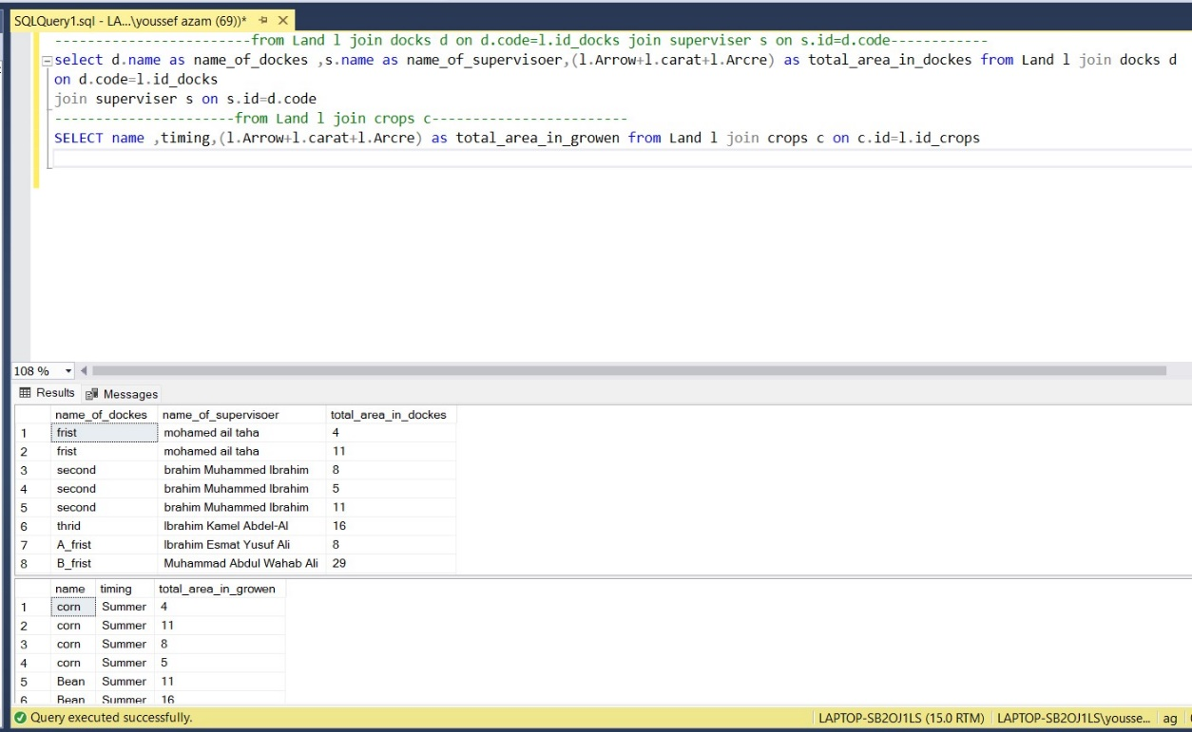

**It is my Dashboard by Power biTableau**

**By: youssef azam data analyst**

**Conclusion:**

**And here we have come to the end of the project, which is the Agricultural College, which contained a manager and supervisors who supervised the ponds, which were one of the most important entities in the project that contain the lands owned by the owners, and who have the right to take agricultural supplies that are indispensable in the institution and every owner or tenant. Cultivate these lands in a valid way and use the seeds from the original association in order to produce the best crop and thus get the best results for the development of our project and our country.**

**There is no doubt that our position has done our best to reach this level, and this is thanks to God and the help of Dr. Amira Mohiuddin and Dr. Shaimaa Sayed**

**And each of the members of the team**

**Youssef Azzam Mahfouz Mohamed, Mohamed Gamal Abdel Halim Sayed, Ahmed Atef Mohamed Mohamed and Amr Ahmed Mohamed Ahmed.**