

**Faculty of engineering - Shoubra**

**Benha University**

**Literature Review**

in fulfillment of the requirements of

|  |  |
| --- | --- |
| **Department** | Engineering Mathematics and Physics |
| **Division** | --------------- |
| **Academic Year** | 2019-2020 Preparatory |
| **Course name** | Computer |
| **Course code** | ECE001 |

**Title(s): -**

**Artificial Intelligence**

By:

|  |  |  |  |
| --- | --- | --- | --- |
|  | Name | Edu mail | B.N |
| 1 | يوسف فهمي يوسف فهمي | Youssif196201@feng.bu.edu.eg | 1069 |

**Approved by:**

|  |  |
| --- | --- |
| Examiners committee | Signature |
| Dr.Ahmed Bayoumi |  |
| Dr.Shady Elmashad |  |
| Dr. Abdelhamid Attaby |  |

* **Github link** : https://github.com/youssef-fahmy/html.project.repository

***Application Brief :-***

In this article, I chose this topic because it is closer to the department and also closer to the future of many departments of engineering, whether it is an electrical department or a strong mechanics department or a programming section (for the computer) where many departments are gathered, which makes it a comprehensive and important study and many applications of artificial intelligence science as applications Artificial intelligence is endless. Technology can be applied to many different sectors and industries. Artificial intelligence is tested and used in the healthcare industry for different drug doses and treatments in patients, and for surgical procedures in the operating room.

Other examples of AI machines include computers playing chess and self-driving cars. Each of these machines must weigh the consequences of any action you take, because each action will affect the end result. In chess, the end result is to win the game. For self-driving cars, the computer system must compute all external data and account for it to work in a collision-preventing manner.

Artificial intelligence also has applications in the financial industry, where it is used to detect activity in banking and finance such as the unusual use of debit card and large account deposits - all of which helps the bank's fraud department. Artificial intelligence applications are also used to help simplify trading and make it easier. This is done by facilitating the estimation of supply and demand and pricing of securities.

* When most people hear the term artificial intelligence, the first thing they usually think of is robots. That's because big-budget films and novels weave stories about human-like machines that wreak havoc on Earth. But nothing could be further from the truth.
* Artificial intelligence is based on the principle that human intelligence can be defined in a way that a machine can easily mimic it and execute tasks, from the most simple to those that are even more complex. The goals of artificial intelligence include learning, reasoning, and perception.
* As technology advances, previous benchmarks that defined artificial intelligence become outdated. For example, machines that calculate basic functions or recognize text through optimal character recognition are no longer considered to embody artificial intelligence, since this function is now taken for granted as an inherent computer function.
* AI is continuously evolving to benefit many different industries. Machines are wired using a cross-disciplinary approach based in mathematics, computer science, linguistics, psychology, and more.

# Screenshots

1. **Main page**

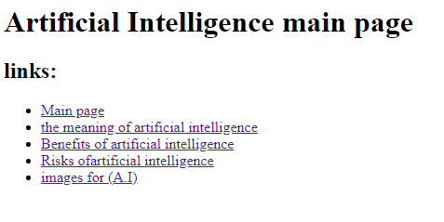

1. **The definition**

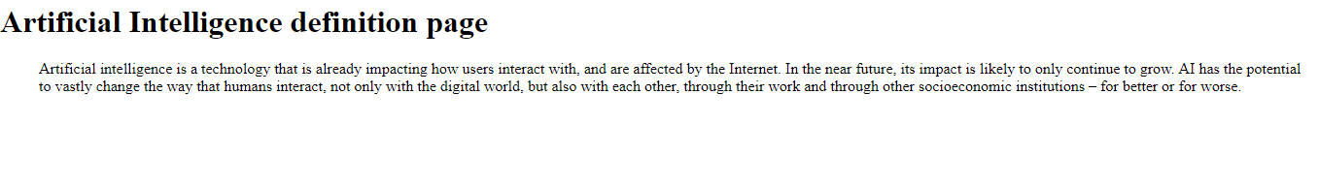

1. **Images**

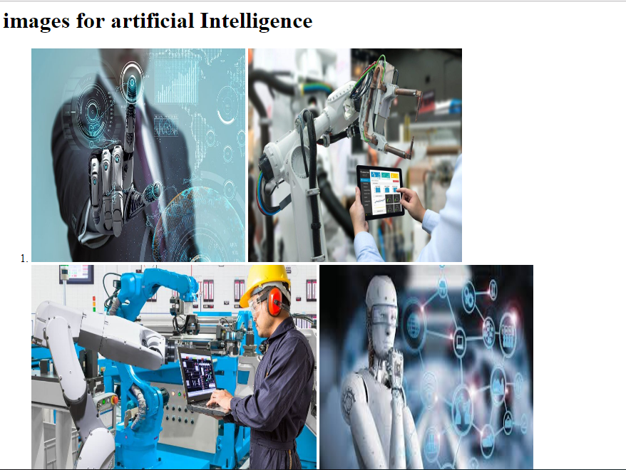

# Scorce code :-

1. **Main page (code)**

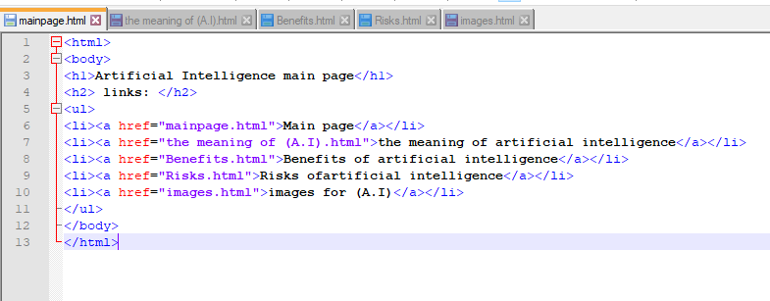

1. **The definition (code)**

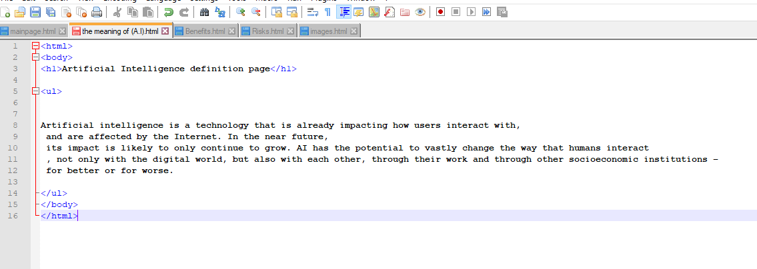

1. **Images (code)**



